Graph Representation and Algorithm Performance Analysis
Alexander Ricciardi
Colorado State University Global
CSC506 - Design and Analysis of Algorithms
Professor Dr. Jonathan Vanover
May 3, 2026

Graphs are important in computer science because they model relationships between objects. A graph can describe roads between cities, links between network devices, dependencies between tasks, or relationships between people. In this project, two graph storage models are implemented and evaluated: AdjacencyListGraph and AdjacencyMatrixGraph. The project also evaluates four graph algorithms: breadth-first search (BFS), depth-first search (DFS), Dijkstra's shortest-path algorithm, and Bellman-Ford.
The purpose of this analysis is to examine how each representation behaves both theoretically and practically. Theoretical analysis uses Big-O notation to describe how performance grows as the number of vertices V and edges E increases. Practical analysis uses benchmark data collected from the Benchmark Lab across sparse and dense graph workloads using vertex counts of 25, 50, and 100. The saved benchmark data compares construction, adjacency checks, neighbor scans, BFS, DFS, Dijkstra, Bellman-Ford, and edge removal.
It is important to note that representation choice depends strongly on the workload. The list-based model records real neighbor relationships, which makes it a good fit for sparse workloads. The matrix-based model allocates a row-column position for each source-target pair; that design can help in dense, stable workloads where direct edge checks are common (CSU Global, n.d.; Lysecky & Vahid, 2019). The benchmark results in this project support that point clearly. In particular, the results show how strongly graph density influences the practical difference between list-based and matrix-based storage.

Adjacency List Representation
AdjacencyListGraph stores each vertex beside the vertices directly connected to it. In this project, the list representation uses dictionary-backed neighbor maps, which means a vertex only stores relationships that actually exist. This structure fits sparse graphs because absent edges do not require a stored source-target cell.
From a Big-O perspective, list-based graph storage uses O(V + E) space. Traversal algorithms such as BFS and DFS also fit naturally with this representation because each step uses the current vertex's stored neighbors. On a sparse workload, that behavior avoids scanning many empty relationships. This is why list-based representations are commonly recommended when edge counts remain much lower than the maximum number of possible vertex pairs (Lysecky & Vahid, 2019).
In practice, the saved benchmark results strongly favor list-based storage on sparse workloads. At 100 vertices in the sparse workload, the list implementation is faster for build, neighbor scan, BFS, DFS, Dijkstra, Bellman-Ford, and edge removal. The only sparse 100-vertex operation where the matrix wins is direct adjacency checking, and even there the matrix advantage is modest. These results show that list-based storage is the strongest default for the kind of sparse relationship data that appears often in real applications.

Adjacency Matrix Representation
AdjacencyMatrixGraph stores graph connections in a square table. Each row and column represents a vertex, and each cell records whether a source-target pair has an edge. If the row and column are already known, an adjacency check can be performed in O(1) time. That direct lookup is the main theoretical advantage of the matrix representation (CSU Global, n.d.; Lysecky & Vahid, 2019).
The trade-off is space. A matrix uses O(V^2) storage because it must allocate a cell for each source-target pair, even when most pairs do not have edges. This makes matrix storage less attractive for sparse workloads. It becomes more reasonable in dense workloads because a larger share of the allocated cells contain useful edge information.
In practice, the matrix representation remains valuable in this project, but it is more specialized than list-based storage. The saved dense benchmark results show matrix wins for dense Dijkstra at all tested sizes. At 100 vertices, dense Bellman-Ford also favors the matrix. Still, list-based storage wins most dense operation buckets overall. This means the matrix should not be treated as the automatic choice for every dense graph. It is most useful when the workload has stable vertices, many direct pair checks, or a specific shortest-path pattern in which matrix storage benchmarks better.

Traversal and Shortest-Path Algorithms
BFS and DFS both explore reachable vertices, but they organize the search in different ways. BFS expands outward from the start vertex in layers, while DFS follows one path deeply before it backtracks (Colorado State University Global, 2020; Lysecky & Vahid, 2019). In this project, the Traversal Lab shows that the same graph can produce different visit orders depending on whether the program uses BFS or DFS.
Figure 1
Traversal Lab BFS result
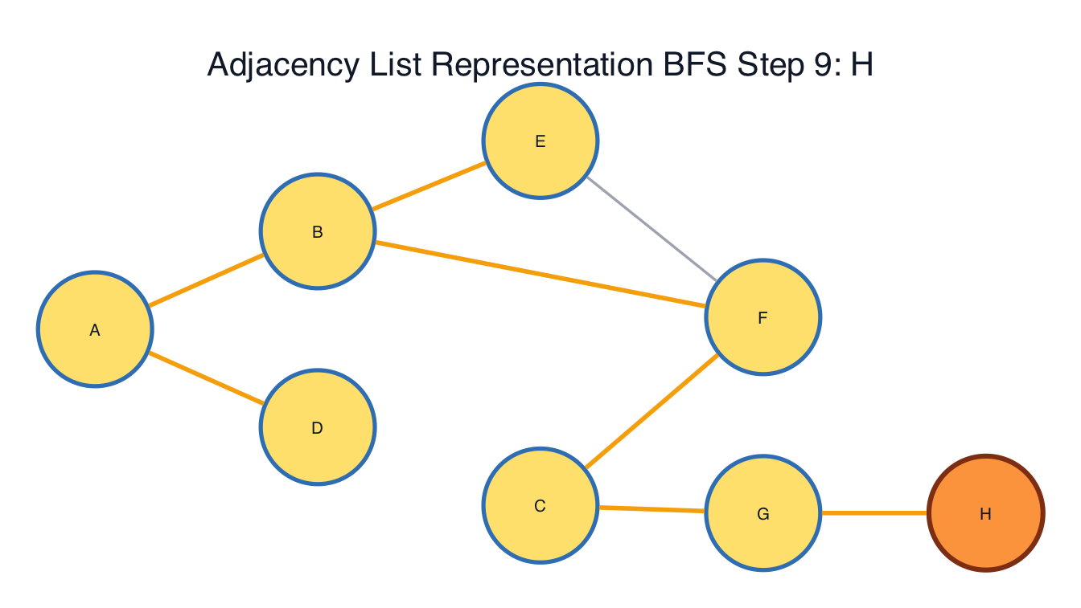
Traversal Lab BFS result
Note: This image marks the final BFS traversal result from the sample traversal graph.
Shortest-path algorithms add a different kind of decision. Dijkstra is the right practical default when every edge weight is non-negative. Bellman-Ford is slower in Big-O terms, but it supports negative edge costs and can detect reachable negative cycles (Rao & Murugan, 2019; Lysecky & Vahid, 2019). That correctness distinction matters more than representation performance. A matrix may be efficient for some dense shortest-path workloads, but it cannot make Dijkstra valid on a graph containing negative costs.
The Shortest Path Lab examples show this difference clearly. On the positive route demo, Dijkstra finds the Denver-to-Vail route Denver -> Boulder -> Vail for a total distance of 139. On the negative cost demo, Bellman-Ford is the correct choice because discount and credit edges reduce the running cost. The resulting path reaches Order Complete with a total cost of 69.

Comparative Big-O Analysis
Big-O notation is useful in this project because it shows why the benchmark rankings are not accidental. List-based storage scales with stored relationships, while matrix storage scales with every possible source-target pair. That difference becomes especially visible in sparse workloads. Operations that only need real neighbors usually favor the list-based model, while direct pair checks are the clearest theoretical strength of the matrix.
Table 1
Theoretical Complexity Summary for CTA-7 Graph Structures and Algorithms
Operation | AdjacencyListGraph | AdjacencyMatrixGraph | Key implementation note
Space | O(V + E) | O(V^2) | List storage follows real edges; matrix storage follows every source-target pair.
Build graph | O(V + E) | O(V^2 + E) | Matrix construction must prepare the square row-column structure.
Check adjacency | O(deg(V)) in the report model | O(1) | This implementation's dictionary-backed list keeps practical checks competitive.
Scan neighbors | O(V + E) | O(V^2) | Matrix scans can inspect empty cells.
BFS / DFS | O(V + E) | O(V^2) | Traversal requests each vertex's stored neighbors.
Dijkstra | O((V + E) log V) | O(V^2 log V) | Dijkstra benchmark inputs use positive edge values.
Bellman-Ford | O(VE) | O(VE) | Bellman-Ford is slower but supports negative edge cases.
Remove edges | O(1) average | O(1) | Both structures can remove a known edge directly in the current code.
Note: This table follows the implementations and benchmark labels used in this project, not every possible graph design.
Table 1 helps explain the saved results. On sparse graphs, E is much smaller than V^2; list storage therefore avoids a large amount of unused matrix work. On dense graphs, E approaches V^2, narrowing the practical gap and creating selected situations in which matrix storage can compete or win.

Benchmark Findings
The Benchmark Lab measured list and matrix runtime using 25, 50, and 100 vertices across sparse and dense graph workloads. The sparse workload becomes less dense as the vertex count increases, while the dense workload keeps density at 0.6000.
Table 2
Saved Benchmark Workloads
Graph kind | Vertices | Edges | Density
Sparse | 25 | 30 | 0.1000
Sparse | 50 | 61 | 0.0498
Sparse | 100 | 124 | 0.0251
Dense | 25 | 180 | 0.6000
Dense | 50 | 735 | 0.6000
Dense | 100 | 2,970 | 0.6000
Note: The benchmark workload summary is populated from analysis/benchmark_results.csv.
Table 3
Operation Winner Summary
Graph kind | AdjacencyListGraph  winner buckets | AdjacencyMatrixGraph  winner buckets | Interpretation
Sparse | 23 | 1 | The list-backed model is the clear default because absent edges dominate.
Dense | 19 | 5 | The matrix becomes competitive, while list-backed storage remains the broader default.
Note: The winner summary is populated from analysis/operation_winners.csv.
Table 4
Largest Saved Sparse Workload at 100 Vertices
Operation | Fastest structure | Fastest time (ms) | Runner-up | Winner gap
Build graph | AdjacencyListGraph | 0.0724 | AdjacencyMatrixGraph | 69.2%
Check adjacency | AdjacencyMatrixGraph | 0.0382 | AdjacencyListGraph | 8.5%
Scan neighbors | AdjacencyListGraph | 0.0237 | AdjacencyMatrixGraph | 85.4%
BFS | AdjacencyListGraph | 0.4662 | AdjacencyMatrixGraph | 24.1%
DFS | AdjacencyListGraph | 0.3995 | AdjacencyMatrixGraph | 37.2%
Dijkstra | AdjacencyListGraph | 0.6392 | AdjacencyMatrixGraph | 35.5%
Bellman-Ford | AdjacencyListGraph | 0.4678 | AdjacencyMatrixGraph | 14.8%
Remove edges | AdjacencyListGraph | 0.0797 | AdjacencyMatrixGraph | 63.3%
Note: The sparse 100-vertex results show list-backed storage holding its largest practical advantage.
Table 5
Largest Saved Dense Workload at 100 Vertices
Operation | Fastest structure | Fastest time (ms) | Runner-up | Winner gap
Build graph | AdjacencyListGraph | 1.3605 | AdjacencyMatrixGraph | 4.3%
Check adjacency | AdjacencyListGraph | 0.0351 | AdjacencyMatrixGraph | 7.5%
Scan neighbors | AdjacencyListGraph | 0.0753 | AdjacencyMatrixGraph | 78.7%
BFS | AdjacencyListGraph | 1.1333 | AdjacencyMatrixGraph | 1.4%
DFS | AdjacencyListGraph | 1.2648 | AdjacencyMatrixGraph | 2.3%
Dijkstra | AdjacencyMatrixGraph | 16.5533 | AdjacencyListGraph | 4.4%
Bellman-Ford | AdjacencyMatrixGraph | 6.0751 | AdjacencyListGraph | 77.5%
Remove edges | AdjacencyListGraph | 1.3623 | AdjacencyMatrixGraph | 5.7%
Note: The dense 100-vertex results show why the matrix implementation should remain available even though list-backed storage wins more total operations.
Figure 2
Representation profile comparison
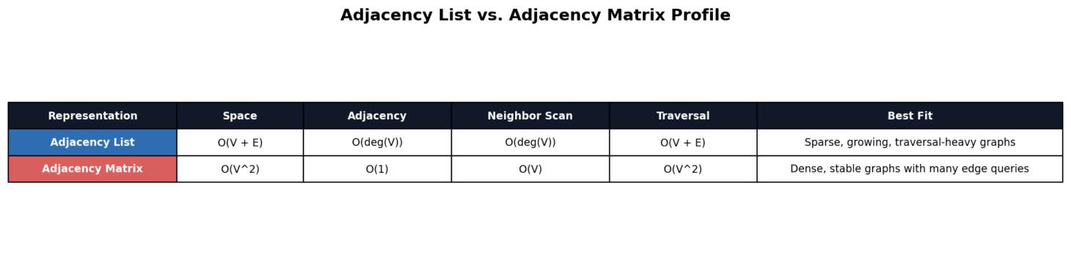
Note: The chart summarizes how the two graph representations compare across major operation groups.
Figure 3
Runtime by operation group
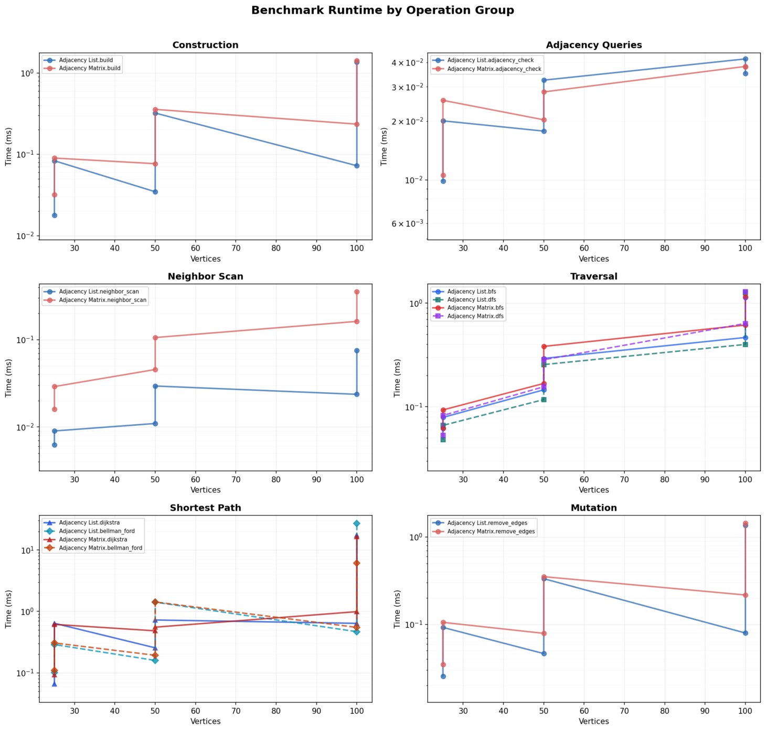
Note: The chart makes traversal and shortest-path costs easier to compare.

Figure 4
Sparse and dense runtime comparison
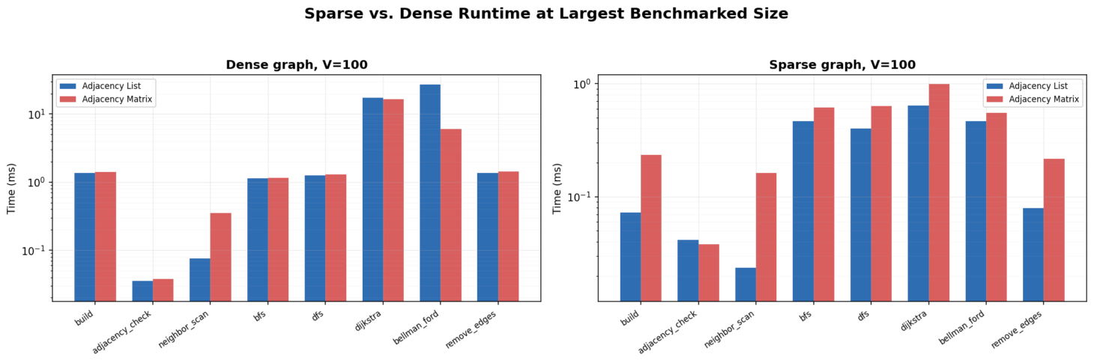
Note: The chart shows how graph density changes the practical gap between list-based and matrix-based storage.
Figure 5
Operation winner heatmap
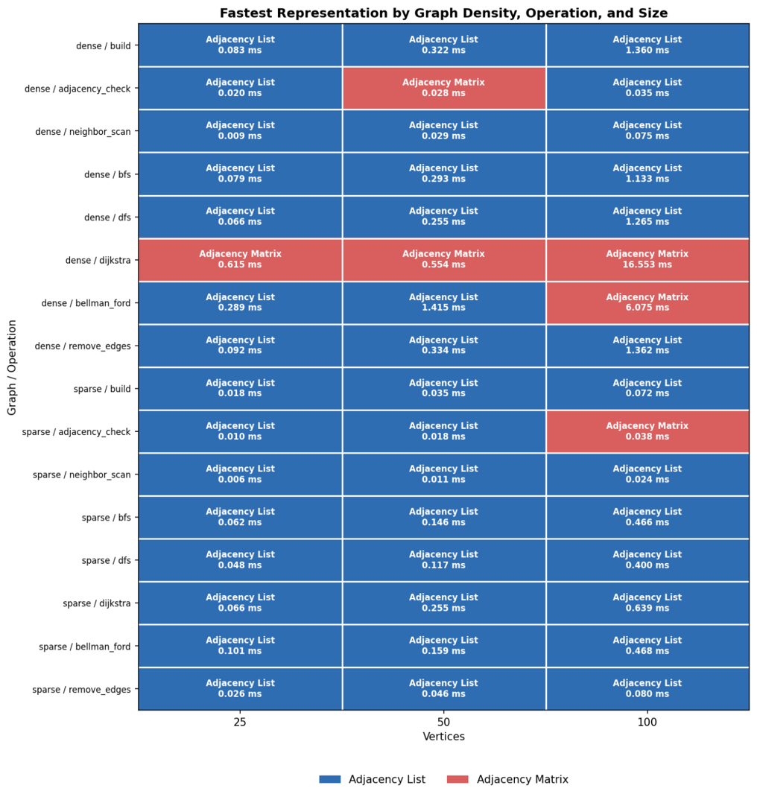
Note: The heatmap shows list-based storage winning most saved benchmark buckets, while the matrix still earns meaningful wins in selected dense shortest-path workloads.
Overall, the benchmarks identify list-based storage as the stronger general representation in this project. In sparse workloads, it wins 23 of 24 operation-size buckets. At the largest sparse size, it is especially strong for neighbor scanning, build time, and edge removal because it only works with stored relationships.
Dense workloads tell a more detailed story: list-based storage still wins 19 of 24 dense operation-size buckets, including build, neighbor scan, DFS, and edge removal at 100 vertices. The matrix wins dense Dijkstra at all saved sizes and dense Bellman-Ford at 100 vertices. These results show that high density can push the matrix into stronger territory when the workload uses the full vertex-pair structure.
Scaling also matters. In the dense workload, adjacency-list Bellman-Ford grows from 0.2888 ms at 25 vertices to 27.0049 ms at 100 vertices, a 93.50x increase. Matrix Bellman-Ford grows from 0.3069 ms to 6.0751 ms over the same sizes, a 19.79x increase. Dijkstra grows sharply for both representations because the dense workload presents a much larger edge set to evaluate. This scaling evidence supports the central lesson of the module: storage choice and operation mix jointly drive graph runtime.

Where Graph Representations Help Most
List-based graphs help most when a program stores sparse relationship data, changes the graph over time, or traverses repeatedly from vertex to vertex. Examples include road maps, social networks, prerequisite graphs, router connections, and dependency networks. In those cases, storing only real edges keeps memory use lower and gives traversal algorithms direct access to the neighbors that matter.
Matrix-based graphs help most for dense data, stable vertex sets, and workloads that ask many direct pair questions. A matrix is also useful for teaching because the table view makes each source-target pair visible. The cost is that empty relationships still occupy matrix space, making matrix storage harder to justify for sparse workloads.
Algorithm choice is a separate decision. For example, BFS is used for tasks that require layered reachability or the smallest edge count in unweighted settings. DFS is used for deep exploration with later backtracking. Dijkstra is used for non-negative shortest paths. Bellman-Ford is used for negative costs or negative-cycle detection. A correct graph workflow matches the representation to the data and matches the algorithm to the graph's weight rules.

Conclusion
The results of this project show that the implemented graph structures behave the way algorithm analysis predicts. List-based storage performs well because it stores actual relationships instead of allocating cells for every source-target pair. Under sparse workloads, that advantage is clear across nearly all operations. For that reason, list-based storage is the best default representation for most applications.
At the same time, the adjacency matrix still matters. It supports direct pair reasoning, gives a clear table-based view into graph connections, and wins selected dense shortest-path workloads in the saved benchmarks. For that reason, matrix storage is not a weaker version of list storage. It follows a separate cost model.
The most important conclusion of this module is that graph performance is a workload decision. Density, mutation pattern, adjacency-query frequency, traversal needs, and edge-weight rules all affect the best choice. For sparse data or graphs that change over time, list-based storage is usually stronger. For dense, stable, pair-heavy data, matrix storage should be considered and benchmarked. When negative costs may occur, Bellman-Ford must be chosen first to preserve correctness; representation tuning comes afterward.

References
CSU Global. (n.d.). Lecture 7: Graphs. CSC506: Design and Analysis of Algorithms. Canvas.
Rao, K. P. K., & Murugan, T. S. (2019). An efficient routing algorithm for software defined networking using Bellman Ford algorithm. International Journal of Online Engineering, 15(14), 87-95. https://doi.org/10.3991/ijoe.v15i14.11546
Lysecky, R., & Vahid, F. (2019). Module 7: Graphs. Data structures essentials: Pseudocode with Python examples. zyBooks.

