Recommendation Guide: Choosing the Right Hashing Approach
Alexander Ricciardi
Colorado State University Global
CSC506 - Design and Analysis of Algorithms
Professor Dr. Jonathan Vanover
April 26, 2026

Choosing the right key-value lookup approach depends on several factors, not on speed only. When choosing between a BST-backed TreeMap and a list-backed ListMap, it is important to consider whether repeated lookup matters, whether keys need to remain ordered, whether minimum and maximum lookup are useful, how tree height will change as items are inserted, and how the cost changes as the dataset becomes larger. The Module 6 Benchmark Lab compared TreeMap search against ListMap search across random_insertion and sorted_insertion scenarios. The saved dataset sizes ranged from 50 to 500. Based on those benchmark results and the balance-detection feature, this guide recommends when or in which instance each approach is best suited.

When to Use TreeMap
TreeMap is the better choice when:
- If the workload performs repeated key lookups on the same dataset. TreeMap is the better choice for this purpose because it can use tree ordering to narrow the search path instead of scanning every pair one by one.
- If the program needs keys to remain logically ordered. TreeMap is well suited for this purpose because in-order traversal returns keys in sorted order.
- If the program needs direct support for minimum key and maximum key lookup. TreeMap is useful for this purpose because those operations follow the leftmost and rightmost paths of the tree.
- If insertion order is likely to keep the tree relatively short. In this kind of case, TreeMap is the better choice because its search cost depends on tree height rather than only on the total number of stored items.
It is important to note that TreeMap is not automatically the best choice in every case. In this project, TreeMap performs very well when the tree stays relatively short, but it becomes much weaker when sorted insertions create a severely skewed plain BST.
Example: Suppose a program stores student records by student ID and must later display those records in sorted order while also supporting repeated lookup by ID. TreeMap is useful for this kind of problem because one structure supports both searching and ordered output.

When to Use ListMap Instead of TreeMap
ListMap is the better choice when:
- If the dataset is very small. ListMap is acceptable for this purpose because a short linear scan may still be simple and fast enough in absolute time.
- If only one or two searches will ever be performed. In that case, the added structure of a tree-backed map may not be necessary.
- If insertion order matters more than sorted key order. ListMap is useful for this purpose because it preserves the stored sequence directly rather than reordering keys by BST comparisons.
- If the workload is at high risk of producing a severely skewed plain BST. In this kind of case, ListMap may be the better choice because its performance is predictable and does not depend on tree shape.
It is important to note that ListMap is simpler, but simplicity does not mean better scalability. The Module 6 benchmark results show that ListMap only becomes the better practical choice when the plain BST loses its shape advantage.
Example: Suppose a program stores a very small temporary list of recent items and only searches it once in a while. ListMap is useful for this kind of problem because a simple direct scan may be enough.

When a Plain BST-Based Map Is a Strong Choice
A plain BST-backed map is the better choice when:
- If insertions are distributed in a way that keeps the tree much shorter than the dataset itself. In Module 6, the random_insertion scenario fits this pattern.
- If the workload includes many misses. TreeMap is useful for this purpose because a relatively short search path can still fail much faster than a full linear scan.
- If the program needs both ordered traversal and repeated search. TreeMap is the better choice for this purpose because ListMap does not provide sorted traversal as part of its basic search model.
- If the goal is to combine map-style lookup with tree-based analysis of height and balance. This module is well suited for that purpose because the project explicitly reports tree height and balance status after benchmark runs.
It is important to note that the benchmark results strongly support this recommendation under random_insertion. At 50 items, TreeMap was already slightly faster for hits and about 1.53x faster for misses. At 500 items, the gap widened much more. TreeMap became 5.66x faster for hits and 21.74x faster for misses. Over the same sizes, tree height grew only from 7 to 19, which helps explain why the tree-based map remained effective.
Example: In a course-registration system, a tree-backed map is the better choice when records must be searched repeatedly by student ID and later listed in sorted order. This is useful because the same structure supports both tasks.

When TreeMap Becomes Weaker Than ListMap
TreeMap becomes the weaker choice when:
- If insertions arrive in sorted order. This is risky in a plain BST because the structure can become almost a one-branch chain.
- If tree height grows almost one-for-one with dataset size. In that case, the search path becomes much longer and the tree loses its main advantage.
- If misses are common in a skewed tree. In this kind of case, the search may still need to walk a long path before reporting failure.
- If the workload does not need sorted traversal strongly enough to justify the tree-shape risk.
It is important to note that the sorted_insertion benchmark results make this problem very clear. At 500 items, the sorted tree reached a height of 499, while the random-insertion tree reached a height of only 19. That shape difference appeared directly in runtime. For hit queries at 500 items, TreeMap required 8.2306 ms while ListMap required only 1.8111 ms. For miss queries, TreeMap required 16.0256 ms while ListMap required only 3.5021 ms. These results show that a plain BST can degrade so badly that the list-backed baseline becomes the better practical choice.
Example: Suppose new keys always arrive in already sorted order, such as consecutive IDs inserted from smallest to largest. In this kind of case, a plain BST-backed map is a weak choice because the tree can become heavily skewed.

Search Comparison Snapshot
The following table summarizes the TreeMap-versus-ListMap search comparison shown in the Module 6 Benchmark Lab.
Scenario | Query Mode | Size | ListMap (ms) | TreeMap (ms) | Speedup
random_insertion | hits | 50 | 0.0501 | 0.0481 | 1.04x
random_insertion | hits | 100 | 0.1933 | 0.1261 | 1.53x
random_insertion | hits | 500 | 3.8953 | 0.6878 | 5.66x
random_insertion | misses | 50 | 0.0497 | 0.0325 | 1.53x
random_insertion | misses | 100 | 0.1844 | 0.0652 | 2.83x
random_insertion | misses | 500 | 5.1100 | 0.2351 | 21.74x
sorted_insertion | hits | 50 | 0.0227 | 0.0949 | 0.24x
sorted_insertion | hits | 100 | 0.0825 | 0.3492 | 0.24x
sorted_insertion | hits | 500 | 1.8111 | 8.2306 | 0.22x
sorted_insertion | misses | 50 | 0.0348 | 0.1482 | 0.23x
sorted_insertion | misses | 100 | 0.1350 | 0.5911 | 0.23x
sorted_insertion | misses | 500 | 3.5021 | 16.0256 | 0.22x
It is important to note that the practical recommendation changes with insertion pattern. Under random_insertion, the speedup values grow above 1.00x, which means TreeMap is faster than ListMap. Under sorted_insertion, the values fall well below 1.00x, which means TreeMap is actually slower than the list-backed baseline.

Balance Snapshot
The following table summarizes how tree height changed across the saved benchmark scenarios.
Scenario | Size | Height | Balanced
random_insertion | 50 | 7 | No
random_insertion | 100 | 12 | No
random_insertion | 500 | 19 | No
sorted_insertion | 50 | 49 | No
sorted_insertion | 100 | 99 | No
sorted_insertion | 500 | 499 | No
It is important to note that both saved scenarios are marked as not balanced by the strict balance rule. However, the benchmark results show that these cases are still not equally healthy. The random-insertion trees remain much shorter, while the sorted-insertion trees become severely skewed.

Recommendation Figures
The following figures summarize the main recommendation results from the Module 6 Benchmark Lab.
Figure 1
TreeMap vs. ListMap search runtime
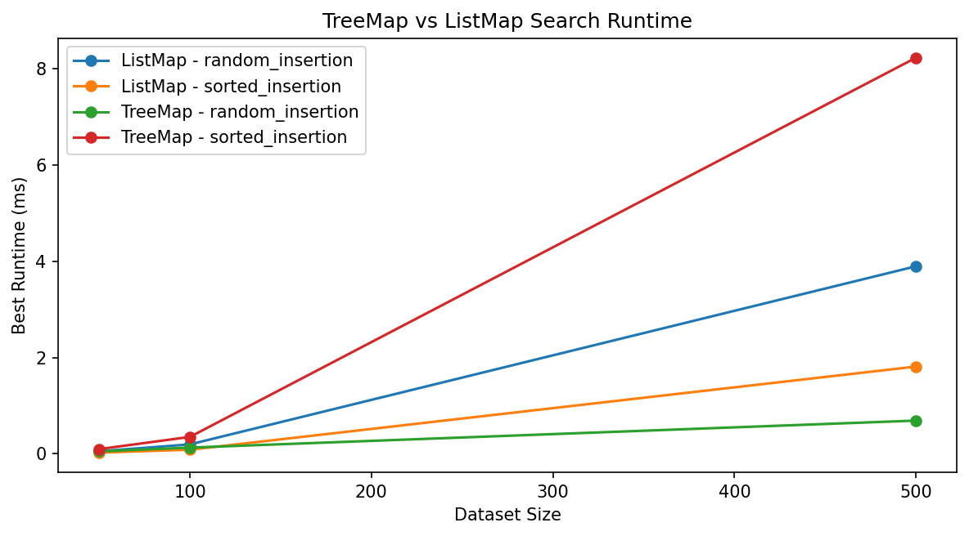
Note: The runtime chart shows that TreeMap performs well when insertion order keeps the BST relatively short, but performs poorly when sorted insertions create a skewed tree.
Figure 2
Search speedup summary
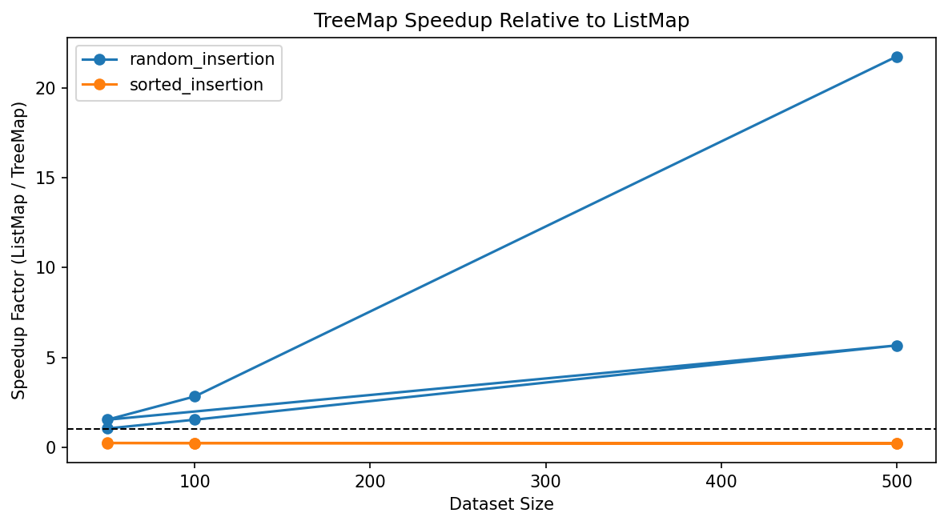
Note: The speedup chart shows that TreeMap gains a practical advantage only when the BST shape remains favorable.
Figure 3
Balance detection profile
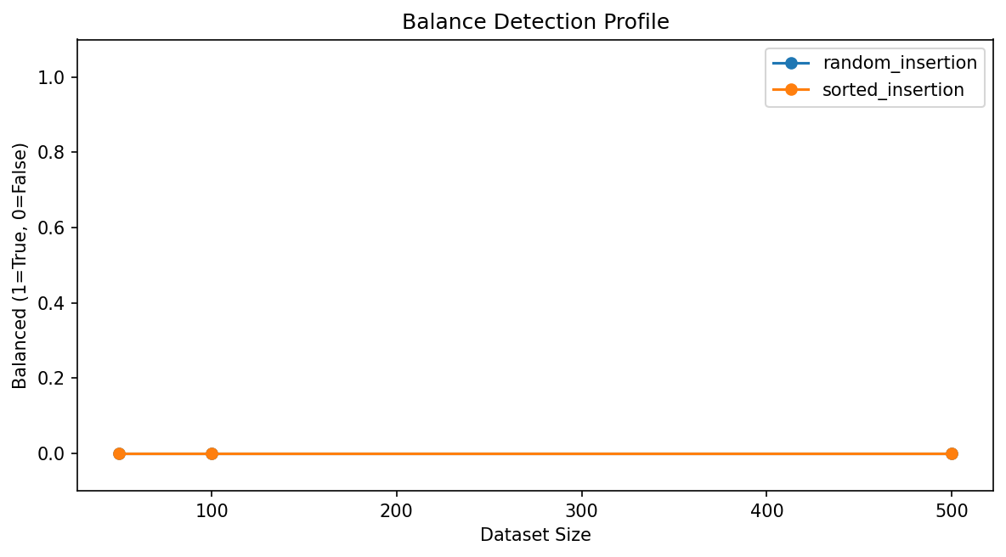
Note: The balance chart shows that strict balance detection marks both saved scenarios as unbalanced, even though the random trees remain much healthier than the sorted trees in practice.

Practical Summary

Criterion | TreeMap | ListMap
Best use case | Repeated lookup with ordered keys | Small or simple key-value storage
Best practical condition | Tree stays relatively short | Dataset remains small or skew risk is high
Main strength | Search plus sorted traversal in one structure | Simplicity and predictable linear behavior
Main weakness | Can degrade badly when the plain BST becomes skewed | Search always grows linearly with dataset size
Module 6 role | Main tree-based map under study | Baseline comparison structure
Strong benchmark result | Faster under random_insertion | Faster under sorted_insertion

Key Takeaway
In practice, there is no single best map choice for every situation. If the program needs repeated key lookup, sorted key output, and minimum or maximum support, TreeMap is the better choice when insertion order keeps the tree relatively short. If the dataset is very small, or if insertion order is likely to create a severely skewed plain BST, ListMap is the better choice because its behavior remains simple and predictable.
Based on Benchmark Lab results and the balance-detection feature, the most practical recommendation in this project is to use TreeMap when the workload benefits from ordered searching and the tree shape remains healthy enough to preserve that advantage. Use ListMap when simplicity matters more than ordering, or when the insertion pattern is likely to make the plain BST lose its performance benefit.

