Data Structure Performance Analysis
Alexander Ricciardi
Colorado State University Global
CSC506 - Design and Analysis of Algorithms
Professor Dr. Jonathan Vanover
April 26, 2026

Binary search trees are important in computer science because they support both key-based search and ordered traversal within the same structure. A plain Binary Search Tree (BST) is useful when a program needs faster-than-linear lookup while also preserving sorted relationships between keys. In this project, three related components are implemented and evaluated: BinarySearchTree, a BST-backed Map called TreeMap, and a list-backed ListMap baseline used for search comparison.
The purpose of this analysis is to examine how each structure behaves both theoretically and practically. Theoretical analysis uses Big-O notation to describe how performance grows as input size n increases. Practical analysis uses benchmark results collected from the Module 6 Benchmark Lab across two insertion scenarios, random_insertion and sorted_insertion, and two query modes, hits and misses. The saved benchmark sizes used in the generated report are 50, 100, and 500 items, which is enough to show how strongly tree height influences search performance.
It is important to note that the same BST idea can behave very differently depending on insertion order. When keys are inserted in a way that keeps the tree relatively short, search only follows a limited root-to-leaf path. When keys are inserted in sorted order, the same plain BST can become heavily skewed and behave much more like a linked list (CSU Global, n.d.; Tutorials Point, n.d.-a). More broadly, tree data structures are useful because they organize information hierarchically while still supporting targeted navigation through parent-child relationships (Tutorials Point, n.d.-b). The benchmark results in this project support that point clearly. In particular, the results show how strongly tree height and skew influence real performance.

Binary Search Tree
A binary search tree stores each key according to an ordering rule. Keys in the left subtree compare smaller than the current node, and keys in the right subtree compare larger. That ordered structure makes searching natural and it also makes in-order traversal return keys in sorted order (CSU Global, n.d.; Tutorials Point, n.d.-a). In this project, the BST implementation supports insert, search, delete, minimum, maximum, and the three required traversals: in-order, pre-order, and post-order.
Deletion is the most complex BST operation because it must preserve the BST ordering rule. The implementation handles the standard cases for deleting a leaf node, deleting a node with one child, and deleting a node with two children. In the two-child case, the deleted node is replaced with its in-order successor so the ordering property remains valid (CSU Global, n.d.). The same ordered structure also makes minimum and maximum lookup straightforward, because the minimum key is found by following the leftmost path and the maximum key is found by following the rightmost path.
From a Big-O perspective, the plain BST has two very different performance profiles. Insert, search, delete, minimum, and maximum are all O(h), where h is the height of the tree. When the tree remains relatively short, that behavior is typically close to O(log n). The worst case is still O(n) because a plain BST can become severely skewed. Traversals remain O(n) because they must visit every node. That height-dependent difference is one of the central ideas of this project.
In practice, the saved balance results make that point easy to see. Under random_insertion, tree height grows from 7 at 50 items to 19 at 500 items. Under sorted_insertion, tree height grows from 49 at 50 items to 499 at 500 items, which is nearly a one-branch chain. These results show that a BST is not just defined by its ordering rule. Its real performance also depends strongly on its shape.

TreeMap and the ListMap Baseline
A map stores key-value pairs rather than standalone keys. In this project, TreeMap uses the BST to store comparable keys with associated values, while ListMap serves as a linear-search baseline. That comparison is important because it shows when ordered tree navigation provides a real benefit over a simple sequential scan.
From a Big-O perspective, TreeMap.search is O(h), which can be close to O(log n) when the tree stays relatively short but can degrade to O(n) when the tree becomes skewed. ListMap.search is consistently O(n) because it must inspect stored pairs from left to right until a match is found or the list is exhausted. TreeMap also supports minimum key, maximum key, and sorted traversal naturally through the BST structure, while ListMap does not provide those ordered operations as part of its basic search model.
In practice, the random-insertion results strongly favor TreeMap. At 500 items, TreeMap needs 0.6878 ms for hit queries and 0.2351 ms for miss queries, while ListMap requires 3.8953 ms and 5.1100 ms for the same workloads. This means TreeMap is 5.66x faster for hits and 21.74x faster for misses at the largest saved random benchmark size. These results show that a relatively short BST can outperform linear scanning by a wide margin.
The sorted-insertion results show the opposite pattern. At 500 items, TreeMap needs 8.2306 ms for hit queries and 16.0256 ms for miss queries, while ListMap requires only 1.8111 ms and 3.5021 ms. In other words, ListMap becomes about 4.54x faster for hits and 4.58x faster for misses once the plain BST becomes severely skewed. These results make it clear that a tree-backed map is not automatically better than a list-backed one. The outcome depends on tree height.

Balance Detection and Tree Shape
The balance-detection system in this project does not rebalance the tree. Its purpose is to measure when a plain BST has drifted far enough from a healthy shape that performance expectations should change. This distinction matters because the assignment is about evaluating standard BST behavior, not replacing it with AVL rotations or another self-balancing design (CSU Global, n.d.).
The saved balance summary shows is_balanced = False for both insertion scenarios at every tested size. However, those results should not be read as meaning the random trees and sorted trees are equally poor. The important difference is how far each tree drifts from an ideal shape. At 500 items, the random tree height is only 19, while the sorted tree height is 499. In other words, both scenarios fail the strict balance rule, but the random case still remains much shorter and much more efficient in practice.

Comparative Big-O Analysis
Big-O notation is useful in this project because it explains why the benchmark rankings are not accidental. A shorter BST path can outperform a list scan, but a highly skewed BST can lose that advantage and move toward linear behavior (CSU Global, n.d.; Tutorials Point, n.d.-a). Those same ideas appear clearly in the benchmark results. Operations that benefit from short tree height stay fast, while operations forced through long root-to-leaf paths become much more expensive as n grows.

Table 1
Theoretical Complexity Comparison of the Data Structures in This Project
Structure | Insert | Search | Delete | Traversal / Min-Max | Key implementation note
Binary Search Tree | Typical O(log n), worst O(n) | Typical O(log n), worst O(n) | Typical O(log n), worst O(n) | Traversal O(n); min/max O(h) | Plain BST with no self-balancing
TreeMap | Typical O(log n), worst O(n) | Typical O(log n), worst O(n) | Typical O(log n), worst O(n) | Sorted key/value iteration O(n); min/max O(h) | Stores key-value pairs through the BST
ListMap | Append/update up to O(n) | O(n) | O(n) | Not naturally sorted | Uses a Python list of key-value pairs with linear search
Note: The table reflects the specific implementations used in this project, not every possible implementation of maps or trees.
Table 1 helps explain the scaling patterns in the saved report. Under random_insertion, TreeMap search remains much faster than ListMap because the BST path stays far shorter than the dataset itself. Under sorted_insertion, the plain BST loses that advantage because tree height grows almost one-for-one with input size. That is exactly the kind of behavior Big-O analysis predicts for a structure whose cost depends on height rather than only on the number of stored items.

Benchmark Results
The benchmark lab feature measured search runtime for TreeMap and ListMap at sizes 50, 100, and 500 across random_insertion and sorted_insertion scenarios.
Table 2
Benchmark Results for All Saved Workloads
Method | Scenario | Query Mode | Size | Time (ms) | Height | Balanced
ListMap | random_insertion | hits | 50 | 0.0501 | - | -
TreeMap | random_insertion | hits | 50 | 0.0481 | 7 | No
ListMap | random_insertion | hits | 100 | 0.1933 | - | -
TreeMap | random_insertion | hits | 100 | 0.1261 | 12 | No
ListMap | random_insertion | hits | 500 | 3.8953 | - | -
TreeMap | random_insertion | hits | 500 | 0.6878 | 19 | No
ListMap | random_insertion | misses | 50 | 0.0497 | - | -
TreeMap | random_insertion | misses | 50 | 0.0325 | 7 | No
ListMap | random_insertion | misses | 100 | 0.1844 | - | -
TreeMap | random_insertion | misses | 100 | 0.0652 | 12 | No
ListMap | random_insertion | misses | 500 | 5.1100 | - | -
TreeMap | random_insertion | misses | 500 | 0.2351 | 19 | No
ListMap | sorted_insertion | hits | 50 | 0.0227 | - | -
TreeMap | sorted_insertion | hits | 50 | 0.0949 | 49 | No
ListMap | sorted_insertion | hits | 100 | 0.0825 | - | -
TreeMap | sorted_insertion | hits | 100 | 0.3492 | 99 | No
ListMap | sorted_insertion | hits | 500 | 1.8111 | - | -
TreeMap | sorted_insertion | hits | 500 | 8.2306 | 499 | No
ListMap | sorted_insertion | misses | 50 | 0.0348 | - | -
TreeMap | sorted_insertion | misses | 50 | 0.1482 | 49 | No
ListMap | sorted_insertion | misses | 100 | 0.1350 | - | -
TreeMap | sorted_insertion | misses | 100 | 0.5911 | 99 | No
ListMap | sorted_insertion | misses | 500 | 3.5021 | - | -
TreeMap | sorted_insertion | misses | 500 | 16.0256 | 499 | No
Note: The table above is populated from the Benchmark Lab results saved in analysis/benchmark_results.csv.
Table 3
TreeMap Search Speedup Relative to ListMap
Scenario | Query Mode | Size | ListMap (ms) | TreeMap (ms) | Speedup
random_insertion | hits | 50 | 0.0501 | 0.0481 | 1.04x
random_insertion | hits | 100 | 0.1933 | 0.1261 | 1.53x
random_insertion | hits | 500 | 3.8953 | 0.6878 | 5.66x
random_insertion | misses | 50 | 0.0497 | 0.0325 | 1.53x
random_insertion | misses | 100 | 0.1844 | 0.0652 | 2.83x
random_insertion | misses | 500 | 5.1100 | 0.2351 | 21.74x
sorted_insertion | hits | 50 | 0.0227 | 0.0949 | 0.24x
sorted_insertion | hits | 100 | 0.0825 | 0.3492 | 0.24x
sorted_insertion | hits | 500 | 1.8111 | 8.2306 | 0.22x
sorted_insertion | misses | 50 | 0.0348 | 0.1482 | 0.23x
sorted_insertion | misses | 100 | 0.1350 | 0.5911 | 0.23x
sorted_insertion | misses | 500 | 3.5021 | 16.0256 | 0.22x
Note: The speedup summary is populated from analysis/search_speedup_summary.csv.
Table 4
BST Height and Balance Summary
Scenario | Size | Height | Balanced
random_insertion | 50 | 7 | No
random_insertion | 100 | 12 | No
random_insertion | 500 | 19 | No
sorted_insertion | 50 | 49 | No
sorted_insertion | 100 | 99 | No
sorted_insertion | 500 | 499 | No
Note: The balance summary is populated from analysis/balance_summary.csv.

See next page

Figure 1
TreeMap vs. ListMap search runtime
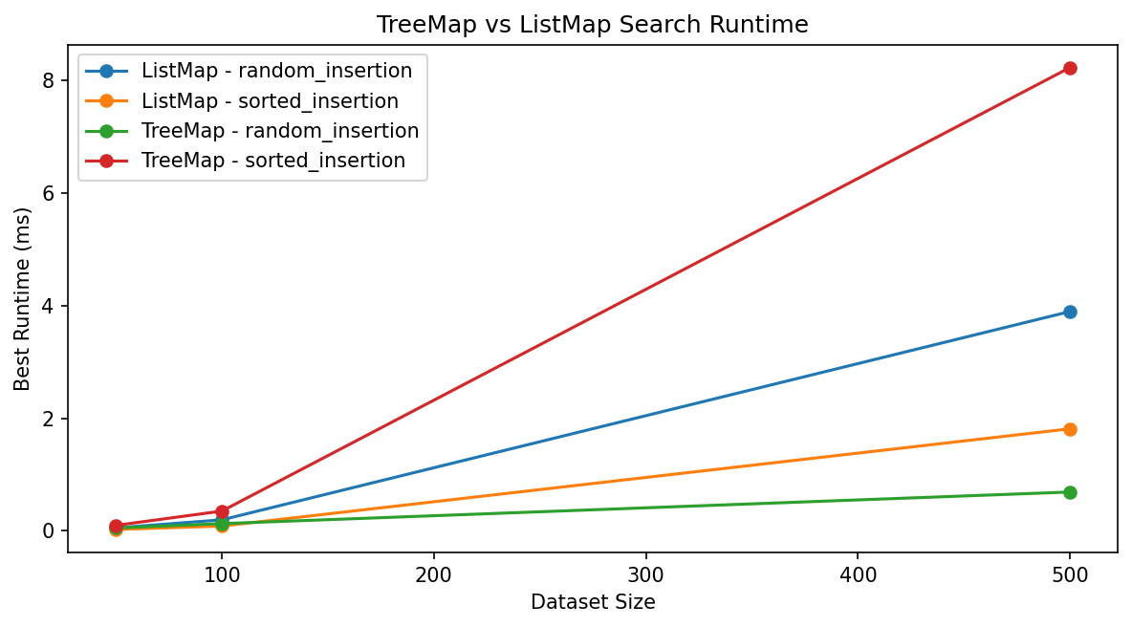
Note: The chart makes it easier to compare tree-based search and linear search under both insertion scenarios.
Figure 2
TreeMap speedup summary
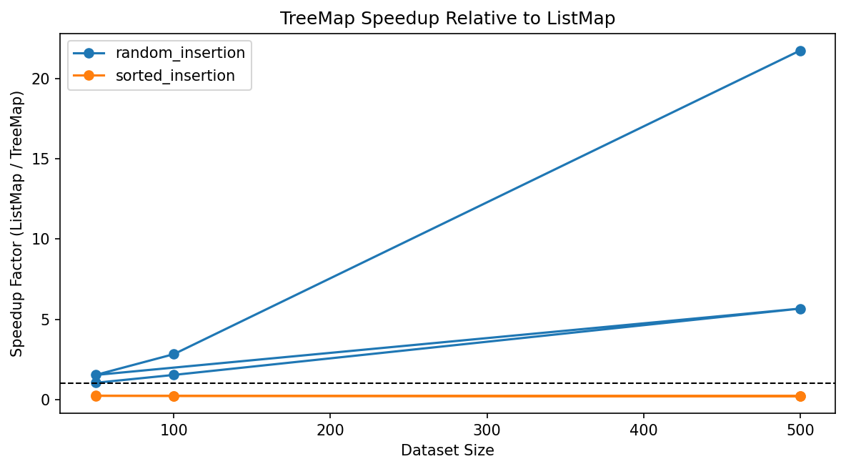
Note: The speedup chart highlights where TreeMap gains a strong advantage and where the skewed BST falls behind the list-backed baseline.
Figure 3
BST height growth by insertion scenario
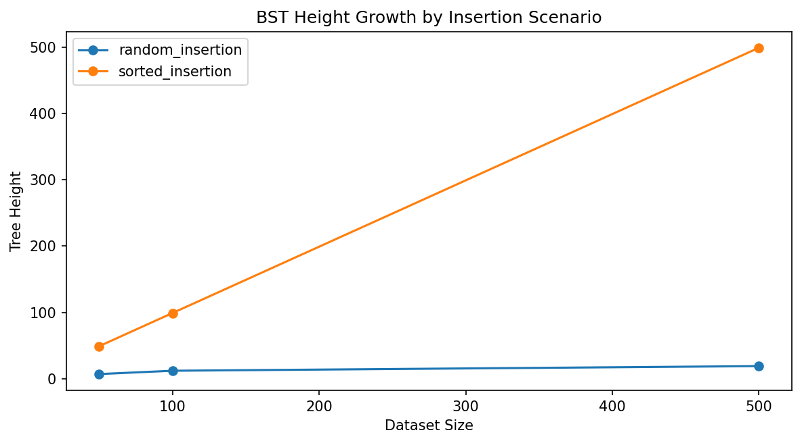
Note: The height chart makes the structural difference between random and sorted insertions easy to see.
Figure 4
Balance detection profile
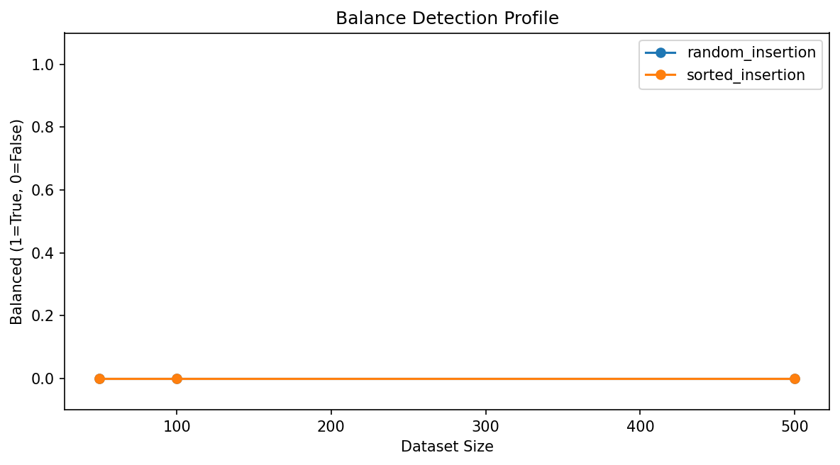
Note: The balance profile shows that the strict balance test marks both scenarios as unbalanced, even though their practical search performance differs substantially.
The benchmark results show that TreeMap is the stronger lookup structure in this project when insertion order keeps the BST relatively short. At 500 items under random_insertion, TreeMap completes hit searches in 0.6878 ms and miss searches in 0.2351 ms, while ListMap requires 3.8953 ms and 5.1100 ms. That gap is especially important for misses because a miss forces the list-backed map to exhaust the entire scan, while the shorter tree still only follows one search path.
The sorted-insertion results are equally important because they show the main limitation of a plain BST. At 500 items under sorted_insertion, TreeMap search slows to 8.2306 ms for hits and 16.0256 ms for misses, while ListMap finishes in 1.8111 ms and 3.5021 ms. The balance summary explains why. The random-insertion tree reaches height 19, but the sorted-insertion tree reaches height 499. These results show that the same BST implementation can move from strong performance to weak performance simply because insertion order changes the shape.
Taken together, the saved benchmark data reinforces the central lesson of the module. Tree-based lookup is highly effective when the tree remains reasonably short, and it is especially valuable when a program also needs ordered traversal, minimum, or maximum operations. However, a plain BST is vulnerable to skew, which means its practical performance can collapse toward linear time without any bug in the code itself.

When Trees Are Most Beneficial
Tree data structures are most beneficial when a program needs several features at once: key-based searching, ordered output, multiple traversal views, and efficient access to minimum and maximum values. Examples include maintaining a sorted collection of records, storing key-value pairs that must later be shown in order, or supporting repeated lookup operations where a full linear scan would become too costly (CSU Global, n.d.; Tutorials Point, n.d.-b).
At the same time, the benchmark results in this project show that a plain BST is most beneficial when insertion order does not drive the tree into a highly skewed shape. If that risk is high, a developer would need either a controlled insertion strategy or a self-balancing tree design outside the scope of this assignment.

Conclusion
The results of this project show that the implemented structures behave the way algorithm analysis predicts. The plain binary search tree and the BST-backed TreeMap perform well when insertion order keeps the tree relatively short, because search only has to follow a limited root-to-leaf path. Under those conditions, TreeMap clearly outperforms the list-backed baseline.
At the same time, the benchmark results show the main limitation of a plain BST. When keys are inserted in sorted order, tree height grows almost as quickly as the dataset itself, and the search advantage disappears. For that reason, the most important conclusion of this module is not that trees are always better than lists. The more important conclusion is that tree shape determines whether a plain BST is actually beneficial. When a program needs sorted traversal and reasonably efficient lookup, a BST-backed map is a strong choice. When insertion order is likely to create severe skew, a developer would need a different strategy, such as controlled insertion order or a self-balancing tree outside the scope of this assignment.

References
CSU Global. (n.d.). Lecture 6: Comprehensive study of trees [Interactive Lecture]. CSC506 - Design and Analysis of Algorithms. Canvas.
Tutorials Point. (n.d.-a). Binary Search Tree. Tutorials Point. https://www.tutorialspoint.com/data_structures_algorithms/binary_search_tree.htm
Tutorials Point. (n.d.-b). Tree Data Structure. Tutorials Point. https://www.tutorialspoint.com/data_structures_algorithms/tree_data_structure.htm

