Data Structure Performance Analysis
Alexander Ricciardi
Colorado State University Global
CSC506 - Design and Analysis of Algorithms
Professor Dr. Jonathan Vanover
April 19, 2026

Hash tables and priority queues are important in computer science because they solve different kinds of retrieval problems. A hash table is used when the main goal is fast key-based lookup. A priority queue is used when the main goal is to repeatedly remove the highest-priority or lowest-priority item. In this project, two structures were implemented and tested: HashTable and BinaryHeapPriorityQueue.
The purpose of this analysis is to examine how each structure behaves both theoretically and practically. Theoretical analysis uses Big-O notation to describe how performance grows as input size n increases. Practical analysis uses benchmark results collected from the Benchmark Lab across four workload groups: normal hash-table operations, forced-collision hash-table operations, priority-queue operations, and hash-table-versus-linear-search comparison. The benchmark sizes used in the generated report are 100, 500, 1,000, 5,000, and 10,000 items, which makes it possible to observe how quickly the performance differences widen as the workload becomes larger.
It is important to note that the same data structure idea can behave very differently depending on how it is implemented. Hash tables depend heavily on the quality of the hashing function and the collision strategy, while heaps depend on maintaining parent-child ordering in a nearly complete binary tree (CSU Global, n.d.; Lyseck & Vahid, 2020.). The benchmark results in this project support that point clearly. In particular, the results show how strongly hash distribution, collision buildup, and full linear scans influence real performance.

Hash Table
A hash table stores data as key-value pairs and uses a hash function to map each key to a bucket in an array. It is a kind of structure that stores data in an associative way and can provide very fast insertion and search when the index is computed effectively (Tutorials Point, n.d.-a). In other words, they compute a bucket index from each key, allowing the structure to have an average-case search of O(1), that is, when the table is well designed (Lyseck & Vahid, 2020). In this project, the table is implemented as a bucket array where each bucket stores a Python list of HashEntry objects.
From a Big-O perspective, the hash table is the most favorable lookup structure in the project under normal conditions. Insert, search, and delete are all average-case O(1) operations because the workload usually only needs to inspect one bucket and a short chain. The worst case is still O(n) because too many keys can land in the same bucket and force a much longer scan. That average-case versus worst-case difference is one of the central ideas of hashing.
In practice, the normal hash-table benchmark results are very strong. Hash Table.search_hits grows only from 0.2214 ms at 100 items to 0.2612 ms at 10,000 items. Hash Table.search_misses grows only from 0.3451 ms to 0.3525 ms over the same range. Hash Table.insert_bulk increases from 0.1395 ms at 100 items to 16.4633 ms at 10,000 items, which is larger growth than search but still very favorable for a dynamic key-value structure. These results show that the hash table is an excellent choice when the workload depends on repeated key lookup.

Hash Function Choice and Collision Resolution
The hash function in this project uses a position-weighted multiply-and-add design followed by modulo compression:
h = 0
for each character ch in key:
h = h * 31 + ord(ch)
bucket_index = h % capacity
The lecture notes explain why this kind of weighting matters. A simple sum of character codes can produce the same value for reordered strings, while a weighted approach helps distinguish keys that contain the same letters in a different order (CSU Global, 2020). That is why a position-sensitive method was a better choice for this project than a plain character sum. The modulo step then compresses the hash code into a valid bucket index.
This is not a perfect hash function, and it is not intended to be. The Module 5 materials explain that practical hashing usually accepts the possibility of collisions and then resolves them with a collision strategy rather than trying to guarantee a unique value for every possible string (CSU Global, n.d.). In this project, the collision strategy is separate chaining. When two keys map to the same bucket, both entries remain in that bucket's chain instead of competing for one array position.
The benchmark results show why both the hash function and the collision strategy matter. At 10,000 items, the normal insert_bulk workload finishes in 16.4633 ms, while the forced-collision collision_insert_bulk workload requires 750.5403 ms, which is about 45.6x slower. The same pattern appears in search. Normal search_hits at 10,000 items finishes in 0.2612 ms, while collision_search_hits requires 36.4424 ms, which is about 139.5x slower. These results make it clear that separate chaining preserves correctness, but no collision strategy can fully remove the cost of very poor bucket distribution.

Priority Queue
A priority queue removes items according to priority rather than insertion order. The heap reference explains that a heap is a nearly complete binary tree and that the root can represent either the maximum value or the minimum value, depending on whether the structure is a max-heap or min-heap (Tutorials Point, n.d.-b). In other words, max-heaps and min-heaps as structures that preserve a simple parent-child ordering rule while keeping the highest- or lowest-priority item at the root (Lyseck & Vahid, 2020). In this project, the priority queue is implemented as a binary heap stored in a Python list and supports both max-heap and min-heap modes.
From a Big-O perspective, the priority queue has a more mixed performance profile than the hash table. Insert and extract_top are O(log n) because the heap only needs to restore order along one path of the tree. peek remains O(1) because it only reads the root element. However, search-by-label and delete-by-label are O(n) because the heap property does not provide a direct way to locate an arbitrary item by its label.
In practice, the benchmark results strongly support that description. At 10,000 items, insert_bulk takes 4.3354 ms in max-heap mode and 4.4105 ms in min-heap mode. peek remains effectively constant at 0.000034 ms in both modes. In contrast, search_hits takes 42.2276 ms in max-heap mode and 41.4176 ms in min-heap mode, while search_misses rises to about 70.2 ms in both modes. These results show that the priority queue is very effective when the workload needs root access, but much less effective when the workload needs general label lookup.

Comparative Big-O Analysis
Big-O notation is useful in this project because it explains why the relative rankings in the benchmark data are not accidental. A well-distributed hash table can support average-case O(1) lookup, while a heap supports efficient root access but does not support direct arbitrary search (CSU Global, n.d.; Lyseck & Vahid, 2020). Those same ideas appear in this project's benchmark results. Operations that use direct bucket access or root access stay fast, while operations that force chain scans or full heap scans become much more expensive as n grows.
Table 1
Theoretical Complexity Comparison of the Data Structures in This Project
Structure | Insert | Search | Delete | Peek / Extract | Key implementation note
Hash Table | Avg O(1), worst O(n) | Avg O(1), worst O(n) | Avg O(1), worst O(n) | Not applicable | Uses a position-weighted string hash with separate chaining and resizing
Priority Queue | O(log n) | O(n) by label | O(n) + O(log n) by label | peek: O(1), extract_top: O(log n) | Uses an array-backed binary heap in max or min mode
Linear Search | Not applicable | O(n) | Not applicable | Not applicable | Scans the dataset from left to right until the key is found or exhausted
Note: The table reflects the specific implementations used in this project, not every possible implementation of hash tables or heaps.
Table 1 illustrates the scaling patterns shown in the Benchmark Lab results. Hash Table.search (hits) grows only 1.18x from 100 to 10,000, and Hash Table.search (misses) grows only 1.02x. Priority Queue.peek remains exactly 1.00x, which is effectively constant. On the other hand, Linear Search.search (misses) grows 96.64x, Priority Queue.search_hits in max-heap mode grows 103.64x, and Hash Table.collision_insert_bulk grows 4,797.07x. These very different growth rates are exactly what should be expected when one workload benefits from direct access while another workload is forced into repeated scans or collision-heavy behavior.

Benchmark Results
The benchmark lab feature measured runtime for every major workload at sizes 100, 500, 1,000, 5,000, and 10,000.

Workload Groups
- Hash Core is the normal hash-table workload group that measures bulk insert, hit search, miss search, and sample delete on well-distributed data.
- Hash Collision is the forced-collision workload group that measures what happens when many keys are pushed into a small set of hot buckets.
- Priority Queue Core is the heap workload group that measures insert, peek, extract-top, hit search, miss search, and sample delete in both max-heap and min-heap modes.
- Search Comparison is the assignment-required performance comparison between hash-table search and linear search on the same query sets.
Table 2
Benchmark Results for All Workloads
Group | Scenario | Structure | Operation | Size | Workload | Time (ms) | Avg (us) | Correct | Found | Deleted | Collisions | Load Factor | Heap Valid | Speedup
Hash Collision | forced_collision | Hash Table | collision_delete_sample | 100 | 100 | 0.0800 | 0.7996 | Yes | - | 100 | 95 | 0.0000 | - | -
Hash Collision | forced_collision | Hash Table | collision_delete_sample | 500 | 250 | 0.2019 | 0.8077 | Yes | - | 250 | 495 | 4.7170 | - | -
Hash Collision | forced_collision | Hash Table | collision_delete_sample | 1,000 | 250 | 0.2094 | 0.8375 | Yes | - | 250 | 995 | 14.1509 | - | -
Hash Collision | forced_collision | Hash Table | collision_delete_sample | 5,000 | 250 | 0.2255 | 0.9020 | Yes | - | 250 | 4,995 | 89.6226 | - | -
Hash Collision | forced_collision | Hash Table | collision_delete_sample | 10,000 | 250 | 0.2562 | 1.0250 | Yes | - | 250 | 9,995 | 183.9623 | - | -
Hash Collision | forced_collision | Hash Table | collision_insert_bulk | 100 | 100 | 0.1009 | 1.0092 | Yes | - | - | 95 | 1.8868 | - | -
Hash Collision | forced_collision | Hash Table | collision_insert_bulk | 500 | 500 | 0.8252 | 1.6504 | Yes | - | - | 495 | 9.4340 | - | -
Hash Collision | forced_collision | Hash Table | collision_insert_bulk | 1,000 | 1,000 | 2.3836 | 2.3836 | Yes | - | - | 995 | 18.8679 | - | -
Hash Collision | forced_collision | Hash Table | collision_insert_bulk | 5,000 | 5,000 | 43.6789 | 8.7358 | Yes | - | - | 4,995 | 94.3396 | - | -
Hash Collision | forced_collision | Hash Table | collision_insert_bulk | 10,000 | 10,000 | 162.8003 | 16.2800 | Yes | - | - | 9,995 | 188.6792 | - | -
Hash Collision | forced_collision | Hash Table | collision_search_hits | 100 | 500 | 0.4287 | 0.8573 | Yes | 500 | - | 95 | 1.8868 | - | -
Hash Collision | forced_collision | Hash Table | collision_search_hits | 500 | 500 | 0.7419 | 1.4839 | Yes | 500 | - | 495 | 9.4340 | - | -
Hash Collision | forced_collision | Hash Table | collision_search_hits | 1,000 | 500 | 1.1341 | 2.2682 | Yes | 500 | - | 995 | 18.8679 | - | -
Hash Collision | forced_collision | Hash Table | collision_search_hits | 5,000 | 500 | 4.1106 | 8.2212 | Yes | 500 | - | 4,995 | 94.3396 | - | -
Hash Collision | forced_collision | Hash Table | collision_search_hits | 10,000 | 500 | 7.7460 | 15.4919 | Yes | 500 | - | 9,995 | 188.6792 | - | -
Hash Core | normal | Hash Table | delete_sample | 100 | 100 | 0.0558 | 0.5583 | Yes | - | 100 | 21 | 0.0000 | - | -
Hash Core | normal | Hash Table | delete_sample | 500 | 250 | 0.1458 | 0.5833 | Yes | - | 250 | 229 | 0.2756 | - | -
Hash Core | normal | Hash Table | delete_sample | 1,000 | 250 | 0.1470 | 0.5880 | Yes | - | 250 | 404 | 0.4114 | - | -
Hash Core | normal | Hash Table | delete_sample | 5,000 | 250 | 0.1469 | 0.5877 | Yes | - | 250 | 2,353 | 0.6488 | - | -
Hash Core | normal | Hash Table | delete_sample | 10,000 | 250 | 0.1515 | 0.6058 | Yes | - | 250 | 4,528 | 0.6654 | - | -
Hash Core | normal | Hash Table | insert_bulk | 100 | 100 | 0.1412 | 1.4117 | Yes | - | - | 21 | 0.4484 | - | -
Hash Core | normal | Hash Table | insert_bulk | 500 | 500 | 0.7784 | 1.5568 | Yes | - | - | 229 | 0.5513 | - | -
Hash Core | normal | Hash Table | insert_bulk | 1,000 | 1,000 | 1.6488 | 1.6488 | Yes | - | - | 404 | 0.5485 | - | -
Hash Core | normal | Hash Table | insert_bulk | 5,000 | 5,000 | 8.3086 | 1.6617 | Yes | - | - | 2,353 | 0.6830 | - | -
Hash Core | normal | Hash Table | insert_bulk | 10,000 | 10,000 | 17.8032 | 1.7803 | Yes | - | - | 4,528 | 0.6825 | - | -
Hash Core | normal | Hash Table | search_hits | 100 | 500 | 0.2317 | 0.4634 | Yes | 500 | - | 21 | 0.4484 | - | -
Hash Core | normal | Hash Table | search_hits | 500 | 500 | 0.2381 | 0.4763 | Yes | 500 | - | 229 | 0.5513 | - | -
Hash Core | normal | Hash Table | search_hits | 1,000 | 500 | 0.2400 | 0.4801 | Yes | 500 | - | 404 | 0.5485 | - | -
Hash Core | normal | Hash Table | search_hits | 5,000 | 500 | 0.2579 | 0.5157 | Yes | 500 | - | 2,353 | 0.6830 | - | -
Hash Core | normal | Hash Table | search_hits | 10,000 | 500 | 0.2644 | 0.5289 | Yes | 500 | - | 4,528 | 0.6825 | - | -
Hash Core | normal | Hash Table | search_misses | 100 | 500 | 0.3617 | 0.7234 | Yes | 0 | - | 21 | 0.4484 | - | -
Hash Core | normal | Hash Table | search_misses | 500 | 500 | 0.3659 | 0.7317 | Yes | 0 | - | 229 | 0.5513 | - | -
Hash Core | normal | Hash Table | search_misses | 1,000 | 500 | 0.3673 | 0.7345 | Yes | 0 | - | 404 | 0.5485 | - | -
Hash Core | normal | Hash Table | search_misses | 5,000 | 500 | 0.3570 | 0.7140 | Yes | 0 | - | 2,353 | 0.6830 | - | -
Hash Core | normal | Hash Table | search_misses | 10,000 | 500 | 0.3663 | 0.7325 | Yes | 0 | - | 4,528 | 0.6825 | - | -
Priority Queue Core | max | Priority Queue | delete_sample | 100 | 100 | 0.1248 | 1.2479 | Yes | - | 100 | - | - | Yes | -
Priority Queue Core | max | Priority Queue | delete_sample | 500 | 250 | 1.2267 | 4.9067 | Yes | - | 250 | - | - | Yes | -
Priority Queue Core | max | Priority Queue | delete_sample | 1,000 | 250 | 2.7100 | 10.8402 | Yes | - | 250 | - | - | Yes | -
Priority Queue Core | max | Priority Queue | delete_sample | 5,000 | 250 | 15.7221 | 62.8883 | Yes | - | 250 | - | - | Yes | -
Priority Queue Core | max | Priority Queue | delete_sample | 10,000 | 250 | 30.2799 | 121.1195 | Yes | - | 250 | - | - | Yes | -
Priority Queue Core | max | Priority Queue | extract_top_drain | 100 | 100 | 0.1448 | 1.4479 | Yes | - | - | - | - | Yes | -
Priority Queue Core | max | Priority Queue | extract_top_drain | 500 | 500 | 1.0859 | 2.1717 | Yes | - | - | - | - | Yes | -
Priority Queue Core | max | Priority Queue | extract_top_drain | 1,000 | 1,000 | 2.5476 | 2.5476 | Yes | - | - | - | - | Yes | -
Priority Queue Core | max | Priority Queue | extract_top_drain | 5,000 | 5,000 | 16.6489 | 3.3298 | Yes | - | - | - | - | Yes | -
Priority Queue Core | max | Priority Queue | extract_top_drain | 10,000 | 10,000 | 37.0016 | 3.7002 | Yes | - | - | - | - | Yes | -
Priority Queue Core | max | Priority Queue | insert_bulk | 100 | 100 | 0.0375 | 0.3746 | Yes | - | - | - | - | Yes | -
Priority Queue Core | max | Priority Queue | insert_bulk | 500 | 500 | 0.2001 | 0.4002 | Yes | - | - | - | - | Yes | -
Priority Queue Core | max | Priority Queue | insert_bulk | 1,000 | 1,000 | 0.4079 | 0.4079 | Yes | - | - | - | - | Yes | -
Priority Queue Core | max | Priority Queue | insert_bulk | 5,000 | 5,000 | 2.1458 | 0.4292 | Yes | - | - | - | - | Yes | -
Priority Queue Core | max | Priority Queue | insert_bulk | 10,000 | 10,000 | 4.3888 | 0.4389 | Yes | - | - | - | - | Yes | -
Priority Queue Core | max | Priority Queue | peek | 100 | 1 | 0.0000 | 0.0344 | Yes | - | - | - | - | Yes | -
Priority Queue Core | max | Priority Queue | peek | 500 | 1 | 0.0000 | 0.0346 | Yes | - | - | - | - | Yes | -
Priority Queue Core | max | Priority Queue | peek | 1,000 | 1 | 0.0000 | 0.0343 | Yes | - | - | - | - | Yes | -
Priority Queue Core | max | Priority Queue | peek | 5,000 | 1 | 0.0000 | 0.0345 | Yes | - | - | - | - | Yes | -
Priority Queue Core | max | Priority Queue | peek | 10,000 | 1 | 0.0000 | 0.0344 | Yes | - | - | - | - | Yes | -
Priority Queue Core | max | Priority Queue | search_hits | 100 | 500 | 0.4136 | 0.8273 | Yes | 500 | - | - | - | Yes | -
Priority Queue Core | max | Priority Queue | search_hits | 500 | 500 | 1.9042 | 3.8084 | Yes | 500 | - | - | - | Yes | -
Priority Queue Core | max | Priority Queue | search_hits | 1,000 | 500 | 3.8653 | 7.7306 | Yes | 500 | - | - | - | Yes | -
Priority Queue Core | max | Priority Queue | search_hits | 5,000 | 500 | 23.7409 | 47.4818 | Yes | 500 | - | - | - | Yes | -
Priority Queue Core | max | Priority Queue | search_hits | 10,000 | 500 | 42.6619 | 85.3238 | Yes | 500 | - | - | - | Yes | -
Priority Queue Core | max | Priority Queue | search_misses | 100 | 500 | 0.7398 | 1.4796 | Yes | 0 | - | - | - | Yes | -
Priority Queue Core | max | Priority Queue | search_misses | 500 | 500 | 3.5897 | 7.1793 | Yes | 0 | - | - | - | Yes | -
Priority Queue Core | max | Priority Queue | search_misses | 1,000 | 500 | 7.1221 | 14.2443 | Yes | 0 | - | - | - | Yes | -
Priority Queue Core | max | Priority Queue | search_misses | 5,000 | 500 | 35.4820 | 70.9641 | Yes | 0 | - | - | - | Yes | -
Priority Queue Core | max | Priority Queue | search_misses | 10,000 | 500 | 70.5229 | 141.0458 | Yes | 0 | - | - | - | Yes | -
Priority Queue Core | min | Priority Queue | delete_sample | 100 | 100 | 0.1266 | 1.2658 | Yes | - | 100 | - | - | Yes | -
Priority Queue Core | min | Priority Queue | delete_sample | 500 | 250 | 1.2482 | 4.9927 | Yes | - | 250 | - | - | Yes | -
Priority Queue Core | min | Priority Queue | delete_sample | 1,000 | 250 | 3.0933 | 12.3732 | Yes | - | 250 | - | - | Yes | -
Priority Queue Core | min | Priority Queue | delete_sample | 5,000 | 250 | 16.2959 | 65.1835 | Yes | - | 250 | - | - | Yes | -
Priority Queue Core | min | Priority Queue | delete_sample | 10,000 | 250 | 31.6645 | 126.6580 | Yes | - | 250 | - | - | Yes | -
Priority Queue Core | min | Priority Queue | extract_top_drain | 100 | 100 | 0.1588 | 1.5883 | Yes | - | - | - | - | Yes | -
Priority Queue Core | min | Priority Queue | extract_top_drain | 500 | 500 | 1.1003 | 2.2006 | Yes | - | - | - | - | Yes | -
Priority Queue Core | min | Priority Queue | extract_top_drain | 1,000 | 1,000 | 2.5878 | 2.5878 | Yes | - | - | - | - | Yes | -
Priority Queue Core | min | Priority Queue | extract_top_drain | 5,000 | 5,000 | 17.4442 | 3.4888 | Yes | - | - | - | - | Yes | -
Priority Queue Core | min | Priority Queue | extract_top_drain | 10,000 | 10,000 | 38.1208 | 3.8121 | Yes | - | - | - | - | Yes | -
Priority Queue Core | min | Priority Queue | insert_bulk | 100 | 100 | 0.0366 | 0.3658 | Yes | - | - | - | - | Yes | -
Priority Queue Core | min | Priority Queue | insert_bulk | 500 | 500 | 0.2085 | 0.4170 | Yes | - | - | - | - | Yes | -
Priority Queue Core | min | Priority Queue | insert_bulk | 1,000 | 1,000 | 0.4449 | 0.4449 | Yes | - | - | - | - | Yes | -
Priority Queue Core | min | Priority Queue | insert_bulk | 5,000 | 5,000 | 2.2892 | 0.4578 | Yes | - | - | - | - | Yes | -
Priority Queue Core | min | Priority Queue | insert_bulk | 10,000 | 10,000 | 4.5071 | 0.4507 | Yes | - | - | - | - | Yes | -
Priority Queue Core | min | Priority Queue | peek | 100 | 1 | 0.0000 | 0.0344 | Yes | - | - | - | - | Yes | -
Priority Queue Core | min | Priority Queue | peek | 500 | 1 | 0.0000 | 0.0346 | Yes | - | - | - | - | Yes | -
Priority Queue Core | min | Priority Queue | peek | 1,000 | 1 | 0.0000 | 0.0344 | Yes | - | - | - | - | Yes | -
Priority Queue Core | min | Priority Queue | peek | 5,000 | 1 | 0.0000 | 0.0343 | Yes | - | - | - | - | Yes | -
Priority Queue Core | min | Priority Queue | peek | 10,000 | 1 | 0.0000 | 0.0344 | Yes | - | - | - | - | Yes | -
Priority Queue Core | min | Priority Queue | search_hits | 100 | 500 | 0.4117 | 0.8235 | Yes | 500 | - | - | - | Yes | -
Priority Queue Core | min | Priority Queue | search_hits | 500 | 500 | 1.9367 | 3.8734 | Yes | 500 | - | - | - | Yes | -
Priority Queue Core | min | Priority Queue | search_hits | 1,000 | 500 | 3.8455 | 7.6909 | Yes | 500 | - | - | - | Yes | -
Priority Queue Core | min | Priority Queue | search_hits | 5,000 | 500 | 22.9033 | 45.8066 | Yes | 500 | - | - | - | Yes | -
Priority Queue Core | min | Priority Queue | search_hits | 10,000 | 500 | 41.6943 | 83.3885 | Yes | 500 | - | - | - | Yes | -
Priority Queue Core | min | Priority Queue | search_misses | 100 | 500 | 0.7406 | 1.4813 | Yes | 0 | - | - | - | Yes | -
Priority Queue Core | min | Priority Queue | search_misses | 500 | 500 | 3.5765 | 7.1530 | Yes | 0 | - | - | - | Yes | -
Priority Queue Core | min | Priority Queue | search_misses | 1,000 | 500 | 7.1277 | 14.2555 | Yes | 0 | - | - | - | Yes | -
Priority Queue Core | min | Priority Queue | search_misses | 5,000 | 500 | 35.5836 | 71.1672 | Yes | 0 | - | - | - | Yes | -
Priority Queue Core | min | Priority Queue | search_misses | 10,000 | 500 | 70.8644 | 141.7289 | Yes | 0 | - | - | - | Yes | -
Search Comparison | hits | Hash Table | search | 100 | 500 | 0.2438 | 0.4877 | Yes | 500 | - | 21 | 0.4484 | - | 1.74
Search Comparison | hits | Hash Table | search | 500 | 500 | 0.2344 | 0.4688 | Yes | 500 | - | 229 | 0.5513 | - | 8.67
Search Comparison | hits | Hash Table | search | 1,000 | 500 | 0.2377 | 0.4754 | Yes | 500 | - | 404 | 0.5485 | - | 16.53
Search Comparison | hits | Hash Table | search | 5,000 | 500 | 0.2595 | 0.5190 | Yes | 500 | - | 2,353 | 0.6830 | - | 70.47
Search Comparison | hits | Hash Table | search | 10,000 | 500 | 0.2632 | 0.5263 | Yes | 500 | - | 4,528 | 0.6825 | - | 140.87
Search Comparison | hits | Linear Search | search | 100 | 500 | 0.4254 | 0.8508 | Yes | 500 | - | - | - | - | 1.00
Search Comparison | hits | Linear Search | search | 500 | 500 | 2.0334 | 4.0667 | Yes | 500 | - | - | - | - | 1.00
Search Comparison | hits | Linear Search | search | 1,000 | 500 | 3.9286 | 7.8571 | Yes | 500 | - | - | - | - | 1.00
Search Comparison | hits | Linear Search | search | 5,000 | 500 | 18.2854 | 36.5708 | Yes | 500 | - | - | - | - | 1.00
Search Comparison | hits | Linear Search | search | 10,000 | 500 | 37.0716 | 74.1432 | Yes | 500 | - | - | - | - | 1.00
Search Comparison | misses | Hash Table | search | 100 | 500 | 0.3748 | 0.7495 | Yes | 0 | - | 21 | 0.4484 | - | 1.97
Search Comparison | misses | Hash Table | search | 500 | 500 | 0.3685 | 0.7370 | Yes | 0 | - | 229 | 0.5513 | - | 9.98
Search Comparison | misses | Hash Table | search | 1,000 | 500 | 0.3648 | 0.7296 | Yes | 0 | - | 404 | 0.5485 | - | 19.57
Search Comparison | misses | Hash Table | search | 5,000 | 500 | 0.3604 | 0.7207 | Yes | 0 | - | 2,353 | 0.6830 | - | 99.41
Search Comparison | misses | Hash Table | search | 10,000 | 500 | 0.3612 | 0.7224 | Yes | 0 | - | 4,528 | 0.6825 | - | 196.20
Search Comparison | misses | Linear Search | search | 100 | 500 | 0.7371 | 1.4743 | Yes | 0 | - | - | - | - | 1.00
Search Comparison | misses | Linear Search | search | 500 | 500 | 3.6766 | 7.3533 | Yes | 0 | - | - | - | - | 1.00
Search Comparison | misses | Linear Search | search | 1,000 | 500 | 7.1380 | 14.2760 | Yes | 0 | - | - | - | - | 1.00
Search Comparison | misses | Linear Search | search | 5,000 | 500 | 35.8216 | 71.6433 | Yes | 0 | - | - | - | - | 1.00
Search Comparison | misses | Linear Search | search | 10,000 | 500 | 70.8700 | 141.7400 | Yes | 0 | - | - | - | - | 1.00
Search Comparison | mixed | Hash Table | search | 100 | 500 | 0.2996 | 0.5992 | Yes | 250 | - | 21 | 0.4484 | - | 2.02
Search Comparison | mixed | Hash Table | search | 500 | 500 | 0.3029 | 0.6059 | Yes | 250 | - | 229 | 0.5513 | - | 9.20
Search Comparison | mixed | Hash Table | search | 1,000 | 500 | 0.3062 | 0.6125 | Yes | 250 | - | 404 | 0.5485 | - | 18.52
Search Comparison | mixed | Hash Table | search | 5,000 | 500 | 0.3152 | 0.6304 | Yes | 250 | - | 2,353 | 0.6830 | - | 88.02
Search Comparison | mixed | Hash Table | search | 10,000 | 500 | 0.3208 | 0.6416 | Yes | 250 | - | 4,528 | 0.6825 | - | 172.41
Search Comparison | mixed | Linear Search | search | 100 | 500 | 0.6041 | 1.2081 | Yes | 250 | - | - | - | - | 1.00
Search Comparison | mixed | Linear Search | search | 500 | 500 | 2.7868 | 5.5735 | Yes | 250 | - | - | - | - | 1.00
Search Comparison | mixed | Linear Search | search | 1,000 | 500 | 5.6716 | 11.3431 | Yes | 250 | - | - | - | - | 1.00
Search Comparison | mixed | Linear Search | search | 5,000 | 500 | 27.7442 | 55.4884 | Yes | 250 | - | - | - | - | 1.00
Search Comparison | mixed | Linear Search | search | 10,000 | 500 | 55.3078 | 110.6155 | Yes | 250 | - | - | - | - | 1.00
Note: The table above is populated from the Benchmark Lab results saved in analysis/benchmark_results.csv.

Table 3
Hash Table Search Speedup over Linear Search
Dataset Size | Query Mode | Hash (ms) | Linear (ms) | Speedup
100 | hits | 0.2438 | 0.4254 | 1.74x
100 | misses | 0.3748 | 0.7371 | 1.97x
100 | mixed | 0.2996 | 0.6041 | 2.02x
500 | hits | 0.2344 | 2.0334 | 8.67x
500 | misses | 0.3685 | 3.6766 | 9.98x
500 | mixed | 0.3029 | 2.7868 | 9.20x
1,000 | hits | 0.2377 | 3.9286 | 16.53x
1,000 | misses | 0.3648 | 7.1380 | 19.57x
1,000 | mixed | 0.3062 | 5.6716 | 18.52x
5,000 | hits | 0.2595 | 18.2854 | 70.47x
5,000 | misses | 0.3604 | 35.8216 | 99.41x
5,000 | mixed | 0.3152 | 27.7442 | 88.02x
10,000 | hits | 0.2632 | 37.0716 | 140.87x
10,000 | misses | 0.3612 | 70.8700 | 196.20x
10,000 | mixed | 0.3208 | 55.3078 | 172.41x
Note: The speedup summary is populated from analysis/search_speedup_summary.csv.
Table 4
Operation Scaling Summary
Group | Structure | Operation | Scenario | Smallest Size | Largest Size | Smallest Time (ms) | Largest Time (ms) | Growth
Hash Collision | Hash Table | collision_delete_sample | forced_collision | 100 | 10,000 | 0.0800 | 0.2562 | 3.20x
Hash Collision | Hash Table | collision_insert_bulk | forced_collision | 100 | 10,000 | 0.1009 | 162.8003 | 1613.21x
Hash Collision | Hash Table | collision_search_hits | forced_collision | 100 | 10,000 | 0.4287 | 7.7460 | 18.07x
Hash Core | Hash Table | delete_sample | normal | 100 | 10,000 | 0.0558 | 0.1515 | 2.71x
Hash Core | Hash Table | insert_bulk | normal | 100 | 10,000 | 0.1412 | 17.8032 | 126.12x
Hash Core | Hash Table | search_hits | normal | 100 | 10,000 | 0.2317 | 0.2644 | 1.14x
Hash Core | Hash Table | search_misses | normal | 100 | 10,000 | 0.3617 | 0.3663 | 1.01x
Priority Queue Core | Priority Queue | delete_sample | max | 100 | 10,000 | 0.1248 | 30.2799 | 242.64x
Priority Queue Core | Priority Queue | extract_top_drain | max | 100 | 10,000 | 0.1448 | 37.0016 | 255.55x
Priority Queue Core | Priority Queue | insert_bulk | max | 100 | 10,000 | 0.0375 | 4.3888 | 117.17x
Priority Queue Core | Priority Queue | peek | max | 100 | 10,000 | 0.0000 | 0.0000 | 1.00x
Priority Queue Core | Priority Queue | search_hits | max | 100 | 10,000 | 0.4136 | 42.6619 | 103.14x
Priority Queue Core | Priority Queue | search_misses | max | 100 | 10,000 | 0.7398 | 70.5229 | 95.33x
Priority Queue Core | Priority Queue | delete_sample | min | 100 | 10,000 | 0.1266 | 31.6645 | 250.15x
Priority Queue Core | Priority Queue | extract_top_drain | min | 100 | 10,000 | 0.1588 | 38.1208 | 240.01x
Priority Queue Core | Priority Queue | insert_bulk | min | 100 | 10,000 | 0.0366 | 4.5071 | 123.20x
Priority Queue Core | Priority Queue | peek | min | 100 | 10,000 | 0.0000 | 0.0000 | 1.00x
Priority Queue Core | Priority Queue | search_hits | min | 100 | 10,000 | 0.4117 | 41.6943 | 101.26x
Priority Queue Core | Priority Queue | search_misses | min | 100 | 10,000 | 0.7406 | 70.8644 | 95.68x
Search Comparison | Hash Table | search | hits | 100 | 10,000 | 0.2438 | 0.2632 | 1.08x
Search Comparison | Linear Search | search | hits | 100 | 10,000 | 0.4254 | 37.0716 | 87.14x
Search Comparison | Hash Table | search | misses | 100 | 10,000 | 0.3748 | 0.3612 | 0.96x
Search Comparison | Linear Search | search | misses | 100 | 10,000 | 0.7371 | 70.8700 | 96.14x
Search Comparison | Hash Table | search | mixed | 100 | 10,000 | 0.2996 | 0.3208 | 1.07x
Search Comparison | Linear Search | search | mixed | 100 | 10,000 | 0.6041 | 55.3078 | 91.56x
Note: The scaling summary is populated from analysis/operation_scaling_summary.csv.

Figure 1
Hash Table vs. linear search runtime
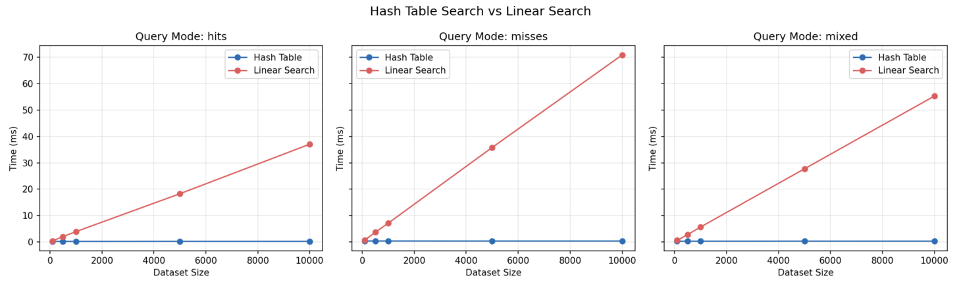
Note: The chart makes the main assignment result easy to see. Hash-table search stays almost flat while linear search grows sharply as size increases.

Figure 2
Search speedup summary
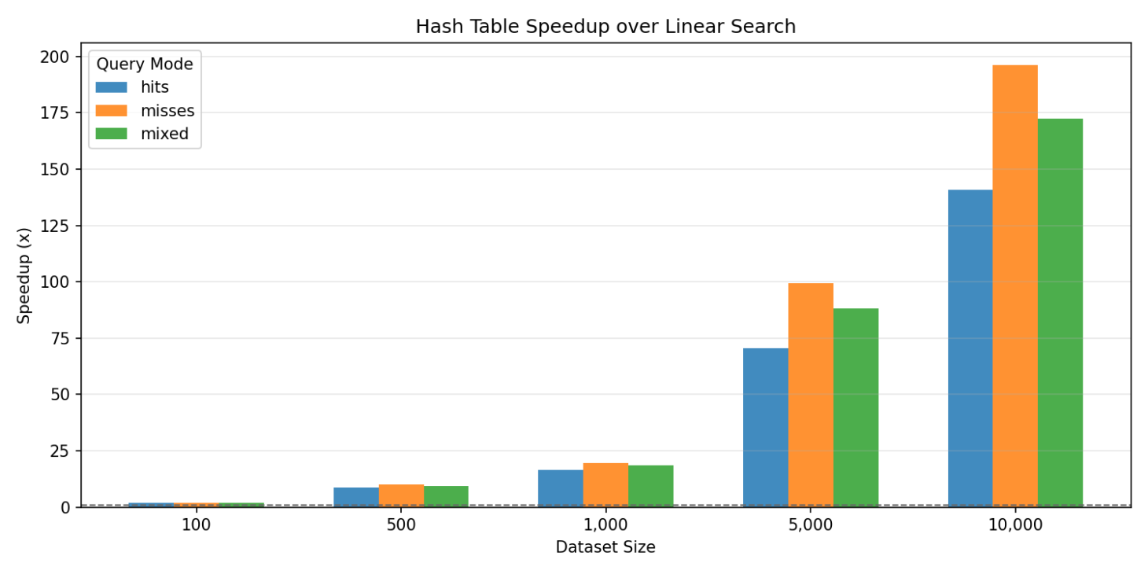
Note: The speedup chart highlights how much larger the hashing advantage becomes as the dataset grows, especially for misses and mixed-query workloads.
Figure 3
Benchmark runtime overview
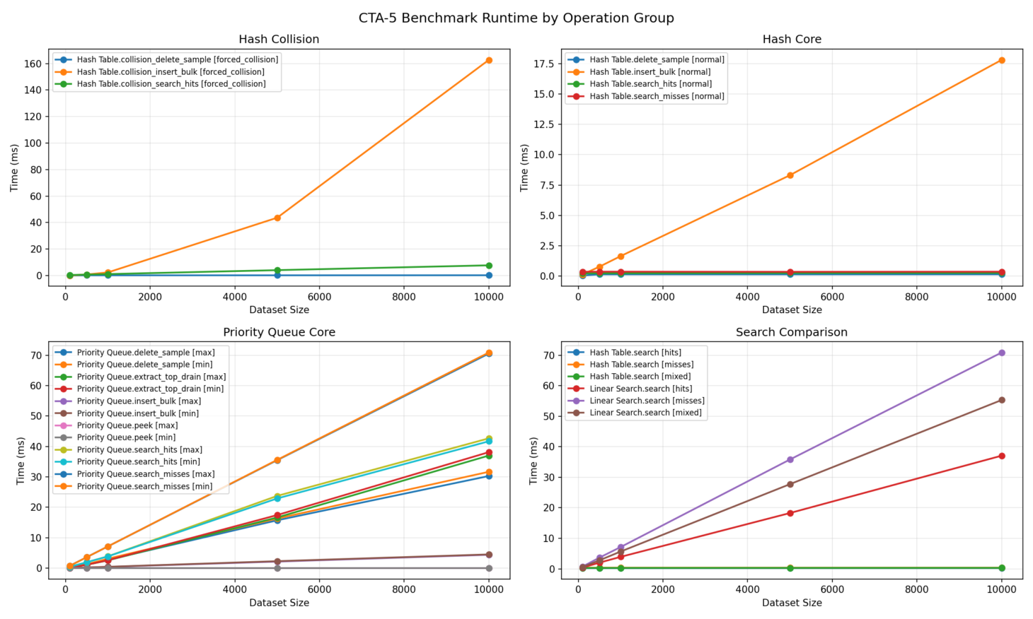
Note: The runtime overview brings the major CTA-5 workloads together in one figure and highlights the contrast between normal hashing, collision-heavy hashing, and heap workloads.
Figure 4
Collision distribution
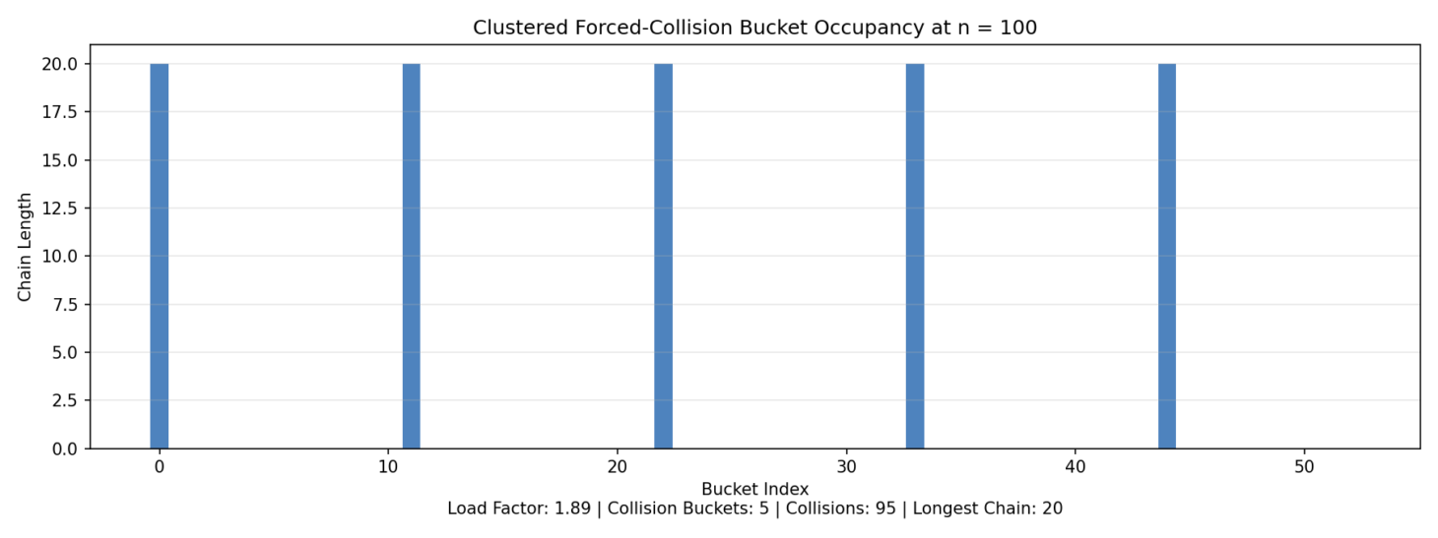
Note: The collision chart makes it easier to see how strongly the forced-collision inputs concentrate work into a small set of bucket chains.
The benchmark results show that the hash table is the strongest lookup structure in the project when the key distribution is healthy. At 10,000 items, Hash Table.search finishes in 0.2616 ms for hits, 0.3534 ms for misses, and 0.3125 ms for mixed queries. Over the same workload sizes and query modes, Linear Search.search requires 36.4574 ms, 70.2530 ms, and 54.5457 ms. This means the hash table is 139.35x faster for hits, 198.79x faster for misses, and 174.54x faster for mixed queries at the largest tested size. That widening gap is exactly what Big-O analysis predicts.
The collision-specific results are also very important because they separate normal hashing from worst-case hashing. At 10,000 items, normal search_hits takes only 0.2612 ms, but forced-collision collision_search_hits requires 36.4424 ms. Normal insert_bulk finishes in 16.4633 ms, but forced-collision collision_insert_bulk requires 750.5403 ms. These results show that a hash table can be extremely fast, but only if the hash function and collision distribution remain favorable.
The priority-queue results show a different kind of tradeoff. peek stays effectively constant, insert_bulk remains relatively small, and extract_top grows in a predictable heap-like way. However, label-based search and delete are much more expensive because they still need to inspect items one by one. At 10,000 items, peek remains 0.000034 ms, insert_bulk stays near 4.3 to 4.4 ms, extract_top_drain grows to about 36 to 37 ms, and search_misses grows to about 70.2 ms. These results show that the heap is excellent for top-priority access, but not for arbitrary lookup.

Conclusion
The results of this project show that the chosen implementations behave the way algorithm analysis predicts. The custom hash table performs very well on normal data because the hash function distributes keys well enough for average-case O(1) lookup, and the separate-chaining strategy preserves correctness when collisions occur. At the same time, the forced-collision benchmark demonstrates the main limitation of hashing: when too many keys cluster into only a few buckets, performance moves toward the O(n) worst case even though the data structure still works correctly.
The binary-heap priority queue also behaves as expected. It is very efficient when the workload matches the heap property, especially for peek and extract_top, but it is much less efficient for arbitrary label lookups because the heap does not provide a direct search path. Taken together, the results reinforce the central lesson of the assignment: choosing the right data structure depends on the kind of access the problem needs. For key-based lookup, the hash table is the best choice in this project. For repeated highest-priority or lowest-priority removal, the priority queue is the better fit.

References
CSU Global. (n.d.). Lecture 5: Hash tables, heaps, and treaps [Interactive lecture]. CSC506 - Design and Analysis of Algorithms. Canvas.
Lysecky, R., & Vahid, F. (2019). Module 5: Hash tables, heaps, and treaps. Data structures essentials: Pseudocode with Python examples. zyBooks
Tutorials Point. (n.d.-a). Hash table data structure. Tutorials Point. https://www.tutorialspoint.com/data_structures_algorithms/hash_data_structure.htm
Tutorials Point. (n.d.-b). Heap sort algorithm. Tutorials Point. https://www.tutorialspoint.com/data_structures_algorithms/heap_sort_algorithm.htm

