Problem2

Given a set of training examples, each marked as belonging to one or the other of two categories, an SVM training algorithm builds a model that assigns new examples to one category or the other, making it a non-probabilistic binary linear classifier.

1. To do multi-class classification, we need to reduce the problem into multi binary classification problems. There are two ways to do it. One is to do the classification by one vs rest. For example, class0 vs all the rest classes as one class (class1, 2, 3, 4, 5, 6, 7, 8, 9), class1 vs all the rest classes as one class (class0, 2, 3, 4, 5, 6, 7, 8, 9). It is done by a winner-takes-all strategy, in which the classifier with the highest output function assigns the class. In the picture below is a data in training set. It should belong to the class0. The other way is to do the classification by one vs one. We build pairs of data class0&class1, class0&class2, … class1&class2, class1&class3, … class8&class9 which are totally 45 pairs. It is done by a max-wins voting strategy, in which every classifier assigns the instance to one of the two classes, then the vote for the assigned class is increased by one vote, and finally the class with the most votes determines the instance classification.

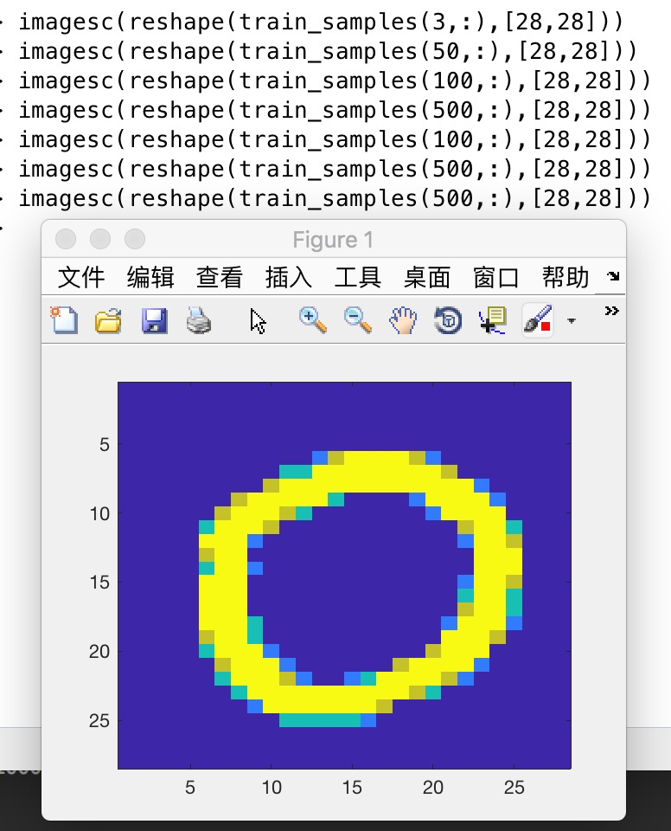

The output of onevsone and onevsall

Onevesone:

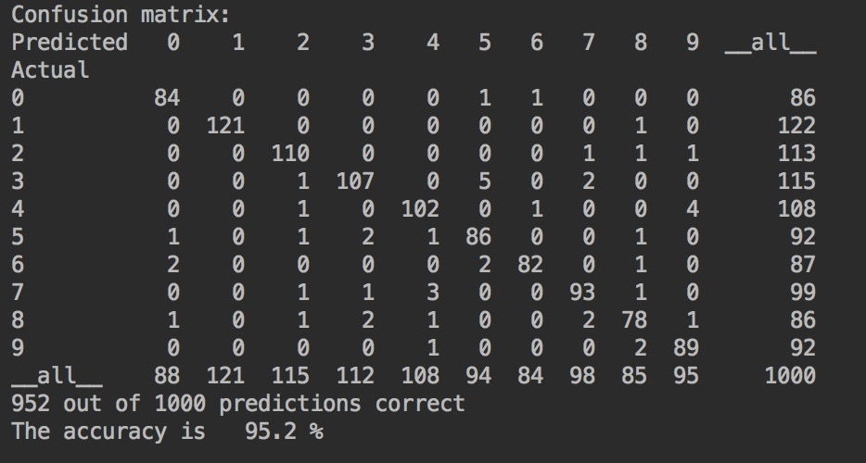

onevsall:

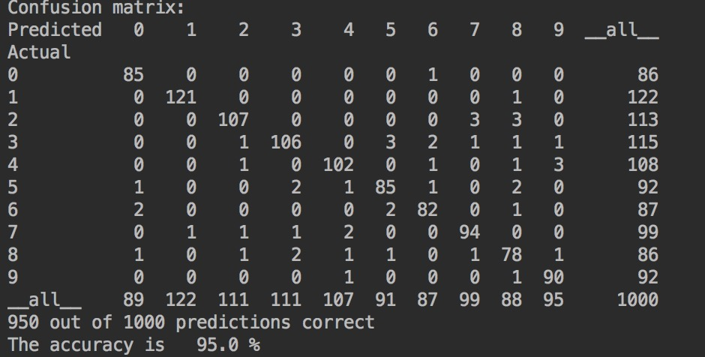

1. Directed acyclic graph(DAG) is another way to do multi classification with SVM. It is similar to onevsone but use a different way to organize the pairs. In the paper, there is a structure for 4-class-classification. We only need to change it to 10-class-classification (class0, 1, 2, 3, 4, 5, 6, 7, 8, 9). At the root node, we check 0vs9. If it not belongs to 0, go to the left sub-node which check 1vs9 otherwise go to the right sub-node which check 0vs8. In SVM with DAG, we go through the tree and find the best class of the data. It is fast and the data will be classified without overlap classification. However, if the classification is wrong at the beginning. We won’t be able to correct it.

The output of dag:

dag

