PROJECT

**Names:** Omema Ahmed & Aiman Junaid

**IDs**: oa04320 & aj05161

**Tasks completed:**

* All instructions in single cycle processor are working fine **True**
* Single Cycle processor is correctly executing bubble sort algorithm **True**
* All instructions are working fine in the pipelined processor **True**
* Hazard detection is working fine in the pipelined processor **False**
* Stall circuitry is working fine in the pipelined processor **False**
* Pipelined processor is correctly executing bubble sort algorithm **False**

**Task#1:**

**Bubble Sort**

Sorts array = [3, 2, 10]

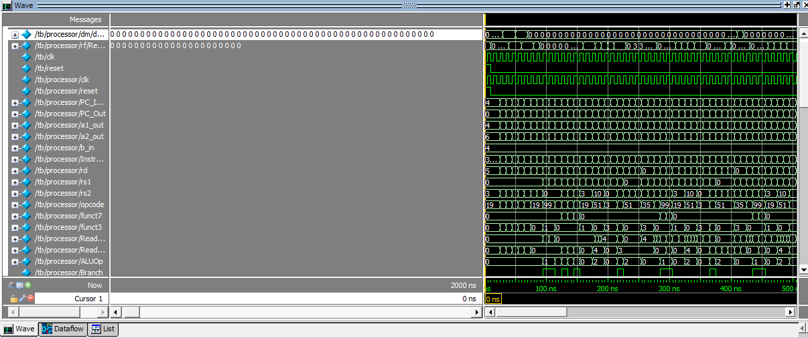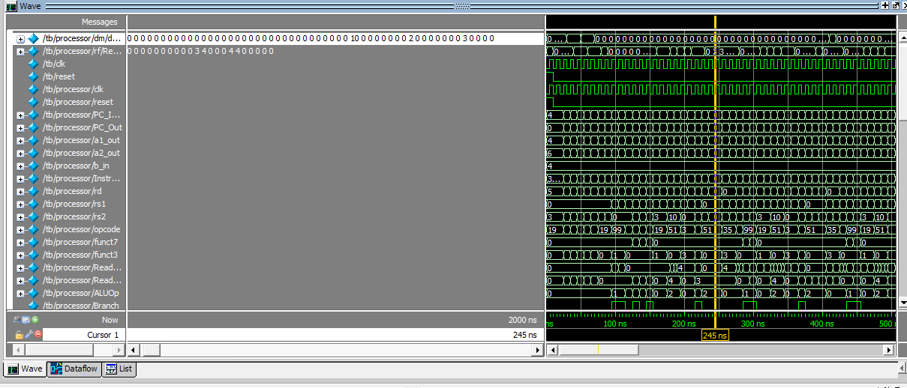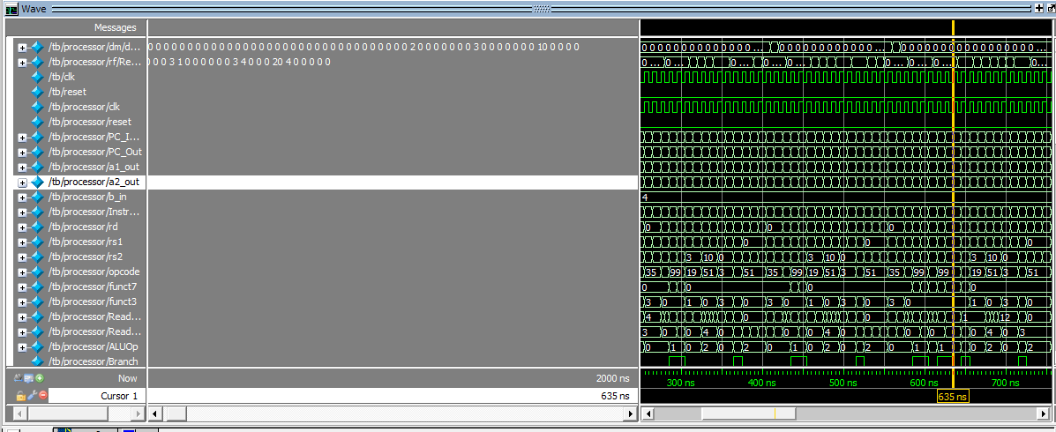

**Task#2:**

**Instruction: add x5, x0, 3**

Value stored in register x0 was 0. The value added to register x5 is 0+3 = 3, as shown

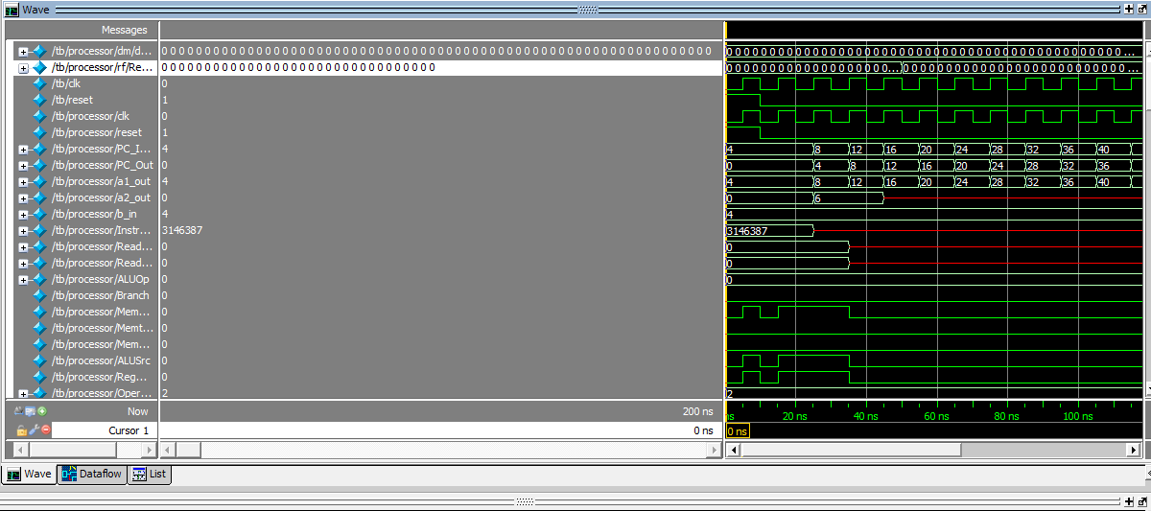

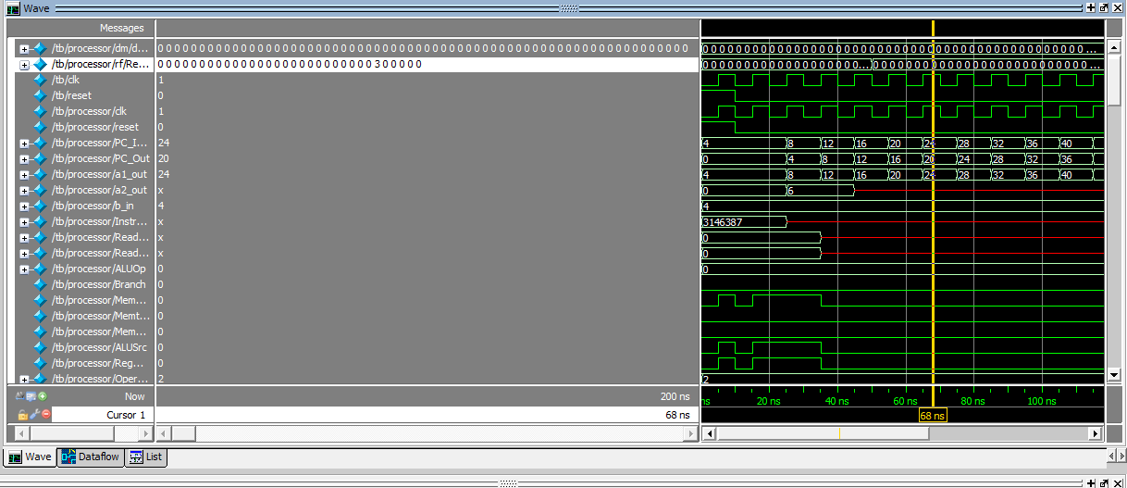

**Instruction: ld x9, 40(x10)**

Value stored at 40th array location in data memory was 8. The value was loaded in register x9 as shown.

