PROJECT BASED LEARNING REPORT
On
HOTEL MANAGEMENT SYSTEM
Object Oriented Programming: 5.0CE101C01H Submitted by:
Soumitra Jana (1/24/SET/BCS/112) Yash Goyal (1/24/SET/BCS/114)

Under the Guidance of:
Ms. Shobha Tyagi

in partial fulfillment for the award of the degree of

BACHELOR OF TECHNOLOGY
IN
Computer Science & Engineering


School of Engineering & Technology
MANAV RACHNA INTERNATIONAL INSTITUTE OF RESEARCH AND STUDIES, Faridabad
NAAC ACCREDITED ‘A++’ GRADE
2025

ABSTRACT
The Hotel Management System is a software application developed to manage essential hotel operations such as room availability, booking, customer registration, check-in, and checkout. The system ensures smooth functioning of hotel services by maintaining accurate, real-time data about room status and customer information.
This project integrates Object-Oriented Programming (OOPS) in C++ with DBMS concepts using SQLite for data storage. It demonstrates the use of classes, objects, encapsulation, constructors, and file/database handling. The system provides essential functionalities like room booking, billing, status updates, and efficient record management.
The project replicates real hotel workflows and showcases how a digital management system improves accuracy, reduces manual errors, and enhances customer experience. Overall, it reflects practical implementation of OOPS, DBMS, schema design, CRUD operations, and user-interface logic.

TABLE OF CONTENTS

Sr.No. | Content
1 | Cover Page
2 | Abstract
3 | Introduction
4 | Objectives
5 | System Analysis
6 | ER Diagram and Schema Design
7 | Implementation
8 | Results and Discussion
9 | Conclusion and Future Work
10 | References
11 | GitHub Link

INTRODUCTION
Hotel operations involve handling room details, customer data, billing, and service management. Manual handling often leads to errors such as overlapping bookings, data loss, and slow service.
The Hotel Management System solves these problems by providing a digital interface that enables:
- Viewing available rooms
- Booking rooms
- Recording customer information
- Updating room status in real-time
- Managing checkouts and payments
The system is built using C++ (OOPS concepts) and SQLite for storing persistent data. It is designed to be simple, modular, and efficient, following good software engineering practices.
This project clearly demonstrates how DBMS principles and OOPS can be combined to create a functional hotel automation system.

OBJECTIVES
- To design a digital system that manages hotel room operations efficiently.
- To apply OOPS concepts such as classes, objects, encapsulation, and constructors.
- To use SQLite to maintain persistent records of rooms and customers.
- To implement CRUD operations for booking, checkout, and room updates.
- To prevent double-booking and ensure correct room status at all times.
- To create a menu-driven, user-friendly interface.

SYSTEM ANALYSIS
The system performs two main operations:
- Room Management
  - Stores room details such as room number, type, price, and availability.
  - Displays all available rooms to the user.
  - Prevents double-booking by updating availability instantly.
- Booking & Checkout Management
  - Records customer name, room number, and duration of stay.
  - Marks room as “Booked” on successful reservation.
  - Allows checkout with automatic bill generation.
  - Updates the room back to "Available" after checkout. Key Features
  - Simple and modular class design.
  - Multiple rooms managed using arrays/objects.
  - Real-time room status updates.
  - Can be extended for billing, food orders, or admin login.
  - Suitable for small hotels or educational demo projects.

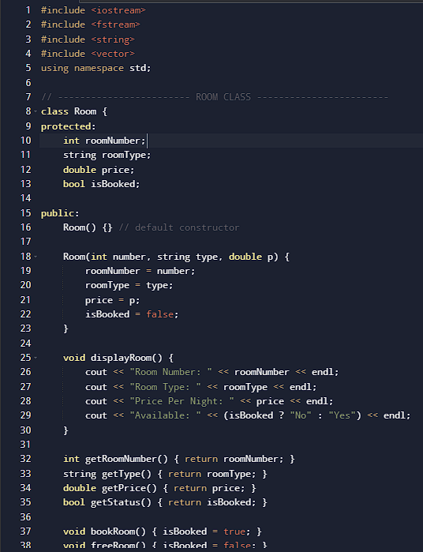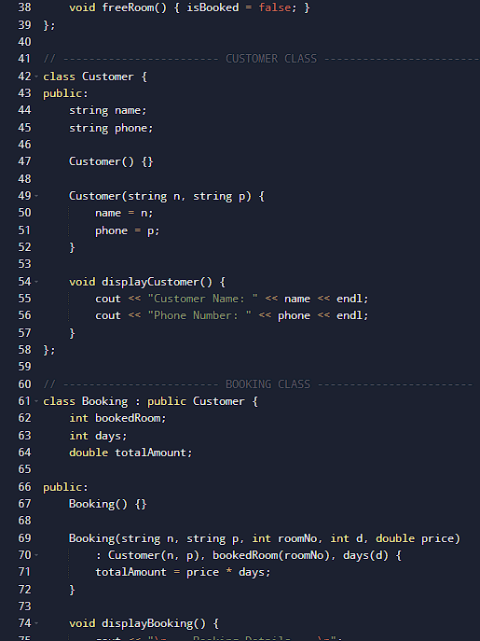

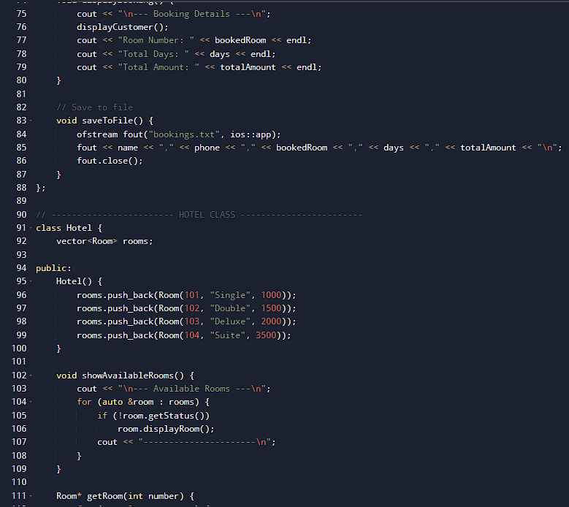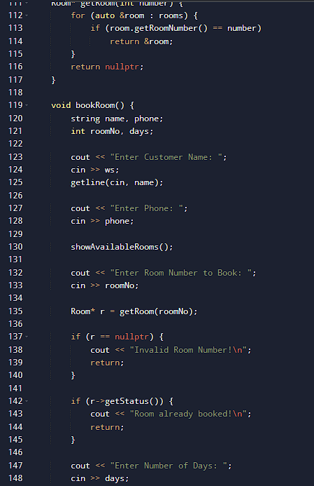

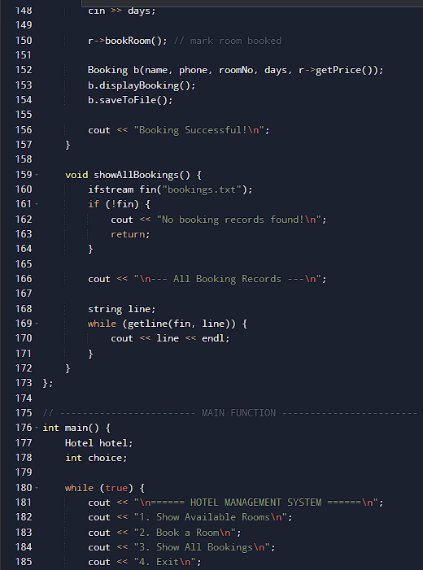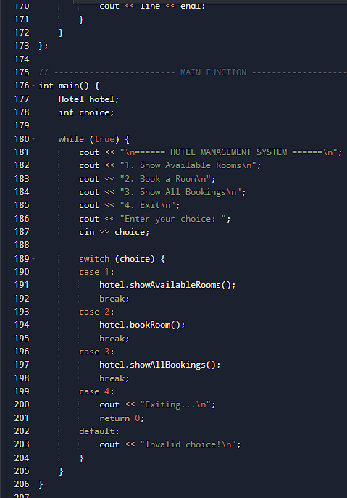

ER DIAGRAM AND SCHEMA DESIGN

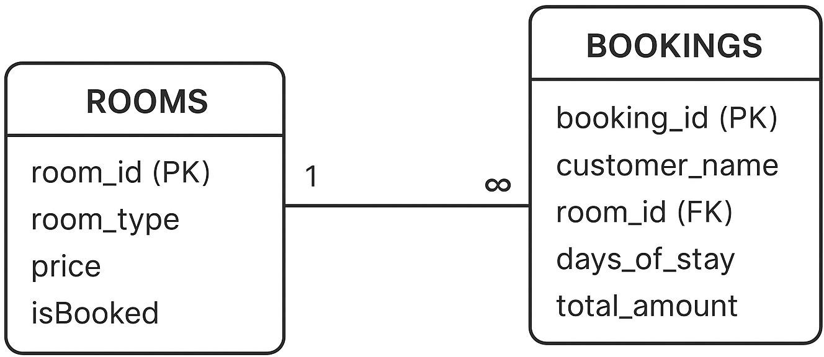

.

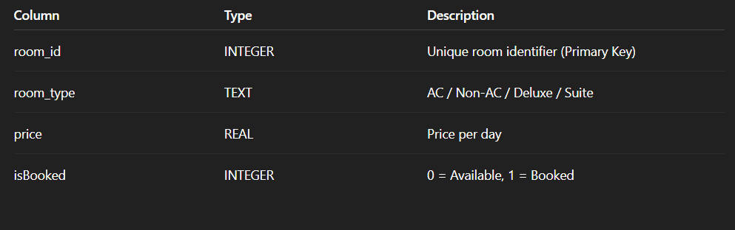
Attributes:

IMPLEMENTATION

TECHNOLOGIES USED
  - C++ (OOPS) – For logic, menus, and system functions
  - SQLite – For storing room and booking records
  - File handling (optional) – For logs and backups
  - Classes Used:
    - Room — manages room info and availability
    - Hotel — manages all rooms, bookings, and customer operations Implementation Overview
  - A list/array of rooms is created during initialization.
  - Each room object stores room number, type, price, and booking status.
  - Booking a room updates:
    - booking table
    - room availability
  - Checkout calculates total amount and resets room status. Sample Functionalities
  - showAvailableRooms()
  - bookRoom()
  - checkoutRoom()
  - displayRoomDetails()
  - storeRecordToDatabase()

RESULTS AND DISCUSSION
The Hotel Management System successfully performs all core operations:
  - Displays all available rooms correctly.
  - Allows smooth booking with validation checks.
  - Prevents booking of already reserved rooms.
  - Generates accurate billing during checkout.
  - Provides clear, menu-based navigation for users.
  - Stores all booking and room details in the SQLite database.
  - Ensures no two customers can book the same room simultaneously. This confirms correct implementation of OOPS and DBMS concepts.
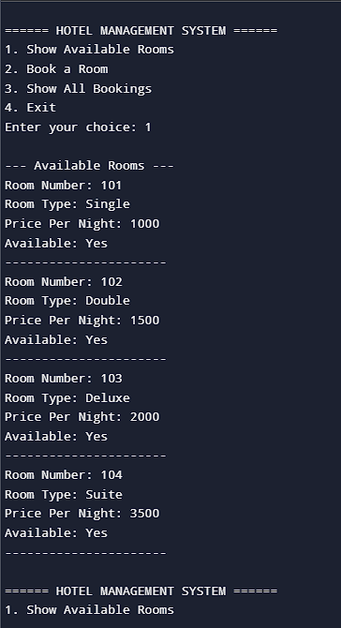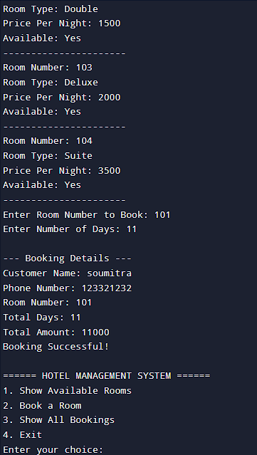

CONCLUSION AND FUTURE WORK
The Hotel Management System achieves its goal of digitizing hotel operations using C++ and SQLite. It demonstrates key OOPS principles like encapsulation, abstraction, and modularity, while also using DBMS concepts such as relational tables, keys, and persistent storage.
Future Enhancements
  - Add customer login and admin login.
  - Implement food ordering and room service modules.
  - Introduce online payment and invoice generation (PDF).
  - Add graphical user interface (HTML/CSS/Qt).
  - Enable advanced search filters (price, type, occupancy).
  - Connect system with cloud database for remote access.

REFERENCES
  - C++ Programming Documentation
  - OOPS Concept Tutorials
  - SQLite Documentation – https://sqlite.org
  - W3Schools DBMS Notes – https://w3schools.com/sql
  - Classroom Notes and Project Guidelines

GITHUB LINK

