CNDC(Lab)

MID – Term Project

Project Title: Enterpize Network System

Group Name: Network Innovators
Group Members :
  - M.Omar Baig (2112390)
  - M.Ahmed Baig (2112389)

Course Name: Computer Networks and Data Communications

Instructor Name: Mam Shafaq Rasheed

Submission Date: April 10, 2025

Introduction:

Our project is focused on designing a scalable and efficient hierarchical network for a medium-sized organization. The design follows the Cisco three-layer hierarchical model—core, distribution, and access layers—to ensure modularity, scalability, and fault tolerance. The main goal is to create a network that supports departmental segmentation, centralized management, and secure communication across all connected devices.

Components:

Hardware Components:

- 3 Cisco 2811 Routers
- 4 Cisco 3560-24PS Multilayer Switches
- 6 Cisco 2960-24TT Access Switches
- 4 Server-PT Devices (for web, file, DNS, and backup)
- 20 PC-PT Devices (representing clients in different departments)

Software Components:

- Cisco Packet Tracer (Simulation Software)
- Cisco IOS (for configuration and routing)
- Windows OS (for server and client-side configuration)

Methodology:

- Planning and Design:
  - Designed the network topology using Cisco Packet Tracer.
  - Followed a three-layer hierarchical architecture.
- Core Layer Setup:
  - Connected three routers (Router7, Router8, Router9) in a redundant triangle configuration to ensure continuous network availability.
- Distribution Layer Setup:
  - Used four multilayer switches to route traffic between the core and access layers.
  - Connected each switch to its corresponding access switches and routers.
- Access Layer Setup:
  - Distributed 20 PCs across 6 access switches to simulate departmental distribution.
  - Connected servers for different network services.

- IP Configuration and Routing:
  - Assigned static IPs and subnetted the network.
  - Implemented routing protocols on routers.
  - Verified communication between departments and servers.
- Testing and Troubleshooting:
- Performed ping tests across all segments.
- Resolved link and configuration issues.

Applications:

- Enterprise Networking: Enables seamless inter-departmental communication.
- Data Security: Server segmentation supports centralized access control and backup management.
- Scalability: Easily expandable for future devices or departments.
- Redundancy: Multiple uplinks reduce downtime in case of failure.
- Remote Access: Supports remote management and monitoring of the network.

Benefits of Enterprise Networking
Improved Data Security
With centralized control and server segmentation, enterprise networks allow for stronger access control, regular data backups, and easier implementation of security policies.
Scalability
Enterprise networks are designed to grow with the organization. They can be easily expanded to support new devices, users, and departments without overhauling the entire infrastructure.
Centralized Management
Network resources, software updates, and security settings can be managed from a central location, reducing complexity and administrative overhead.
Cost Efficiency
Through shared resources and streamlined communication, enterprise networking can reduce operational costs over time.
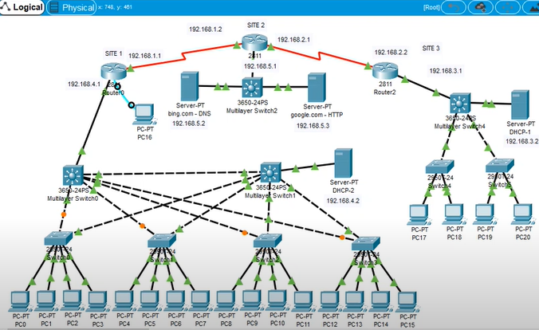

Conclusion:

This project demonstrates the implementation of a reliable and scalable enterprise network using Cisco devices. It reflects real-world networking concepts and prepares us for handling advanced infrastructure setups in professional environments. It also helped us understand the importance of structured network design in maintaining performance and reliability. Through this project, we gained hands-on experience with essential services and configurations, which will be beneficial in real-world scenarios.

