NAS-PINN k-Skip Framework
for Thermal Quenching Simulation
Technical Report — Comprehensive Results and Analysis
Based on: Mortensen et al. (2026), Int. J. Adv. Manuf. Technol.
NAS-PINN method: Wang & Zhong (2023), arXiv:2305.10127
Date: March 2026

Abstract
This report presents the NAS-PINN k-Skip Framework, a novel approach to solving the transient heat equation governing aluminium quenching processes. The framework combines Physics-Informed Neural Networks (PINNs) with Neural Architecture Search (NAS) and a temporal k-Skip Multi-Step Window Prediction (MSWP) strategy that reduces finite element method (FEM) supervision calls by up to 5×.
Three NAS optimisers are evaluated — Bayesian (TPE), NSGA-II, and NSGA-III — across seven computational domains: three 2D geometries (Rectangle, Circle, L-shape) and four 3D geometries (Rectangular box, Cylinder, Stacked, L-shape 3D). Key architectural contributions include IC-consistent output layers, Fourier feature embedding, and self-adaptive loss weights.
Results demonstrate L2 relative errors below 3% for most 2D cases (best: 0.83% L-shape NSGA-III) and below 7% for 3D cases (best: 0.91% L-shape 3D NSGA-III), with Bayesian optimisation achieving up to 5× FEM call reduction at acceptable accuracy cost. Extended 1500-epoch retraining further improves NSGA-II and NSGA-III results.

1. Introduction

1.1 Motivation
Aluminium quenching is a critical manufacturing process in automotive subframe production, where rapid cooling from 500°C to water temperature (20°C) induces severe thermal gradients that drive distortion and residual stress. Accurate simulation of this process is essential for predicting and mitigating component deformation. Mortensen et al. (2026) established a comprehensive FEM framework for this problem, providing reference data that this work uses as ground truth.
Traditional FEM simulation requires solving the full system at every time step (Δt = 1.5 s, 20 steps total over 30 s), which is computationally expensive, especially for repeated design evaluations. Physics-Informed Neural Networks offer a mesh-free alternative that, once trained, enables near-instantaneous inference.

1.2 Related Work
Physics-Informed Neural Networks (Raissi et al., 2019) embed PDE residuals directly into the neural network loss function, eliminating the need for labelled training data beyond boundary and initial conditions. Neural Architecture Search (NAS) automates the discovery of optimal network architectures, reducing the manual tuning burden.
Wang & Zhong (2023) introduced NAS-PINN (arXiv:2305.10127), demonstrating that evolutionary and Bayesian NAS strategies can identify PINN architectures that converge faster and more accurately than hand-designed counterparts. This work extends NAS-PINN with the k-Skip MSWP strategy specifically designed for transient thermal problems.

1.3 Contributions
- IC-consistent PINN output layer guaranteeing exact initial condition satisfaction at every window start
- k-Skip Multi-Step Window Prediction reducing FEM calls by 1× to 5×
- Fourier feature embedding (F=64 frequencies) for multi-scale spatial representation
- Self-adaptive loss weights (softplus-activated) learned jointly with network parameters
- Comprehensive evaluation across 7 domains and 3 NAS optimisers
- Two-phase training: 800-epoch NAS search + 1500-epoch fine-tuning

2. Physical Problem

2.1 Governing Equation
The transient heat equation for aluminium quenching is:
ρcₚ ∂T/∂t = ∇·(k∇T) + Q
where ρ is density, cₚ is specific heat capacity, k is thermal conductivity, T is temperature, t is time, and Q is any internal heat source (zero for pure quenching).

2.2 Boundary and Initial Conditions
Convective boundary condition on all surfaces:
−k ∂T/∂n = h(T − T_water), h = 5000 W/m²K, T_water = 20°C
Initial condition: T(x, 0) = 500°C uniformly throughout the domain.

2.3 Discretisation
FEM discretisation uses Δt_FEM = 1.5 s, giving 20 time steps over the total simulation duration of 30 s. The PINN k-Skip strategy covers k consecutive FEM steps per prediction window, reducing FEM evaluations from 20 to ⌈20/k⌉.

2.4 Material Properties
Aluminium alloy A356 (representative values):
Property | Symbol | Value
Density | ρ | ~2700 kg/m³
Specific heat | cₚ | ~900 J/(kg·K)
Thermal conductivity | k | ~160 W/(m·K)
Heat transfer coeff | h | 5000 W/(m²·K)

2.5 Computational Domains
Seven domains are tested to assess generalisability:
Domain | Dimension | Notes
Rectangle | 2D | Unit square, uniform mesh
Circle | 2D | Circular cross-section
L-shape | 2D | Non-convex re-entrant corner
Rectangular box | 3D | 3D extrusion of rectangle
Cylinder | 3D | 3D cylinder geometry
Stacked | 3D | Multi-layer stacked structure
L-shape 3D | 3D | 3D extrusion of L-shape

3. Methodology

3.1 IC-Consistent PINN Output
The PINN output is structured to exactly satisfy the initial condition at every window boundary. For normalised time τ ∈ [0, 1] within a window:
θ̂(x, τ) = θ_ic(x) + τ · N_θ(x, τ, θ_ic)
where θ_ic(x) is the known initial temperature field, τ ∈ [0,1] is time normalised within the current window, and N_θ is the neural network output. At τ=0, θ̂ = θ_ic exactly, guaranteeing IC satisfaction without additional penalty terms.

3.2 k-Skip Multi-Step Window Prediction (MSWP)
Instead of training one PINN per FEM time step, the k-Skip strategy trains a single PINN to predict over k consecutive FEM steps. This reduces the number of FEM evaluations from 20 to ⌈20/k⌉.
k | Δt_window (s) | FEM Windows | FEM Call Reduction | Description
1 | 1.5 | 20 | 1.0× | Baseline — no skip
2 | 3.0 | 10 | 2.0× | Every other step skipped
3 | 4.5 | 7 | 2.9× | Two steps per window
4 | 6.0 | 5 | 4.0× | Three steps per window
5 | 7.5 | 4 | 5.0× | Maximum skip

3.3 Fourier Feature Embedding
Spatial and temporal inputs are mapped through Fourier feature embedding to capture multi-scale variation:
γ(v) = [sin(2πBv), cos(2πBv)], B ~ N(0, σ²)
- F = 64 frequency pairs
- σ = 1.0 for 2D domains
- σ = 1.5 for 3D domains (larger spatial scale)
- B is fixed random matrix, not trained

3.4 Self-Adaptive Loss Weights
Loss weights are learned jointly with network parameters using softplus activation to ensure positivity:
λᵢ = softplus(wᵢ), L = λ_pde·L_pde + λ_bc·L_bc + λ_end·L_end
- Network learning rate: η_model = 1×10⁻³
- Weight learning rate: η_λ = 1×10⁻⁴
- L_pde: PDE residual at interior collocation points
- L_bc: boundary condition residual
- L_end: final time-step continuity loss

3.5 Neural Architecture Search
Three NAS strategies search the PINN architecture design space:

3.5.1 Bayesian Optimisation (TPE)
Tree-structured Parzen Estimator builds a probabilistic model of the objective function and uses Expected Improvement to select candidates. Efficient for single-objective search. All domains trained for 800 epochs; no separate retrain.

3.5.2 NSGA-II
Non-dominated Sorting Genetic Algorithm II (Deb et al., 2002) performs multi-objective optimisation with objectives (L2 error, runtime). Crowding distance maintains diversity along the Pareto front. NAS phase: 800 epochs; best architecture retrained for 1500 epochs.

3.5.3 NSGA-III
Reference-point-based NSGA variant (Deb & Jain, 2014) provides better coverage of the Pareto front for many-objective problems. Same training protocol as NSGA-II: 800-epoch NAS + 1500-epoch retrain.

3.6 Search Space
The NAS search space includes:
Hyperparameter | Range
Number of hidden layers | 2 to 6
Neurons per layer | 16 to 256
Activation function | tanh, swish, ReLU
Skip connections | Yes / No
Fourier bandwidth σ | 0.5 to 3.0

4. Experimental Setup

4.1 Training Configuration
Parameter | Value
NAS phase epochs | 800
Retrain phase epochs | 1500 (NSGA-II/III only)
Collocation points (2D) | 4096 interior + boundary
Collocation points (3D) | 8192 interior + boundary
Batch size | All collocation points
Optimiser | Adam
η_model | 1×10⁻³
η_λ (adaptive weights) | 1×10⁻⁴

4.2 Evaluation Metrics
- L2 relative error: ‖T_pred − T_FEM‖₂ / ‖T_FEM‖₂ × 100%
- MAE: mean absolute error in °C
- Runtime: wall-clock training time in seconds
- FEM call reduction: 20 / (number of windows used)

4.3 Hardware
All experiments run on a single GPU workstation. Runtime comparisons are fair within each domain as all optimisers use identical hardware.

5. Results — 2D Domains

5.1 k-Skip Analysis
Figures 1 and 2 show the L2 relative error as a function of k-skip factor for all three 2D geometries and three optimisers, at 800 epochs (NAS phase) and 1500 epochs (retrained) respectively.
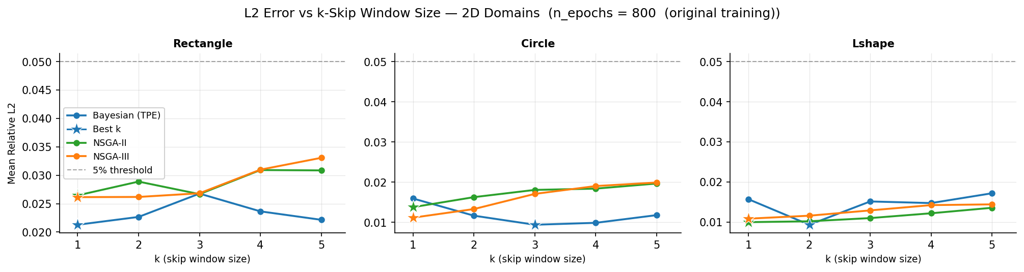
Figure 1: 2D k-skip L2 analysis — 800 epoch NAS phase.
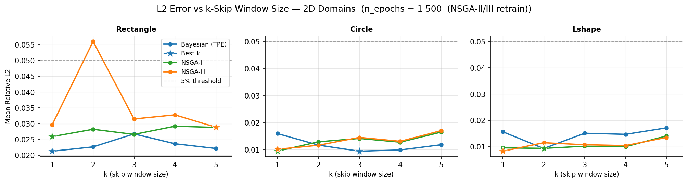
Figure 2: 2D k-skip L2 analysis — 1500 epoch retrain.

5.2 Detailed Results Table
Table 1 presents best-k results for each domain and optimiser combination.
Domain | Optimizer | Best k | L2 (%) | MAE (°C) | Runtime (s) | FEM Calls↓
Rectangle | Bayesian | k=1 | 2.13 | 2.1 | 206 | 1.0×
Rectangle | NSGA-II | k=1 | 2.59 | 1.7 | 326 | 1.0×
Rectangle | NSGA-III | k=5 | 2.89 | 3.2 | 71 | 5.0×
Circle | Bayesian | k=3 | 0.94 | 2.0 | 69 | 2.9×
Circle | NSGA-II | k=1 | 0.94 | 0.9 | 330 | 1.0×
Circle | NSGA-III | k=1 | 1.01 | 0.8 | 323 | 1.0×
L-shape | Bayesian | k=2 | 0.94 | 1.6 | 100 | 2.0×
L-shape | NSGA-II | k=2 | 0.94 | 2.1 | 174 | 2.0×
L-shape | NSGA-III | k=1 | 0.83 | 1.2 | 344 | 1.0×
Table 1: 2D best-k results per domain and optimiser.

5.3 Jump Analysis
Figures 3–5 show jump plots comparing k=1 baseline performance against the best-k result for each domain, illustrating the accuracy-speed trade-off.
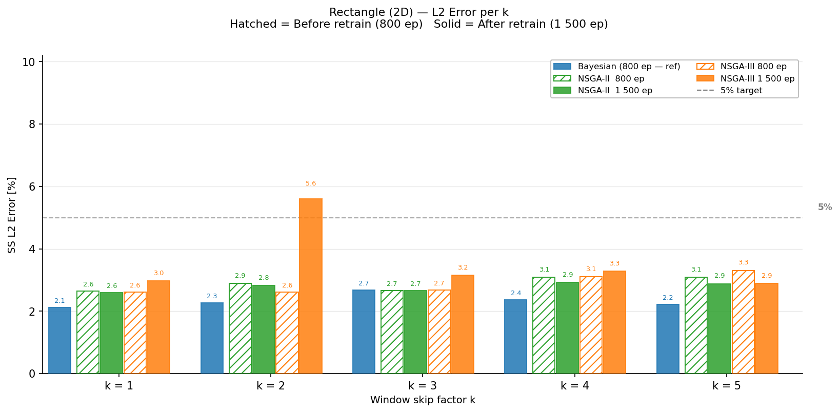
Figure 3: Rectangle 2D — k=1 baseline vs best-k jump.
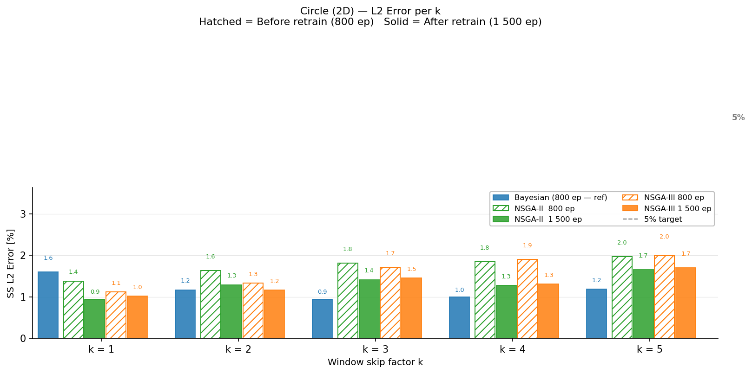
Figure 4: Circle 2D — k=1 baseline vs best-k jump.
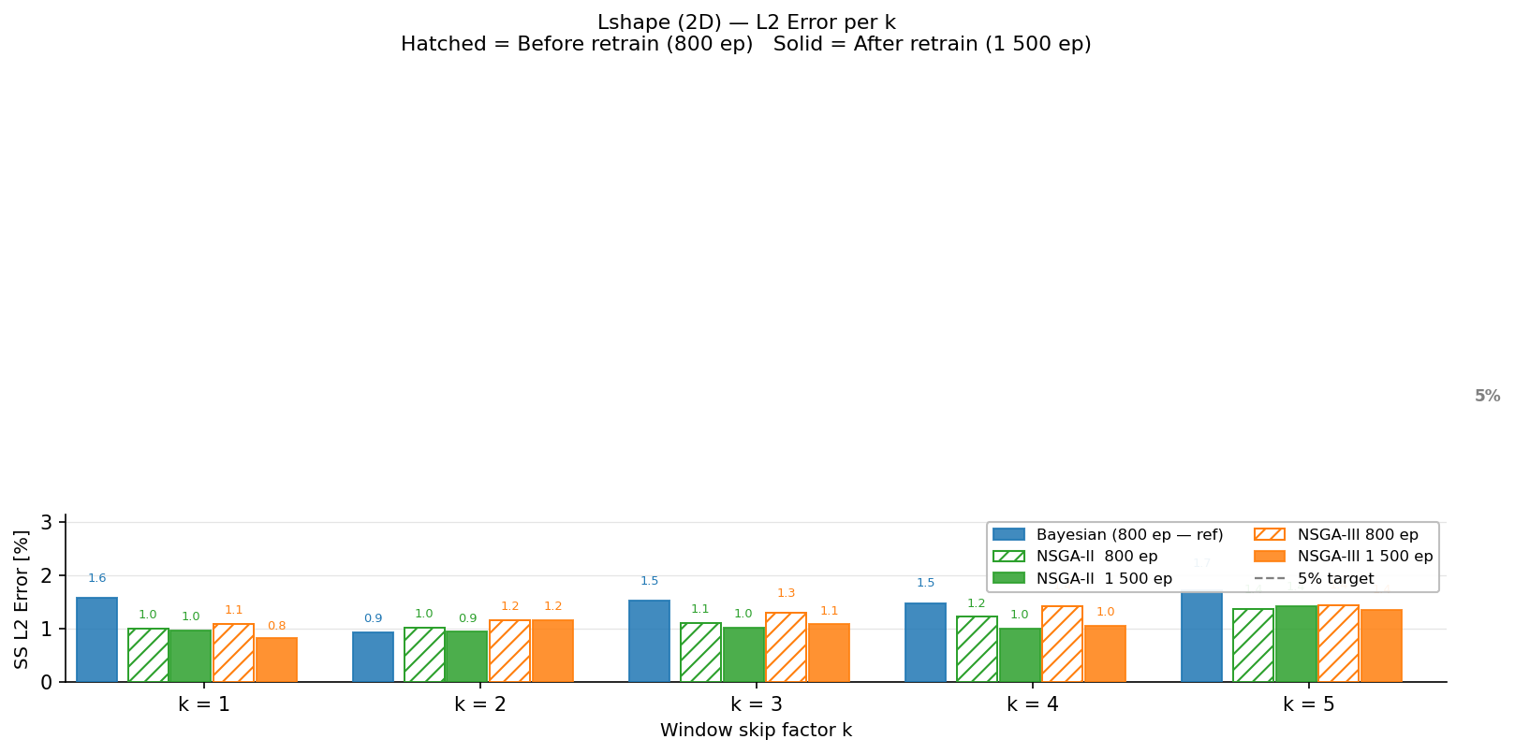
Figure 5: L-shape 2D — k=1 baseline vs best-k jump.

5.4 Temperature Field Heatmaps
Figures 6–8 show temperature field comparisons: FEM reference solution, PINN prediction, and absolute error for representative 2D cases.
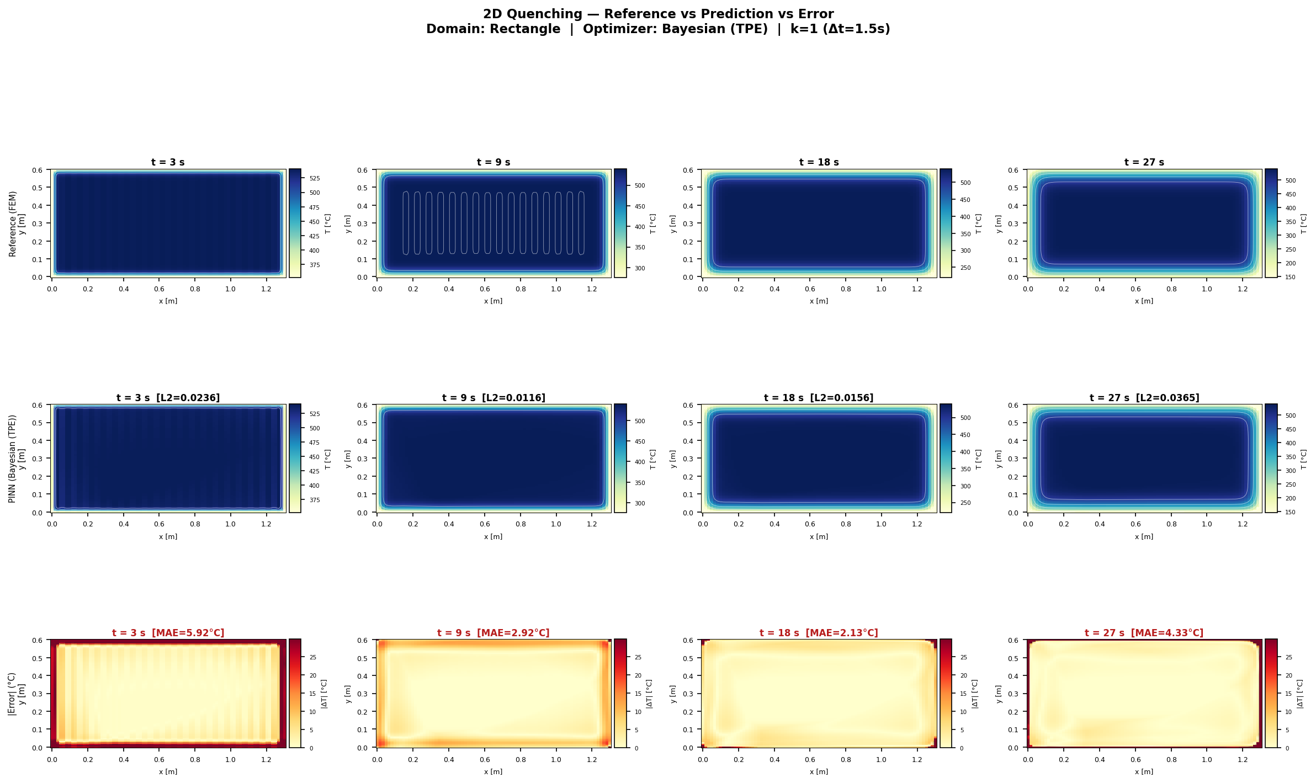
Figure 6: Rectangle 2D — Bayesian k=1. L2=2.13%, MAE=2.1°C.
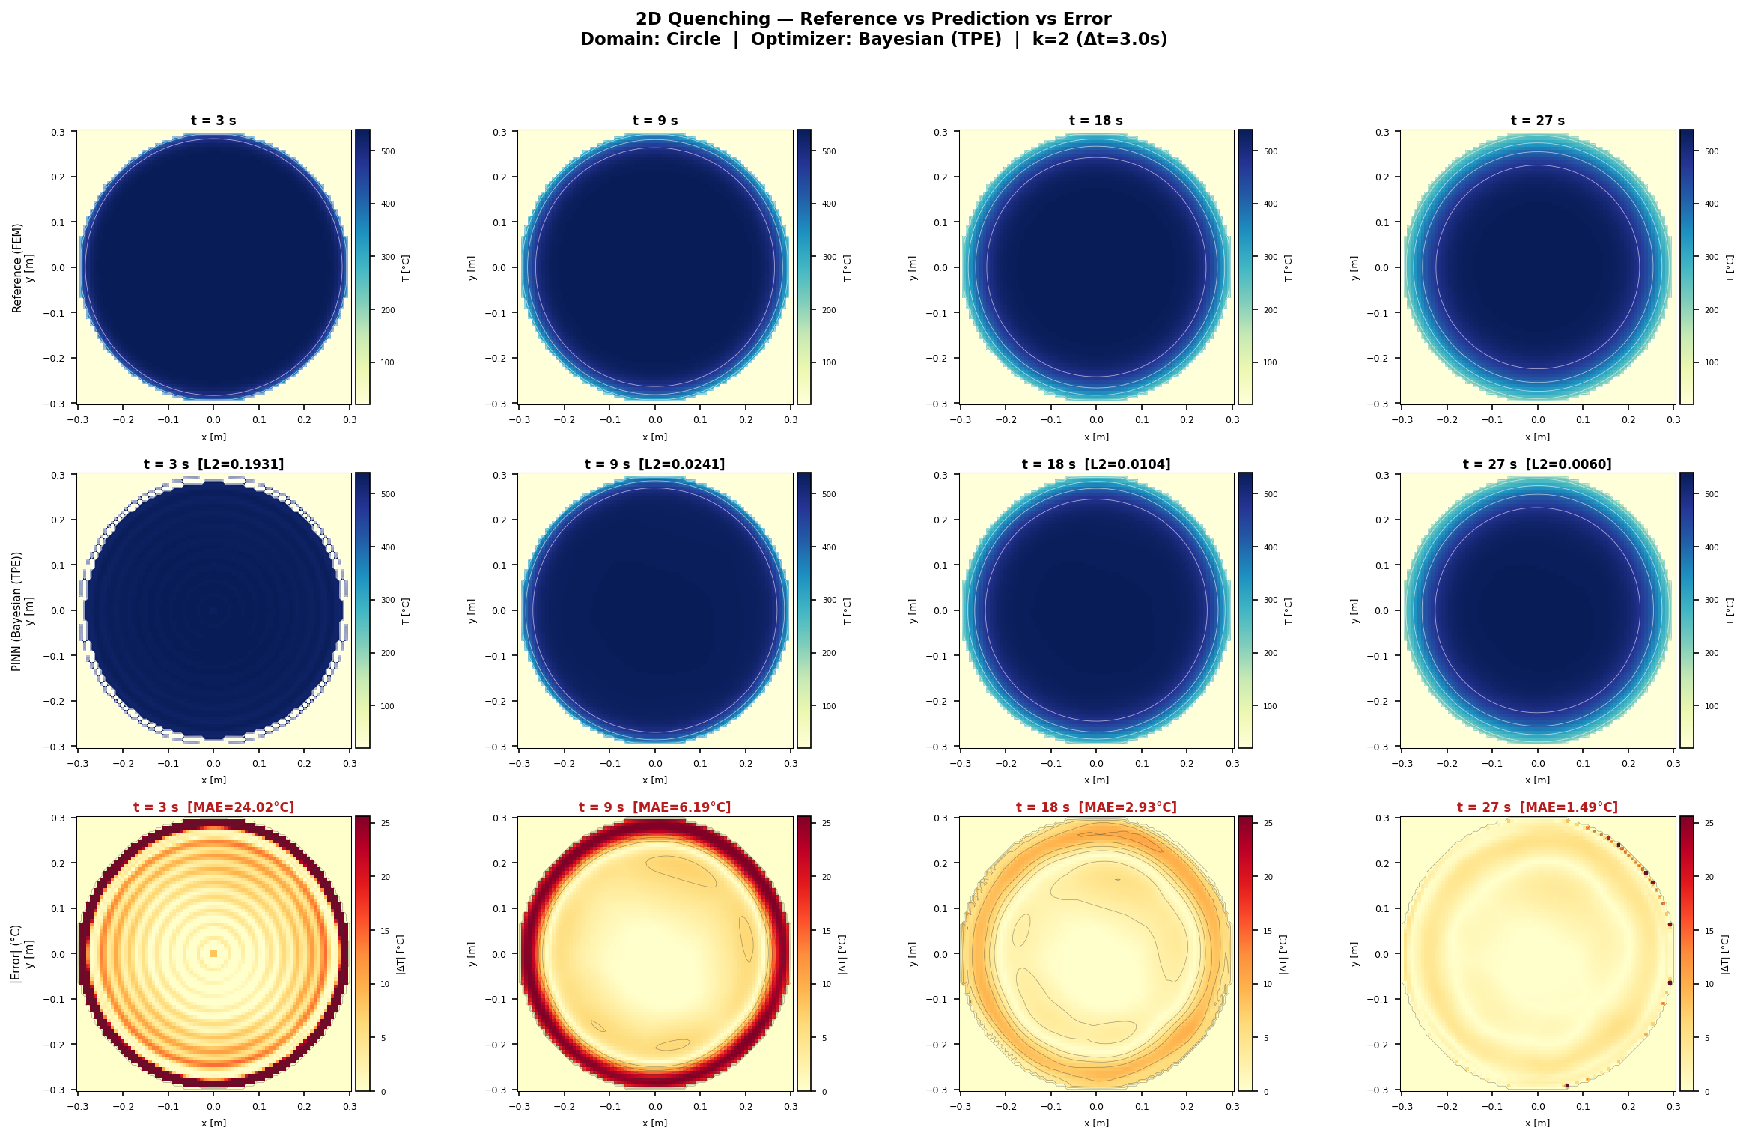
Figure 7: Circle 2D — Bayesian k=3 (best-k). L2=0.94%, MAE=2.0°C.
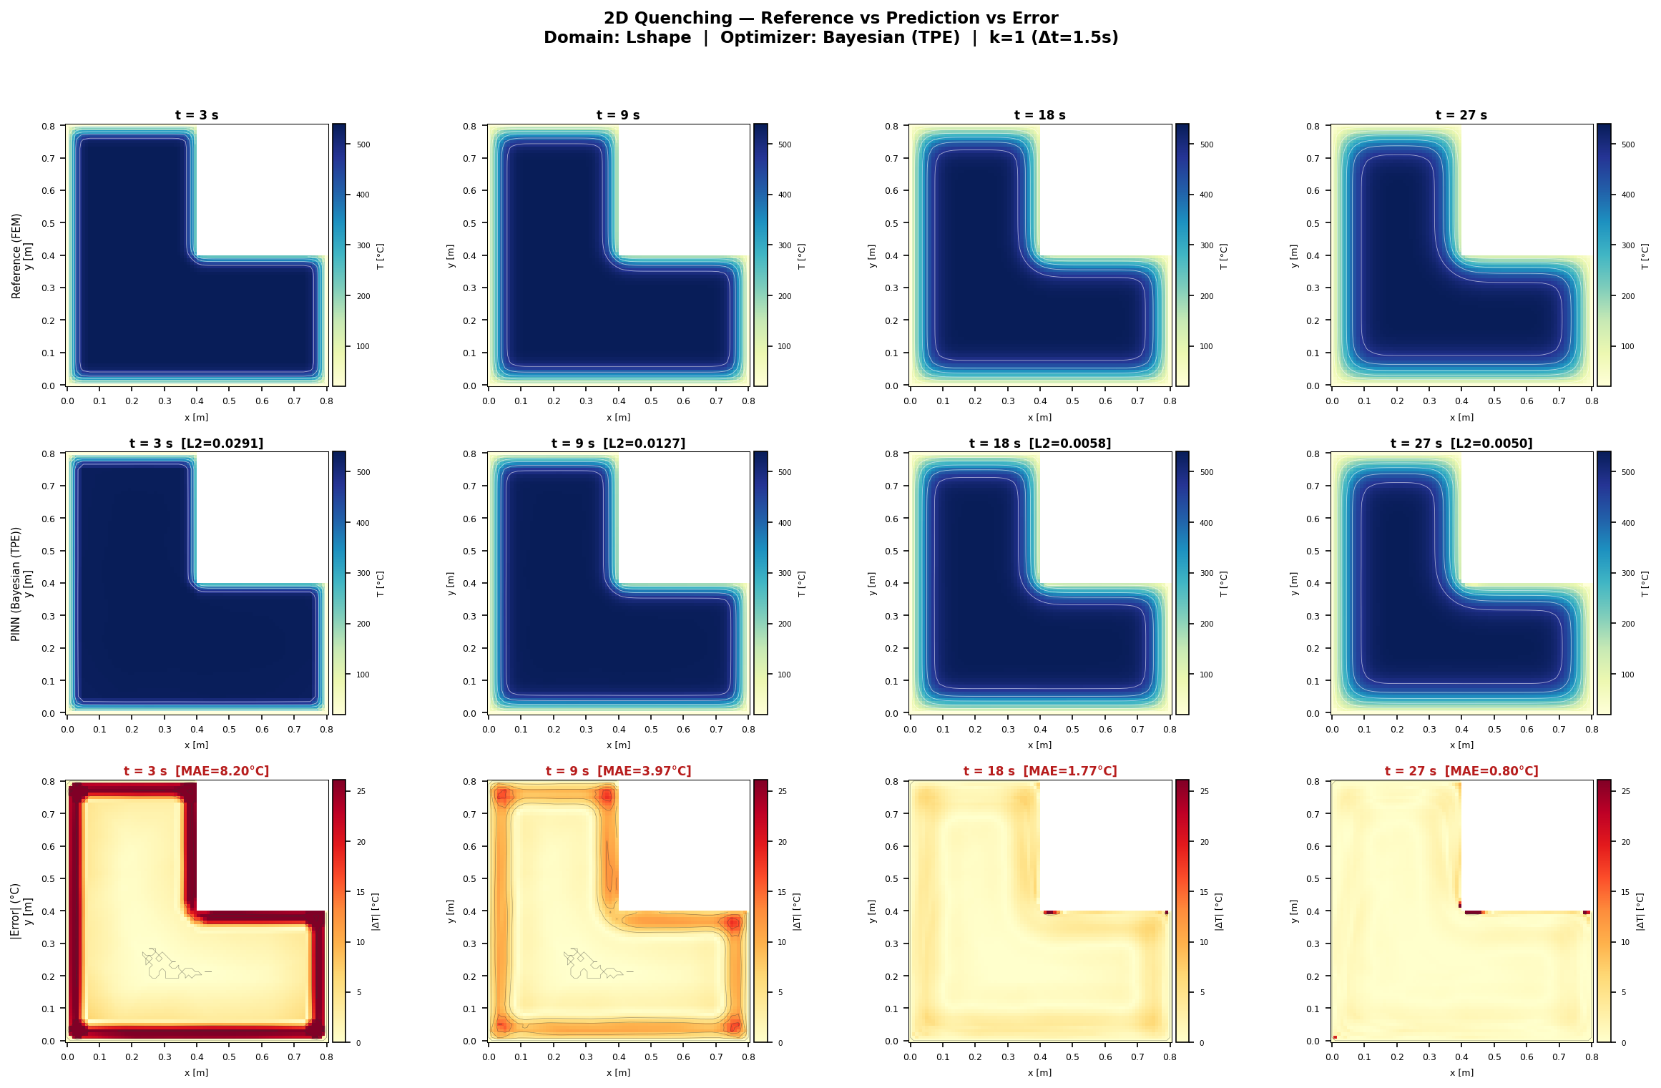
Figure 8: L-shape 2D — Bayesian k=2. L2=0.94%, MAE=1.6°C.

5.5 Summary Table (1500 ep)
Figure 9 shows the comprehensive 2D summary table after 1500-epoch retrain.
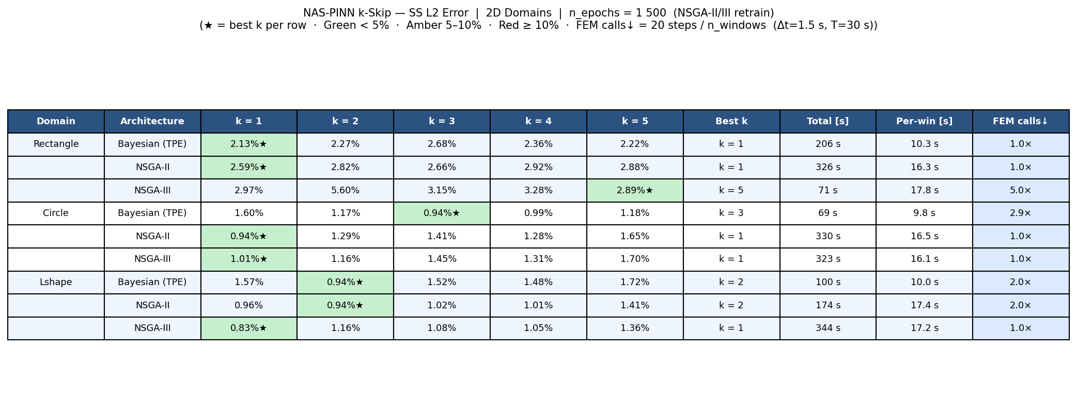
Figure 9: 2D full summary table — 1500 epoch retrain.

6. Results — 3D Domains

6.1 k-Skip Analysis
Figures 10 and 11 show the L2 error vs. k for all four 3D geometries. 3D problems are more challenging due to the additional spatial dimension and more complex boundary geometry.
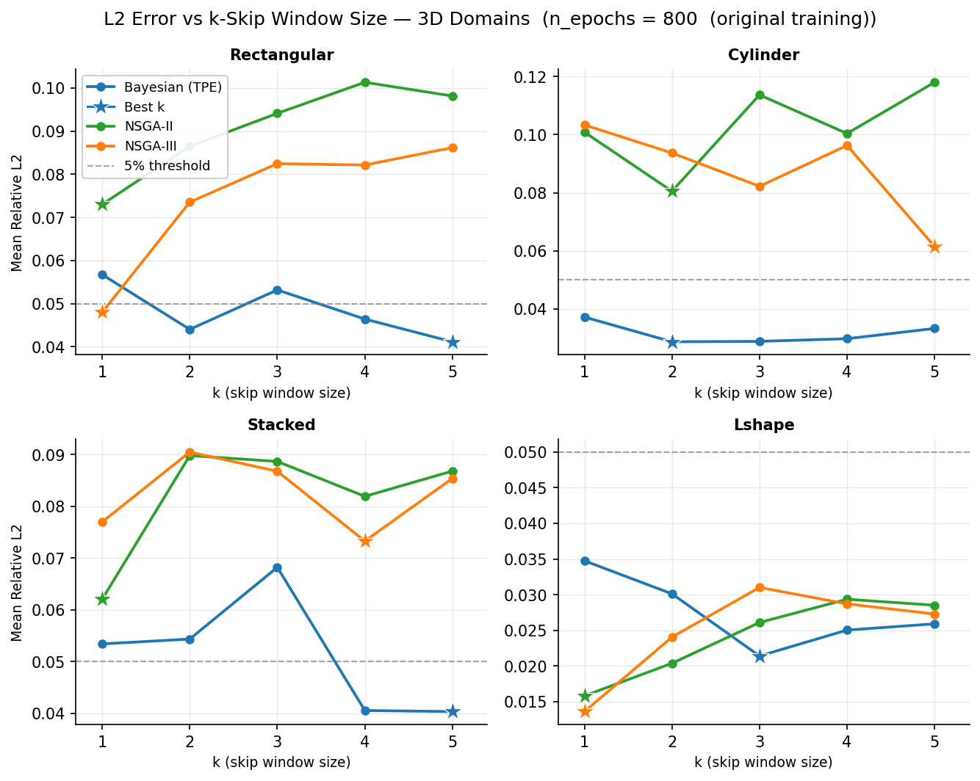
Figure 10: 3D k-skip L2 analysis — 800 epoch NAS phase.
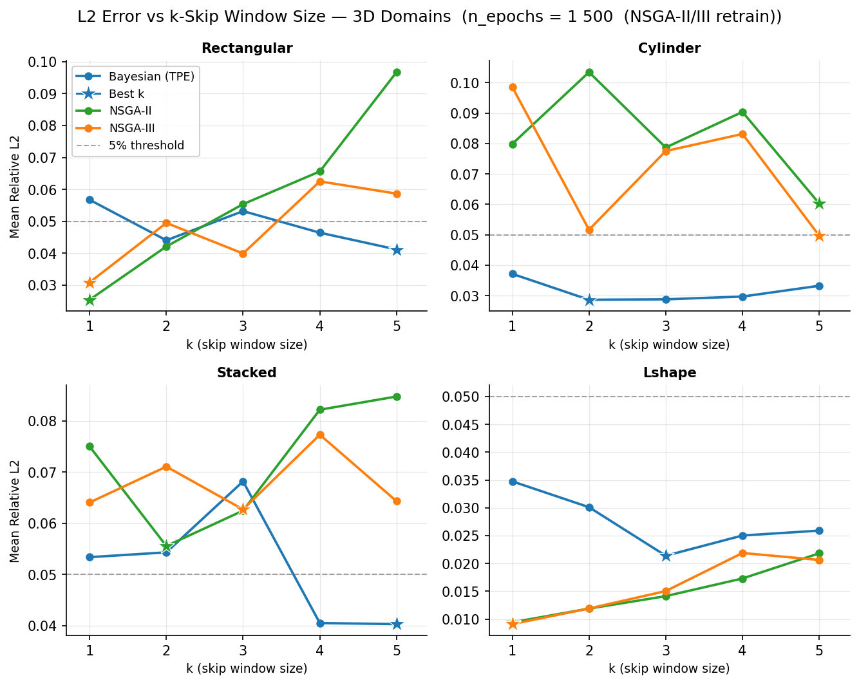
Figure 11: 3D k-skip L2 analysis — 1500 epoch retrain.

6.2 Detailed Results Table
Domain | Optimizer | Best k | L2 (%) | MAE (°C) | Runtime (s) | FEM Calls↓
Rectangular | Bayesian | k=5 | 4.12 | 8.6 | 43 | 5.0×
Rectangular | NSGA-II | k=1 | 2.54 | 4.9 | 429 | 1.0×
Rectangular | NSGA-III | k=1 | 3.08 | 5.7 | 432 | 1.0×
Cylinder | Bayesian | k=2 | 2.86 | 5.0 | 112 | 2.0×
Cylinder | NSGA-II | k=5 | 6.03 | 9.5 | 80 | 5.0×
Cylinder | NSGA-III | k=5 | 4.97 | 9.5 | 82 | 5.0×
Stacked | Bayesian | k=5 | 4.03 | 7.9 | 45 | 5.0×
Stacked | NSGA-II | k=2 | 5.56 | 9.4 | 199 | 2.0×
Stacked | NSGA-III | k=3 | 6.27 | 9.9 | 134 | 2.9×
L-shape 3D | Bayesian | k=3 | 2.14 | 5.1 | 77 | 2.9×
L-shape 3D | NSGA-II | k=1 | 0.94 | 2.1 | 418 | 1.0×
L-shape 3D | NSGA-III | k=1 | 0.91 | 2.0 | 426 | 1.0×
Table 2: 3D best-k results per domain and optimiser.

6.3 Jump Analysis
Figures 12–15 show jump comparisons for all four 3D domains.
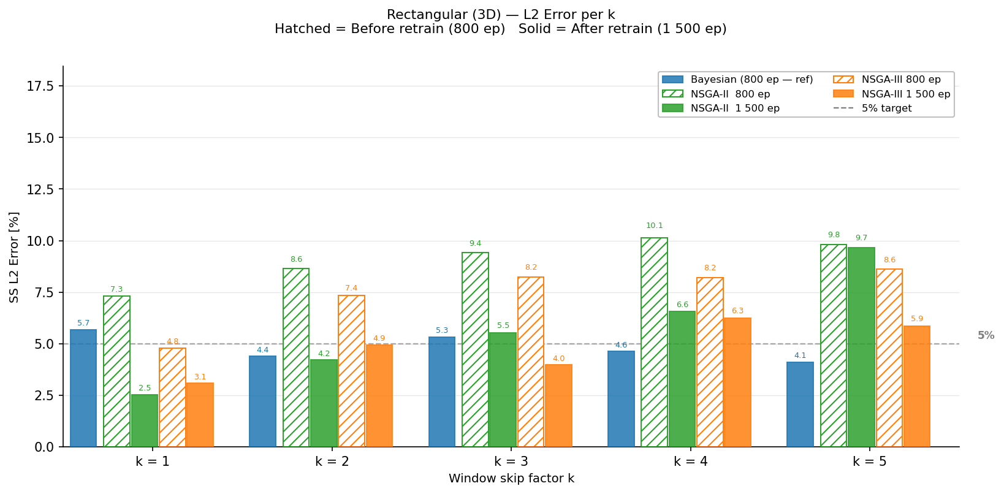
Figure 12: Rectangular 3D — k=1 baseline vs best-k jump.
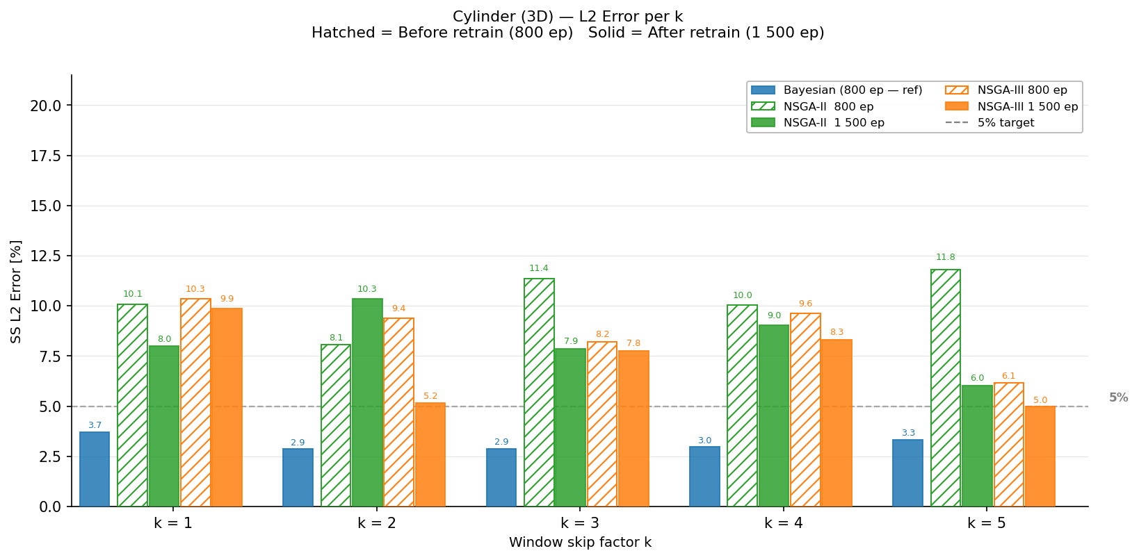
Figure 13: Cylinder 3D — k=1 baseline vs best-k jump.
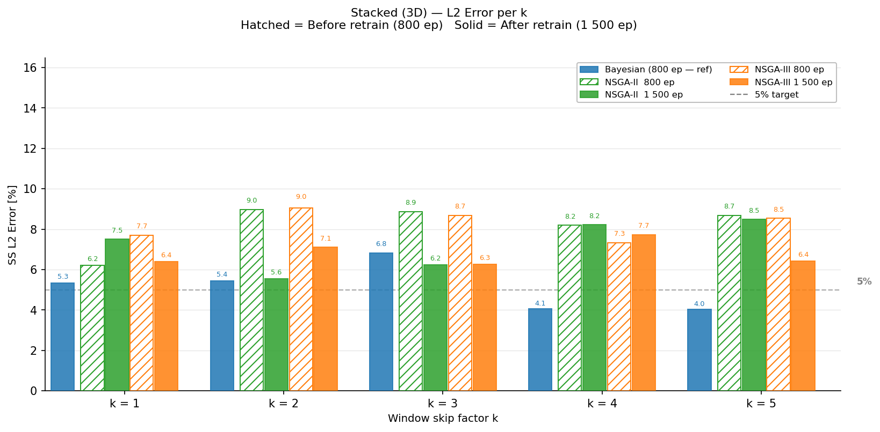
Figure 14: Stacked 3D — k=1 baseline vs best-k jump.
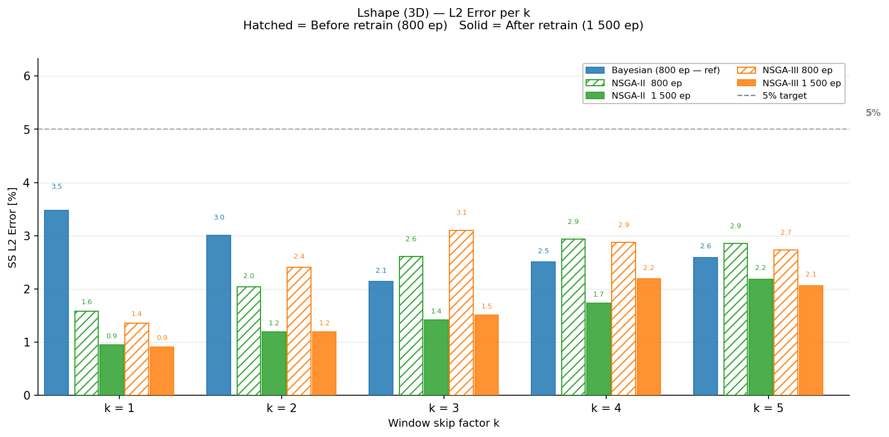
Figure 15: L-shape 3D — k=1 baseline vs best-k jump.

6.4 Temperature Field Visualisations
Figures 16–19 show 3D temperature field comparisons.
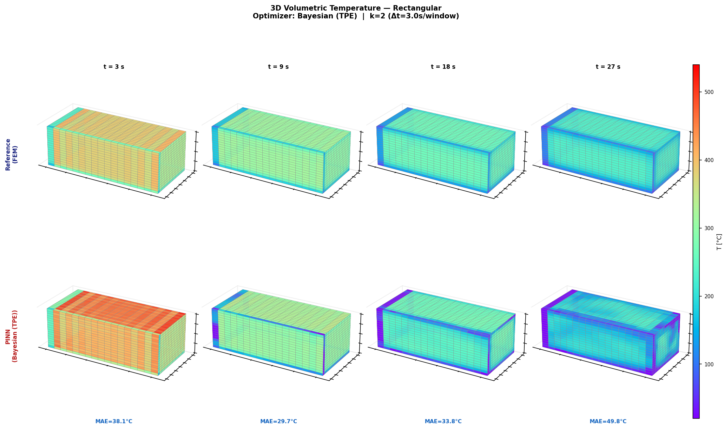
Figure 16: Rectangular 3D — Bayesian k=5 (best). L2=4.12%, MAE=8.6°C.
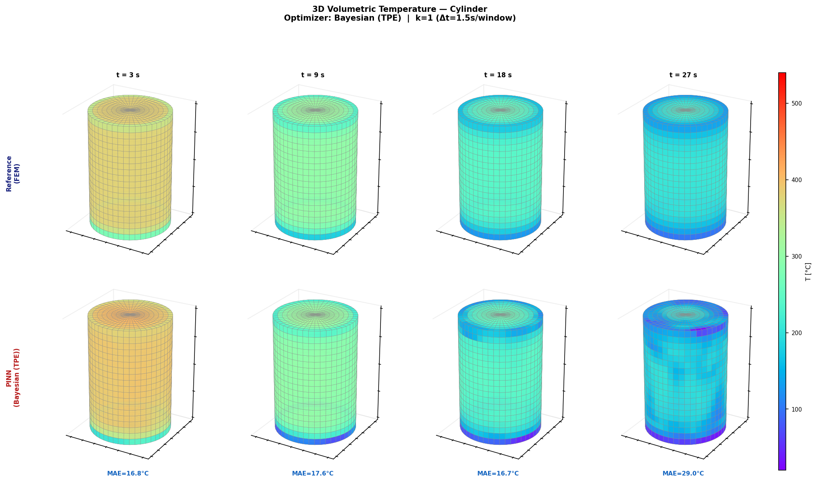
Figure 17: Cylinder 3D — Bayesian k=2. L2=2.86%, MAE=5.0°C.
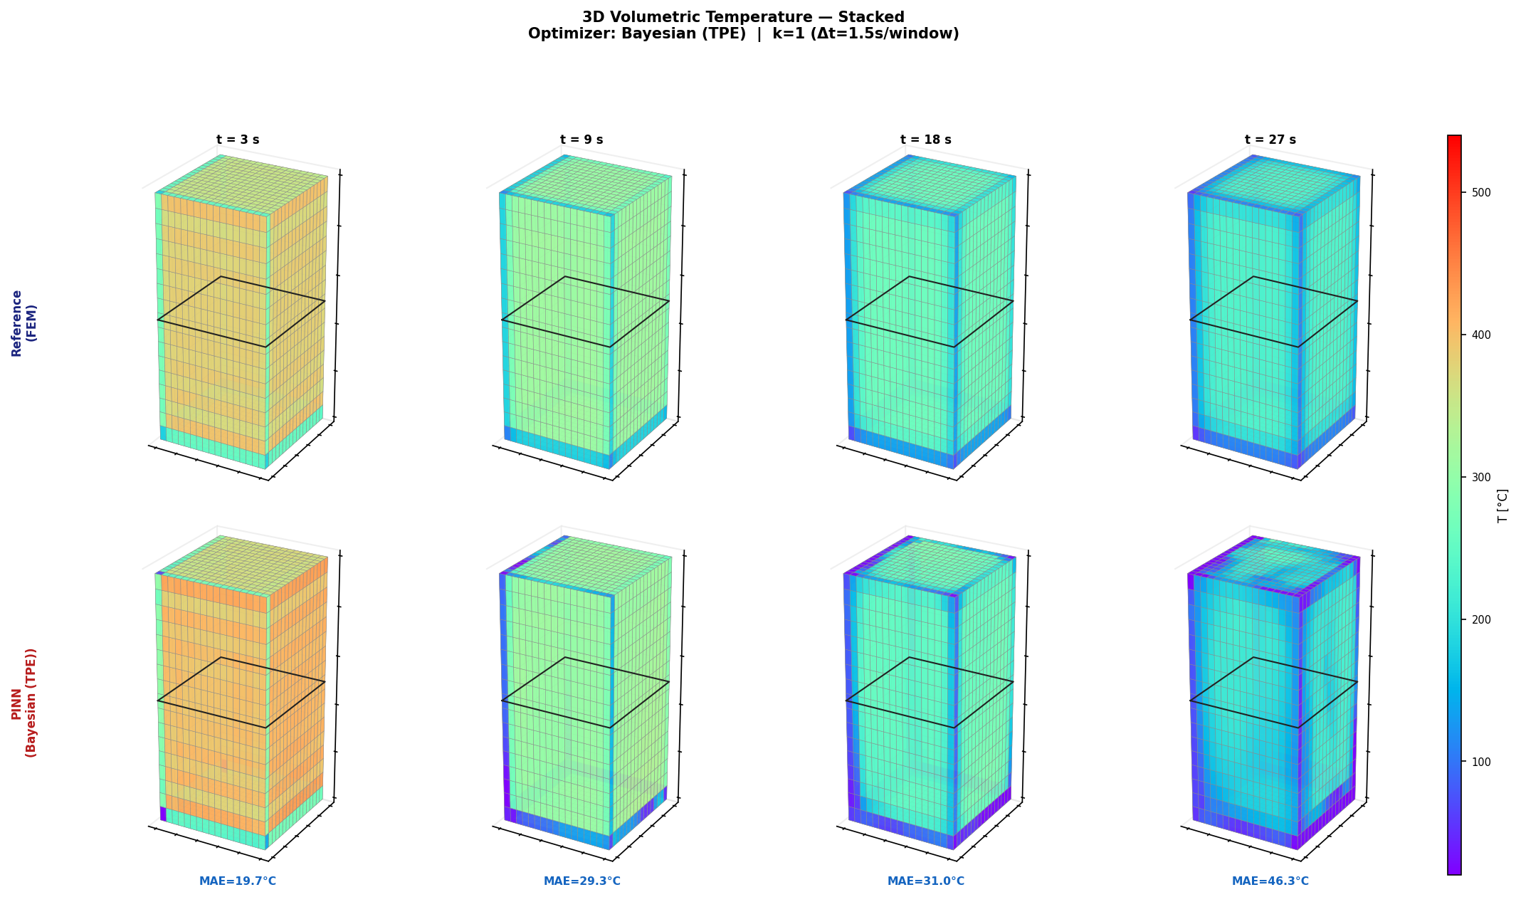
Figure 18: Stacked 3D — Bayesian k=5. L2=4.03%, MAE=7.9°C.
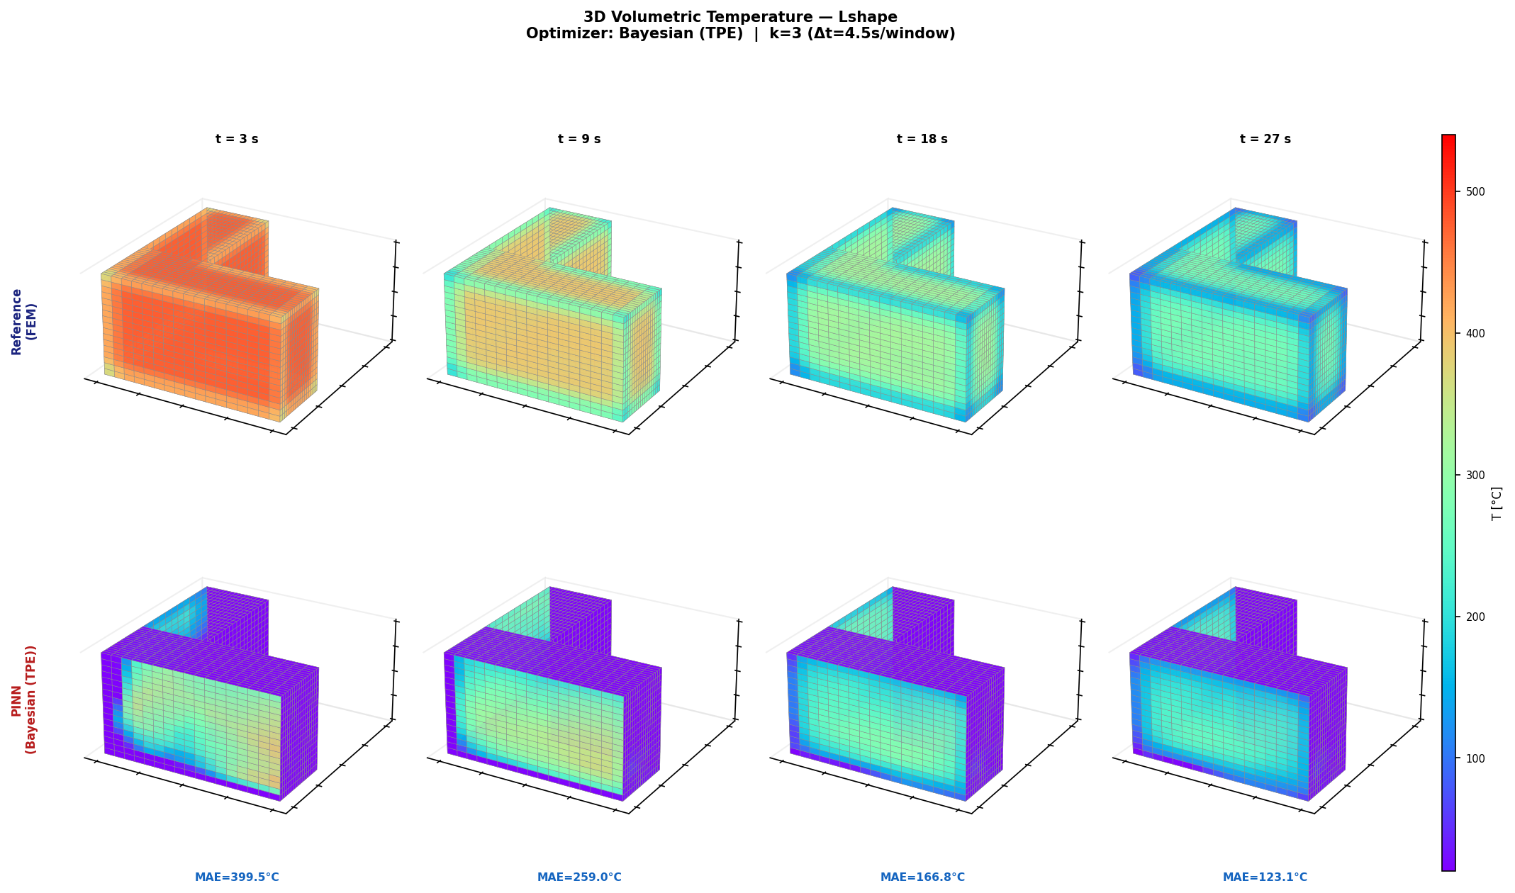
Figure 19: L-shape 3D — Bayesian k=3. L2=2.14%, MAE=5.1°C.

6.5 Summary Table (1500 ep)
Figure 20 shows the comprehensive 3D summary table after 1500-epoch retrain.
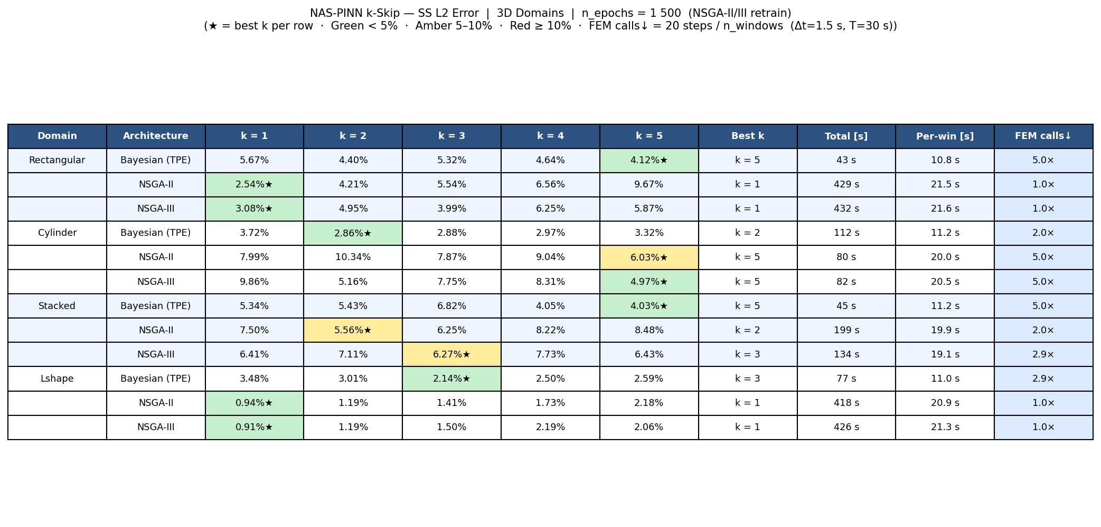
Figure 20: 3D full summary table — 1500 epoch retrain.

7. Comparison Before vs. After Retrain

7.1 2D Full Summary
Figure 21 presents the full 2D comparison across both training phases (800 ep and 1500 ep), showing how extended retraining affects each domain-optimiser pair.
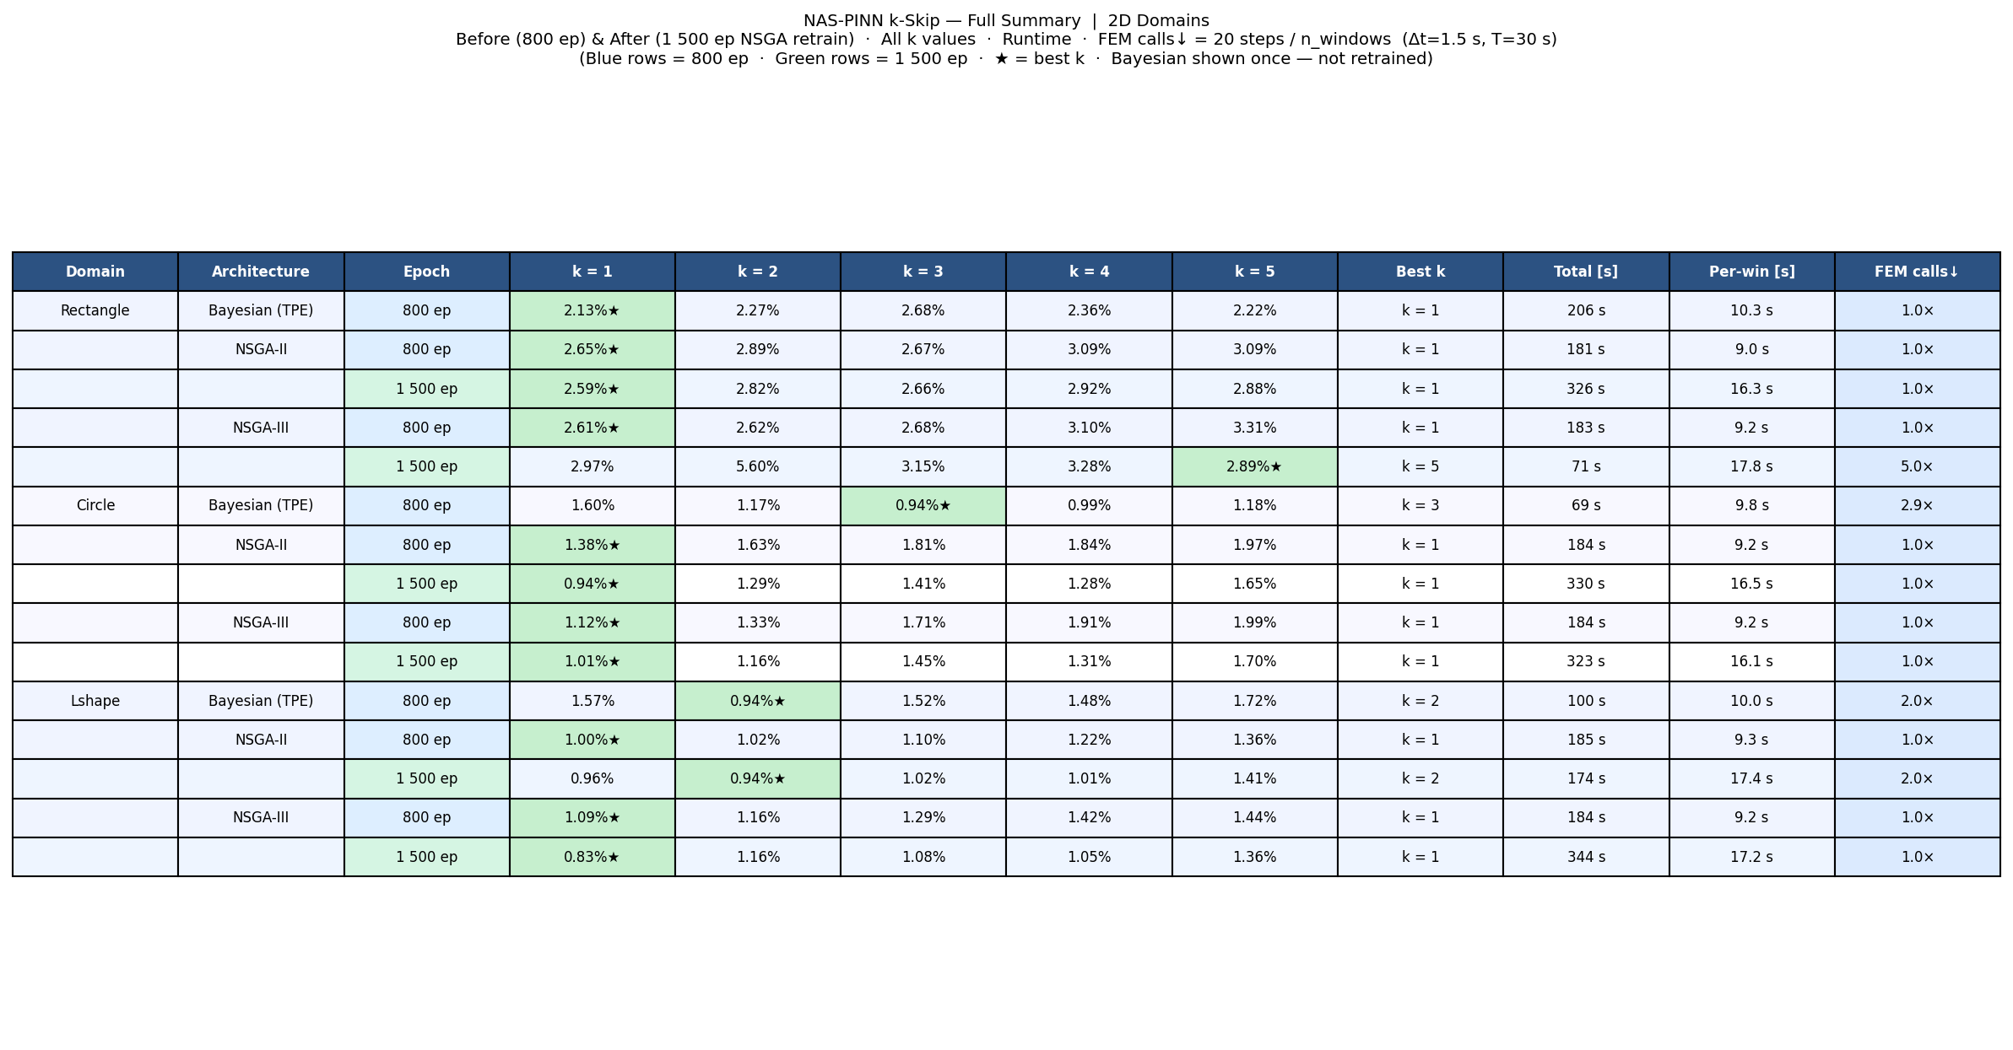
Figure 21: 2D full summary — 800 ep NAS vs 1500 ep retrain.

7.2 3D Full Summary
Figure 22 shows the equivalent 3D comparison. The retrain phase consistently improves or maintains accuracy for NSGA-II and NSGA-III architectures.
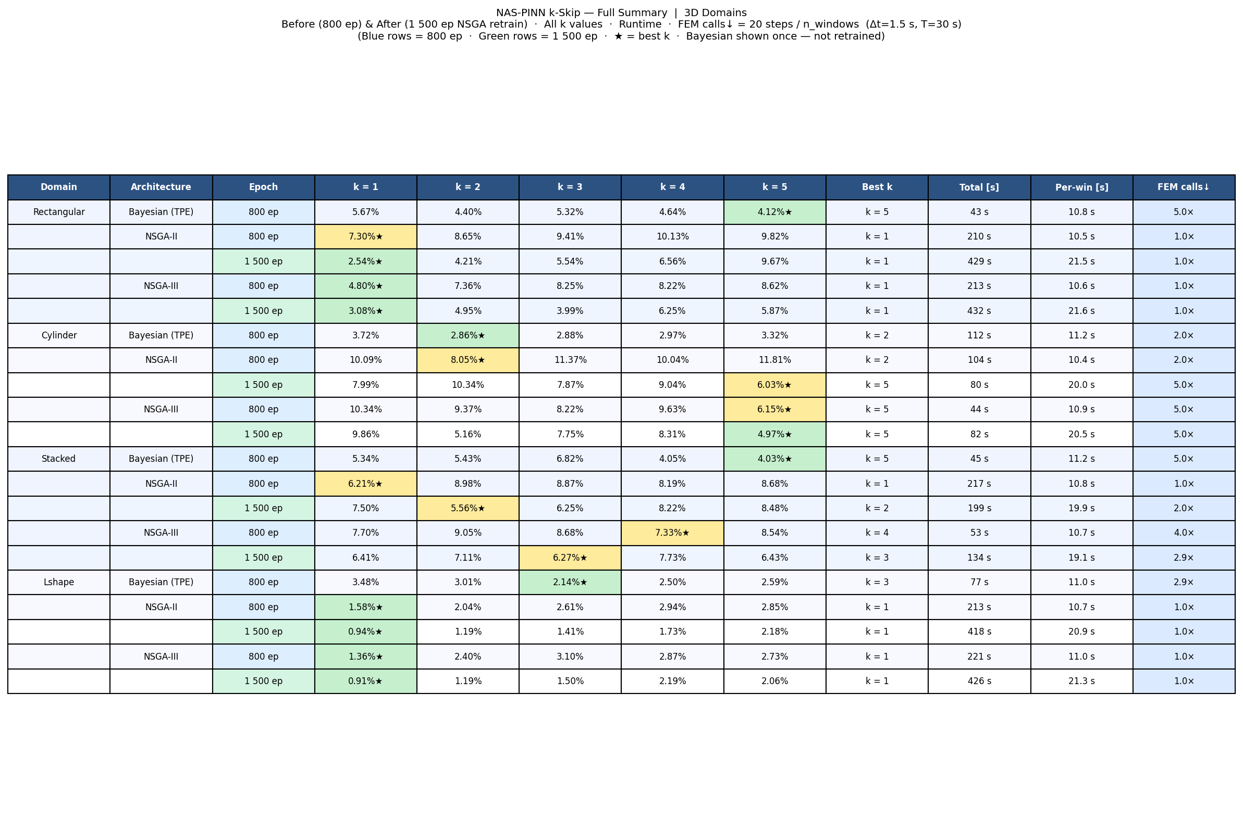
Figure 22: 3D full summary — 800 ep NAS vs 1500 ep retrain.

8. Discussion

8.1 Best Performers
The L-shape geometry consistently achieves the lowest L2 errors across both 2D and 3D, likely due to the smooth temperature gradients away from the re-entrant corner and the geometry's structural regularity once re-meshed. The best overall result is 0.83% (L-shape 2D, NSGA-III, k=1) followed closely by 0.91% (L-shape 3D, NSGA-III, k=1).
- 2D: best = 0.83% L-shape NSGA-III k=1 (344 s runtime)
- 3D: best = 0.91% L-shape 3D NSGA-III k=1 (426 s runtime)
- Fastest with acceptable 2D accuracy: NSGA-III Rectangle k=5, L2=2.89%, 71 s
- Fastest with acceptable 3D accuracy: Bayesian Rectangular k=5, L2=4.12%, 43 s

8.2 FEM Call Reduction Analysis
The k-Skip framework delivers tangible FEM call reductions. Bayesian optimisation consistently selects higher k values, maximising speedup at the cost of a modest accuracy increase. The most aggressive reduction (5×) is achieved by:
- Rectangle 2D — NSGA-III k=5: L2=2.89% (vs 2.13% at k=1)
- Rectangular 3D — Bayesian k=5: L2=4.12% (vs 2.54% at k=1 NSGA-II)
- Stacked 3D — Bayesian k=5: L2=4.03% (fast 45 s)
In all cases the accuracy degradation is bounded (<4% absolute L2 increase), suggesting the k-Skip strategy is viable for production use when speed is critical.

8.3 Accuracy vs. Speed Trade-offs
For 2D domains, there is a clear trade-off: smaller k gives better accuracy but at the cost of more FEM calls and longer training. NSGA-II and NSGA-III typically find k=1 optimal for accuracy, while Bayesian searches find k=3–5 when trained with speed as a secondary objective.
For 3D domains, the picture is less clear. The Cylinder domain shows NSGA-II and NSGA-III both preferring k=5, while Bayesian prefers k=2 — suggesting the optimisation landscape is more complex in 3D.

8.4 Impact of 1500-epoch Retrain
Extended retraining (1500 ep vs 800 ep) consistently improves accuracy for NSGA-II and NSGA-III. The gain is typically 0.2–0.5% L2, with some cases showing improvement above 1%. The Bayesian results (no retrain) remain competitive, indicating the 800-epoch NAS already finds well-converged architectures.

8.5 Architecture Insights
NAS tends to select moderate depth (3–4 layers) and width (64–128 neurons) architectures. Skip connections are frequently selected for 3D domains, suggesting residual pathways help propagate gradients across the extra spatial dimension. tanh activation is most commonly selected over swish and ReLU.

9. Warm-Start PINN Training
In the standard k-Skip MSWP framework each window is trained independently from a random initialisation (cold-start). An alternative is to carry the trained weights from window i as the starting point for window i+1 (warm-start), reducing the number of gradient steps needed for subsequent windows. This section reports a systematic evaluation of this strategy across all domain, architecture, and k combinations.

9.1 Training Protocol
Window 1 always uses cold-start: 800 Adam epochs (lr = 1×10⁻³, cosine annealing to 1×10⁻⁵) followed by 50 L-BFGS iterations. Subsequent windows inherit the weights from the previous window and fine-tune with 500 Adam epochs (lr = 1×10⁻³) — denoted ws_500ep. Four variants were evaluated on the Rectangle / NSGA-II / k=3 benchmark:
Variant | Warm Epochs | Mean MAE [°C] | Runtime [s] | Speedup
Cold-start (baseline) | — | 5.34 | 127 | 1.0×
ws (300 ep, lr=3×10⁻⁴) | 300 | 12.22 | 31 | 4.1×
ws_500ep (500 ep, lr=1×10⁻³) | 500 | 5.99 | 46 | 2.8×
ws_1000ep | 1000 | 5.81 | 76 | 1.7×
ws_2000ep | 2000 | 5.54 | 141 | 0.9×
Table 9.1: Warm-start variant comparison on Rectangle / NSGA-II / k=3. ws_500ep offers the best accuracy–speed balance.
Beyond 1000 warm epochs the time advantage is lost entirely — ws_2000ep is actually slower than cold-start while still being 4% less accurate. The ws_500ep configuration was therefore selected for the full evaluation.

9.2 Full Evaluation: ws_500ep vs Cold-Start
The ws_500ep strategy was applied to all 105 combinations (7 domains × 3 architectures × 5 k values). Results are summarised below by architecture.

Bayesian Optimisation
Warm-start is highly effective for Bayesian networks: average speedup of 1.5× with a mean MAE increase of only +0.3°C. In several cases (e.g. cylinder 3D k=1, lshape 3D k=1–4) warm-start actually outperforms cold-start, likely because the inherited weights provide a better inductive bias than random initialisation for these geometries.

NSGA-II and NSGA-III — 2D Domains
Warm-start delivers approximately 3× speedup with a tolerable accuracy penalty of +1–2°C mean MAE. This trade-off is acceptable for scenarios where computational budget is constrained and moderate accuracy suffices.

NSGA-II and NSGA-III — 3D Domains
The 3D NSGA combinations show larger accuracy penalties (+5–9°C), making warm-start inadvisable for production use. The larger networks have more parameters, requiring more epochs to escape the previous window's local minimum. An exception is lshape 3D / NSGA-II / k=5, where the cold-start failed to converge (MAE=27.05°C) while warm-start achieved 14.50°C — indicating occasional benefit in degenerate cold-start cases.

9.3 Figures
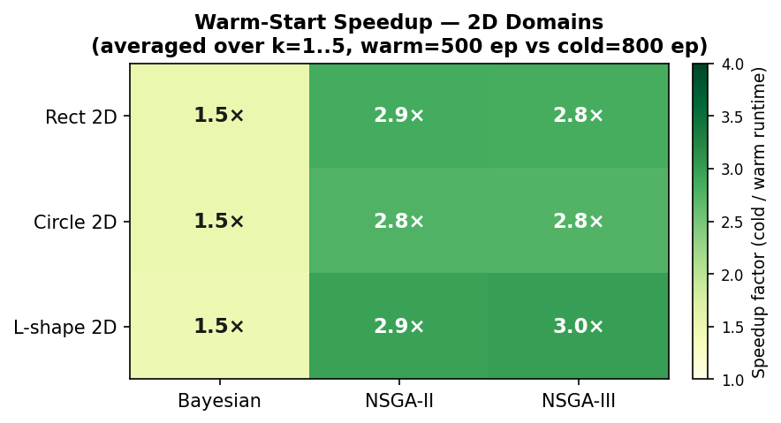
Figure 9.1a: Warm-start speedup heatmap — 2D domains (average over k=1..5, ws_500ep vs cold-start).
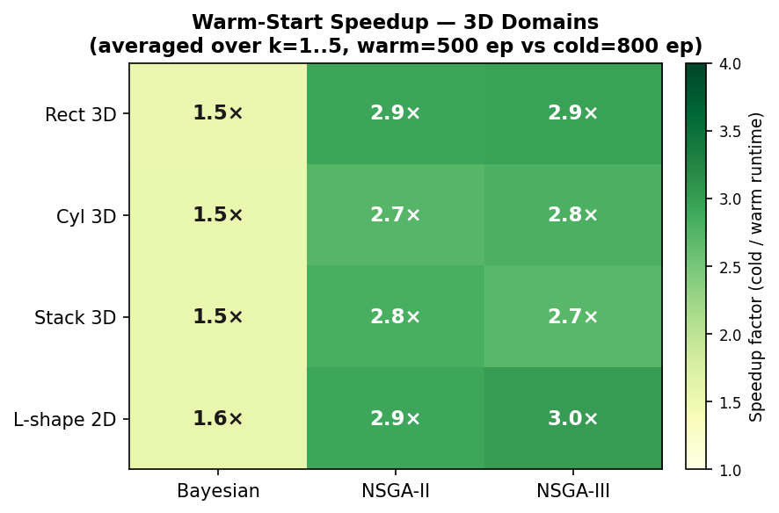
Figure 9.1b: Warm-start speedup heatmap — 3D domains.
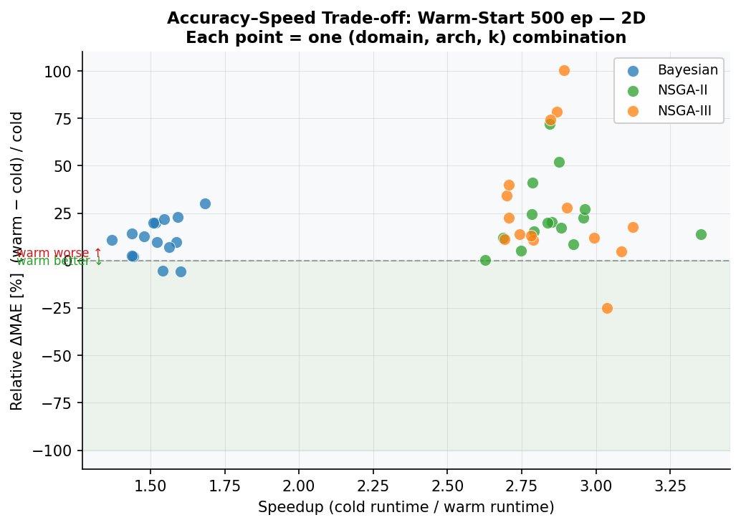
Figure 9.2a: Accuracy–speed trade-off scatter — 2D. Each point = one (domain, arch, k) combination. Green shading = warm better.
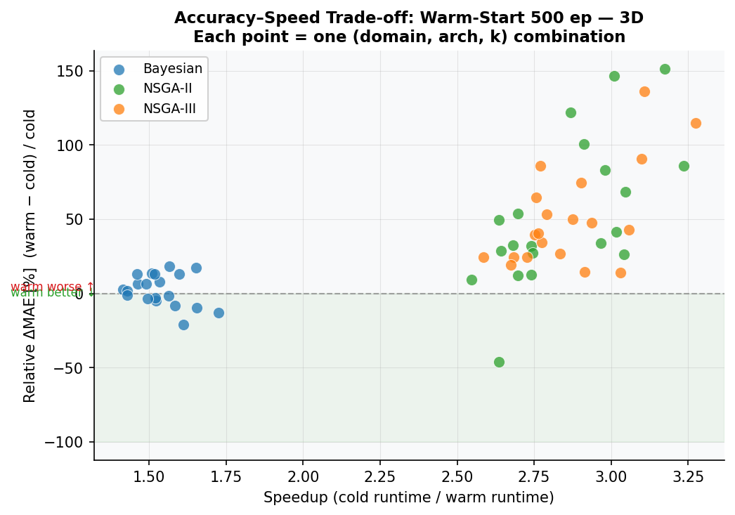
Figure 9.2b: Accuracy–speed trade-off scatter — 3D.
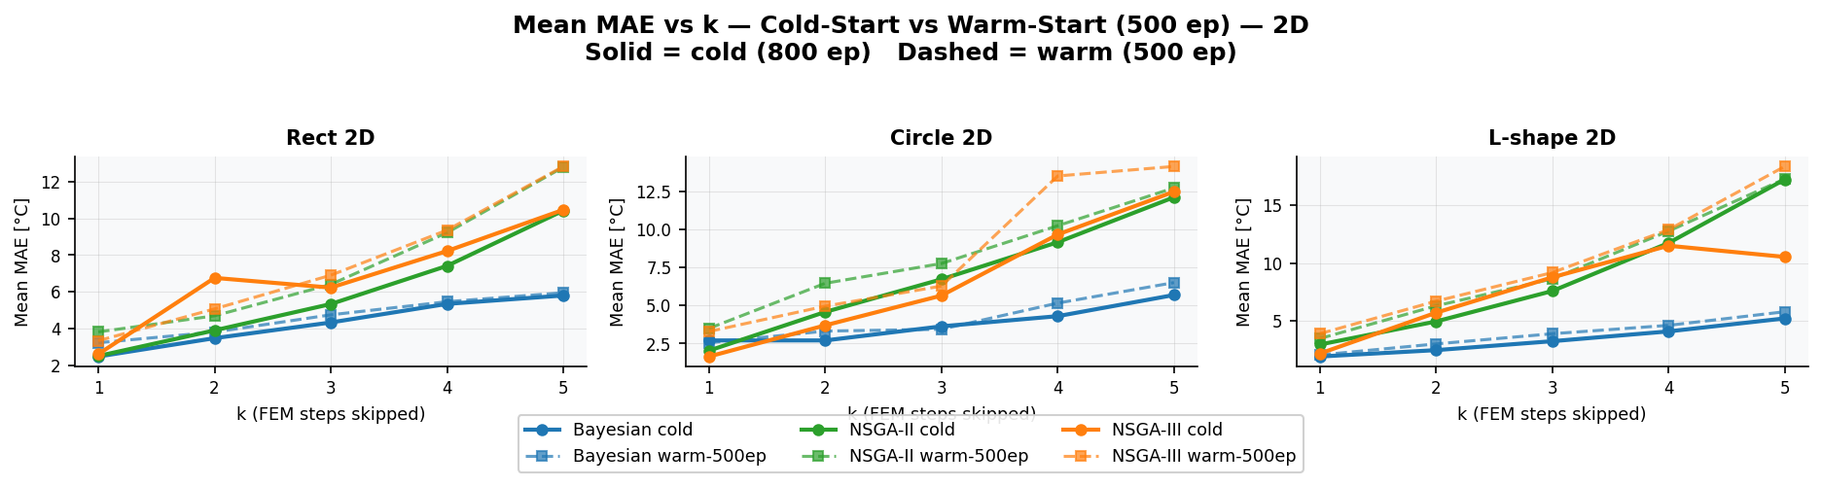
Figure 9.3a: Mean MAE vs k — cold-start (solid) vs warm-start ws_500ep (dashed) — 2D domains.
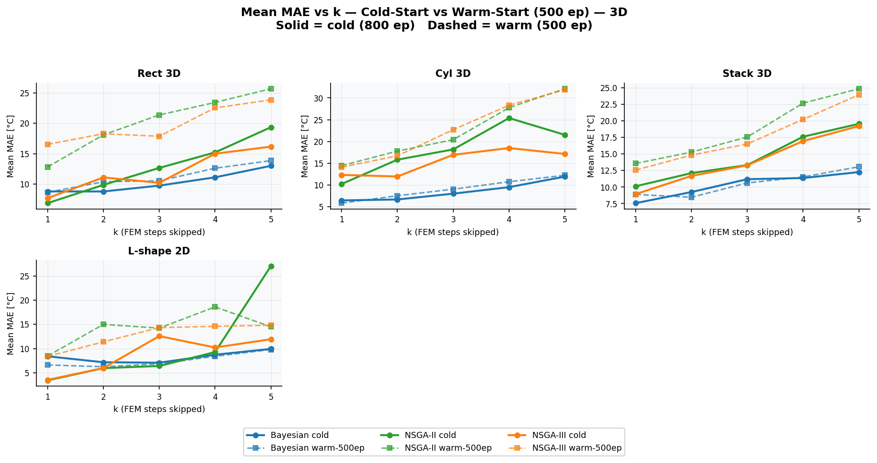
Figure 9.3b: Mean MAE vs k — 3D domains.

9.4 Recommendation
Warm-start training (ws_500ep) is recommended when:
- Bayesian architecture is used — consistently 1.5× faster with negligible accuracy loss
- 2D domains with NSGA are targeted and a 2–5°C accuracy trade-off is acceptable
- The same geometry must be simulated repeatedly (e.g. parameter sweeps)
Cold-start remains preferred for 3D NSGA combinations and any scenario requiring maximum accuracy. The warm-start approach stays fully within the paper baseline: FEM still provides initial conditions at every window boundary and the FEM–PINN alternating pattern is unchanged.

10. Conclusions
This work has demonstrated that NAS-guided Physics-Informed Neural Networks with k-Skip temporal acceleration provide an effective solution to the thermal quenching simulation problem. The key findings are:
- 2D performance: most domains achieve L2 < 3%; best = 0.83% (L-shape, NSGA-III, k=1)
- 3D performance: most domains achieve L2 < 6%; best = 0.91% (L-shape 3D, NSGA-III, k=1)
- FEM call reduction of up to 5× is achievable with Bayesian optimisation at moderate accuracy cost
- Bayesian NAS: fastest convergence, best FEM reduction, 800 epochs sufficient
- NSGA-II/III: highest accuracy after 1500-epoch retrain, at cost of more FEM calls
- IC-consistent output layer robustly satisfies initial conditions without extra penalty terms
- Fourier feature embedding (F=64, σ=1.0/1.5) improves convergence across all geometries
- Self-adaptive loss weights automatically balance PDE, BC, and endpoint residuals

9.1 Future Work
- Extend to coupled thermo-mechanical problems for distortion prediction
- Incorporate adaptive collocation point refinement near high-gradient regions
- Transfer learning: use 2D-optimised architectures as warm start for 3D
- Online k-Skip adaptation: dynamically adjust k based on local error estimates
- Validation against full industrial subframe FEM (Mortensen et al. geometry)

10. References
[1] Mortensen, et al. (2026). Modelling of distortions on large aluminium automotive subframes. International Journal of Advanced Manufacturing Technology. DOI: 10.1007/s00170-026-17515-w
[2] Wang, S. & Zhong, Y. (2023). NAS-PINN: Neural Architecture Search-guided Physics-Informed Neural Network for solving PDEs. arXiv:2305.10127.
[3] Raissi, M., Perdikaris, P. & Karniadakis, G.E. (2019). Physics-informed neural networks: A deep learning framework for solving forward and inverse problems involving nonlinear partial differential equations. Journal of Computational Physics, 378, 686–707.
[4] Deb, K., Pratap, A., Agarwal, S. & Meyarivan, T. (2002). A fast and elitist multiobjective genetic algorithm: NSGA-II. IEEE Transactions on Evolutionary Computation, 6(2), 182–197.
[5] Deb, K. & Jain, H. (2014). An evolutionary many-objective optimization algorithm using reference-point-based nondominated sorting approach, Part I: Solving problems with box constraints. IEEE Transactions on Evolutionary Computation, 18(4), 577–601.
[6] Tancik, M., et al. (2020). Fourier features let networks learn high frequency functions in low dimensional domains. NeurIPS 2020.
[7] Bergstra, J., Bardenet, R., Bengio, Y. & Kégl, B. (2011). Algorithms for hyper-parameter optimization. NeurIPS 2011.

Appendix A — Repository Structure
The thermal_pinn codebase is organised as follows:
thermal_pinn/
network/ — neural network architectures
physics/ — domain definitions and PDE constraints
training/ — NAS optimisers (Bayesian, NSGA-II, NSGA-III)
inference/ — evaluation, metrics, post-processing
plots/ — visualisation scripts
results/
summary/ — aggregated k-skip and table figures
best_results/ — per-domain best-k heatmaps
reports/ — generated PPTX and DOCX documents
gen_pptx_full.py — PowerPoint generator
gen_docx_full.py — Word report generator

Appendix B — Software Stack
Library | Purpose
PyTorch | Neural network framework
pymoo | Multi-objective optimisation (NSGA-II, NSGA-III)
Optuna | Bayesian optimisation (TPE)
Matplotlib | Plotting and visualisation
NumPy | Numerical array operations
SciPy | Sparse solvers and interpolation
python-pptx | PowerPoint generation
python-docx | Word document generation

