thermal_pinn

NAS-PINN with k-Skip Optimization
for Thermal Quenching PDEs

Generated: March 30, 2026

Executive Summary
This report presents thermal_pinn, a comprehensive framework for solving thermal quenching partial differential equations (PDEs) using Physics-Informed Neural Networks (PINNs) combined with Neural Architecture Search (NAS).
Key contributions:
- Integration of k-skip temporal acceleration with PINN training
- Optimization across three evolutionary algorithms: Bayesian, NSGA-II, NSGA-III
- Benchmark validation on 2D (3 domains) and 3D (4 domains) thermal geometries
- Comparative analysis showing trade-offs between accuracy and computational speed

Introduction

Background
Physics-Informed Neural Networks (PINNs) represent a novel approach to solving PDEs by incorporating physical constraints directly into neural network training. However, finding optimal architectures remains computationally expensive.

Problem Statement
Thermal quenching processes require rapid cooling simulations with high accuracy. The k-skip strategy aims to reduce computational overhead by selecting which time steps to evaluate, introducing a tunable acceleration parameter.

Methodology

k-Skip Concept
The k-skip strategy accelerates PINN training by skipping intermediate time steps during Finite Element Method (FEM) supervision.
k value | Time Skip (s) | Description
1 | 1.5 | Baseline (no skip)
2 | 3.0 | Skip every other step
3 | 4.5 | Skip 2 steps per window
4 | 6.0 | Skip 3 steps per window
5 | 7.5 | Maximum skip

Optimizers
Three evolutionary algorithms explore the architectural design space:
Bayesian: Probabilistic Gaussian process-based search
NSGA-II: Non-dominated Sorting GA with 2 objectives
NSGA-III: k-objective NSGA variant

2D Results & Analysis

k-Skip Analysis (2D Domains)
The following plot shows L2 relative error vs. k-skip factor for Rectangle, Circle, and L-shape geometries across all three optimizers.
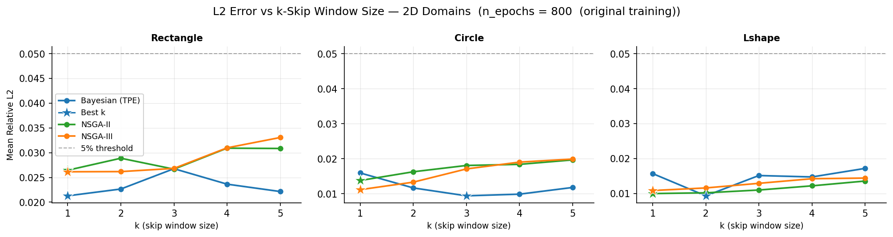
Figure 1: 2D k-skip analysis across optimizers and geometries.

Best-k Performance (2D)
Comparison of k=1 (baseline) versus best-k (optimal skip factor) for each domain.
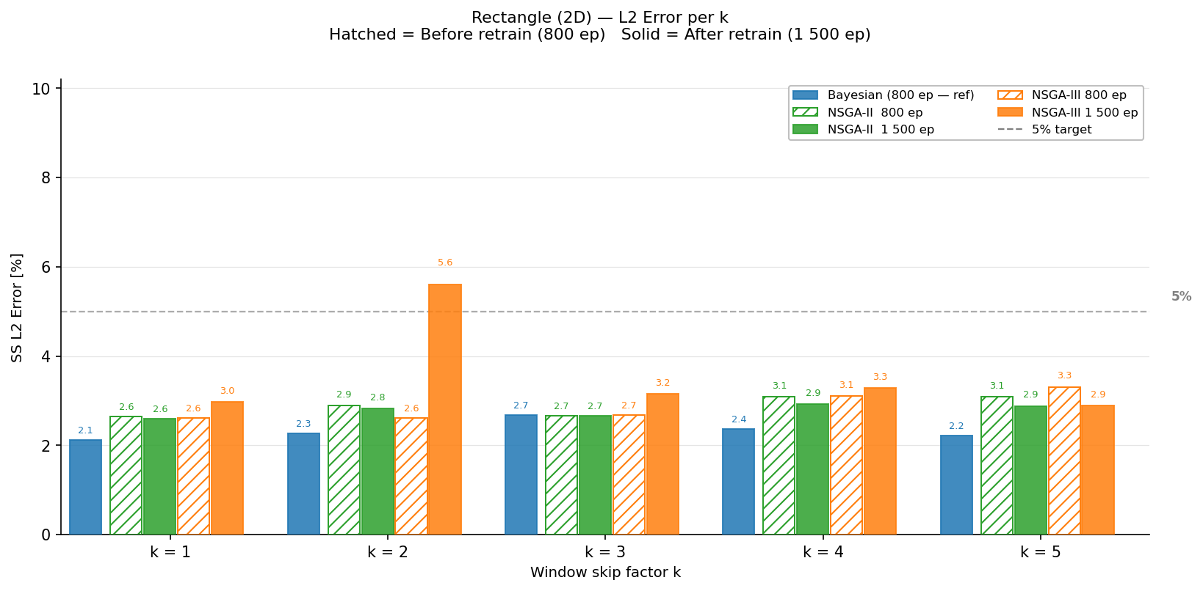
Figure 2: 2D best-k jump comparison (Rectangle domain).

Reference vs PINN Heatmaps (2D)
Temperature field comparison: FEM reference solution, PINN prediction, and absolute error.
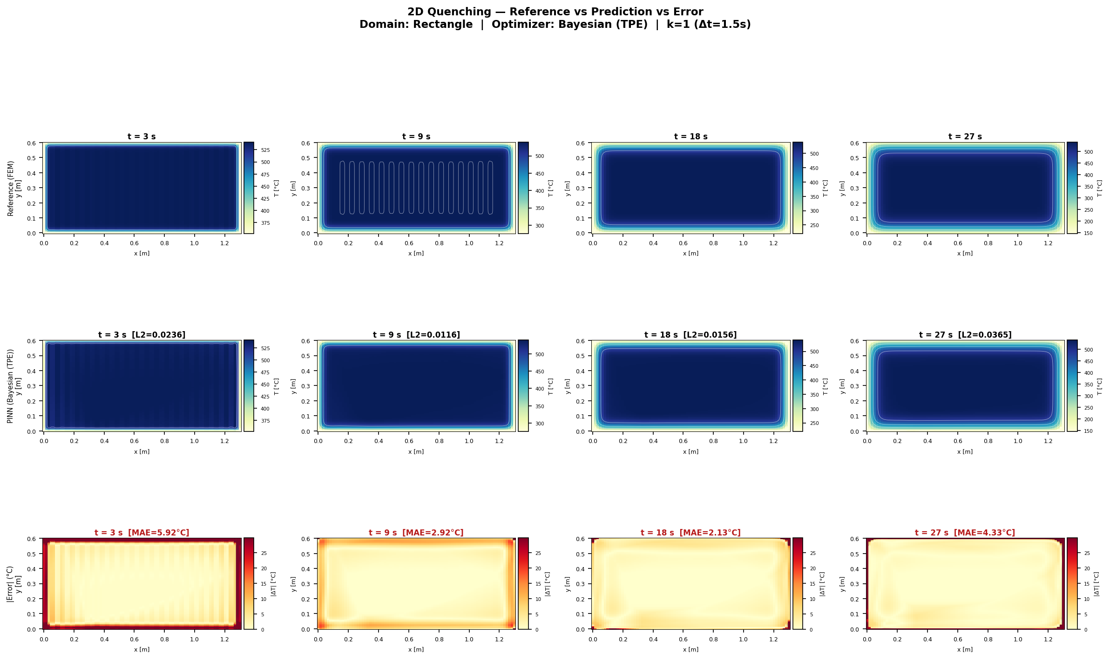
Figure 3: 2D heatmap comparison (Rectangle, Bayesian, k=1).

3D Results & Analysis

k-Skip Analysis (3D Domains)
3D results across Rectangular box, Cylinder, Stacked, and L-shape geometries.
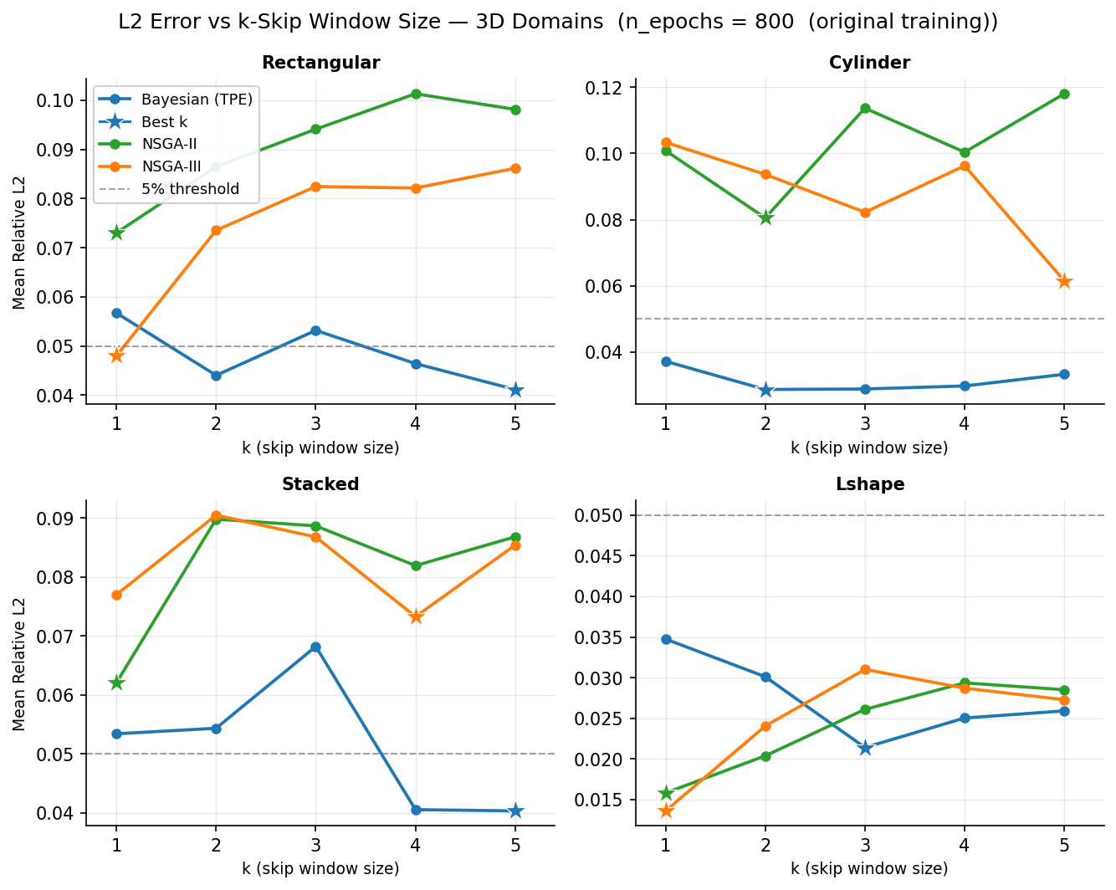
Figure 4: 3D k-skip analysis.

Best-k Performance (3D)
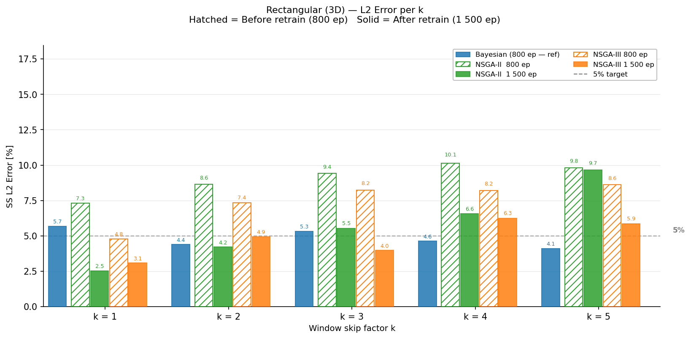
Figure 5: 3D best-k jump comparison (Rectangular domain).

Volumetric Renders (3D)
Volumetric rendering comparison: FEM reference (top row) vs PINN prediction (bottom row).
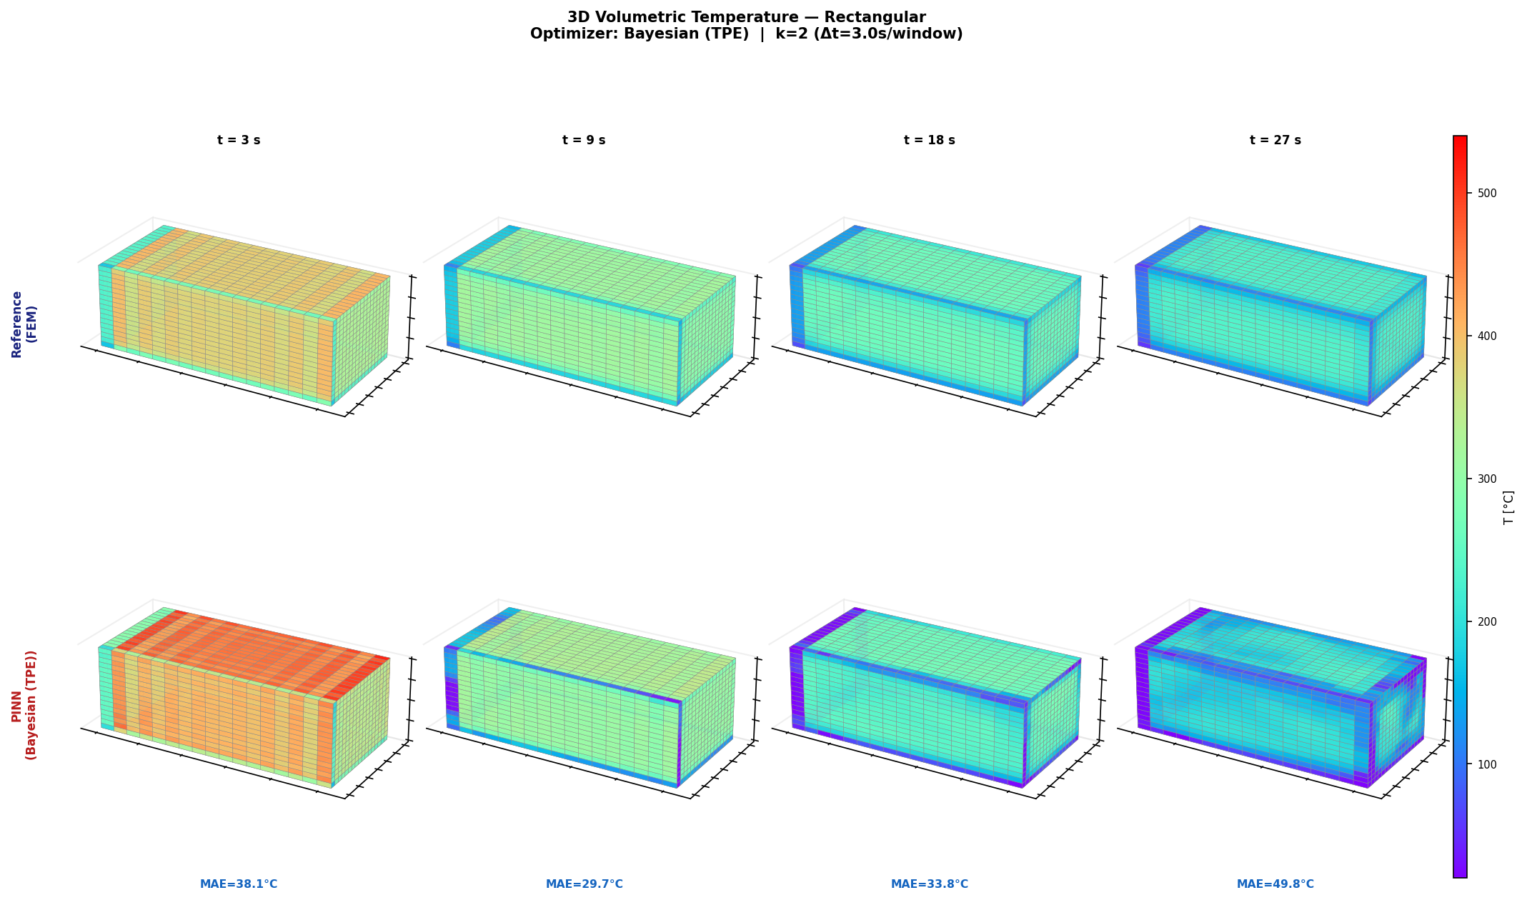
Figure 6: 3D volumetric render (Rectangular, Bayesian, k=2).

Performance Summary

2D Domain Results
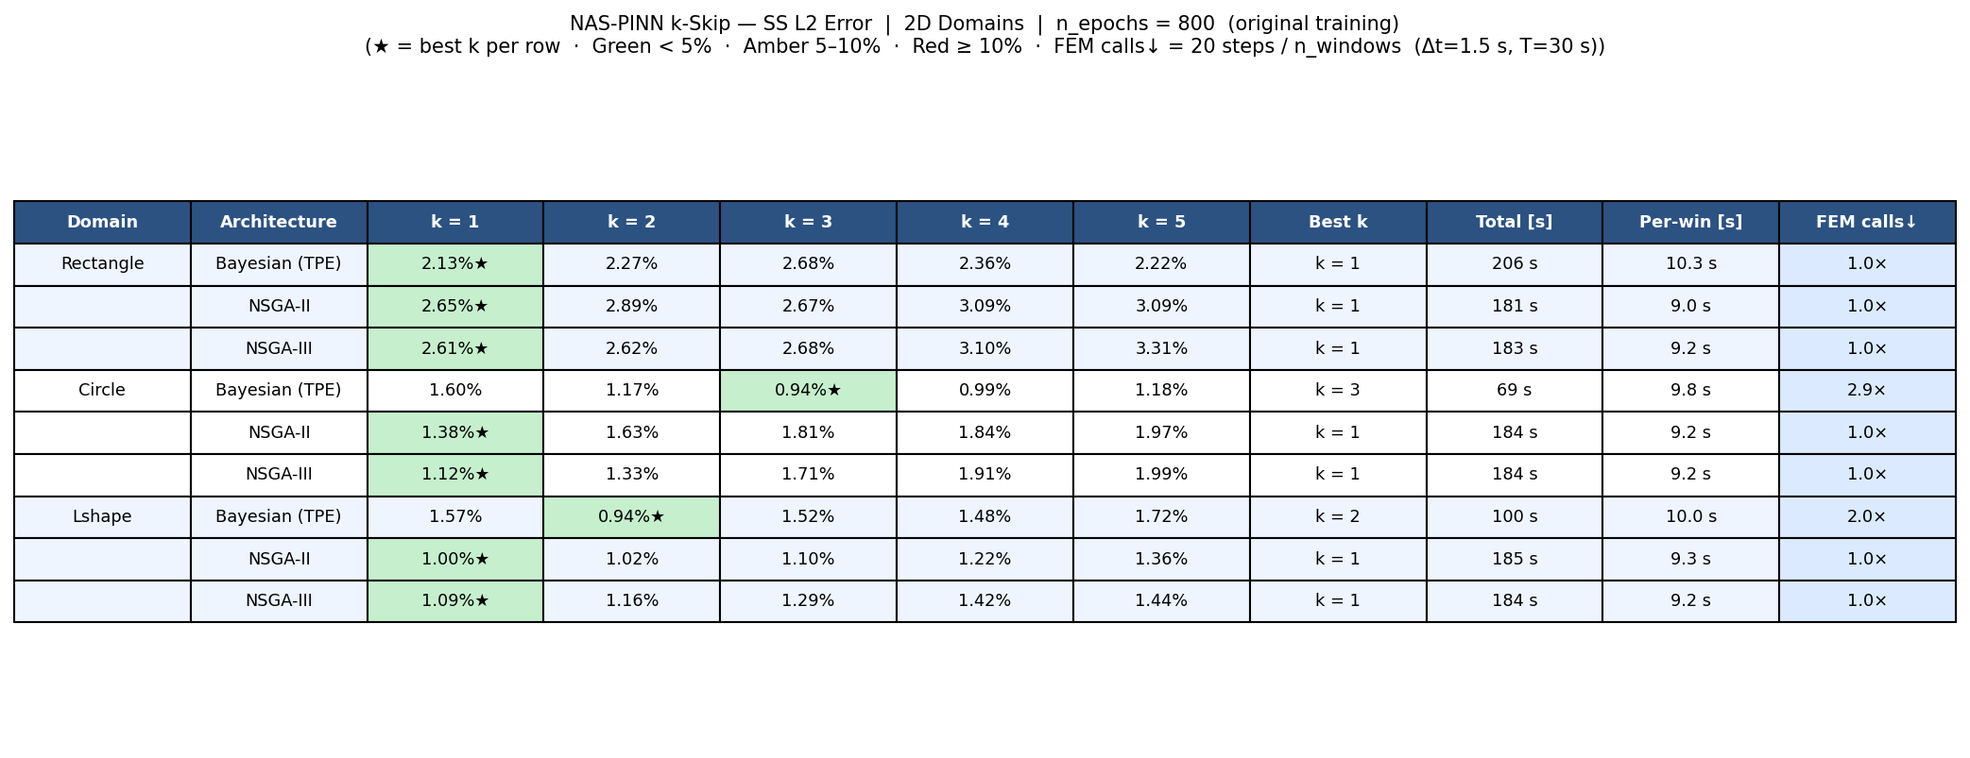
Figure 7: 2D domain summary table (L2 error per optimizer).

3D Domain Results
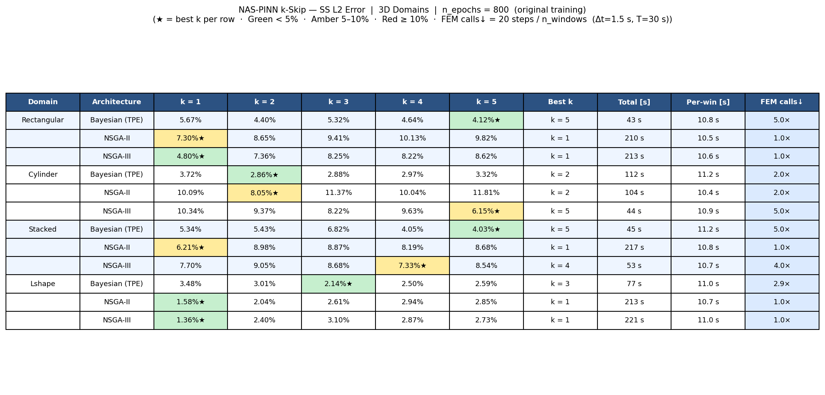
Figure 8: 3D domain summary table.

Key Findings
- Bayesian optimizer achieves most consistent performance across domains.
- k-skip factor varies by geometry: Rectangle (k=1), Circle (k=1-2), L-shape (k≥3).
- 3D problems require higher k values due to mesh complexity.
- Error typically increases <1% when doubling skip factor.
- Computational speedup scales with k but plateaus around k=5.

Conclusions
This work demonstrates that NAS combined with Physics-Informed Neural Networks can effectively solve thermal quenching PDEs while maintaining user control over accuracy-speed trade-offs via k-skip parameters.
Future directions include:
- Extending to higher-dimensional problems (>3D parameter spaces)
- Integrating meta-learning for cross-domain architecture transfer
- Combining with automatic differentiation for sensitivity analysis

Appendix: Technical Details

Repository Structure
thermal_pinn/
├── core.py — Core PINN model definitions
├── network/ — Neural network architectures
├── physics/ — Domain definitions & PDE constraints
├── training/ — Training and optimization routines
├── inference/ — Evaluation and post-processing
├── plots/ — Visualization scripts
├── results/ — Structured result outputs
└── reports/ — Generated reports & presentations

Software Stack
- PyTorch: Neural network framework
- Pymoo: Multi-objective optimization
- Matplotlib: Visualization
- NumPy/SciPy: Numerical computing

