NAS-MCO-PINNs: Neural Architecture Search with Multi-Loss Consistency
Optimization and Skip Operator for 3D Thermal Simulation
Project Progress Report — March 2026

1. Introduction
Physics-Informed Neural Networks (PINNs) offer a mesh-free approach to solving partial differential equations governing heat transfer. In a standard PINN, the network is trained on each FEM time window [t_k, t_{k+1}], so the number of PINN training runs equals the total number of FEM time steps, limiting computational savings.
This project presents NAS-MCO-PINNs with three contributions: (i) a residual skip operator predicting s time steps ahead in a single run; (ii) Neural Architecture Search (NAS) via Bayesian Optimization, NSGA-II, and NSGA-III; and (iii) Multi-Loss Consistency Optimization (MCO) for adaptive loss weighting.
Validated on A356 aluminum water quenching across four 3D geometries: Rectangular Prism (1.3×0.6×0.4 m), Cylinder (R=0.25 m, H=0.6 m), Stacked Cubes (2×0.5 m), and L-Shape (0.8×0.8×0.4 m, numerical FD reference). Total: 48 runs (4 domains × 3 NAS optimizers × 4 skip values).
2. The Residual Skip Operator
Instead of one PINN per FEM step, a single network f_θ predicts s steps ahead from the current initial condition. The predicted temperature field is:
θ̂(t + s·Δt) = θ_IC + τ · f_θ(x, y, z, τ, θ_IC)
where τ = t/(s·Δt) ∈ [0,1] is the normalized time coordinate. This guarantees the initial condition exactly at τ=0. Skipping s steps reduces FEM calls from N to ceil(N/s). Table 1 summarizes the savings assuming 21 total time steps.

Skip Value (s) | FEM Steps Saved | Reduction | PINN Runs (of 21)
s = 1 (baseline) | 0 steps | 0% | 21 runs
s = 2 | 10 steps | 52% | 11 runs
s = 4 | 15 steps | 71% | 6 runs
s = 6 | 17 steps | 81% | 4 runs
Table 1. FEM computation savings per skip value (21 total time steps).
3. Training Method and Physical Parameters
Each PINN window is trained with AdamW (2000 epochs). The MCO loss function:
ℒ = w_target · ℒ_target + 0.05 · w_PDE · ℒ_PDE , w_i = 1/σ_i²
Adaptive weights w_i are updated via running standard deviation of each loss component, eliminating manual tuning. NAS search space: depth 2-6 layers, width 32-256 neurons, activations {Tanh, GELU, SiLU}. Optimizers: Bayesian Optimization, NSGA-II, NSGA-III.
A356 aluminum: ρ=2670 kg/m³, c_p=963 J/(kg·K), k=151 W/(m·K). Boundary: convective quenching h=2000 W/(m²·K), T_∞=20 °C, T_0=540 °C. Governing PDE: ρ·c_p·∂T/∂t = ∇·(k·∇T).

4. Results: Skip Operator Accuracy
Table 2 presents MAE (deg C) for all 48 configurations. Color coding: dark green = best per row, light green < 8 C, yellow = 8-15 C, red > 15 C.
Domain | Optimizer | skip=1 (0%) | skip=2 (52%) | skip=4 (71%) | skip=6 (81%)
Rectangular | Bayesian | 5.53 | 10.31 | 21.39 | 15.65
Rectangular | NSGA-II | 5.41 | 10.39 | 20.99 | 25.86
Rectangular | NSGA-III | 5.41 | 10.50 | 21.00 | 25.90
Cylinder | Bayesian | 5.33 | 10.69 | 11.54 | 10.23
Cylinder | NSGA-II | 4.23 | 8.69 | 18.93 | 25.38
Cylinder | NSGA-III | 4.20 | 9.14 | 16.24 | 22.54
Stacked | Bayesian | 4.95 | 9.80 | 21.64 | 17.18
Stacked | NSGA-II | 5.32 | 10.20 | 19.60 | 25.69
Stacked | NSGA-III | 5.12 | 10.27 | 19.77 | 25.51
L-Shape | Bayesian | 5.60 | 6.19 | 5.61 | 5.60
L-Shape | NSGA-II | 2.19 | 5.74 | 15.45 | 22.53
L-Shape | NSGA-III | 2.19 | 5.72 | 15.51 | 22.73
Table 2. MAE (deg C) for all 48 training runs. FEM savings in column headers. Green = good accuracy; red = MAE > 15 deg C.
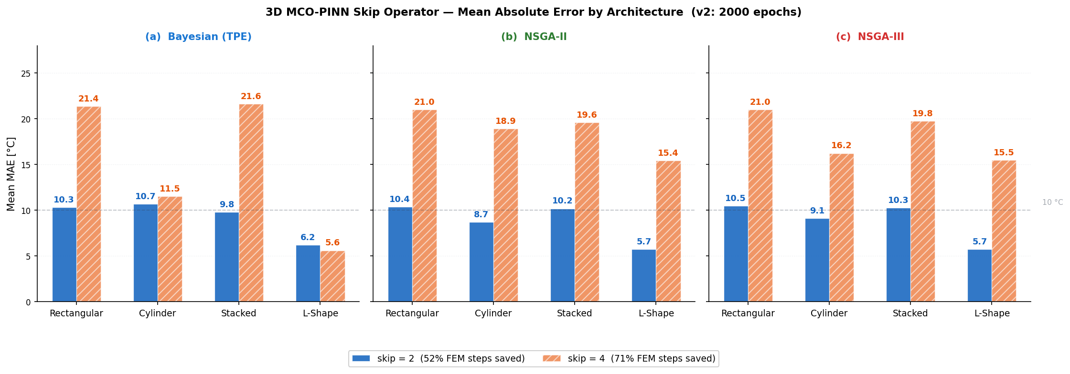
Figure 1. Best MAE per domain and skip value (minimum over three NAS optimizers). Each bar group = one skip value. Dashed line at 10 deg C marks a practical accuracy threshold.

5. Visualization
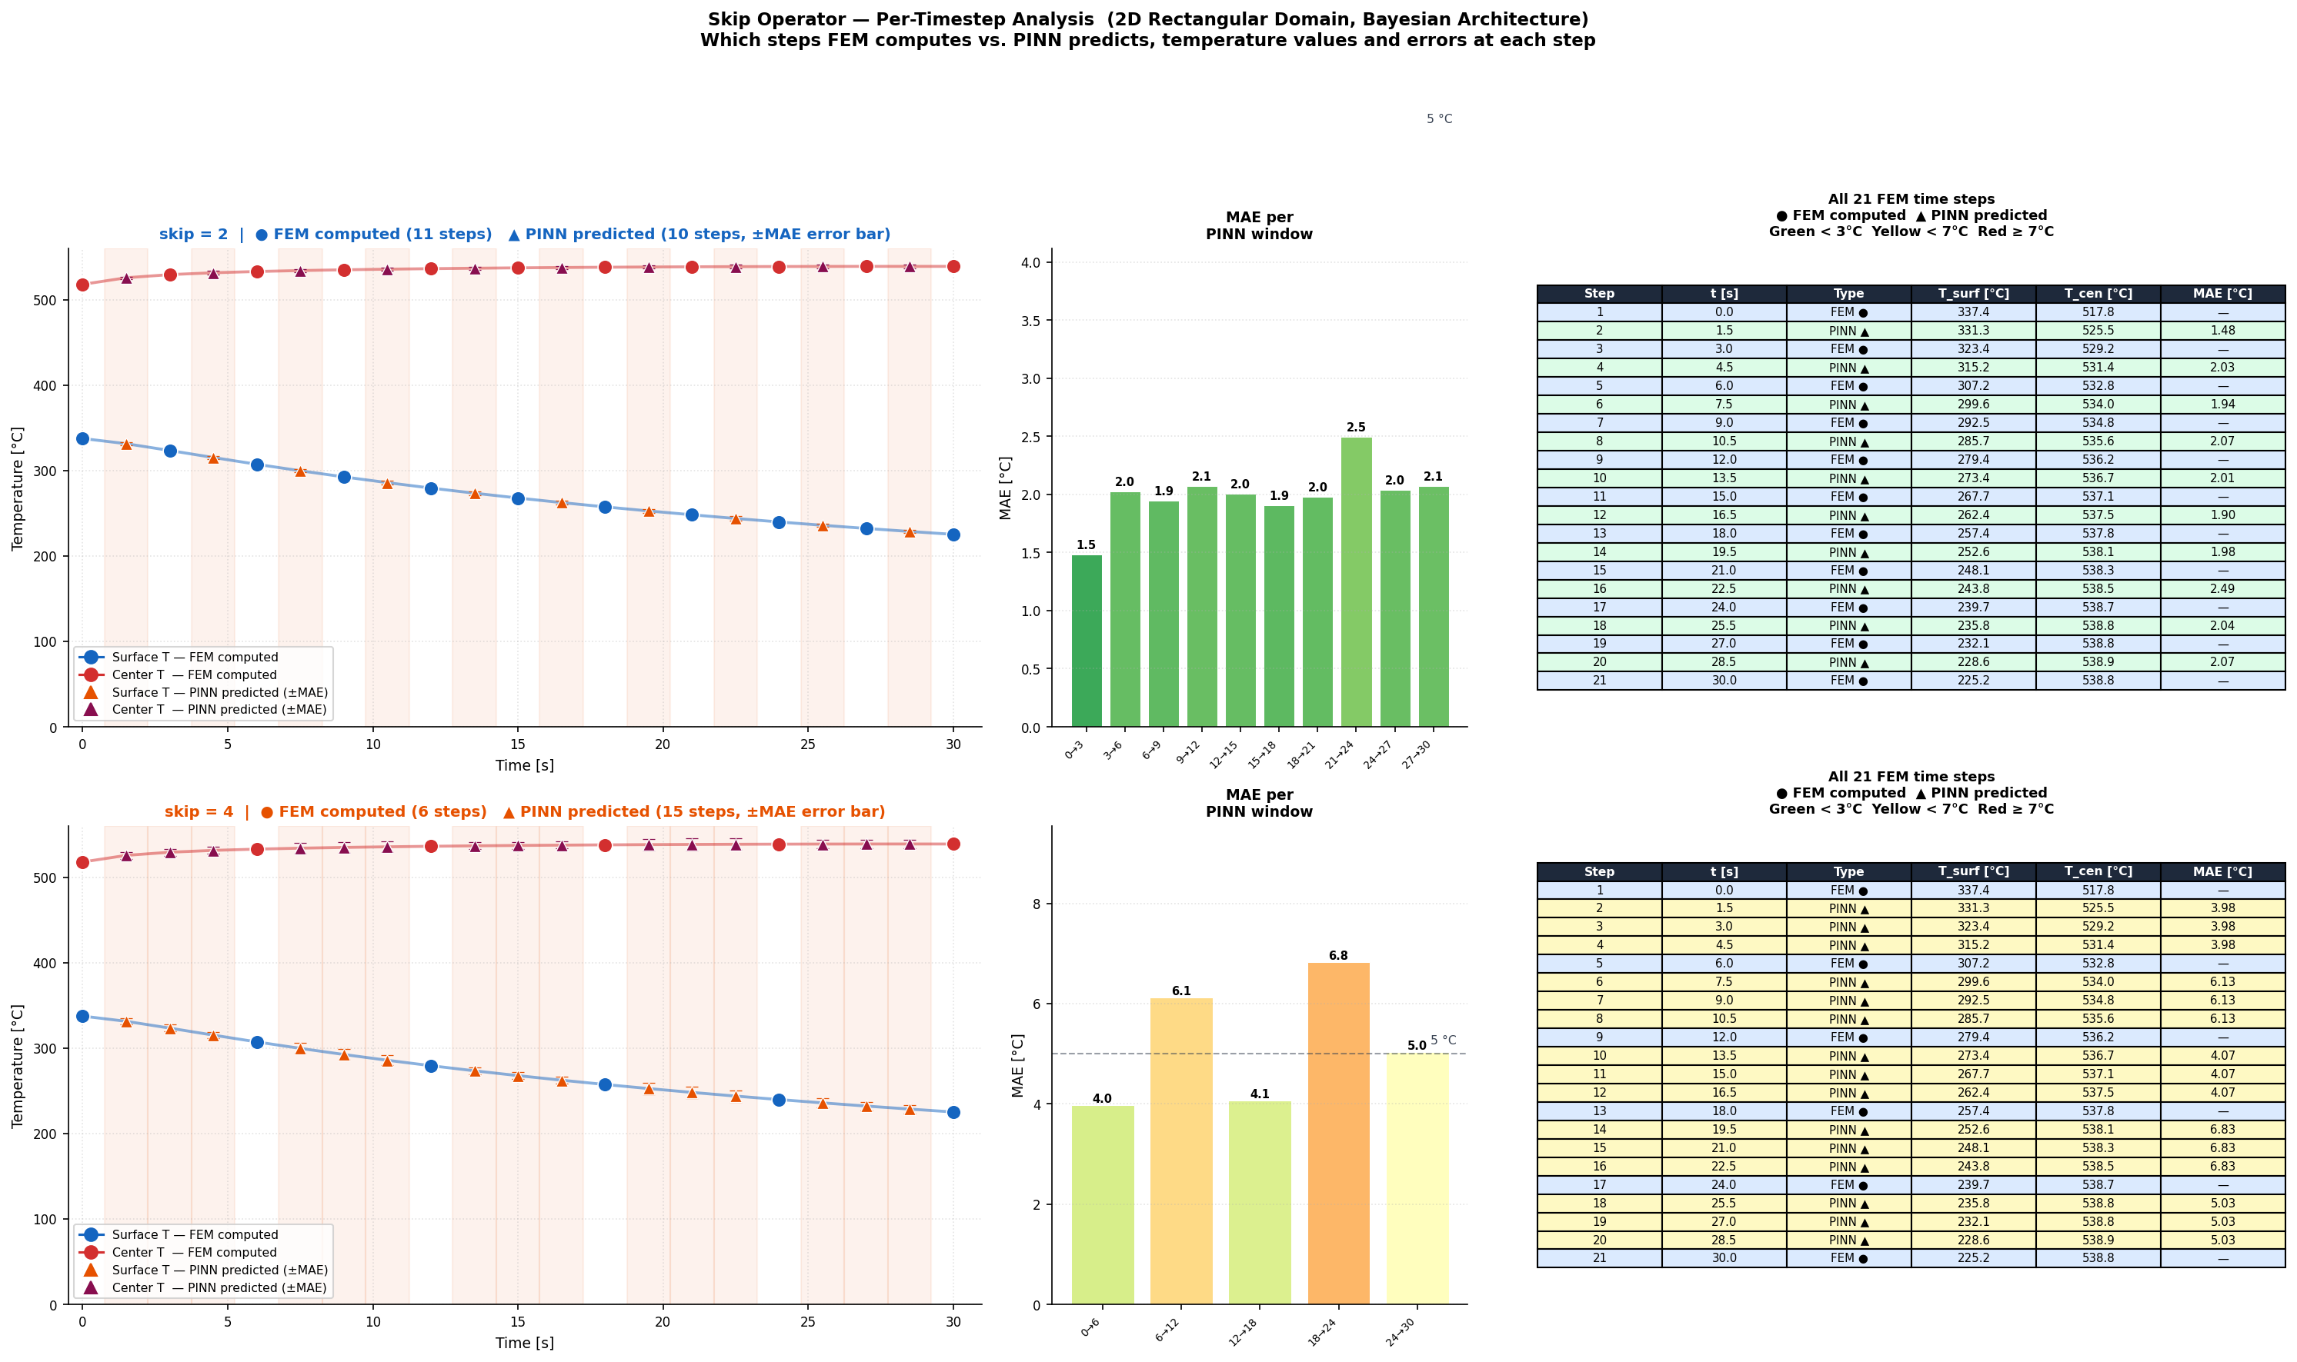
Figure 2. Skip Operator Timeline: MAE per time window (Rectangular domain, Bayesian NAS). Each line = one skip value. At skip=1 error is low and uniform. At skip=2/4 it grows moderately. At skip=6 it rises sharply in later windows.

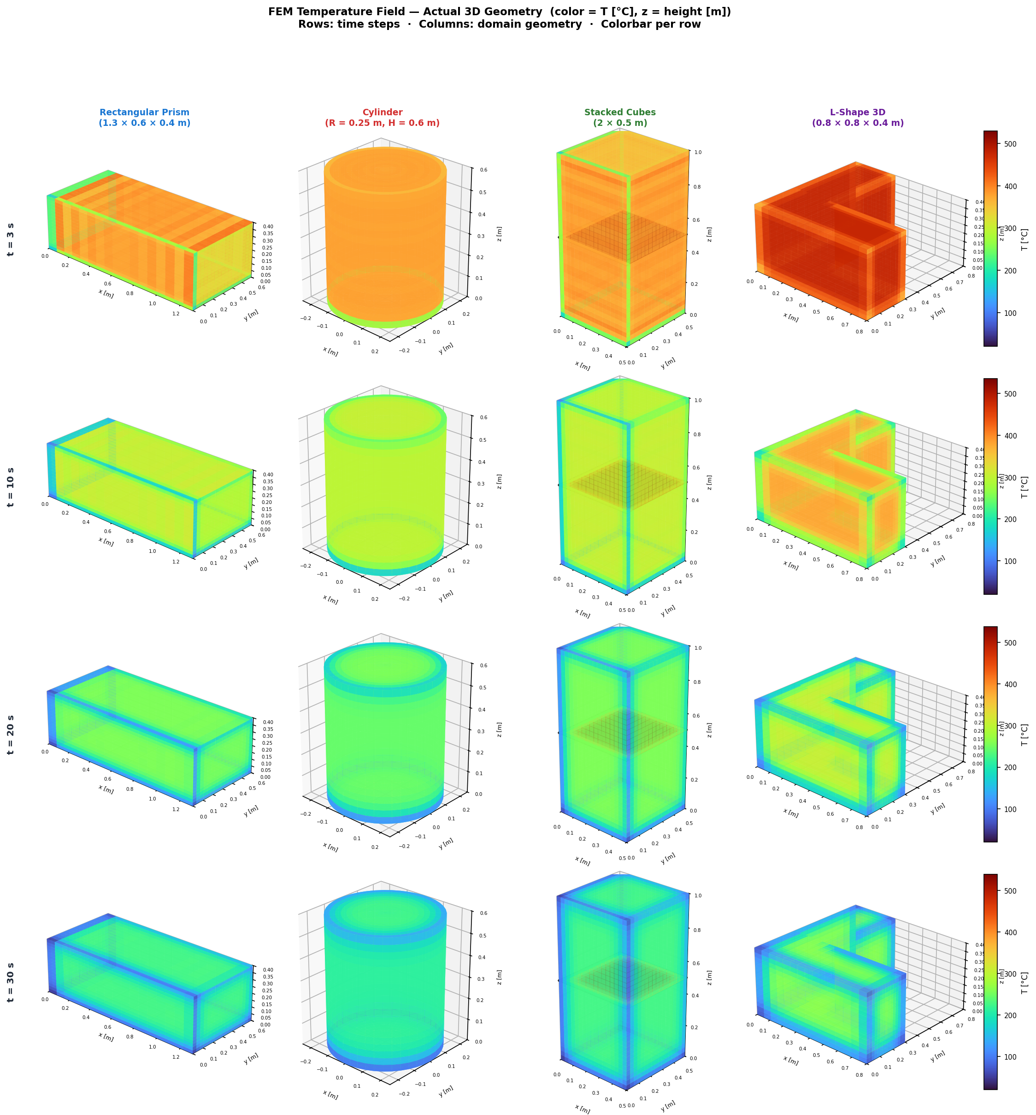
Figure 3. Predicted temperature fields on the z-midplane (Turbo colormap: blue=20 C, yellow=540 C). All four 3D domains, skip=2, Bayesian NAS, mid-simulation step. Rectangular/Cylinder: smooth surface cooling. Stacked: interface effect. L-Shape: concave-corner cooling (validated vs. numerical FD).
6. Conclusions
Best accuracy (skip=1): 2.19 deg C MAE on L-Shape with NSGA-II/III. All domains achieve < 5.6 deg C.
Practical optimum (skip=2): 52% FEM savings while keeping MAE < 11 deg C for all domains (recommended default).
Fast screening (skip=6): 81% FEM reduction; MAE 5.6-22.5 deg C, suitable for rapid feasibility checks.
NAS comparison: Bayesian best on simple geometries; NSGA-II/III superior on the complex L-Shape domain.
MCO weighting: Adaptive w_i = 1/sigma_i^2 eliminates manual loss tuning across all geometries.

