NAS-Guided FEM-Anchored PINNs
for Transient Heat Transfer Simulation
Step Optimization in Thermal Simulation Using Selective Finite Element Method Step Skipping

Author: | Ömer Çetinkaya
Supervisor: | Prof. Turgay Celik
Institution: | University of Agder (UiA), Norway
Year: | 2026

Abstract
In this thesis, we developed a Finite Element Method (FEM)-anchored Physics-Informed Neural Network (PINN) framework for transient water-quenching simulation of A356 aluminium. We based the study on the industrial quenching scenario of Mortensen et al. (2026). Our central question was: how many FEM solver calls can be replaced by PINN predictions while keeping the temperature error within engineering limits?
We adopted Multi-Step Window Prediction (MSWP) as the core strategy. The FEM solver provides anchor temperature fields at selected time steps. The PINN predicts the field between consecutive anchors. The skip factor k controls the anchor spacing. We compared three Neural Architecture Search (NAS)-selected architectures: Bayesian/TPE (5×151, ReLU), NSGA-II (3×153, tanh), and NSGA-III (3×75, tanh). We conducted experiments across ten unique benchmark geometries in two studies. The canonical study covers eight domains: three 2D, four 3D, and the Thermal Fin, originally a 2D steady-state RBniCS benchmark that we extended to a 3D transient quenching scenario. A complementary adaptive-k study added Square and Flower as two new 2D geometries.
On the adaptive-k study, we found 83–85% FEM saving with mean absolute error (MAE) below 2.5°C across all architectures. On the canonical 2D domains with fixed k, Bayesian/TPE stayed below 5°C through k=3 on all three domains. On the 3D domains, Bayesian/TPE remained acceptable at k=5 with MAE below 14°C. On the Thermal Fin, Bayesian/TPE with Fourier embedding reached k=5 at 12.55°C (ten-seed mean). NSGA-II and NSGA-III held through k=4. We demonstrated that FEM-anchored PINNs can reproduce transient quenching fields with 65–85% fewer solver calls within practical engineering accuracy.
Keywords: Physics-Informed Neural Networks, Neural Architecture Search, Finite Element Method, Transient Heat Transfer, Water Quenching, Multi-Step Window Prediction, Adaptive Skip-Factor Scheduling, FEM-Anchored Surrogate Modelling, Fourier Feature Embeddings, Thermal Fin Benchmark, A356 Aluminium.

Visual Abstract
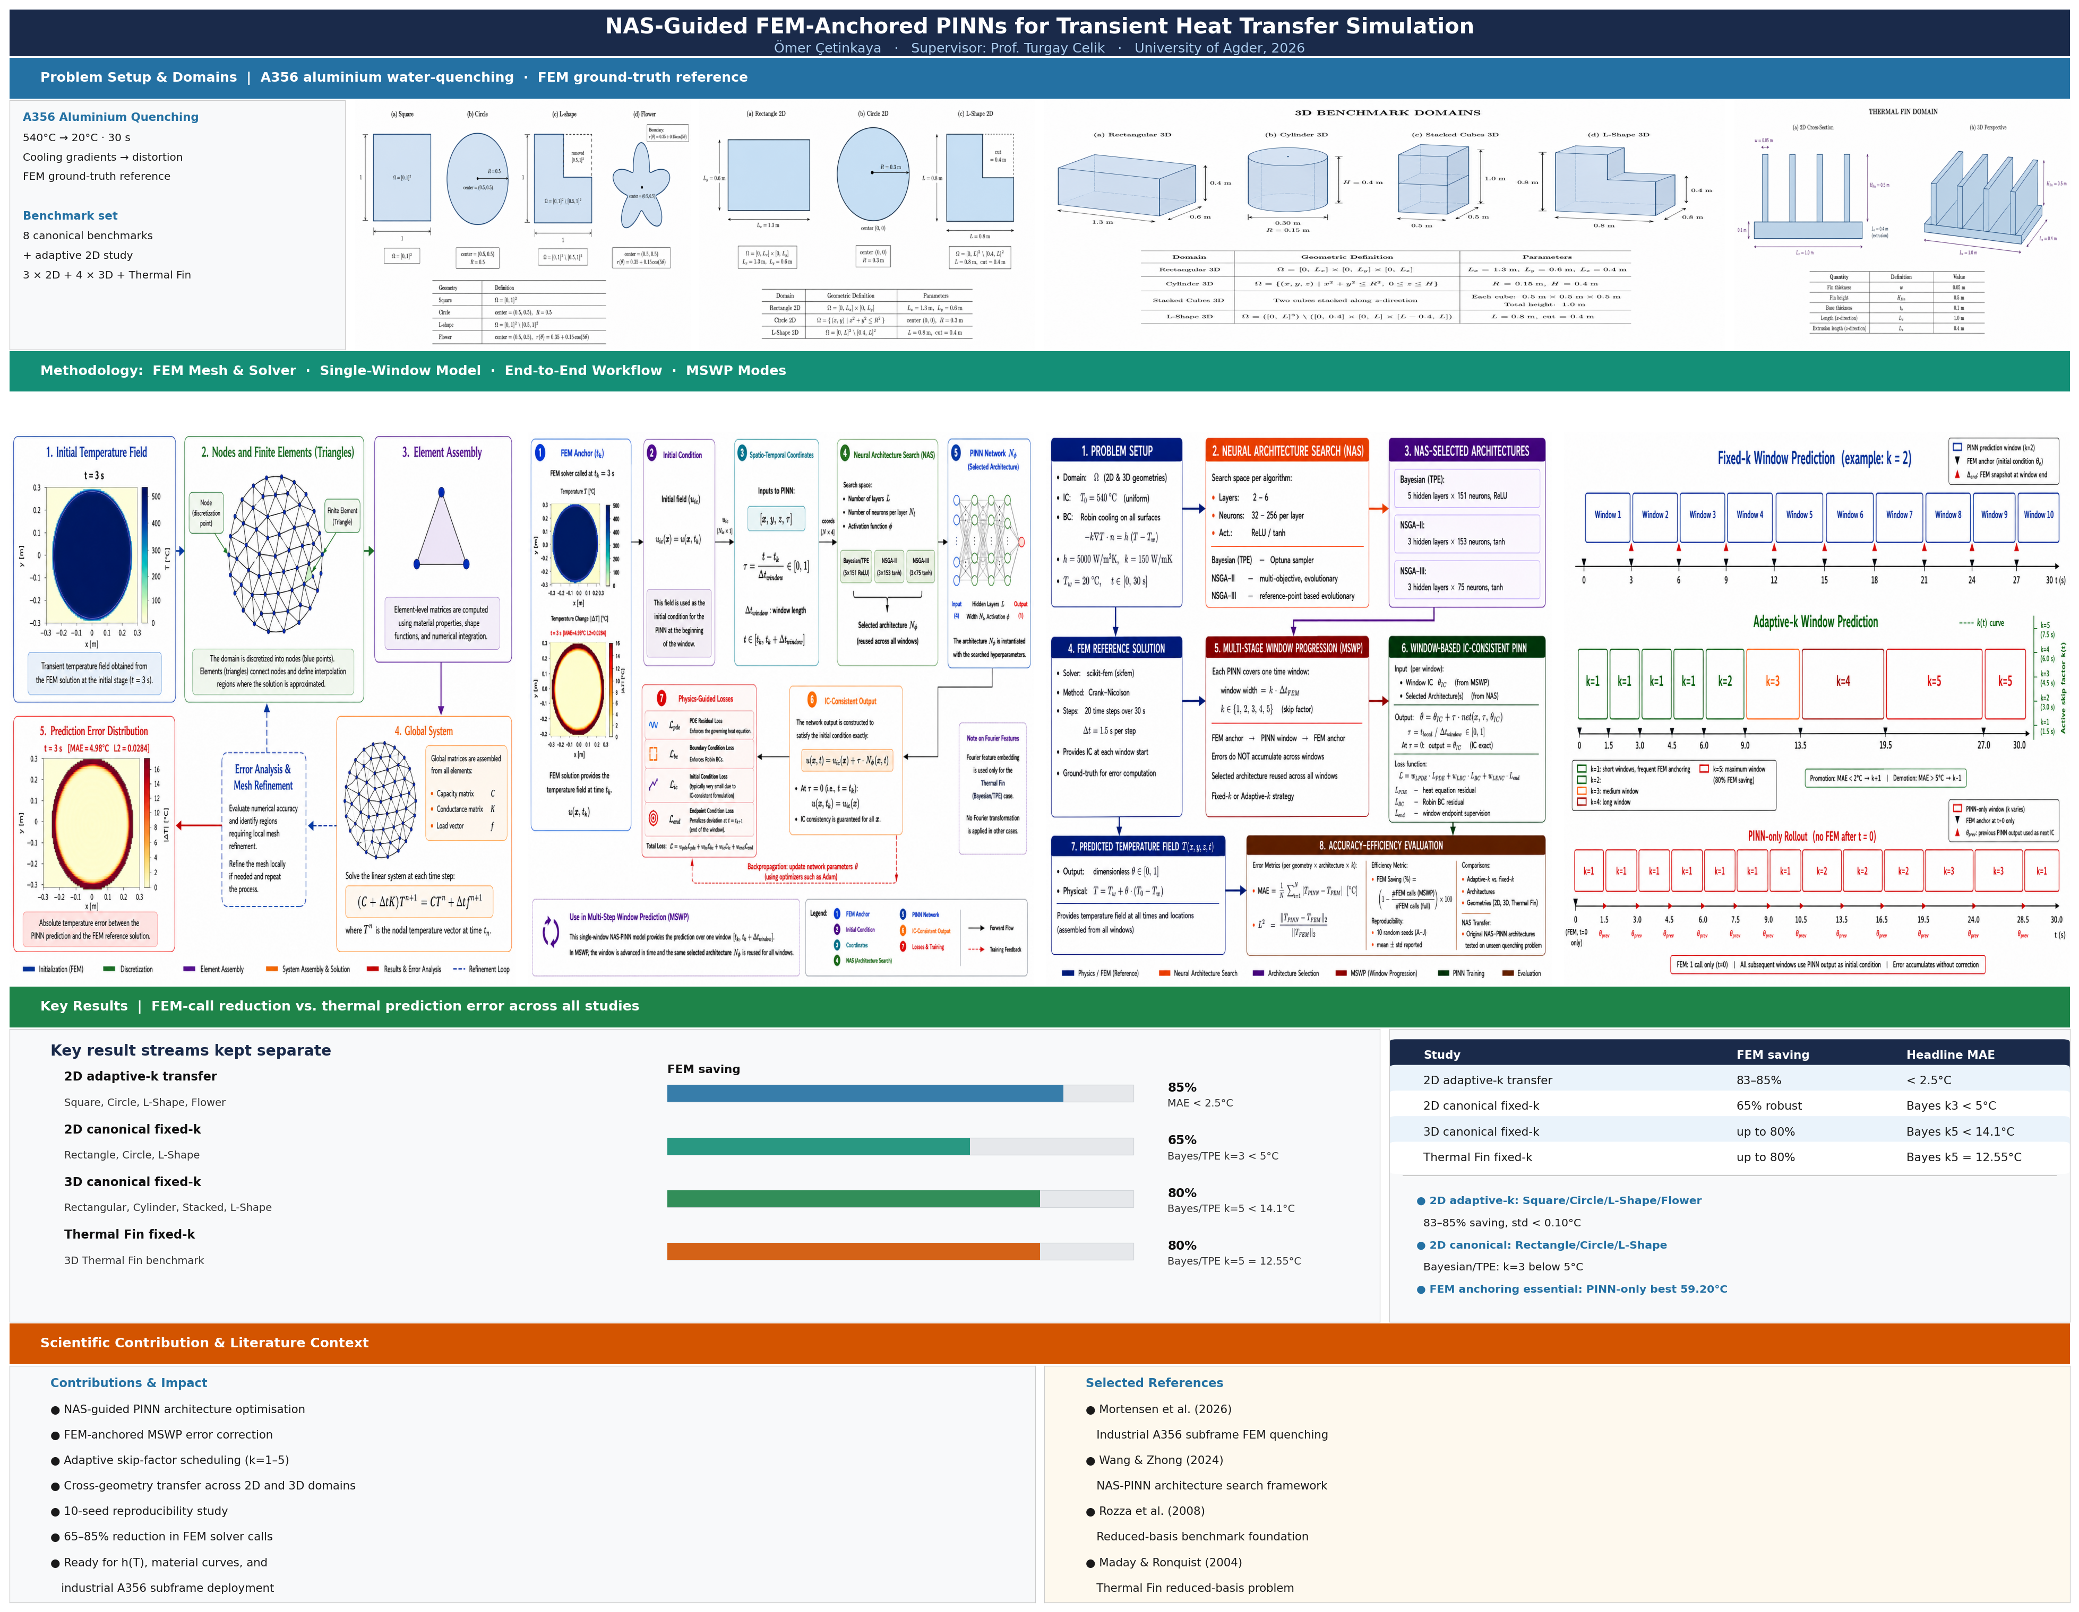
Visual summary: top row — A356 quenching problem and benchmark geometries; middle row — FEM reference solver, NAS-PINN framework, and MSWP strategy; bottom rows — accuracy–efficiency results, contributions, and application impact.

