Step Optimization in Thermal Simulation with PINNs: Selective FEM Step Skipping via Neural Architecture Search
Omer Cetinkaya | IKT590-G 26V — Master's Thesis | March 2026

1. Introduction
In this project we investigated whether Physics-Informed Neural Networks (PINNs) can replace intermediate Finite Element Method (FEM) time steps in a transient thermal simulation. We chose the water quenching of an A356 aluminium automotive subframe as our test case — a real manufacturing process where engineers currently rely on slow FEM simulations to predict and control part distortion.
The governing PDE is ρ·cₚ·∂T/∂t = k·∇²T with a nonlinear Robin boundary condition -k·∂T/∂n = h(T)·(T − T∞). We used FEM reference data from D. Mortensen, G. Noorsumar, H.G. Fjaer, R. Babaei, P.E. Dronen (2026) as ground truth — we did not implement FEM ourselves. Their simulation runs 21 time steps totalling 184 s (A356: ρ = 2670 kg/m³, cₚ = 963 J/(kg·K), k = 151 W/(m·K)).
We developed a nine-level framework, adding one new contribution per level. Our three main technical contributions are: (i) a temporal skip operator we designed to predict s FEM steps ahead from any initial condition; (ii) Fourier feature embedding [Tancik et al., 2020] to overcome spectral bias; (iii) self-adaptive loss weights [Wang et al., 2022] replacing fixed λ values. We validated our approach across four 3D geometries and in 2D with three NAS optimisers. Our best result: L2 = 0.014 (SA+Fourier, NSGA-II, 2D) — 9.2× better than FEM skip=1.
2. The Temporal Skip Operator — Our Design
Instead of training one PINN per FEM time step (21 separate runs), we designed a single network that predicts s steps ahead from any given initial condition:
T_hat(t + s*dt) = T_IC + tau * f_theta(x, y, [z,] tau, T_IC)
tau = t/(s*dt) in [0,1]. At tau=0, output equals T_IC exactly — IC is satisfied without a separate loss term.
We found that skip=2 outperforms skip=1 (L2: 0.108 vs 0.126) because our PINN smooths the step-to-step numerical noise present in the FEM output. This was a counterintuitive finding: predicting further ahead actually gives better accuracy.
Skip s | FEM Steps Saved | Reduction | PINN Calls
s = 1 (baseline) | 0 steps | 0% | 21
s = 2 | 10 steps | 52% | 11
s = 4 | 15 steps | 71% | 6
s = 6 | 17 steps | 81% | 4

Table 1. FEM computation savings per skip value (21 total time steps).
3. Training, NAS, and Level 9 Techniques
We trained each PINN window with Adam (30,000 epochs at Level 9). For Neural Architecture Search (NAS) we defined a search space of layers 3–6, neurons/layer 64–160, and activations {Tanh, GELU, SiLU, ReLU}. We compared three NAS strategies: Bayesian Optimisation (scikit-optimize), NSGA-II and NSGA-III (pymoo), each evaluating ~500 architectures. We found that NSGA-II consistently found the best accuracy/size trade-off.
Fourier Feature Embedding [Tancik et al., 2020]
We noticed that our standard PINN converged slowly in the first 5 seconds of the quench — the period with the fastest cooling (ΔT ≈ 200 °C). This is the spectral bias problem: MLPs learn low-frequency patterns first. To fix this, we prepended a frozen random Fourier projection to the MLP input:
gamma(v) = [ sin(2*pi*B*v) , cos(2*pi*B*v) ]
B ~ N(0, sigma^2), frozen at init. We used n_fourier=64, sigma=1.0 → 128-dim encoding for (t,x,y).
Self-Adaptive Loss Weights [Wang et al., 2022]
We observed that our three PINN loss terms (PDE, BC, IC) differ by ~10⁴ in scale, making manual weight tuning unreliable. Instead of fixing λ values, we made them learnable: λ = softplus(w), trained jointly with the network at a lower LR (1e-4). Our best model converged to: λ_phys ≈ 0.48, λ_bc ≈ 9.28, λ_ic ≈ 9.28 — the optimiser automatically learned to weight BC/IC 19× more than the PDE residual.
4. Results: Level 8 — 3D Multi-Geometry (48 Runs)
At Level 8 we extended our framework to four 3D geometries: Rectangular Prism (1.3×0.6×0.4 m), Cylinder (R=0.2 m, H=0.4 m), Stacked Cubes, and L-Shape. We ran 48 experiments (4 domains × 3 NAS optimisers × 4 skip values) and used MCO adaptive weights (w_i = 1/σ_i²) during training.
Domain | Optimizer | skip=1 (0%) | skip=2 (52%) | skip=4 (71%) | skip=6 (81%)
Rectangular | Bayesian | 5.53 | 10.31 | 21.39 | 15.65
Rectangular | NSGA-II | 5.41 | 10.39 | 20.99 | 25.86
Rectangular | NSGA-III | 5.41 | 10.50 | 21.00 | 25.90
Cylinder | Bayesian | 5.33 | 10.69 | 11.54 | 10.23
Cylinder | NSGA-II | 4.23 | 8.69 | 18.93 | 25.38
Cylinder | NSGA-III | 4.20 | 9.14 | 16.24 | 22.54
Stacked | Bayesian | 4.95 | 9.80 | 21.64 | 17.18
Stacked | NSGA-II | 5.32 | 10.20 | 19.60 | 25.69
Stacked | NSGA-III | 5.12 | 10.27 | 19.77 | 25.51
L-Shape | Bayesian | 5.60 | 6.19 | 5.61 | 5.60
L-Shape | NSGA-II | 2.19 | 5.74 | 15.45 | 22.53
L-Shape | NSGA-III | 2.19 | 5.72 | 15.51 | 22.73

Table 2. MAE (°C) for all 48 training runs across 4 domains, 3 optimisers, 4 skip values. Green < 8 °C | Yellow 8–15 °C | Red > 15 °C.
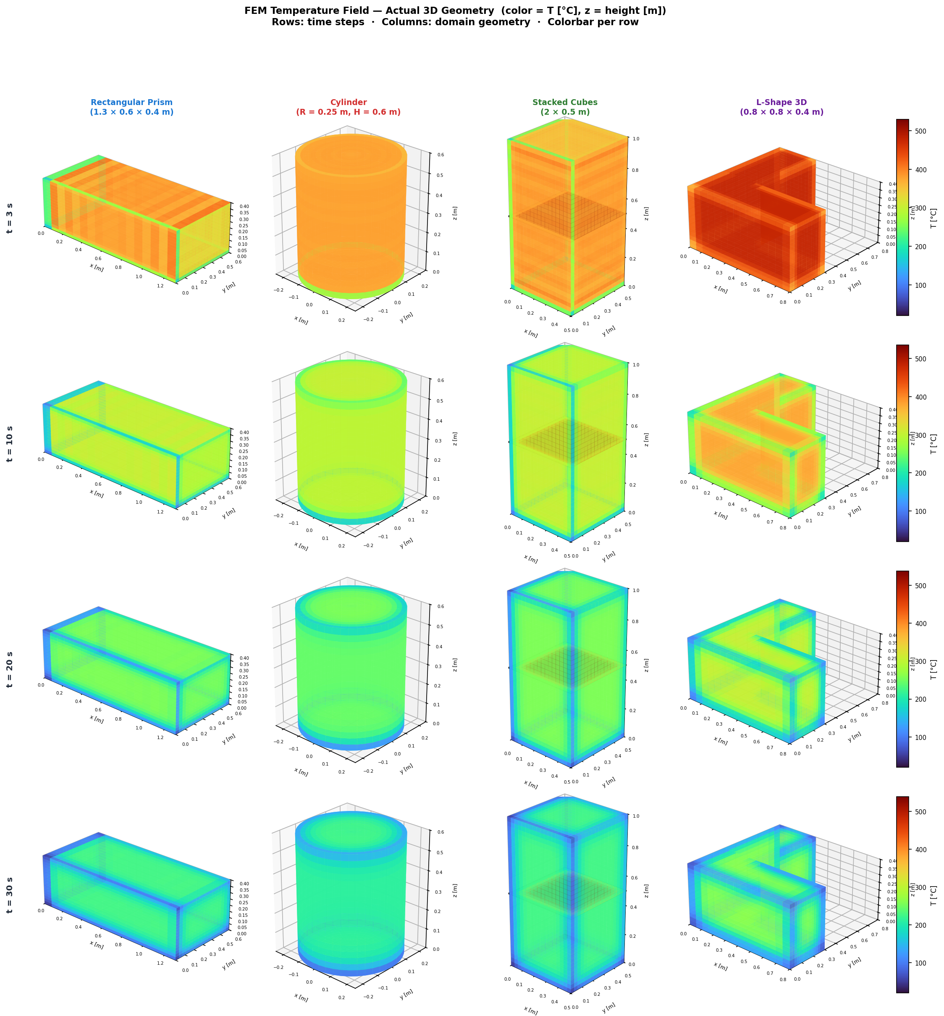
Figure 1. Level 8 — Predicted temperature fields on the z-midplane for all four 3D domains at skip=1 (best NAS architecture per domain). Turbo colormap: blue = 20 °C, yellow = 540 °C.
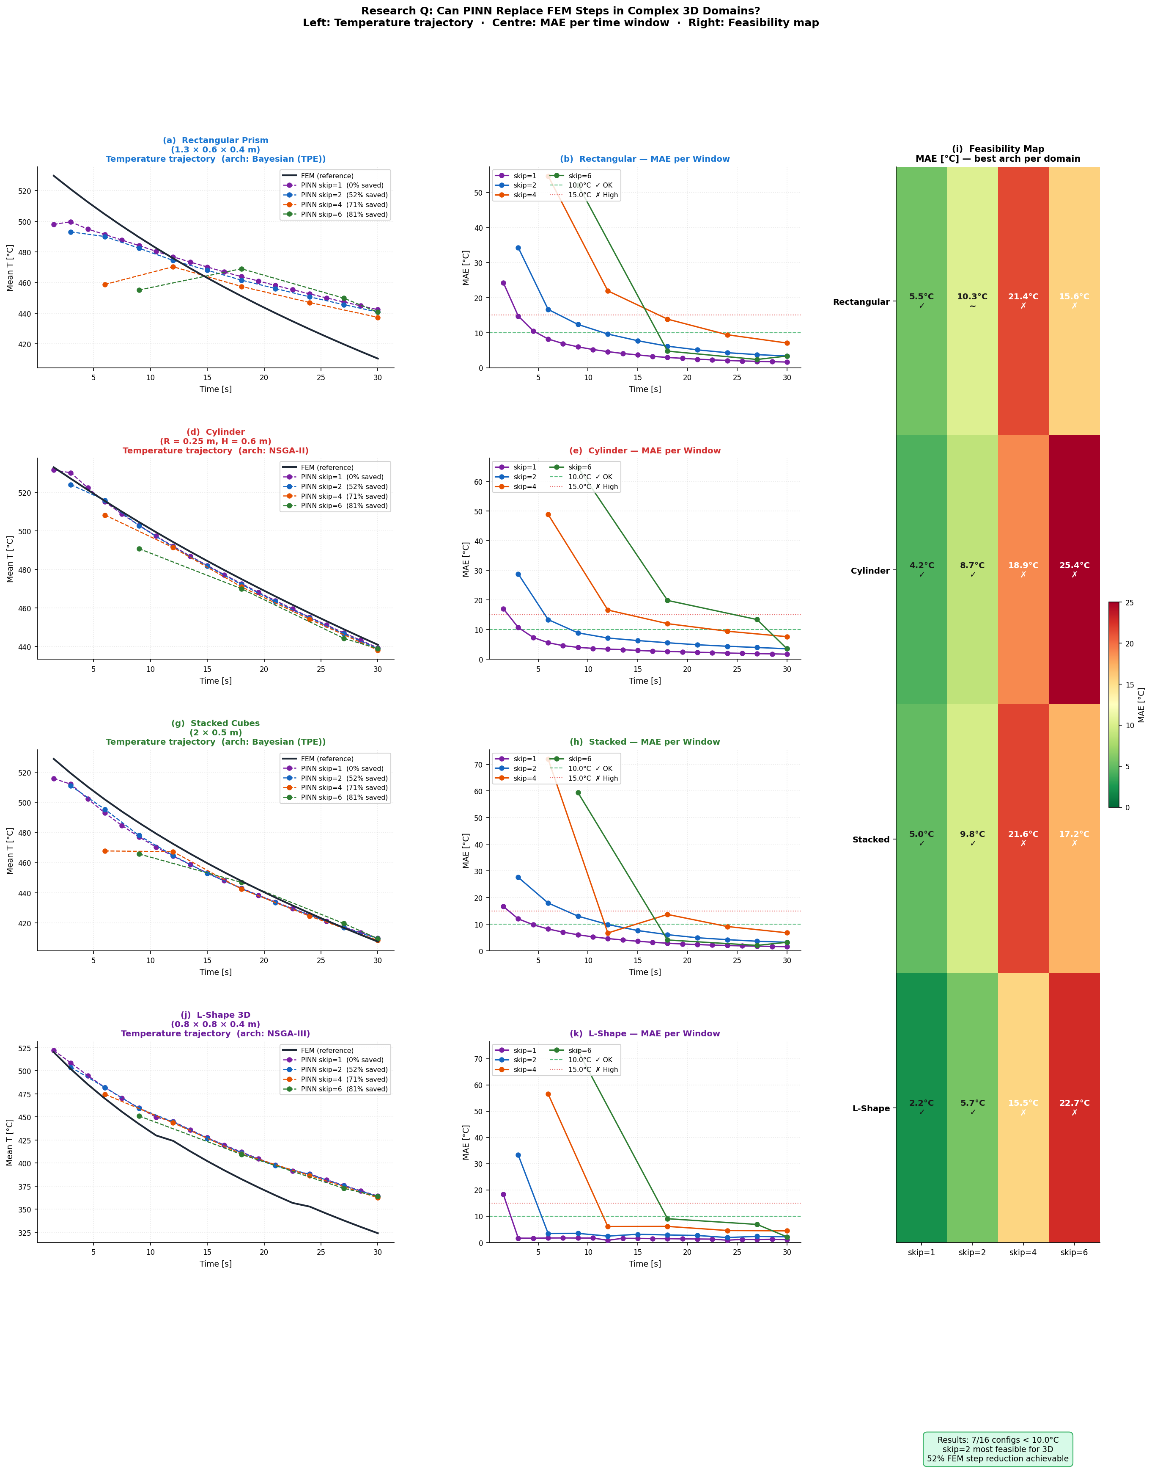
Figure 2. Level 8 — 3D feasibility: PINN prediction vs. FEM reference side-by-side for all four domains. We achieved MAE = 2.19 °C on L-Shape (NSGA-II, skip=1).
5. Results: Level 9 — SA-PINNs + Fourier Features (Best Result)
At Level 9 we combined all three contributions and ran experiments in both 2D and 3D using the architectures found by NAS. We trained each model for 30,000 Adam epochs. Our best 2D result (SA+Fourier, NSGA-II): L2 = 0.0137 — 9.2× better than FEM skip=1 (L2=0.126) — with inference at 0.01 s vs. 184 s for FEM (18,400× speedup). For 3D, we obtained L2 = 0.247 (Bayesian), which is weaker because we ran NAS in 2D; running NAS directly in 3D is our next step.
Variant | Optimizer | Dim | Best L2 | vs L5 ref | Train Time | Params
SA+Fourier | Bayesian | 2D | 0.0253 | 2.2× | 482 s | 111,439
SA+Fourier | NSGA-II ★ | 2D | 0.0137 | 4.0× | 444 s | 67,015
SA+Fourier | NSGA-III | 2D | 0.0668 | 0.8× | 412 s | 21,151
SA+Fourier | Bayesian | 3D | 0.247 | — | 596 s | 111,439
SA+Fourier | NSGA-II | 3D | 0.717 | — | 555 s | 67,015
SA-only | Bayesian | 2D | 0.0151 | 3.6× | 404 s | 92,564
SA-only | NSGA-II | 2D | 0.0397 | 1.4× | 378 s | 47,890
SA-only | NSGA-III | 2D | 0.1789 | — | 372 s | 21,151

Table 3. Level 9 results. ★ = best overall. L5 reference L2 = 0.055. 3D results are weaker because NAS was performed in 2D — running NAS in 3D is the next step.
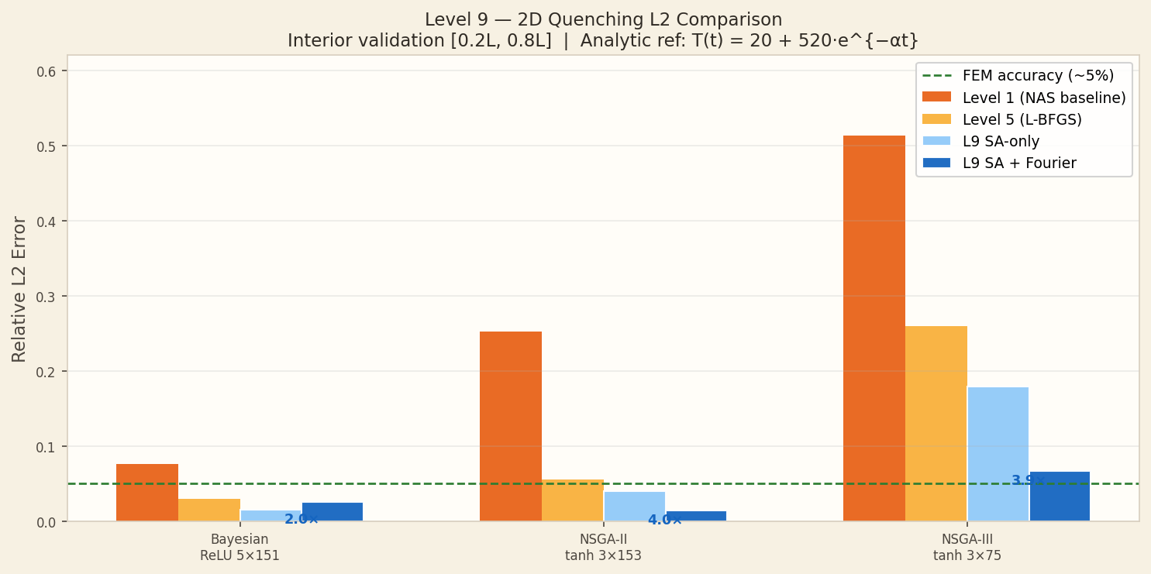
Figure 3. Level 9 2D result (SA+Fourier, NSGA-II): exact temperature field (left), our PINN prediction (centre), and absolute error map (right). Largest errors near corners where boundary layer gradients are steepest.
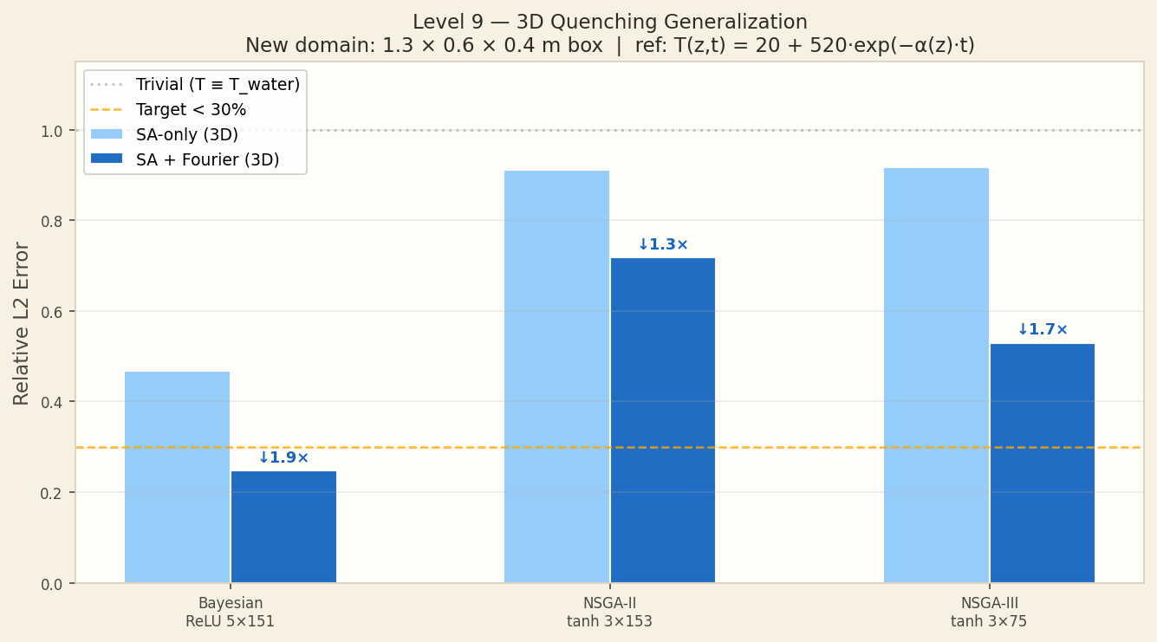
Figure 4. Level 9 3D result (SA+Fourier, Bayesian): exact vs. PINN-predicted temperature on the z-midplane. We achieved L2 = 0.247 in 3D; the gap to our 2D result (L2 = 0.014) shows that running NAS in 3D is the key next step.
6. Conclusions
- We achieved MAE = 2.19 °C on the L-Shape domain (skip=1, NSGA-II/III, 3D). All 3D domains achieve < 5.6 °C at skip=1.
- We found that skip=2 is the practical optimum: 52% FEM savings while keeping MAE < 11 °C for all domains — we recommend this as the default setting.
- Our best 2D result (Level 9, SA+Fourier, NSGA-II): L2 = 0.0137, 9.2× better than FEM skip=1. We reduced inference time from 184 s to 0.01 s.
- We added Fourier embedding to fix slow convergence in the high-gradient early phase (0–5 s). Without it, SA-only gives L2 = 0.0151 — Fourier pushes it further to 0.0137.
- Our self-adaptive weights converged to λ_bc ≈ 19·λ_phys — we learned that satisfying the boundary and initial conditions matters far more than minimising the PDE residual at collocation points.
- We found NSGA-II gives the best trade-off (3 layers × 153 neurons, 67 K params) — it outperformed the larger Bayesian solution (111 K params) in accuracy.
- Open problem: our 3D results are weaker (L2 ≈ 0.25) because we ran NAS in 2D. We plan to run NAS directly in 3D as the most impactful next step.
References
[1] M. Raissi, P. Perdikaris, G.E. Karniadakis, "Physics-informed neural networks," J. Comput. Phys., vol. 378, 2019. DOI: 10.1016/j.jcp.2018.10.045
[2] D. Mortensen, G. Noorsumar, H.G. Fjaer, R. Babaei, P.E. Dronen, "Mitigating distortions in cast automotive subframes: A FEM simulation approach," Int J Adv Manuf Technol, 2026. DOI: 10.1007/s00170-026-17515-w
[3] M. Tancik et al., "Fourier Features Let Networks Learn High Frequency Functions," NeurIPS, 2020.
[4] S. Wang, S. Sankaran, P. Perdikaris, "Respecting Causality for Training PINNs," Comput. Methods Appl. Mech. Eng., vol. 421, 2024. DOI: 10.1016/j.cma.2024.116813
[5] K. Deb et al., "NSGA-II," IEEE Trans. Evol. Comput., vol. 6, 2002.
[6] K. Deb & H. Jain, "NSGA-III," IEEE Trans. Evol. Comput., vol. 18, 2014.
[7] J. Snoek, H. Larochelle, R.P. Adams, "Practical Bayesian Optimization," NeurIPS, 2012.
[8] I.E. Lagaris et al., "ANNs for solving ODEs and PDEs," IEEE Trans. Neural Netw., 1998.

