***PROJECT ALPHA***

**Muhammad Qamar (U2165403)**

**Abdulkhaliq Ajibola Olatunji (U2174273)**

**Shingirai Rice (U2168901)**

**Umer Munir (U2257319)**

**Muhammad Khan (U2083268)**

**Waleed Hassan (U2180706)**

***Table of Contents***

**Introduction** 2

**The Team** 2

**Research (Requirement analysis)** 3

**Design and Modelling** 4

**Development & Implementations** 6

**Project Planning & Management** 6

**PLESI Issues** How did you handle the professional, legal, ethical, and social issues that may concern your project? 8

**Evaluation** 9

**References | Bibliography | Appendices** 9

# **Introduction**

We as a group decided to make a student accommodation website to help international students book a room they wish to stay during their studies. This idea is inspired by booking.com where people can easily find hotel rooms from different parts of the world. As students ourselves we found that it is quite difficult to find detailed information about accommodations in different places. With our website students are open to different options and packages to renting the rooms. Our website will also make it easy to compare prices across different areas within your local city. The goal of our website is to provide students with user-friendly platform to find comfortable and affordable accommodation as well as offer features that fit their lifestyle.

# **The Team**

***Muhammad Qamar - Team Leader***

* Created and set tasks for each member of the teams.
* Communicate with the team to ensure that they are up to date with the project.
* Tracking all the progress

***Shingirai Rice – Designer***

* Helped with designing the diagrams.
* Managed the report.

***Abdulkhaliq Ajibola Olatunji – Researcher***

* Research on competitors
* Found reviews and saw what could be improved.

***Umer Munir – Coder***

* Lead the development team in designing project.
* Gave out tasks and assisted well.

***Muhammad Khan  -Coder/Designer***

* Helped design the website.
* Designed sketches.

***Waleed Hassan – Researcher***

* Did research for the website to see what could be added.
* Found universities with positive reviews.

# **Research (Requirement analysis)**

Developing a student accommodation website requires identification of the key requirements and preferences of the international community. completely it is essential for the website to cater to the needs of students and provide a seamless user experience throughout the accommodation search process in order for it to succeed. We have opted for international students as our target audience due to the strenuous nature which they go through in finding accommodations here in the UK as other accommodation websites like Trivago, Vannila lettings and Booking.com Show case more of hotels and heavily priced apartments which not all students can afford and are mostly not interested in.

Firstly, identifying the needs and preferences of international students in terms of accommodations is the first step in the research process in order to generate unique value propositions, research identifies main factors affecting International Student Accommodations including location, costs, facilities and safety as well as market developments and competition. Secondly, the website would possess filtering options by type of accommodation, location, renting prices, availability and secure reservation system with payment option, the website needs a robust search engine.

# **Design and Modelling**

Our website consists of a home page which gives students an introduction to the website services and all the features included. We have included a fitting background image that blends well with the student tone and environment. When students visit our website, they will be taken into a relaxed and social world with a detailed look at some of the most comforting common rooms within our student accommodations. We have included a large title in the middle of the homepage with a nice catchy phrase to keep students engaged and explore more of our website.

Our homepage also includes a search engine to allow students to type in the names of each location in the UK and acquire information about the accommodations. The search engine is consistent throughout the pages, so students always have access to it. The website also includes a range of navigation buttons that can be accessed on each page. They are positioned at the top of the website. This feature is user friendly and will make it easy for students to navigate around the website. We have also included the service logo where this is visible on the homepage of our website.

Within the homepage at the very bottom of the page is a map feature. Students can use this map to locate the accommodations around the country and find the one that’s right for them. This can be good when combined with the search engine to make the students experience with our website swift and efficient. They are also a form that the students can use to write their reviews and ratings of their experience. Also, there’s an about us page including details about our services and contact information.

**This image shows our login and sign-up page.**

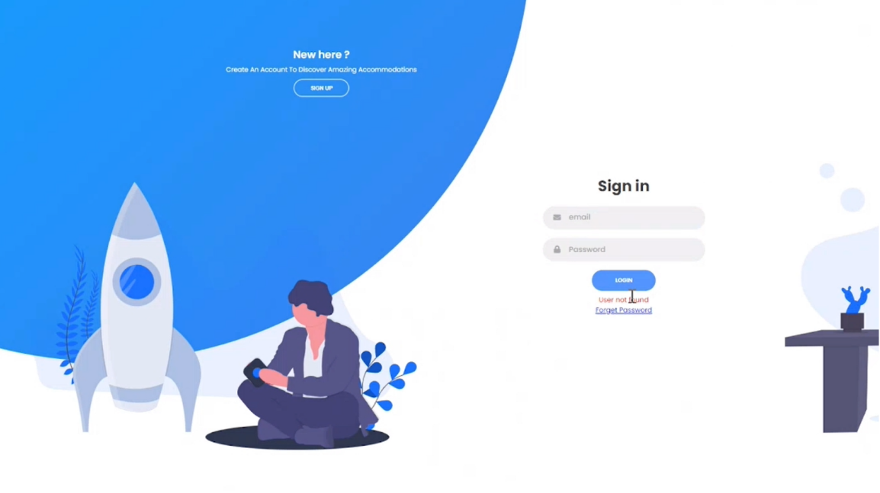

**This shows out main page of the site.**

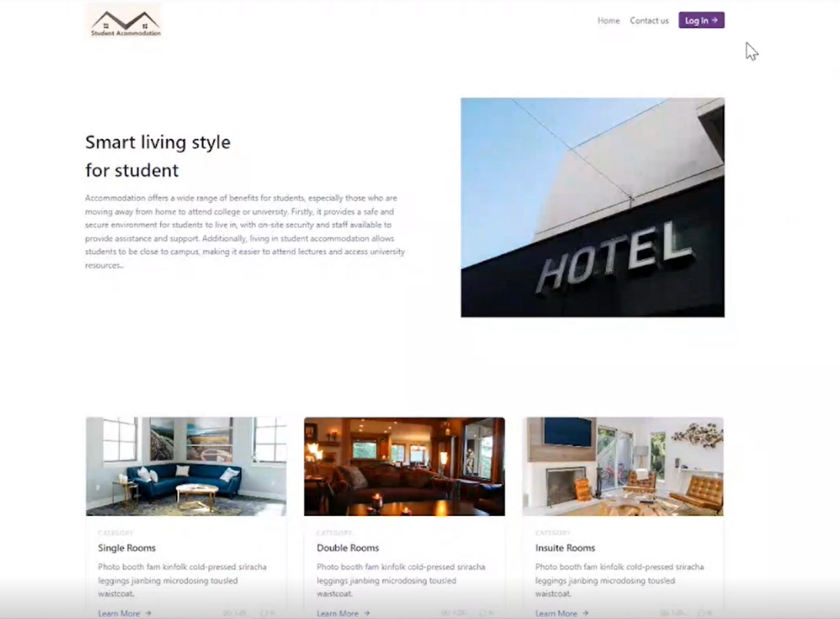

# **Development & Implementations**

The tools that the selected members of the group used was a sever which is of the university known as Selene where they could access all here work from the university’s server. This is useful as they can have all the shared code on a server and use the server to have it on the website. The reason Selene was chosen was because of its easy, free and simple to access for us students and all that was required was an email to the administrators for the credentials. Some of the challenges that come with designing a website is working out how to start the project, finding out who doing what, luckily 3 members of the group knew a lot more about designing website, so we handed them, the tasks of doing the actual product whilst the rest do the UML diagrams and planning on what’s going to be ion the actual website.

# **Project Planning & Management**

Firstly, we had to determine who would be the project leader, making it easier to know who to contact if we did not know what to do. Next, we decided on what our project would be based on. We decided that it would be a website that assists students to find accommodation, as this is something we found to be useful to us if we were new students. We arranged a weekly meeting time on Ms Teams so that we could discuss how the project was progressing and if someone were having difficulties the other members could assist them. We addressed what we each brought to the group when selecting roles, we wanted to know what each person was strong at, so we started distributing who would be the coders, researchers, designers, analyst and so on. There were 3 confident members who wanted to be the main designers as they had more knowledge than the rest of the group, as they had more knowledge than the rest of the teams.

We discussed who would be good at what on the project and discussed if them felt comfortable to do this part of the project. Once we had allocated each task to each student. So far, every project member is following the laid-out plan and completing their assigned tasks on time. During the progression of the course, 3 of the members who were the main developers of the website did have an extra meeting which took place on Tuesdays evenings according to the main developer and they had discussions on how they could make the website better and what other features could they add who was le which We have noticed that when it comes to designing the prototype it will be hard for some of us to assist as most have never coded a website so the rest of the group will support the programmer in helping him design the website, such as aesthetics, colour, layout and more.

**Flow Chart of our project planning**

Below show our planning phases throughout the weeks of designing the website

|  |  |  |  |  |  |  |  |
| --- | --- | --- | --- | --- | --- | --- | --- |
| **Task** | W1 | W2 | W3 | W4 | W5/6 | W7 | W8 |
| Gather Data from international students |  |  |  |  |  |  |  |
| Have a chat on the execution of the product |  |  |  |  |  |  |  |
| Research on it |  |  |  |  |  |  |  |
| Made a CSS and java script-based template (half) |  |  |  |  |  |  |  |
| Project timeline |  |  |  |  |  |  |  |
| Made the other half java script-based template |  |  |  |  |  |  |  |
| Project management diagram |  |  |  |  |  |  |  |
| Made a website |  |  |  |  |  |  |  |
| Add overview |  |  |  |  |  |  |  |
| Add logo |  |  |  |  |  |  |  |
| Add map |  |  |  |  |  |  |  |
| Add UML diagram, activity diagram, float charts |  |  |  |  |  |  |  |
| Add use case diagram, class diagram |  |  |  |  |  |  |  |
| Designs in photoshop |  |  |  |  |  |  |  |
| Add login |  |  |  |  |  |  |  |
| Add universities and accommodations |  |  |  |  |  |  |  |
| Add navigation bar |  |  |  |  |  |  |  |
| Add search engine |  |  |  |  |  |  |  |
| Add about us |  |  |  |  |  |  |  |
| Add feedback |  |  |  |  |  |  |  |
| Add support |  |  |  |  |  |  |  |
| Add chat page for students to interact with each other |  |  |  |  |  |  |  |
| Add encryption and deception |  |  |  |  |  |  |  |
| Add security |  |  |  |  |  |  |  |
| Finalize everything |  |  |  |  |  |  |  |
| Add android app |  |  |  |  |  |  |  |
| Get feedback from tutor |  |  |  |  |  |  |  |
| Finalize report |  |  |  |  |  |  |  |

# **PLESI Issues** How did you handle the professional, legal, ethical, and social issues that may concern your project?

Some of the professional issues of our project could be the security data where the data of the tenants must be kept save and store in a place where it cannot be accessed by another person, this can also be data such as the tenants phone number and location being leaked, this can cause a lot of issues with the tenants and the companies as the privacy contract had been breached and the reputation with the company can be ruined, Some of the legal issues could be monthly notices where a monthly notice is sent to the tenant letting them know that the rent may be due so that they don’t fall behind with payments, another legal issue could be bank transfer information where their bank may offer help with payments for those who are struggling to pay their rent or check their credit card references which can help people significantly. Some of the ethical issues could be tenant and landlord privacy where you if you were a tenant, you would want your information safe and not to be authorised by others as this could have your personal information including bank details, living details and more so you would want your information stored somewhere safe. Another could be back analysis of location of burglary where in the case you have been burgled you don’t want your information to be taken or if your belongings were taken you would want to make sure that your property is secure. The Social issues are where you rent a place with a bunch of other students, you would want them to have a chat with each other before they settle into a place together, this is where the chat feature of our website comes in handy where you can talk to each other before renting the place.

# **Evaluation**

Conclusion, an extensive study process and comprehensive understanding of the target audience are needed to create a student housing website for international students. The website offers a positive experience for students and helps them to find appropriate accommodation solutions that meet their needs through the provision of user-friendly platforms with accurate information and additional support services. We as a team feel that our website will offer the best help to newcomers that are starting university and help them meet new people with finding the best recommendation accommodations for the students’ financial situations to helping them meet new people with our integrated chat feature. We hope to develop on our website and add more features by hopefully using a review feature where any of the users that use our app can recommend improvements to help future university students making it easier.

# **References | Bibliography | Appendices**

* Marginson, S., Nyland, C., Erlenawati Sawir, & Forbes-Mewett, H. (2010). International Student Security. Cambridge University Press. ‌‌
* Accommodation for Students: New research reveals most (and least) expensive places for student rented accommodation in UK;
* Student Accommodation One Rewires Their Website to Help Students Secure Conducive Accommodation. (2020, Nov 16). *M2 Presswire*
* Accommodationforstudents.com confirms London and Oxford at top of average student rent list, Hull and Middlesborough the lowest. (2003, Feb 26). *M2 Presswire* <https://www.proquest.com/wire-feeds/accommodation-students-new-research-reveals-most/docview/445867017/se-2>
* Google Maps Platform  |. (n.d.). Google Developers. <https://developers.google.com/maps>