# Appendices

## Fastqc on raw barcodes

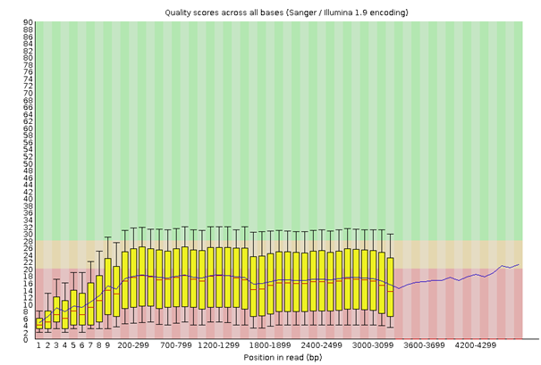

Figure 12: Fastqc of raw barcode_01_06

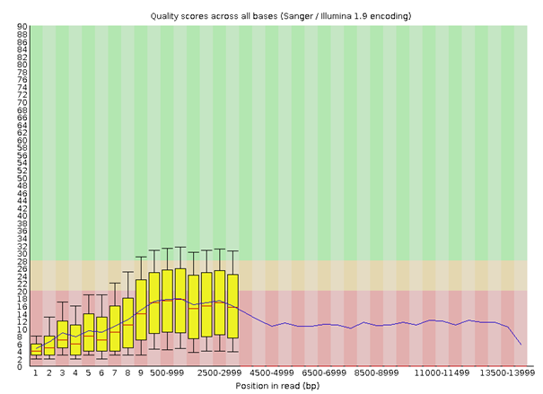

Figure 13: Fastqc of raw barcode_01_07

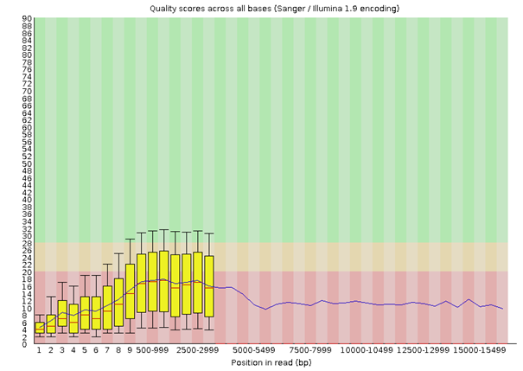

Figure 14: Fastqc of raw barcode_01_08

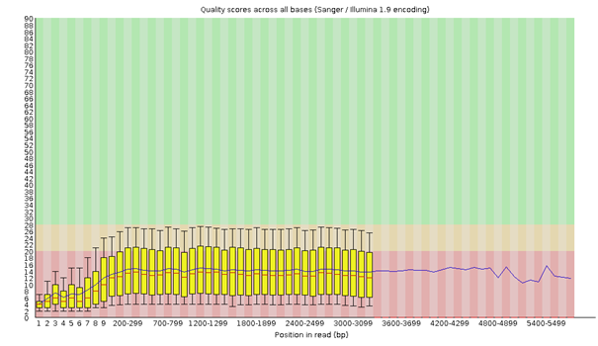

Figure 15: Fastqc of raw barcode_02_01

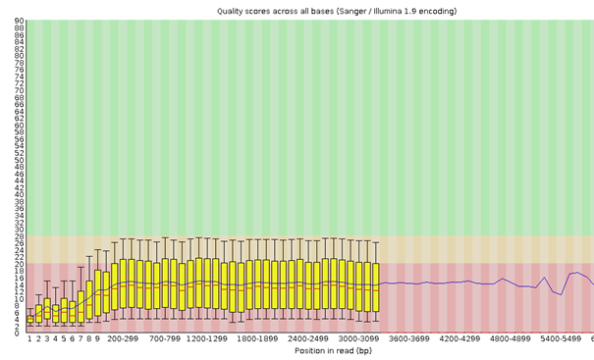

Figure 16: Fastqc of raw barcode_02_11

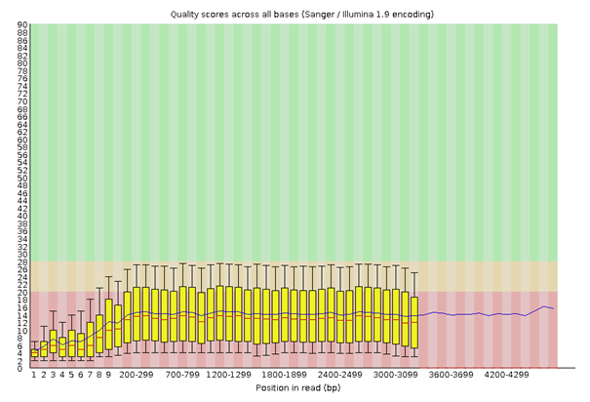

Figure 17: Fastqc of raw barcode_02_12

## GC content of barcodes











Figure 18: MultiQC on raw data. GC content

Fastqc after Porechop

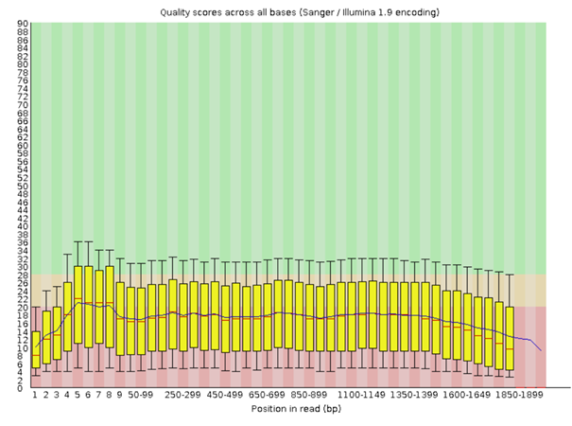

Figure 19: Fastqc on barcode_01_06 after trimming with Porechop

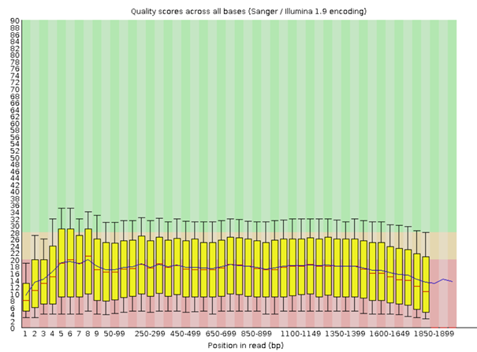

Figure 20: Fastqc on barcode_01_07 after trimming with Porechop

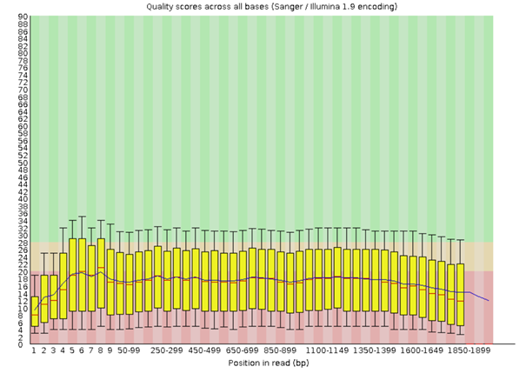

Figure 21: Fastqc on barcode_01_08 after trimming with Porechop

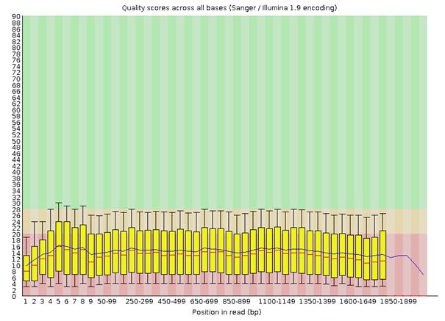

Figure 22: Fastqc on barcode_02_01 after trimming with Porechop

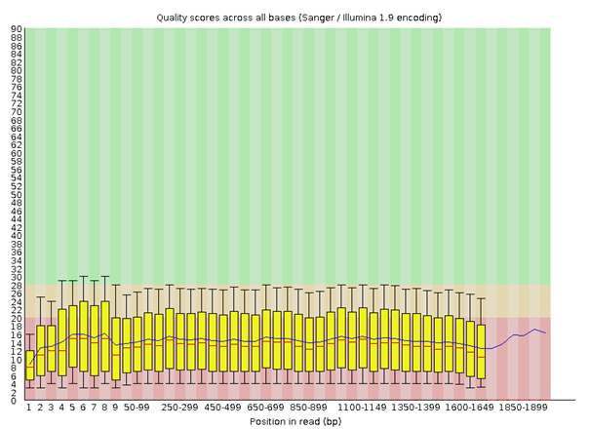

Figure 23: Fastqc on barcode_02_11 after trimming with Porechop

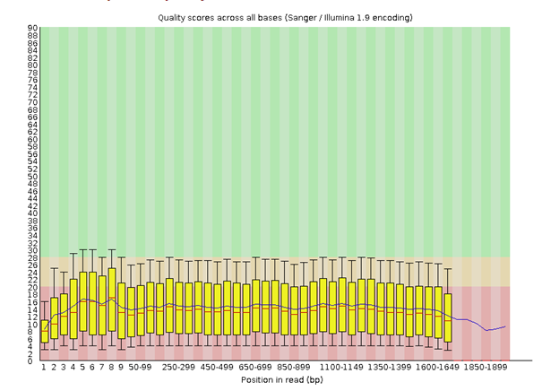

Figure 24: Fastqc on barcode_02_12 after trimming with Porechop

## MultiQC after Porechop

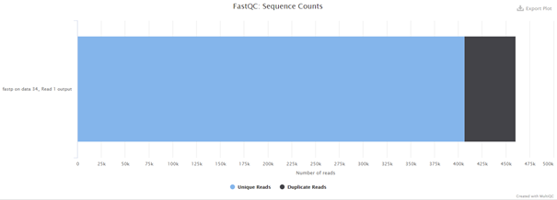

Figure 25: Barcode_01_06

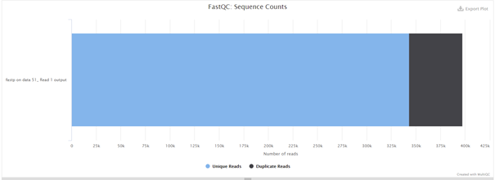

Figure 26: Barcode_01_07

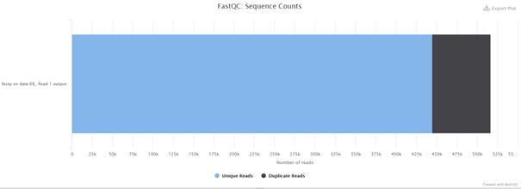

Figure 27: Barcode_01_08

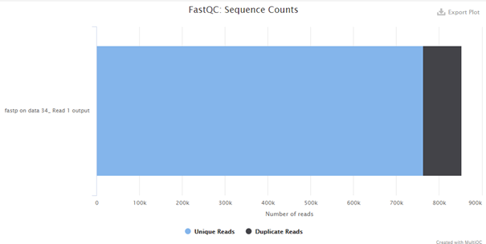

Figure 28: Barcode_02_01

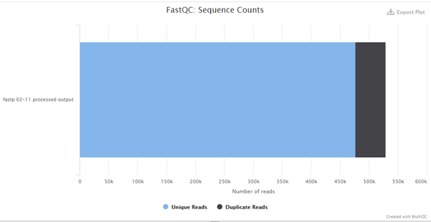

Figure 29: Barcode_02_11

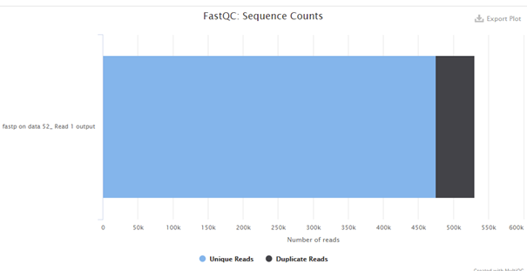

Figure 30: Barcode_02_12