# Attachments

## Fastqc on raw barcodes

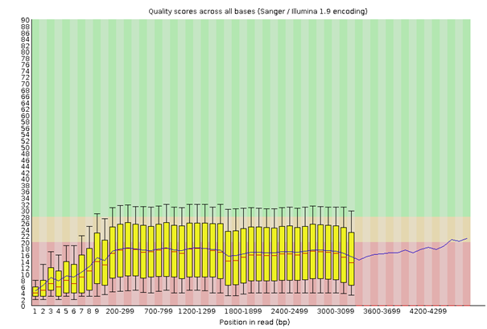

Figure 1: Fastqc of raw barcode_01_06

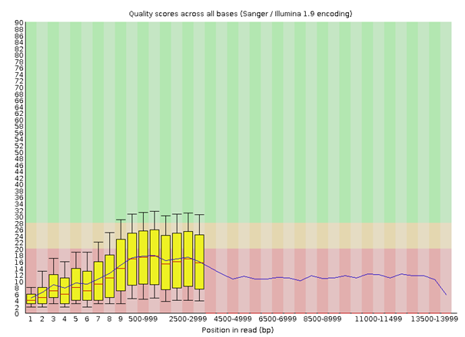

Figure 2: Fastqc of raw barcode_01_07

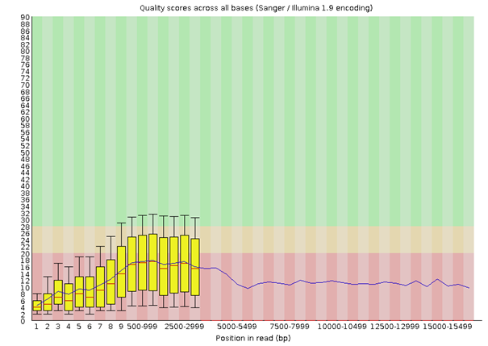

Figure 3: Fastqc of raw barcode_01_08

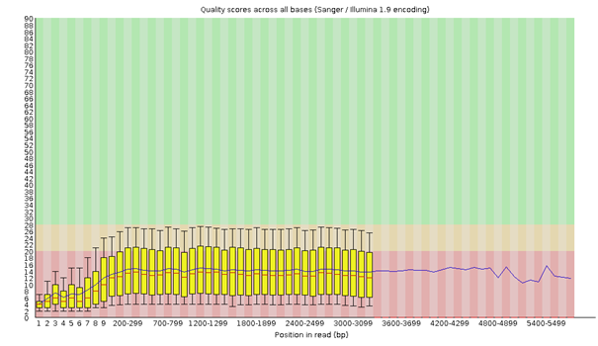

Figure 4: Fastqc of raw barcode_02_01

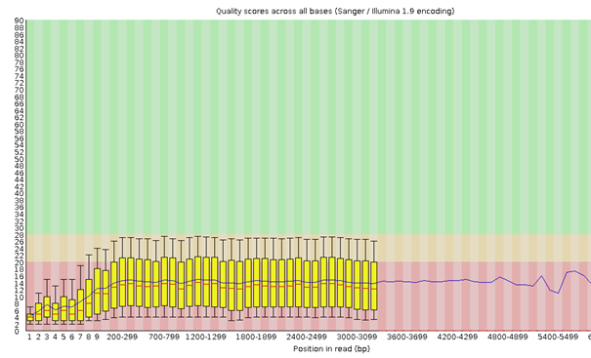

Figure 5: Fastqc of raw barcode_02_11

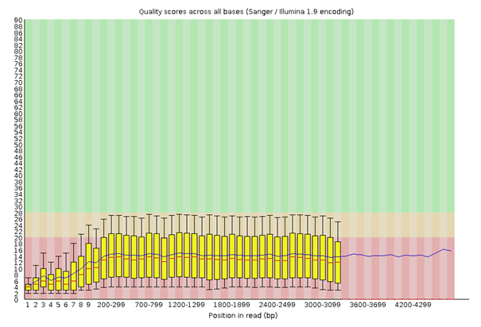

Figure 6: Fastqc of raw barcode_02_12

## GC content of barcodes











Figure 7: MultiQC on raw data. GC content

Fastqc after Porechop

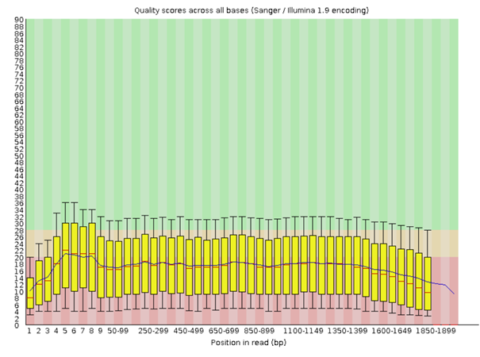

Figure 8: Fastqc on barcode_01_06 after trimming with Porechop

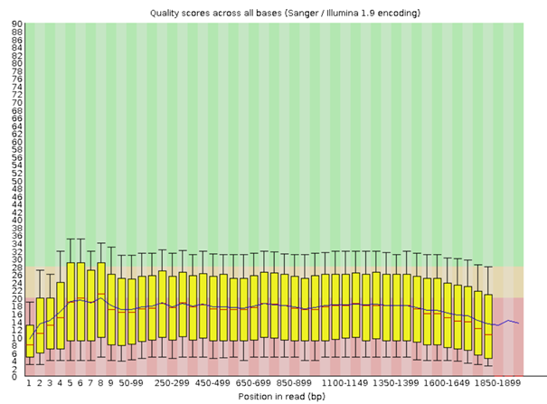

Figure 9: Fastqc on barcode_01_07 after trimming with Porechop

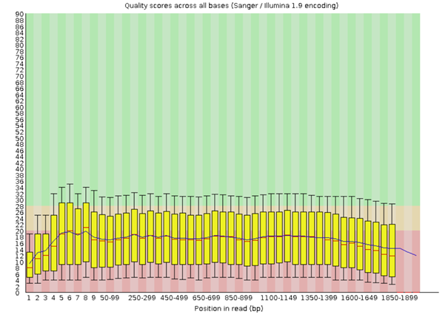

Figure 10: Fastqc on barcode_01_08 after trimming with Porechop

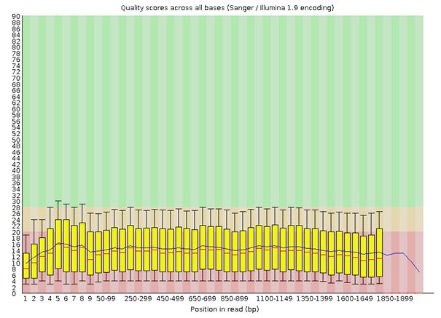

Figure 11: Fastqc on barcode_02_01 after trimming with Porechop

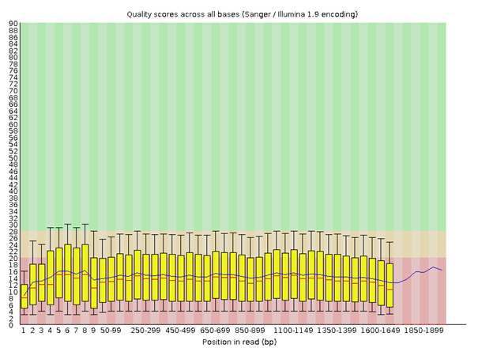

Figure 12: Fastqc on barcode_02_11 after trimming with Porechop

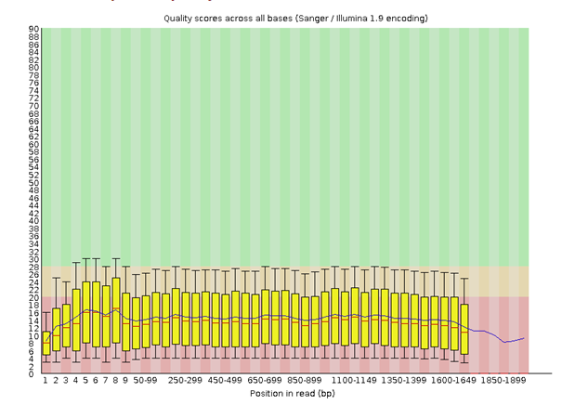

Figure 13: Fastqc on barcode_02_12 after trimming with Porechop

## MultiQC after Porechop

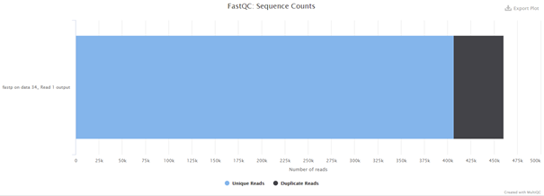

Figure 14: Barcode_01_06

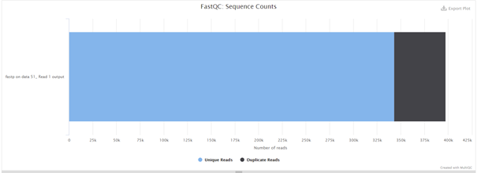

Figure 15: Barcode_01_07

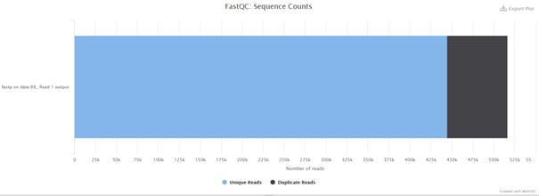

Figure 16: Barcode_01_08

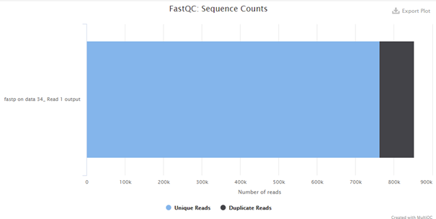

Figure 17: Barcode_02_01

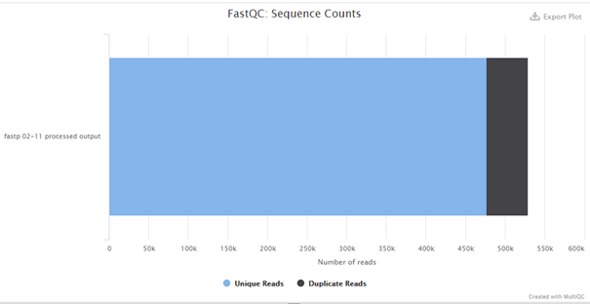

Figure 18: Barcode_02_11

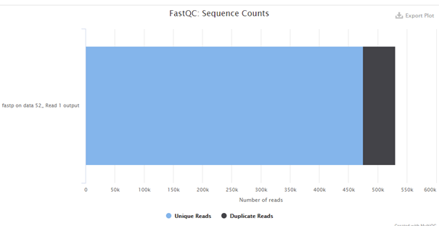

Figure 19: Barcode_02_12