Software Requirements Specification
for
Accounting Software
Version 0.1 approved
Prepared by Ömer Can Danacıoğlu

21.11.2017
Table of Contents
Table of Contents ii
Revision History ii
1. Introduction 1
1.1 Purpose 1
1.2 Document Conventions 1
1.3 Intended Audience and Reading Suggestions 1
1.4 Project Scope 1
1.5 References 1
2. Overall Description 2
2.1 Product Perspective 2
2.2 Product Features 2
2.3 User Classes and Characteristics 2
2.4 Operating Environment 2
2.5 Design and Implementation Constraints 2
2.6 User Documentation 2
2.7 Assumptions and Dependencies 3
3. System Features 3
3.1 System Feature 1 3
3.2 System Feature 2 (and so on) 4
4. External Interface Requirements 4
4.1 User Interfaces 4
4.2 Hardware Interfaces 4
4.3 Software Interfaces 4
4.4 Communications Interfaces 4
5. Other Nonfunctional Requirements 5
5.1 Performance Requirements 5
5.2 Safety Requirements 5
5.3 Security Requirements 5
5.4 Software Quality Attributes 5
6. Other Requirements 5
Appendix A: Glossary 5
Appendix B: Analysis Models 6
Appendix C: Issues List 6

Revision History
Name | Date | Reason For Changes | Version

Introduction

Purpose
Creating a software that can manage and solve daily and long-term problems of accountants. Database should be accessible from every computer which has internet and this software. So that people can do or control tasks from afar.

Document Conventions
Every technology and requirement mentioned in this document might change in the future until it is marked as final decision. If marking is not final then, stakeholders can make the final decision.

Intended Audience and Reading Suggestions
This document is intended for developers, project managers and designers. Developer should consider every aspect of this document. Project managers and designers can consider their related fields.

Project Scope
Software is going to help accounting firms and their personal by keeping track of their customers both people and companies. It should be able to conduct all repetitive tasks instead of personal, by giving times. It will always keep the personal and customers informed about their related jobs by e-mail or any means necessary.

Customer should enter their necessary information from a web page or from a software that is going to be kept in, this main software’s servers.

References
No references yet.

Overall Description

Product Perspective
This software is meant to replace other related software’s. Software is going to be highly maintainable, because of modules that are going to be added into it. Modules are parts of the software that are going to handle the main tasks. So, while these modules handle the main parts, the main accounting software is going to be responsible for managing connections between client and server. Main software will have an ability to add more modules after release or update-delete the current modules. Main software will require a user login system for accessing and using it.
Software will require constant internet connection and won’t have any local databases. It will only use the server database. 2 different connection types will there for the database system. One is main software connection and other one is for the web page. Web page is only going to be used for adding a customer and nothing more. Main project will use standard CRUD operations and more complicated operations.

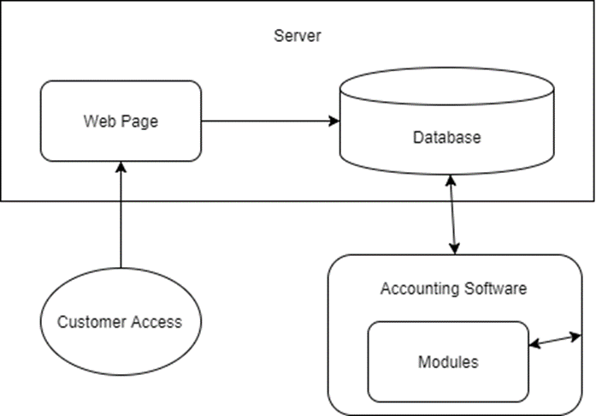

Product Features

Main Software
- Add, update, delete customers
- Login system
- Adding user
- Module selection & control

Modules
- Accounting operations
- Add, update, delete template
- Auto-Fill according to the templates
- Send Mails and WhatsApp messages
- Documentation checks

Web Page
- Add customer
- Login system

These features might change in the future. Modules can be merged or separated.

User Classes and Characteristics
- Administrator
- Personnel
- Customer

Administrator
Responsible for creating, adding and deleting personnel and customer. Should be able to access and change any document.

Personnel
Can have various types of personnel which is allowed to do different things depending on administrator assignment. Since user specification is not clear, it is going to be decided later.

Customer
Should be able to send their information via given login credentials by administrator trough the web page.

Operating Environment
Main software program is going to work on machines that supports .NET Framework 4.6.1 or higher.
Web page is going to work on any platform which has an internet browser that supports HTML5.
Server is going to be working on specified machine so, machine can be adjusted to support the server. Cannot clarify due to unknown condition of server system.

Design and Implementation Constraints
Since the modules can be altered, added and deleted later, software must be able to support these changes. Creating custom controls and using libraries should make it easier.

Constant internet connection is required. Database items cannot be hold locally and must be accessed from server only.

Database size might not be enough. Regular checks on available disk space can be required for server side.

Main program will work on various types of computers and monitors. Monitor size shall be accepted minimum of 1024x768 and maximum 3840x2160 (4K). Software should be done accordingly.

User Documentation
Help videos will be delivered to the customers. Responsibility is on Personnel and Administrator. And not on the developers.

Developers will guide Personnel and Administrator personally. No documentation is needed unless it is decided against by stakeholders.

Assumptions and Dependencies
Web page will always work on computers and not on mobile phone. Cannot be expected to enter lots of information through a mobile phone.

All the components are depending on an internet connection. Software cannot be used by anybody without it.

Server costs expected to be covered by the accounting firm. Any external programs associated with this software is also must be covered by the firm. It may lead to software change.

Server database is only meant to be accessed from different computers and no change will be made to the server computer unless stakeholders are all informed.

System Features
The system will accept credentials of many different types of people and/or companies. This information will be saved and used for accounting functions as the user desires. Output of the system and regulation of the system is going to be done according to the user specification.

Document Check

Description and Priority
Administrator and Personnel is going to check the received documents with this feature. Check criteria might include many options so, Administrator will define these criterias. Defined criterias might have multiple answers. Administrator will define the answers as well. Administrator also should be able to see which Personnel made the change on which document and when the change has been made. Criterias should be filterable and can be shown in percentage according to the filter.

Stimulus/Response Sequences

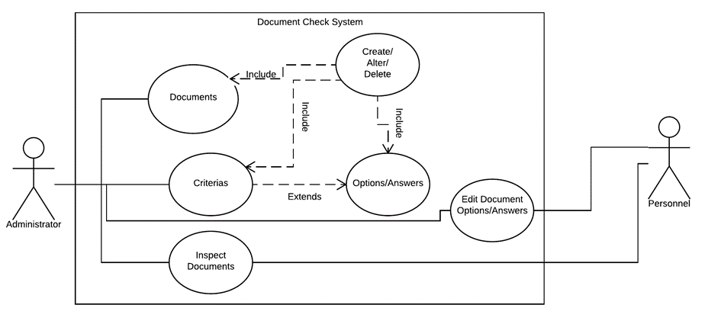
3.1.3 Functional Requirements
<Itemize the detailed functional requirements associated with this feature. These are the software capabilities that must be present in order for the user to carry out the services provided by the feature, or to execute the use case. Include how the product should respond to anticipated error conditions or invalid inputs. Requirements should be concise, complete, unambiguous, verifiable, and necessary. Use “TBD” as a placeholder to indicate when necessary information is not yet available.>

<Each requirement should be uniquely identified with a sequence number or a meaningful tag of some kind.>

REQ-1:
REQ-2:

Main Program

Description and Priority
This is the part of the software where the database connections will be made and where modules will be accessed. Not all modules will be accessible for all users. Different personnel might have different modules unlocked or locked. Modules can be shown as locked or not shown at all. It is going to have a users form where Administrator can Create-Alter-Delete, Personnel and Customers. It has to have a login screen that Administrator and Personnel can enter only.

External Interface Requirements

User Interfaces
<Describe the logical characteristics of each interface between the software product and the users. This may include sample screen images, any GUI standards or product family style guides that are to be followed, screen layout constraints, standard buttons and functions (e.g., help) that will appear on every screen, keyboard shortcuts, error message display standards, and so on. Define the software components for which a user interface is needed. Details of the user interface design should be documented in a separate user interface specification.>

Hardware Interfaces
<Describe the logical and physical characteristics of each interface between the software product and the hardware components of the system. This may include the supported device types, the nature of the data and control interactions between the software and the hardware, and communication protocols to be used.>

Software Interfaces
<Describe the connections between this product and other specific software components (name and version), including databases, operating systems, tools, libraries, and integrated commercial components. Identify the data items or messages coming into the system and going out and describe the purpose of each. Describe the services needed and the nature of communications. Refer to documents that describe detailed application programming interface protocols. Identify data that will be shared across software components. If the data sharing mechanism must be implemented in a specific way (for example, use of a global data area in a multitasking operating system), specify this as an implementation constraint.>

Communications Interfaces
<Describe the requirements associated with any communications functions required by this product, including e-mail, web browser, network server communications protocols, electronic forms, and so on. Define any pertinent message formatting. Identify any communication standards that will be used, such as FTP or HTTP. Specify any communication security or encryption issues, data transfer rates, and synchronization mechanisms.>

Other Nonfunctional Requirements

Performance Requirements
<If there are performance requirements for the product under various circumstances, state them here and explain their rationale, to help the developers understand the intent and make suitable design choices. Specify the timing relationships for real time systems. Make such requirements as specific as possible. You may need to state performance requirements for individual functional requirements or features.>

Safety Requirements
<Specify those requirements that are concerned with possible loss, damage, or harm that could result from the use of the product. Define any safeguards or actions that must be taken, as well as actions that must be prevented. Refer to any external policies or regulations that state safety issues that affect the product’s design or use. Define any safety certifications that must be satisfied.>

Security Requirements
<Specify any requirements regarding security or privacy issues surrounding use of the product or protection of the data used or created by the product. Define any user identity authentication requirements. Refer to any external policies or regulations containing security issues that affect the product. Define any security or privacy certifications that must be satisfied.>

Software Quality Attributes
<Specify any additional quality characteristics for the product that will be important to either the customers or the developers. Some to consider are: adaptability, availability, correctness, flexibility, interoperability, maintainability, portability, reliability, reusability, robustness, testability, and usability. Write these to be specific, quantitative, and verifiable when possible. At the least, clarify the relative preferences for various attributes, such as ease of use over ease of learning.>

Other Requirements
<Define any other requirements not covered elsewhere in the SRS. This might include database requirements, internationalization requirements, legal requirements, reuse objectives for the project, and so on. Add any new sections that are pertinent to the project.>
Appendix A: Glossary
<Define all the terms necessary to properly interpret the SRS, including acronyms and abbreviations. You may wish to build a separate glossary that spans multiple projects or the entire organization, and just include terms specific to a single project in each SRS.>
Appendix B: Analysis Models
<Optionally, include any pertinent analysis models, such as data flow diagrams, class diagrams, state-transition diagrams, or entity-relationship diagrams.>
Appendix C: Issues List
< This is a dynamic list of the open requirements issues that remain to be resolved, including TBDs, pending decisions, information that is needed, conflicts awaiting resolution, and the like.>

