Final Group Project – Network Programming

Seung Chul, Jaehuhn, Cora

Student # 0801937, 0014324

Due: December 8, 2016

Prof. Benjamin Mcilmoyle

**Agenda**

1. Introduction
2. Build and Execute
3. Play Instruction
4. Screenshots

**Introduction**

This is the final project for Network Programming class. We implemented a game similar with monopoly. Additionally, I inserted 5 user accounts that are test1..test5, and passwords are ‘password’. Also, the clients are two types that are console and graphical.

**Build and Execute**

1. Select release or debug with x86 platform.
2. Configure the Solution Property Pages that choose the multiple startup projects and change the Action to the Start of AuthenticationServer, TCPServer and TCP Client.  
   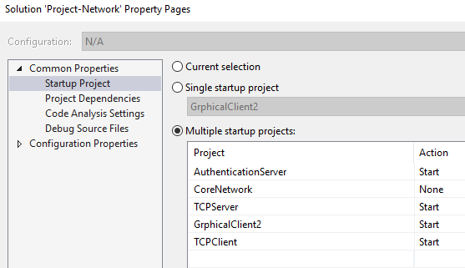
3. Build the solution.
4. Select the Start Debug menu item.

**Play Instruction**

1. Two servers and two console clients are executed.
2. You can use existed user information that the ids are test1… test5, and all passwords are same ‘password’.
3. When two players join a room, the game is automatically started.
4. Then as a debug mode, one client will run based on console, and another client will run based graphical window.
5. You can start without debug, then run more client with any type.
6. When play the game, two required input will display.
   1. When throw two dice.  
      
   2. When buy a building, station or utility.  
      
7. There will be **confusing** things that the graphical window does not show proper messages like above messages, hence, you should check console window when play with the graphical window. Also, when required input keyboard, you should active the graphical window to press the key instead of the console window which is for checking the messages.

**Screenshots**

1. Git relevant  
   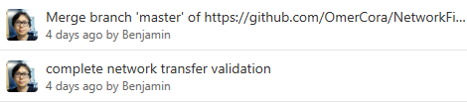  
   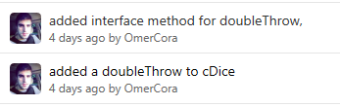  
   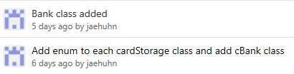
2. ChatClient, ChatServer, AuthenticationServer  
   