Design & Implementation Document
CULater
Version 0.1

Prepared by Group A1
Omer Ege Ozyaba | 1155240599 | 1155240599@link.cuhk.edu.hk
Addison Chen | 1155240408 | 1155240408@link.cuhk.edu.hk
Simon Reiterer | 1155240528 | 1155240528@link.cuhk.edu.hk
Chong Kai Cheng | 1155199401 | 1155199401@link.cuhk.edu.hk
Ho Zhe Shen | 1155205642 | 1155205642@link.cuhk.edu.hk

Instructor: | Dr. LAM Tak Kei
Course: | CSCI 3100
Lab Section: | T01
Teaching Assistant: | LAM Man Ho
Date: | 2025-03-10

1. Introduction 3
1.1 Overview 3
1.2 Project Description 3
2. System Architecture 3
2.1 Architecture Overview 3
2.2 Architecture Diagram 4
3. Data Models 5
3.1 Entity Relationship Diagram 5
4. System Design 6
4.1 Components 6
4.1.1 Frontend 6
4.1.2 Backend 7
4.1.2.1 Design reasoning and considerations: 8
4.2 Data Flow 10
4.3 Interface Design 10
4.3.2 Communication Between Components 10
4.3.3 API Endpoints 10
4.3.4 Expected Exceptions & Handling 12
4.3.5 Security Measures 12
4.4 Low Level Component Design 12
4.4.1 Frontend Components (React) 12
4.4.2 Backend Components (Flask) 13
4.4.3 Database Schema (PostgreSQL) 14
4.4.4 Algorithms 15
5. User Interface 16
5.1 Interface Design Diagram 16
5.2 Wireframe Diagram 17

1. Introduction

1.1 Overview
This document outlines the design and implementation details of CULater, including architectural decisions, system components, and the integration of software interfaces such as web browsers, backend services, and cloud infrastructure. It also provides insights into the development process, including the use of CI/CD tools to ensure efficient and reliable deployment. By adhering to the requirements specified in the Software Requirements Specification (SRS), CULater aims to deliver a robust, scalable, and user-centric solution for collaborative task and group management.

1.2 Project Description
CULater is a Web based planner application designed specifically for the Chinese University of Hong Kong (CUHK) community, facilitating the creation and management of tasks for individual users, as well as for student groups, university departments, and other school related groups/organizations. It addresses the need for a centralized platform where CUHK members can efficiently manage their academic and extracurricular commitments. The primary objective of this product is to simplify the organization of academic and social activities, solve the problem of fragmented communication and scheduling by providing a cohesive tool that keeps everyone informed and organized, hence improving collaboration between students and faculty. By allowing users to create and manage groups, and share group related tasks, CULater hopes to encourage a more connected and active campus environment.

2. System Architecture

2.1 Architecture Overview
CULater follows a three-tier client-server architecture:
- Frontend (Client)
  - Built with React.js.
  - Communicates with the backend via RESTful APIs.
  - Provides a Graphical User Interface (GUI) for user interactions.
- Middleware (Backend API)
  - Developed using Flask (Python).
  - Implements core business logic.
  - Manages user authentication, task handling, group management.
  - Interacts with the database via SQLAlchemy ORM.
- Database (PostgreSQL)
  - Stores users, tasks, groups, notifications.
  - Ensures data integrity, indexing, and security.

2.2 Architecture Diagram
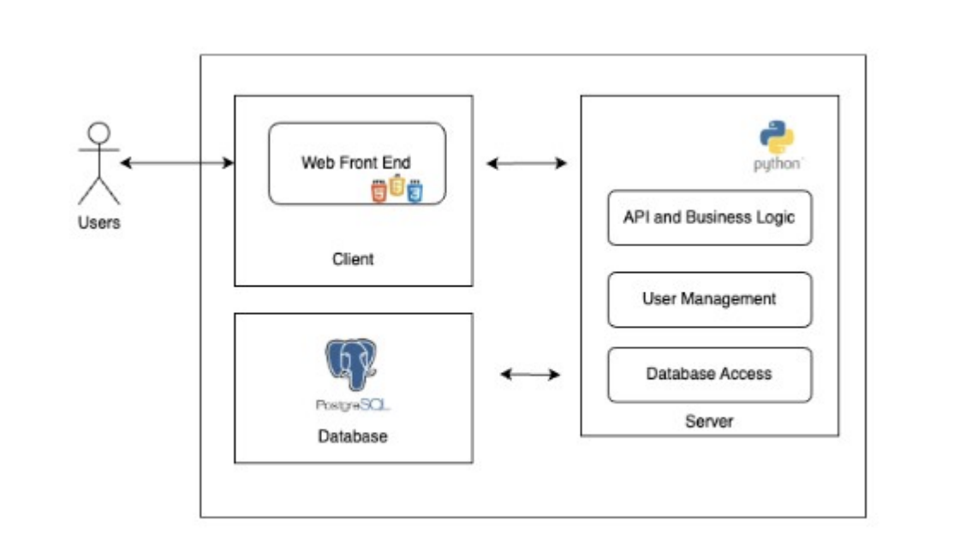

3. Data Models

3.1 Entity Relationship Diagram
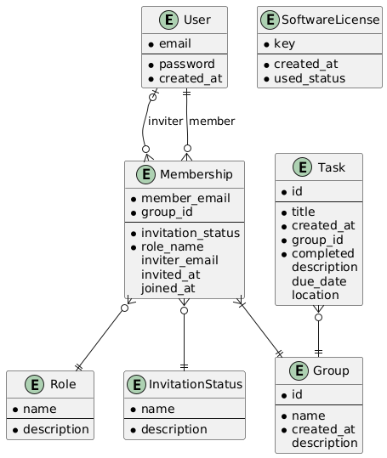

- User: A user of the application. The email is unique and used as the identifier. We also store each users password
- SoftwareLicense: This table stores all valid keys for account creation. Once used, we change the used_status attribute
- Membership: A membership binds a single user to a group. We also store information on who invited the user and when. A membership with the InvitationStatus Pending or Declined is handled as an invite. The inviter attribute can be empty when the group is the default group of the user
- Task: Hold information about a task. The completed flag allows users to set a task to completed without deleting the task
- Role: The role which a user can have in a group. F.e. admin
- InvitationStatus: The status of an invite. F.e. pending, accepted or declined
- Group: A group which tasks can be assigned to

4. System Design

4.1 Components

4.1.1 Frontend
The frontend / user-interface of the program will be built in ReactJS, HTML, CSS, and JavaScript as outlined prior. The following contains an architecture diagram detailing the design of the CULater frontend. The diagram organizes the frontend into two main layers within the entire frontend application. The UI layer is represented by distinct interface components for screens and sub-components that make up a screen, this details the flow of how a user may interact with the application. The service layer comprises components/code which manage API calls to the backend. Arrows illustrate the flow of interactions, with the user initiating actions on UI components that then invoke corresponding services.

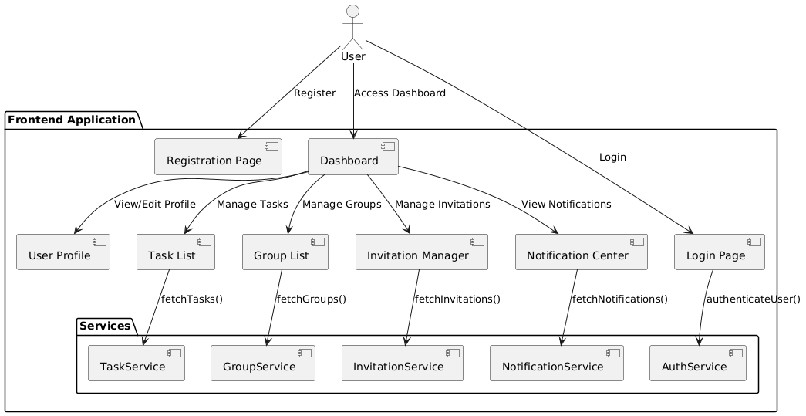

4.1.2 Backend
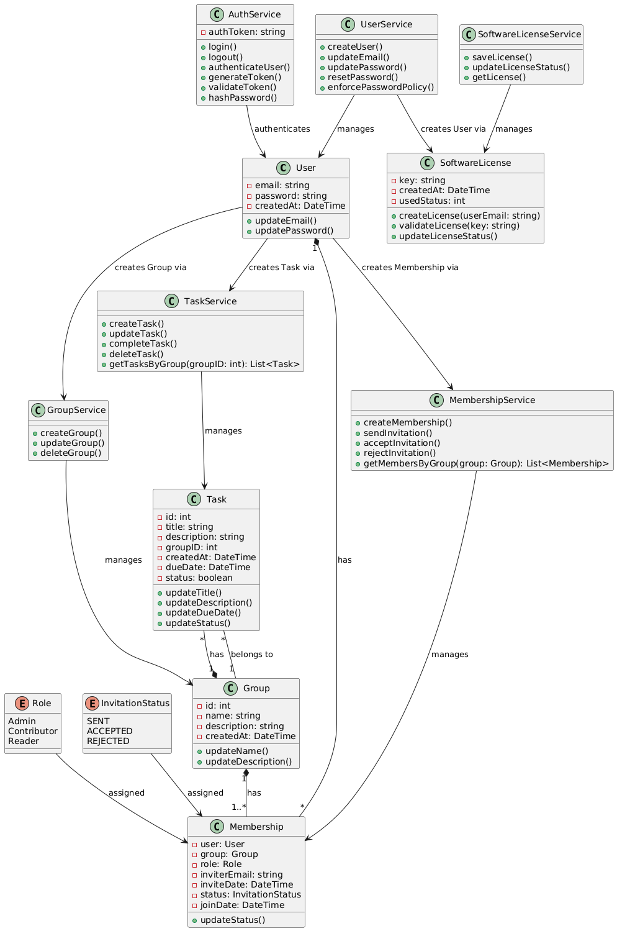

4.1.2.1 Design Reasoning and Considerations:

Classes/enumerations and their purposes:

User:
- Represents a user in the system, identified by their unique email
- Holds user credentials (email, password) and information about user creation

UserService:
- Manages operations related to users, such as creating users, updating their emails, and updating/resetting their passwords, enforcing password policy for security
- Interacts with the database

Task:
- Represents a task in the system
- Has properties like title, description, due date, status, and the group ID the task is assigned to

TaskService:
- Manages tasks in the system
- Interacts with the database to create tasks, update them, mark them as completed/deleted, retrieve them by the group they're assigned to

Group:
- Represents a group in the system
- Each group has a name, description, and creation date

GroupService:
- Manages groups in the system, creating them, updating, and deleting them
- Interacts with the database

Membership:
- Represents the membership of a user in a group
- Tracks the user's role, invitation status, who invited them, when they were invited and when they joined

MembershipService:
- Manages memberships in the system, including sending invitations, accepting/rejecting invitations, retrieving memberships by group, addition/removal of users to/from groups
- Interacts with the database

AuthService:
- Manages user authentication
- Handles login, logout, token generation, validation, password hashing
- Interacts with the database

SoftwareLicense:
- Represents a software license in the system
- Contains unique license key, its creation date, and its usage status

SoftwareLicenseService:
- Manages software licenses in the system
- Handles saving new licenses to the database, updating usage status, and retreiving licenses
- Interacts with the database

Role (enumeration):
- Defines possible roles a user can have in a group
- Each role comes with special permissions

InvitationStatus (enumeration):
- Defines possible statuses of an invitation
- Determines the membership of a user in a group

Design considerations:
- Separation of Concerns principle is respected by dividing responsibility between primary classes and service classes. While the primary classes are responsible for implementing business logic about objects in the system, service classes are tasked with data persistence.
- Scalability and extensibility is considered by dividing TaskService and GroupService. Tasks and groups can be focused on independently, which allows adding new features like task notifications without affecting the other services.
- MembershipService is separated from Group and User classes for managing users' roles and statuses within different groups. It separates membership-related logic, allowing for flexible role assignment and status tracking.
- Password policy enforcement in UserService provides necessary security to prevent weak passwords.
- The use of enums for user roles and invitation statuses allow for better maintainability, as any new role or status additions can be easily handled by modifying the enums. This also prevents hardcoding in the codebase.
- Service classes are modular which means new features can be added to the system without large-scale changes.
- Each class encapsulates a specific set of responsibilities which make the system more maintainable.

Possible improvements:
- For performance reasons, consider implementing caching strategies for frequently queried data.
- Querying tasks for a group can become performance-heavy as the application grows. Efficient indexing and caching will improve scalability.

4.2 Data Flow
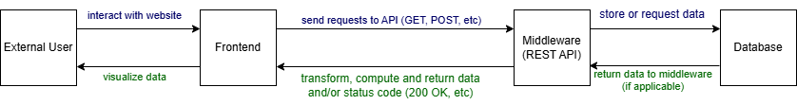
- The user interacts with the frontend
- The frontend communicates with the API of the middleware to retrieve or store data
- The middleware is the middleman between the DB and the frontend. It will transform and save data to the DB, or it will request data from the DB
- If the middleware requests data from the DB, it will do computations and transformations afterwards to prepare the data for the frontend
- The frontend receives the response and a status code from the API
- The frontend finally shows the result to the user

4.3 Interface Design

4.3.2 Communication Between Components
Component | Communication Partner | Protocol | Expected Input | Expected Output | Error Handling
Frontend (React.js) | Middleware (Flask) | REST API (HTTPS, JSON) | API requests (Login, Task Creation, Group Join) | JSON responses (Success/Error messages, Data) | Displays error messages, redirects user
Middleware (Flask) | Database (PostgreSQL) | SQL Queries via SQLAlchemy | Queries for user auth, task CRUD, group management | Query results (User data, Tasks, Groups) | Rollback transactions, return HTTP 400/500
Middleware (Flask) | External Authentication (OAuth, CUHK Login API) | OAuth2.0 / JWT | User credentials | JWT token | Invalid tokens return HTTP 401
Middleware (Flask) | CI/CD Pipeline (GitHub Actions) | Webhooks | Code push events | Deployment status | Logs errors in CI/CD dashboard

4.3.3 API Endpoints
Endpoint | Method | Description | Request Body | Response
User Management
/api/auth/signup | POST | Register new user | { email, password } | 201 Created / 400 Bad Request
/api/auth/login | POST | Authenticate user | { email, password } | { token } / 401 Unauthorized
Task Management
/api/tasks | GET | Fetch all tasks | Authorization: Bearer <token> | [ { task_id, title, description } ]
/api/tasks | POST | Create new task | { title, description, date, location, group_id } | 201 Created / 400 Bad Request
Group Management
/api/groups | GET | Fetch user groups | Authorization: Bearer <token> | [ { group_id, name } ]
/api/groups/join | POST | Join a group | { group_id } | 200 OK / 400 Bad Request
Invitations & Memberships
/api/invites/send | POST | Send an invite to a user | { member_email, group_id, role_name } | 201 Created / 400 Bad Request
/api/invites | GET | Fetch pending invites | Authorization: Bearer <token> | [ { member_email, group_id, inviter_email, invited_at } ]
/api/invites/accept | POST | Accept an invite | { group_id } | 200 OK / 400 Bad Request
/api/invites/decline | POST | Decline an invite | { group_id } | 200 OK / 400 Bad Request
/api/memberships | GET | Fetch group memberships | Authorization: Bearer <token> | [ { group_id, role_name, joined_at } ]

4.3.4 Expected Exceptions & Handling
Scenario | Exception | Handling Strategy
User enters wrong credentials | 401 Unauthorized | Frontend displays error message
Task creation with missing title | 400 Bad Request | Backend returns validation error
Unauthorized task deletion | 403 Forbidden | Backend denies request
Database connection failure | 500 Internal Error | Retry mechanism, logs error
User tries to accept an expired invite | 400 Bad Request | Backend returns error message

4.3.5 Security Measures
- Authentication & Authorization
  - JWT Tokens for session management.
  - Role-based access control (RBAC) (Admin, Contributor, Reader).
- Data Security
  - Password hashing via bcrypt.
  - HTTPS encryption for all API requests.
- Input Validation & Protection
  - Prevent SQL Injection (ORM with parameterized queries).
  - Validate all user inputs.

4.4 Low Level Component Design

4.4.1 Frontend Components (React)
Component | Responsibilities | Input | Output
LoginPage.js | Handles user login | { email, password } | JWT Token / Error
TaskList.js | Displays tasks | User ID | [{ task_id, title, date }]
TaskForm.js | Create/Edit tasks | { title, date, group_id } | 201 Created / Error
GroupList.js | View user groups | User ID | [{ group_id, name }]

4.4.2 Backend Components (Flask)
Module | Responsibilities | Input | Output
auth.py | Manages user login/signup | { email, password } | { token }
tasks.py | Handles task CRUD operations | { title, date, group_id } | { task_id }
groups.py | Manages group creation/joining | { name } | { group_id }
invites.py | Handles group invitations | { member_email, group_id, role_name } | 201 Created / Error
memberships.py | Manages memberships | { group_id } | { membership_id }

Example: User Authentication (Flask)
from flask import Flask, request, jsonify
from flask_jwt_extended import create_access_token
from werkzeug.security import check_password_hash
from models import User
app = Flask(__name__)
@app.route('/api/auth/login', methods=['POST'])
def login():
data = request.json
user = User.query.filter_by(email=data['email']).first()
if user and check_password_hash(user.password, data['password']):
token = create_access_token(identity=user.id)
return jsonify({"token": token}), 200
return jsonify({"error": "Invalid credentials"}), 401

4.4.3 Database Schema (PostgreSQL)
CREATE TABLE users (
email VARCHAR(255) PRIMARY KEY,
password_hash TEXT NOT NULL,
created_at TIMESTAMP DEFAULT CURRENT_TIMESTAMP
);
CREATE TABLE tasks (
id SERIAL PRIMARY KEY,
title VARCHAR(255) NOT NULL,
description TEXT,
due_date DATE,
location VARCHAR(255),
created_at TIMESTAMP DEFAULT CURRENT_TIMESTAMP,
group_id INTEGER REFERENCES groups(id)
);
CREATE TABLE groups (
id SERIAL PRIMARY KEY,
name VARCHAR(255) NOT NULL,
description TEXT,
created_at TIMESTAMP DEFAULT CURRENT_TIMESTAMP
);
CREATE TABLE roles (
name VARCHAR(50) PRIMARY KEY,
description TEXT
);
CREATE TABLE memberships (
member_email VARCHAR(255) REFERENCES users(email),
group_id INTEGER REFERENCES groups(id),
accepted BOOLEAN DEFAULT FALSE,
role_name VARCHAR(50) REFERENCES roles(name),
inviter_email VARCHAR(255) REFERENCES users(email),
invited_at TIMESTAMP DEFAULT CURRENT_TIMESTAMP,
joined_at TIMESTAMP,
PRIMARY KEY (member_email, group_id)
);
CREATE TABLE software_licenses (
key VARCHAR(255) PRIMARY KEY,
created_at TIMESTAMP DEFAULT CURRENT_TIMESTAMP,
used_status BOOLEAN DEFAULT FALSE
);

4.4.4 Algorithms

Task Filtering by Group
def get_tasks_by_group(user_id, group_id):
tasks = Task.query.filter_by(user_id=user_id, group_id=group_id).all()
return tasks

User Authentication
def authenticate(email, password):
user = User.query.filter_by(email=email).first()
if user and check_password_hash(user.password, password):
return create_access_token(identity=user.id)
return None

Handling Invitation
def send_invite(member_email, group_id, role_name, inviter_email):
new_invite = Membership(
member_email=member_email,
group_id=group_id,
role_name=role_name,
inviter_email=inviter_email,
accepted=False
)
db.session.add(new_invite)
db.session.commit()
return new_invite

Accepting Invitation
def accept_invite(member_email, group_id):
invite = Membership.query.filter_by(member_email=member_email, group_id=group_id, accepted=False).first()
if invite:
invite.accepted = True
invite.joined_at = datetime.utcnow()
db.session.commit()
return invite
return None

5. User Interface

5.1 Interface Design Diagram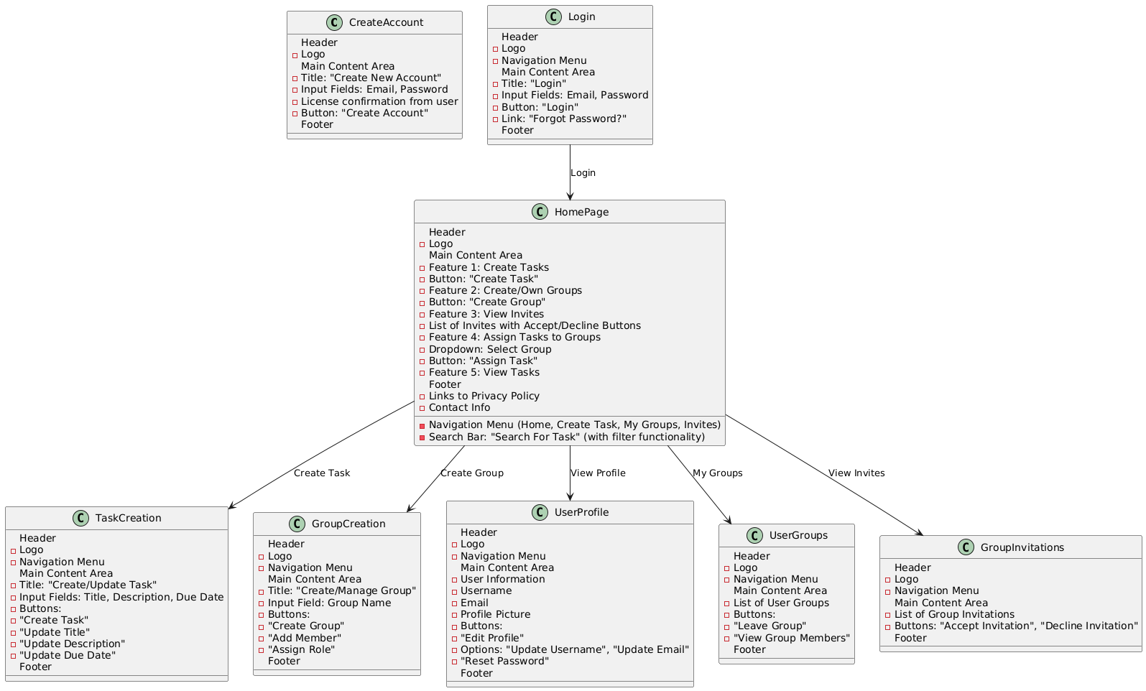

5.2 Wireframe Diagram
