*20/2/2017*

**Notions 1 Team Engineering Journal\***

***Introduction:***

Notions 1 is a team consisting of 3 members, participating in RCJ’17 Rescue line category.

***Team members:***

Louai Zahran (Electrical / Programmer)

Rowan Ashraf (Mechanical)

Omar Elboray (Electrical)

***Project’s Outlines:***

It was agreed that the project would mainly depend on an Arduino Mega as a microcontroller and Servos as motors used for both moving and gripping, to be different from other teams competing with us, it was decided that some sensors and boards would be exclusively made by the team members.

***Table of contents:***

1. Introduction.…………………………………………………………………. ‎ *1*
2. Project’s development …………………………………………………… *2*
3. Schematics and drawing ………………………………………………… *15*
4. References …………………………………………………………………. *17*

*For best readability experience, read the journal using Word 2016 print layout mode

*21/2/2017*

* **Agenda**

1. Determining the main components of the project.
2. Calculating the required torque of the servos according to the estimated weight of the main components and the used materials.
3. Agreeing on the programs used for designing the body/boards of the project and determining the used materials.

* **Progress**

1. It was agreed that an Arduino mega will be used as a microcontroller, some of the parts of the project would be fabricated using 3d printing due to the complexity of them as the available materials in the market wouldn’t give us the ability to fabricate these parts in any other material, while other simpler parts that had small thickness would be cut from acrylic or MDF sheet.
2. Due to our desire to let the project’s dimensions be as small as possible, it was decided that the traditional DC motors wouldn’t be used and servo motors would be used instead for their compact size, high torque and low power consumption.
3. The total weight of the project was estimated to be around 1.5Kilograms, accordingly, a 9 kg.cm torque 60 RPM servos were the best available motors to be used according to the following formula:

Where T is the required torque, F is the applied forces, r is the radius of the wheels used, m is the mass of the robot, g is the gravitational constant = 9.8 m/s2, j is the frictional constant and is the angle of incline of the ramp which equals 25.

1. For power-supplying the servos and the rest of the project, a 5v 12,000mAh power bank was chosen because all circuits require an exact potential difference of 5 volts.
2. SolidWorks was the program chosen to design the body mechanically on and eagle was the one that would be used to design the boards of the project.

* **Issues**

None

*23/2/2017*

* **Agenda**

1. Designing a prototype base on solidworks.
2. Prototyping a light sensing circuit.

* **Progress**

1. Implemented a light sensing schematic [1] on a breadboard and sampled its readings on both white and black colors and found that the difference was very small.
2. Designed a board of single light sensor to test its range and readings with different heights and sent it to be routed.
3. Designed the prototype base on solidworks and sent the design to be cut from a MDF 3mm thickness sheet.

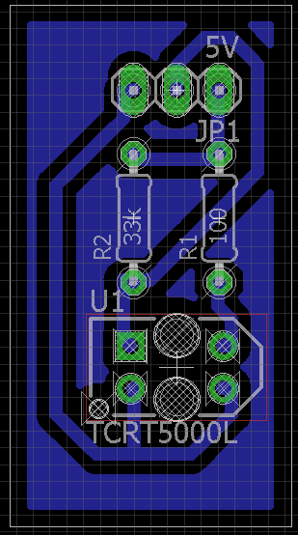 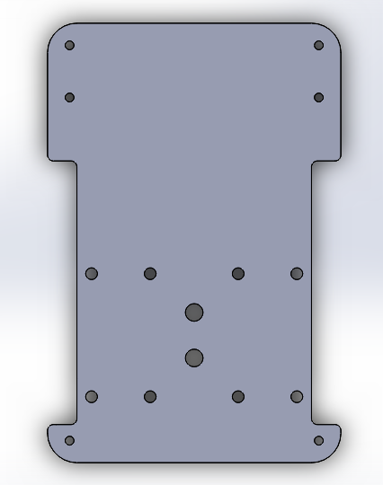

*Light Sensor Board Prototype base*

* **Issues**

1. The difference in readings between white tiles and black line was very small that no line tracking algorithm can rely on.

* **Solution**

1. By trying different combinations of resistors, we reached a perfect combination of 100 resistor on the TCRT’s emitter IR led and 33k resistor on its photodiode.

*25/2/2017*

* **Agenda**

1. Design a simple power distribution board and fabricate it by etching.
2. Receive the routed light sensor board and sample its readings.
3. Receive the prototype base and design a servo mount for it.
4. Prototype a RGB color sensing circuit.

* **Progress**

1. Designed a compact power distribution board for prototyping purposes.
2. Implemented a schematic [2] known for color sensing using RGB led and photodiode but it turned out that the differences between colors weren’t large enough and that the brightness of the RGB led wasn’t enough too.
3. Tested the light sensor board at different heights and found that it works best at a height of **1** cm from the ground.
4. Designed a servo mount for the prototype base and sent it to be 3D

printed.

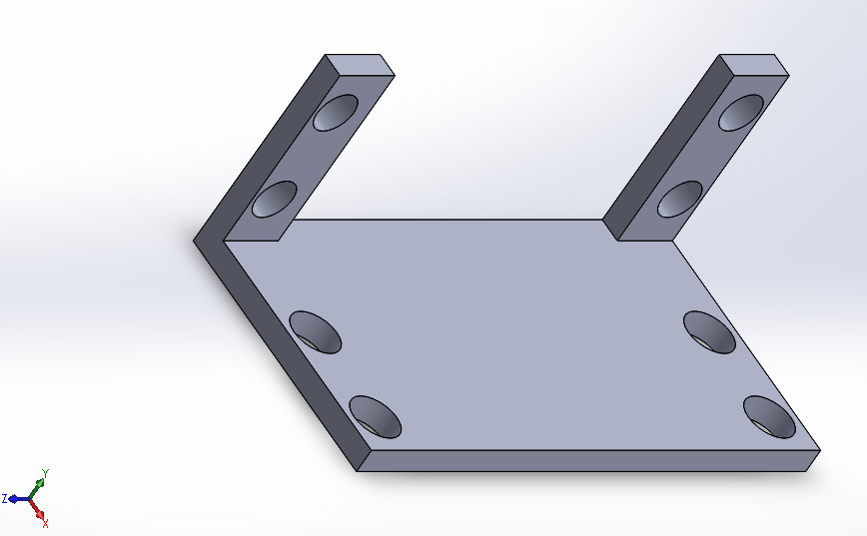 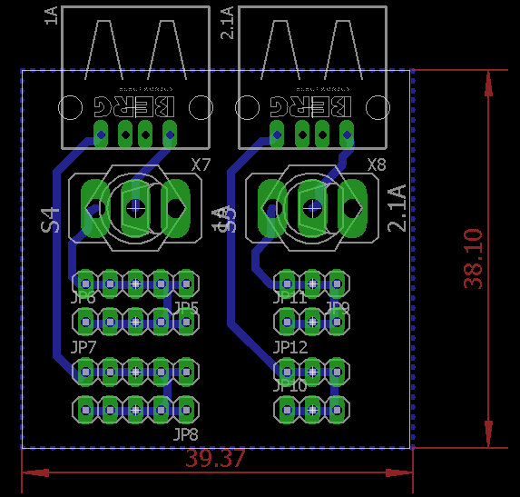

*The Servo Mount The power distribution board*

* **Issues**

1. There were undesired readings for different colors that made the process of differentiation between colors difficult.
2. The brightness of the RGB led wasn’t enough to reach to ground and reflect to make the difference between colors large enough.

* **Solution**

1. It was agreed to purchase a color sensor codenamed “GY-31” that was known for its accurate readings.

*27/2/2017*

* **Agenda**

1. Designing an IR array.
2. Begin designing the final body.

* **Progress**

1. Designed an TCRT array on eagle referring to the single TCRT board done before.
2. Begin designing the final body by designing the powerbank holder which was decided to be implemented by 3D printing because its thickness is bigger than the most thick acrylic sheet available in market.

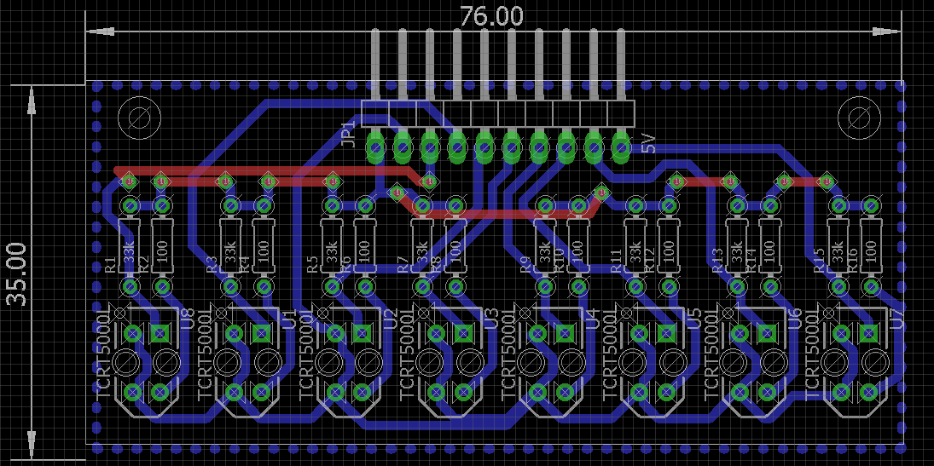

*TCRT Array Board*

* **Issues**

1. The board couldn’t be routed by any routing machine in Alexandria because its clearance was 0.6mm and the most accurate machine in Egypt require a clearance of 0.8mm at least.

* **Solution**

1. It was decided that the board would be fabricated using etching method.

*3/3/2017*

* **Agenda**

1. Drilling, soldering and testing the light sensor board.
2. Designing a mount for the caster wheels, TCRT Array board and color sensor.
3. Finishing the design of the base of the robot.

* **Progress**

1. Drilled, soldered, tested and mounted the light sensor board on the prototype base to test its readings on the same height that the board would be at in the final design.
2. Finished the design of the base of the robot and sent it to be 3D printed.
3. Designed a caster mount that was to be fabricated by 3D printing as well.

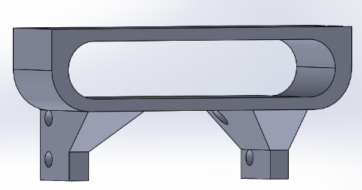 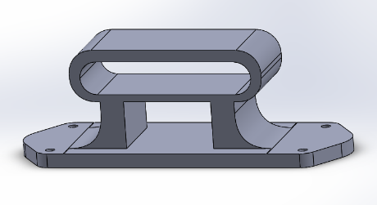

*The Power-Bank Holder 3D Model The Caster Mount 3D Model*

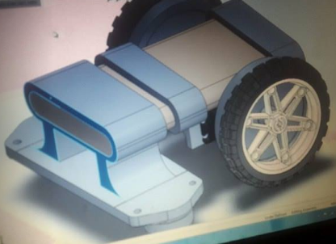

*The Final Body Assembled 3D Model*

* **Issues**

1. The purchased color sensor may produce a friction force with the ground when climbing the ramp down because of its height which is obviously undesired.

* **Solution**

1. According to the issue happened today, the drilled, soldered TCRT array board was abandoned and a new TCRT array w/ color sensor would be designed and fabricated, but this time the color sensor would use a 3 separate leds (transparent red led, transparent green led, transparent blue led) instead of one RGB led and a LDR would be used instead of photodiode.

5/3/2017

* **Agenda**

1. Prototyping the new light w/ color sensor board.
2. Redesigning another caster mount that can be cut from an acrylic sheet to lower the budget.

* **Progress**

1. Prototyped a circuit of light w/ color sensor on breadboard using an array of 6 TCRT5000 for light intensity sensing, and 3 leds (1 Red, 1 Green, 1 Blue) and a 5mm LDR in their center for color sensing.
2. Designed the new light w/ color sensor board and fabricated it using etching method.
3. Drilled, soldered, and tested the board.
4. Finished designing the new caster mount. 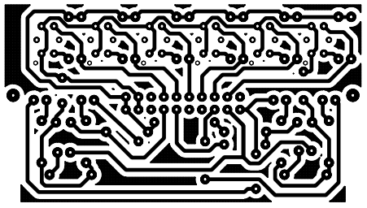 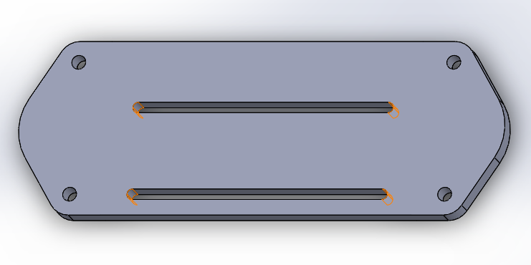*The new light w/ color sensor board The new caster mount*

* **Issues**

1. The differences between the readings of the color sensor on different colors was acceptable, but we desired a wider range and a more accurate way to differentiate between colors.

* **Solution**

1. Due to our desire for more sensitive readings and wider range of differences between colors, it was decided that the last board would be implemented again but with a more sensitive 10mm LDR this time instead of a 5mm LDR.

*7/3/2017*

* **Agenda**

1. Redesigning and fabricate the light w/ color sensor board with 10mm LDR.
2. Testing a simple line tracking program using the new board mounted on the prototype base.
3. Beginning designing a ball gripper for victims in evacuation zone.

* **Progress**

1. Finished redesigning the 10mm LDR light w/ color sensor board and fabricated, drilled, soldered, and tested it using the code below:

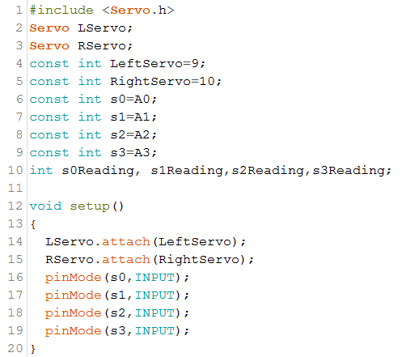

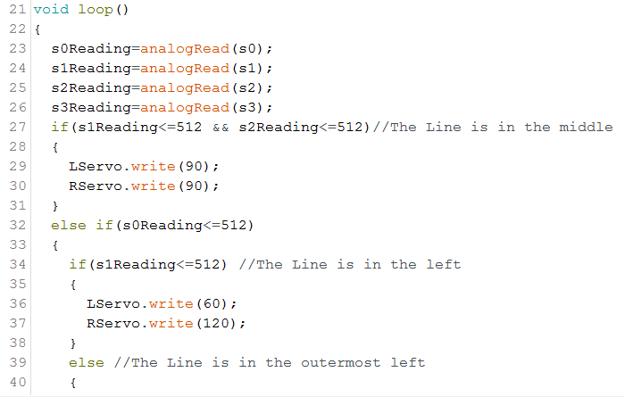

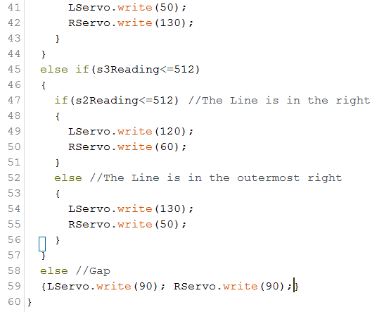

1. After discussion, it was agreed that a cylinder would perform the task of gripping and holding the balls best, on that basis, the designing of the gripper began.

* **Issues**

1. The code shown above was not efficient enough in some tiles especially sharp curves as the robot leaves the line and a lack of progress occurs.

* **Solution**

1. An algorithm depending on feedback mechanism has to be implemented, and the best algorithm in this category is PID algorithm, its idea of working is shown below:

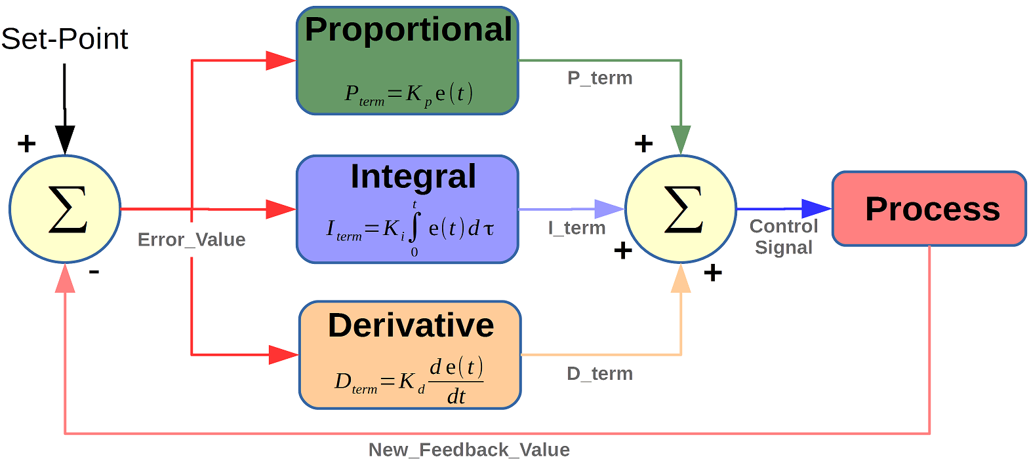

*PID Controller Algorithm block diagram*

*9/3/2017*

* **Agenda**

1. Continue designing the gripper.
2. Discussing the required sensors other than light and color sensors and begin designing the main board on that basis.

* **Progress**

1. After discussion, it turned out that we need an accelerometer module to detect the ramp, a compass module that may help us in the turns and in the evacuation zone, and 3 ultrasonic sensors (1 in the front for detecting obstacles and victims, the other 2 are for detecting the walls of the evacuation zone) on that basis, the schematic of the main board was designed using eagle in a way that satisfy our needs.
2. Almost finished the design of the gripper.

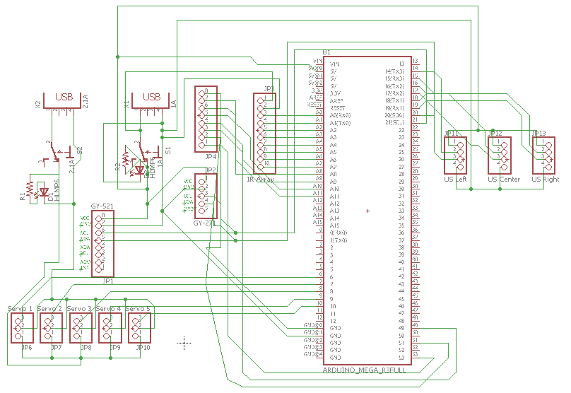

*Main board schematic*

* **Issues:** None

*13/3/2017*

* **Agenda**

1. Finish designing the gripper.
2. Finish designing the main board.

* **Progress**

1. Finished designing the cylinder on SW and discussed the material that may be used to implement the design, there were mainly 2 options: PVC or Carton, after looking at the advantages and disadvantages of each material, it was decided that Carton would fit best because of its light weight compared to PVC.
2. Finished designing the main board on eagle and planned to mount it on the base using 8 spacers, 4 in the corners and 4 in the center.

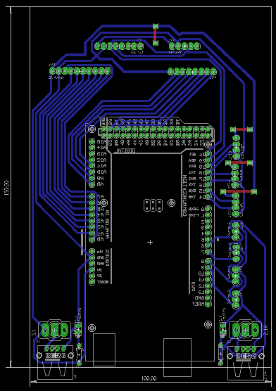 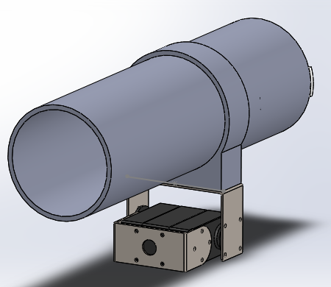

*Main board design The gripper mechanism*

*16/3/2017*

* **Agenda**

1. Fabricate the main board and mount it on the robot.
2. Testing the Ultrasonic sensors because according to the sound reflection theories, the rays would diverge after falling on the victims’ surfaces.

* **Progress**

1. Etched the main board, drilled it, soldered it and mounted it on the robot.
2. Tested the ultrasonic sensors and sampled its values through this code:

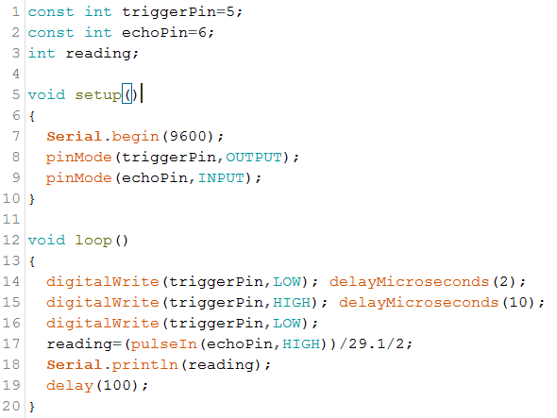

* **Issues**

1. As expected, the ultrasonic rays diverge when the hit the victims from distance more than 20cm.
2. The main board dimensions are pretty large relative to the dimensions of the main body, and the gripper may hit it while deploying victims.

* **Solutions**

1. To resolve the ultrasonic sensor’s issue, it was replaced by a long-range infrared proximity sensor that measures distance with more accuracy.
2. It was agreed to design a new board of the same dimensions of the power bank (82*132 mm).

18*/3/2017*

* **Agenda**

1. Redesign and fabricate the main board.
2. Test the gripper and proof its validity.

* **Progress**

1. The main board is redesigned with the new dimensions (82*132 mm). To reach this compact size, it was a must to edit the footprint and symbol of the Arduino Mega board from Sparkfun-board library and delete the digital pins numbered from 22 to 53 along with 5V@1, 5V@2, GND@2, GND@3 pins.

* **Issues**

1. The cylinder didn’t function as expected because it has a circular path of motion that require a perfect placement with infinitesimal error which couldn’t be achieved with the available parts and sensor.

* **Solutions**

1. The cylinder gripper development path was terminated and a gripper with a gear mechanism similar to the one shown below would be designed and fabricated.

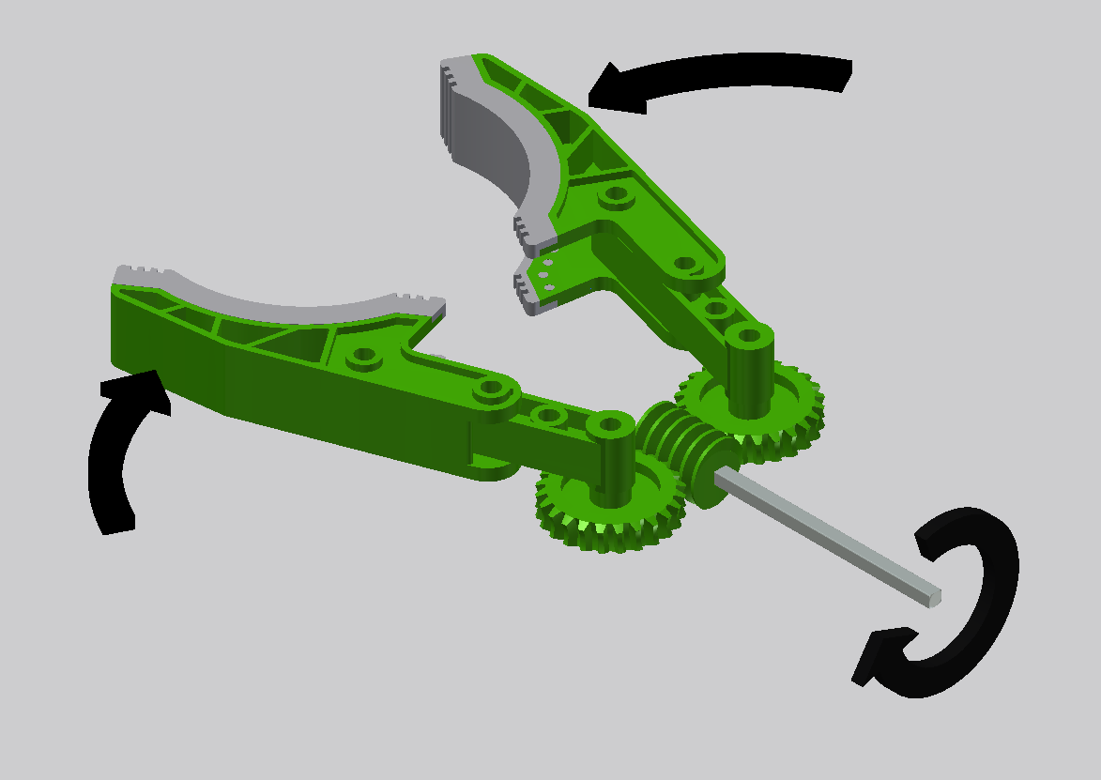 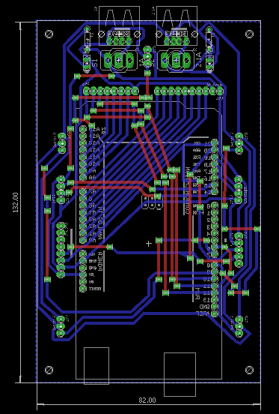

*Gripper mechanism idea Re-designed main board*

***Used Schematic******s***

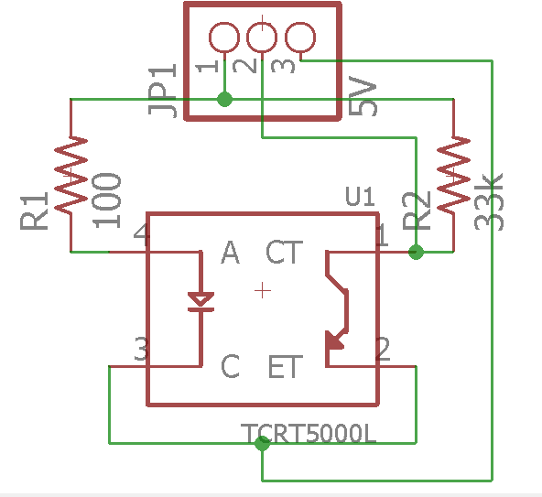

*Single TCRT board schematic*

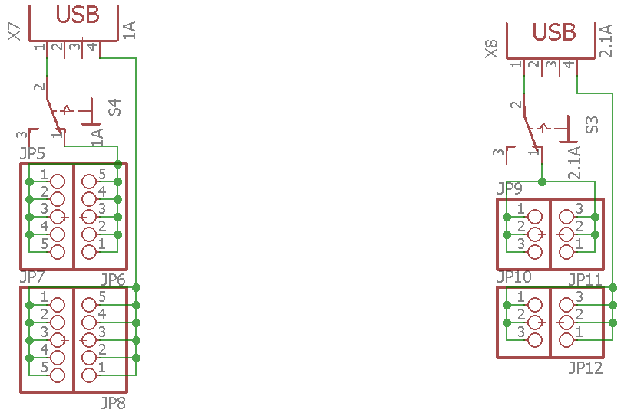

*Power distribution prototype board schematic*

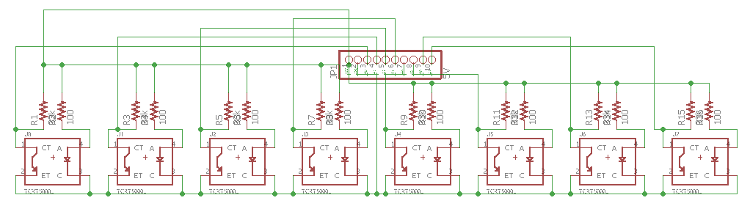

*8 TCRT5000 IR Array*

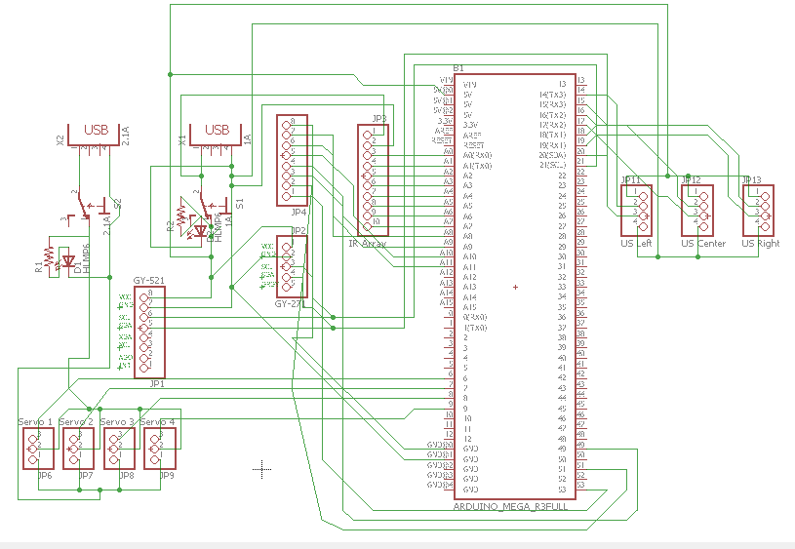

*Main Board Schematic v1.0*

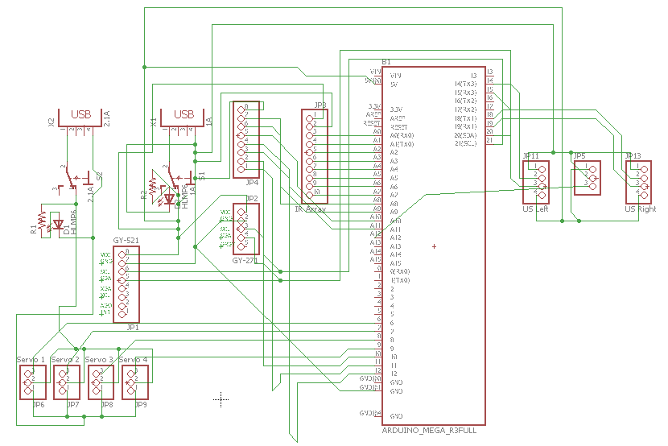

*Main Board Schematic v1.1*

***Referenc******es***

*Schematic [1]* : <http://www.bajdi.com/wp-content/uploads/2012/04/tcrt5000-connection.jpg>

*Schematic[2]*: <https://i.stack.imgur.com/qHwVj.jpg>

*Arduino Wire library documentation :* <https://www.arduino.cc/en/reference/wire>

*Arduino Servo library documentation :* <https://www.arduino.cc/en/reference/servo>

*I2Cdev library documentation :* <https://www.i2cdevlib.com>

*MPU6050 library:* <https://github.com/jrowberg/i2cdevlib/tree/master/Arduino/MPU6050>

*HMC588L library:* <https://github.com/jrowberg/i2cdevlib/tree/master/Arduino/HMC5883L>