**Development task;**

**Pneumatic driven collar charging machine**

designing a pneumatic driven collar charging device, using the defined data set (You can find any data in the following table).

Data set:

Pressure: p = 6 bar;   
Friction coeffitient µ = 0.1;   
Number of stations: n [piece];   
The dimensions of the cylindrical workpiece: dmin [mm], dmax [mm];   
Distance between the stations: t [mm];   
The mass of workpiece: m [kg]   
The kind of displacement: H (horizontal, direction Y), V (vertical, direction Z).

|  |  |  |  |  |  |  |
| --- | --- | --- | --- | --- | --- | --- |
| **number** | **n [db]** | dmin [mm] | dmax [mm] | t [mm] | m [kg] | kind of displacement |
| 1 | 2 | 15 | 30 | 120 | 0.1 | H |
| 2 | 3 | 20 | 30 | 130 | 0.2 | V |
| 3 | 4 | 30 | 40 | 140 | 0.5 |  |
| 4 | 5 | 40 | 50 | 150 | 0.6 |  |
| 5 | 6 | 40 | 60 | 160 | 0.7 |  |
| 6 |  | 50 | 80 | 180 | 0.8 |  |
| 7 |  | 35 | 90 | 200 | 1 |  |
| 8 |  | 40 | 100 | 220 | 1.2 |  |
| 9 |  | 50 | 110 | 240 | 1.3 |  |
| 10 |  | 60 | 120 | 250 | 1.5 |  |

Requirements:

* The cumulated cycle time must be less than 8 sec.
* For velocity control, one directional flow control valves are required.
* Usage of hydraulic damping elements.
* To apply of locking and releasing motions of the gripper arsms, we use two jawed devices (HGPL).
* For the guidance of motion elements we use profilized rails and roller-bearing carriages.
* For sensing the booth „end” positions of elements of motion devices, we use inductive sensors placing them to fix positions.

The parts of the task:

1. On the basis of the predefined geometry, choose the pneumatic actors.
2. design the gripping arms, the guidance system and the mainframe of the device! For the solution, use any 3D CAD system (the kind of the application is not predefined). The result of final solution must be a 3D solid model, represented with all fine details, generated by the applied CAD system.
3. On the basis of moved masses, frictional forces and cycle time, calculate the forces affected by the pneumatic actors, using pneumatic and dynamic simulations, given by FESTO applications.
4. Otherwise, try to simulate the pneumatic actors by using dynamic forces.
5. The mechanical verification is needed for the gripping arms, attended of bending and shearing loads.
6. Try to repeat 1-5. points until You can get a result based on pre-defined requirements.
7. Insert the 3D models of choosed pneumatic actors, one-way flow control valves and sensors to the drawing! Please, design the holders of inductive sensors, and insert them to the drawing.
8. On the basis of pneumatic simulation, calculate the flow of air, the diameters of tubes, and choose the required device of air supply. use modular air supply unit with manual turn/stop valve, with electro-magnetic turn/stop valve and automatic pressure control valve with filter.
9. Choose the required direction control valves for motion using 5/2 by-stabile form, driven by electro-magnetic ways. If it is possible, please, organize theese valves to a valve terminal.
10. Prepare the part-list of applied devices, defining the application specificated, manually designed parts, the required screws, bolts, etc., the applied pneumatic actors, the valves (valve-terminal), the air supply connections, the sensors, the air-supply unit and the required electrical connectors and cables.
11. Prepare the drawings of the application-specificated and designed parts using the required format. The outfit must be a printed in 2D drawing made by representation on paper.
12. Insert the 3D model of valves (valve terminal) and air-supply unit to the drawing.

Formal requirements:

* You have to prepare the development document with any word processor in A4 format sheets, printed to paper!
* To represent the 3D model, as it is required and possible, please illustrate this with any picrures, generated by the 3D CAD system, and insert them to the development document!
* You must prepare the part drawings printed to the paper one-by-one, performed by the CAD application, in desired format, please, force Yourselves to reach M1:1 ratio!
* You have to insert the part list to the development document!

Literature:

* FESTO on-line part catalogue, [www.festo.com](http://www.festo.com) (The application for pneumatic simulation is reachable in the sub-page of the choosed parts.)
* PARTdataManager v11, or newer, downloadable from the www.festo.com.
* QuickSearch, downloadable from the www.festo.com.
* [www.powerbelt.hu](http://www.powerbelt.hu) (for linear guidances and carriages).
* [www.pepperl-fuchs.com](http://www.pepperl-fuchs.com) (for choosing inductive sensors).

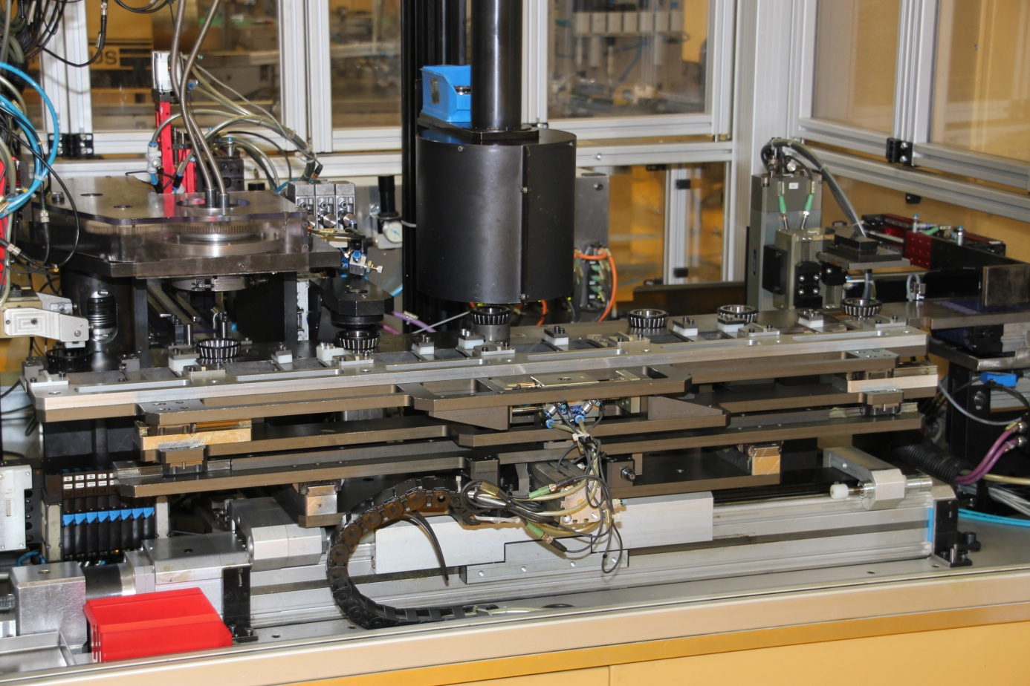

Debrecen, 2022. 09. 02.