ELE432 - Advanced Digital Design
Preliminary Work 3: Multicycle Processor
Ömer Faruk Sert 2210357097
1. I spent 10 hours to complete this preliminary work
2. 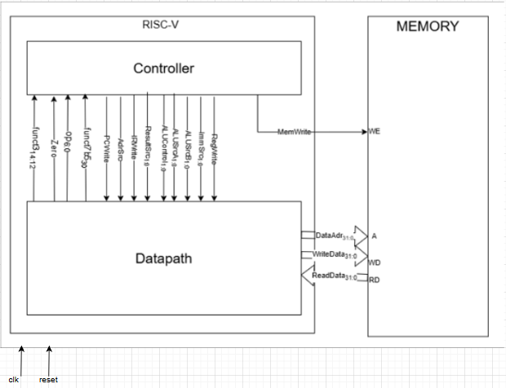
This diagram depicts the high-level structural design of a multi-cycle RISC-V microprocessor. The entire system is housed inside a primary top-level module and comprises two fundamental components:
- Unified Memory (mem): A single storage unit holding both the program's code and its associated data. It manages memory access—both reads and writes—directed by the DataAdr, WriteData, and MemWrite lines, and delivers the requested information back through the ReadData port.
- Processor Core (riscv rv): The central computational hub of the system, which is further separated into two distinct sub-sections:
  - Datapath (dp): The execution hardware. This block contains the Arithmetic Logic Unit (ALU), the register file, routing multiplexers, and essential state elements (such as the Program Counter and Instruction register) necessary to carry out mathematical operations and physically move data around.
  - Controller (c): The system's command center. It relies on a Finite State Machine (FSM) to interpret incoming instructions and produce the vital control signals required to synchronize and direct the actions of both the memory block and the datapath.
3.
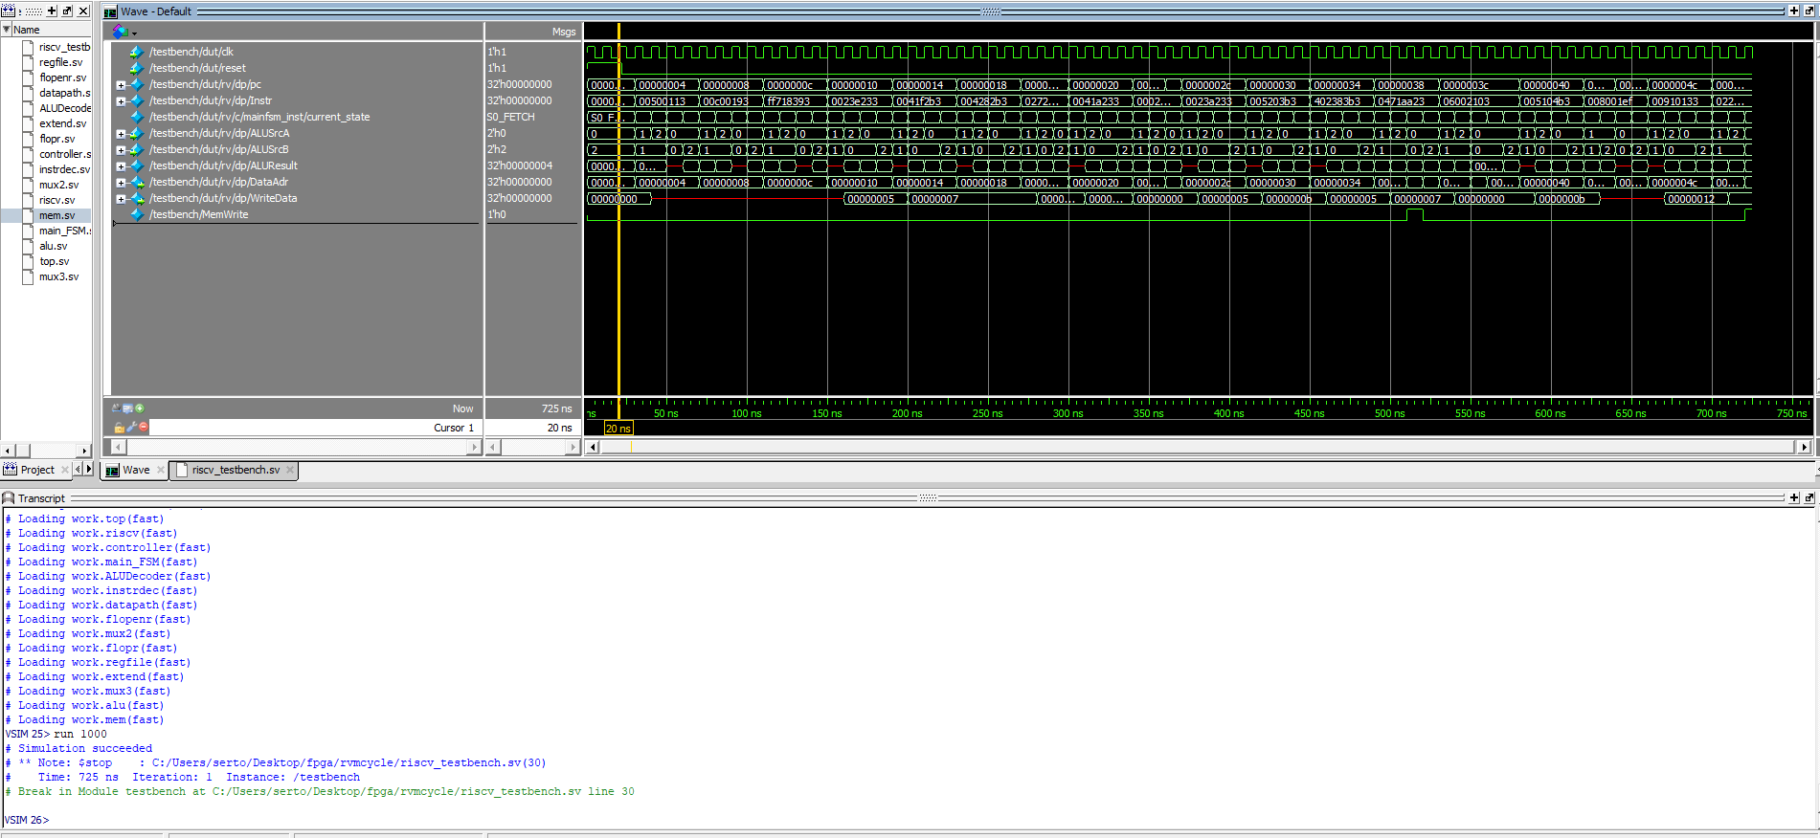
The simulation trace demonstrates that the CPU accurately processes the test program, ultimately storing the data value 25 at memory location 100. This final result verifies the proper functionality of the multi-cycle architecture.
Step (Adım) | PC (Hex) | Instr (Hex) | State (Durum) | Result (Hex) | Result Notes (Açıklama)
7 | 4 | 00c00193 | S0: Fetch | 8 | PC + 4 (Yeni PC değeri hesaplanır)
8 | 8 | 00c00193 | S1: Decode | X (veya Adres) | Branch Target hesaplanır (OldPC + Imm)
9 | 8 | 00c00193 | S8: ExecuteI | 0C | ALUResult = x0(0) + 12 = 12 (Hex: C)
10 | 8 | 00c00193 | S7: ALUWB | 0C | Result = ALUOut, bu değer x3 yazmacına yazılır.
11 | 8 | ff718393 | S0: Fetch | 0C | PC + 4 (Yeni PC değeri hesaplanır)
12 | 0C | ff718393 | S1: Decode | X | Branch Target hesaplanır
13 | 0C | ff718393 | S8: ExecuteI | 3 | ALUResult = x3(12) + (-9) = 3
14 | 0C | ff718393 | S7: ALUWB | 3 | Result = ALUOut, bu değer x7 yazmacına yazılır.
15 | 0C | 2,30E+234 | S0: Fetch | 10 | PC + 4 (Yeni PC değeri hesaplanır)
16 | 10 | 2,30E+234 | S1: Decode | X | Branch Target hesaplanır
17 | 10 | 2,30E+234 | S6: ExecuteR | 7 | ALUResult = x7(3) OR x2(5) = 7 (Binary: 011 OR 101 = 111)
18 | 10 | 2,30E+234 | S7: ALUWB | 7 | Result = ALUOut, bu değer x4 yazmacına yazılır.

5.
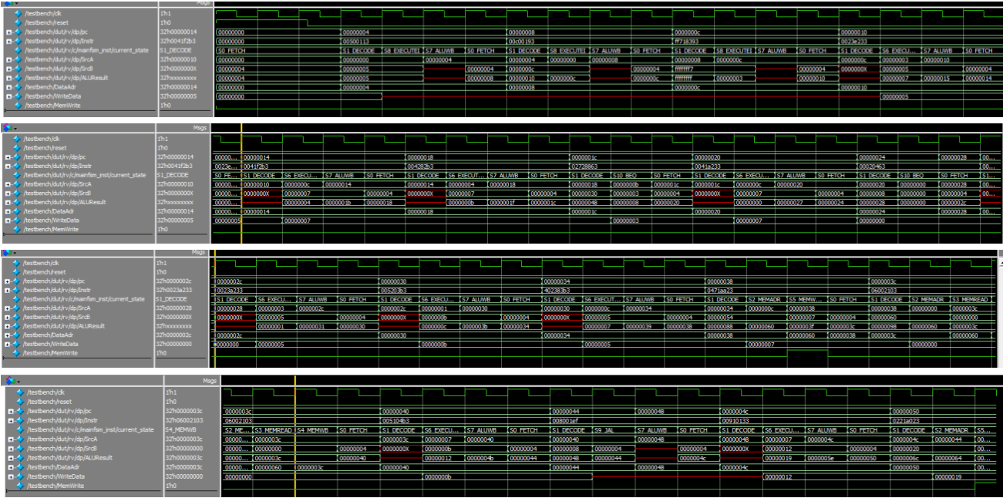
I divided waveform into 4 sequential part. From top to bottom the simulation time propagates.
6.
https://github.com/OmerFarukSert/ELE432-Pre3

