**GUIDE**

**Introduction**

QGIS serves as the cornerstone for a myriad of GIS-related application developments. Mastering its basic operations and ensuring its installation on your local machine are crucial initial steps for undertaking further tasks during your internship tenure. Acquiring proficiency in QGIS not only facilitates spatial data analysis but also forms the bedrock for advanced geographic information system applications. This foundational knowledge will be indispensable as you delve deeper into GIS project development and spatial data management throughout your internship.

**Aim**

To get up and running QGIS with Python on your PC **Deadline:** 01 Week

**Installation Guide:**

To use this software, you need to install following software on computer. Details of the requisite software are as follows:

* Install PyCharm community
* Install QGIS (3.22.16)

**[Do not download / install any other version, required version is 3.22.16]**

Once you have downloaded and installed the software, then Python interpreter need to be set in PyCharm.

**Installing Python libraries:**

Search the **OSGeo4W** in the search bar, or locate the OSGeo4W in C:\ drive of your PC inside QGIS (3.22.16) folder located / installed in C drive

**Select Local Disk C > Open Program files > Select QGIS 3.22.16 Folder > Open OSGeo4W.bat**

The below command prompt will appear on your screen.

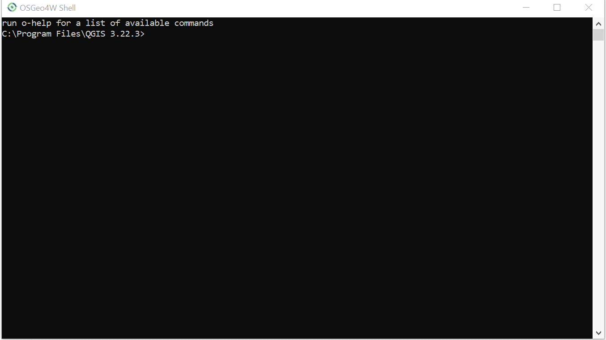

First of all install the version of pip compatible with QGIS 3.22.16.

**Python – m install pip == 21.2.4**

Now to install the libraries in this prompt you have to write the below code

For example, you want to install NumPy you will write **pip install NumPy.**

Before installing additional libraries, it's advisable to check for any pre-installed ones to avoid redundancy. Open the OSGeo4W Shell from the QGIS 3.22.16 installation directory (C:\Program Files\QGIS 3.22.16\OSGeo4W.bat) and start the Python interpreter by typing python. This will launch the Python shell where you can import libraries. Verify the availability of libraries by importing them; if they are already installed, you can skip their installation during setup.

**Required libraries to be installed**

Install the following libraries in OSGeo4W Shell

|  |  |
| --- | --- |
| **S No** | **Libraries** |
| 1 | NumPy |
| 2 | Pandas |
| 3 | Geopy |
| 4 | Matplotlib |
| 5 | Pyproj |
| 6 | Pyshp |
| 7 | zmq |
| 8 | Sklearn |
| 9 | Pytest |
| 10 | Haversine |

After installation of above above-mentioned libraries, setup the PyCharm interpreter

**Python Interpreter Settings in PyCharm**

* Open PyCharm Community on your computer and navigate to File > Open to access an existing project. Typically, software projects are located on the D: drive of your computer. Browse to D:\ProjectFolder, select it, and click OK to open the project in PyCharm

**Select File > Open > Browse the file path > Click OK**

Project will be opened and will be displayed on the left side menu under Project Tab.

* Now before executing python code files, relevant interpreter in PyCharm need to be configured, in this regard, click on **Settings** on the top right corner (as shown in following picture). The setting dialogue box will appear on your screen.

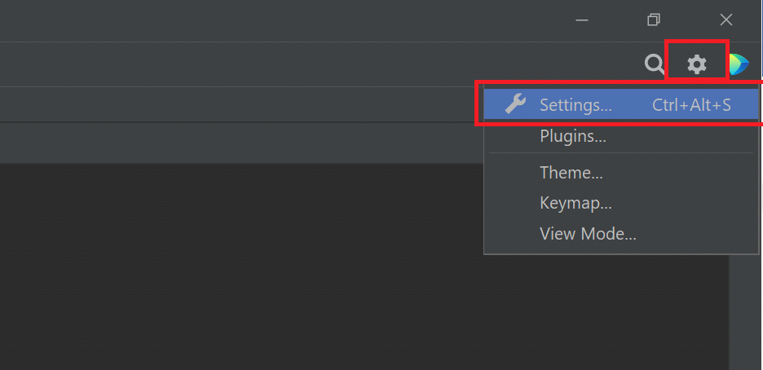

From the above settings dialogue box **Select Project > Python Interpreter**

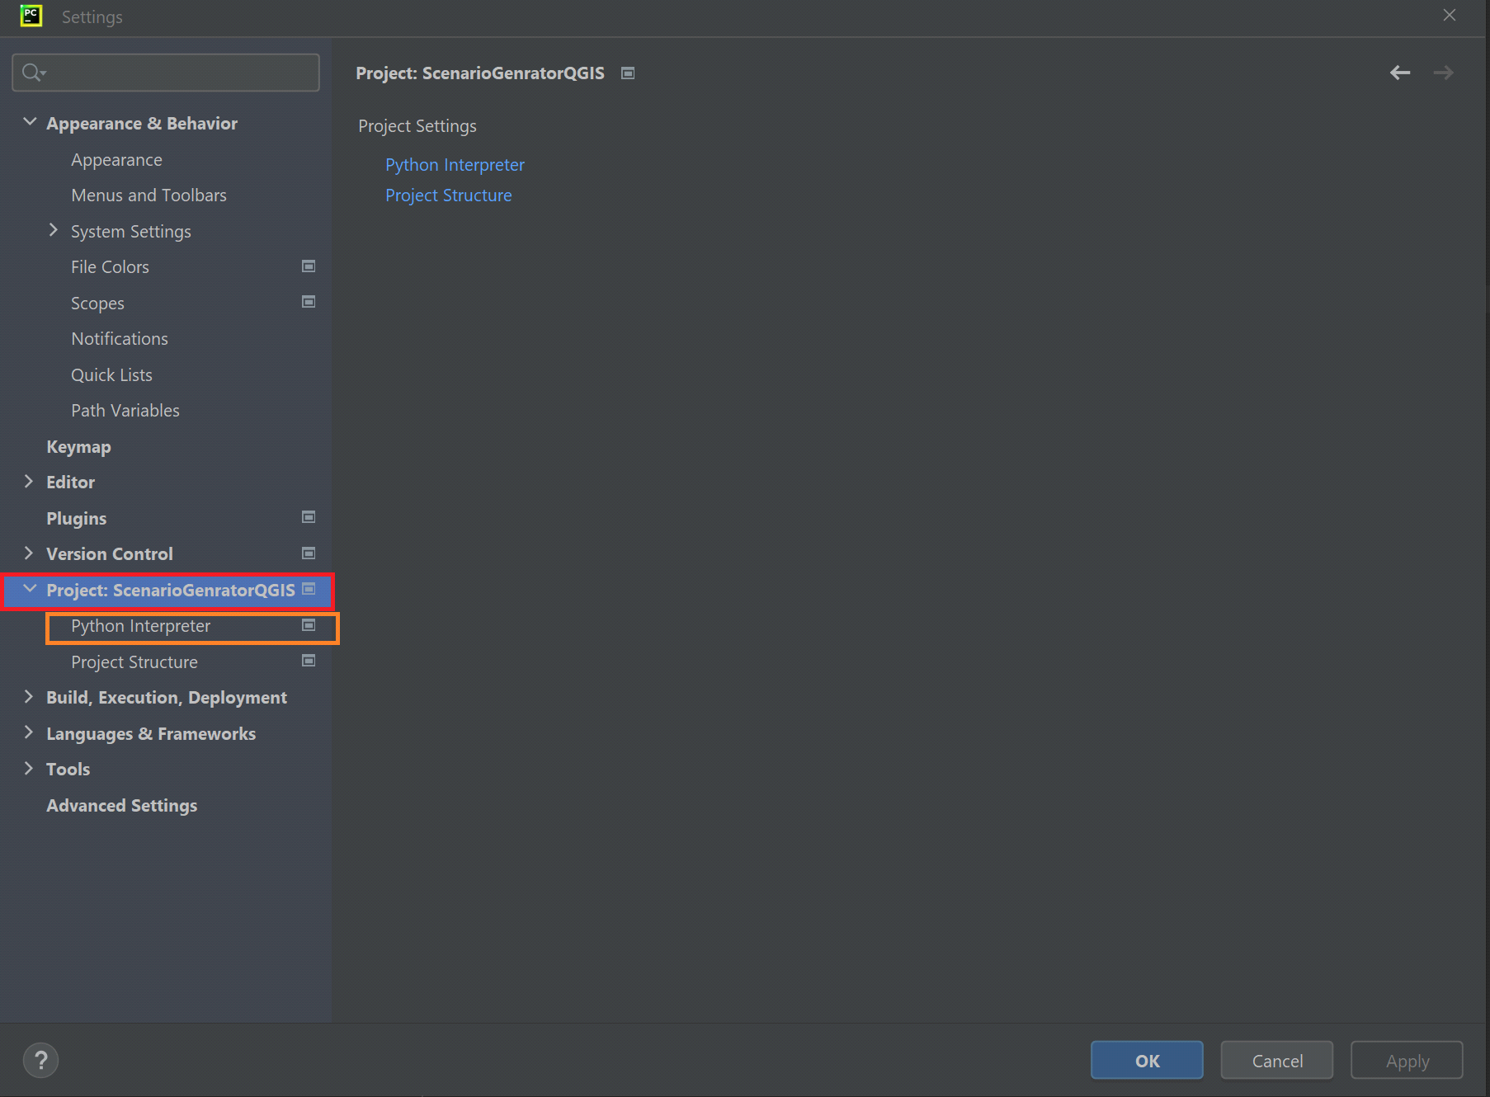

Open Python interpreter following dialogue box will appear on your screen.

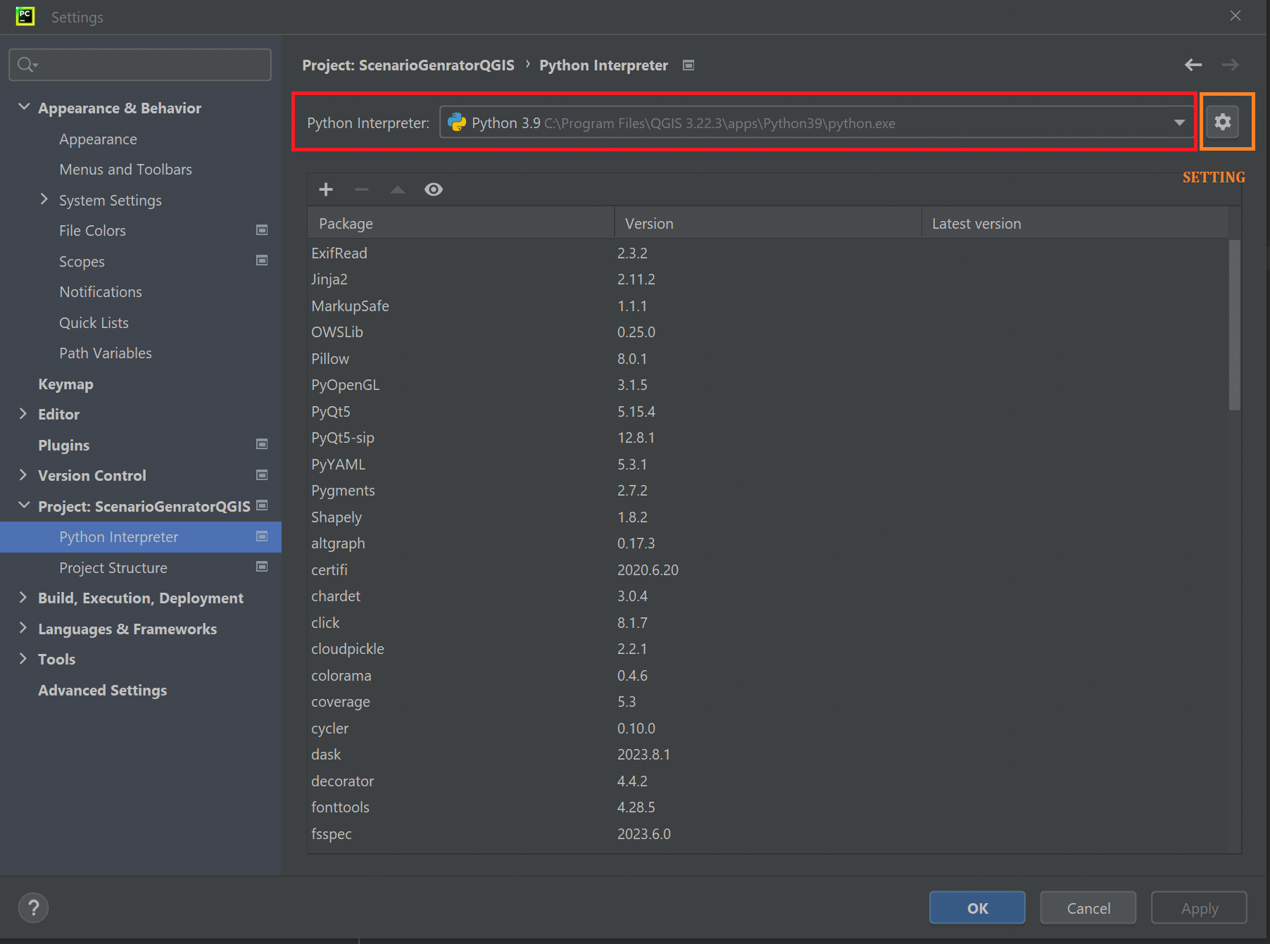

Click on add interpreter and then add local interpreter as shown below.

You will see the following interface.

Click on existing and then browse to the path below.

**C:\Program Files\QGIS 3.22.3\apps\Python39\python.exe**

Click ok to set path and pk another time to add interpreter.

)

You can see the setting option in front of python interpreter selection drop down menu. Click on **Gear icon** and select **Add**. Locate and Select QGIS Python on following Path

**C:\Program Files\QGIS 3.22.3\apps\Python39\python.exe**

**Adding Custom Paths in Python Interpreter in PyCharm**

Go to **Interpreter settings**, click **show all**, then go to **Interpreter paths** and set the

following paths in the python interpreter:

QGIS in C drive as default installation.

1. "C:\Program Files\QGIS 3.22.16\apps\qgis-ltr\python\plugins\processing"
2. "C:\Program Files\QGIS 3.32.16\apps\qgis-ltr\python\plugins"
3. "C:\Program Files\QGIS 3.22.16\apps\qgis-ltr\python\plugins\processing\core"
4. "C:\ProgramFiles\QGIS 3.22.16\apps\qgis-ltr\python\plugins\processing\algs\qgis"
5. "C:\Program Files\QGIS 3.22.16\apps\qgis-ltr\python"
6. "C:\Program Files\QGIS 3.22.16\apps\qgis-ltr\bin"

**Expected errors while executing in PyCharm**

1) DLL load failed while importing network

The above error can be resolved by following steps.

1. Run OSGeo4W shell as administrator.
2. Run “pip uninstall pyproj” and follow prompt to uninstall pyproj.
3. Run “pip install pyproj” and follow prompt to install pyproj again.
4. Rerun the project.

2) Could not find lib geos_c.dll

The above error can be resolved by following steps.

1. Run OSGeo4W shell as administrator.
2. Run “pip uninstall shapely” and follow prompt to uninstall pyproj.
3. Run “pip install shapely” and follow prompt to install pyproj again.
4. Run “pip uninstall pyshp” and follow prompt to uninstall pyproj.
5. Run “pip install pyshp” and follow prompt to install pyproj again.
6. Rerun the project.

3) DLL load failed for while importing _ssl

The above error can be resolved by commenting on lines 21, 25 and 29 of adaptors.py file that is shown in the error message.

**Post Installation: Integrating Python with QGIS**

1. **Understanding PyQGIS**: Learn about PyQGIS, the Python API for QGIS. Understand the structure and classes used for accessing QGIS functionalities programmatically. QGIS documentation serves detailed information of PyQGIS API implementation.
2. **Writing Simple Scripts**: Write and execute simple Python scripts within QGIS Python Console. Start with basic tasks such as loading layers, manipulating geometries, or performing spatial analyses.
3. **Writing Scripts in PyCharm:** Write and execute simple Python scripts within PyCharm IDE.