Apt simulatör quiz
What "Remote System Discovery" technique process was executed the most?
data.win.system.eventID:1 AND "Remote System Discovery"
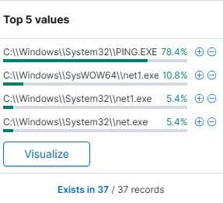
PING.EXE
What other "Remote System Discovery" technique processes were executed?
data.win.system.eventID:1 AND "Remote System Discovery"
net.exe
What was the parent image for both Remote System Discovery techniques?
data.win.system.eventID:1 AND "Remote System Discovery"
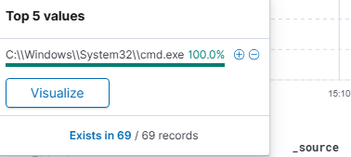
cmd.exe

DNS queries were run for 3 domains (Not google or github). List the first one in alphabetical order.
data.win.system.eventID:22
freenow.chickenkiller.com
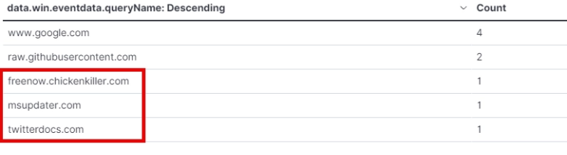
Has the first one domain ever been reported as being related to malicious activity?
yes
https://www.virustotal.com/gui/url/010a95efe8c0ee7b386f226c29a806fb14aa7f9956b861e6295bebb5523e94e6
Has the second domain (aphabetically) ever been reported as being related to malicious activity?
yes
https://www.virustotal.com/gui/domain/msupdater.com
Has the third domain (alphabetically) ever been reported as being related to malicious activity?
yes
https://www.virustotal.com/gui/domain/twitterdocs.com

Multiple PowerShell files (.ps1) were executed from the TMP directory? What was the first one in alphabetical order?
data.win.system.eventID:4104 AND data.win.eventdata.path:*TMP*
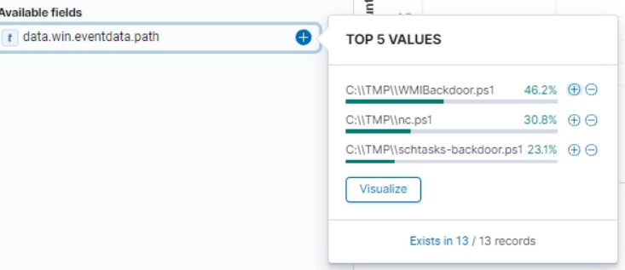
nc.ps1

What function is nc.ps1 defining?
powercat
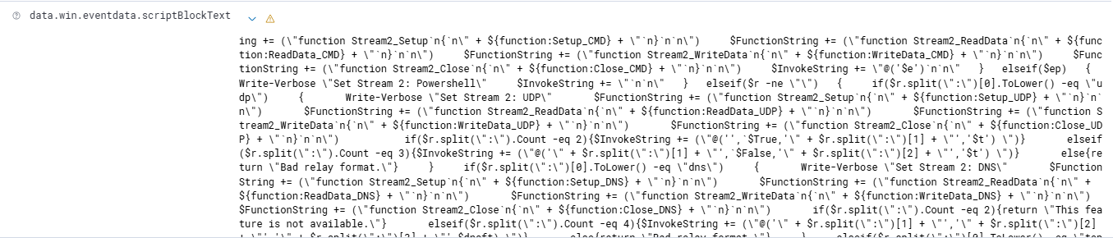

Similar to netcat, nc.ps1 gives the attacker a reverse ____to get access of the system? Fill in the blank.
shell

What image (.exe file) was involved in the "Maquerading" technique
data.win.system.eventID:1 AND "Masquerading"
svchost.exe
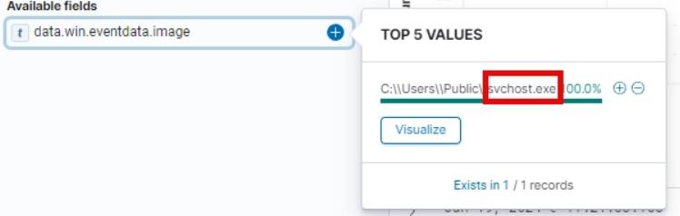

What well known password stealer was installed as a scheduled task?
Mimikatz

What is the output file of the password stealer identified in the previous question?
o.txt

What is the parent Image of both scheduled tasks?
Cmd.exe

