22

**Software Engineering**

**Online Food Ordering System**

Online Food Ordering System

1.1 Introduction

Online restaurant is a process of ordering food from a local restaurant or food cooperative through a web page. The Online Restaurant Management System provides convenience for the customers. This system increases the takeaway of foods than visitors and also provide service of delivery , customer can get his order online. Therefore, this system enhances the speed and standardization of taking the order from the customer. It provides a better communication platform. The user’s details are noted electronically. Restaurant bookings is a system to restaurant orders. This System set up menu online and the customers easily places the order with a simple mouse click. By using the food menu online anyone can easily track the orders, maintain customer's database and improve food delivery service. This system allows the user to select the desired food items from the displayed menu. The user orders the food items. The payment can be made online or pay-on-delivery system. The user’s details are maintained confidential because it maintains a separate account for each user. After the customer choose his order, the system asks the customer personal information (full name – address – emailphone number), the system saves all information and details of bill in the restaurant DB. Sometimes customer have offer discount when number of person more than 100 in his order and The discount rate determined by the manager. The system calculates the cost of the bill and Display it to confirm the booking with the time limit given to him for payment, All the input and output operation should stored in database by date and which user have done it. Alerts an important issue in this system such as new order, new addition and new foods.

1.2 Problem description

With the development of technology ,and accourding to health conditions. The online food order:

1. overcomes the disadvantages of the traditional queuing system.
2. Provides convenience for the customers.
3. It provides a better communication platform and the procedure

of taking a customer’s order became easier with this technology.

1. Enhances the speed and standardization of taking the order from the customer.
2. Speeds up the buying movement and securing user details,

Customers may place orders fast utilising the online meal ordering system, which generates an online menu.

Customers can also use a meal menu to keep track of their orders.

1.3 Scope

It may help collecting perfect management in details. In a very short time, the collection will be obvious, simple and sensible. It will help a person to know the management of passed year perfectly and vividly. It also helps in current all works relative to Online Food Ordering System. It will be also reduced the cost of collecting the management and collection procedure will go on smoothly.

Our project aims at Business process automation, i.e. we have tried to computerize various processes of Online Food Ordering System.

* In computer system the person has to fill the various forms and number of copies of the forms can be easily generated at a time.
* In computer system, it is not necessary to create the manifest but we can directly print it, which saves our time.
* To assist the staff in capturing the effort spent on their respective working areas.
* To utilize resources in an efficient manner by increasing their productivity through automation.
* The system generates types of information that can be used for various purposes.
* It satisfy the user requirement
* Be easy to understand by the user and operator .
* Be easy to operate .
* Have a good user interface .

1.4 Purpose

The purpose of online food ordering system:

1-faciliting the staff and manager of the restaurant to treat with customer as well as making it easier for customer to make order through the web where users can log on to our server and make a selection of whatever goods or food they like and pay via the internet

2-can make offer for customer who made many orders and they can suggest new food in the menu

3- this will provide a user friendly environment between the customer and employee

4-it will also help for easy retrieval of orders made by customer

5-A smart delivering system for helping delivery staff improves the quality delivering service

1.5 constrains

- to select the order ,user must login first

- when customer record a certain number of orders, we make a discount.

1.6 Requirments

Food ordering is a system to restaurant orders.

At the first time the program works the manager should add foods menu and the ingredients for each meal to restaurant DB,

Customer who wants to booking the restaurant

(Date – Kind of food – number of people – kind of booking).

User visit the restaurant website and verification of the possibility of booking the date on which the customer wants, then review menus

available in the restaurant, after that The system allows the customer to install the booking within the time limit given to the customer to pay the bill,

in the end the system allows the customer to suggest new and special meals or birthday cake to the main menu. After the customer choose all that steps,

the system asks the customer personal information (full name – address – emailphone number),

the system saves all information and details of bill in the restaurant DB.

Sometimes customer have offer discount when number of person more than 100 in his order and The discount rate determined by the bookkeeper.

which is added to the customer requests.

Pricing of new orders (new additions), which is added to the

customer requests.

System Requirements (Functional requirements)

4.1. The functional requirements of the customer

Access into the Website Verification of the possibility of booking the date on which the customer wants. Review menus available in the restaurant. The possibility of booking installed within the time limit given to the customer to pay the bill.

The possibility of adding new varieties (Birthday cake) to the main menu.

The functional requirements of the manager

Create new menus for customers. Edit menus Delete menus Add new foods

The functional requirements of the system

View the system to the customer the cost of booking.

Display system to the customer paid the amount required to confirm the booking with the time limit given to him for payment.

System offers customer discounts in case the number of guests exceeded 100 people.

System Requirements (Non-functional requirements)

The application must be able to work with all browsers used and also be the application interface is simple deal, and ensure ease of use and speed of response,

taking into account the high level of safety , reliability and the speed of the delivery request

0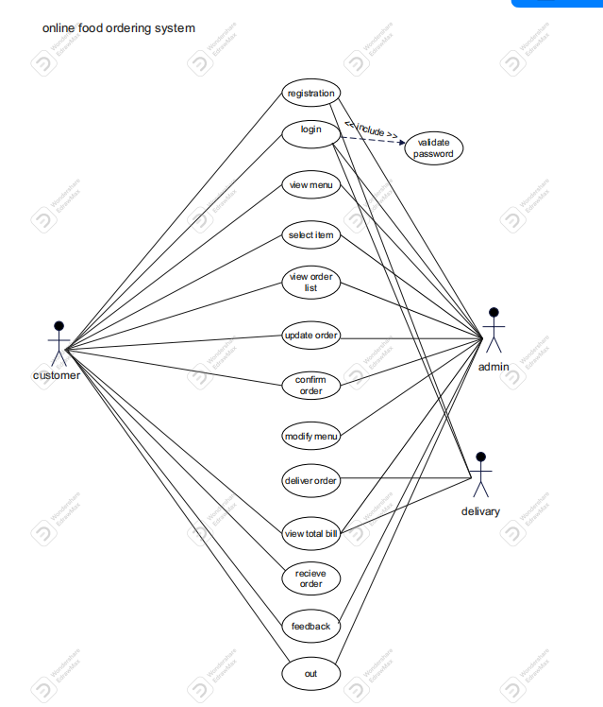

r

2.Use case diagram

2.1 Use case description

|  |  |
| --- | --- |
| **Use Case ID:** | 1 |
| **Use Case Name:** | register |
| **Actors:** | Admin, delivery, customer |
| **preconditions** | Customer enter it’s information |
| **Postconditions:** | User login the website |
| **Normal Flow:** | 1.user view website  2display registration page  3.Enter user’s name , number phone , password  4.prompt submit |
| **Alternative Flows:** | In step 4  Submit ‘s invalid |
| **Exceptions:** | System doesn’t work f there ‘s no connection |

|  |  |
| --- | --- |
| **Use Case ID:** | 2 |
| **Use Case Name:** | Login include password |
| **Actors:** | Admin, Customer, Delivery |
| **Preconditions:** | It must validate a user to enter in administrator mode using password. |
| **Postconditions:** | Login successfully.  Allow either customer or an administrator to view menu |
| **Alternative Flows:** | In step 1:  Insert the incorrect username  In step 2:  Insert the incorrect password |
| **Normal Flow:** | 1.Enter the username  2.Enter the password  3.login |
| **Exceptions:** | Login failed if username or password entered failed |

|  |  |
| --- | --- |
| **Use Case ID:** | 3 |
| **Use Case Name:** | View menu |
| **Actors:** | Admin, Customer |
| **Preconditions:** | It must validate a user to enter in administrator mode using password. |
| **Postconditions:** | Login successfully.  Allow either customer or an administrator to view menu. |
| **Normal Flow:** | 1.Select customer’s ID  2.Search by ID  3.view menu details |
| **Alternative Flows:** | In step 1:  Entered ID doesn’t exist |
| **Exceptions:** | Menu doesn’t display if ID doesn’t exist. |

|  |  |
| --- | --- |
| **Use Case ID:** | 4 |
| **Use Case Name:** | Select item |
| **Actors:** | Admin, Customer |
| **Preconditions:** | It must validate a user to enter in administrator mode  At the time of select item, each customer must be assigned a unique id number |
| **Postconditions:** | Login successfully  Allow the customer to select item |
| **Normal Flow:** | 1.Type customer’s ID, sometimes it is written automatically  2.press button to select item |
| **Alternative Flows:** | In step 1:  Doesn’t type the customer’s id  In step 2:  Item selected unsuitable |
| **Exceptions:** | ID is auto number and not null |

|  |  |
| --- | --- |
| **Use Case ID:** | 5 |
| **Use Case Name:** | View order list |
| **Actors:** | Customer |
| **Preconditions:** | It must validate a user to enter in administrator mode using password |
| **Postconditions:** | 1.login successfully  2.Allow the customer to view order list |
| **Normal Flow:** | 1.Customer login system  2.Customer click on button  2.The order list displayed on the system |
| **Alternatives Flows:** | In step 1  Doesn’t type customer’s id |
| **Exceptions:** | Item not selected, display please, select item |

|  |  |
| --- | --- |
| **Use Case ID:** | 6 |
| **Use Case Name:** | Update order |
| **Actors:** | Admin, Customer |
| **Preconditions:** | Login successfully  Allow the admin to enter in administrator mode using password |
| **Postconditions:** | Login successfully  Allow admin add item or delete item |
| **Normal Flow:** | 1.The admin open and logged system  2.The modify menu displayed on the system  3.Admin enters the information on the update form |
| **Alternative Flows:** | In step 1  Doesn’t type customer’s id |
| **Exceptions:** | Customer not satisfied , update database |

|  |  |
| --- | --- |
| **Use Case ID:** | 7 |
| **Use Case Name:** | Confirm order |
| **Actors:** | Admin, customer |
| **Precondition:** | It must validate a user to enter in administrator mode using password |
| **Postconditions:** | Login successfully  Allow the admin to confirm order |
| **Normal Flow:** | 1.The admin opened and logged in the system  2.Enter Full Name  3.Enter Address  4.Enter Email  5.Enter phone number |
| **Alternative Flows:** | In step 1  Doesn’t type customer ‘s id |
| **Exceptions:** | Customer not satisfied, update database |

|  |  |
| --- | --- |
| **Use Case ID:** | 8 |
| **Use Case Name:** | Modify menu |
| **Actors:** | Admin |
| **Precondition:** | It must validate a user to enter in administrator mode using password |
| **Postconditions:** | Allow the administrator to modify or update the menu |
| **Normal Flow:** | 1.the admin open and modify menu  2.the user click the menu button and the form’s displayed  3.the user click the modify button and can delete or add item  4.the menu’s modified |
| **Alternative Flows:** | Admin doesn’t fill the correct information in the form |
| **Alternative Flows:** | Admin doesn’t fill the correct information in the form |
| **Exceptions** | The system doesn’t work when there’s no connection |

|  |  |
| --- | --- |
| **Use Case ID:** | 9 |
| **Use Case Name** | Deliver order |
| **Actors** | delivery |
| **Preconditions:** | It must validate a user to enter in administrator mode using password |
| **Postconditions:** | Order’s delivered by delivery to customer |
| **Normal Flow:** | 1.check order’s ready  Prompt deliver done successfully |
| **Alternative Flows:** | In step 1  Order’s not ready delivery wait until it ‘s ready |
| **Exceptions:** | none |

|  |  |
| --- | --- |
| **Use CaseID** | 10 |
| **Use Case Name** | View total bill |
| **Actors** | Admin, Customer |
| **Preconditions:** | It must validate a user to enter in administrator mode using password |
| **Postconditions:** | Admin or customer can view total bill |
| **Normal Flow:** | 1.Enter card number  2.check card number’s valid  3.prompt successfully payment |
| **Alternative Flows:** | In step2  Enter invalid card |
| **Exceptions:** | The system doesn’t work when there ‘s no connection |

3.Activity diagram

ACTIVITY DIAGRAM is basically a flowchart to represent the flow from one activity to another activity. The activity can be described as an operation of the system. The basic purpose of activity diagrams is to capture the dynamic behavior of the system, It is also called object-oriented flowchart.

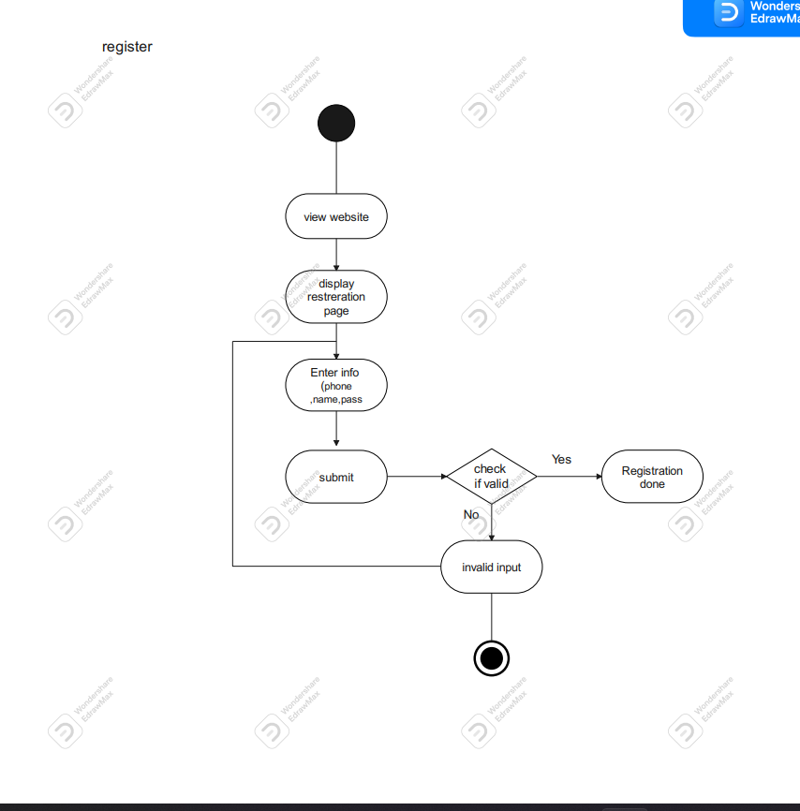

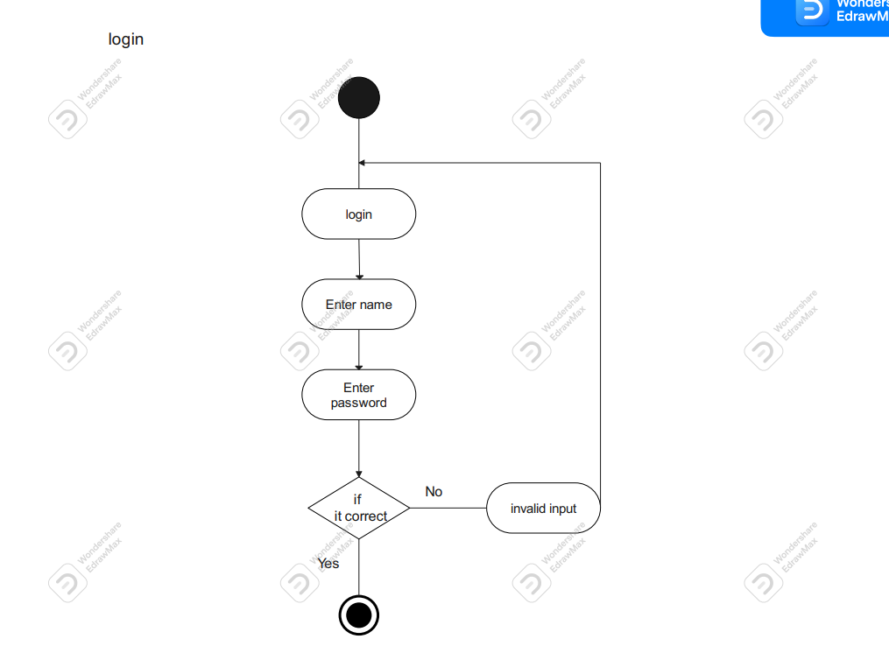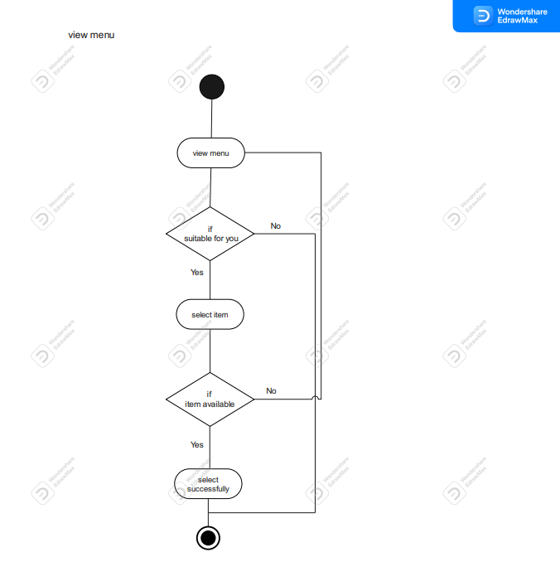

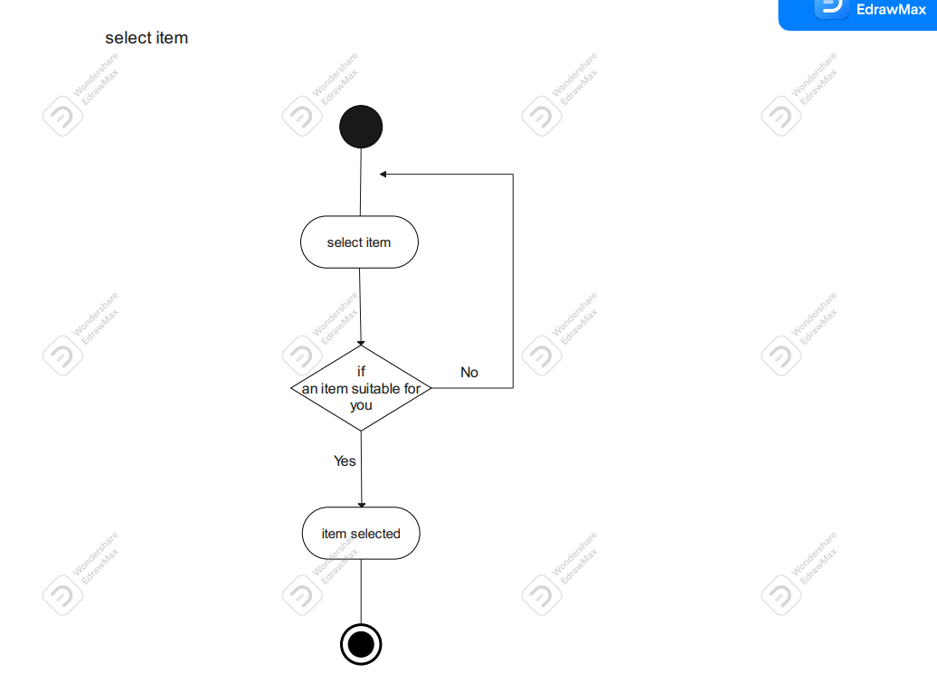

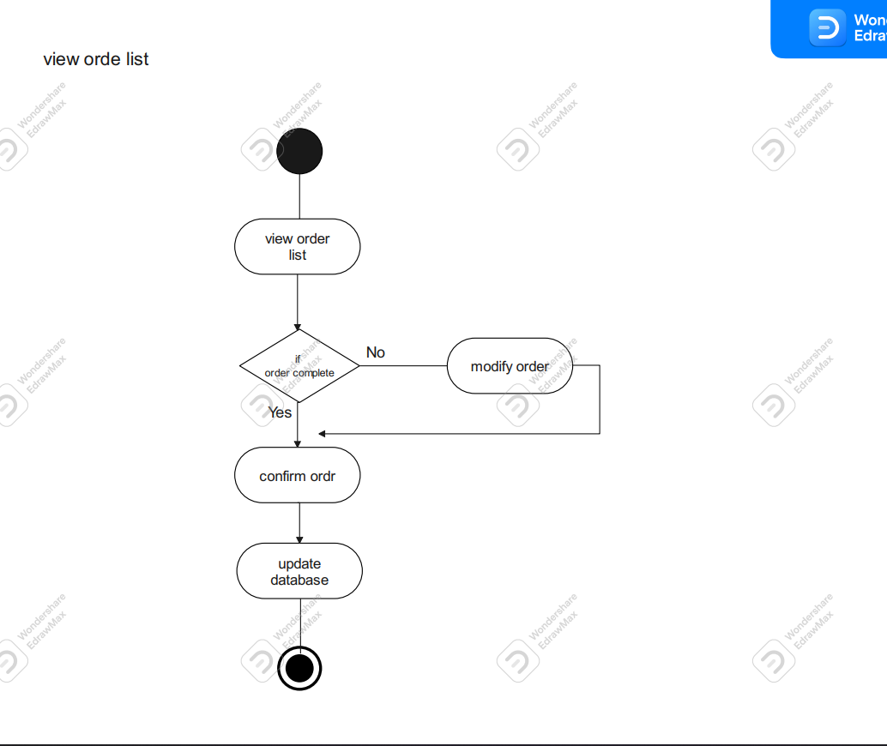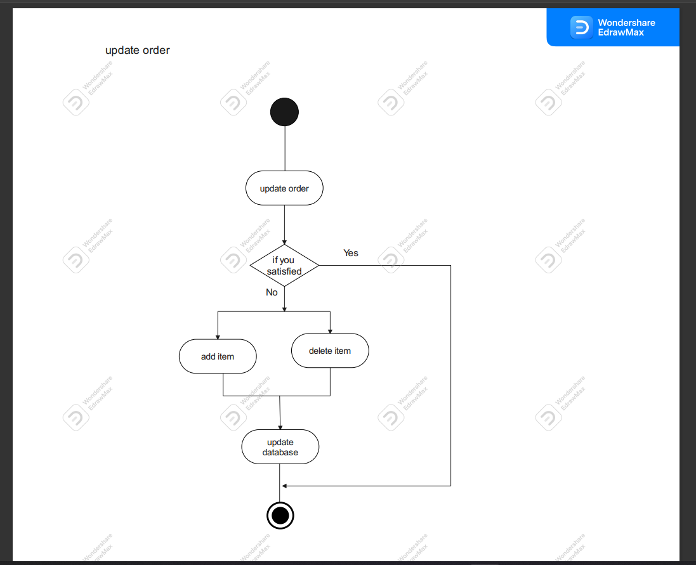

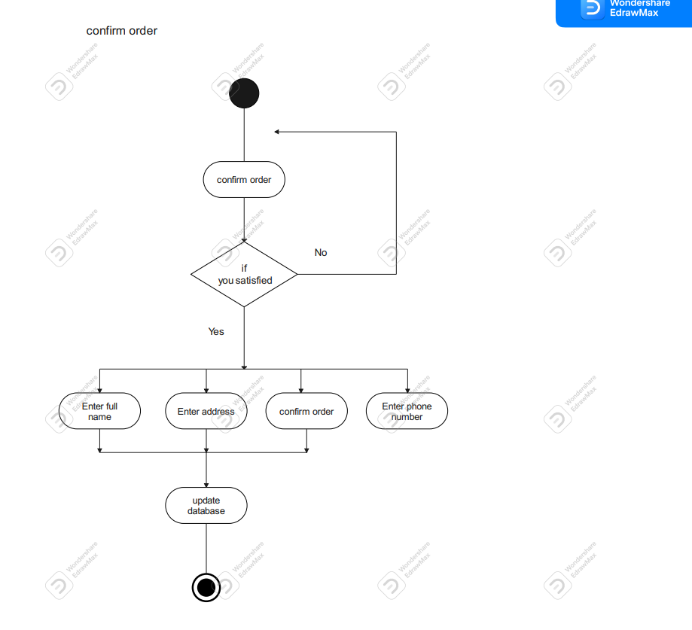

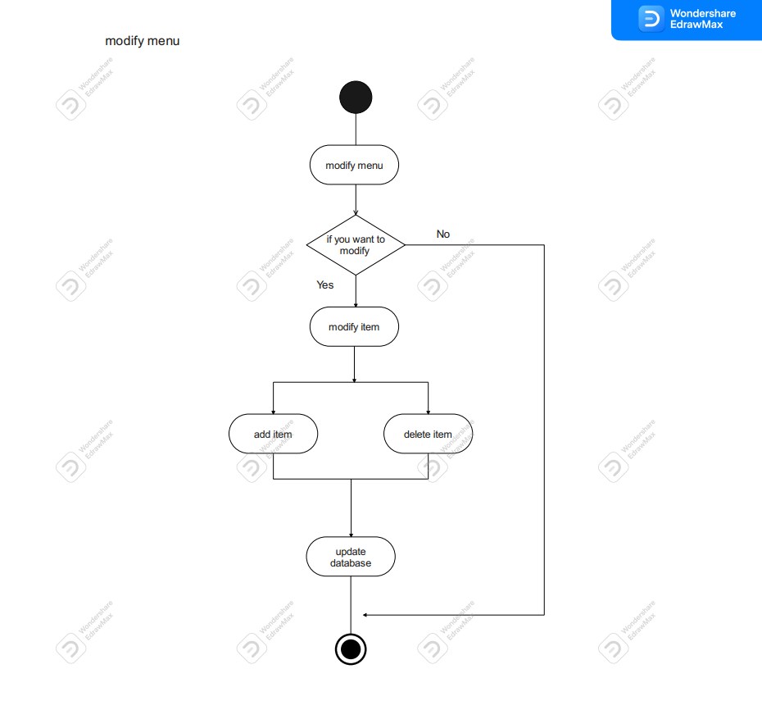

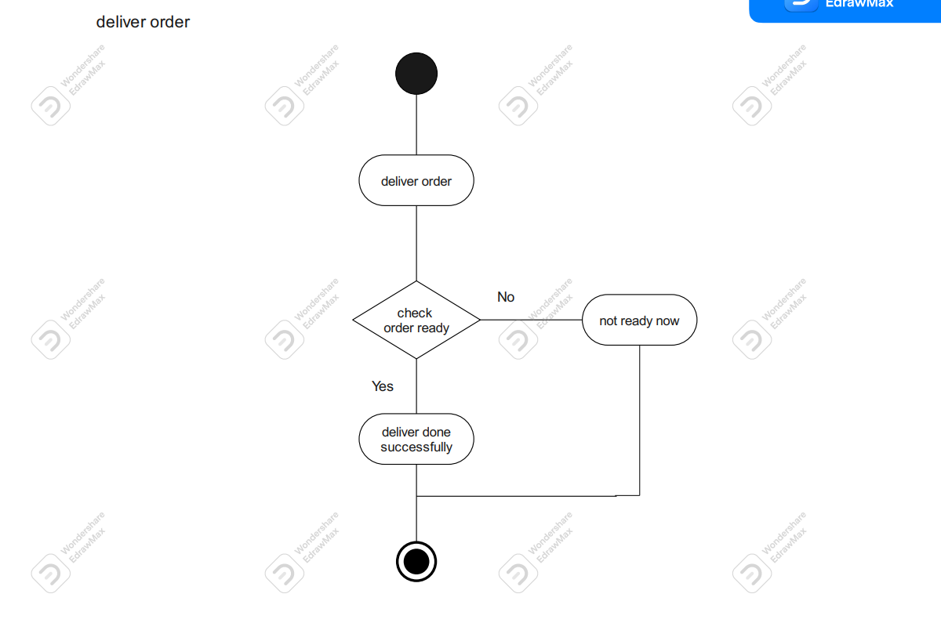

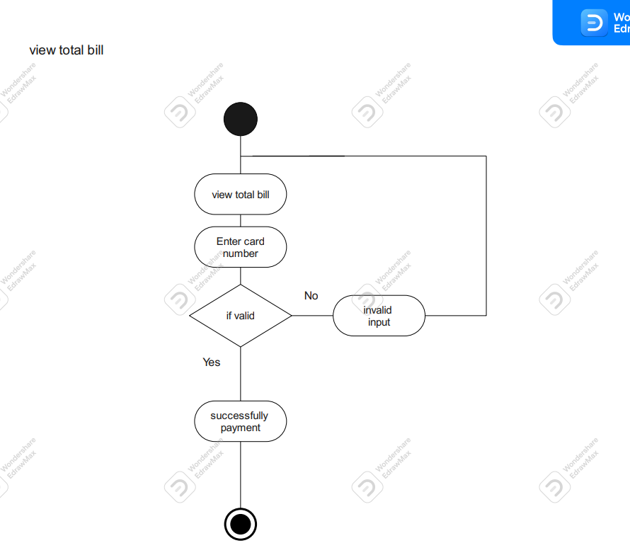

**3. class diagram**

class diagram in the Unified Modeling Language (UML) is a type of static structure diagram that describes the structure of a system by showing the system's classes, their attributes, operations (or methods), and the relationships among objects.

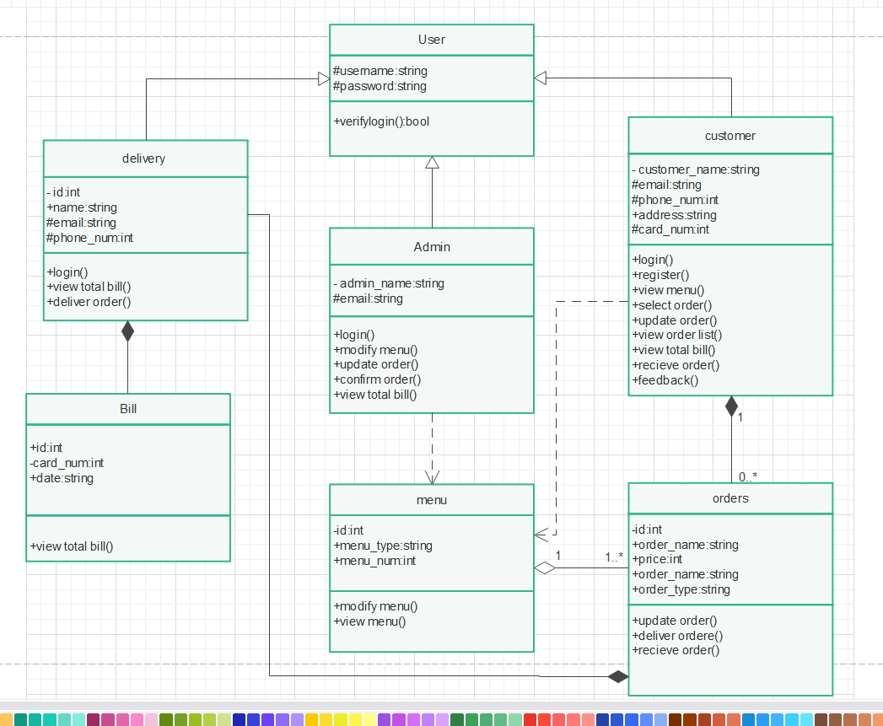

**4. Sequence diagram**

Sequence Diagrams are interaction diagrams that detail how operations are carried out. They capture the interaction between objects in the context of a collaboration. Sequence Diagrams are time focus and they show the order of the interaction visually by using the vertical axis of the diagram to represent time what messages are sent and when.

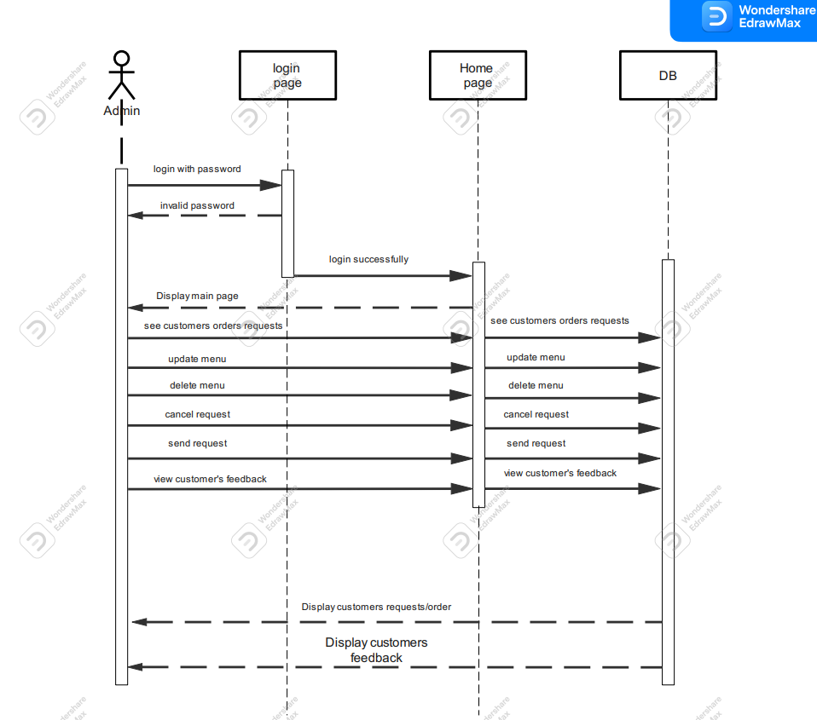

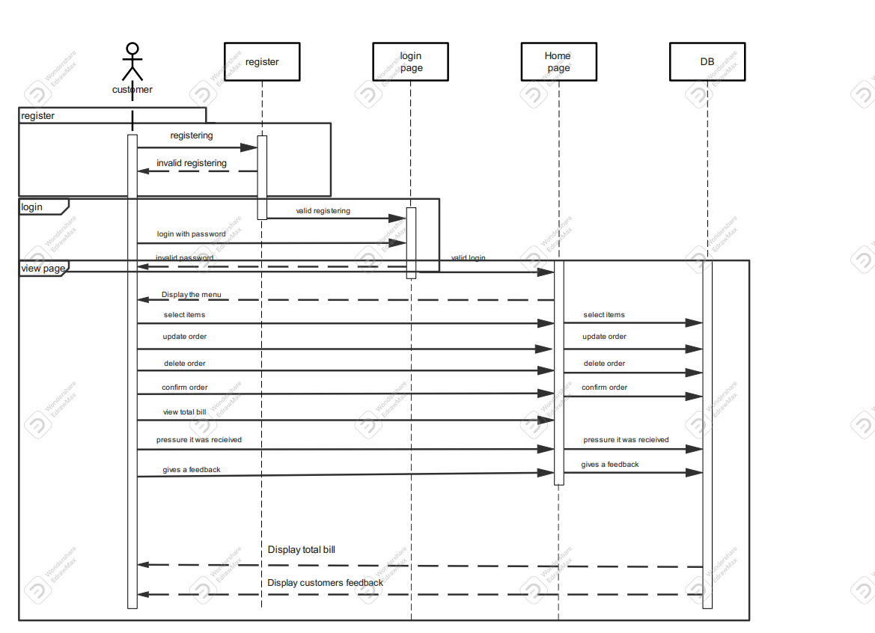

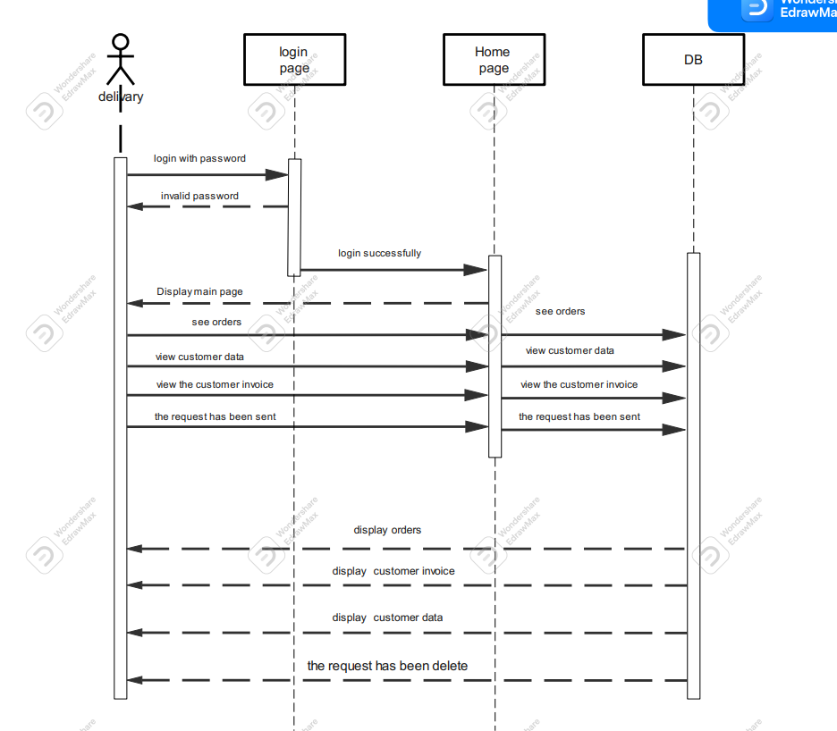

**5. ERD diagram**

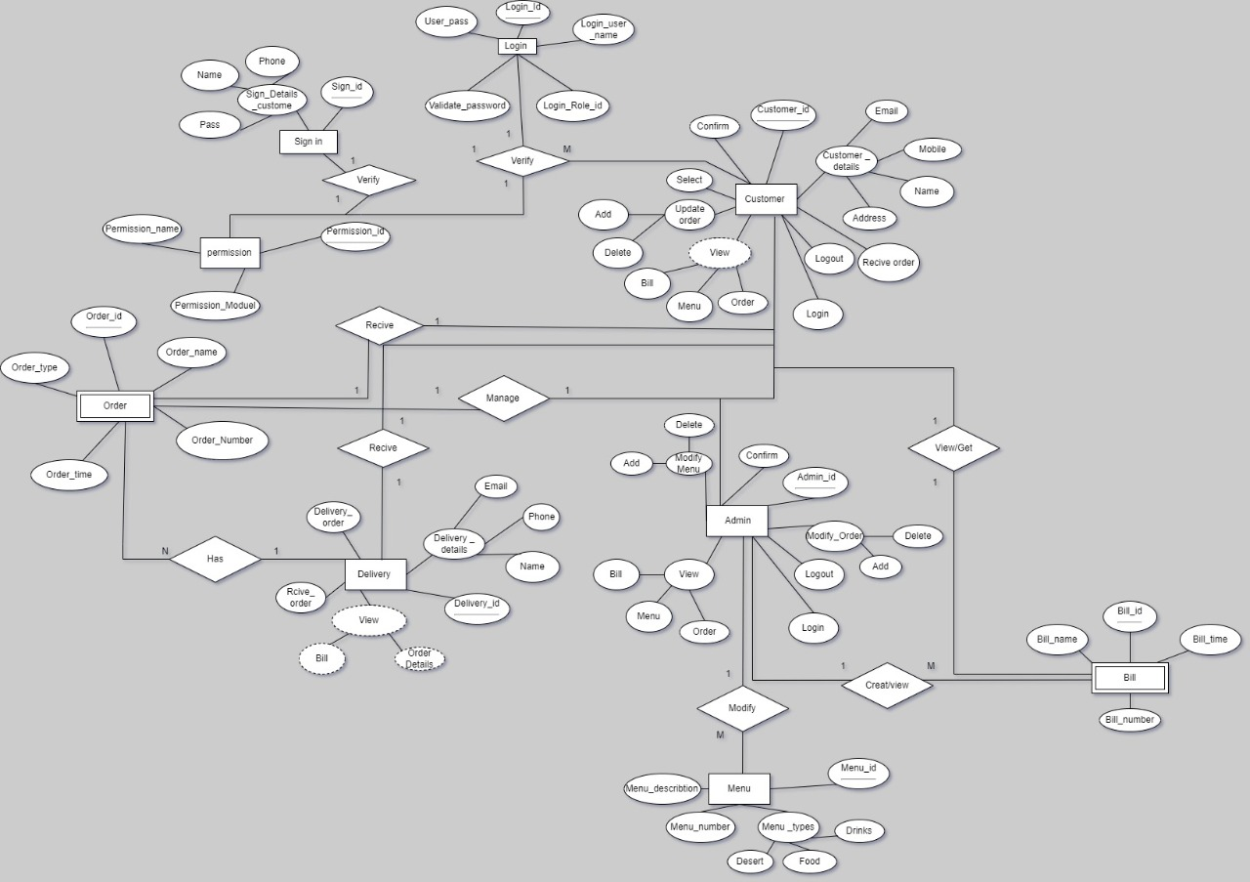

**6. Data flow diagram**



