TABLE OF CONTENTS

1. INTRODUCTION 1
1.1. Problem Statement 1
1.2. About OCR 1
1.3. Scope 4
1.4. Goal 4
1.5. Methodology 4
1.6. Report Overview 6

2. REVIEW OF LITERATURE 7
2.1 OCR System 7
2.2 Preprocessing 8
2.3 Feature Extraction 12
2.4 Character Recognition 13
2.5 Neural Network 15
2.5.1 Back Propagation Algorithm 18
2.6 Summary 19

3. DESIGN 20
3.1 Data Collection 20
3.2 Binarization 21
3.3 Segmentation 21
3.4 Framing 23
3.5 Thinning 24
3.6 Skew detection and correction. 25
3.7 Feature Extraction 26
3.8 Recognition System 28

4. IMPLEMENTATION 30
4.1 Choice of Platform 30
4.2 System Implementation 30
4.3 System Testing 36

5. CONCLUSION AND FURTHER WORK 40
5.1 Conclusion 40
5.2 Limitations 41
5.3 Further Work 41

6. REFERENCES 43

ACKNOWLEDGEMENT

SUMMARY

INTRODUCTION

Problem Statement
To implement Optical Character recognition software for Marathi language for the identification of machine printed discrete characters in Devanagari script. It should allow us to process an image and then identify the character distinctly. It should also take into consideration various variations and distortions in the characters.

About OCR
Optical Character Recognition refers to translating the text from image format into a desirable form that a computer can read and manipulate later. It is abbreviated as OCR. OCR can be either online accepting input from the user directly or offline recognition where inputs are already captured images which can be an image of previously typed document or image of handwritten text. Recognition can be classified into two categories:
- Recognition of machine printed data
- Recognition of handwritten data.
Machine printed characters are uniform in size, position and pitch for any given font. In contrast, handwritten characters are non-uniform; they tend to depend on the writer, environment, and mood of the person writing it. So the character style may be different every time it is written.
There are two basic methods used for OCR:
- Template matching
- Feature extraction.
Template matching is the simplest and the worst method as it does not consider variations like orientation and distortion. If there is a slight difference in the pattern, the system will fail to recognize the character. A library of character is maintained. During recognition, matching between the character and that of the standard dictionary is made.
Feature extraction is the process where we emphasize on the features that distinguish one character from other character. Set of these distinguishing features are prepared forming the feature vector. This feature vector is used for recognition of character. The system looks for general features such as loops, curves, vertical lines, horizontal lines, inclined lines, their position, size, etc.
OCR involves five discrete processes subsequent to image capture:
1. Identification of text and image blocks in the image: The document may have text and an image; for any OCR system images does not have any relevance. Text is important as we have to recognize those texts. Apart form it this document may also contain tables. Hence before the character recognition system is activated we have to remove those images and also the table borders and the cell borders. Only textual part is needed. Elimination of images and table layouts will help us convert the documents (set of character) in appropriate formats like ASCII and UNICODE.
2. Preprocessing: The images have to be processed for better identification. This process involves the elimination of distortions and variations, if any, in the image. It includes various preprocessing activities such as binarization, noise removal, segmentation, framing, thinning and skew detection.
3. Feature extraction: This is one of the important phases in character recognition. Recognition system is able to differentiate between the characters because of the features. Thus care must be taken while selecting the features so that the feature vector that we get is different for each character.
4. Identification/recognition: The feature vector is used for identification. It is compared with the definition of the character it has and finally generates the output.
5. Formatting output: This is the post OCR process. Once we have the character recognized we convert those into appropriate format which can be used later for editing.
OCR is important because it can help us save hours of labor when it becomes necessary to convert printed material into electronic format. Digitizing the document allows anyone on the web to submit them online. It also reduces the heap of paper and hectic process of posting. The character in ASCII or UNICODE format takes less space as compared to images. OCR is important because it helps us to use pen as an input device. People are accustomed to writing the documents rather than typing them. Typing is usually more time consuming work for a rookie typist. Pen will make the input process easy. Thus to implement pen input system we need the character recognition system to identify the character that the user writes.

Scope
Our project focuses on recognizing offline Marathi Language Characters. Our system works for discrete characters our project limit to only recognizing printed text. The system will be taking input in the form of printed image in .jpeg format. The characters can be of variable size. Our system also takes care of skew. Skew up to 10 to 15 degrees can be detected and corrected.

Goal
Lot of work has been done for OCR in English and in few Indian Language like Kanada, Hindi, and Oriya; no work has been done on Marathi language yet. Thus we are implementing an OCR system for Marathi language.
Following are the major tasks:
- Creating data resources for Devanagari script recognition.
Creating a standard training and testing set of machine printed characters to evaluate character recognition systems.
- Developing recognition engine that include:
- Techniques for image processing
- Techniques for recognition

Methodology
There are three main technical aspects of this project:
- Development of Data Resources
- Text Image Processing
- Recognition engine
Development of Data Resources
The following tasks have to be performed:
1. Collection of data sets: In this step data is collected by scanning images of characters.
2. Creating a representative collection of different fonts with varied size: Here the collected data is arranged as per the fonts and size of characters. It is then categorized as training set and testing set of data.
Text Image Processing
Devnagari script consists of 16 vowels and 36 basic consonants. Each of the consonant combines with vowel modifiers to create new characters. Optical Character recognition of Marathi language starts with scanning the image under consideration i.e. data acquisition. Once the image is scanned the image has to undergo various preprocessing steps such as binarization, skew detection and correction, framing, thinning, and segmentation followed by feature extraction. Every character will be recognized by its peculiar features.
Recognition engine
We have used neural networks for recognition. We have considered feed forward network with back propagation logic. The inputs are first trained using suitable training set and later the system is tested with the help of testing set of data.

Report Overview
Chapter 2 covers the literature review where relevant work reported in literature is explained along with the relevance of that work with our system under consideration.
Chapter 3 gives the description of optical character recognition systems, the various techniques involved and the various modes of operations.
Chapter 4 gives the design considerations of our system. It explains the various techniques we have applied in the implementation of the system.
Chapter 5 gives detailed implementation details along with GUI's and the basic implementation work flow.
Chapter 6 discusses results, conclusion and the further work that can be done.

REVIEW OF LITERATURE

OCR System
In recent times there has been much emphasis on optical character recognition for English characters and on some Indian Language likes Kanada, Oriya and Hindi but no work has been done in Marathi language. OCR is the system designed to interpret typewritten or handwritten character into appropriate format (e.g. ASCII or Unicode).
The basic stages in any OCR system are:
- Data acquisition
- Preprocessing activities
- Feature extraction
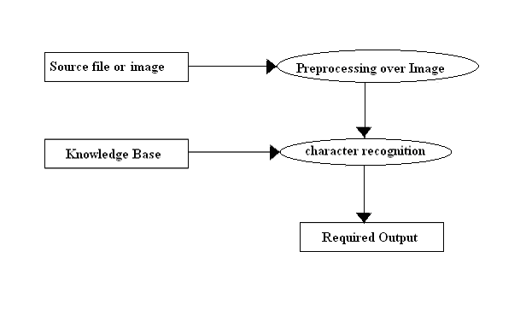
- Character recognition
Figure 2.1 Basic Stages in character recognition.
These are explained in detail below.
Data acquisition is the process of collection of sample data which can be used by the system. The sample can be hand written, scanned image or type written document. The image file acquired can be of type JPEG, TIFF, GIF etc.

Preprocessing
Image preprocessing is used to enrich the image. The features extracted from this ameliorated image are more eminent. The different processing activities are binarization, noise removal, segmentation, framing, thinning and skew detection and correction.
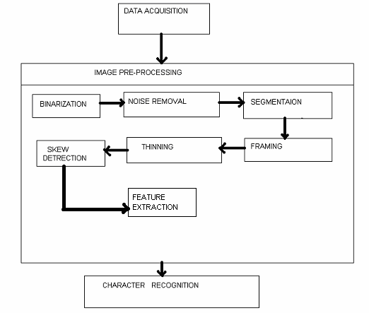
Figure 2.2 Pre Processing steps

i) Binarization: Image binarization converts a gray scale image into a black and white image. It helps us identify the pixels that constitute the character. We plot the histogram of an image and select the appropriate threshold value from the histogram. This threshold value is used to binarize the image. The input file may also contain the image (pictures) like some logo or charts along with the text so before binarization all such irrelevant pictures must be removed [8].
ii) Noise Removal: This event occurs when there is presence of external noise. The major work in this event for the system is, monitoring the image & eliminating any white or black noise, if present. Noise may be a single point but in Marathi script there are characters which have isolated set points which is significant. For example, character ‘am’ and character ‘a’, the difference is that ‘am’ has a dot over ‘a’. Thus during noise removal care must be taken these significant points in the character are not removed assuming it to be noise.

iii) Segmentation: In segmentation, a field is separated into its individual characters. Segmentation is needed because the character may be a consonant or a combination of consonants and vowels and a single character acts as input for recognition. Also a document contains paragraphs that have words and words are the set of characters; thus we need to isolate the characters for recognition. Paragraphs has lines, these lines must be separated before characters are isolated. To segment we plot the histogram, that is, count the number of pixels that are set in each row or column of the image. Appropriate candidate points are selected in the histogram and are fragmented into sub components as shown in figure 2.3. When histogram is applied to the row (horizontal histogram), line separation is performed where as histogram applied on column (vertical histogram) gives character segmentation [8].
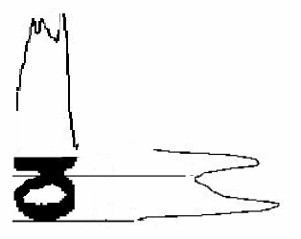
Fig 2.3 Horizontal and vertical histogram

iv) Framing: It is used to scale the image to the specified size. It makes the system scale invariant. It has two options zooming or shrinking. Either of it is selected to make the size of grid fixed. Different characters will have different sizes and if the size of character is greater than the frame size, to accommodate it shrinking is used and if the character is smaller we use zooming. Zooming has two steps: the creation of new pixel location and assignment of the gray level to those pixels to maintain the continuity of the images; care should be taken that there are no breaks in the image. In order to assign the gray level to any pixel we look for the closest pixels in the original image and assign it to the new pixels. This method is called nearest neighbor interpolation. We can use pixel replication method for zooming the image to its integral multiples, for instance for the frame of double size we can replicate the columns. Duplication is done to zoom the image till the required size is obtained. Although the near neighbor method is fast, it brings checkerboard effect. The shrinking process is somewhat similar to the zooming process the only difference is instead of adding the new column in zooming; we just delete the rows or the column for reducing the size of the character. It is basically deletion of redundant pixels [8].

v) Thinning: It is the process of peeling of pixels without loosing its original shape. In this process we remove redundant data. The basic properties of thinning are:
- Obtained image should be as thin as possible.
- Obtained image should be connected.
For thinning, morphological operation can be used. Hilditch Algorithm can also be used for thinning [8]. Figure 2.4 shows the result of thinning operation on any image map.
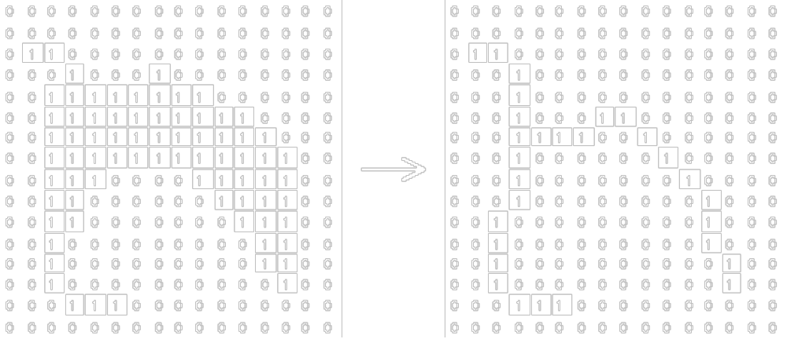
Fig 2.4 Result of Thinning operation

vi) Skew Detection and Correction: When the image is scanned, due to orientation of the image, skew is introduced in the scanned image. To eliminate this, skew detection and correction is used. As this image is forwarded for recognition an effective skew detection and correction method is required. To correct the inclination (skew) Hough transform can be applied to the image array but it has a high computational cost [11]. In another way, we can divide a document into blocks and use median and cross correlation on those block for calculation of skew angle [12]. We can also use moments and histogram on the entire document [13].

Feature Extraction
Features are the prominent characteristics of the characters. Feature extraction is the process of drawing out these features from the characters and giving it to the recognition engine for recognition. Different methods used for the feature extraction are as follows:

1 Image Descriptor: Image is considered as an array with values ‘0’ or ‘1’. This entire bitmap is passed to the classifier. This mechanism is not font invariant, also if the image size is 100* 100 then number of inputs to the image will be as high as 10000. It is not noise tolerant. To reduce the number of input to the system we introduce blocking. We divide image into block and count number of set pixels and pass the value. It helps to control the number of inputs.
2 Structural descriptor: Structural descriptors consider strokes (vertical or horizontal strokes) and orientation strokes of a character. Structural descriptors examine the shape of the character. Shapes are recognized, then they are coded. These codes are decided according to their nature of shape. The shapes within the character are considered while constructing the feature vector as explained. Consider an example, we divide image into regions and then describe them. In each of obtained regions, we look out for the strokes (horizontal bar or vertical bar), loops, and different curves and record even their orientation. We describe all of the above using the Freeman’s code. Now we create the chain code by appending all the code in the given region. The chain codes for all the regions form the feature vector. The difficulties in this method are in segmentation of the regions into specified curves, strokes and loops [5].
3 Mathematical descriptors: In this method various transform such as Fourier Transform and wavelet Transform can be used. Wavelet Transform is the alternative to Fourier Transform [14].
Zernike moment can also be used as features for the character. Moments of appropriate order is calculated using the basic function which is complex polynomial based on image intensity and is defined in unit circle. It is robust to noise and is rotation invariant [6].

Character Recognition
Character recognition is a process in which a character is recognized by its features. Features here could be the information about the character image or the information derived from the image.

Template Matching: In this method the input image is simply ANDed with the Sample images of each character. It operates on each pixels of the image. This character recognition method is noise sensitive. Minor changes in orientation of input image might result in failure of the system to recognize the character. It is not a reliable procedure for character recognition.

Generalized Hausdorff distance: The input image and the model image are considered to be the set of points. Hausdorff distance is calculated from the input image to the sample image. Each pixel in input image is ranked. The rank is based on the distance based on the nearest point in the sample image. Higher rank is given to the point with higher distance i.e. higher ranks are allotted to the pixel least similar. The housdorff distance methods measures the degree of dissimilarity between the two images [3].

Support vector machine: In this method the set of sample data are collected and plotted as sample points on a plane. This plane is divided into hyper planes. The distance between the hyper planes is calculated. This function simply does mapping of input to some function of sample. This function is derived from the distance between these hyper planes. This method has good generalization capability but the computation time increases during the testing phase [15].

Neural network and fuzzy logic: This method combines the learning of neural network by weight adjustment and human like reasoning of fuzzy logic using the fuzzy set. It follows if-then rules where we check, which membership function represents the input and appropriate action for that membership functions is performed. The knowledge in represented in form of fuzzy rule. In fuzzy set the boundary conditions change gradually as in real word [10].

Artificial Neural network: An artificial neural network (ANN) or commonly just neural network (NN) is an interconnected group of neurons. ANN has neurons and all those neurons are connected by synapse. Each synapse has some weights associated with it and the identification information about the source and the destination neuron. The weights on each synapse are adjusted using back propagation logic [10].

Neural Network
Neuron is the basic building block of a neural network. A neuron is a communication medium that both accepts input and produces output. The neuron receives its input either from other neurons or the user program. Similarly, the neuron sends its output to other neurons or the user program. When a neuron produces output, that neuron is said to activate, or fire. A neuron will activate when the sum of its inputs satisfies the neuron’s activation function.
Consider a neuron that is connected to a number of other neurons. The vector “w” represents the weights between this neuron and the other “k” neurons. We will say that this neuron is connected to “k” other neurons. The vector “x” represents the input to this neuron from each of the other neurons. Therefore we must calculate the sum of every input x multiplied by the corresponding weight “w”. This is shown in the following equation.
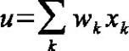
This sum must be given to the neurons activation function and the corresponding neuron fires if the value of u is greater than the threshold value set.
Neurons are usually grouped into layers. Layers are groups of neurons that perform similar functions. There are three types of layers. The input layer is the layer of neurons that receive input from the user program. The layer of neurons that send data to the user program is the output layer. Between the input layer and output layer can be zero or more hidden layer. Hidden layer neurons are connected only to other neurons and never directly interact with the user program.
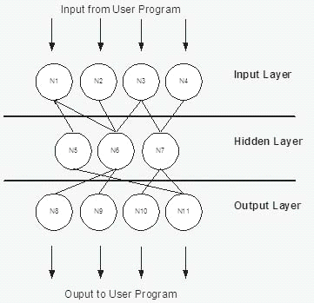
Figure 2.5 Neural Network Layers
(Adapted from http://www.heatonresearch.com)
Figure 2.5 shows a neural network with one hidden layer. Here you can see the user program sends a pattern to the input layer. The input layer passes the intermediate values of the input layer neurons activation function to the hidden layer and then the hidden layer passes its values to the output layer. Finally the output layer neuron fires.

There are two types of networks:
Ø Feed forward
Ø Feedback
Feed forward

I
N
P
U
T
S
O
U
T
P
U
T
S
Figure 2.6 Feed forward Network
Feed forward networks are the ones where the input is passed from one layer to the other. For example neuron of 1st layer is connected to that of 2nd, 2nd to 3rd and so on till (n-1) is connected to nth layer neuron. Here the solutions are known and weights are learned. It is characterized by the lack of feedback. This type of connection can be connected in cascade to create a multilayer network. It is also termed as multilayer perceptrons.
I
N
P
U
T
S
Feedback
O
U
T
P
U
T
S
Figure 2.7 Feedback Network
Feedback networks can be obtained from the feed forward network by connecting the neuron outputs to their inputs. For example neuron of 1st layer is connected to that of 2nd, 2nd to 3rd and so on till (n-1) is connected to nth layer neuron and their outputs are again connected as feedback to the inputs.

2.5.1 Back Propagation Algorithm
Back propagation is a form of supervised training. When using a supervised training method the network must be provided with sample inputs and anticipated outputs. These anticipated outputs will be compared against the actual output from the neural network. Using these anticipated outputs the "back propagation" training algorithm then takes a calculated error and adjusts the weights of the various layers backwards from the output layer all the way back to the input layer.

Summary
The character recognition process has many preprocessing activities, as mentioned in this chapter. These activities are performed to enhance the image. To reduce redundancy we use thinning where as variation in the character set is removed by skew detection and correction and framing is done for size invariance. Segmentation is used only to extract the required information. These image processing activities gives a robust image which can be used to extract the features of the character.
Different methods discussed in the chapter for feature extraction are Image descriptors, Structural descriptors, Mathematical descriptors. Image descriptor is the approach in which the image itself is given as an input for recognition. Structural descriptor is based on the components present in the character where as mathematical descriptors are based on the mathematical properties in numeric form.
Various methods can be used for recognition process. Template matching is the simplest and most inefficient method. Generalized Hausdorff distance, Support Vector Machine, Neural Network, Neural network and fuzzy logic are some of the other better methods, which can be used for recognition.

DESIGN
This section discusses our approach towards character recognition. This project focuses on recognizing discrete Marathi Language Characters. System will be taking input i.e. characters in form of scanned image. This image is binarized and then it undergoes various pre-processing and processing activities. Features are then extracted from this digitized image and these are used for training the Neural Network. Once the network is trained it is used for recognizing.

We will now discuss the various steps involved in our systems and our approach to implementing them. Specific implementation aspects are covered in the next chapter.
Steps Involved in our system are as follows:

3.1 Data Collection
We have collected samples of Marathi characters. Image containing single discrete character is scanned and the image is stored in .JPEG (Joint Photographic Experts Group).The reason for selecting jpeg as the file format is because jpeg supports image of any size, resolution and source. Source of our data is printed document which is stored in disk.

We have two sets of samples. Size variations in fonts are accepted by the engine. One set is used for training the network while the other is used for testing. Our training set includes eleven fonts while testing set includes five fonts.

Fonts used for making the Training set are Shiv01, Shusha, Kruti Dev 010, Kruti Dev 011, Kruti Dev 012, Kruti Dev 013, Kruti Dev 014, Kruti Dev 035, Kruti Dev 060, Kruti Dev 110 and Kruti Dev 111.

Fonts used for making the Testing set are Kruti Dev 016, Kruti Dev 26, Kruti Dev 36, Kruti Dev 041 and Kruti Dev 044.

3.2 Binarization
Image Binarization is a mandatory step required by our recognition engine. This is the first pre-processing activity done by our engine.
In this step a gray scale image is converted into a black and white image. It helps us to identify the pixels that constitute the character. Histograms for various characters are plotted. By observing various histograms we have selected an appropriate threshold value. The threshold value selected by us is 105. This threshold value is used to binarize the image.

3.3 Segmentation
In segmentation, a field is separated into its individual characters. Segmentation is needed because the character may be a consonant or the combination of consonants and vowels as single character act as input for recognizing system.

To segment we pass the scan line in the image. To separate the character row wise we pass the horizontal scan line and to isolate the character column wise we pass the vertical scan line. First we separate the row and then isolate the character in the row by passing the vertical scan line. The steps for identifying the starting and the ending point of the character is as explained below:
- Pass the scan line for ever row or column.
- Count the number of pixels in the scan line.
- When the count of the number of pixels in any scan line is greater than the minimum count value, we set that as the starting point of the character.
- When the count of the number of pixels in scan line decreases to minimum count value we set that point as the end point of the character.
- We use these points to isolate the character.
111111111111111111111111111
111111111111111111111111111
111111111111111111111111111
000000000001111000000000000
000000000001111000000000000
000000000001111000000000000
000001111111111011111100000
000011111111111111111100000
000111111111111111111111000
000111110111111111111111100
001111100001111111001111100
001111000001111110001111100
001111000001111100000111100
001111000001111100000111100
001111000011111000001111100
001111000011111000001111100
001111110111111000001111100
001111111111111000111111100
000111111111111000111111000
000001111111111001111100000
000001111111111001111100000
000000000001111000111000000
000000000001111000000000000
000000000001111000000000000
000000000001111000000000000

Figure 3.1Output after Binarization and Segmentation

3.4 Framing

We do framing on the segmented image. Framing is done to scale the image to a specified size required by the engine. For our system we have set our frame size to 40*40 pixels. If the segmented image is less than the set frame size than we perform zooming else we perform shrinking.
Out of the two methods neighborhood and pixel replication we have used pixel replication. The reason for selecting pixel replication is because neighborhood method gave checkerboard effect.
At the end of framing activity we get the segmented image in the standard size of 40*40pixels.We give this image further for thinning purpose.
1111111111111111111111111111111111111111
1111111111111111111111111111111111111111
1111111111111111111111111111111111111111
0000000000000000011111100000000000000000
0000000000000000011111100000000000000000
0000000000000000011111100000000000000000
0000000011111111111111101111111110000000
0000001111111111111111111111111111000000
0000111111110011111111111111111111111000
0000111111110011111111111111111111111000
0001111111100000011111111111001111111100
0001111111000000011111111110000111111100
0001111111000000011111111100000111111100
0001111111000000111111100000000111111100
0001111111000000111111100000000111111100
0001111111000001111111100000001111111000
0001111111110011111111100000001111111000
0000111111111111111111100000111111111000
0000111111111111111111100000111111110000
0000000011111111111111100011111110000000
0000000000000000011111100011111110000000
0000000000000000011111100000111100000000
0000000000000000011111100000000000000000
0000000000000000011111100000000000000000
0000000000000000011111100000000000000000

Figure 3.2: Output after Framing (40 * 40)

3.5 Thinning
Though shrinking removes the redundant pixels still it is not the same as thinning, the grid size is reduced in shrinking but where as thinning reduces thickness of the character. Thinning is the process of peeling of pixels without loosing its original shape. In this process we remove redundant data.
For thinning we had two approaches, one using Hit and Miss Transformation and the other is using Hilditch algorithm. The Hit and Miss Transform method had many passes and was slower in computation.Hilditch algorithm on the other hand is faster and contains lesser number of passes. Hence, we have used Hilditch algorithm.
Thus after thinning the system gives a 40*40 pixel image with reduced thickness of the character. The original shape of the character is not lost here.
1111111111111111111111111111111111111111
1000000000000000000000100000000000000001
1000000000000000000000100000000000000001
0000000000000000000000100000000000000000
0000000000000000000000100000000000000000
0000000000011111000000100000000000000000
0000000000110000111111100000110000000000
0000000001100000000000100011001100000000
0000000011000000000000111100000010000000
0000000010000000000000100000000001000000
0000000010000000000000100000000000100000
0000000010000000000000100000000000010000
0000000010000000000000100000000000011000
0000000010000000000000100000000000010000
0000000010000000000000100000000000110000
0000000010000000000000100000000000100000
0000000010000000000000100000000011000000
0000000001000000000111100000000010000000
0000000000111111111000100000000010000000
0000000000000000000000100000000100000000
0000000000000000000000100000001000000000
0000000000000000000000100000000000000000
0000000000000000000000100000000000000000
0000000000000000000000100000000000000000

Figure 3.3: Output after Thinning

3.6 Skew detection and correction.

If the scanned image is oriented by some angle, then in order to remove this we use skew detection and correction. In this method skew is identified and accordingly corrected.
Hough Transform can be used to detected and correct the skew. The problem with Hough transform is that it has high computational cost. For detecting skew we have used moments and histogram on the entire image file. The algorithm used is as mentioned below:
- Centroid of the image is calculated.
- Variance and covariance is computed.
- Orientation is computed using the covariance and the variance.
Variance is given by
µ_{xx}= (Σ (X- Centroid (X)) ² / N)
µ_{yy}= (Σ (Y- Centroid (Y)) ² / N)
Covariance is given by
µ_{xy}= (Σ (X- Centroid (X)) * (Y- Centroid (Y)) / N)
Orientation is given by
Skew(µ_{xx} > µ_{yy )=} ( µ_{yy} - µ_{xx} + ( ( µ_{yy} - µ_{yy} ) ² + 4 * µ_{xy} ² ) ^{1/2} ) / ( 2 * µ_{xy} )
Skew( µ_{yy} > µ_{xx )=} ( 2 * µ_{xy} )/ ( µ_{yy} - µ_{xx} + ( ( µ_{yy} - µ_{yy} ) ² + 4 * µ_{xy} ² ) ^{1/2} )
Our System can correct skew upto 10 to 15 degrees. When the skew is increased above 15 degrees the distortion introduced in image increases abruptly. After correction i.e. after removing skew the image is then given to engine for feature extraction.

3.7 Feature Extraction

Feature extraction process gives the prominent characteristics of each character. These features are useful in recognizing the character uniquely.

Different methods for feature extraction are
1. Image Descriptor
2. Structural descriptor
3. Mathematical descriptors

Out of the above three methods we have used mathematical descriptors. We have used Zernike moments as features for every character. Zernike moments are complex polynomial. They are rotation invariant since they use magnitude of the polynomial as feature. The lower order moments represent the basic structure of the character and the higher order gives fine details. We have calculated Zernike moments of order 14 which gives around 70 moments for every character. We selected order 14 because if we reduce the order then we get less number of moments which gives less amount of information about the character. . This less information makes it difficult for the engine to recognize the character. If we increase the order above 14 noise is introduced in the features as mentioned in the previous chapter

Zernike moments are calculated on the basis of the following formulae:
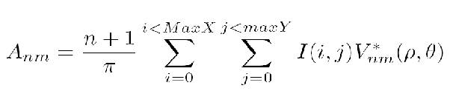
Let n be the order of the moment.
I(x, y) be the pixel intensity function for the image. For a binary image the values it returns are 0 and 1 for black and white respectively.
V is the basis function and V* is complex conjugate of V
ρ and θ are the polar co-ordinates of x and y
and the following constraints hold:
n ≥ 0
n ≥ |m|
n − |m| is even
x2 + y2 ≤ 1.
The basis function is given as
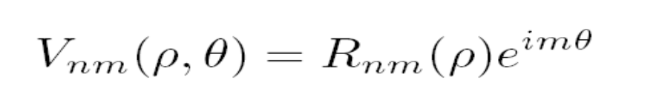

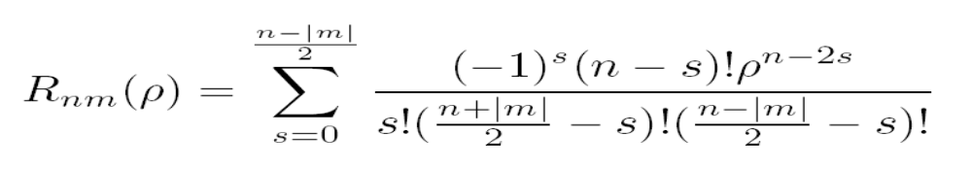

3.8 Recognition System

We have selected neural network with back propagation logic for recognition. The 70 moments calculated for every character are given as input to the neurons.

In the training phase, moments of characters from training set are given to the system. The system is trained with these moments. In the testing phase, moments of characters from the testing set are used. These moments are used by system for character recognition.

We have implemented back propagation algorithm for the neural network, in java.
In general, the algorithm can be given as follows:

- Initialize the network (weights and threshold).
- Calculate the change in weight for the output layer.
- Change the weight between the output layer and the last hidden layer.
- Calculate the change in the top most hidden layer.
- Change the weights
- Continue recursively down the hidden layers until we reach the input layer.
- Now the network is trained for the pattern.
Change the pattern and go to step 2.

The structure of neural network is as follows:
1. One input and one output layer
2 Two hidden layers.
3. Learning Rate: 0.3
4. Iterations: 10000
5. Training Set: 11 fonts
6. Testing Set: 5 fonts
7. No of neurons in 1st hidden layer: 60
8. No of neurons in 2nd hidden layer: 36

We arrived at the above structure after trial and error method. Training the system for less iteration didn’t give the desired output. Whereas, training the system for more than 10000 iterations gave better results but at the same time took large amount of time. Two hidden layers were selected as it did not learn pattern in 10000 iterations. The output produced by single layer would be same irrespective of inputs given. Learning rate was selected as 0.3 because higher learning rates produce oscillation during change of weights. The out put The above results proved best in comparison with all other combinations and hence we selected them as the neural network structure.

IMPLEMENTATION

Choice of Platform

We have selected java as our programming language. Java is architecturally neutral i.e. platform independent. Java is functional in environments where applications are capable of executing on a variety of network architectures.

System Implementation

The input to our system is monochrome image. The size of image is not a constraint as the image is framed by the software to a fixed size (40 X 40 pixels). A set of sample of characters are used for Training and remaining set of characters are used for testing. Neural Network has been trained for 11 fonts of each character. The sample moments for training are stored in the file named ‘input.dat’.

The back hand algorithms used for implementing the system are explained below. The classes used are discussed later.

Data Acquisition: In this stage the image is read and stored in the matrix form. The class Image, Toolkit which is inbuilt is used in to read image of format jpeg and store them in array using PixelGrabber class.

Binarization: The threshold value is decided and any pixel having intensity value greater than the threshold is set (1), else it is reset (0). This is implemented in class Threshold.

Segmentation: In segmentation we plot the histogram (which is the count of number of pixels that are active or set in a particular row or column) for row as well as column. In this process just remove the blank spaces that does not have any significance.

The result after binarization and segmentation is given in the figure 3.1

Thinning: In thinning the Hilditch algorithm is used. It is implemented in class Thinning.
The result after thinning is performed on the image is given in the figure 3.3

Skew detection and Correction: In skew detection and correction the histogram is plotted and moments are calculated, these moments and histogram is used to implement the skew detection and correction.

Feature Extraction: Zernike Moments up to the order 14 are used. Thus considering the repetition we get 70 input vectors.

For the input
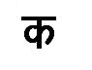
The GUI is as shown below
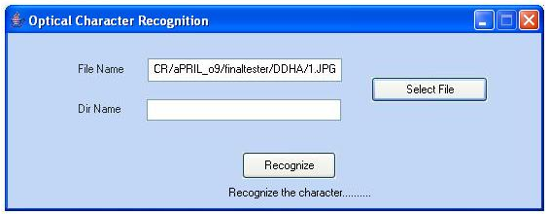
The GUI for inititialization is as shown below
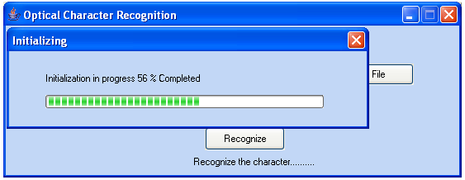
The GUI for training is shown below
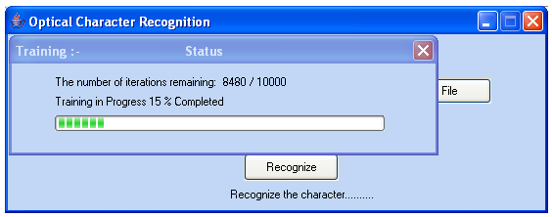
The number of iterations gives the information about the iteration count.

Once the input is given the Feature vector produced based on the input is
{495.0967783346009, 21.37872928897025, 7.020838329669308, 10.517189210874013, 138.02275766351056, 31.25983412875131, 124.61701695783822, 9.62276435506639, 15.66887128158163, 7.753527717492236, 198.17343607870424, 8.833606785504402, 211.5089708477056, 14.842259380383952, 16.95113374270183, 7.5436050698104316, 15.262145873241742, 6.349247955923338, 103.46926637167093, 16.22189959374636, 9.638031493597465, 26.679193547016467, 54.00184951502445, 4.1375562007596, 25.980252928129573, 10.389903010112972, 9.993696262527978, 4.479047133720183, 139.37916882692437, 50.42301146116273,149.55979001091168, 15.129890667901154, 111.59183351116273,10.305750131016906,45.354187390537135, 2.862637730522128, 26.439778952177658, 4.704592691161906, 8.921978030025047, 5.181588244408765, 7.892147382570732, 79.08370374658907, 9.299265480637784, 55.19112338510252, 9.074851468956746, 25.41669594877977, 28.813328191386685, 68.83462271139568, 22.60875449737543, 27.52061914007409, 14.209314123396183, 16.02410521062337, 7.615715621592735, 3.2429215087969268, 97.41219033391782, 25.135593709131836, 77.4815483371183, 17.007490262129014, 115.84332877654406, 3.3653703260111674, 72.99672808954541, 6.7100671955861335, 45.77249502209832, 16.801962437939487, 3.521710731681296, 30.24664654480964, 19.87402684437415, 8.433506943939634, 7.871311472282847, 4.912769688373188 }
This feature vector is passed on to Neural Network. For training the neural network back propagation algorithm is used.

For the input image the output generated is as shown below
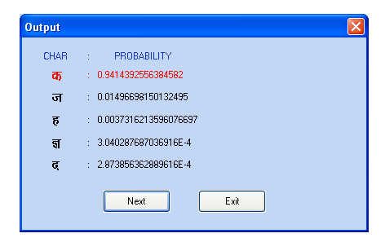
The next button gives you next probable characters. The list displayed is according to decreasing order of probabilities.

Information about classes used in the code is as follows:

OpticalCharRecog: This class is the main class which calls function initializeComponent() which is used for initializing the GUI. Then it calls constructor function NeuralNetwork(70, 34) to create new object of class NeuralNetwork and initializes it with 70 input neurons and 34 output neurons. Then it calls constructor function Sample() of class Sample which initializes all the sample dataset values. Finally it calls function learn() which is used for training the neural network. Once the neural network is trained it calls the test() function which is used for recognizing the character.

Sample: This class calculates and stores the feature vector of moments for all the characters which acts as input to the neural network. For calculating the moments from the input image it performs various preprocessing activities. For this, it calls the constructor function of the class Binarize() ,Thinning() ,Skew() and finally Scale().

Binarize: This class implements binarization algorithm to convert the images into monochrome form with the help of Threshold class.

Threshold : This class converts the input image into the binary form depending on the threshold value.

Thinning: This class implements the thinning algorithm onto the binarized image.

Scale: This class is used for framing the binarized input image into the fixed grid size of 40x40 pixels. This class maps all the pixels from the input image in to the new framed window.

DCOMPLEX: This class is used to perform complex operations which are used in Zernike class for calculating the moments.

Zernike: This class applies the formulas for finding Zernike moments to the framed image.

Layer: This class creates the objects of class Neuron depending on the number of neurons in this layer.

Neuron: This class stores the weights of the links of each neuron which are initially set to random values between the range -1.5 to 1.5.

NeuralNetwork: This class creates the neural network. Depending on the number of hidden layers it creates the objects of class Layer. This class also has the functions for training and testing the neural network. The feature vector obtained after finding moments of all the characters of different fonts in Sample class are given as input argument to train() method of this class whereas test function accepts as input the moments of the character to be recognized and gives the output as the probability values of all the characters.

System Testing

The system is tested with both Training fonts as well as Testing fonts.
It is observed that we get maximum accuracy (100 %) with the training fonts and moderate accuracy (approximately 70 %) with the testing fonts.

Testing performance:

- The various fonts used for training are as under:
Shiv01, Shusha, Kruti Dev 010, Kruti Dev 011, Kruti Dev 012, Kruti Dev 013, Kruti Dev 014, Kruti Dev 035, Kruti Dev 060, Kruti Dev 110 and Kruti Dev 111.
We get 100 % accuracy with the above training fonts.

- The various fonts used for testing are:
- Kruti Dev 016
- Kruti Dev 26
- Kruti Dev 36
- Kruti Dev 041
- Kruti Dev 044.

The following chart shows testing results with the above fonts.
Character |  | F | O | N | T | S |  | Accuracy %
 |  | 1 | 2 | 3 | 4 | 5
BA |  | # | # | CHA | # | # |  | 80
BHA |  | # | # | # | # | # |  | 100
CHA |  | # | # | BA | VA | # |  | 60
CHAA |  | # | # | # | # | # |  | 100
DA |  | # | VA | DA | THA | # |  | 40
DAA |  | # | # | # | # | # |  | 100
DDHA |  | # | NA | # | # | SHA |  | 60
DHA |  | # | DDA | # | THA | # |  | 60
FA |  | # | # | # | # | # |  | 100
GA |  | # | # | BHA | SHA | NYA |  | 40
GHA |  | # | # | PA | # | PA |  | 60
HA |  | # | # | DA | # | # |  | 80
JA |  | # | # | SHAK | # | # |  | 80
KA |  | # | # | # | # | # |  | 100
KHA |  | # | # | BA | JA | # |  | 60
LA |  | # | VA | NA | # | # |  | 60
LLAA |  | # | DHA | # | # | # |  | 80
MA |  | # | # | # | KA | JA |  | 60
NA |  | # | # | BA | # | JA |  | 60
NAAA |  | # | # | # | # | # |  | 100
PA |  | # | # | MA | GHA | # |  | 60
RA |  | # | # | # | MA | MA |  | 60
SA |  | # | # | MA | FA | # |  | 60
SHA |  | JA | # | # | SHYA | SHYA |  | 40
SHAK |  | VA | # | # | # | NA |  | 60
SHYA |  | # | # | THA | # | # |  | 80
TA |  | YA | # | YA | TTHA | TTHA |  | 20
THA |  | BHA | # | # | # | # |  | 80
TTA |  | # | # | # | # | # |  | 100
TTHA |  | # | # | # | # | # |  | 100
VA |  | # | BA | # | TA | TA |  | 40
YA |  | # | SA | SHAK | VA | VA |  | 20
ZHA |  | # | # | # | # | # |  | 100
% Accuracy |  | 93.33 | 76.67 | 53.33 | 56.66 | 66.66
per font

Table 4.1 Testing results for testing fonts
# indicates proper recognition.

It is observed that we get overall 70 % accuracy with the testing fonts. Accuracy has been calculated by taking the mean of percentage accuracy per font.

According to the results as shown in Table 4.1 we get maximum accuracy for Kruti Dev 016 font (93.33) and minimum accuracy for Kruti Dev 36 (53.33).We observed that the accuracy for fonts which were similar to our training fonts are higher than other fonts. Font Kruti Dev 036 gave poor accuracy among all the testing fonts. The reason for giving such results is because this font has a distinct mark after each character. This mark changes the moment values considerably. Due to this, the system finds it difficult to recognize the correct character.

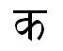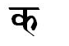
Normal Font Kruti Dev 036

CONCLUSION AND FURTHER WORK

Conclusion

We have implemented the OCR system in Java. The code takes in printed document images of .jpeg (joint photographic expert group) format. This image acts as an input to the OCR system.

The image undergoes various processes inside the OCR system. In binarization, gray scale image is converted into a black and white image. Framing is done to scale the image to a specified size (40 * 40) as required by the system. Thinning is the process of peeling of redundant pixels without loosing its original shape. If the scanned image is oriented by some angle then in order to remove this, we use skew detection and correction. We have used Zernike moments as features for every character. We have calculated Zernike moments of order 14 which gives around 70 moments for every character. The recognition is done with the help of artificial neural network using back propagation logic. The 70 moments calculated for every character are given as input to the neurons. In the training phase, moments of characters from training set are given to system. The system is trained with these moments. In the testing phase, moments of characters from the testing set are used. These moments are used by the system for recognizing the character and the character recognition is done.

It is observed that the time taken to initialize the system is 2 min 9 sec where as time take to train is 10 min 35 sec for configuration of Pentium 4, 2.66 GHz, HT technology. The testing time on an average for 1 character is the character is 1.28 sec where testing time is calculated as time taken to test 10 character / 10.

Having implemented the project we are getting the accuracy of 70%(approx) this accuracy is maximum for those fonts that are similar to training.

Limitations

- The software does not recognize handwritten documents; it works for only printed characters.
- It does not work for continuous characters.
- Skew of only about 10 to 15 degrees can be detected and corrected

Further Work

The project can be further improved upon by incorporating the following:

The project could incorporate recognition of more fonts by increasing the training set and the testing set of data. This will improve the performance of the system.
The accuracy of the system can be further increased by increasing the number of features .This can be achieved by increasing the order of the moments.
More noise removal algorithms could be used to make the system immune to noise. This will help in recognition of inferior quality documents. To improve the efficiency we may introduce new features by combining the existing features with features obtained by structural descriptor or even combination of all the feature extraction methods mentioned in review of literature.

REFERENCES
[1] Veena Bansal and R.M.K. Sinha, ‘How To Describe Shapes Of Devanagari Characters And Use Them For Recognition’, Proceedings-fifth International Conference on Document Analysis and Recognition, IEEE publication, Bangalore, Sept 21-23, 1999.

[2] Veena Bansal and R.M.K.Sinha, ‘Integrating Knowledge Sources in Devanagari Text Recognition’, IEEE Transaction on Systems, Man and Cybernetics, Vol. 30,4,2000.

[3] Veena Bansal and R.M.K. Sinha, ‘A Complete OCR for Printed Hindi Text in Devnagari Script’, Sixth International Conference on Document Analysis and Recognition, IEEE publication, Seatle, USA, 2001.

[4] Aparna K G and A G Ramakrishnan, ‘Tamil Gnani- an OCR on Windows’, Department of Electrical Engineering, IISc, Bangalore, 2001.

[5] B.B. Chaudhuri, U Pal and M Mitra, ‘Automatic Recognition of Printed Oriya Script’, Sadhana Vol.27, Part 1, February 2002, pp. 23-34.

[6] Gholam Reza Amayeh, Ali Erol, George Bebis, and Mircea Nicolescu, ‘Accurate and Efficient Computation of High Order Zernike Moments’, Computer Vision Laboratory, University of Nevada, Reno, NV 89557

[7] Sorin Draghici, ‘A Neural Network Based Artificial Vision System For Licence Plate Recognition, Dept. of Computer Science, Wayne State University, 1997
[8] Rafael C.Gonzalez, ‘Digital Image Processing’, Second Edition, Addison-Wesley Publishing, 1987.
[9] William K.Pratt, ‘Digital Image Processing’, Second Edition, Wiley Interscience Publication 1991.

[10] Zurada. J. M, ‘Introduction to Artificial Neural Networks’, Second Edition, Jaico
Publishing house 2006.

[11] Avanindra and Subhasis Chaudhuri, 'Robust Detection of Skew in Document Images', IEEE Transactions,
Volume 6, Issue 2, Feb 1997, Page(s):344 - 349.

[12] J. J. Hull, 'A Document Skew Detection Method Using the Hough Transform',Springer London,Volume 3,Sept 2000.

[13] D.R.Ramesh Babu, Piyush M Kumat and Mahesh D Dhannawat, 'Skew Angle Estimation and Correction of Hand Written, Textual and Large areas of Non-Textual Document Images: A Novel Approach', Proceedings of the 2006 International Conference on Image Processing, Computer Vision & Pattern Recognition, Las Vegas, Nevada, USA, June 26-29, 2006, Volume 2

[14] Mowlaei A, Faez, K, T. Haghighat A, 'Feature Extraction with Wavelet Transform for Recognition of Isolated Handwritten Farsi/Arabic Characters and Numerals', 14th International Conference on Digital Signal Processing Proceedings DSP, 2002, Page(s): V- XLVIII

[15] "A Tutorial on Support Vector Machines for Pattern Recognition", Christopher J.C. Burges, Bell Laboratories,Lucent Technologies,2002.

