



Material Tracking System

ACME Limited

Design Qualification Document

This user’s guide includes the design qualification document defined for the application.

Prepared By: Omkar G Version Number: 1.0.0

BAR CODE INDIA, 145 Udyog Vihar Phase I, Gurugram, Haryana-122016, PH: 0124 4337555

Notice:

This document contains information, which is the proprietary property of Bar Code India. This document is received in confidence and its contents cannot be disclosed or copied without the prior written consent of Bar Code India.

Nothing in this document constitutes a guaranty, warranty, or license, express or implied. Bar Code India disclaims all liability for all such guaranties, warranties, and licenses, including but not limited to: Fitness for a particular purpose; merchantability; not infringement of intellectual property or other rights of any third party or of Bar Code India; indemnity; and all others. The reader is advised that third parties can have intellectual property rights that can be relevant to this document and the technologies discussed herein and are advised to seek the advice of competent legal counsel, without obligation of Bar Code India.

Bar Code India retains the right to make changes to this document as per discussion with the Customer.

COPYRIGHT

Copyright © ***BCI*** 2022. All rights reserved. TRADEMARKS

*Other product and corporate names may be trademarks of other companies and are used only for explanation and to the owners' benefit, without intent to infringe.

Table of Contents

PROTOCOL APPROVAL 1

OBJECTIVE 2

SCOPE 2

Qualification Team 2

RESPONSIBILITIES 3

HARDWARE ARCHITECTURE 4

LOGICAL ARCHITECTURE 5

NETWORK ARCHITECTURE 6

DEVIATION SHEET 7

IDENTIFICATION OF PARTICIPANTS 8

|  |  |  |  |
| --- | --- | --- | --- |
| **DESIGN QUALIFICATION** | | | |
| System Name | Material Tracking System | System Id No | WH-MTS-01 |
| Document No. | ACME-MTS-Design-Qualification | Department | Warehouse |
| Version No. | 1.0 | Page No. | Page 1 of 9 |

# 1 PROTOCOL APPROVAL

|  |  |  |
| --- | --- | --- |
| **Prepared By** | | |
| **Name** | **Designation** | **Signature & Date** |
| Omkar Gaonkar | Technical Writer |  |
| **Checked By** | | |
| **Name** | **Designation** | **Signature & Date** |
|  |  |  |
|  |  |  |

|  |  |  |  |
| --- | --- | --- | --- |
| **Approved By** | | | |
| **Department** | **Name** | **Designation** | **Signature & Date** |
|  |  |  |  |

|  |  |  |  |
| --- | --- | --- | --- |
| **DESIGN QUALIFICATION** | | | |
| System Name | Material Tracking System | System Id No | WH-MTS-01 |
| Document No. | ACME-MTS-Design-Qualification | Department | Warehouse |
| Version No. | 1.0 | Page No. | Page 2 of 9 |

# 2 OBJECTIVE

The objective of this protocol is:

1. To define the Design Qualification (139) requirements for the Minimal Tracking System.
2. The details in this document describe the Installation and configuration of the implantation of the Material Tracking System from a Business Technical and functional perspective.

# 3 SCOPE

The scope of this protocol include design qualification procedure of the Material Tracking System for ACME GENERICS LLP.

This protocol defines the procedure alums. Documentation, acceptance criteria & re-qualification criteria.

# 4 QUALIFICATION TEAM

Responsible staff from:

1. I.T
2. Stores
3. QC
4. Quality Assurance

|  |  |  |  |
| --- | --- | --- | --- |
| **DESIGN QUALIFICATION** | | | |
| System Name | Material Tracking System | System Id No | WH-MTS-01 |
| Document No. | ACME-MTS-Design-Qualification | Department | Warehouse |
| Version No. | 1.0 | Page No. | Page 3 of 9 |

# 5 RESPONSIBILITIES

**Responsible persons for validation activity as following:**

|  |  |
| --- | --- |
| **Responsibilities** | **Details** |
| Vendor’s | Supplying drawings, manual, certificates and necessary documents for the generation and implementation of this protocol |
| QA | * Preparation of the document * Checking of documents * To verify the design activity as per document * Review the data documented during design qualification. * Final approval of protocol and report |
| I.T, Warehouse and QC | * Checking of document * To provide area for design and make related arrangements |

|  |  |  |  |
| --- | --- | --- | --- |
| **DESIGN QUALIFICATION** | | | |
| System Name | Material Tracking System | System Id No | WH-MTS-01 |
| Document No. | ACME-MTS-Design-Qualification | Department | Warehouse |
| Version No. | 1.0 | Page No. | Page 4 of 9 |

# 6 HARDWARE ARCHITECTURE

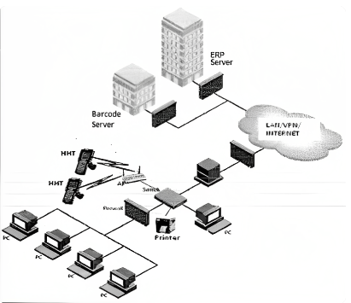

The application architecture will be “Central Server Architecture”.

* + 1. All the plants will access the data from the Central Server.
    2. There will be a database server kept at ACME Generics LLP.
    3. The mobile data transfer will be through Wireless.
    4. The Server will be connected to SQL Database.
    5. The work station will be directly connected to SQL Database.

|  |  |  |  |
| --- | --- | --- | --- |
| **DESIGN QUALIFICATION** | | | |
| System Name | Material Tracking System | System Id No | WH-MTS-01 |
| Document No. | ACME-MTS-Design-Qualification | Department | Warehouse |
| Version No. | 1.0 | Page No. | Page 5 of 9 |

# 7 LOGICAL ARCHITECTURE

Logical Architecture consist of Mobile Client and Server

**Mobile Client**

Mobile client will define the User Screens, Communication system with the mobile server and logs of the system in the mobile client

**Mobile Server**

Mobile server will consist of a barcode server and the barcode server will carry all the business logic, authentication, ERP Interfaces and updating data in SQL database.

|  |  |  |  |
| --- | --- | --- | --- |
| **DESIGN QUALIFICATION** | | | |
| System Name | Material Tracking System | System Id No | WH-MTS-01 |
| Document No. | ACME-MTS-Design-Qualification | Department | Warehouse |
| Version No. | 1.0 | Page No. | Page 6 of 9 |

# 8 NETWORK ARCHITECTURE

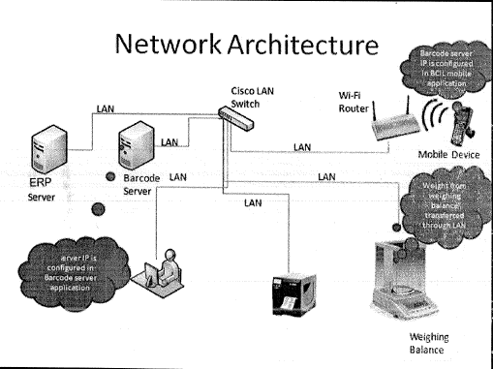

|  |  |  |  |
| --- | --- | --- | --- |
| **DESIGN QUALIFICATION** | | | |
| System Name | Material Tracking System | System Id No | WH-MTS-01 |
| Document No. | ACME-MTS-Design-Qualification | Department | Warehouse |
| Version No. | 1.0 | Page No. | Page 7 of 9 |

# 9 DEVIATION SHEET

|  |  |  |  |  |
| --- | --- | --- | --- | --- |
| **Sr.No** | **Description of Deviation** | **GMP Criticality** | **Corrective Action** | **Need to be closed before OQ** |
|  |  |  |  |  |
|  |  |  |  |  |
|  |  |  |  |  |
|  |  |  |  |  |
|  |  |  |  |  |

|  |  |  |  |
| --- | --- | --- | --- |
| **Interferences** | | | |
| **Name** |  |  |  |
| **Sign** |  |  |  |
| **Date** |  |  |  |
| **Department** | **Prepared By** | **Checked By** | **Verified By** |

|  |  |  |  |
| --- | --- | --- | --- |
| **DESIGN QUALIFICATION** | | | |
| System Name | Material Tracking System | System Id No | WH-MTS-01 |
| Document No. | ACME-MTS-Design-Qualification | Department | Warehouse |
| Version No. | 1.0 | Page No. | Page 8 of 9 |

# 10 IDENTIFICATION OF PARTICIPANTS

In the list below all persons having participated in the execution of DQ and having signed on any of the tests are identified with their full name, department and function and their signature. With this signature the test participant confirms awareness of procedures to be followed in qualification tests and completion of associated documentation.

|  |  |  |  |
| --- | --- | --- | --- |
| **Review & Approval (Cipla Team)** | | | |
| **Department** | **Name** | **Designation** | **Signature & Date** |
| Warehouse |  |  |  |
| IT |  |  |  |
| QC |  |  |  |
| QA |  |  |  |
| Warehouse |  |  |  |

|  |  |  |  |
| --- | --- | --- | --- |
| **DESIGN QUALIFICATION** | | | |
| System Name | Material Tracking System | System Id No | WH-MTS-01 |
| Document No. | ACME-MTS-Design-Qualification | Department | Warehouse |
| Version No. | 1.0 | Page No. | Page 9 of 9 |

Design Qualification Document –Material tracking system,  
 ACME Ltd

Confidential & Copyright©2022