

PDF Label Printing

Bata Limited

User Manual

The document explains the process of using the application in detail to End Users.

Prepared By: Omkar Gaonkar

Version Number: V1.0

BAR CODE INDIA, 691 Udyog Vihar Phase V, Gurugram, Haryana-122016, PH: 0124 4337555

BAR CODE INDIA, 691 UDYOG VIHAR PHASE V, GURUGRAM, HARYANA - 122016, Ph.: 0124 4337555

Notice:

This document contains information, which is the proprietary property of Bar Code India. This document is received in confidence and its contents cannot be disclosed or copied without the prior written consent of Bar Code India.

Nothing in this document constitutes a guaranty, warranty, or license, express or implied. Bar Code India disclaims all liability for all such guaranties, warranties, and licenses, including but not limited to: Fitness for a particular purpose; merchantability; not infringement of intellectual property or other rights of any third party or of Bar Code India; indemnity; and all others. The reader is advised that third parties can have intellectual property rights that can be relevant to this document and the technologies discussed herein and are advised to seek the advice of competent legal counsel, without obligation of Bar Code India.

Bar Code India retains the right to make changes to this document at any time, without notice. Bar Code India makes no warranty for the use of this document and assumes no responsibility for any errors that can appear in the document nor does it make a commitment to update the information contained herein.

COPYRIGHT

Copyright © ***BCI*** 2020. All rights reserved.

TRADEMARKS

*Other product and corporate names may be trademarks of other companies and are used only for explanation and to the owners' benefit, without intent to infringe.

Revision History

|  |  |  |  |  |
| --- | --- | --- | --- | --- |
| Revision Number | Date | Prepared By | Reviewed By | Comment |
| 1.0 | 03-08-2022 | Omkar | Shubham Kumar | User manual for Bata PDF Generation |

Table of Contents

Introduction 1

Web Application Login 2

File Generation 4

Generate Barcode 4

Existing Barcode 6

Approval Barcode 8

New Generated Barcode 10

Existing Barcode 12

Report 14

Barcode Report 14

# Introduction

The Barcode Generation system is a web application developed for Bata Ltd. to efficiently generate the PDF barcodes for Boxes to be packed and dispatched.

The application allows users to generate the barcode for the existing article number of the manufacturing and the vendor user and get the label printed for the same. The File Generation screen allows the user to create the new and existing barcode request. The Approval screen allows the user to approve the request for barcode label data. Then only the barcode can be generated in the PDF format. The report can be downloaded for the dates for the article number barcode printed as per user selection from the Calendar.

# Web Application Login

To access the web application, enter the hosted URL (i.e. local host:53316) of the web application in any client browser. On browsing, following Login screen will appear

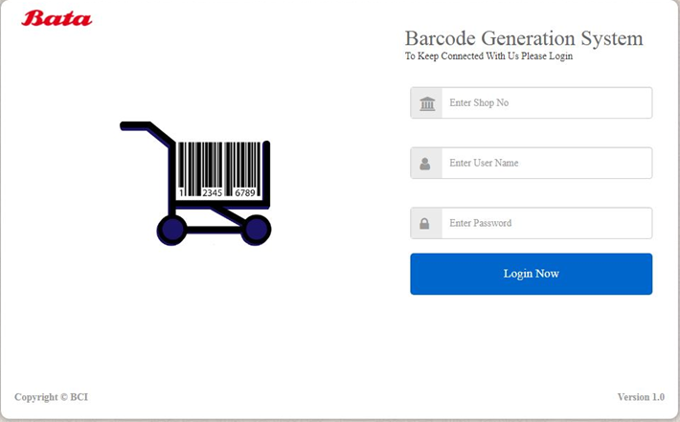

1. Enter *Shop Number*, *User ID* and *Password.*

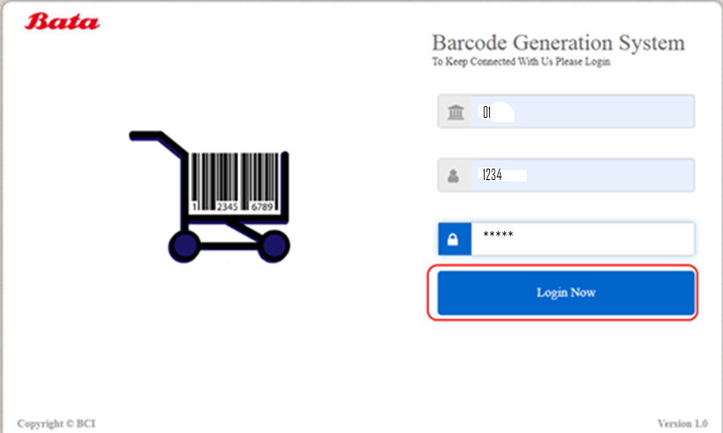

1. Click on **Login.** The system will authenticate the entered User Id and Password.

*\* In case of wrong User Id* *and Password, an error message will be displayed.*

**Close**

1. Click on **Close** to exit the application.

## File Generation

### Generate Barcode

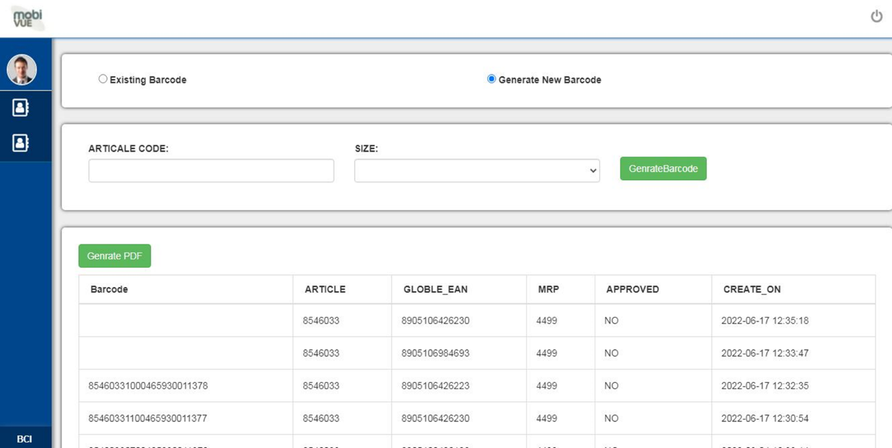This module is used to generate number barcode for user. Click on **Generate New Barcode** from the selection option following screen will get displayed.

**Generate Barcode**

1. Enter *Article Number* and *Size.*
2. Enter *Size* of the Article.
3. 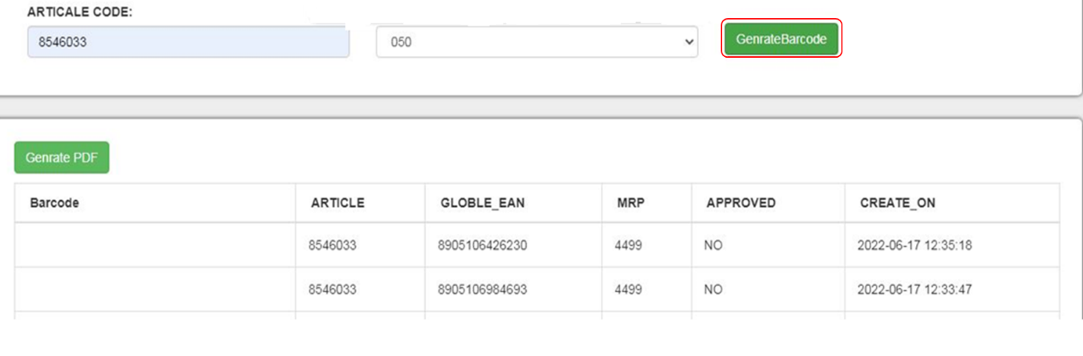Click on **Generate Barcode** button**.**
4. The *article number* details gets updated in the database.
5. The barcode number success message with gets displayed on window.

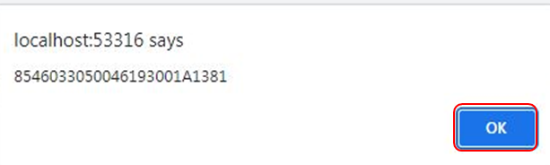

1. Click on **Ok**, to close the window.
2. 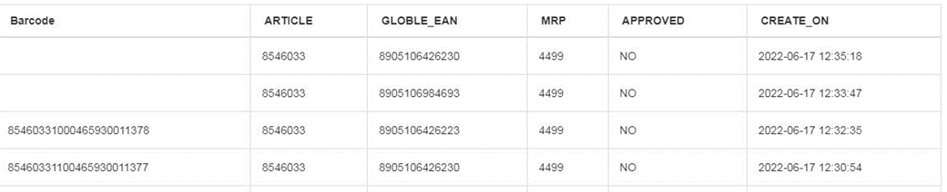Barcode details once saved, appears in the table grid below.

**Print Barcode Label**

1. To print Label, Click on **Generate PDF**.

*\*All the labels that are in approved state gets downloaded in form of PDF.*

1. A label PDF is generated and gets successfully downloaded.

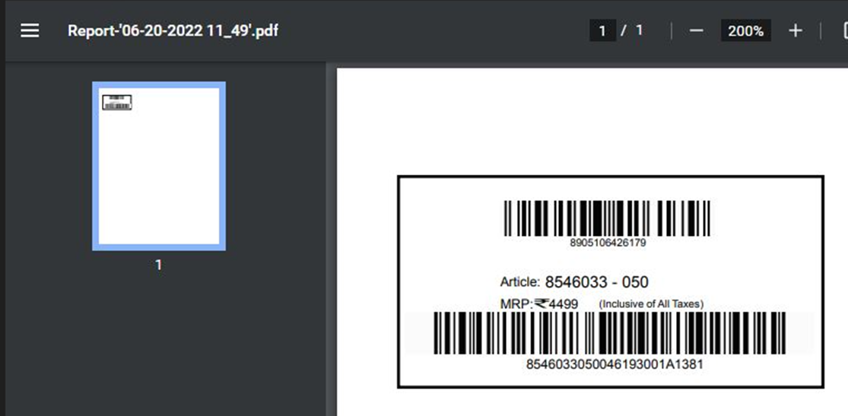

1. Label consist of *Article Number, MRP Price* and *barcode* l*abel* number.

**Cancel and Close**

1. Click on **Close** to return to the main screen.

### Existing Barcode

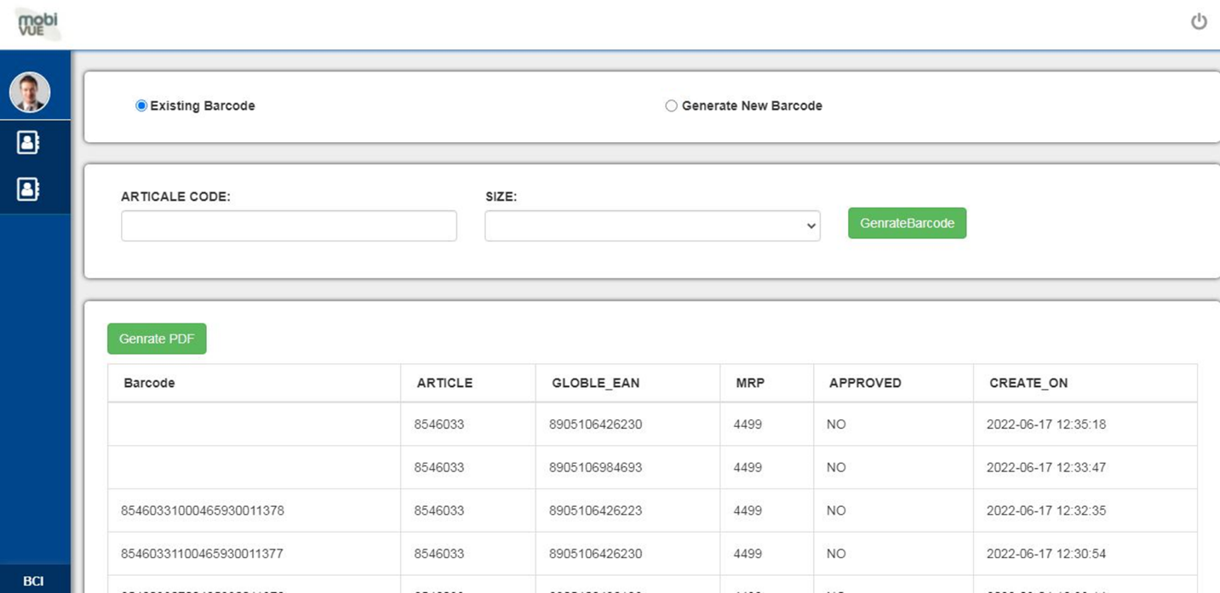This module is used to regenerate existing barcode for user. Click on **Existing Barcode** from the selection option following screen will get displayed.

**Generate Barcode**

1. Select the Existing *Barcode* button*.*
2. Select the *Manufacture by Vendor* or *Manufacturer by bata*.

*\*User can select anyone as per the barcode requirement*.

1. 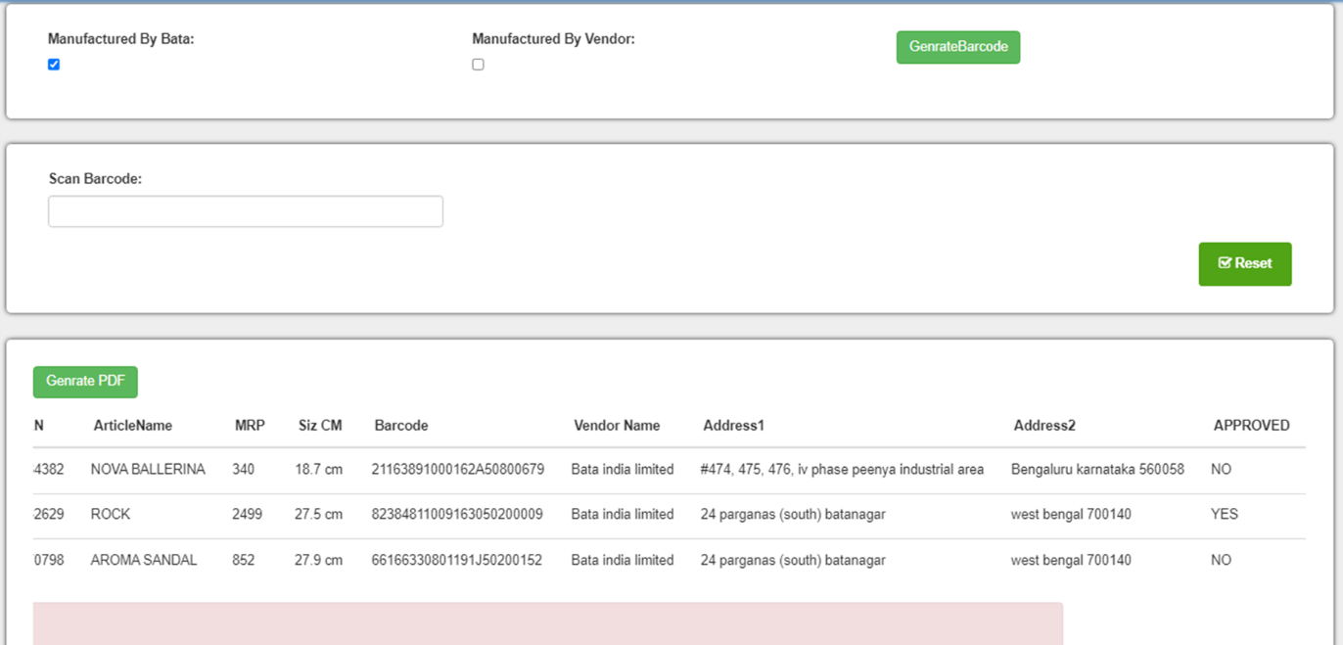Scan or Enter the existing *barcode label* details
2. Click on **Generate Barcode** button.
3. Barcode details are fetched from database, and gets displayed in the table grid. 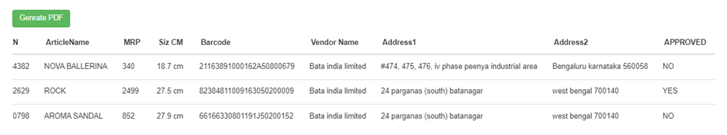

**Print Barcode Label**

1. Click on **Generate PDF**, and the approved label gets downloaded.

*\* Only Approved Article Number gets barcode label generated.*

*\*\*Article number that is not approved gets downloaded without label and shows error.*

1. A label PDF is generated and gets successfully downloaded.

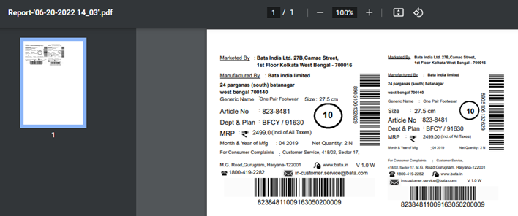

1. Label consist of *Size*, *Article Number, Dept. & Plan*, *MRP details,* *MFG Month/Year, quantity*.

**Cancel and Close**

1. Click on **Close** to return to the main screen.

## Approval Barcode

To access the approval screen, enter into the web application screen in any client browser. On browsing, following Login screen will appear:

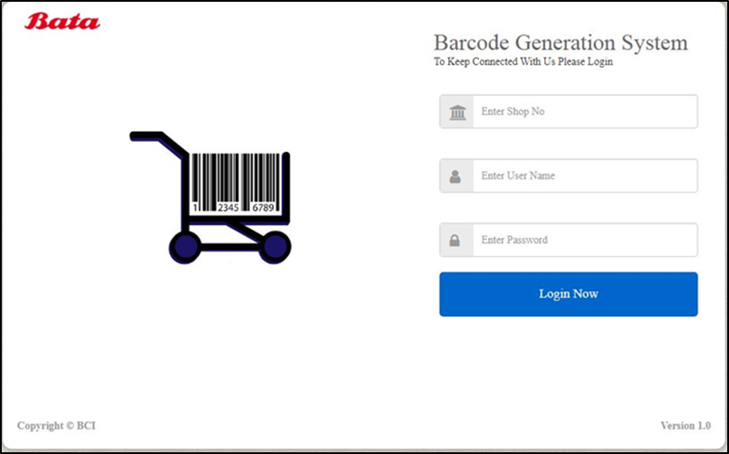

1. Enter *Shop Number*, *User ID* and *Password.*

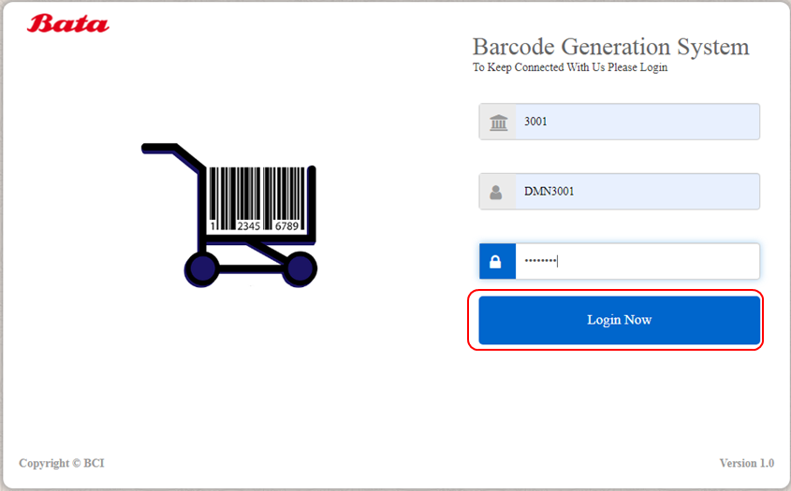*\*The User Id details will be provided by Bata concern person.*

1. Click on **Login.** The system will authenticate the entered User Id and Password*.*

*\* In case of wrong User Id* *and Password, an error message will be displayed.*

**Close**

1. Click on **Close** to exit the application.

### New Generated Barcode

This module is used to approve the new generated article barcode for the user. Click on Generate New Barcode from the selection option following screen will get displayed.

1. After Login, Select the *Generate New Barcode* radio button.

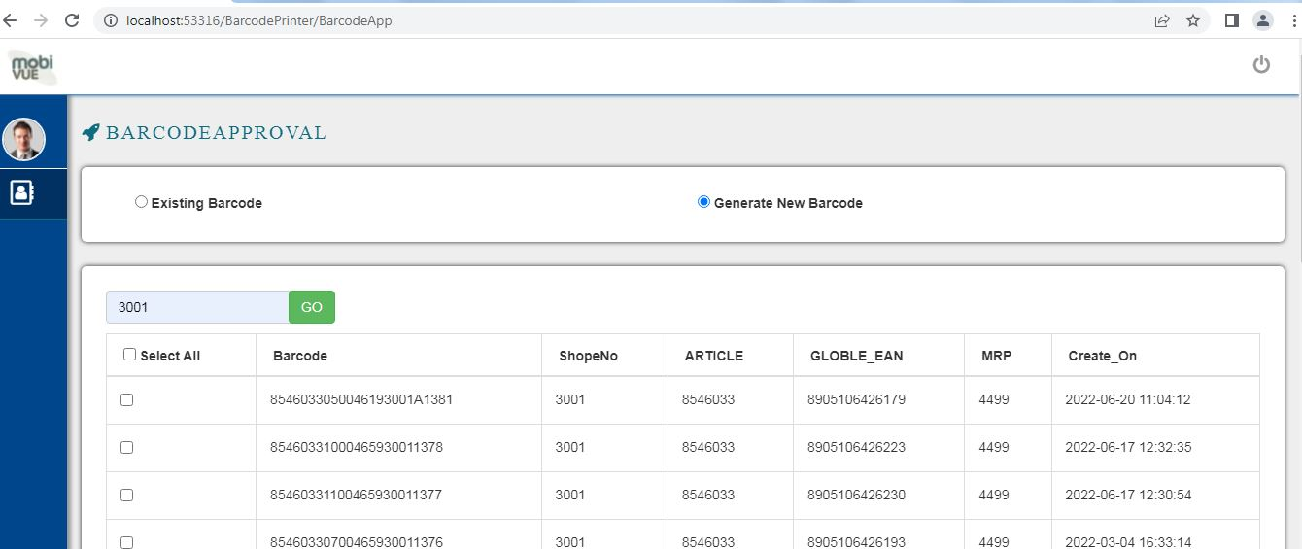

1. Search the *Article Number, Barcode Number* or by *Shop* Number.

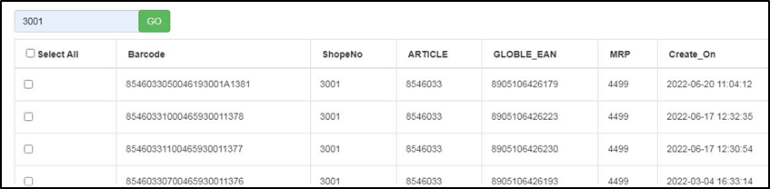

1. 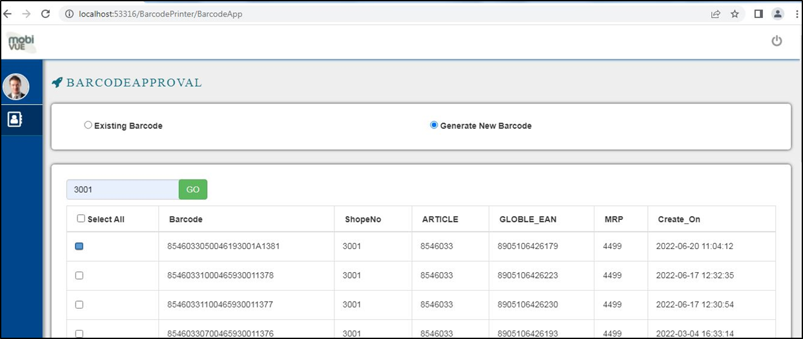Select the *Barcode* against the *shope No* or *Article* Number.
2. Click on **Approve**, the article number gets approved.
3. A success message appears on the top of screen.

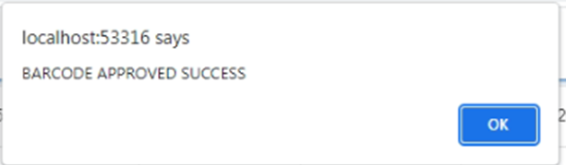

1. Click on **OK**, to back on main screen.
2. User login back to generation barcode for barcode printing.

**Cancel and Close**

1. Click on **Cancel** to clear the selections and text fields.
2. Click on **Close** to close the current screen

*Note: Once the approval for the new barcode label approved. User needs to re login to barcode Generation Web Application and* *Click on Generate PDF* *to get the barcode labels.*

### Existing Barcode

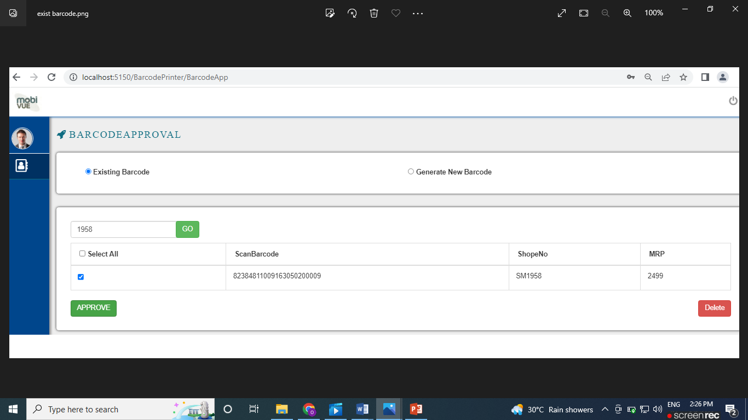This module is used to approve the existing article barcode for the user. Click on **Existing Barcode** from the selection option following screen will get displayed.

**Process Steps:**

1. Select *Existing barcode* from the radio buttons.
2. Enter the existing *Shope No*. in the *Search* option.
3. Click on **Go** button, to search the details.
4. The details of the barcode gets displayed in the below grid.
5. Select the box against the *Scan barcode Code* for selection.



1. Click on **Approve**, to approve the existing barcode for printing.
2. Click on **Delete**, to delete the details for barcode from database.
3. On approval the success message gets displayed on screen.

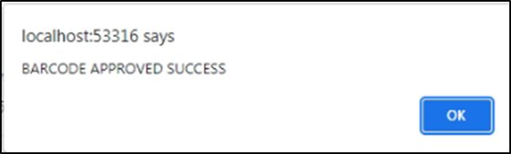

1. Click on OK to go back on the main menu screen.
2. Details get updated in the database.

**Cancel and Close**

1. Click on **Cancel** to clear the selections and text fields.
2. Click on **Close** to close the current screen

*Note: Once the approval for the existing barcode label approved. User needs to re login to barcode Generation Web Application and* *Click on Generate PDF* *to get the barcode labels.*

## Report

### Barcode Report

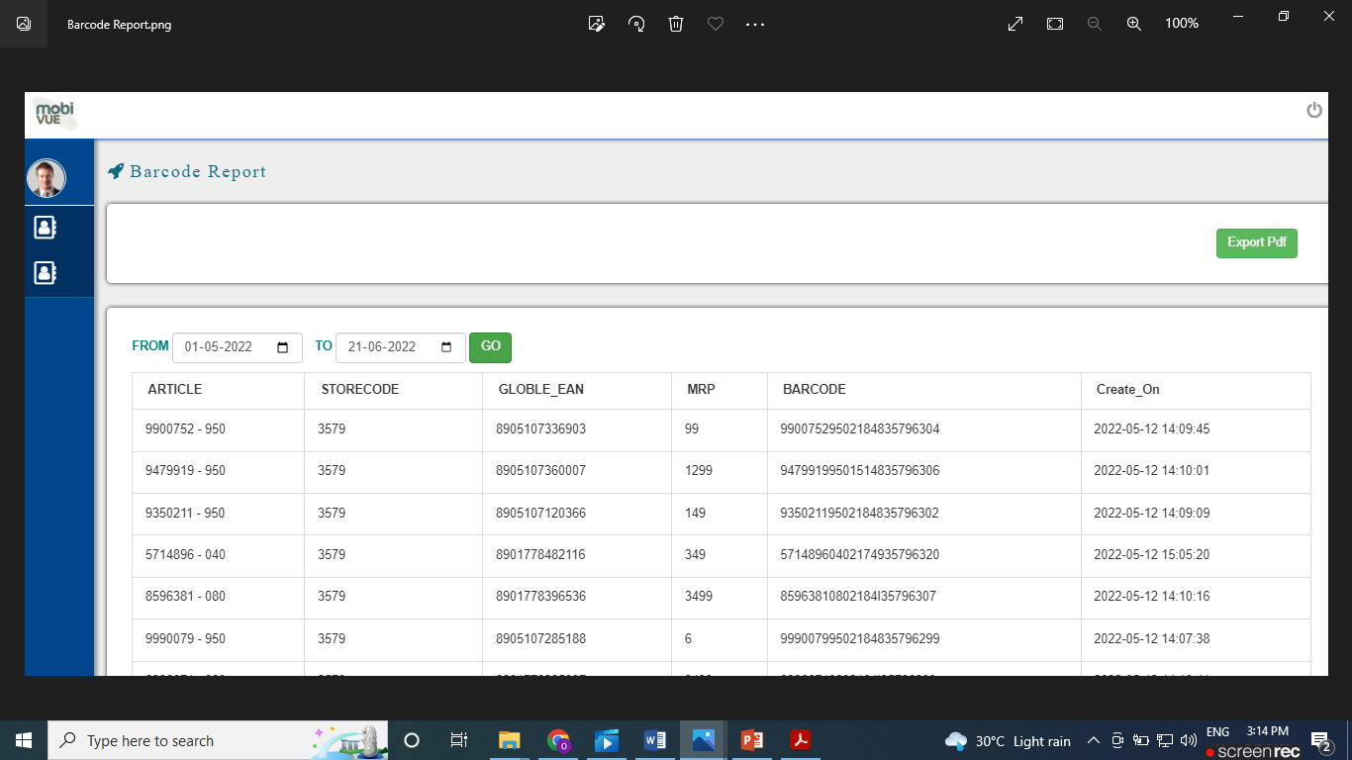This screen allows user to generate barcode report providing details of date supplied during the calendar screen. To view this screen, click on **Barcode** Report from main menu screen, following screen will get displayed:

**Generate Report**

1. Enter/ select required date from the calendar screen.
2. Enter the *FROM date* till the *To date* from the screen.
3. 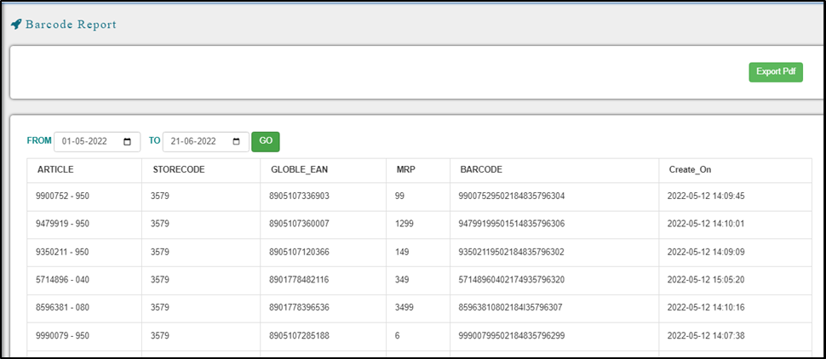Click on **Go** to fetch the details that get displayed in the below grid.

**Export to PDF file**

1. Click on **Export PDF** to generate a PDF file.
2. A window will appears with success message that file is downloaded successfully.
3. Click on *downloaded file* all report details get displayed.

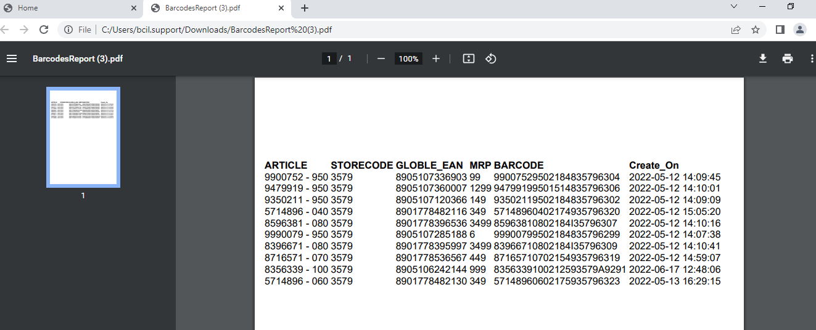

**Close Screen**

1. Click on **Close** to close the current screen

End User Manual

Bata Limited – PDF Label Printing

Confidential & Copyright©2022