

Supplier Tracking Application

Bata Limited

User Manual

The document explains the process of using the application in detail to End Users.

BAR CODE INDIA, 691 Udyog Vihar Phase V, Gurugram, Haryana-122016, PH: 0124 4337555

BAR CODE INDIA, 691 UDYOG VIHAR PHASE V, GURUGRAM, HARYANA - 122016, Ph.: 0124 4337555

Notice:

This document contains information, which is the proprietary property of Bar Code India. This document is received in confidence and its contents cannot be disclosed or copied without the prior written consent of Bar Code India.

Nothing in this document constitutes a guaranty, warranty, or license, express or implied. Bar Code India disclaims all liability for all such guaranties, warranties, and licenses, including but not limited to: Fitness for a particular purpose; merchantability; not infringement of intellectual property or other rights of any third party or of Bar Code India; indemnity; and all others. The reader is advised that third parties can have intellectual property rights that can be relevant to this document and the technologies discussed herein and are advised to seek the advice of competent legal counsel, without obligation of Bar Code India.

Bar Code India retains the right to make changes to this document at any time, without notice. Bar Code India makes no warranty for the use of this document and assumes no responsibility for any errors that can appear in the document nor does it make a commitment to update the information contained herein.

COPYRIGHT

Copyright © ***BCI*** 2020. All rights reserved.

TRADEMARKS

*Other product and corporate names may be trademarks of other companies and are used only for explanation and to the owners' benefit, without intent to infringe.

Revision History

|  |  |  |  |  |
| --- | --- | --- | --- | --- |
| Revision Number | Date | Prepared By | Reviewed By | Comment |
| 1.0 | 18-03-2019 | Ritika Makkar | Gaurav Kumar | User Manual of Bata |
| 1.1 | 04-09-2019 | Ritika Makkar | Kanishka | Quality Module, Picklist Rollback, Quality Report etc. added |
| 1.2 | 10-01-2020 | Sneha | Rajeev Roy | Data Scheduler updated. |
| 1.3 | 12-05-2020 | Kanishka | Rajeev Roy | New Reports and Delete Module added |
| 1.4 | 14-06-2022 | Omkar | Rajeev Roy | New Transactions and Main Menu Screen |

Table of Contents

Introduction 2

Communication Server 3

Data Scheduler 4

Desktop & Device Application 6

Main Menu 7

Master 9

User Master 9

User Rights 11

Change Password 12

PPOB Master 13

Transactions 14

Order Planning 14

Device Application- Login 16

Application Configuration 17

Login 18

Main Menu 19

Mono Outer Packing 20

Delete Item 22

Quality Checking 24

Picklist Generation 25

Picklist Modification 26

Dispatch (Device Application) 27

Invoice Generation 29

Invoice Update 30

Reprint Invoice 31

Invoice Cancellation 32

Invoice Rollback 33

Picking Rollback 34

Swap Outerbox 35

Enable Invoice for syncing 36

Report 37

Supply Report 37

Order Balance Report 38

RFD Report 39

INV Report 40

Picklist Report 41

Production Planning 42

Planning Vs Actual Report 43

Pending Invoice Report 44

Quality Check Report 45

Production Report 46

Inventory Report 47

Picking Report 48

# Introduction

The Supplier Tracking Application is a desktop and device application developed for Bata Ltd. to efficiently track the Boxes to be packed and dispatched.

The application allows user to scan and pack Mono Boxes/ Articles in Outer Boxes. Once Mono – Outer packing is complete, cartons will be forwarded for quality check process and status i.e. Hold or Accepted will be updated for the same in the database. The application also allows user to generate Picklist against selected Destination and Order (fetched from central Server); cartons will be dispatched against the same and invoice will be generated for the scanned Outer Boxes.

# Communication Server

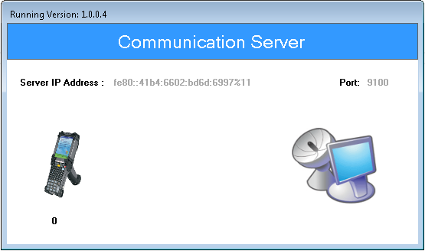Once the application is successfully installed in the system, double click the application’s shortcut icon on the desktop, following window will appear:

Communication Server is a desktop application which builds connection between application and the database.

*\*Note: Communication server should be running while using device application.*

# Data Scheduler

Scheduler is a desktop application which runs 24x7 to fetch and upload data from/to server.

It fetches Master, Plan, Assortment Mapping and all the required data from server and uploads all required data to server. It also provides manual way of downloading and uploading data from/ to server in case scheduler is unable to fetch and upload data from/ to server by just clicking the required module.

The Supplier barcode serial no details data gets posts/download details on cloud server.

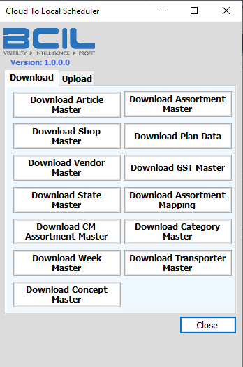

**Note:**

* Data Scheduler will get start running in background as soon as system on which it is installed is turned on.
* If the Data scheduler is stopped at any point of time, it should be turned on by user manually.
* Data Scheduler must always run at backend while transactions/ processes are in progress.
* Once a process or transaction is completed, system needs at least 30 minutes to upload the Back-Log data.

**Manual Downloading**

1. Select from the given option i.e. Download
2. Select Download:

* Click on **Download Article Master/ Download Shop Master/ Download Vendor Master/ Download State Master/ Download CM Assortment Master/ Download Week Master/ Download Concept Master/ Download Assortment Master/ Download Plan Data/ Download GST Master/ Download Assortment Mapping/ Download Category Master/ Download Transporter Master** to download details.

**Manual Uploading**

1. 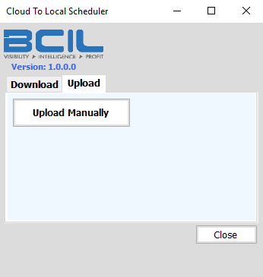Select from the given option i.e. Upload
2. Select the Upload
3. Click on **Upload Manually** to upload details.

*\*On click of ‘Upload Manually’, system will upload 100 records at a time.*

**Close**

1. Click on **Close** to close the current screen.

# Desktop & Device Application

Once the **desktop application** is successfully installed in the system, double click the application’s shortcut icon on the desktop, following Login Window will appear:

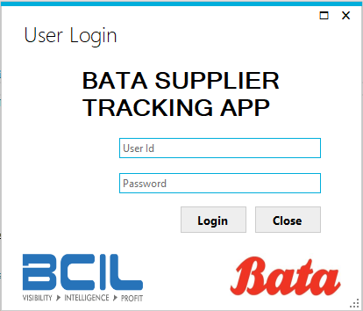

1. Enter *User ID* and *Password.*
2. Click on **Login.** The system will authenticate the entered User Id and Password.

*\* In case of wrong User Id* *and Password, an error message will be displayed.*

**Close**

1. Click on **Close** to exit the application.

## Main Menu

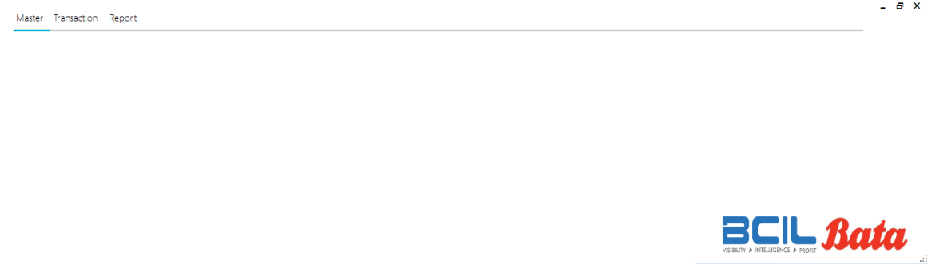As user login to application, **Main Menu** will appear as follow:

**Menu Options**

1. 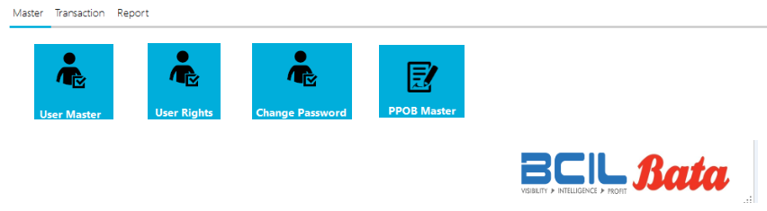Master

* User Master
* User Rights
* Change Password
* PPOB Master

1. Transaction

* 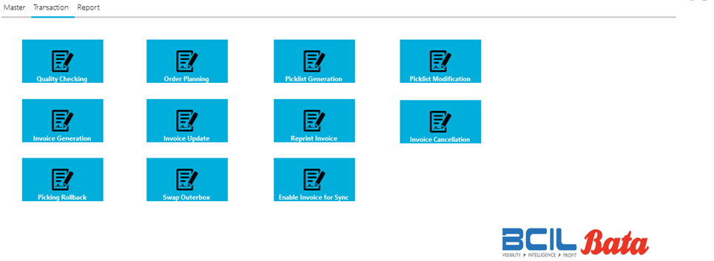Quality Checking
* Order Planning
* Picklist Generation
* Picklist Modification
* Invoice Generation
* Invoice Update
* Reprint Invoice
* Invoice Cancellation
* Picking Rollback
* Swap Outerbox
* Enable Invoice for Sync

1. Report
   * Supply Report
   * Order Balance Report
   * RFD Report
   * 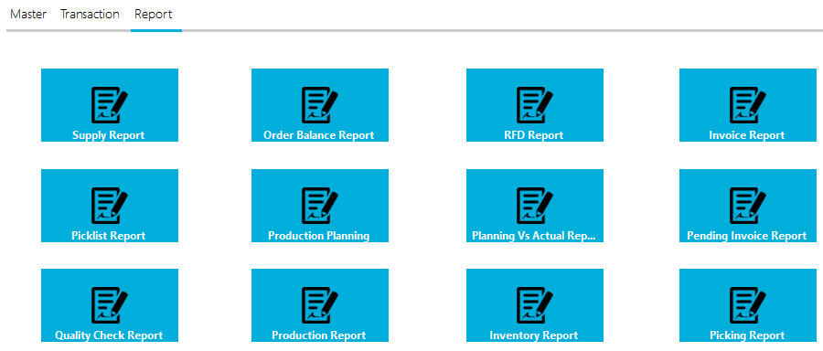INV Report
   * Picklist Report
   * Production Planning
   * Planning Vs Actual Report
   * Pending Invoice Report
   * Quality Check Report
   * Production Report
   * Inventory Report
   * Picking Report

## Master

### User Master

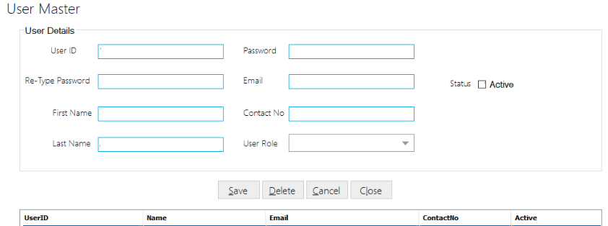This module is used to add, update or delete an application User details. Click on **Masters** from the main menu and select **User Master**, following screen will get displayed:

**Add User**

1. Enter *User ID, Email ID* and *Password*, *First Name, Last Name* and *Contact Number.*
2. Retype password in *Retype Password* text field.
3. Select *User Role* from the dropdown list.
4. Check the *Active* checkbox to make the current user as an active User.

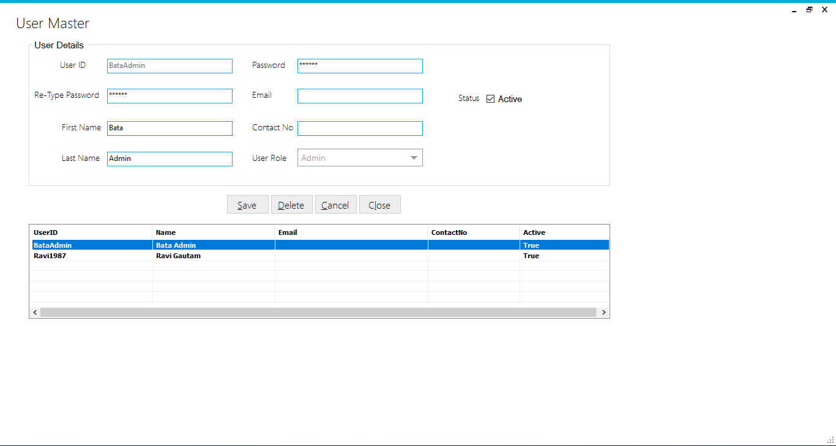

1. Click on **Save**, success message will get displayed if user details are saved successfully.

**Delete User**

1. To delete User, select user ID from the data grid and Click on **Delete**.
2. A success message will get displayed if selected User is deleted successfully.

**Cancel and Close**

1. Click on **Cancel** to clear the selections and text fields.
2. Click on **Close** to return to the main screen.

### User Rights

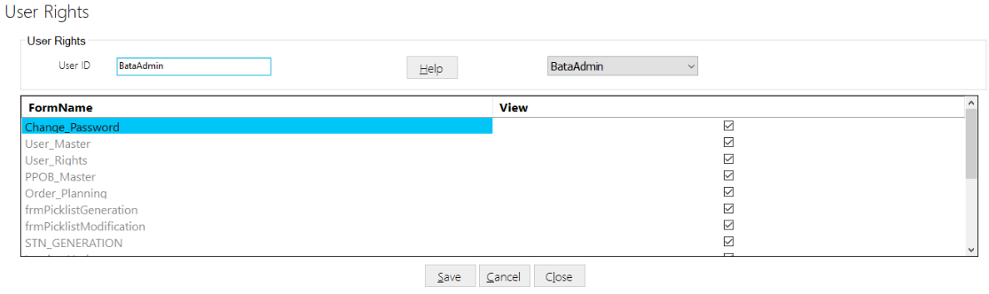This module is used to assign access rights to the users. Click on **Master** from main menu and select **User Rights,** following screen will get displayed:

**Assign Rights**

1. Select *User ID* from the dropdown list.
2. Forms/Modules Name along with the view checkboxes will be appeared in below grid.
3. Check the “*View”* column checkbox against the form name for which you want to give access rights to the selected user.



1. Click on **Save**, success message will get displayed if rights are assigned successfully to the selected user.

**Cancel and Close**

1. Click on **Cancel** to clear the selections and text fields.
2. Click on **Close** to close the current screen.

### Change Password

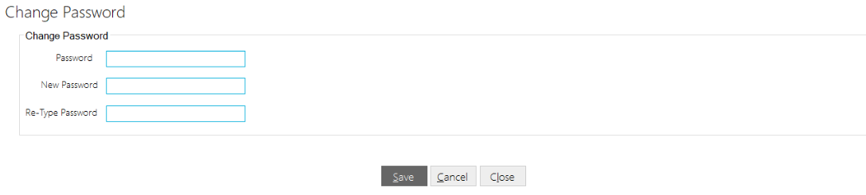This screen allows to change password for the logged-in user. To view this screen, click on **Master** from main menu screen and click on **Change Password**, following screen will get displayed:

**Change Password**

1. Enter *Password* and *New Password.*
2. Retype password in *Retype Password* text field.
3. Click on **Save,** success message will get displayed if password is updated successfully.

**Cancel and Close**

1. Click on **Cancel** to clear the selections and text fields.
2. Click on **Close** to close the current screen.

### PPOB Master

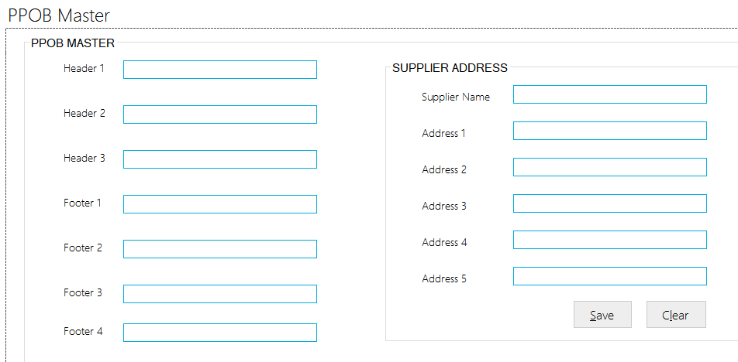This screen allows user to add supplier details which will be visible in header and footer of Invoice. To view this screen, click on **Master** from main menu screen and click on **PPOB Master**, following screen will get displayed:

1. Enter *Header 1, header 2, Footer 1, Footer 2, Supplier Name, Address etc.*
2. Click on **Save**, success message will get displayed if header and footer details are saved successfully.

**Cancel and Close**

1. Click on **Cancel** to clear the selections and text fields.
2. Click on **Close** to close the current screen.

## Transactions

### Order Planning

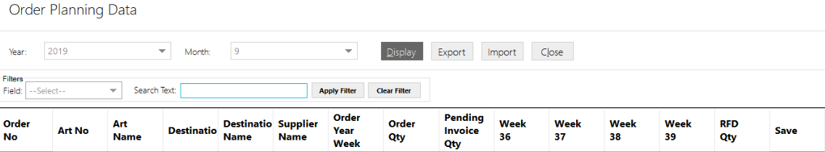This screen allows user to save Order Planning data fetched from central server. It also allows to export Order Planning details in excel file format. By doing modifications on that excel file user can upload that same file for doing planning. To view this screen, click on **Transactions** from main menu screen and click on **Oder Planning**, following screen will get displayed:

1. Select *Year* and *Month* from dropdown list.
2. Click on **Display**, corresponding details will get displayed:

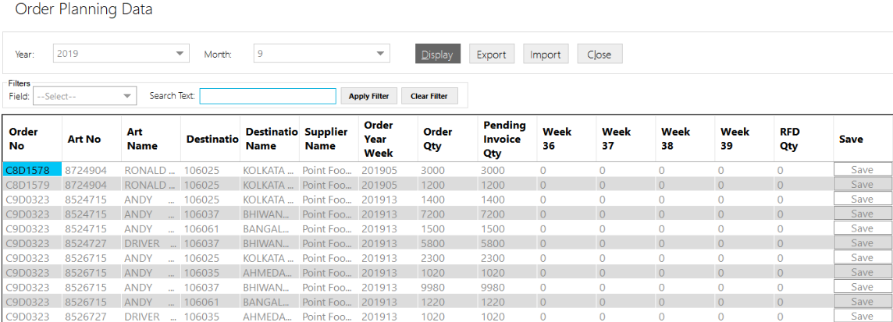

1. User can also save by doing changes on single rows in the grid and then by clicking on **Save,** success message will get displayed if details are saved successfully.

**Export**

1. To generate an excel file, click on the **Export** button from available options.



1. File will get saved in excel format.

**Cancel and Close**

1. Click on **Cancel** to clear the selections and text fields.
2. Click on **Close** to close the current screen.

***\*Note: Switch to the Device Application to perform Mono-Outer Carton Packing.***

### Device Application- Login

Click on the application’s shortcut icon on device to run the application. A login screen will appear:

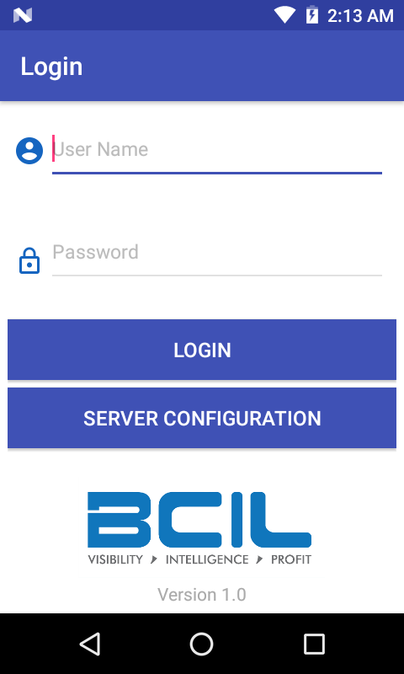

If the application is running for the first time, click on **Server Configuration** to configure the communication server setting.

**Note: If the communication server is not running then device application will not work!**

### Application Configuration

The following screen is used to configure the IP Address and Port Number of the server where communication server will be installed in order to fetch and transfer data to/ from device.

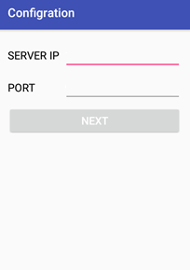

1. Enter *Server IP* and *Port Number*

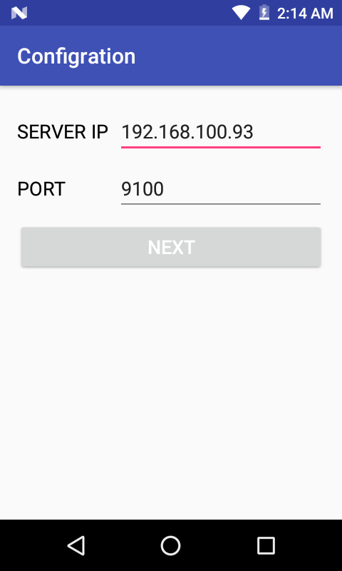

1. Click on **Next.**

### Login

Screen is used to login/ access the device application using authorized credentials.

1. Enter *User Name* and *Password*.
2. Click on **Login.**

*\* In case of wrong User Name* *and Password, an error message will be displayed.*

### Main Menu

On successful login, following main menu screen will get displayed to the user:

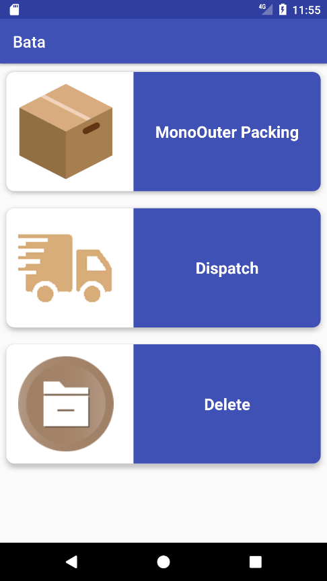

The main menu options are as follows:

1. Mono Outer Packing
2. Dispatch
3. Delete

### Mono Outer Packing

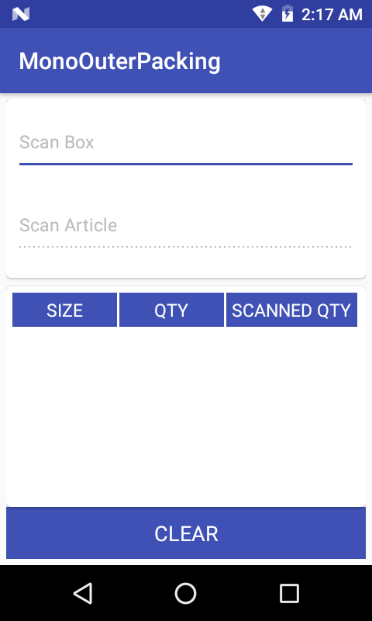This screen allows user to scan and pack Mono – Boxes/ Articles in Outer Box. To view this screen, click on **Mono Outer Packing** from device’s main menu screen, following screen will get displayed:

1. Scan *Outer* *Box* Barcode Label, all the details will get displayed in the data grid:

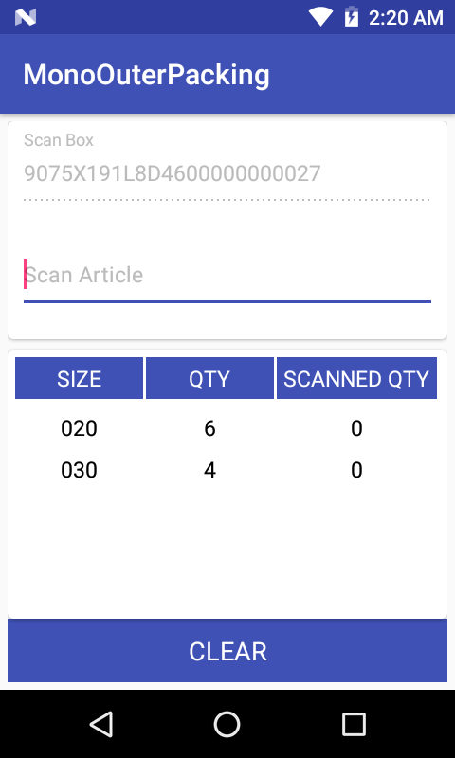

1. Scan *Article (Monobox)* Barcode Label.

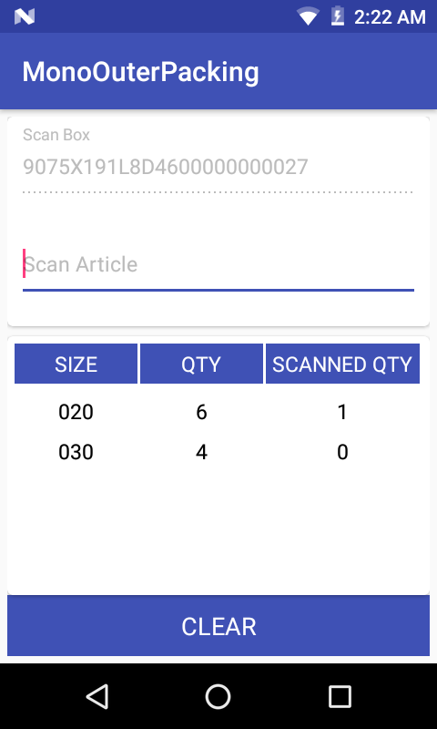

1. After each valid scan, *Scanned Quantity* counter will get incremented.
2. Once all Monobox is scanned for a particular size, following success message will get displayed:

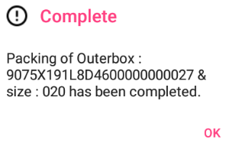

1. Click on **OK.**
2. Once all articles are scanned, following success message will get displayed:

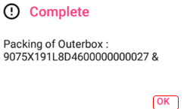

1. Click on **OK.**

**Clear**

1. Click on **Clear** to clear the text fields and selections.

***\*Note: Switch to Desktop Application to perform Quality Checking activity.***

### Delete Item

The screen will be used to delete outer box details from database, before picking is done. Click on **Delete** from device’s main menu screen, following screen will appear:

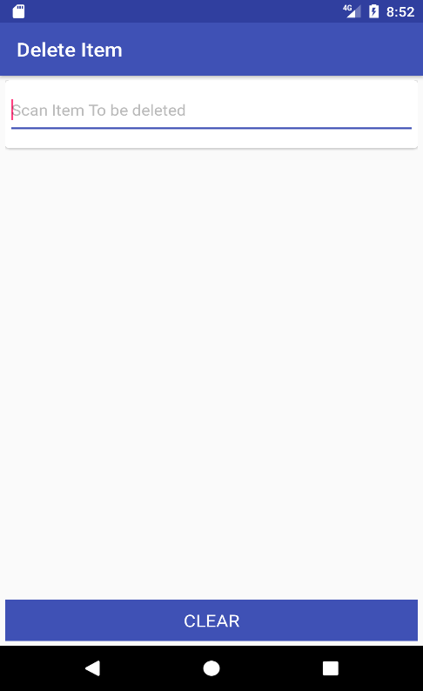

1. *Scan Item to be deleted*

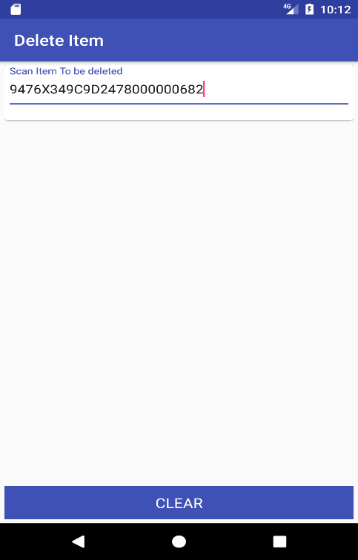*\*Outer box barcode label is required to be scanned.*

1. Once outer box label is scanned successfully, outer box details are deleted and following success message will appear on screen

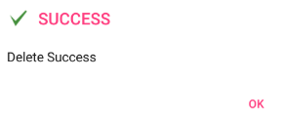

1. Click on OK.

**Clear**

1. Click on **Clear** to clear / reset the text field.

### Quality Checking

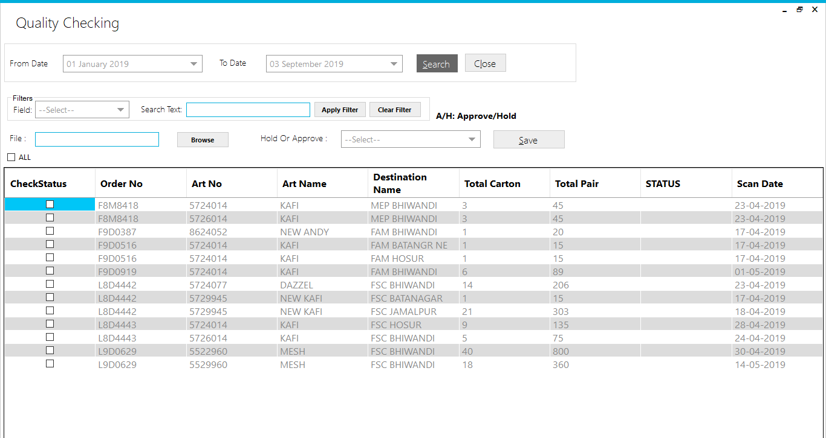This screen allows user to update Quality Check status of Cartons, after mono-outer packing in done. To view this screen, click on **Transaction** from main menu and click on **Quality Checking**, following screen will get displayed:

1. Select *From Date* and *To Date* from date picker.
2. Click on **Search**, cartons packed during selected time interval will get displayed in the data grid.



1. To update the quality status, check the checkbox against the Article Number from data grid and select *Status* i.e. *Hold* or *Approved* from the dropdown list.
2. To upload the file, click on **Browse** from Quality Check screen to browse the location where the file is saved.
3. Select the required file and click on **Open.**

*\*Authorized Super User can update the status of the articles and upload the required file. However Normal User can also be assigned rights to upload file in case file needs to be uploaded later.*

1. Click on **Save** to save the quality checking details.

### Picklist Generation

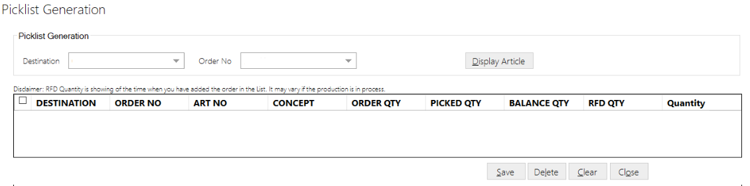This screen allows user to generate Picklist against Order number. To view this screen, click on **Transactions** from main menu screen and click on **Picklist Generation**, following screen will get displayed:

**Picklist Generation**

1. Select *Destination* and *Order Number* from the dropdown list.
2. Click on **Display Article**, corresponding details will get displayed in the data grid given below:

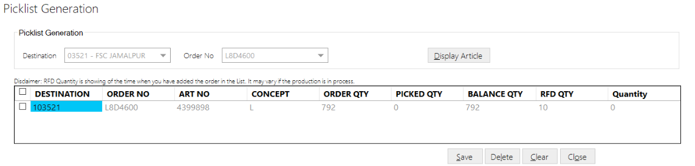

1. Enter *Quantity*.

*\*Quantity entered cannot be greater than RFD Quantity.*

1. Click on **Save,** success message will get displayed if details are saved successfully.

**Delete**

1. To delete, check the checkbox against the record from the grid.
2. Click on **Delete**, success message will get displayed if selected record is deleted successfully.

**Cancel and Close**

1. Click on **Cancel** to clear the selections and text fields.
2. Click on **Close** to close the current screen.

### Picklist Modification

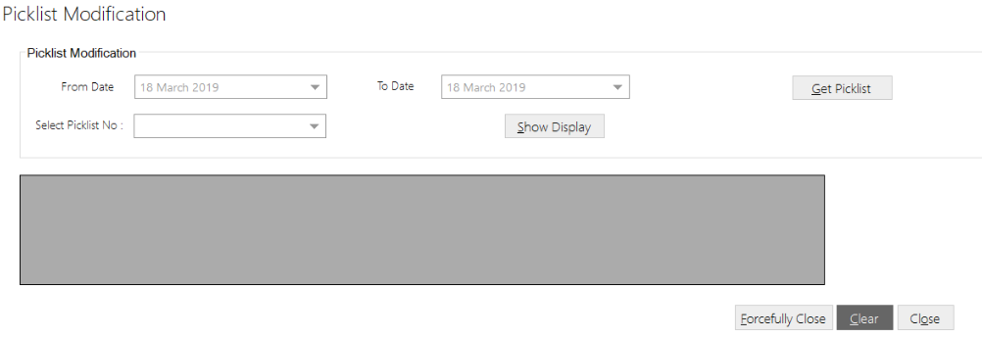This screen allows to modify and forcefully close Picklist. To view this screen, click on **Transactions** from main menu screen and click on **Picklist Modification**, following screen will get displayed:

**Picklist Modification**

1. Select *From Date* and *To Date* from date picker.
2. Click on **Get Picklist.**
3. Select *Picklist Number* from the dropdown list.
4. Click on **Show Display**, corresponding details will get displayed in the data grid.
5. Make required changes.

**Forcefully Close**

1. Select *From Date* and *To Date* from date picker.
2. Click on **Get Picklist.**
3. Select *Picklist Number* from the dropdown list.
4. Click on **Show Display**, corresponding details will get displayed in the data grid.
5. Click on **Forcefully close,** success message will get displayed if selected Picklist is closed successfully.

**Cancel and Close**

1. Click on **Cancel** to clear the selections and text fields.
2. Click on **Close** to close the current screen.

***\*Note: Switch to Device Application to perform Dispatch activity.***

### Dispatch (Device Application)

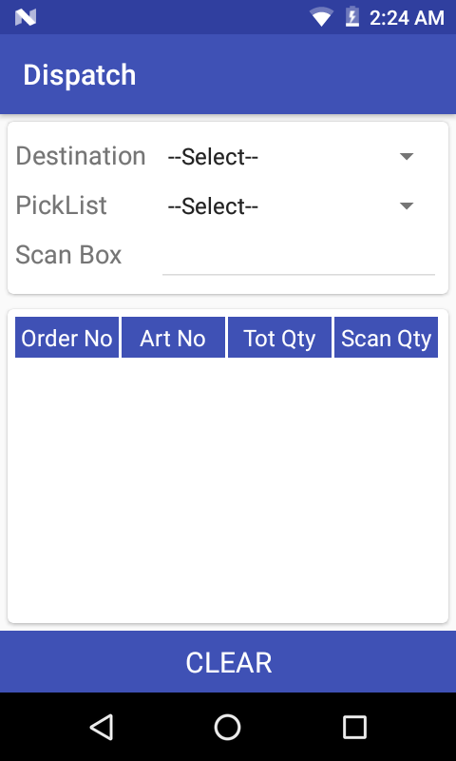This screen allows user to Dispatch Box against Destination and Picklist Number. To view this screen, click on **Dispatch** from device’s main menu screen, following screen will get displayed:

1. 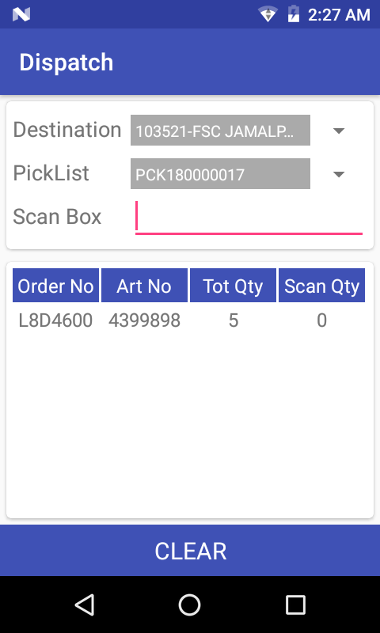Select *Destination* and *Picklist* from the dropdown list, details will get displayed in the data grid.
2. Scan *Box* Barcode Label.
3. After each valid scan, *Scan Quantity* counter will get incremented.
4. Once all Boxes are scanned, following success message will get displayed:

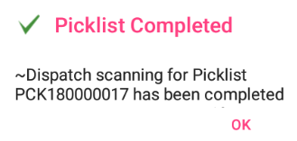

1. Click on **OK.**

***\*Note: Switch to Desktop Application for Invoice Generation activity.***

### Invoice Generation

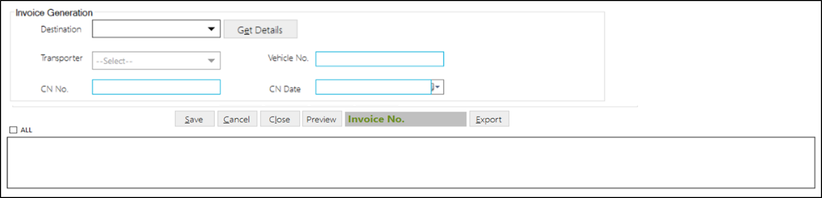This screen allows user to generate Invoice. The invoice creation details and serial numbers need to be saved in the table which will later be posted to the cloud and then BCODE. To view this screen, click on **Transactions** from main menu screen and click on **Invoice Generation**, following screen will get displayed:

1. Select *Destination* from the dropdown list.
2. Click on **Get Details.**
3. Select the **Picklist** record from the table grid.

*\*Picklist details, Number of boxes and number of pair’s details gets displayed.*

1. Select the Transporter details, Vehicle Number, Challan Number and Challan Date in the respective text fields.
2. Click on Save, success message will get displayed if details are saved successfully.

**Preview Button**

1. Select the number of **Picklist** records from the table grid.
2. Click on **Preview,** and all selected picklist details get displayed.

**Export Button**

1. Choose the **invoice** number in the text field.
2. Click on **Export** for the Invoice details.

*\*Export will regenerate the previous invoice details for label printing.*

**Cancel and Close**

1. Click on **Cancel** to clear the selections and text fields.
2. Click on **Close** to close the current screen.

### Invoice Update

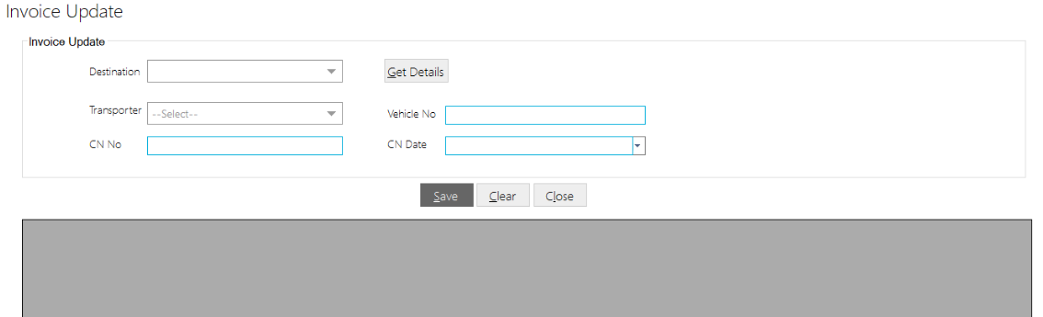This screen allows user to update Invoice. The invoice update details and serial numbers need to be save/update in the table which will later be posted to the cloud and then BCODE. To view this screen, click on **Transactions** from main menu screen and click on **Invoice Update**, following screen will get displayed:

1. Select *Destination* from the dropdown list.
2. Click on **Get Details**, corresponding details will get displayed in the data grid.
3. Select the record from the grid you want to update and corresponding details will appear in respective text fields.
4. Make required changes.
5. Click on **Save**, success message will get displayed if details are updated successfully.

**Cancel and Close**

1. Click on **Cancel** to clear the selections and text fields.
2. Click on **Close** to close the current screen.

### Reprint Invoice

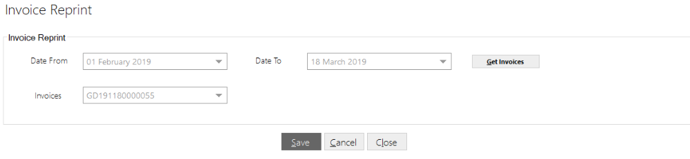This screen allows user to reprint Invoice. To view this screen, click on **Transactions** from main menu screen and click on **Reprint** **Invoice**, following screen will get displayed:

1. Select *Date From* and *To Date* from date picker.
2. Click on **Get Invoices.**
3. Select *Invoice* from the dropdown list, details will appear in data grid.
4. Click on **Save** to re-print Invoice, success message will get displayed if invoice is reprinted successfully.

**Cancel and Close**

1. Click on **Cancel** to clear the selections and text fields.
2. Click on **Close** to close the current screen.

### Invoice Cancellation

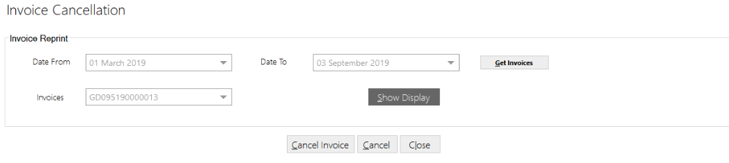This screen allows user to cancel Invoice created between specific time intervals. To view this screen, click on **Transaction** from main menu and click on **Invoice Cancellation**, following screen will get displayed:

1. Select *Date From* and *Date To* from date picker, click on **Get Invoices** to get invoiced created during selected time interval.
2. Select Invoice Number from the dropdown list.
3. Click on **Show Display** to display data in the data grid.
4. Click on **Cancel Invoice** to discard the selected invoice.

**Cancel and Close**

1. Click on **Cancel** to clear the selections and text fields.
2. Click on **Close** to close the current screen.

### Invoice Rollback

This screen allows user to roll / cancel the the invoices that are cancelled. The invoice rollback details need to be deleted from the tables. To view this screen, click on **Transaction** from main menu and click on **Invoice Rollback**, following screen will get displayed:

**Rollback**

1. Select *From Date* and *To Date* from date picker, click on **Get Invoices** to get the invoice created between selected time interval.
2. Select *Invoice Number* from the dropdown list and click on **Show Display** to show invoice data in data grid.
3. Click on **Cancel Invoice** to rollback selected invoice details.

**Clear and Close**

1. Click on **Clear** to clear the selections and text fields.
2. Click on **Close** to close the current screen.

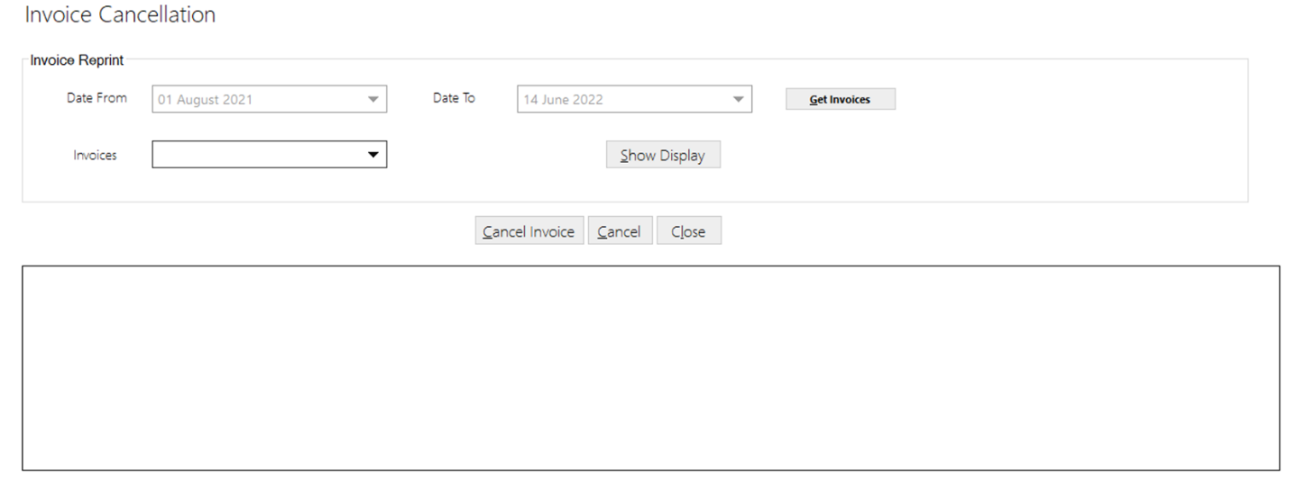

### Picking Rollback

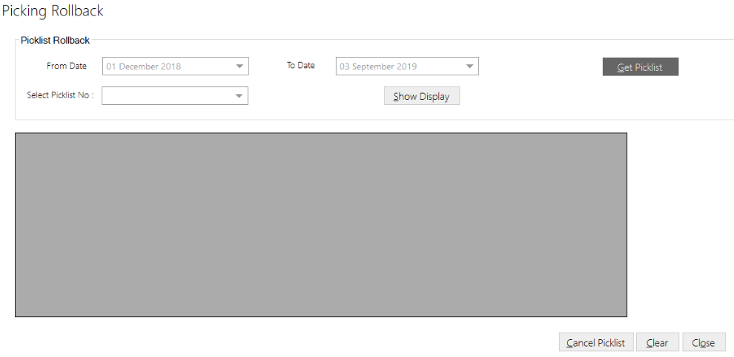This screen allows user to rollback/ cancel the Cartons picked against Picklist. To view this screen, click on **Transaction** from main screen and click on **Picking** **Rollback**, following screen will get displayed:

**Rollback**

1. Select *From Date* and *To Date* from date picker, click on **Get Picklist** to get the picklist created between selected time interval.
2. Select *Picklist Number* from the dropdown list and click on **Show Display** to show picklist data in data grid.
3. Click on **Cancel Picklist** to rollback selected picklist.

**Clear and Close**

1. Click on **Clear** to clear the selections and text fields.
2. Click on **Close** to close the current screen.

### Swap Outerbox

This screen allows user to swap the barcode label for existing Outerbox label. The existing barcode label gets scanned and replaced with new barcode label on outer box that contains number of monoboxes. To view this screen, click on **Transaction** from main screen and click on **Swap Outerbox**, following screen will get displayed

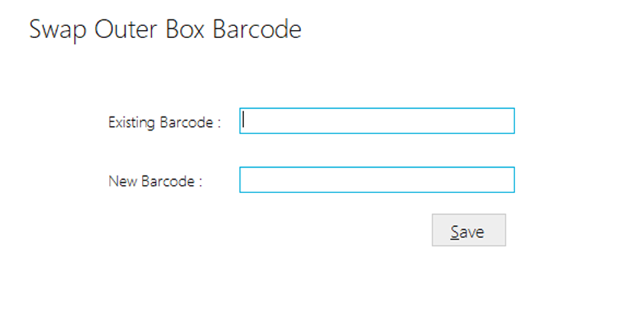

1. Scan the **existing** barcode label of the Outerbox.
2. Scan the **new generated** barcode label to be pasted.
3. Click on **Save,** to swap the barcode label in system database.
4. Paste the new barcode label on the existing outerbox label.

### Enable Invoice for syncing

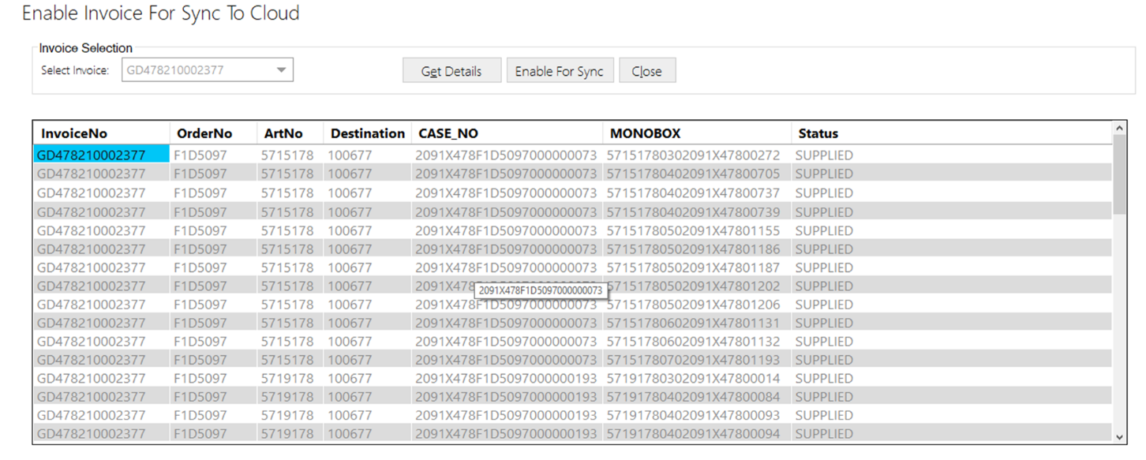This screen allows user to enable invoice data to sync with cloud database. If supplier wants to sync any existing Invoice data from supplier to Cloud this can be achieved using this screen. To view this screen, click on **Transaction** from main screen and click on **Enable Invoice for Syncing**, following screen will get displayed:

1. Select *Invoice Number* from dropdown list.
2. Click on **Get Details,** all details of Invoice gets displayed in table grid.
3. Click on **Enable to Sync**, all displayed details gets uploaded to cloud server.
4. A success message will get displayed if details are synced successfully.

**Close**

1. Click on **Close** to close the current screen.

## Report

### Supply Report

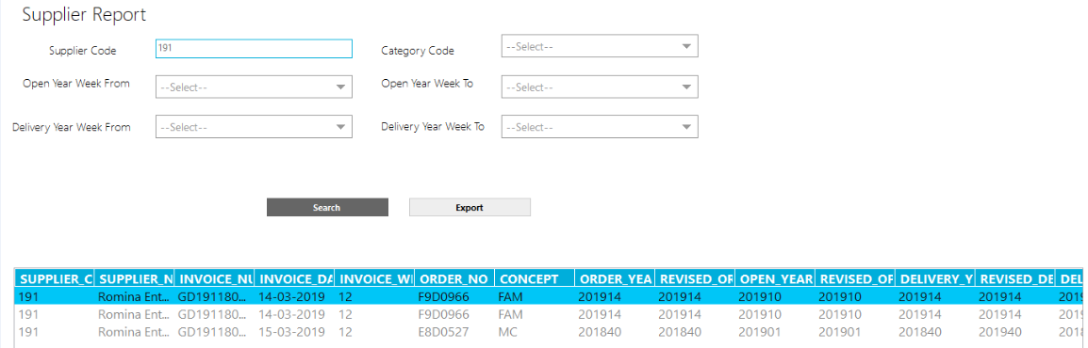This screen allows user to generate supplier report providing details of articles supplied during set time interval. To view this screen, click on **Report** from main menu screen and click on **Supply Report**, following screen will get displayed:

**Generate Report**

1. Enter/ select required data.
2. Click on **Search** to fetch the details.

**Export to Excel file**

1. Click on **Export** to generate an excel file.
2. A window will appear, enter the *File Name*, click on **Save**, success message will be displayed if file is created successfully.

### Order Balance Report

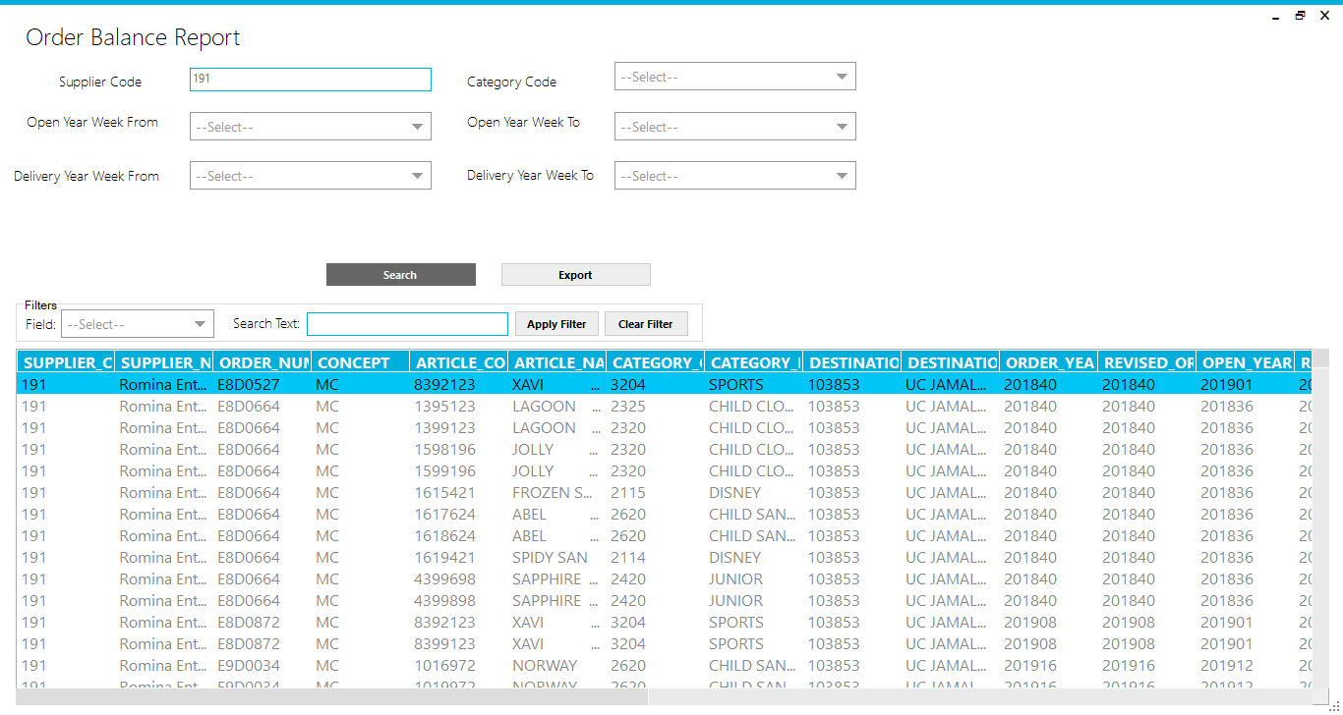This screen allows user to generate Order Balance report. To view this screen, click on **Report** from main menu screen and click on **Order Balance Report**, following screen will get displayed:

**Generate Report**

1. Enter/ select required data.
2. Click on **Search** to fetch the details.

**Export to Excel file**

1. Click on **Export** to generate an excel file.
2. A window will appear, enter the *File Name*, click on **Save**, success message will be displayed if file is created successfully.

**Clear Filter**

1. Click on **Clear Filter** to clear the selections and text fields.

### RFD Report

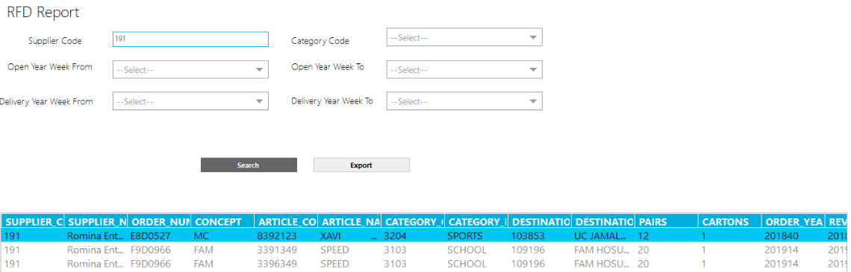This screen allows user to generate RFD report providing details of articles to be dispatched to RFD. To view this screen, click on **Report** from main menu screen and click on **RFD Report**, following screen will get displayed:

**Generate Report**

1. Enter/ select required data.
2. Click on **Search** to fetch the details.

**Export to Excel file**

1. Click on **Export** to generate an excel file.
2. A window will appear, enter the *File Name*, click on **Save**, success message will be displayed if file is created successfully.

### INV Report

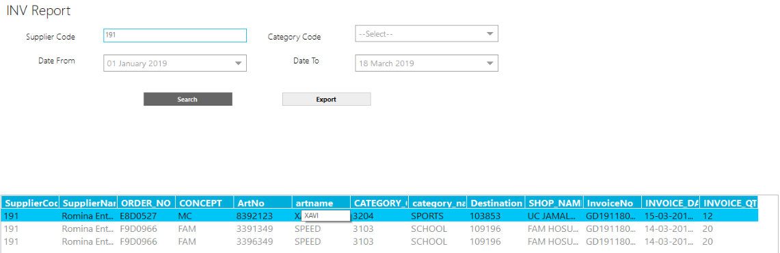This screen allows user to generate INV report providing details of invoices created supplier wise. To view this screen, click on **Report** from main menu screen and click on **INV Report**, following screen will get displayed:

**Generate Report**

1. Enter/ select required data.
2. Click on **Search** to fetch the details.

**Export to Excel file**

1. Click on **Export** to generate an excel file.
2. A window will appear, enter the *File Name*, click on **Save**, success message will be displayed if file is created successfully.

### Picklist Report

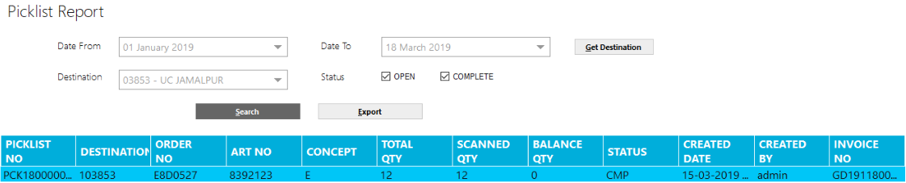This screen allows user to generate picklist report providing details of Open/ Closed Picklist between selected time interval. To view this screen, click on **Report** from main menu screen and click on **Picklist Report**, following screen will get displayed:

**Generate Report**

1. Enter/ select required data.
2. Click on **Search** to fetch the details.

**Export to Excel file**

1. Click on **Export** to generate an excel file.
2. A window will appear, enter the *File Name*, click on **Save**, success message will be displayed if file is created successfully.

### Production Planning

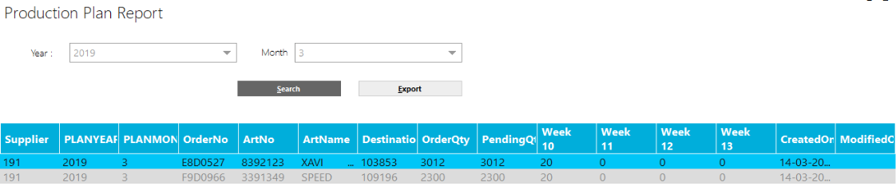This screen allows user to generate Production Planning report. To view this screen, click on **Report** from main menu screen and click on **Production Planning** **Report**, following screen will get displayed:

**Generate Report**

1. Enter/ select required data.
2. Click on **Search** to fetch the details.

**Export to Excel file**

1. Click on **Export** to generate an excel file.
2. A window will appear, enter the *File Name*, click on **Save**, success message will be displayed if file is created successfully.

### Planning Vs Actual Report

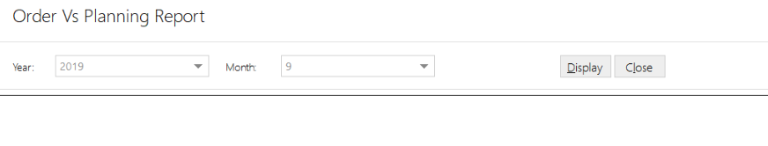This screen allows user to generate report providing details difference in item quantity during production planning and in actual order production. To view this screen, click on **Report** from main menu and click on **Planning vs Actual Report**, following screen will get displayed:

**Generate Report**

1. Select *Year* and *Month* from the dropdown list.
2. Click on **Display** to view the details.

**Close**

1. Click on **Close** to close the current screen.

### Pending Invoice Report

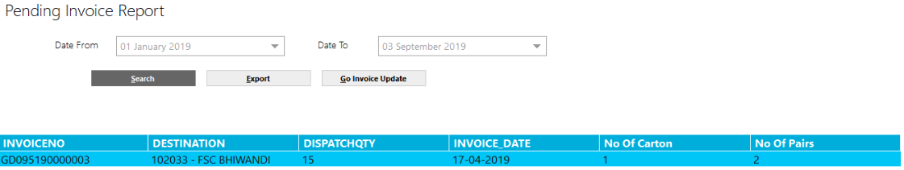This screen allows user to generate report providing details of pending invoices between selected time interval. To view this screen, click on **Report** from main menu and click on **Pending Invoice Report,** following screen will get displayed:

**Generate Report**

1. Select *Date From* and *To Date* from date picker.
2. Click on **Search** to view the details in the data grid:



1. Click on **Go Invoice Update** to update the selected invoice, if required.

**Export to Excel file**

1. Click on **Export** to generate an excel file.
2. A window will appear, enter the *File Name*, click on **Save**, success message will be displayed if file is exported successfully.

### Quality Check Report

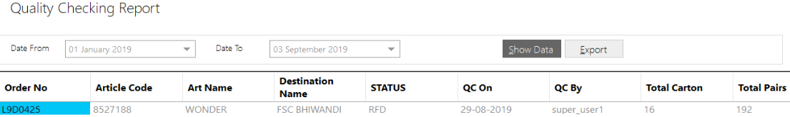This screen allows user to generate report providing details of Quality Status of the articles on which quality check was performed during selected time interval. To view this screen, click on **Report** from main menu and click on **Quality Check Report**, following screen will get displayed:

**Generate Report**

1. Select *Date From* and *To,* from date picker.
2. Click on **Show Data**.

**Export to Excel file**

1. Click on **Export** to generate an excel file.
2. A window will appear, enter the *File Name*, click on **Save**, success message will be displayed if file is exported successfully.

### Production Report

The screen is used to generate report providing details of Articles for which packing has been done during selected time interval but quality checking is pending. To view this screen, click on **Report** from main menu and select **Production Report**

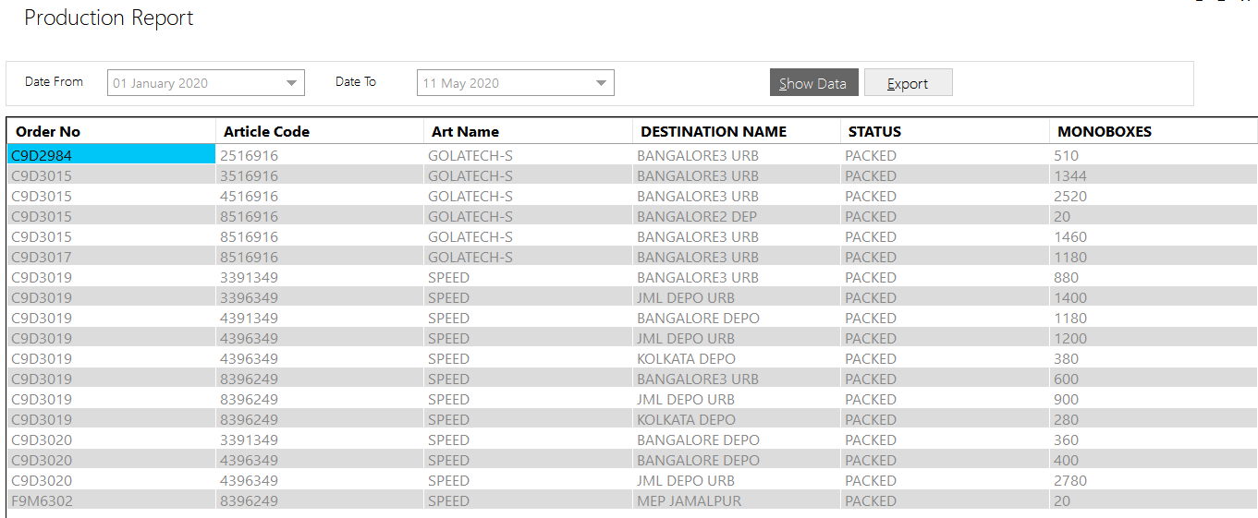

**Generate Report**

1. Select *Date From* and *To,* from date picker.
2. Click on **Show Data,** details ofpacked articles which are pending for quality check will appear in data grid.

**Export to Excel file**

1. Click on **Export** to generate an excel file.
2. A window will appear to export the records, enter the *File Name*, click on **Save**, success message will be displayed if file is exported successfully.

### Inventory Report

The screen is used to view and generate report of the articles for which quality checking has been done and are ready for dispatch. To view this screen, click on **Report** from main menu screen and select **Inventory Report**

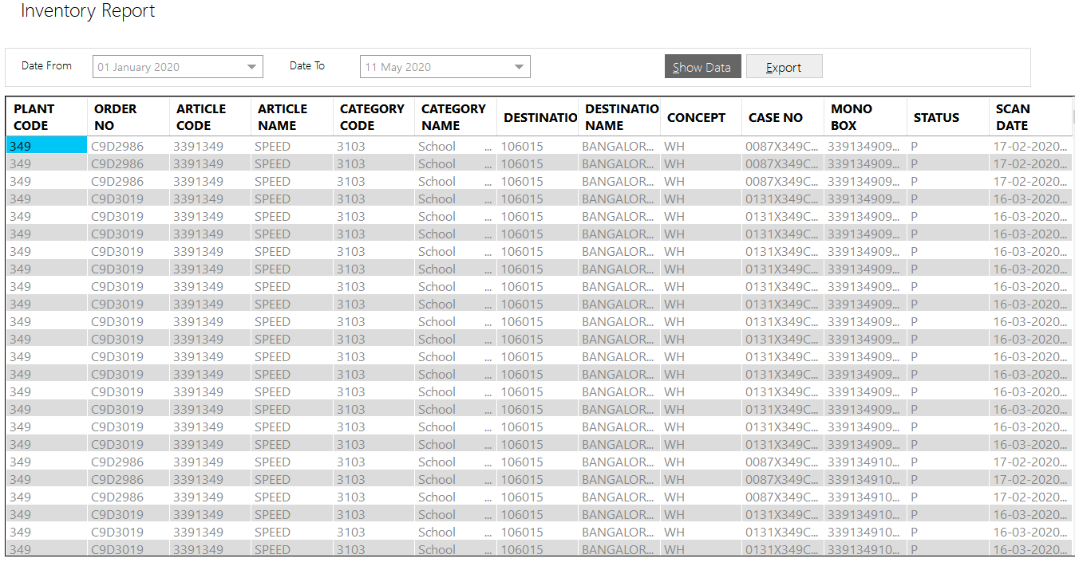

**Generate Report**

1. Select *Date From* and *To,* from date picker.
2. Click on **Show Data,** inventory articles will appear in data grid.

**Export to Excel file**

1. Click on **Export** to generate an excel file.
2. A window will appear to export the records, enter the *File Name*, click on **Save**, success message will be displayed if file is exported successfully.

### Picking Report

The screen is used to view and generate report of all the articles which have been picked during selected time interval. To view this screen, click on **Reports** from main menu and select **Picking Report**

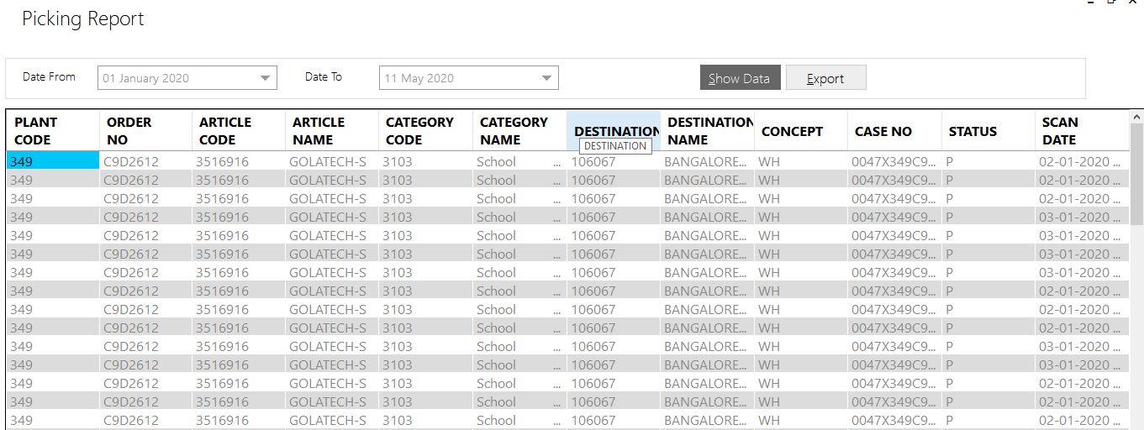

**Generate Report**

1. Select *Date From* and *To,* from date picker.
2. Click on **Show Data,** picked articles will appear in data grid.

**Export to Excel file**

1. Click on **Export** to generate an excel file.
2. A window will appear to export the records, enter the *File Name*, click on **Save**, success message will be displayed if file is exported successfully.

End User Manual

Bata Limited – Supplier Tracking Application

Confidential & Copyright©2020