WIP Automation System- Phase 1




IMI Norgren Herion Pvt. Ltd

Software Requirement Specification (SRS)

The document details the summary of solution architecture and approach for the development of Segment Management System for IMI Norgren Herion Pvt. Ltd. The document is based on the inputs, system study, discussions and meeting held between BCI & IMI Norgren Herion Pvt. Ltd Teams.
Prepared By: Omkar Gaonkar
Submission Date: 13- 06-2023
Version: 1.2
BAR CODE INDIA, 691 Udyog Vihar Phase V, Gurugram, Haryana-122016, PH: 0124 4337555

REVISION NO. | DATE | PREPARED BY | REVIEWED BY | COMMENT
1.0 | 05-06-2023 | Omkar Gaonkar | Prateeksha  Brajesh S | SRS Document for WIP Automation System
1.1 | 07-06-2023 | Omkar Gaonkar | Brajesh S | Changes in Line Master Screen, Production Issuance Screen and PVG Assembly FG Screen and Reports screen added.
1.2 | 13-06-2023 | Omkar Gaonkar | Brajesh S | BOM file shifted to Masters, MRR file and BOM file Sample format added. .
  - REVISION HISTORY

Abbreviations:
Name | Abbreviation
BCI | Bar Code India
QTY | Quantity
FG | Finished Goods
QR Code | Quick Response Code
REF | Reference

  - Table of Contents
1 Specification Organization 2
2 Introduction 3
2.1 Intended Audience and Reading Suggestions 3
2.2 Project Scope 4
3 Software/Hardware Requirements 5
3.1 Server Configuration 5
3.2 Computers 5
3.3 Hardware Requirements 5
4 Solution Architecture 6
5 User Interface Specification Conventions 7
6 System Log 8
6.1 Error Logs 8
6.2 Audit Logs 8
7 Architectural Design 9
7.1 Desktop Application 9
7.2 Device Application 9
7.3 Communication Server/API 9
8 Application Modules 10
8.1 Application Login- Desktop/Device Application 10
8.2 User Management 11
8.2.1 User Master 11
8.2.2 User Rights/ Permission 13
8.3 Masters 14
8.3.1 Line Master 14
8.3.2 BOM File Upload Master 15
8.4 Transactions 16
8.4.1 MRR file Upload 16
8.4.2 Part Receiving 18
8.4.3 Production Issuance 20
8.4.4 Day Start 22
8.4.5 PVG Assembly Y-FG Barcode 24
8.4.6 Re-Printing 26
9 Reports 28
9.1 Serial Number Report 28
9.2 Conformity Report 29
9.3 Conformity Report with Coil 30
9.4 Conformity Report without coil 31
10 SRS Scope Change Process 32
10.1 Before Sign Off 32
10.2 After Sign Off 32
10.3 SRS Acceptance 32

Specification Organization
The objective of this document is to supply underlying concepts, procedures, and formats used in the design, development and installation of this software application. This specification consists of three sections organized as follows.
Section 1: Introduction

This section provides hardware requirements and documentation conventions.

Section 2: User Interface

This section depicts screen design and logic flow, and is categorized into two groups:
- Application Master Module
- Common Routine

Section 3: System Architecture
This section provides information of system architecture.

Introduction

Intended Audience and Reading Suggestions
The scope of the software would require the development of the front end application, client device application and to transfer data from application to server. The document lays down the specifications of the middleware application, its architecture and infrastructure requirements.
The entire solution consists of followings:
- Desktop Application
- Windows Tablet Application
- Communication Server/API

Project Scope
The objective of the project is to develop a web-based WIP Automation System application for Norgren. Its purpose is to streamline the monitoring of components utilized in the assembly line during the production of the final FG. Our application will transfer / download data to/ from JDA via excel files.
The application solution will generate barcode labels for the components their identification and tracking at the Assembly Line. These components will be scanned and verified. They will then undergo testing in a Part Testing machine, which will assign a unique Serial Number to each component. The application will link the Serial Numbers from the Part Testing output to the assembled components and generate barcode labels for the final FG.
The application will keep record of the components at every stage and update transaction data. MRR data will only be imported through excel files in the application.
The entire solution consists of followings:
- Desktop Application
- Communication Server Application (.NET 6.0)
- Windows Tablet Application

Software/Hardware Requirements
Below are the hardware and the software requirements of the application:

Server Configuration
Central Server Configuration/Database Servers
The solution would require the high performance server with minimum of following:
- Express Intel Xeon E3 (Quad Core) 3.2 GHz 8 MB 1600 MHz 64GB 2x1 TB SATA 7200 RPM 3.5" Simple-Swap MULTI BURNER RAID 0, 1, 5 in built (SR C100)Windows 2012 & above server
- Windows 2012 & above server
- MS SQL 2019 STD or Above (Core Based License).
- VPN Connectivity to Central server and Plant Server as well.
- Optional backup
- Dot net Framework 6.0
- IIS V10.0 (Internet Information Service)

Computers
Desktop would require following specifications:-
- I5/i7 Processor with Windows 10 Operating System
- 16 GB RAM
- 100GB HDD
- Dot net Framework 6.0

Hardware Requirements
Hardware required for the application:
- Windows Tablet (Zebra tablet ET51AT-W12E-00IA)- 2 units
- Barcode Printer (ZT 230) already with Customer

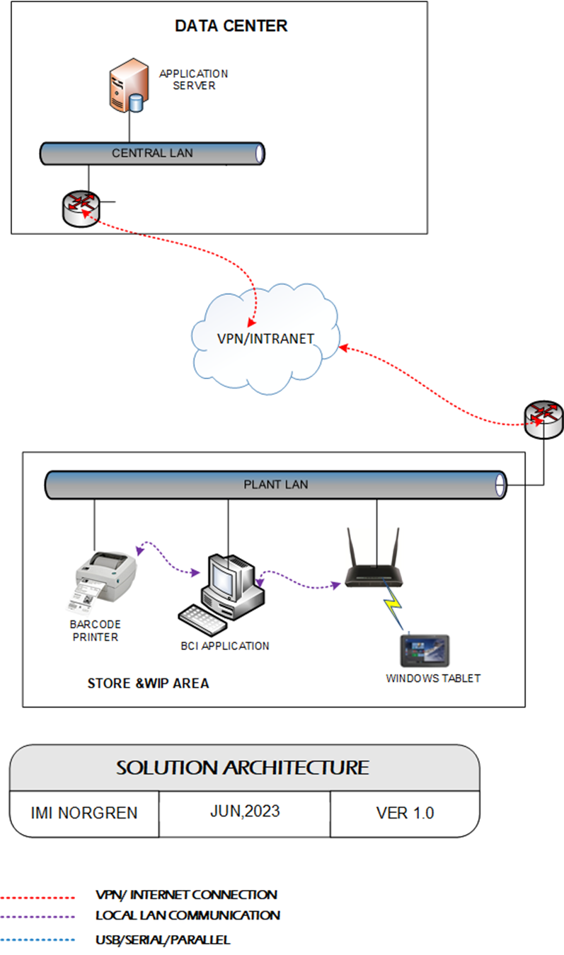
Solution Architecture

User Interface Specification Conventions
This section specifies the user interface portion of the application.

Section Organization
The User Interface Specification presents screen displays or “Dialogs”.
Documentation Conventions
This section incorporates illustrations of the application user interface. Each screen display “Dialog” consists of the screen display image, a process name, a paragraph documenting the processing required for the dialog, a paragraph listing the navigation options, and a table listing for each variable field on the dialog, its database source or destination, format, and any instructions required to process the field.
The following section contains a sample dialog with each area identified.

System Log
System shall maintain internal logs for application.

Error Logs
These logs will contain any errors encountered during runtime for faster resolution of any problem post deployment.

Audit Logs
These logs will monitor the activities of user who accessed the application, made changes to File/ Document and the time stamp of these activities.

Architectural Design
Overall System consists of:
- Desktop Application
- Device application
- Communication Server

Desktop Application
This application will include will be developed for performing transactions like User Master, Line Master, BOM File Master, Upload Rights Permission/Order, Day start, Component Label Printing, , MRR file Upload, Reprint.

Device Application
Windows tablet Application including PVG Assembly Y-FG Barcode module.

Communication Server/API
To GET and Post details into BCI Server.

Application Modules

Application Login- Desktop/Device Application
This login module will provide access to the application modules. Here the admin/user needs to enter the login detail to enter in the application and to perform the desired actions.
Process: User needs to enter the User Name/ID and Password in display fields and press the Login button. Application will validate the user credential.
User will be able to view only those screens/ modules of which he has been given access rights to.
Validation
- User Name/ ID will be unique for all users.
- User Name/ ID and Password length will be set.
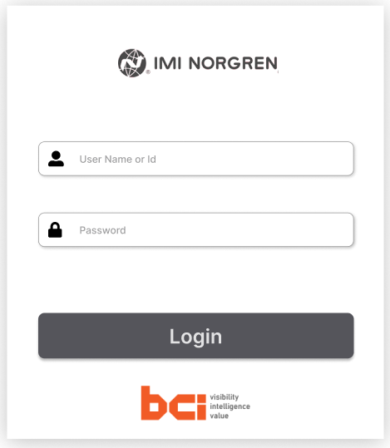
After successful login application menu screen will appear; this screen will have the Master and Transaction options etc.

User Management
The module will let application administrator to manage the Users, and the rights assigned to the same; the rights will define authorized application access of users.
The User Management & Master data will be created using Desktop Application.

User Master
This module will let user to create application users who will access the application. The master will store the users’ details in system.
Data Fields | - ID  - Name  - Password  - Type  - Contact No
Process Steps | - Enter required details i.e. User ID, User Name, Password in system  - Select the type of the user from the list  - Select the Location, Department from the list  - Enter the Contact Number of user  - Click on Save button to save details in database  - Newly added user will appear in data grid
Functions | - Add, Edit/Update, Delete as per requirement  - User ID and Password is used to access the application.
Role | Admin will create/ add user details via window application
Sample Screen | 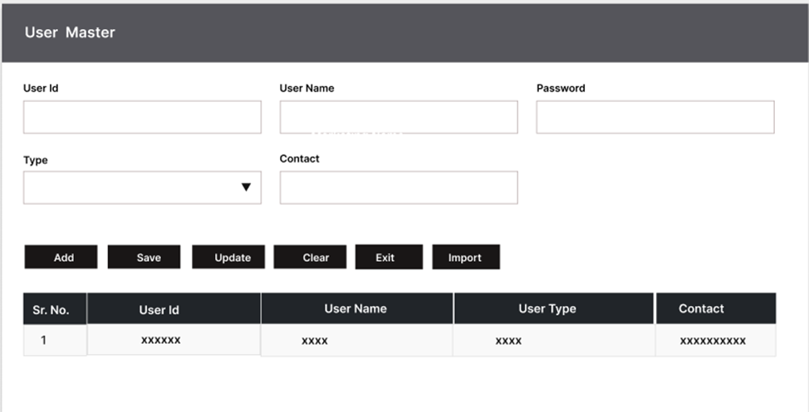

User Rights/ Permission
This module will let admin to assign module / screen access rights to the application users. Once assigned, authorized users can access the application. Once permissions are assigned, user will be able to view only those screens/ modules of which he has been given access rights to by Admin.
Data Fields | - User ID/ Name  - Module /Screen Names
Process Steps | - Admin will select User Name/ID.  - Screen/ module names will appear in data grid along with checkbox.  - Admin will check the checkbox against module/ screen to which selected User should be assigned access permissions.  - Save and Update the details in database
Functions | Add, Edit/Update as per requirement
Role | Admin / Authorized User will assign access rights to the selected User
Sample Screen | 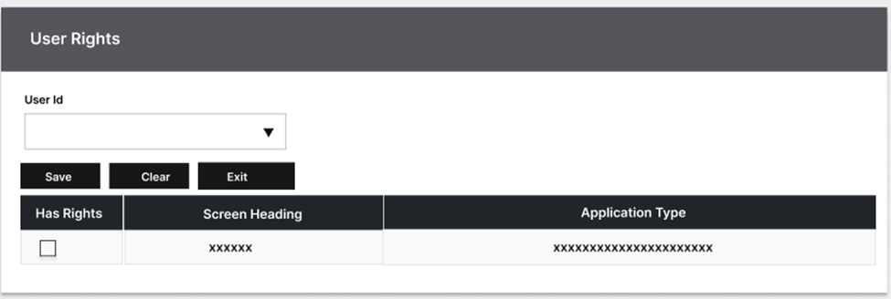

Masters

Line Master
The Line Master contains the details of the assembly line working in the plant.
Data Fields | - Line Code  - Line Name  - Description  - Active/ Inactive
Process Steps | - User will open Line Master screen  - Select the Plant Code.  - Enter required details i.e., Line Code, Name, Description etc.  - Check the Active checkbox to make the line active  - Click on save to store details in database  - Newly added record will appear in data grid.  - Details will get displayed in data grid on screen that is fetched from SAP.
Functions | Add, Edit/Update, Delete as per requirement.
Sample Screens | 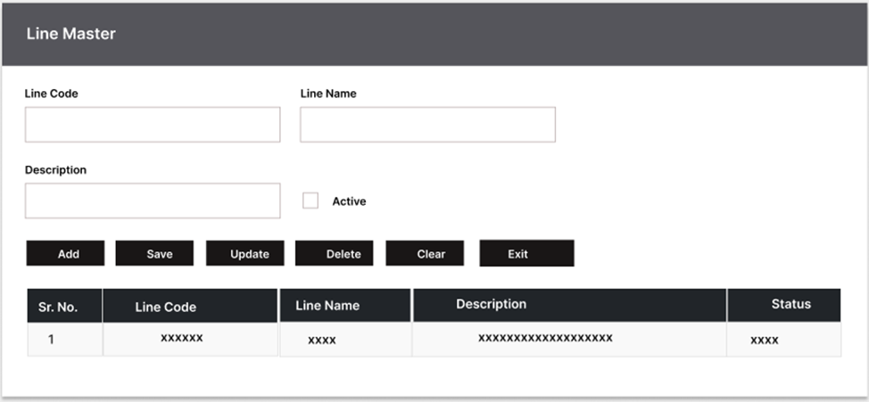

BOM File Upload Master
The BOM Master consist the BOM details of the FG Item.
Activities
Data fields | - BOM file
Process Steps | - User login into the application.  - Browse and select the BOM file.  *BOM file will be in CSV format and to be provided by IMI team.  - The BOM will include BOM number FG Item code and FG Component details  - Upload selected file  - Click on Save button  - Details get updated in the database.
Functions | - Add as per requirement.
Sample Screen | Note: - The provided screens are samples; the actual screen may vary slightly.  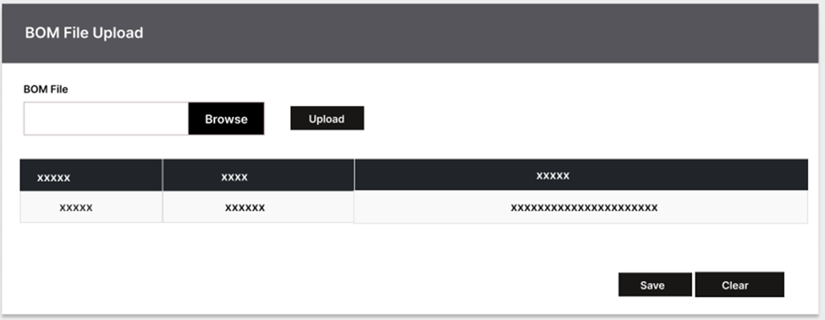  Sample File Upload data Format
  FG Part Code | Child Part Code | Child Part Qty | UOM
  2401103080002400 | 2401103000000000 | 1 | EA
  2401103080002400 | 0000000080002400 | 1 | EA
  2401103080002400 | 0570275000000000 | 1 | EA
  2401103080004800 | 2401103000000000 | 1 | EA

Transactions

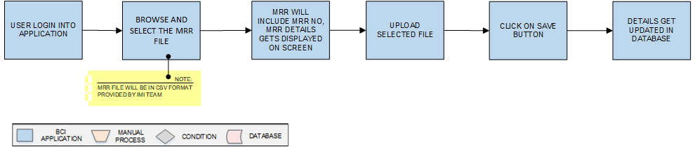
MRR file Upload

Activities
Module Description | The module will be used to upload the MRR details into the system Server.  *This activity will be done using Desktop Application.

Pre-Conditions | - MRR details to be downloaded into system.  - MRR to contain all details in the excel sheet.

Process Steps | - User login into the application.  - Browse and select the MRR file.  *MRR file will be in CSV format and to be provided by IMI team.  - The MRR will include MRR number and MRR details.  - Upload selected file  - Click on Save button  - Details get updated in the database.

Post-Conditions | - MRR file successfully message appears after completion.

Validations | - An alert should be displayed in case invalid details is entered.  - An alert message is displayed in case of any error / invalid activity.

Sample Screen | 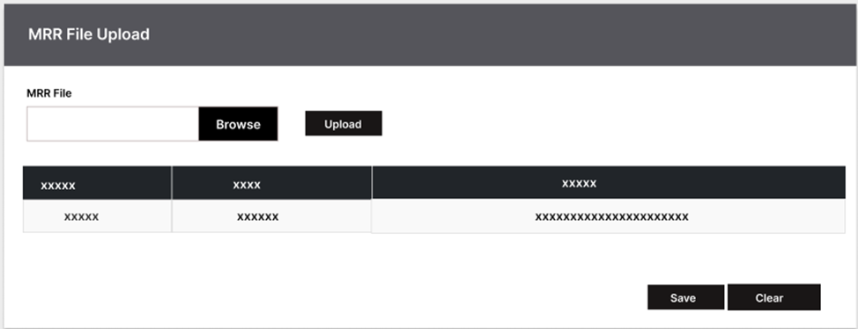  Note: - The provided screens are samples; the actual screen may vary slightly.  Sample File Upload data Format  These MRR file will be downloaded with all the fields:-  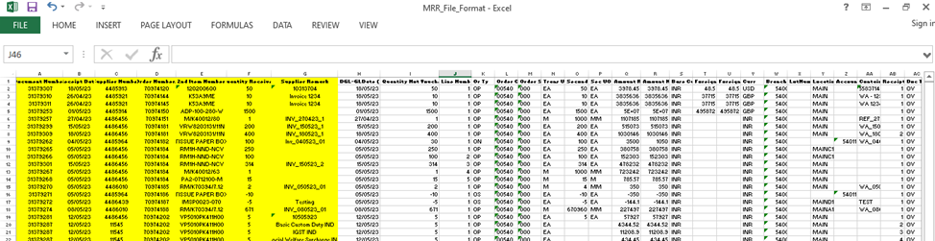  Note: - The application is going to consider the yellow colored columns, these field will be picked and upload in the system.
  Document Number | Receipt Date | Supplier Number | Order Numbers | 2nd Item Number | Quantity Received | Supplier Remark
  31379307 | 18/05/23 | 4485913 | 70974120 | 120200600 | 50 | 10313704
  31379310 | 26/04/23 | 4485921 | 70974144 | K53A9ME | 10 | Invoice 1234
  31379311 | 26/04/23 | 4485921 | 70974145 | K53A9ME | 10 | Invoice 1234

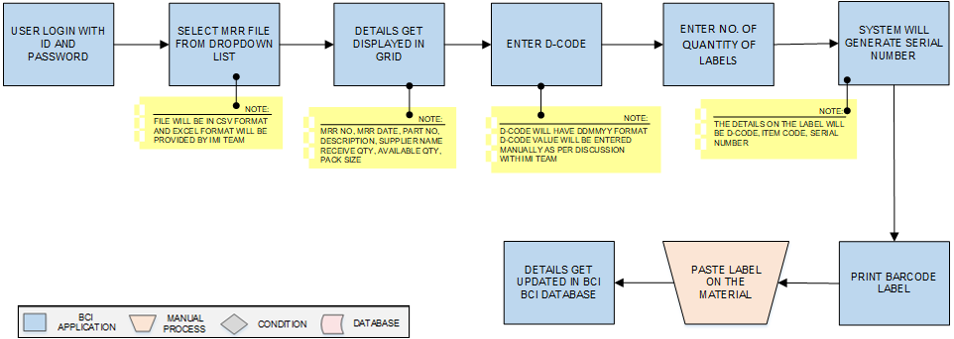
Part Receiving

Activities
Module Description | During this process, barcode labels will be printed for each component using the MRR File. These labels will give each component a unique identification. The MRR File will be created in the JDA ERP system and shared by IMI Norgren as an Excel file.  *This activity will be done using Desktop Application.

Pre-Conditions | - Authorized access to the application.  - MRR excel sheet data to be available in the system.

Process Steps | - User login with Login Id and Password.  - Select the MRR file from the dropdown list.  *File will be in Csv Format and excel format will be Provided by IMI team  - The details of MRR no, MRR date, part no, Description, supplier name, Receive quantity, available quantity and Pack size will appear in table grid  - Enter D-Code.  *D-Code value date will be accepted with the DDMMYY format.  **D-Code will be entered manually as per discussion with IMI team.  - Enter No of Quantity of labels to be printed.  - System will generate the Serial number details.  *The details on label will be D-code, Item code and Serial number.  - Click on Save and Print Barcode Label.  - Paste the label on the material.  - Details gets saved into database

Post-Conditions | - All the component to be labelled.  - The label component to be having serial number details.

Validations | - An alert should be displayed in case invalid label number is entered.  - An alert message is displayed in case of any error / invalid activity.

Sample Screen | 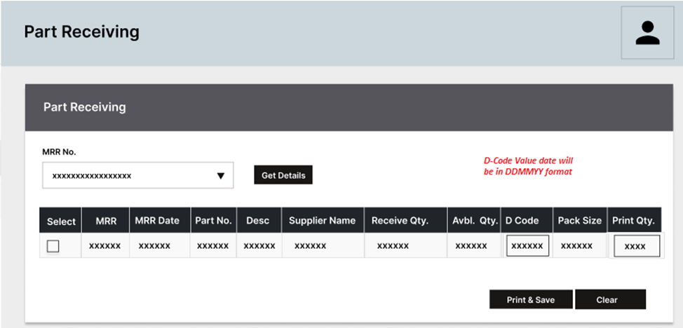  Note: - The provided label are samples; the actual label may vary slightly.  Barcode Label Contains:-  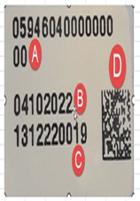

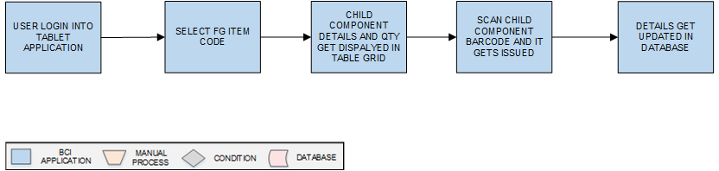
Production Issuance

Activities
Module Description | The module will be used to upload the production Issuance of the child components as per selected FG item code.  *This activity will be done using Desktop Application.

Pre-Conditions | - FG item details to be available in database.

Process Steps | - User login into the application.  - Select the FG Item Code.  - The Child Component details and Quantity will get displayed in table grid.  - Scan the Child component barcode.  - The component gets issued into the system.  - Details get updated in the database.

Post-Conditions | - FG details should get updated in database.

Validations | - An alert should be displayed in case invalid details is entered.  - An alert message is displayed in case of any error / invalid activity.

Sample Screen | 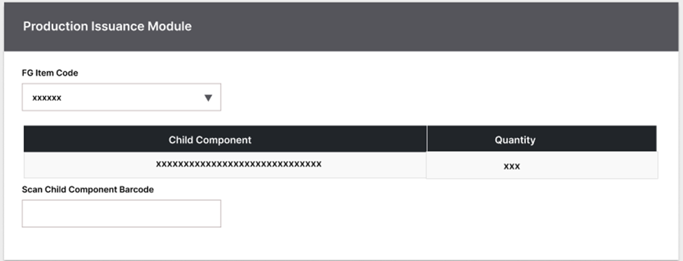  Note: - The provided screens are samples; the actual screen may vary slightly.

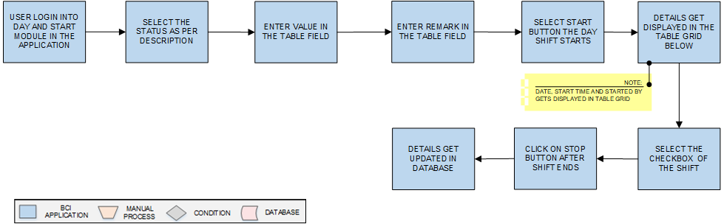
Day Start

Activities
Module Description | The module will be used to save the production details in database. Start and Stop time will be captured.  *This activity will be done using Desktop Application.

Pre-Conditions | - Shift to be started after checking all system working.  - All system to be checked by the user before production.

Process Steps | - User login into the application.  - Select the Start Day module.  - Check the system pre-conditions and select the status accordingly.  - Enter the Value and Remark in the text fields.  - Select the start button to start the shift.  - The details of Start time, Start date and started by details get displayed in the table grid.  - Select the checkbox of the shift from table grid.  - Click on Stop button at the end of the shift.  - Details get updated in the database.  - Posted into BCI Server.

Post-Conditions | - Shift Start and Stop details to be provided by IMI.  - Timing details to get updated if any changes in shifts.

Validations | - An alert should be displayed in case invalid details is entered.  - An alert message is displayed in case of any error / invalid activity.

Sample Screen | Note: - The provided screens are samples; the actual screen may vary slightly.  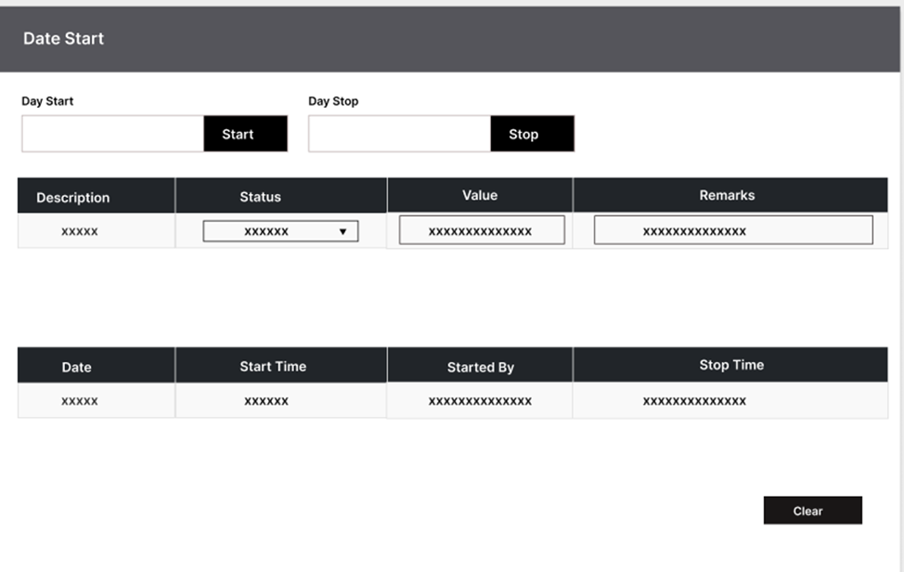

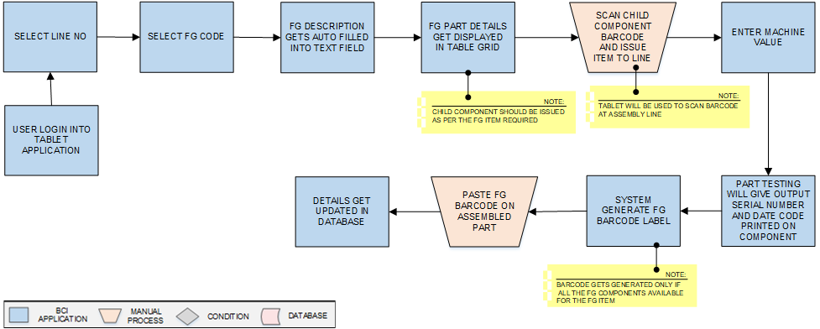
PVG Assembly Y-FG Barcode

Activities
Module Description | In this module, the components issued at the assembly are scanned. After that, they are processed through the Part Testing Machine. The machine will give unique Serial Number to each component as an output which will be mapped with the previously scanned Serial Number. Once the mapping is complete, the application generates the barcode for the final product (FG).  *This activity will be done using Windows Tablet Device Application

Pre-Conditions | - FG details should be uploaded in BCI application.

Process Steps | - Select Line No.  - Select FG Code Number.  - The FG description gets auto filled in the text field.  - FG Part details get displayed in the table field.  *FG component should be issued as per FG item requirement.  - Scan Child Component barcode and issue item to line.  *Windows Tablet will be used to scan item at assembly line.  - Enter Machine Value into the text field.  - Part Testing will give output serial number and Date Code printed on component.  - System generates the FG Barcode label.  *The barcode gets generated if all the child component is available for the FG item.  - Click on Print and paste barcode label on assembled part.  - Details get updated in the database.

Post-Conditions | - Barcode labelled items to be scanned properly.

Validations | - An alert should be displayed in case invalid details is entered.  - An alert message is displayed in case of any error / invalid activity.

Sample Screen | Note: - The provided screens are samples; the actual screen may vary slightly.  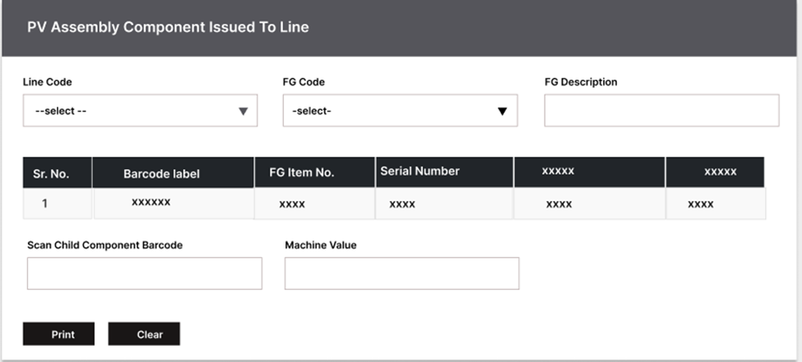
  Barcode label consist of | FG Item No | Serial Number

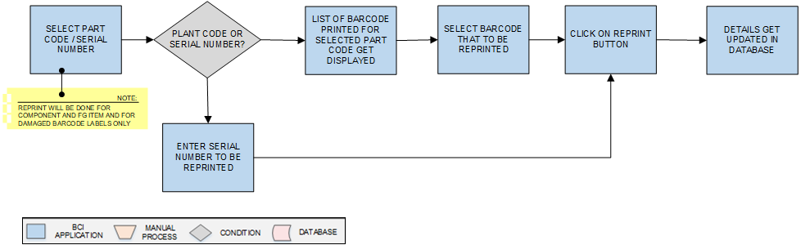
Re-Printing

Activities
Module Description | Barcode labels can be reprinted for components or finished goods (FG) items in case they are damaged or defaced.  *This activity will be done using Desktop Application.

Pre-Conditions | - Authorized User to be given permission.  - Barcode label to be damaged of the items.

Process Steps | - Enter/Select Part Code or Serial Number.  - If Part Code is selected:  - Display all printed barcodes for the selected part code.  - Select the desired barcode for reprinting.  - Reprint the barcode.  - Apply the reprint on the component.  - If Serial Number is selected:  - Enter the Serial Number.  - Reprint the barcode for the specified serial number.  - Apply the reprint on the component  - Details get updated in the database.  - Posted into the BCI Server.

Post-Conditions | - Repacked item to be updated into the system.  - Repacked label to be saved into the database Server.

Validations | - An alert should be displayed in case invalid details is entered.  - An alert message is displayed in case of any error / invalid activity.

Sample Screen | 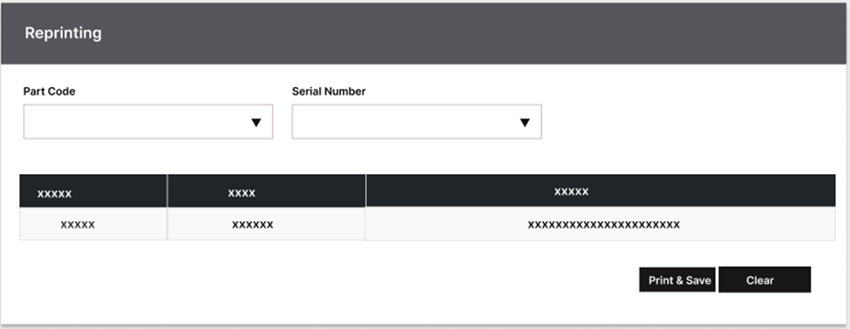  Note: - The provided screens are samples; the actual screen may vary slightly.

Reports
Reporting module will provide access to the data that will be helpful in making well-informed strategic decisions, reduces risk, and increases productivity. The reporting interface will be user-friendly, application users can easily generate, and view required data.
The application will generate customized reports based on required data fields and time interval selected / entered by users.
Note: - BCI will provide a maximum of 5 reports. Currently, 4 reports have been included in the document, and one additional report can be added once the application is developed.

Serial Number Report
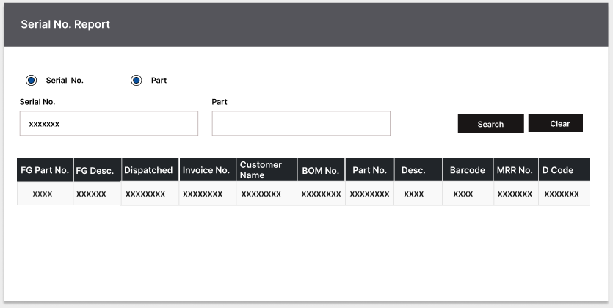

Conformity Report
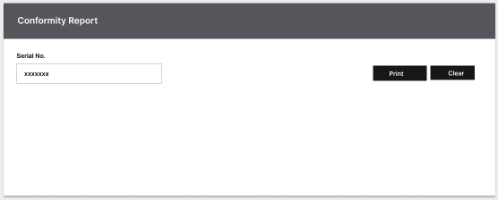

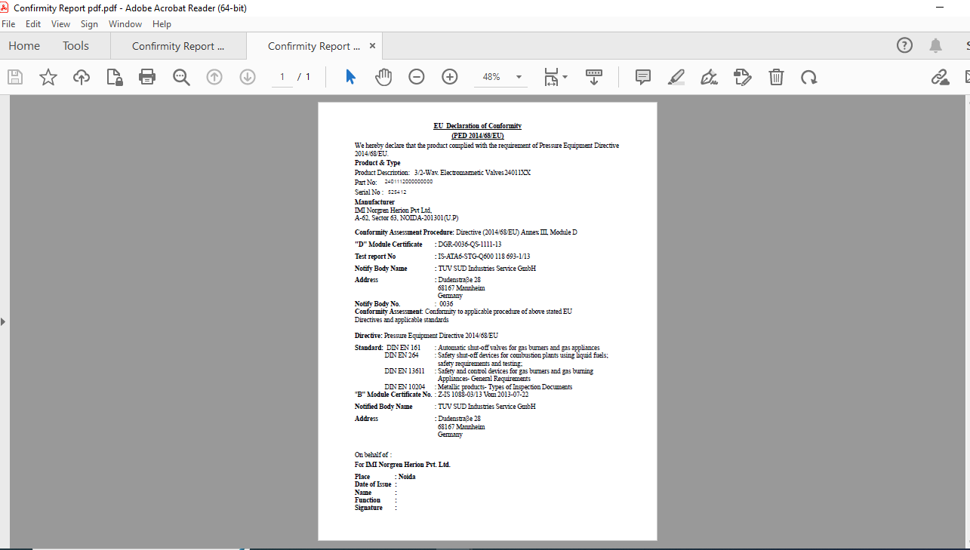
A Report PDF file will get downloaded.

Conformity Report with Coil
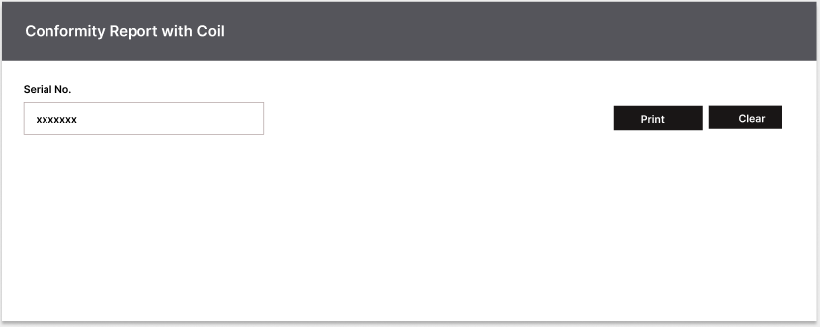

A Report PDF file will get downloaded.
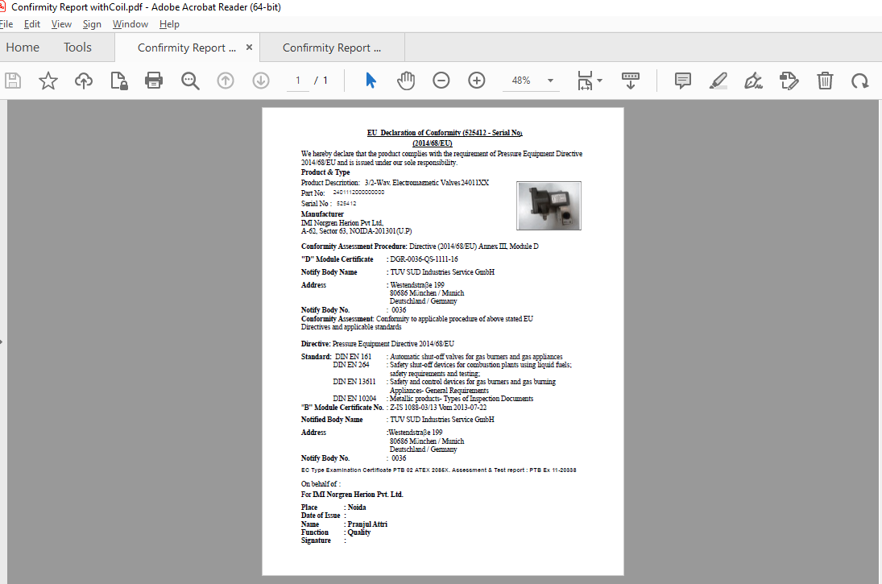

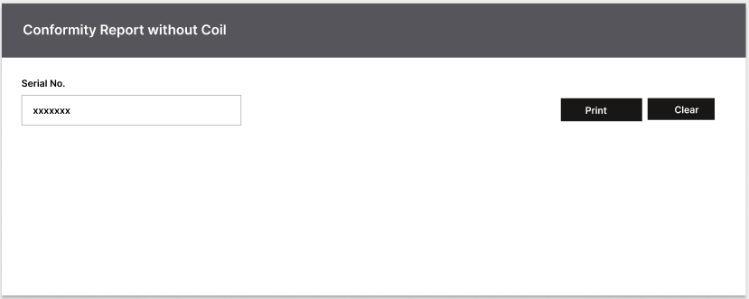
Conformity Report without coil

A Report PDF file will get downloaded.
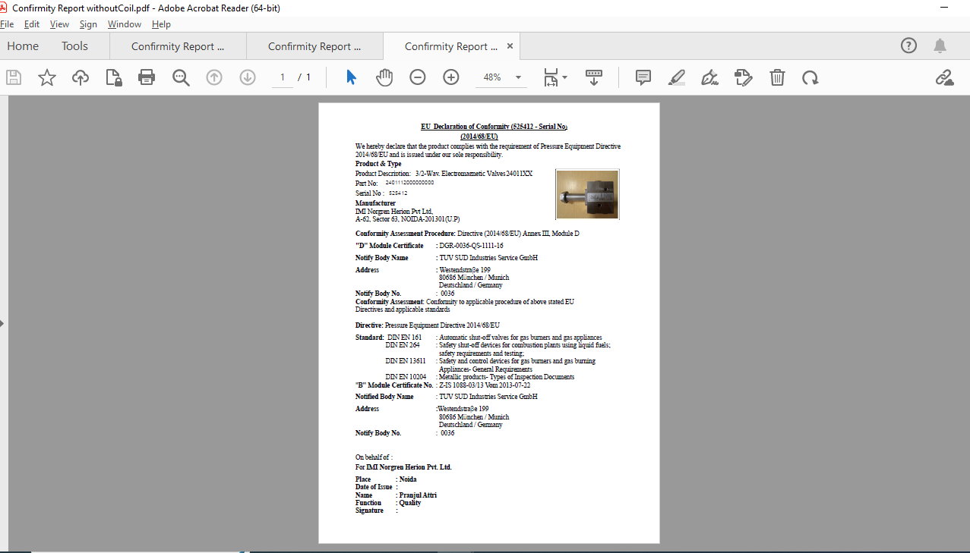

SRS Scope Change Process

Before Sign Off
Any changes in SRS need to be informed in writing by IMI Norgren Herion Pvt. Ltd. It will be incorporated / confirmed only after doing detailed feasibility study by BCI.
- If any change is out of scope then this would be done as a CR post feasibility and priority will be decided based on mutual agreement.
- Once the change is developed , any further change in the same would be considered as a CR

After Sign Off
Any changes in proposed solution after approval of this document by IMI Norgren Herion Pvt. Ltd are subjected to confirmation from BCI, taking feasibility constraints into account. These changes will be incorporated (if any) into the solution only after delivering proposed solution & may be charged as extra.
- Any change in the proposed solution due to customer system design or process will be considered as CR
- Any process which is not mentioned in this document will not be considered as “mutual understanding or default presence or standard practice”.
The changes in proposed solution before & after acceptance will be mutually agreed and duly signed and accepted by IMI Norgren Herion Pvt. Ltd & BCI.

SRS Acceptance
For IMI Norgren Herion Pvt. Ltd. | For Bar Code India (BCI)
Name: | Name:
Designation: | Designation:
Department: | Department:
Agreed and Accepted by IMI Norgren Herion Pvt. Ltd and Bar Code India

