Segment Tracking System



ITD Cementation Pvt Ltd

Software Requirement Specification (SRS)

The document details the summary of solution architecture and approach for the development of Segment Management System for ITD Projects Limited. The document is based on the inputs, system study, discussions and meeting held between BCI & ITD Cementation Pvt Ltd. Teams.

**Prepared By: Omkar Gaonkar**

**Submission Date: 04- 10-2022**

**Version: 1.0**

BAR CODE INDIA, 691 Udyog Vihar Phase V, Gurugram, Haryana-122016, PH: 0124 4337555

|  |  |  |  |  |
| --- | --- | --- | --- | --- |
| REVISION NO. | DATE | PREPARED BY | REVIEWED BY | COMMENT |
| 1.0 | 04-10-2022 | Omkar Gaonkar | Ashutosh Kroria | SRS Document for Segment Tracking System |

REVISION HISTORY

**Abbreviations:**

|  |  |
| --- | --- |
| **Name** | **Abbreviation** |
| Bar Code India | BCI |
| ITD Cementation Pvt Ltd | ITD |

Table of Contents

1 Specification Organization 2

2 Introduction 3

2.1 Intended Audience and Reading Suggestions 3

2.2 Project Scope 4

3 Software/Hardware Requirements 5

3.1 Cloud Server Configuration 5

3.2 Computers 5

3.3 Hardware Requirements 5

4 Solution Architecture 6

5 User Interface Specification Conventions 7

6 System Log 8

6.1 Error Logs 8

6.2 Audit Logs 8

7 Architectural Design 9

7.1 Web Application 9

7.2 Device Application 9

7.3 Communication Server 9

8 Application Modules 10

8.1 Application Login- Web & Device Application 10

8.2 User Management 11

8.2.1 User Master 11

8.2.2 User Rights/ Permission 12

8.2.3 User Login 13

8.3 Masters 14

8.3.1 Mold Master 14

8.3.2 Segment Master 15

8.3.3 Location Master 16

8.3.4 Site Master 16

8.3.5 Zone Master 17

8.3.6 Dispatch Master 18

8.4 Segment Creations 19

8.4.1 Segment Casting & RFID Tagging 19

8.4.2 RFID Tag Molding 21

8.4.3 Concrete Pouring 23

8.4.4 De-molding 25

8.5 RM Operations 27

8.5.1 Quality Inspection 28

8.5.2 Putaway 30

8.5.3 Picklist Creation Plan 32

8.5.4 Queuing Verification 34

8.5.5 Picking 36

8.5.6 Dispatch 38

8.6 Segment Site Identification Operations 40

8.6.1 Segment Delivery Inspection 40

8.6.2 Fixture Identification 42

8.6.3 Segment grouping 44

9 SRS Scope Change Process 45

9.1 Before Sign Off 45

9.2 After Sign Off 45

9.3 SRS Acceptance 45

# Specification Organization

The objective of this document to provide the application to create a Segment Management System Application which will facilitate the automation of manual processes using AIDC Technology required in handling and managing Segments in its yard to fixtures and movement to implementation sites.

**Section 1: Introduction**

This section provides hardware requirements and documentation conventions.

**Section 2: User Interface**

This section depicts screen design and logic flow, and is categorized into two groups:

* Application Master Module
* Common Routine

**Section 3: System Architecture**

This section provides information of system architecture.

# Introduction

## Intended Audience and Reading Suggestions

The scope of the software would require the development of the front end application, client device application and communication server to transfer data from application to server. The document lays down the specifications of the middleware application, its architecture and infrastructure requirements.

The entire solution consists of followings:

1. Web Application

2. Communication Server Application

3. Mobile Device Application

## Project Scope

The scope of the application is to create a Segment Management System Application which will facilitate the automation of manual processes using AIDC Technology required in handling and managing Segments in its yard to fixtures and movement to implementation sites.

Using this application, it is possible to monitor and keep record of the Segment flow, analyze inventory and minimizes the risk of good Segment and rejected Segments. The solution will be proved beneficial for ITD Cementation as it aims to improve data accuracy, increase processing date and inspections, eliminates paper work, reduces time & effort required for the activity and provide instant inventory and other types of pertinent reports.

The scope of the software would require the development of the front end application, client device application and communication server to transfer data from application to server. The document lays down the specifications of the middleware application, its architecture and infrastructure requirements.

The entire solution consists of followings:

* Web Application
* Mobile Device Application
* Communication Server Application

# Software/Hardware Requirements

Below are the hardware and the software requirements of the application:

## Cloud Server Configuration

Central Server Configuration/Database Servers

The solution would require the high performance server with minimum of following:

* • Express Intel Xeon E3 (Quad Core) 3.2 GHz 8 MB 1600 MHz 32GB 2x1 TB SATA 7200 RPM 3.5" Simple-Swap MULTI BURNER RAID 0, 1, 5 in built (SR C100)
* • Windows 2012 & above server
* • MS SQL 2014 STD or Above (Core Based License).
* • VPN Connectivity to Central server
* • Optional backup

## Computers

Desktop would require following specifications:-

* I5/i7 Processor with Windows 10 operating System
* 8 GB RAM
* 100GB HDD
* Dot net Framework 4.5

## Hardware Requirements

Hardware required for the application:

* Innova RFID Tag – 80,000 Nos
* Android Handheld Terminals – 5 Nos
* USB RFID reader – 1 No.

# Solution Architecture

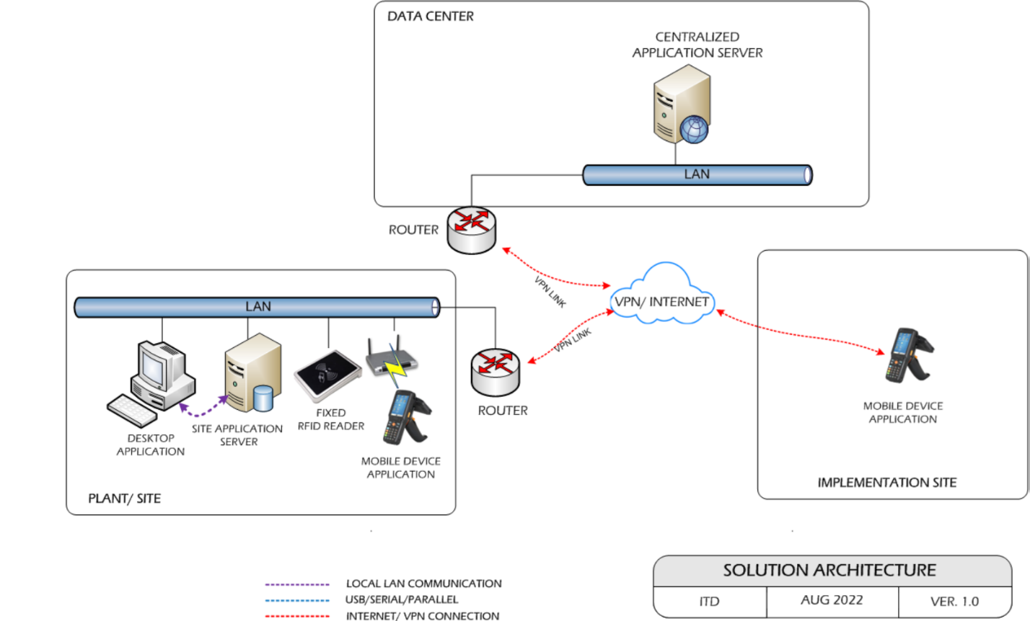

# User Interface Specification Conventions

This section specifies the user interface portion of the application.

**Section Organization**

The User Interface Specification presents screen displays or “**Dialogs**”.

**Documentation Conventions**

This section incorporates illustrations of the application user interface. Each screen display “Dialog” consists of the screen display image, a process name, a paragraph documenting the processing required for the dialog, a paragraph listing the navigation options, and a table listing for each variable field on the dialog, its database source or destination, format, and any instructions required to process the field.

The following section contains a sample dialog with each area identified.

# System Log

System shall maintain internal logs for application.

## Error Logs

These logs will contain any errors encountered during runtime for faster resolution of any problem post deployment.

## Audit Logs

These logs will monitor the activities of user who accessed the application, made changes to File/ Document and the time stamp of these activities.

# Architectural Design

Overall System consists of:

* Web Application
* Device Application
* Communication Server

## Web Application

A Web Application will be developed for performing transactions like Master Creations such as Location, Segment, Zone, Site, Quality Check, Segment Creation, RFID Tag in Mold, Concrete Pouring, De-molding and other activities.

## Device Application

This application will include transactions including Quality Check Inspection, Putaway, Picklist Creation, Queuing Verification, Picking and Dispatch, Segment Delivery Inspection, Fixture Identification, Segment Grouping. Application will directly communicate with user input and process the request to communication server.

## Communication Server

This application will handle the device request in real time. Most of business logic on scanning will run on this module. Communication Server will run on single server with static IP.

# Application Modules

## Application Login- Web & Device Application

This login module will provide access to the application modules. Here the admin/user needs to enter the login detail to enter in the application and to perform the desired actions.



**Process:** User needs to enter the User Name/ID and Password in display fields and press the Login button. Application will validate the user credential.

*User will be able to view only those screens/ modules of which he has been given access rights to.*

**Validation**

* User Name/ ID will be unique for all users.
* User Name/ ID and Password length will be set.

After successful login application menu screen will appear; this screen will have the Master and Transaction options etc.

## User Management

The module will let application administrator to manage the Users, and the rights assigned to the same; the rights will define authorized application access of users.

The User Management & Master data will be created using **Web Application.**

### User Master

This module will let user to create application users who will access the application. The master will store the users’ details in system.

|  |  |
| --- | --- |
| **Data Fields** | 1. User ID 2. User Name 3. Description 4. Password 5. Email 6. Address 7. Contact 8. Active/ Inactive |
| **Process Steps** | 1. Enter required details i.e. User ID, User Name, Description, Password in system 2. Email, Address, Contact are optional data fields 3. Check the Active checkbox to make the user active 4. Click on Save button to save details in database 5. Newly added user will appear in data grid |
| **Functions** | 1. Add, Edit/Update, Delete as per requirement 2. User ID and Password is used to access the application. |
| **Role** | Admin will create/ add user details via window application |
| **Sample Screen** |  |

### User Rights/ Permission

This module will let admin to assign module / screen access rights to the application users. Once assigned, authorized users can access the application. Once permissions are assigned, user will be able to view only those screens/ modules of which he has been given access rights to by Admin.

|  |  |
| --- | --- |
| **Data Fields** | 1. User ID/ Name 2. Module /Screen Names |
| **Process Steps** | 1. Admin will select User Name/ID. 2. Screen/ module names will appear in data grid along with checkbox. 3. Admin will check the checkbox against module/ screen to which selected User should be assigned access permissions. 4. Save and Update the details in database |
| **Functions** | Add, Edit/Update as per requirement |
| **Role** | Admin / Authorized User will assign access rights to the selected User |
| **Sample Screen** |  |

### User Login

This module will let users to login in to the application. Once assigned, authorized users can access the application. Once permissions are assigned, user will be able to view only those screens/ modules of which he has been given access rights to by Admin.

|  |  |
| --- | --- |
| **Data Fields** | 1. User Name 2. Password |
| **Process Steps** | 1. User will enter User Name/ID. 2. Enter the Password as per saved by user. 3. System will check the selected User is valid to login.   *\*User can click on forgot password incase don’t remember the password*   1. Click on Login button to enter the application. 2. The details gets updated in database. |
| **Functions** | Login into the application |
| **Role** | Admin / Authorized User will able to access the login |
| **Sample Screen** |  |

## Masters

### Mold Master

The module will be used to view the Mold ID details downloaded from Customer Site

|  |  |
| --- | --- |
| **Data Fields** | 1. Mold type 2. Mold ID tag |
| **Process Steps** | 1. Enter the Mold Id number 2. Enter the mold tag details 3. Molding Master screen will be visible to authorized personnel only 4. BCI application will download Molding details from Customer database. 5. Save the details in database. |
| **Functions** | View details of the Molding Material and Mold Id. |
| **Sample Screens** |  |

### Segment Master

The module will be used to view the Segment details downloaded from Customer Site.

|  |  |
| --- | --- |
| **Data Fields** | 1. RFI Number 2. Ring Number 3. Mold ID 4. Segment Type 5. RFID TAG ID 6. Casting Yard Report Link 7. Erection Report at Site |
| **Process Steps** | 1. Segment Master screen will be visible to authorized personnel only 2. BCI application will download Segment details from Customer database. 3. Downloaded RFI details such as RFI Number, Ring Number, Mold ID, Segment type, RFID TAG ID, Casting Yard Report Link and Erection Report will get displayed in data grid on screen. |
| **Functions** | View details of the RFI Segment and UHD RFID tags. |
| **Sample Screen** |  |

### Location Master

This module will be used to save Location details in database and provide identification to them by unique RFID tag.

|  |  |
| --- | --- |
| **Data Fields** | 1. Yard Code 2. Bay ID 3. Location Type- Accepted, Rejected |
| **Process Steps** | 1. Enter Yard Location Code and Name. 2. Select Bay ID 3. Select Location Type i.e. Accepted or Rejected. 4. Save the details in database. |
| **Functions** | 1. Add, edit/update and Delete Storage Location details as per requirement. |
| **Sample Screen** |  |

### Site Master

The module will be used for Site details where segment is deployed saved details in the database. User can add, edit and delete the Line details.

|  |  |
| --- | --- |
| **Data Fields** | 1. Site Code 2. Description 3. Address 4. Is Active i.e. Site is Active or Not |
| **Process Steps** | 1. Enter Site Code number. 2. Enter the description of the Site. 3. Enter Address of located site. 4. Select it’s active or in-active. 5. Save the details in database. |

|  |  |
| --- | --- |
| **Functions** | Add, Edit/Update and Delete Line details as per requirement. |
| **Screenshots** |  |

### Zone Master

The module will be used to will be used to save the Zone details in database. The module will be used to add, edit or delete Zone details for segment materials.

|  |  |
| --- | --- |
| **Data Fields** | 1. Site ID 2. Zone ID 3. Zone Description 4. Is Active i.e. Zone is Active or Not |
| **Process Steps** | 1. User will select the Site ID 2. Enter Zone ID and Zone Description 3. Select it’s active or in-active. 4. View Zone details: As user add Zone details, it will be reflected in data grid. 5. Save the details in database. |

|  |  |
| --- | --- |
| **Functions** | Add, Edit/Update, Delete as per requirement. |
| **Sample Screen** |  |

### Dispatch Master

The module will be used to save the segment dispatch planning in database. The module will be used to add, edit or delete dispatch details for segments.

|  |  |
| --- | --- |
| **Data Fields** | 1. RFI Number 2. Segment RFID tag 3. Vehicle/Truck Number 4. Delivery Location |
| **Process Steps** | 1. User will enter RFI Number 2. Enter the Segment ID. 3. Enter the Vehicle/Truck Number. 4. Enter the delivery location of Segment. 5. Save the details in database. |
| **Functions** | Add, Edit/Update, Delete as per requirement. |
| **Sample Screen** |  |

## Segment Creations

### Segment Casting & RFID Tagging

**Activities**

|  |  |
| --- | --- |
| **Module Description** | This module will be used to provide facility to map RFI and Ring Number with the RFID Tag and allocate Segment to Line. Two web links will be uploaded after completion of Yard movement. Casting Yard will be for ITD group and Erection link will be for Site.  ***\*This activity will be done using Web Application.*** |

|  |  |
| --- | --- |
| **Pre-Conditions** | 1. Authorized access to the application. 2. Segment RFI number details provided from Customer database. |

|  |  |
| --- | --- |
| **Process Steps** | 1. Select /enter RFI Number, Ring Number, and Segment ID. 2. Click on Map, the segment gets mapped with RFID Tag. 3. Corresponding permanent marker will be used to write Mold ID and Segment ID on it E.g. (M1S1 or Ring No.). 4. Segment gets allocated to line user by the system. 5. System will generate two web links which will get uploaded. 6. The links can be uploaded after completion of Yard Movement. 7. Update details in database. |

|  |  |
| --- | --- |
| **Post-Conditions** | 1. Segment details will get saved in the database. 2. Segment allocated to line user. |

|  |  |
| --- | --- |
| **Validations** | 1. An alert should be displayed in case invalid RFI number is entered. 2. An alert should be displayed in case Segment details not mapped with RFID. 3. An alert should be displayed in case invalid Segment Code is selected. 4. An alert message is displayed in case of any error / invalid activity. |

|  |  |
| --- | --- |
| **Sample Screen** |  |

### RFID Tag Molding

**Activities**

|  |  |
| --- | --- |
| **Module Description** | This module is Segment Molding is done based on the RFID tag confirmation. System will be validated with RFID tag and start the concrete pouring. Concrete is set for 15 hours. |

|  |  |
| --- | --- |
| **Pre-Conditions** | Material should have MOLD ID tags.  Mold to be iron cased with tag attached to it. |

|  |  |
| --- | --- |
| **Process Steps** | 1. Scan the Mold Tag Number. 2. Scan the Segment of the RFID Tag. 3. System validate the Mold ID and Segment ID.   *\*Incase Mold ID and Segment not matched to be rechecked again.*   1. Validated RFID Tag to be join in the Mold Rod.   *\*In Rebar cage RFID Tags will be fixed.*   1. Details will be saved in the database. |

|  |  |
| --- | --- |
| **Post-Conditions** | Segment details will get saved in the database.  Segment RFID tag attached with the molding material. |

|  |  |
| --- | --- |
| **Validations** | 1. An alert should be displayed in case Mold Tag not scanned. 2. An alert should be displayed in case Segment details not mapped with RFID. 3. An alert should be displayed in case invalid Segment Code is selected. 4. An alert message is displayed in case of any error / invalid activity. |

### Concrete Pouring

**Activities**

|  |  |
| --- | --- |
| **Module Description** | This module process the concrete pouring after confirmation by the molding team. It is based on the concrete vehicle availability segment pouring operation will be take place. The details of the molding with concrete gets saved in database. |

|  |  |
| --- | --- |
| **Pre-Conditions** | Concrete poring should be properly put on RFID tag.  Read Mold RFID Tag to capture process timestamp and start pouring concrete in molding |

|  |  |
| --- | --- |
| **Process Steps** | Scan the Mold ID after the RFID tagging process.  Click on the Start button the Concrete pouring is put on mold..  System will capture the date and time of the process.  *\*Concrete on mold to be poured properly on RFID tag.* |

|  |  |
| --- | --- |
| **Post-Conditions** | Keep concrete in molding for strengthening.  Auto-data updating on server in real time. |

|  |  |
| --- | --- |
| **Validations** | 1. An alert should be displayed in case concrete is over poured in mold. 2. An alert message is displayed in case of any error / invalid activity. |
| **Sample Screen** |  |

### De-molding

**Activities**

|  |  |
| --- | --- |
| **Module Description** | In these module it states, after concrete pour into segment, the mold will be de-mold after 18 hours of concrete pouring. After 18 hours application will allow for de-molding. In case user try to de-mold before the set time, application shall give alerts.  ***\*It will be a device application device.*** |

|  |  |
| --- | --- |
| **Pre-Conditions** | Concrete poring should be properly put on RFID tag.  Read Mold RFID Tag when molding process is complete. |

|  |  |
| --- | --- |
| **Process Steps** | Scan the marked Mold ID after concrete poured on it.  System will be validated If time interval is complete  a. Segment is removed from molding  b. Mold ID will be written manually  If time interval is not complete  a. System will alert user and segment is not allowed to remove.  Scan the Segment RFID and verify the details.   1. Corresponding details will get updated in database. |

|  |  |
| --- | --- |
| **Post-Conditions** | Keep concrete in molding for strengthening.  System will validate the time interval based on Demolding Strength. |

|  |  |
| --- | --- |
| **Validations** | 1. An alert message is displayed in case of any error / invalid activity. 2. In case time interval is not complete, an error / alert message will be displayed. 3. Alert should be displayed if de-molding timing is more. |

|  |  |
| --- | --- |
| **Sample Screen** |  |

## RM Operations

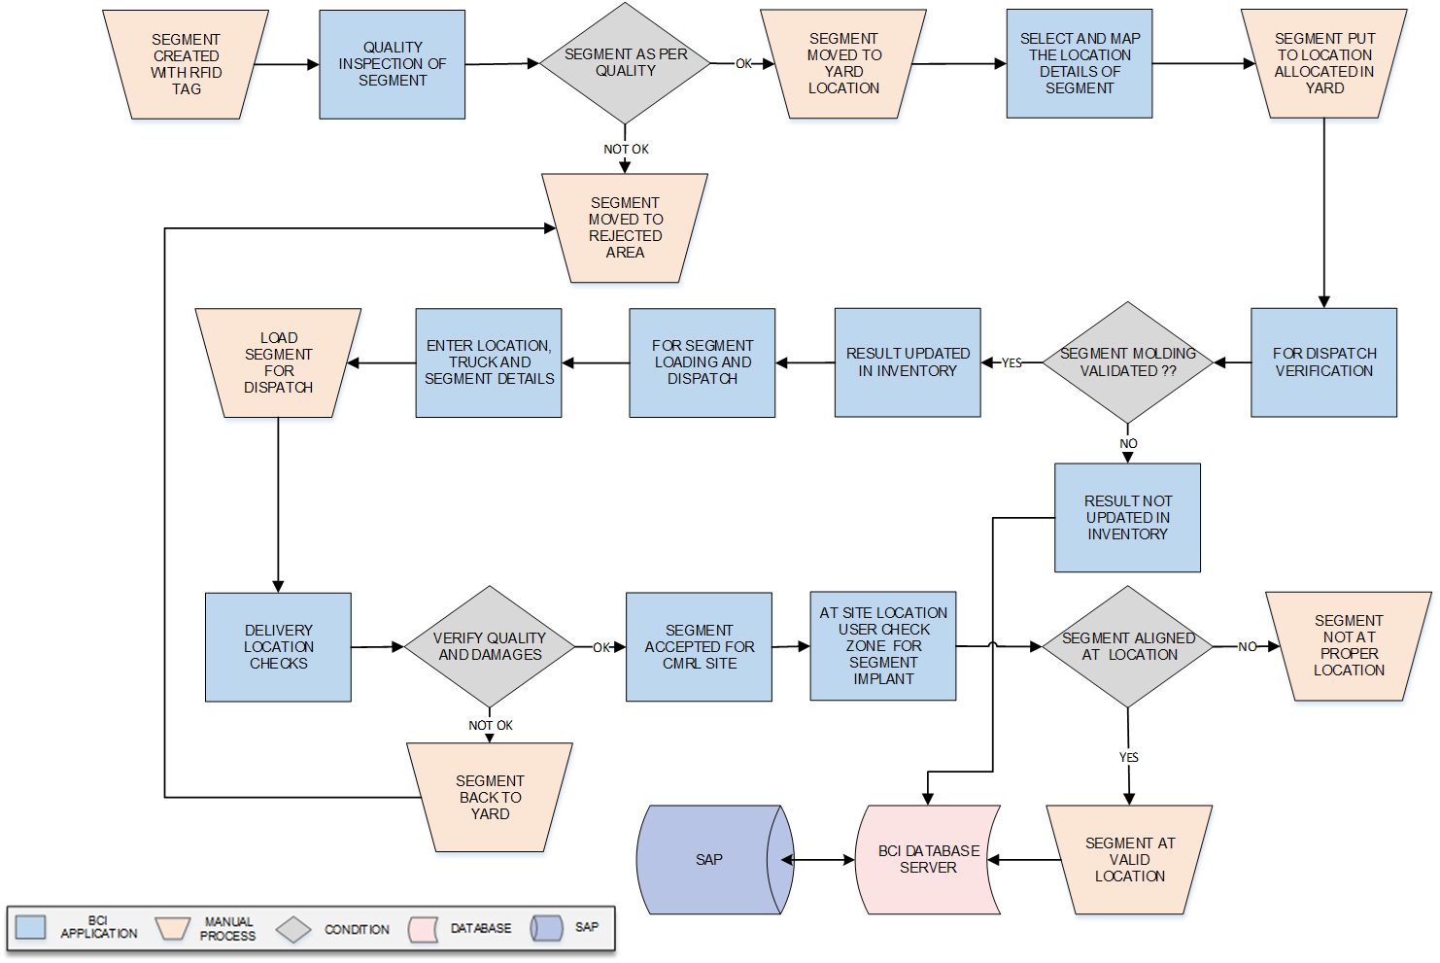Operation at glance:

### Quality Inspection

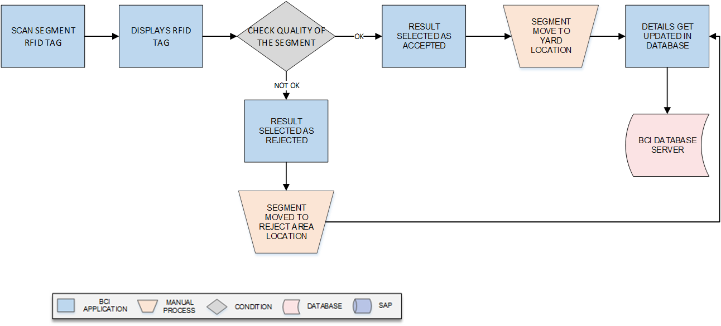**Activities**

|  |  |
| --- | --- |
| **Module Description** | This module compliance quality, validation and quality result management. Quality Inspection module is important tool to prevent the non-satisfactory goods to be stored in the segment production.  ***\*This activity will be done using Device Application.*** |

|  |  |
| --- | --- |
| **Pre-Conditions** | 1. QC personal should check Segment produced against defined parameters. 2. QC personal should check the de-molding time before quality. 3. Segment should have RFID tag inside molding. |

|  |  |
| --- | --- |
| **Process Steps** | 1. Scan the Segment RFID tag. 2. Display RFID tag details in the system. 3. User will check quality of the Segment against set parameters. 4. If Segment Quantity is “OK”: 5. User will enter/ select result as ‘*’Accepted’’* 6. Move Segment to Yard Location for storage. 7. If Segment Quantity is “NOT OK”: 8. User will enter/ select result as ‘*’* Rejected*’’*. 9. Move Segment to rejection area Location. 10. The quality check details gets updated in the database. |

|  |  |
| --- | --- |
| **Post-Conditions** | 1. All accepted Segments shall be moved to Yard Location. 2. All rejected Segments will be moved to Yard Rejection Location. |

|  |  |
| --- | --- |
| **Validations** | 1. An alert message is displayed in case of any error / invalid activity. 2. An alert message is displayed in case Segment details is not available in list. 3. Authorized access to the QC application check. 4. Quality Check should be updated against RFI number. |

|  |  |
| --- | --- |
| **Sample Screen** |  |

### Putaway

**Activities**

|  |  |
| --- | --- |
| **Module Description** | This module will let the user to place Segment in yard bay or location. This will be help in optimizing the yard storage space effectively. |

|  |  |
| --- | --- |
| **Pre-Conditions** | 1. Once Quality team accepted the segment it can be moved to yard. 2. Select Bay ID and scan Segment RFID tags and placed it bay. |

|  |  |
| --- | --- |
| **Process Steps** | 1. Select the Bay ID from the yard location. 2. Scan the Segment RFID tag to be placed. 3. Place the Segment at scanned location availability. 4. Update Location-material mapping details in database. 5. Save the details in the database. |

|  |  |
| --- | --- |
| **Post-Conditions** | 1. Auto- data updating in real time Segment Inventory. |

|  |  |
| --- | --- |
| **Validations** | 1. Segment tracking at highly detailed level 2. An alert message is displayed in case of any error/ invalid activity. 3. An alert message is displayed in case Segment ID and Bay ID is not integrated with application. 4. An alert message is displayed in case System is not connected. |

|  |  |
| --- | --- |
| **Sample Screen** |  |

### Picklist Creation Plan

**Activities**

|  |  |
| --- | --- |
| **Module Description** | This module will let the user to plan the segment delivery. This will be help user to successfully dispatch the Segment to Site Location. |

|  |  |
| --- | --- |
| **Pre-Conditions** | 1. All details required for planning.to be there in system. 2. Selected RFI number and RFID tags, details to be available from database. |

|  |  |
| --- | --- |
| **Process Steps** | 1. Enter the STO number and Segment Id. 2. Enter the Segment RFID tag and dispatch Quantity. 3. Select/ Enter the Customer Number, driver details in the fields.   *\*In case of change of Vehicle number update same in master.*   1. Select delivery Location for the Segments. 2. Save the details in the database. |

|  |  |
| --- | --- |
| **Post-Conditions** | 1. All details planned to be updated in case of change. |

|  |  |
| --- | --- |
| **Validations** | 1. Segment tracking at highly detailed level 2. An alert message is displayed in case of any error/ invalid activity. 3. An alert message is displayed in case Segment ID and RFI number is not integrated with application. 4. An alert message is displayed in case System is not connected. |

|  |  |
| --- | --- |
| **Sample Screen** |  |

### Queuing Verification

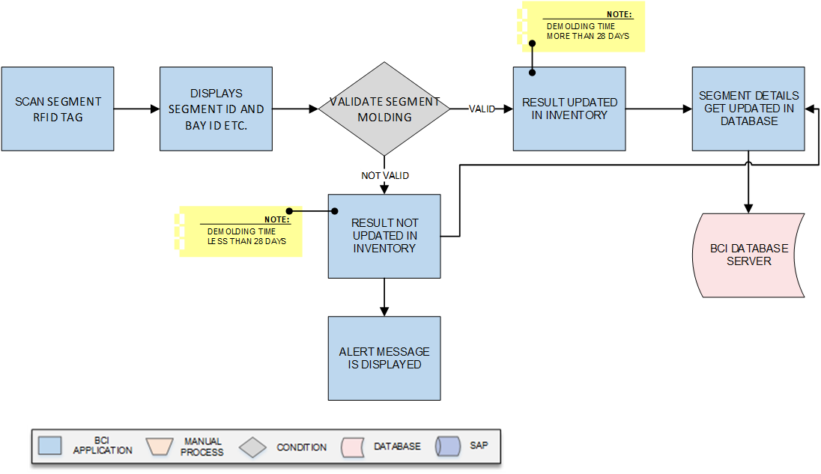

**Activities**

|  |  |
| --- | --- |
| **Module Description** | The module checks the Segment will be verified and checked whether segment curing is for 28 days. Based on this, it will be help to dispatch segment for site implementation.  ***\*This activity will be done using Device Application.*** |

|  |  |
| --- | --- |
| **Pre-Conditions** | 1. Select RFI Number and scan Segments against Dispatch Plan, Select Truck No. 2. Create Delivery challan by entering RFI Number, Segment ID, Quantity, Destination details etc in Web Application. |

|  |  |
| --- | --- |
| **Process Steps** | 1. User will scan Segment RFID. 2. Segment ID, Location , Putaway Date and Time are displayed on screen. 3. System will be validated for 28 days before molded. 4. If valid (28 days over) updated in Inventory 5. If invalid (less than 28 days) it will not updated in inventory and alert is displayed. 6. Segment details will be updated in the database. |

|  |  |
| --- | --- |
| **Post-Conditions** | 1. Load the segments and load into Vehicle for dispatch to Site. 2. User should be able to view the Dispatch details before sending to Customer. |

|  |  |
| --- | --- |
| **Validations** | 1. An alert message is displayed in case of any error/ invalid activity. 2. An alert message is displayed in case Segment ID and Bay ID is not integrated with application. 3. An alert message is displayed in case System is not connected. 4. An alert message is displayed in case Serial Number is not marked on Segment due to any error. 5. An alert message is displayed in case Molding is not set for less than 28 days. |

|  |  |
| --- | --- |
| **Sample Screen** |  |

### Picking

**Activities**

|  |  |
| --- | --- |
| **Module Description** | The module will be used to pick the Segment that will be dispatched to destination from Yard against Delivery Challan and details for the same will be update the corresponding details in database.  ***\*This activity will be done using Device Application.*** |

|  |  |
| --- | --- |
| **Pre-Conditions** | 1. Segment should have RFID barcode marked. 2. Scan Segment RFID and check Quality 3. Delivery details to be verified. |

|  |  |
| --- | --- |
| **Process Steps** | 1. Select Picklist Number on device, corresponding picking details will appear. 2. System will guide user about locations from where segments needs to be picked. 3. Enter the Input location id 4. Scan segment tag against Picklist. 5. Move segment to dispatch area Load and dispatch to Site. 6. Save corresponding details in database. |
| **Post-Conditions** | 1. Segment which are picked can be move for loading. 2. Segment should get updated as per database. |

|  |  |
| --- | --- |
| **Validations** | 1. An alert should be displayed in case segment not marked is scanned. 2. An alert should be displayed if Dispatch details is not available in list. 3. An alert should be displayed if wrong segment is picked. 4. An alert will be displayed if Picked segment quantity entered is more than the quantity stated in segment loading and dispatch list. |

|  |  |
| --- | --- |
| **Sample Screen** |  |

### Dispatch

**Activities**

|  |  |
| --- | --- |
| **Module Description** | The module will be used to dispatch the Segment that will be to destination from Yard against STO number and details for the same will be update the corresponding details in database.  ***\*This activity will be done using Device Application.*** |

|  |  |
| --- | --- |
| **Pre-Conditions** | 1. Segment should have RFID barcode marked. 2. Scan Segment RFID and check Quality 3. Delivery details to be verified. |

|  |  |
| --- | --- |
| **Process Steps** | 1. Select STO 2. Scan Segment against STO 3. Visually check and capture image if required 4. Enter Vehicle details 5. Move segment to dispatch area Load and dispatch to Site. 6. Save corresponding details in database. |
| **Post-Conditions** | 1. Segment which are picked can be move for loading. 2. Segment should get updated as per database. |

|  |  |
| --- | --- |
| **Validations** | 1. An alert should be displayed in case segment not marked is scanned. 2. An alert should be displayed if Dispatch details is not available in list. 3. An alert should be displayed if wrong segment is picked. |

|  |  |
| --- | --- |
| **Sample Screen** |  |

## Segment Site Identification Operations

### Segment Delivery Inspection

**Activities**

|  |  |
| --- | --- |
| **Module Description** | This module will be used after dispatch from yard, truck will reach the destination, and Segment will be unloaded at implementation site. In case of any damaged Segment shall be returned to yard. The module will help user to update the Segment delivery details in database.  ***This activity will be done using device and Web Application.*** |

|  |  |
| --- | --- |
| **Pre-Conditions** | 1. Scan Segment RFID and check Quality. 2. Update Segment Status based on quality – Accepted for Erection or Rejected. |

|  |  |
| --- | --- |
| **Process Steps** | Select the STO number from the list.  Scan the Segment barcode.  Enter the receiver personnel details.  Unload segment from the transport vehicle.  Verify the segments for any damages while transportation.  In case of any damage send the segments back to the Yard location.  The time of delivery will captured by the system.  Corresponding details will be updated in database. |

|  |  |
| --- | --- |
| **Post-Conditions** | 1. All accepted Segments shall be moved to Tunnel Location. 2. All rejected Segments will be moved to Yard Rejection Location. 3. Segment received details will get saved in the database. |

|  |  |
| --- | --- |
| **Validations** | 1. System will validate input data i.e. text field values and selections. 2. An alert/ error message will be displayed in case invalid / duplicate barcode is being scanned. 3. An alert message is displayed in case of any error / invalid activity. |

|  |  |
| --- | --- |
| **Sample Screen** |  |

### Fixture Identification

**Activities**

|  |  |
| --- | --- |
| **Module Description** | This module will be used to validate after erection for the particular zone. Officials will confirm to zone allocated, corresponding details will be updated. When Wi-Fi/ network connectivity is available, details will be updated in the database.  ***\*This activity will be done using Device Application.*** |

|  |  |
| --- | --- |
| **Pre-Conditions** | 1. ITD Inspection Personnel visit the Implementation Site. 2. Select Area and scan each segment RFID tag. |

|  |  |
| --- | --- |
| **Process Steps** | Customer will visit for implementation location at site.  User get the GPS location of segment.  Scan Segment RFID tag.  System will validate the implementation zone with database.  If implementation is at valid locations, Official will confirm with digital signature.  Incase implementation is not at valid location, alert is displayed on screen.  Update corresponding details in the database. |

|  |  |
| --- | --- |
| **Post-Conditions** | 1. System will validate the Grouping ID. 2. Segment details are verified by officials and Saved into the database. |

|  |  |
| --- | --- |
| **Validations** | 1. An alert message is displayed in case of any error / invalid activity. 2. System will validate input data i.e. text field values and selections 3. Segment validation with implemented Zone/ location 4. System will validate Confirmation with digital signature. |

|  |  |
| --- | --- |
| **Sample Screen** |  |

### Segment Grouping

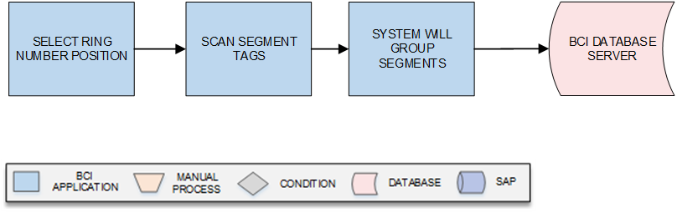

**Activities**

|  |  |
| --- | --- |
| **Module Description** | The module will be used to group segments and details for the same will be update the corresponding details in database.  ***\*This activity will be done using Device Application.*** |

|  |  |
| --- | --- |
| **Pre-Conditions** | 1. Segment should have RFID barcode marked. 2. Location of the material to already selected. |

|  |  |
| --- | --- |
| **Process Steps** | 1. Select Ring Number. 2. Select the position of the segment. 3. Scan the Segment Tags. 4. System validate and make group segments. 5. Save corresponding details in database. |
| **Post-Conditions** | 1. Segment should get updated as per database. |

|  |  |
| --- | --- |
| **Validations** | 1. An alert should be displayed in case segment not marked is scanned. 2. An alert should be displayed if Dispatch details is not available in list. 3. An alert should be displayed if wrong segment is picked. |

# SRS Scope Change Process

## Before Sign Off

Any changes in SRS need to be informed in writing by ITD Cementation Pvt Ltd. It will be incorporated / confirmed only after doing detailed feasibility study by BCI.

* If any change is out of scope then this would be done as a CR post feasibility and priority will be decided based on mutual agreement.
* Once the change is developed , any further change in the same would be considered as a CR

## After Sign Off

Any changes in proposed solution after approval of this document by ITD Cementation Pvt Ltd. are subjected to confirmation from BCI, taking feasibility constraints into account. These changes will be incorporated (if any) into the solution only after delivering proposed solution & may be charged as extra.

* Any change in the proposed solution due to customer system design or process will be considered as CR
* Any process which is not mentioned in this document will not be considered as “mutual understanding or default presence or standard practice”.

The changes in proposed solution before & after acceptance will be mutually agreed and duly signed and accepted by ITD Cementation Pvt Ltd. & BCI.

## SRS Acceptance

|  |  |
| --- | --- |
| **For ITD Cementation Pvt. Ltd** | **For Bar Code India (BCI)** |
| **Name:** | **Name:** |
| **Designation:** | **Designation:** |
| **Department:** | **Department:** |

Agreed and Accepted by ITD Cementation Pvt Ltd. and Bar Code India