WIP and WMS Automation System




Surya Roshini Ltd

Software Requirement Specification (SRS)

The document details the summary of solution architecture and approach for the development of Segment Management System for Surya Roshini Ltd. The document is based on the inputs, system study, discussions and meeting held between BCI & Surya Roshni Teams.
Prepared By: Omkar Gaonkar
Submission Date: 26- 05-2023
Version: 1.0
BAR CODE INDIA, 691 Udyog Vihar Phase V, Gurugram, Haryana-122016, PH: 0124 4337555

REVISION NO. | DATE | PREPARED BY | REVIEWED BY | COMMENT
1.0 | 26-05-2023 | Omkar Gaonkar | Brajesh S | SRS Document for WIP and WMS Automation System
  - REVISION HISTORY

Abbreviations:
Name | Abbreviation
Bar Code India | BCI
FIFO | First IN First Out
QTY | Quantity
QR Code | Quick Response Code
GRN | Good Received Note
REF | Reference
FIFO | First In First Out
QA | Quality Assurance
SAP | System Analysis Program

  - Table of Contents
1 Specification Organization 2
2 Introduction 3
2.1 Intended Audience and Reading Suggestions 3
2.2 Project Scope 4
3 Software/Hardware Requirements 5
3.1 Server Configuration 5
3.2 Computers 5
3.3 Hardware Requirements 5
4 Solution Architecture 6
5 Packing Process at Glance 7
5.1 Serial Generation, laser marking and shipper label Printing 7
6 User Interface Specification Conventions 8
7 System Log 9
7.1 Error Logs 9
7.2 Audit Logs 9
8 Architectural Design 10
8.1 Desktop Application 10
8.2 Device Application 10
8.3 Web Application 10
8.4 Communication Server/API 10
9 Application Modules 11
9.1 Application Login- Desktop Application 11
9.2 User Management 12
9.2.1 User Master 12
9.2.2 User Rights/ Permission 14
9.2.3 User Login 15
9.3 Masters 16
9.3.1 Plant/Warehouse/Marketing Location Master 16
9.3.2 Material/ Item Master 17
9.3.3 Customer Master 18
9.3.4 Line Master 19
9.3.5 Bin Master 20
9.4 Transactions 21
9.4.1 Serial Barcode Generation 21
9.4.2 Laser Marking, Scanning and packing 23
9.4.3 Line and Bin mapping 26
9.4.4 Weight Validation and Shipper Packing 28
9.4.5 Manual Packing 31
9.4.6 Quality Sampling 33
9.4.7 Quality Checking 35
9.4.8 Quality Tested Item placement 38
9.4.9 Transfer to Warehouse from Plant 40
9.4.10 Transfer to Marketing Location from Warehouse 43
9.4.11 Transfer to Customer from Marketing Location 45
9.4.12 Receiving at Marketing Location and Confirmation 47
9.4.13 Revalidation Process 50
9.4.14 Warranty Claim 52
9.4.15 Warranty Tracking 56
10 Reports 58
10.1 Packing Report 58
10.2 Packing Order Barcode Details 59
10.3 Quality Report 59
10.4 Transfer from Floor (Plant) to Warehouse 60
10.5 As on date Inventory 60
10.6 Dispatch from Warehouse 61
10.7 GRN at DC 61
10.8 Dispatch from DC 62
10.9 Revalidation Report 63
10.10 Return to Marketing location From Customer 62
11 SRS Scope Change Process 64
11.1 Before Sign Off 64
11.2 After Sign Off 64
11.3 SRS Acceptance 64

Specification Organization
The objective of this document is to supply underlying concepts, procedures, and formats used in the design, development and installation of this software application. This specification consists of three sections organized as follows.
Section 1: Introduction

This section provides hardware requirements and documentation conventions.

Section 2: User Interface

This section depicts screen design and logic flow, and is categorized into two groups:
- Application Master Module
- Common Routine

Section 3: System Architecture
This section provides information of system architecture.

Introduction

Intended Audience and Reading Suggestions
The scope of the software would require the development of the front end application, client device application and to transfer data from application to server. The document lays down the specifications of the middleware application, its architecture and infrastructure requirements.
The entire solution consists of followings:
- Web Application
- Desktop Application
- Device Application
- Communication Server/API

Project Scope
The scope of the project is to create WIP & WMS Automation System for Surya Roshni using AIDC Technology that will facilitate the automation of manufacturing lines (Bulbs/ Battens/ Down-Lights/ Street Lights) and FG movement to multiple Branch Warehouses.
The solution will be developed for WIP/Shop Floor and FG Warehouses which will make the operations at Surya Roshni Site effective and efficient. This application provides provision to help control and track the movement of Items (multiple Bulb Lines) throughout multiple stages in packing area and keep record of the items processing at each stage. Each item (Bulbs/ Battens/ Down-Lights/ Street
Lights) already has a unique QR Code based identification. Once items are packed in their respective packages i.e. mono and shipper carton, it will be moved to Plant Warehouse from where it will be transferred to Central Warehouse.
The application also keep track of the items received from Vendors in Shipper Boxes in Plant Warehouse. The application will be managing receiving and dispatch operations at Branch Warehouse. The application will keep on recording and updating each stage transaction details in real time on server.
This would require integration of the application with SAP to fetch. The scope of the software would require the development of the front end application, client device application to transfer data from application to server. The document lays down the specifications of the middleware application, its architecture and infrastructure requirements.
The entire solution consists of followings:
- Web Application ( .NET 4.5)
- Desktop Application
- Communication Server Application (.NET 6.0)
- Mobile Device Application ( Native Android)

Software/Hardware Requirements
Below are the hardware and the software requirements of the application:

Server Configuration
Central Server Configuration/Database Servers
The solution would require the high performance server with minimum of following:
- Express Intel Xeon E3 (Quad Core) 3.2 GHz 8 MB 1600 MHz 64GB 2x1 TB SATA 7200 RPM 3.5" Simple-Swap MULTI BURNER RAID 0, 1, 5 in built (SR C100)Windows 2012 & above server
- Windows 2012 & above server
- MS SQL 2019 STD or Above (Core Based License).
- VPN Connectivity to Central server and Plant Server as well.
- Optional backup
- Dot net Framework 6.0

Computers
Desktop would require following specifications:-
- I5/i7 Processor with Windows 10 Operating System
- 16 GB RAM
- 100GB HDD
- Dot net Framework 6.0

Hardware Requirements
Hardware required for the application:
Warehouse Operation Hardware:-
- Mobile Device :- Zebra mobile handheld device TC21
- Power supply:- PS 100-240VAC 5V 2.5A India Plug USB C To USB A Communications and Charger
- Zebra desktop Printer :- ZD230: Thermal Transfer Printer (74/300M)
Branch Operation Hardware:-
- Mobile Device :- Zebra mobile handheld device TC21
- Power supply:- PS 100-240VAC 5V 2.5A India Plug USB C To USB A Communications and Charger
- Zebra desktop Printer :- ZD230: Thermal Transfer Printer (74/300M)

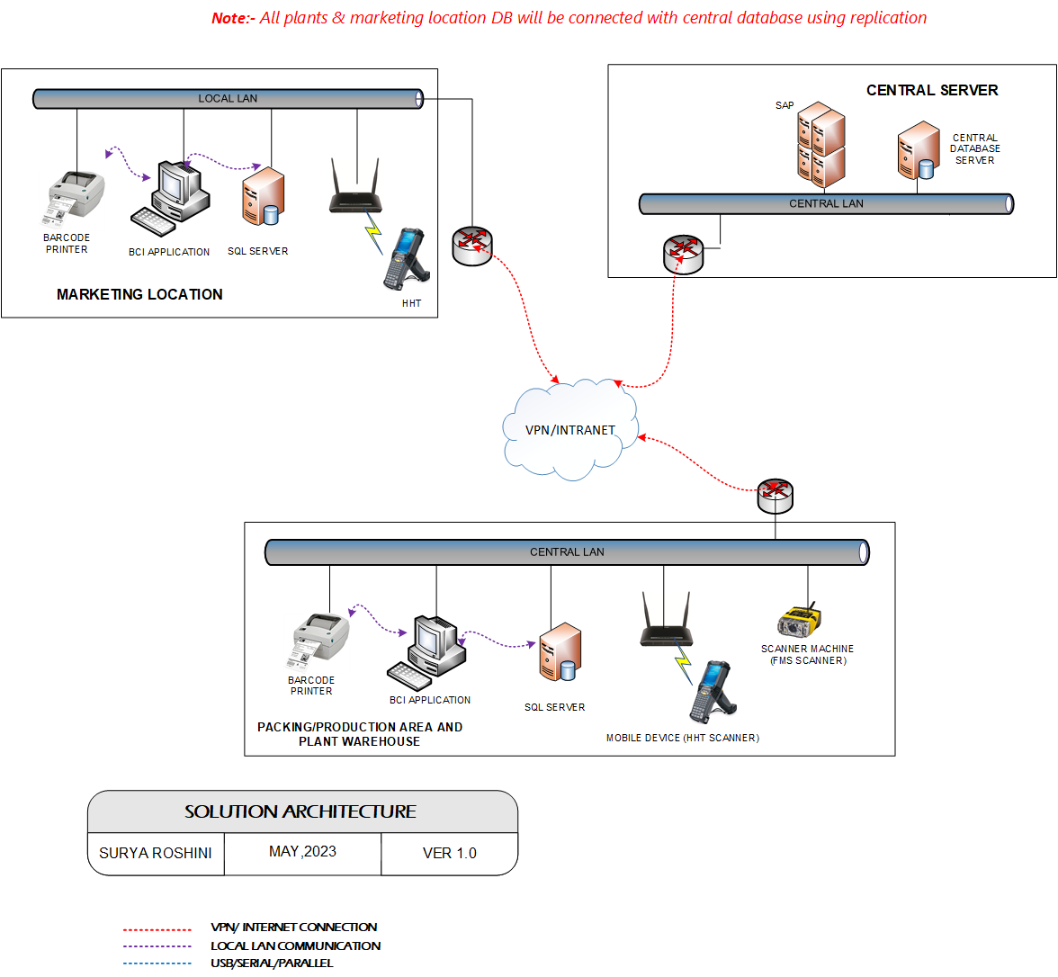
Solution Architecture

Packing Process at Glance

Serial Generation, laser marking and shipper label Printing
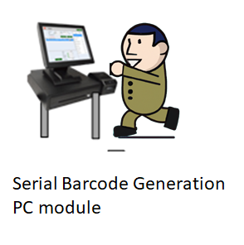

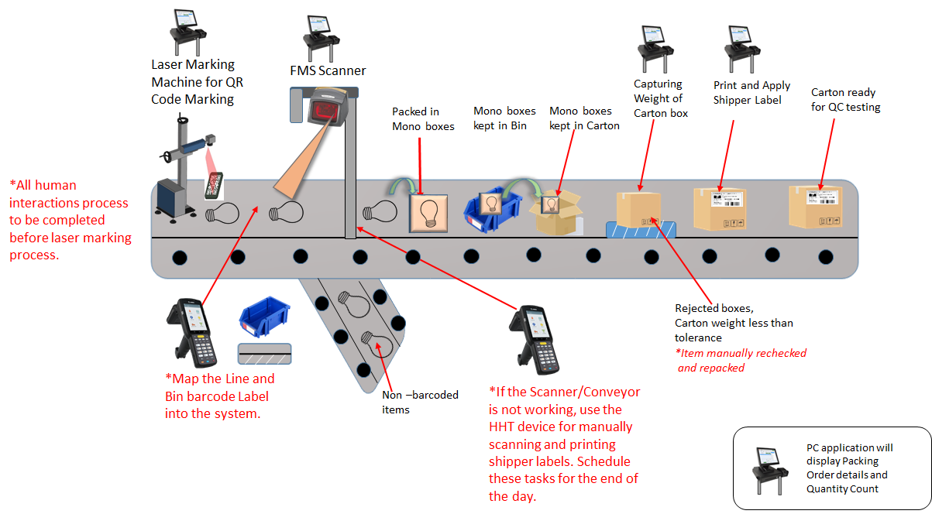
*Total Packing Count will be displayed on screen.

User Interface Specification Conventions
This section specifies the user interface portion of the application.

Section Organization
The User Interface Specification presents screen displays or “Dialogs”.
Documentation Conventions
This section incorporates illustrations of the application user interface. Each screen display “Dialog” consists of the screen display image, a process name, a paragraph documenting the processing required for the dialog, a paragraph listing the navigation options, and a table listing for each variable field on the dialog, its database source or destination, format, and any instructions required to process the field.
The following section contains a sample dialog with each area identified.

System Log
System shall maintain internal logs for application.

Error Logs
These logs will contain any errors encountered during runtime for faster resolution of any problem post deployment.

Audit Logs
These logs will monitor the activities of user who accessed the application, made changes to File/ Document and the time stamp of these activities.

Architectural Design
Overall System consists of:
- Desktop Application
- Device application
- Web application
- Communication Server

Desktop Application
This application will include will be developed for performing transactions like User Master, Rights Permission/Order, Serial Barcode Generation, Laser Marking and packing, ,Quality Checking, , Revalidation and Warranty Claim.

Device Application
Device Application including Bin and Line Mapping, Manual Packing, Weight Validation and Shipper Packing, Quality Checking, Quality Tested Item placement, Transfer to Plant Warehouse, Transfer from Warehouse to Marketing Location, Transfer from Warehouse to Customer Location receiving at Marketing Location, GRN.

Web Application
The web application will be used for Masters that are Plant/Warehouse/Marketing Location Master, Material/Item Master and Customer Master and Reports such as Location wise Inventory Stock, Pending Order, Packing Line and Dispatch Report and Warranty Tracking.

Communication Server/API
To GET and Post details from and to SAP.

Application Modules

Application Login- Desktop Application
This login module will provide access to the application modules. Here the admin/user needs to enter the login detail to enter in the application and to perform the desired actions.
Process: User needs to enter the User Name/ID and Password in display fields and press the Login button. Application will validate the user credential.
User will be able to view only those screens/ modules of which he has been given access rights to.
Validation
- User Name/ ID will be unique for all users.
- User Name/ ID and Password length will be set.
After successful login application menu screen will appear; this screen will have the Master and Transaction options etc.

User Management
The module will let application administrator to manage the Users, and the rights assigned to the same; the rights will define authorized application access of users.
The User Management & Master data will be created using Desktop Application.

User Master
This module will let user to create application users who will access the application. The master will store the users’ details in system.
Data Fields | - ID  - Name  - Password  - Type  - Location  - Department  - Contact No
Process Steps | - Enter required details i.e. User ID, User Name, Password in system  - Select the type of the user from the list  - Select the Location, Department from the list  - Enter the Contact Number of user  - Click on Save button to save details in database  - Newly added user will appear in data grid
Functions | - Add, Edit/Update, Delete as per requirement  - User ID and Password is used to access the application.
Role | Admin will create/ add user details via window application
Sample Screen | 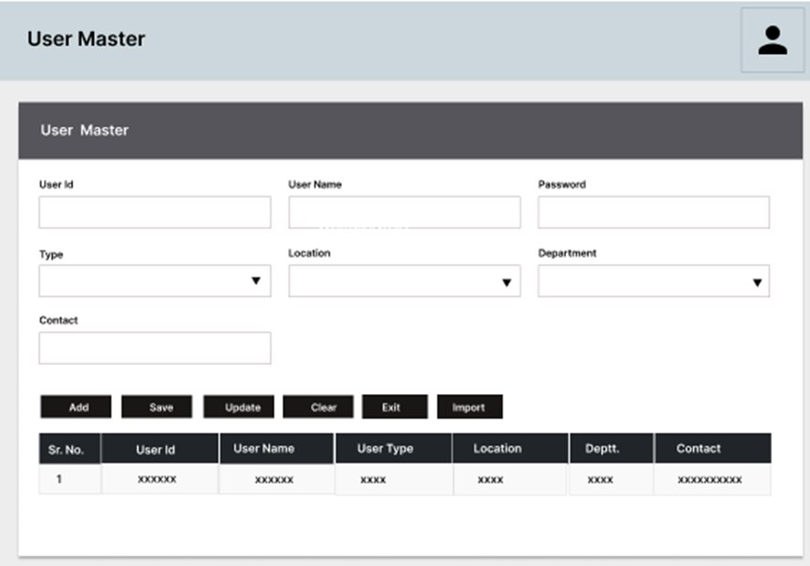

User Rights/ Permission
This module will let admin to assign module / screen access rights to the application users. Once assigned, authorized users can access the application. Once permissions are assigned, user will be able to view only those screens/ modules of which he has been given access rights to by Admin.
Data Fields | - User ID/ Name  - Module /Screen Names
Process Steps | - Admin will select User Name/ID.  - Screen/ module names will appear in data grid along with checkbox.  - Admin will check the checkbox against module/ screen to which selected User should be assigned access permissions.  - Save and Update the details in database
Functions | Add, Edit/Update as per requirement
Role | Admin / Authorized User will assign access rights to the selected User
Sample Screen | 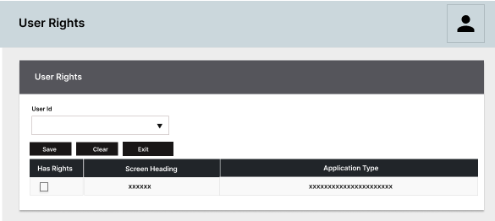

User Login
This module will let users to login in to the application. Once assigned, authorized users can access the application. Once permissions are assigned, user will be able to view only those screens/ modules of which he has been given access rights to by Admin.
Data Fields | - User Name  - Password
Process Steps | - User will select the Plant/Marketing code.  * Only the details of Current specific plant will be enabled while the details of other plants will be disabled.  - User will enter User Name/ID.  - Enter the Password as per saved by user.  - System will check the selected User is valid to login.  *User can click on forgot password incase don’t remember the password  - Click on Login button to enter the application.  - The details gets updated in database.
Functions | Login into the application
Role | Admin / Authorized User will able to access the login
Sample Screen | 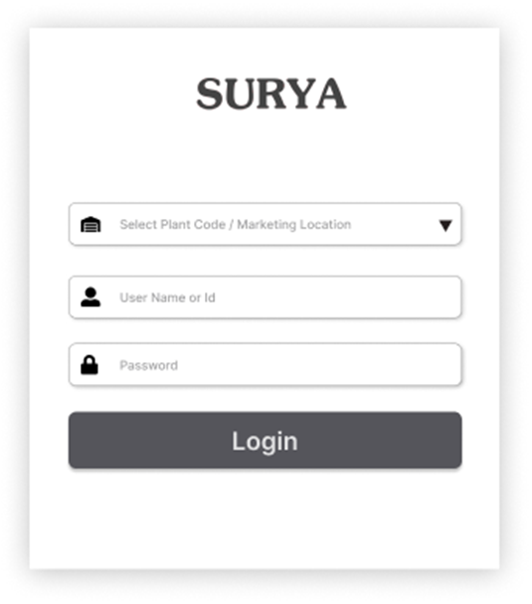

Masters

Plant/Warehouse/Marketing Location Master
The module will be used to view the Plant/Warehouse and Marketing Location details downloaded from SAP.
*The modules data will be provided by the Customer from SAP.
Data Fields | - Code  - Type  - Description  - Address
Process Steps | - Details will get displayed in data grid on screen that is fetched from SAP.
Functions | User can View the Master details in the table field.
Sample Screens | 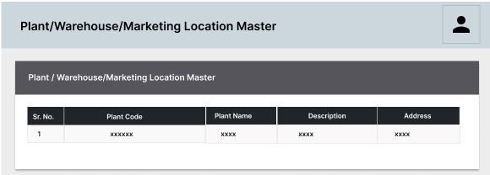

Data required from SAP:-
Sr.No | API Name / Process | Status | Description | API Created By | Message Description | Input Table (POST) | Message Description | Input Table (GET)
1 | Plant/  Marketing Location/  Warehouse Master | Open | API - GET | BCI | S --> Success; F --> Failure. |  |  | Code
 |  |  |  |  |  |  |  | Description
 |  |  |  |  |  |  |  | Type
 |  |  |  |  |  |  |  | Address

Material/ Item Master
The module is used to store item details in database. Item master details are fetched from SAP using API.
Data Fields | - Item Code  - Description  - Pack size  - UOM  - Unit weight  - Tolerance  - Quality Sample size  - Self-life  - Active Yes/No
Process Steps | - Details will get displayed in data grid on screen that is fetched from SAP.
Functions | - User can View the Master details in the table field.
Sample Screen | 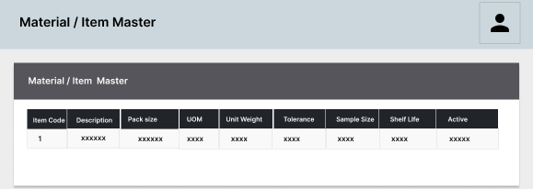

Data required from SAP:-
Sr.  No | API Name / Process | Status | Description | API Created By | Message Description | Input Table (POST) | Message Description | Input Table (GET)
1 | Material Master | Open | API - GET | BCI | S --> Success;  F --> Failure. |  |  | Material Code
 |  |  |  |  |  |  |  | Material Description
 |  |  |  |  |  |  |  | Pack Size
 |  |  |  |  |  |  |  | UOM
 |  |  |  |  |  |  |  | Unit Weight
 |  |  |  |  |  |  |  | Tolerance
 |  |  |  |  |  |  |  | Quality Sample Size
 |  |  |  |  |  |  |  | Self-Life
 |  |  |  |  |  |  |  | Active [Yes/No]

Customer Master
The module will be used to update the details of Customer details. The Customer master stores all the customer details that will be sent/received items from marketing branch.
Data Fields | - Customer Code,  - Customer Name  - Customer Address
Process Steps | - Details will get displayed in data grid on screen that is fetched from SAP.
Functions | - User can View the Master details in the table field.
Sample Screen | 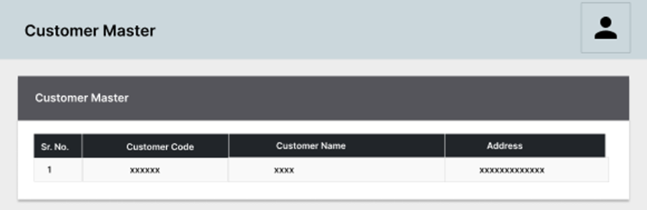

Data required from SAP:-
Sr.No | API Name / Process | Status | Description | API Created By | Message Description | Input Table (POST) | Message Description | Input Table (GET)
1 | Customer Master | Open | API - GET | BCI | S --> Success; F --> Failure. |  |  | Customer Code
 |  |  |  |  |  |  |  | Customer Name
 |  |  |  |  |  |  |  | Customer Address

Line Master
The Line Master contains the details of the assembly line working in the plant.
Data Fields | - Plant Code  - Line Code  - Line Name  - Description  - Active/ Inactive
Process Steps | - User will open Line Master screen  - Select the Plant Code.  - Enter required details i.e., Line Code, Name, Description etc.  - Check the Active checkbox to make the packing line active  - Click on save to store details in database  - Newly added record will appear in data grid.  - Details will get displayed in data grid on screen that is fetched from SAP.
Functions | Add, Edit/Update, Delete as per requirement.
Sample Screens | 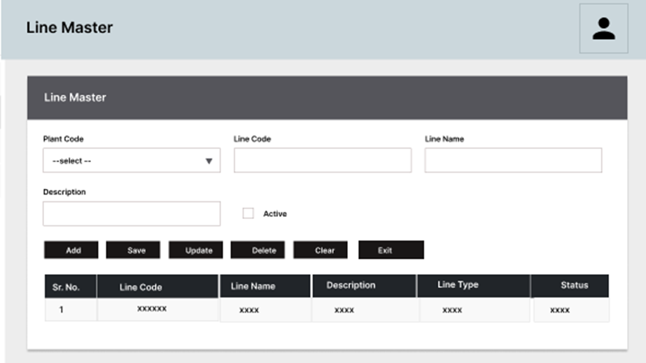

Bin Master
The Bin Master contains the details of the bins used to carry the items.
Data Fields | - Plant Code  - Bin code  - Description  - Active/ Inactive
Process Steps | - User will open Bin Master screen  - Select the Plant Code  - Enter required details i.e., Bin Code, Description etc.  - Check the Active checkbox to make the packing line active  - Click on save to store details in database  - Newly added record will appear in data grid.  - Details will get displayed in data grid on screen that is fetched from SAP.
Functions | Add, Edit/Update, Delete as per requirement.
Sample Screens | 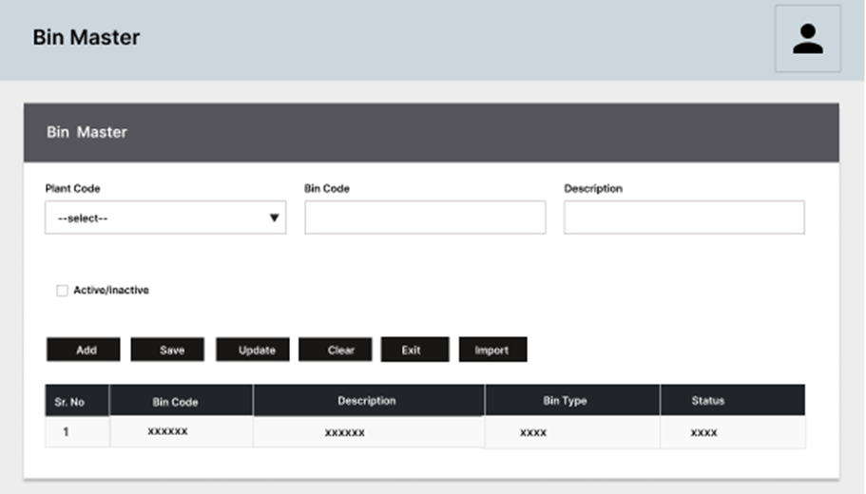

Transactions

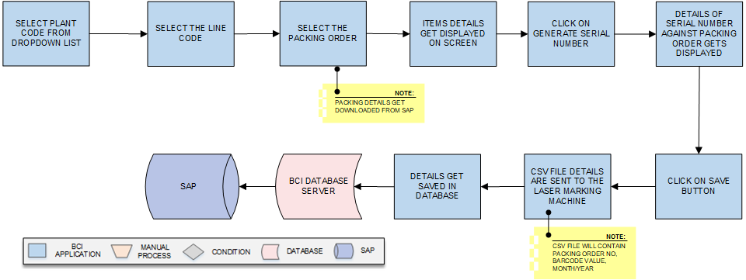
Serial Barcode Generation
Activities
Module Description | This module will be used by application to generate Serial Numbers for each item (such as Bulbs, Batten, Street Lights, and Down Lights) against the Packing Order. These Serial Numbers will then be sent to the Laser Marking Machine for identification purposes.  *This activity will be done using Desktop Application.

Pre-Conditions | - Authorized access to the application.  - API is required to fetch packing order from SAP.

Process Steps | - Select the Plant from dropdown list.  - Select the Line Number from the list.  - Select the Packing Order Number.  * It fetches the Packing Order details from SAP.  - The details of Packing Order Number, Plant Code, Item code, Quantity, Packing date and Line details gets displayed on the screen.  - Click on Generate Serial Number.  - The system generates Serial Numbers for the selected Packing Order quantity.  - Click on Print button to print the serial number.  - The Serial Numbers are sent to the Laser Marking Machine.  *Csv will contain Packing Order details, Barcode Value, Month/Year.  - Details gets saved into database  - Posted into the SAP.

Post-Conditions | - For each packing order there should be a serial number  - Serial Number to be generated in serially for each packing order item.

Validations | - An alert should be displayed in case invalid label number is entered.  - An alert message is displayed in case of any error / invalid activity.

Sample Screen | 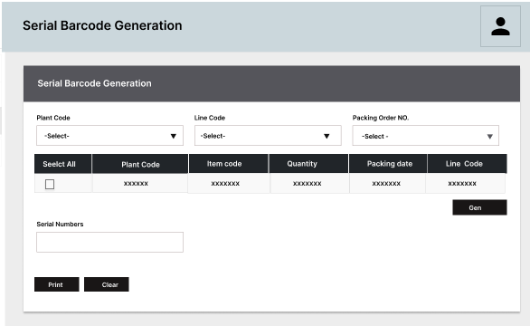  Note: - The provided screens are samples; the actual screen may vary slightly.  Csv File Contains  Barcode Label Contains:-  Packing Order Number+ 5digit Barcode Details
  Packing Order | Barcode Value | Month/Year
  1 | 00001 | 05/23
  2 | 00002 | 05/23

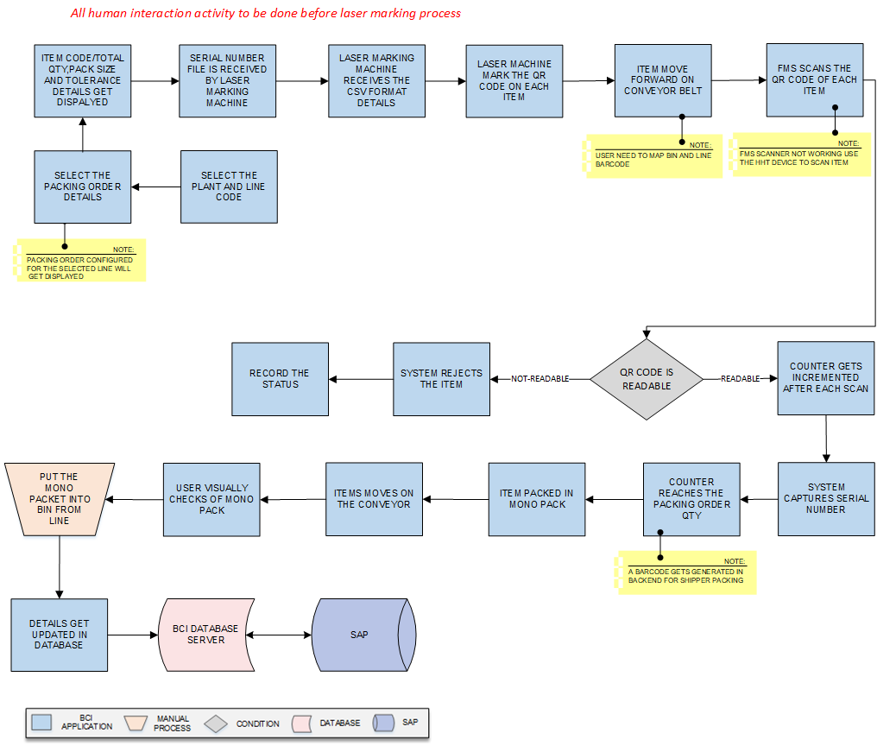
Laser Marking, Scanning and packing

Activities
Module Description | These module will be used to mark a QR Code on each individual item items on the conveyor belt will be packed individually into mono-packs and each item will have a unique QR Code for identification. A Fixed Mount Scanner will be installed at each conveyor line to read the items' Serial Numbers and count them. A bin and Line barcode will be mapped by user to keep the item from particular line in the selected bin for further process.  *This activity will be done using Desktop Application.

Pre-Conditions | - API is required to fetch packing order from SAP.  - Laser machine to mark the QR code to be working properly.  - User can pack the material if required.

Process Steps | - Select the Plant and Line code from dropdown list.  - Select the Packing Order details.  - The item code, pack size, Weight tolerance details get displayed.  - The Serial Numbers is received to the Laser Marking Machine.  *Csv file is sent to the laser marking barcode machine.  - Machine reads the serial number  - The Laser Marking Machine marks a QR Code on each Item,  *The Serial Number is also printed in human-readable format on each item along with the QR Code.  - Items arrive on the conveyor as per the Packing Order.  *Items can be Bulbs, Batten, Street Lights, and Down Lights.  - Map the Bin and Line barcode Label.  - The Fixed Mount Scanner reads the QR Code of each Bulb.  *If FMS scanner is not working user can use the HHT device to scan Item barcode.  - If the QR Code is not readable.  - The system rejects the Bulb and records its status.  - The details get updated into the SAP.  - If the QR Code is readable,  - Counter gets Incremented after each scan  - The system captures the Serial Number.  - System Captures the Serial number of each item.  - System counter reaches the pack size quantity.  *The system will display the counter when the pack size quantity is reached.  *A barcode labels gets generated at the Backend for shipper packing.  - Items moves forward on the conveyor line.  - The Bulb is packed into a mono-pack that moves forward on the line.  - The user visually checks the mono-packs for defects.  - User keeps the mono pack item in the Bin.  *User need to place the item in the bin mapped to the specific line.  - The details get saved in the database and then to SAP.

Post-Conditions | - Conveyor need to be working without delay.  - Packing Order to update as per the order details.  - Mono boxes to be kept as per order details.

Validations | - An alert should be displayed in case invalid label number is entered.  - An alert message is displayed in case of any error / invalid activity.

Sample Screen | 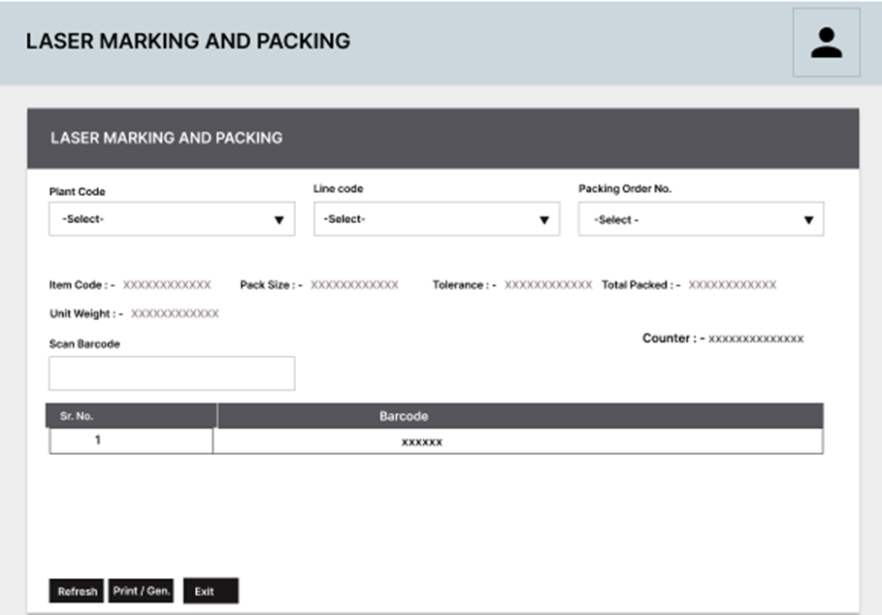  Note: - The provided screens are samples; the actual screen may vary slightly.

Line and Bin mapping

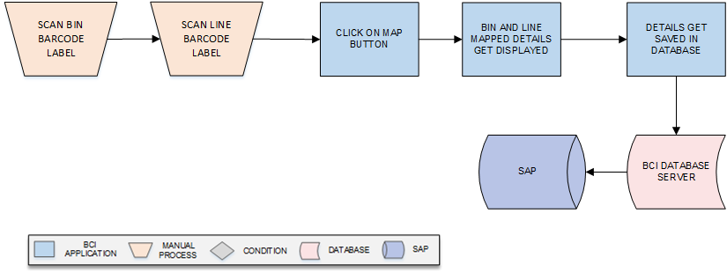
Activities
Module Description | The module will be used to Map the Bin and Line details for the packing order details.  *This activity will be done using Device Application and it’s a manual process.

Pre-Conditions | - Barcode to be properly visible and scanned.  - Bin detail and Line to be already there in SAP.

Process Steps | - Scan the Bin barcode label.  - Scan the Line barcode label.  - Click on Map button.  - The bin and Line barcode details get mapped.  - Details get updated in the database.  - Posted to the SAP.

Post-Conditions | - Manually process to be done only if the Packing machine are not working.  - Scan the barcode of each label and update details into SAP.

Validations | - An alert should be displayed in case invalid details is entered.  - An alert message is displayed in case of any error / invalid activity.

Sample Screen | Note: - The provided screens are samples; the actual screen may vary slightly.  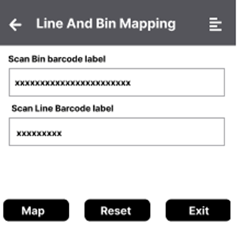

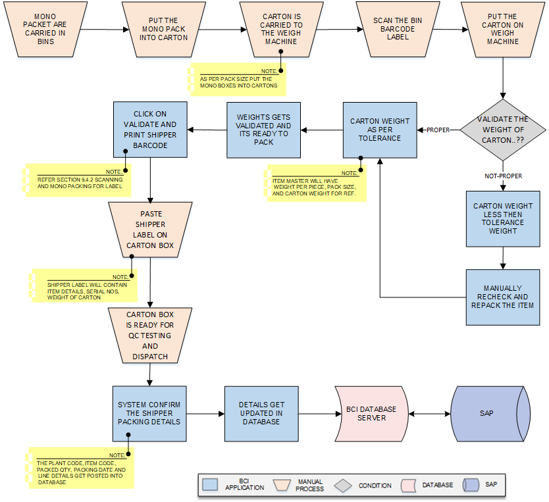
Weight Validation and Shipper Packing

Activities
Module Description | This module will be used for Mono-Boxes are packed into Shipper Cartons, and a barcode label is printed for each carton. Packing details are stored using a module, and a weight machine counts the item weight set by the item master. The weight of the carton if less than tolerance than recheck and repack the item carton as per pack size. The shipper label is pasted on the carton label. Finally, the Shipper Packing data is sent to SAP for Packing Confirmation.  *This activity will be done using Device Application.

Pre-Conditions | - Authorized access to the application.  - Mono box packet to be kept into the cartons.  - Weighing Machine to be properly working.

Process Steps | - Mono-packs are carried into the bins.  - Put the Mono-pack into the carton boxes.  *As per the pack size put the mono boxes into cartons.  - Cartons are carried to the weighing machine.  - Scan the bin barcode label.  - Put the Cartons on the weighing machine.  - Validate the weight of the carton boxes.  - Weight less than tolerance.  - Manually recheck the item and repack the carton  - Carton weight to be packed as per the item lot quantity.  - Weight equal to tolerance.  - Carton weight matches the tolerance of the Items packed.  *Item master will have weight per piece, pack size and carton weight for reference.  - Weights gets validated and ready to pack.  - Click on Validate & Print button to updated and print the barcode.  *The shipper label details get fetched from system/SAP.  - Paste the shipper label on the Carton boxes.  *Shipper label will contain Item details, Serial No and Weight details.  - The Shipper data is posted to confirm packing order details.  * Confirm the printed quantity details in database for the packing order.  *The Packing Order No, Plant code, Item code, Packed Qty, Packing date and Line details get posted to SAP.  - Carton box is ready for the QC testing and then dispatch.  - The cartons are moved to the Plant warehouse.  - The details get saved in the database.  - Post the Packing details to SAP.

Post-Conditions | - The shipper label to be pasted on the master carton label.  - The carton will be stored in the specified locations.

Validations | - An alert should be displayed in case invalid label number is entered.  - An alert message is displayed in case of any error / invalid activity.

Sample Screen | Note: - The provided screens are samples; the actual screen may vary slightly.  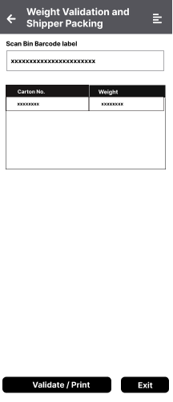

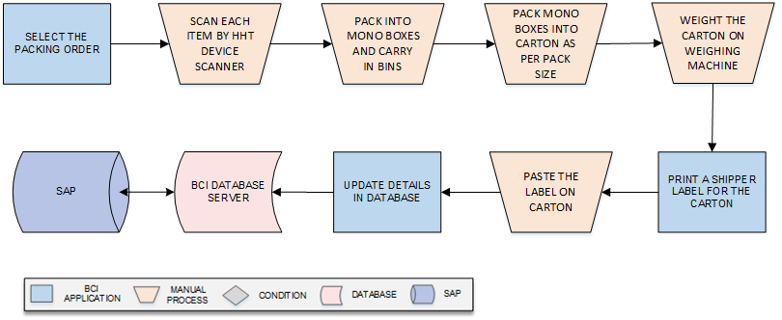
Manual Packing
Activities
Module Description | The module will be used If the fixed mount scanner or conveyor is not functioning, this module provides an alternative solution. The user can manually scan the item's barcode using an HHT scanner, place the item into the designated bin, put into carton as per pack size and complete the carton, and finally generate the shipper label.  *This activity will be done using Device Application and it’s a manual process.

Pre-Conditions | - Authorized User to be given permission.  - Barcode scanning to be done properly.

Process Steps | - Select the Packing order.  - Scan each item by the HHT scanner.  - Pack into the mono box and carry into the bin.  - Pack the mono box into cartons as per pack size.  - Complete the carton box and weight the carton.  - Print a shipper label for the carton box.  - Details get updated in the database and then to the SAP.

Post-Conditions | - Manually process to be done only if the Packing machine are not working.  - Scan the barcode of each label and update details into SAP.

Validations | - An alert should be displayed in case invalid details is entered.  - An alert message is displayed in case of any error / invalid activity.

Sample Screen | Note: - The provided screens are samples; the actual screen may vary slightly.  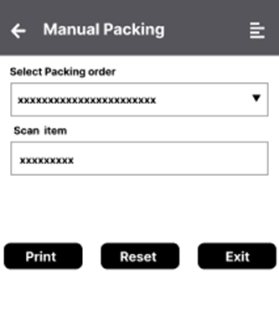

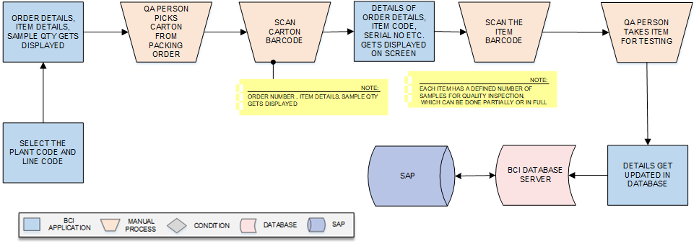
Quality Sampling

Module Description | This module will be used for to remove the item from the carton for Quality as per the sample for each item defined in Item master.  *This activity will be done using Device Application.

Pre-Conditions | - Authorized access to the application.  - Quality check to be done for items as per production order.  - Quality to be as per the standard set by the company.

Process Steps | - QA picks a carton from the production order.  - Select the Plant Code and Line code.  *The Order Number, Item details, Sample Qty gets displayed.  - Scans carton barcode.  - Sample Qty gets displayed on the screen.  - Scans and picks an item for testing.  *Number of quantity for each item defined from item master  - Takes the item to the lab for testing  *Tests the item for quality.  - Details are saved in the database accordingly.

Post-Conditions | - Quality to be as per standard of the product.  - Quality Inspection to be undergone every quality aspect.

Validations | - An alert should be displayed in case invalid label number is entered.  - An alert message is displayed in case of any error / invalid activity.

Sample Screen | 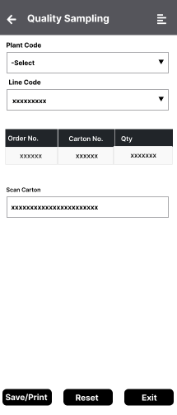

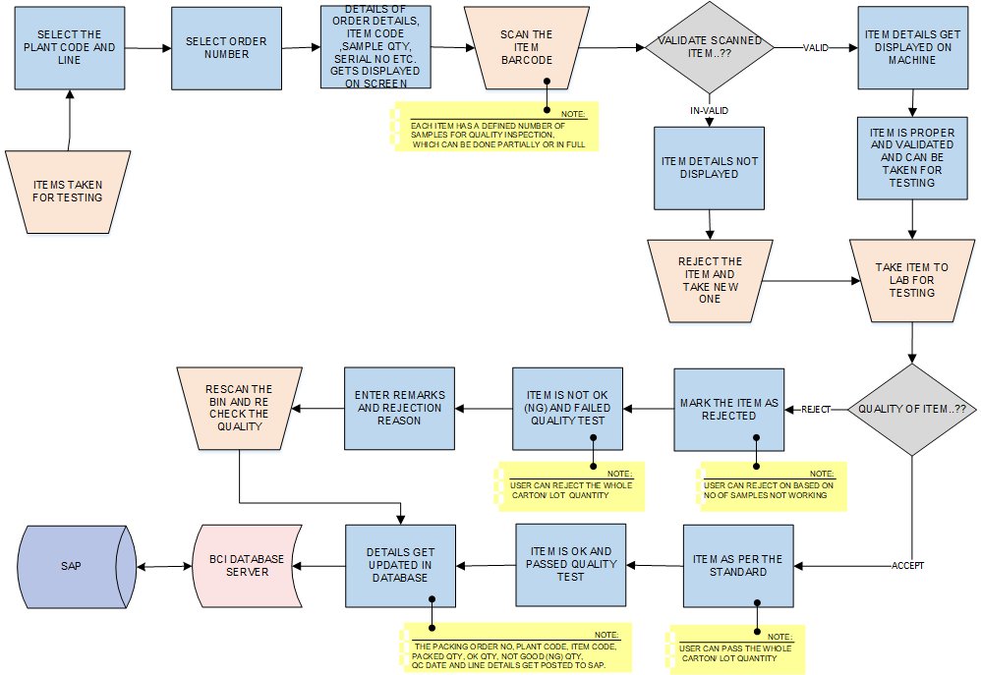
Quality Checking

Activities
Module Description | This module is designed for conducting quality inspections on items based on predefined sample quantities per item. In case an item is rejected, it will be replaced with an acceptable item and returned to the carton. Accepted items are rescanned, placed back in the carton, and prepared for further processing and transfer to the plant warehouse. The details get updated into the SAP.  *This activity will be done using Desktop Application.

Pre-Conditions | - QA person access to the application.  - Quality check to be done for items as per packing order.  - Quality to be as per the standard set by the company.

Process Steps | - User carry the carton bin for QA testing.  - QA picks a carton from the packing order.  - Scans carton barcode label.  - The details such as Order details, Item code, serial number and carton details gets displayed on screen.  - Scans and picks an item for testing.  *Number of quantity for each item to be defined by SAP system.  - Validate the scanned item  - Scanned Item is Valid  - Item details get displayed on screen.  - Item is validated and can be taken for testing.  - Scanned Item is Not-Valid  - Item details get displayed on screen.  - Reject the item and take a new one for testing  - Takes the item to the lab for testing.  *Tests the item for quality.  - If item passes quality test  - Item is as per standard and quality is “OK”  - Item has passed the quality test  *User can pass the whole Carton/ Lot quantity.  - If item fails quality test  - Marks the item as "rejected"  - Item is “NOT OK” (NG) and failed quality test.  - Enters remarks for the reason of rejection  *User can reject the whole Carton/ Lot quantity.  - Save the quality confirmation details of each item from the carton in SAP.  *The Packing Order No, Plant code, Item code, Packed Qty, OK Qty, Not good (NG) Qty, QC date and Line details get posted to SAP.  - Details are saved in the database.  - Posted into the SAP accordingly.

Post-Conditions | - Quality to be as per standard of the product.  - Quality Inspection to be undergone every quality aspect.

Validations | - An alert should be displayed in case invalid label number is entered.  - An alert message is displayed in case of any error / invalid activity.

Sample Screen | Note: - The provided screens are samples; the actual screen may vary slightly.  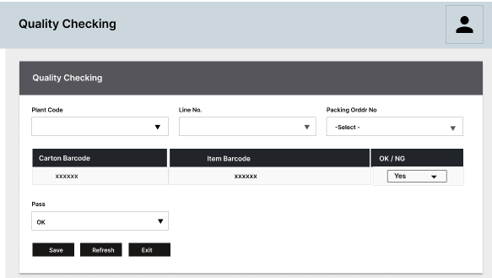

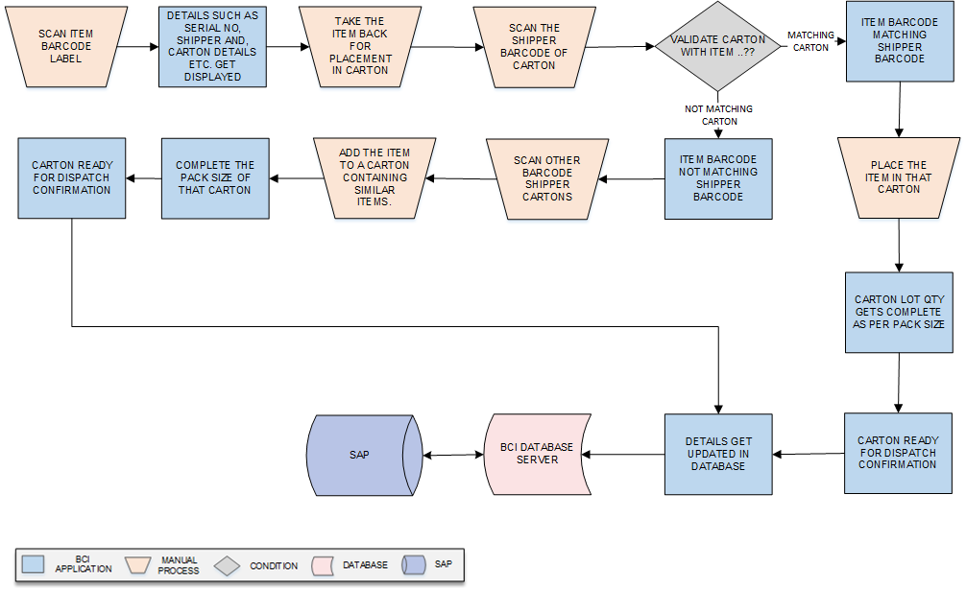
Quality Tested Item placement
Activities
Module Description | This module facilitates the placement of quality-tested items back into their respective carton boxes. The scanned item is placed in its original carton. If the original carton is not found, it is placed in another carton with the same item type to complete the carton pack size. The pack size of the new carton is completed, and it is prepared for dispatch.  *This activity will be done using Device Application.

Pre-Conditions | - QA person access to the application.  - Quality checked item to be taken for placement.  - Quality to be as per the standard set by the company.  - Quality rejected item to be not taken out of testing lab.

Process Steps | - Scan the Item barcode label  - Details such as Serial no, item shipper label, carton details gets displayed.  - Take the quality Ok items back for placement.  - Scan the shipper barcode of item.  - Validate the carton with the Item.  - Item Matching Shipper barcode carton  - Place the Item in that shipper carton.  - Carton Lot qty gets completed.  - Carton ready for dispatch to Plant warehouse.  - Item Not Matching Shipper barcode carton  - Scan other barcode carton label.  - Add the item to a carton containing similar items.  - Complete the pack size of the carton.  - Carton qty completed confirmation to SAP.  - Details are saved in the database accordingly.  - Posted to SAP accordingly.

Post-Conditions | - Place the item in a shipper carton containing similar items.  - Ensure that the item remains undamaged after testing.

Validations | - An alert should be displayed in case invalid label scanned.  - An alert message is displayed in case of any error / invalid activity.

Sample Screen | Note: - The provided screens are samples; the actual screen may vary slightly.  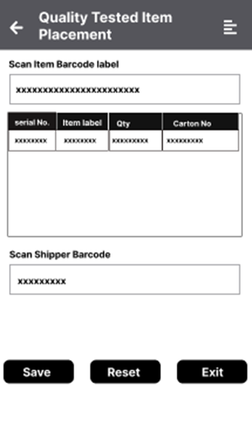

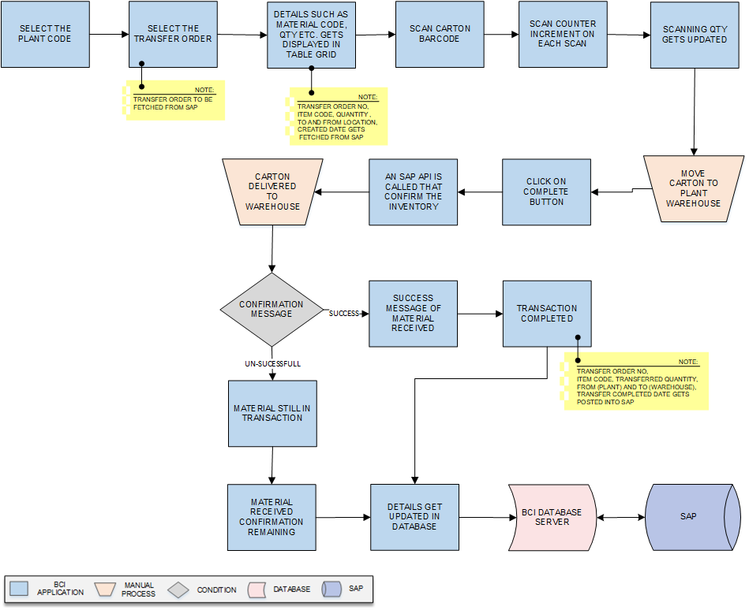
Transfer to Warehouse from Plant

Activities
Module Description | Once packing is complete, finished goods (FG) cartons will be transferred to the plant warehouse, and the system will update the database with relevant information. The data will also be posted to SAP.  *This activity will be done using Device Application.

Pre-Conditions | - Authorized access to the application.  - User need to check for all quality details completed of carton.  - Transfer order to be fetched from the SAP.

Process Steps | - Select the Plant code from dropdown list.  - Select the Transfer Order from the dropdown list.  *Transfer Order details are fetched from SAP.  - Details such as Transfer order No, Item code, Quantity, to and from location, created date gets fetched from SAP displayed. In table grid.  - Scan barcode label of each carton label.  - The Counter increment on each scan.  - Update the scanning quantity accordingly.  - Move the carton to the warehouse.  - Click the complete button to confirm the transaction.  - As soon complete button is clicked SAP API is called that confirm the inventory.  - Carton delivered to warehouse.  - Receive a confirmation message:  - Message received from SAP.  - Success message of material received  - Transaction completed of transfer.  *Transfer order No, Item code, Transferred Quantity, From (plant) and TO (Warehouse), Transfer completed date gets Posted into SAP.  - Message not received from SAP  - Material still in process.  - Material received confirmation remaining  - The corresponding details will be saved in the database.  - Post the data to SAP.

Post-Conditions | - Item carton to be moved by the means of transport.  - Safety of the item to be check will moving the item.  - The inventory to be updated in the warehouse.

Validations | - An alert message is displayed in case of any error / invalid activity.

Sample Screen | Note: - The provided screens are samples; the actual screen may vary slightly.  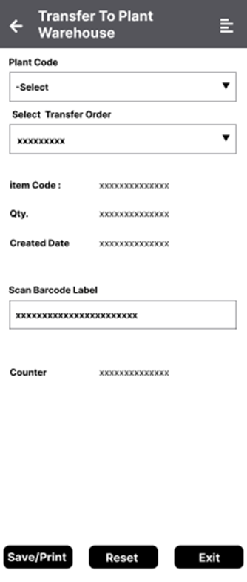

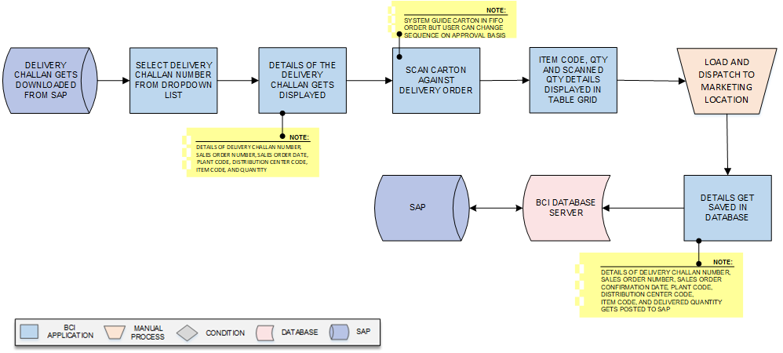
Transfer to Marketing Location from Warehouse
Activities
Module Description | In this module, cartons are dispatched to the marketing location as per the delivery challan. Cartons undergo checking and scanning against the Delivery order details before being transferred to the Marketing /Distribution location.  *This activity will be done using Desktop Application.

Pre-Conditions | - Authorized access to the application.  - Delivery order details to be fetched from SAP.

Process Steps | - Download the delivery challan details from SAP.  - Select the delivery order details from the dropdown list.  - The details Delivery Challan Number, Sales Order Number, Sales Order Date, Plant Code, Distribution Center Code, Item Code, and Quantity gets displayed.  - Scan the carton against delivery order details.  *System will display picking as per FIFO order, but it can be enabled and disabled on approval basis.  - The item Code, Qty and Scanned Qty gets displayed in table grid.  - Load and dispatch the material to the Marketing location.  - Details get updated in database.  *The details of Delivery Challan Number, Sales Order Number, Sales Order Confirmation Date, Plant Code, Distribution Center Code, Item Code, and Delivered Quantity get posted into SAP.  - Posted into the SAP.

Post-Conditions | - Material to be dispatch as per the delivery Order.  - Material to follow FIFO order and change in case of necessity.

Validations | - An alert should be displayed in case invalid details is selected.  - An alert message is displayed in case of any error / invalid activity.

Sample Screen | Note: - The provided screens are samples; the actual screen may vary slightly.  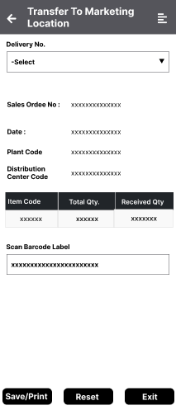

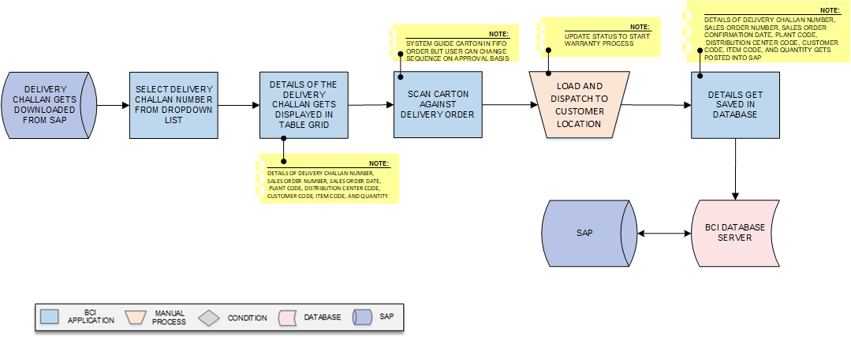
Transfer to Customer from Marketing Location

Activities
Module Description | In this module, cartons are dispatched to the customer location as per the delivery challan. Cartons undergo checking and scanning against the Delivery order details before being transferred to the Customer location.  *This activity will be done using Device Application.

Pre-Conditions | - Authorized access to the application.  - Delivery order details to be fetched from SAP.

Process Steps | - Download the delivery challan details from SAP.  - Select the delivery order details from the dropdown list.  - The details Delivery Challan Number, Sales Order Number, Sales Order Date, Plant Code, Distribution Center Code, Customer Code, Item Code, and Quantity gets displayed.  - Scan the carton against delivery order details.  *System will display picking as per FIFO order, but it can be enabled and disabled on approval basis.  - Load and dispatch the material to the Marketing location.  *Update status of the warranty process.  - Details get updated in database.  *The details of Delivery Challan Number, Sales Order Number, Sales Order Confirmation Date, Plant Code, Distribution Center Code, Item Code, and Delivered Quantity get posted into SAP.  - Posted into the SAP accordingly.

Post-Conditions | - Material to be dispatch as per the delivery Order.  - Material to follow FIFO order and change in case of necessity.

Validations | - An alert should be displayed in case invalid details is selected.  - An alert message is displayed in case of any error / invalid activity.

Sample Screen | 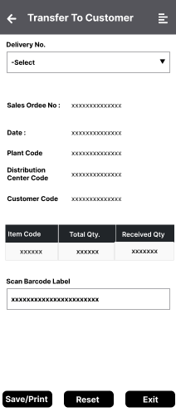  Note: - The provided screens are samples; the actual screen may vary slightly.

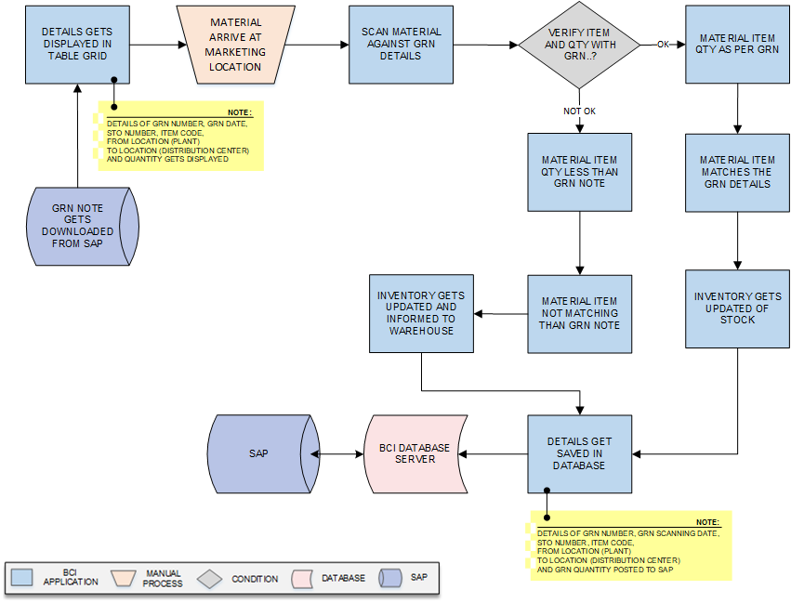
Receiving at Marketing Location and Confirmation
Activities
Module Description | In this module, the marketing location receives the material based on the GRN details from SAP. The material is scanned to match the GRN details, and the quantity of the item is validated against the GRN note. Finally, the inventory stock is updated in SAP to confirm the stock availability.  *This activity will be done using Device Application.

Pre-Conditions | - Authorized access to the application.  - Wrong serial number given for secondary packing.

Process Steps | - GRN details is fetched from the SAP.  - Details such as GRN Number, GRN date, STO Number, Item code, from location (plant) to location (Distribution center) and quantity gets displayed.  - Material is arrived at the Marketing location.  - Select the GRN Number.  - Scan the Material against the GRN details.  - Verify the Material is as per the GRN Qty details.  - If the material matches the GRN details:  - Received item Qty is as per GRN note.  - Received Item matching with GRN detail.  - If the material does not matches the GRN details:  - Received item Qty is as not as per GRN note.  - Received Item not matching with GRN detail.  - Inventory gets updated as per the received material.  - Notify the warehouse of the material details.  *Details of GRN Number, GRN scanning date, STO Number, Item code, From location (plant)To location (Distribution center) and GRN quantity posted to SAP  - Details get updated in the database.  - Posted into SAP.

Post-Conditions | - Material to be verified as per the GRN details.  - Update the Inventory of the stock into SAP.

Validations | - An alert should be displayed in case invalid details is entered.  - An alert message is displayed in case of any error / invalid activity.

Sample Screen | Note: - The provided screens are samples; the actual screen may vary slightly.  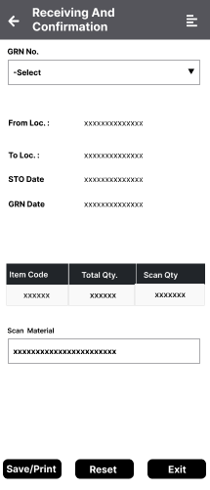

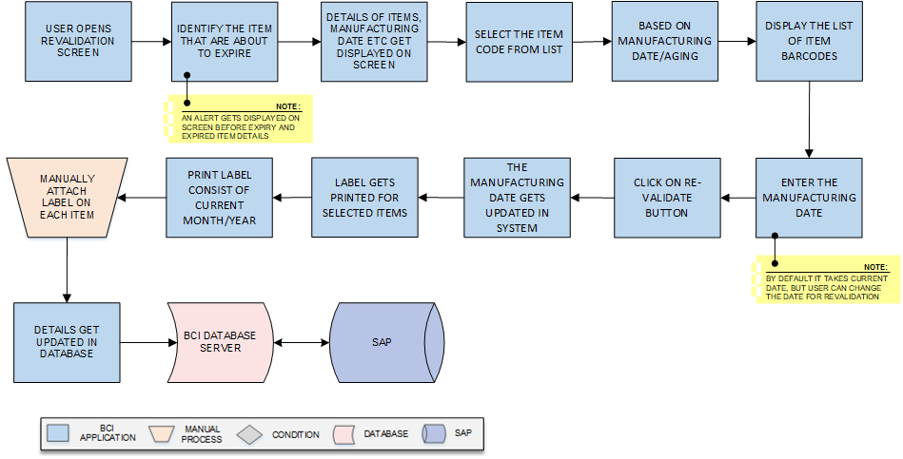
Revalidation Process
Activities
Module Description | During this process, the material is revalidated before it reaches its expiry date. If an item is about to expire or has already expired, the system will alert you. In such cases, a label with the current month and year is printed and attached to each item. The updated information is then recorded in the database and synchronized with SAP.  *This activity will be done using Desktop and Device Application.

Pre-Conditions | - Before proceeding with revalidation, ensure that the process is performed only for items that are about to expire or have already expired.  - Prior to revalidation, visually inspect each item for any physical damages or visible issues.

Process Steps | - User opens the Revalidation Screen  - Identify the items that are expired or nearing expiration and require a change in their manufacturing date.  *An alert gets displayed on the screen before expire or expired item.  - View item details, manufacturing date, and expiration information on screen.  - Select the item code.  - Display a list of item barcodes based on manufacturing date and aging time.  - Enter the Manufacturing date.  *The manufacturing date is set to the current date by default, but users can modify the date for revalidation if needed.  - Click on Re-validate button to confirm.  - The manufacturing date gets updated in the system.  - Label gets printed for the selected Items.  - Printed small stickers displaying the current month and year.  - Manually attach the printed stickers to each individual part as instructed.  - It gets updated in the database and to SAP.

Post-Conditions | - Carefully label each item and repack them in the carton box.  - Avoid pasting labels on damaged items.

Validations | - An alert should be displayed in case invalid details is entered.  - An alert message is displayed in case of any error / invalid activity.

Sample Screen | 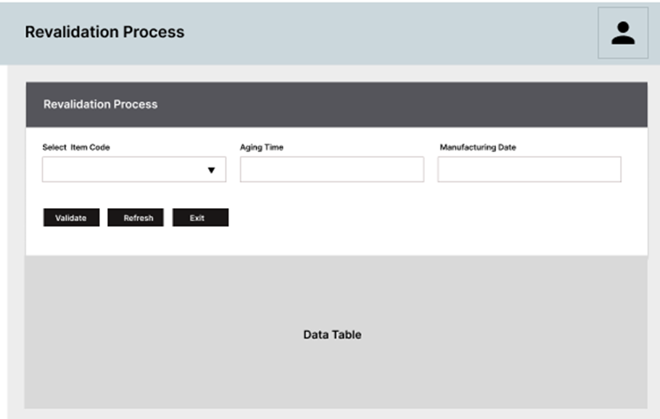  Note: - The provided screens are samples; the actual screen may vary slightly.

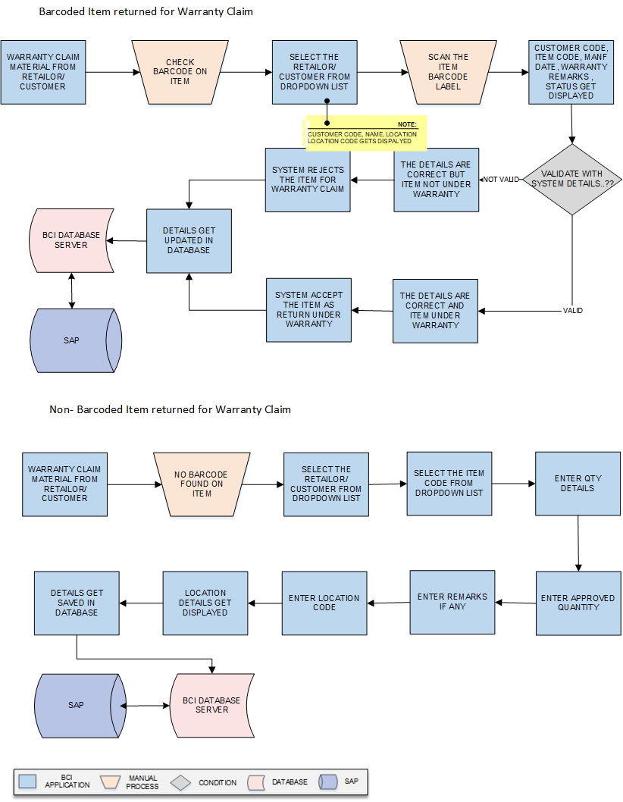
Warranty Claim

Activities
Module Description | In this process, the retailer/customer sends either a barcoded item or a damaged barcoded item for warranty claiming. The user is required to verify whether the item is eligible for warranty and approve or reject the warranty claim accordingly.  *This activity will be done using Desktop and Device Application.

Pre-Conditions | - Authorized access to the application.  - Warranty claim item to be set only for damaged items.  - Warranty time to be set by the company for each item.

Process Steps | When items arrive at the Marketing Location for warranty claims, there are two types: barcoded and non-barcoded.  *Maintain at least min 2years of data into system.  For barcoded items:  - Select the Retailor/ Customer from dropdown list.  *Customer Code, Name and Location code gets displayed.  - Scan the item's barcode label.  - Validate with the system details:  - For Not Valid Items  - Details are correct but item not under warranty  - System rejects the item for Warranty claim.  - For Valid Items  - Details are correct but item under warranty  - System accepts the item for Warranty claim.  - The details get displayed on the screen.  - Save the details and generate a DLI report in the system.  - The report undergoes approval by the designated authority.  - Details get updated in the database and then to the SAP.  For Non-barcoded items:  - Select the Retailor/ Customer from dropdown list.  - Select the item's code from list.  - Enter Qty details of the Items.  - Enter approved Qty  - Enter remarks if required.  - Enter Location code.  - Location Code gets displayed in the screen.  - The accepted and rejected item details get displayed on system.  - Save the details and generate a DLI report in the system.  - The report undergoes approval by the designated authority.  - Details get updated in the database and then to the SAP.

Post-Conditions | - Warranty claim to be passed or rejected by authorized user.  - Warranty of item to be validated before claiming.

Validations | - An alert should be displayed in case invalid details is entered.  - An alert message is displayed in case of any error / invalid activity.

Sample Screen | Note: - The provided screens are samples; the actual screen may vary slightly.  Barcoded Item  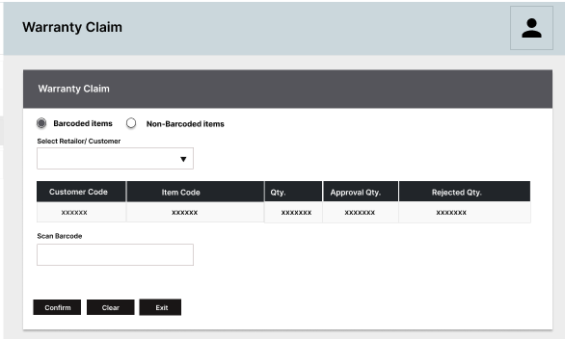  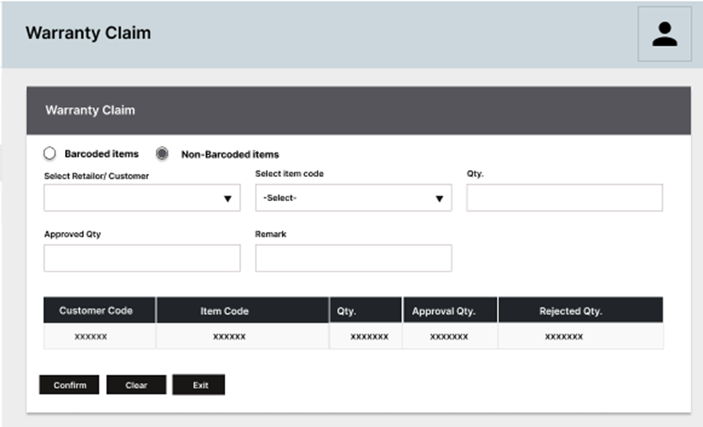  Non barcoded Items

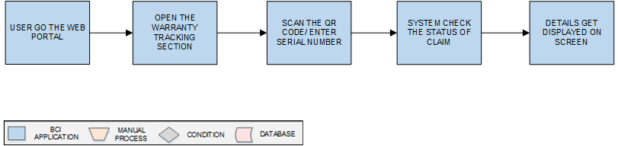
Warranty Tracking
Activities
Module Description | Customers will have access to a web interface for tracking their product warranty, which can be accessed from both mobile phones and desktop computers.  *This activity will be done using Web Application..

Pre-Conditions | - The user should initiate a claim for item replacement.

Process Steps | - Go to the Web Portal and log in  - Open the Warranty Tracking section  - Scan the QR Code on the product or enter the serial number manually  - The system will retrieve the product details from the database and show them on the screen.

Post-Conditions | - Material to be in warranty for claim.  - An alert to displayed if item is invalid

Validations | - An alert should be displayed in case invalid details is entered.  - An alert message is displayed in case of any error / invalid activity.

Sample Screen | 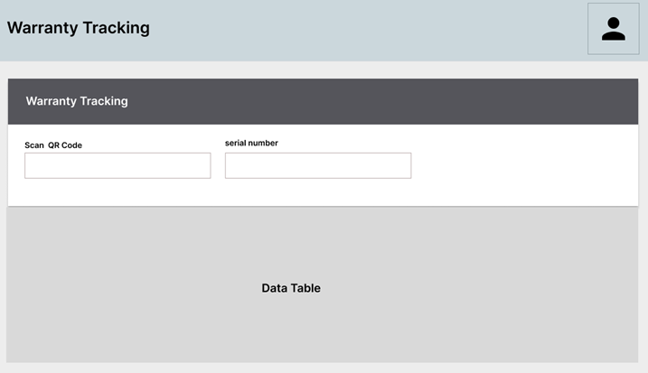  Note: - The provided screens are samples; the actual screen may vary slightly.

Reports
Reporting module will provide access to the data that will be helpful in making well-informed strategic decisions, reduces risk, and increases productivity. The reporting interface will be user-friendly, application users can easily generate, and view required data.
The application will generate customized reports based on required data fields and time interval selected / entered by users.
BCI will provide customized reports, following are 4 reports format, as application is developed:

Packing Report
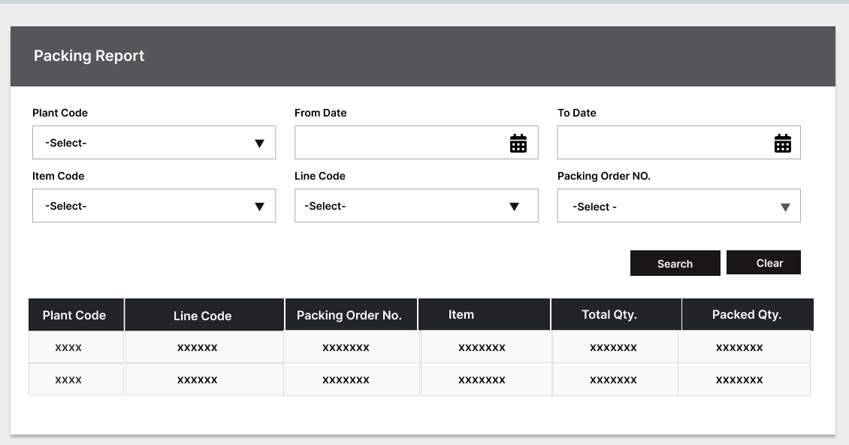
The packing report shows the data for all the items packed once the packing order is finished.

Packing Order Barcode Details
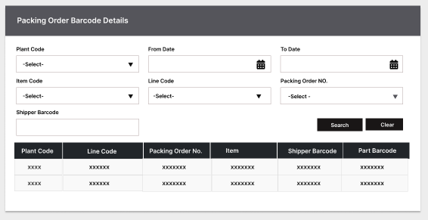
The report shows a list of all the barcodes used for the packing order.

Quality Report
The report indicates the quality status of the tested items, which test items passed and failed the quality test.
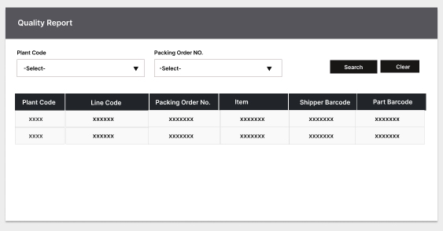

Transfer from Floor (Plant) to Warehouse
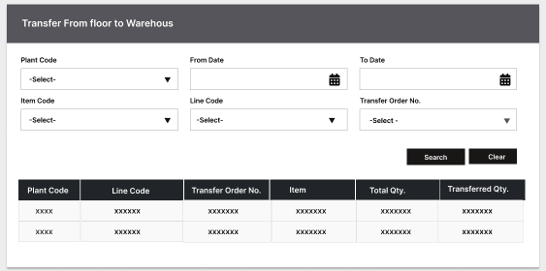
The report displays the quantity of packing orders transferred from the plant to the warehouse. The packing order is sent to the warehouse in accordance with the transfer order.

As on date Inventory
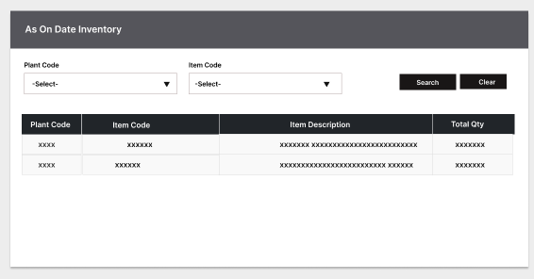
The report shows the current inventory status, including the transferred order inventory and the pending inventory as of today's date.

Dispatch from Warehouse
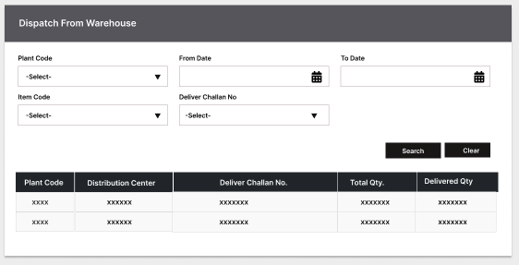
The report displays the dispatched packing orders from the warehouse based on the delivery challan. It also shows the number of packing orders transferred to marketing and customer locations.

GRN at DC
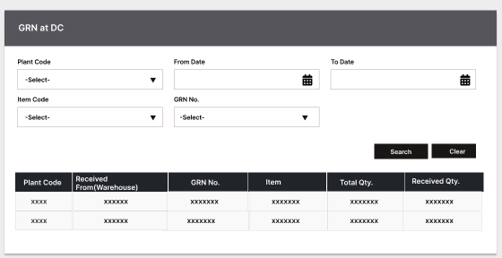
The report shows how many packing orders have been received at the Marketing Location based on the Goods Received Note (GRN). The report presents a comprehensive list of all GRNs along with the corresponding packing orders associated with each GRN.

Dispatch from DC
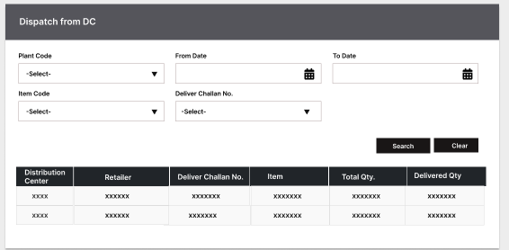
The report displays the dispatched packing orders from the Marketing Location on the delivery challan to Customer. It also shows the number of packing orders transferred to Customer locations.

Return to Marketing Location (DC) From Customer (Retailor)
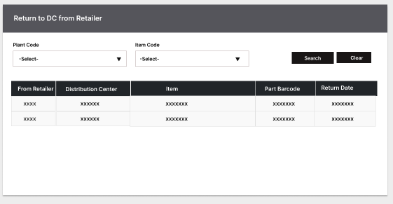
The report shows the items returned by customers (retailors) to the Marketing location. It includes a detailed list of the returned items from each customer, along with their respective information.

Revalidation Report
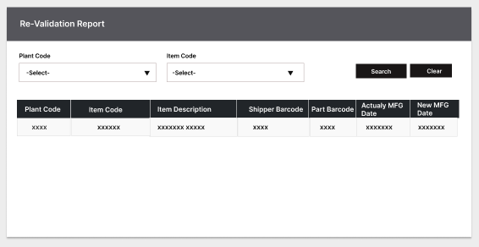
The report indicates the number of items that have undergone revalidation. It provides the revalidated new manufacturing date and other details in the list.

SRS Scope Change Process

Before Sign Off
Any changes in SRS need to be informed in writing by Surya Roshni Ltd. It will be incorporated / confirmed only after doing detailed feasibility study by BCI.
- If any change is out of scope then this would be done as a CR post feasibility and priority will be decided based on mutual agreement.
- Once the change is developed , any further change in the same would be considered as a CR

After Sign Off
Any changes in proposed solution after approval of this document by Surya Roshni Ltd are subjected to confirmation from BCI, taking feasibility constraints into account. These changes will be incorporated (if any) into the solution only after delivering proposed solution & may be charged as extra.
- Any change in the proposed solution due to customer system design or process will be considered as CR
- Any process which is not mentioned in this document will not be considered as “mutual understanding or default presence or standard practice”.
The changes in proposed solution before & after acceptance will be mutually agreed and duly signed and accepted by Surya Roshni & BCI.

SRS Acceptance
For Surya Roshni Ltd. | For Bar Code India (BCI)
Name: | Name:
Designation: | Designation:
Department: | Department:
Agreed and Accepted by Surya Roshni and Bar Code India

