

Process Name

Company Name

User Manual

This user’s guide includes the information you need to work with the designed application. It contains detailed information about how the application will work.

Prepared By:

Version Number:

BAR CODE INDIA, 145 Udyog Vihar Phase I, Gurugram, Haryana-122016, PH: 0124 4337555

BAR CODE INDIA, 691 UDYOG VIHAR PHASE V, GURUGRAM, HARYANA - 122016, Ph.: 0124 4337555

Notice:

This document contains information, which is the proprietary property of Bar Code India. This document is received in confidence and its contents cannot be disclosed or copied without the prior written consent of Bar Code India.

Nothing in this document constitutes a guaranty, warranty, or license, express or implied. Bar Code India disclaims all liability for all such guaranties, warranties, and licenses, including but not limited to: Fitness for a particular purpose; merchantability; not infringement of intellectual property or other rights of any third party or of Bar Code India; indemnity; and all others. The reader is advised that third parties can have intellectual property rights that can be relevant to this document and the technologies discussed herein and are advised to seek the advice of competent legal counsel, without obligation of Bar Code India.

Bar Code India retains the right to make changes to this document at any time, without notice. Bar Code India makes no warranty for the use of this document and assumes no responsibility for any errors that can appear in the document nor does it make a commitment to update the information contained herein.

COPYRIGHT

Copyright © ***BCI*** 2022. All rights reserved.

TRADEMARKS

*Other product and corporate names may be trademarks of other companies and are used only for explanation and to the owners' benefit, without intent to infringe.

Revision History

|  |  |  |  |  |
| --- | --- | --- | --- | --- |
| Revision Number | Date | Prepared By | Reviewed By | Comment |
|  |  |  |  |  |

Table of Contents

1 Getting Started with Application 1

1.1 Introduction 1

1.2 Pre- Requisite for Application Working 2

1.3 Starting or Logging on the Application 2

2 Application Overview & Working 3

3 Working with File Upload & Download in Application 4

4 Application Modules 5

4.1 Login- Desktop & Device Application 5

4.1.1 Desktop- Login 5

4.1.2 Device- Login 5

4.2 Dashboard 6

4.3 Master Modules 7

4.3.1 Plant Master 7

4.4 Managing Users & Role/ Rights 9

4.5 Transactions 10

5 Reports 11

# Getting Started with Application

## Introduction

## Pre- Requisite for Application Working

[List all the necessary points or tasks that should have been performed to run the applications.]

Example:

1. **Web or Desktop Application**
   1. Start the Web Browser on Computer [Web Application].
   2. Install the application on the Desktop.
   3. System should fulfill the minimum requirement to run the Application.
2. **Device Application**
   1. Device Calibration should have been completed.
   2. Application should be installed on Device.
3. **Communication Server:**
   1. Communication Server should be installed on server for Device and Database connection.
4. **Barcode Printer:**
   1. Barcode should be calibrated and connected with PC or on Network.

## Starting or Logging on the Application

**Web Environment**

To start Applications in a Web environment enter the appropriate URL for your site in certified browser.

**Windows Environment**

To start Applications in the Windows environment double–click on an Applications icon.

**Device Application**

**Communication Server**

# Application Overview & Working



# Working with File Upload & Download in Application

## DOWNLOAD FILE TEMPLATE

This functionality is given in the masters. When working on master, you need to download the file template through which data can be imported in to the application. To download the file template, follow these steps:

# Application Modules

## Login- Desktop & Device Application

### Desktop- Login

### Device- Login

Click on the application’s shortcut icon on device to run the application, a configuration screen will appear:

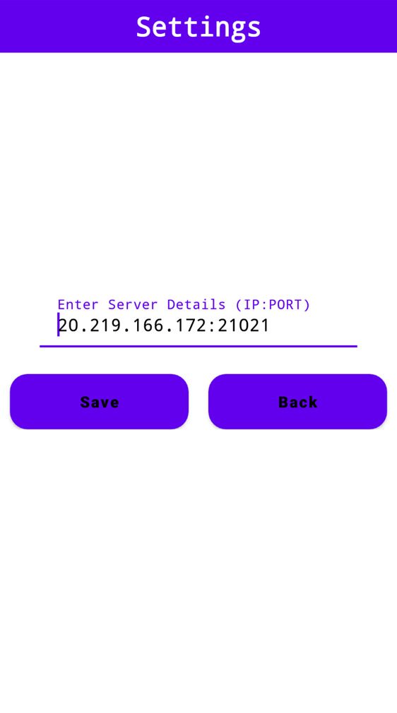

### APPLICATION CONFIGURATION

The following screen is used to configure the application with database server in order to fetch and transfer data to/ from device.



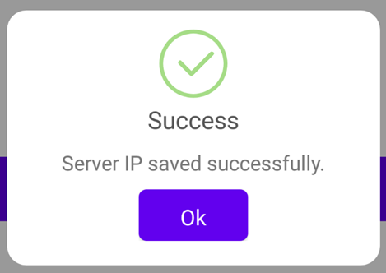

1. Enter the IP Address of the system on which application is installed.
2. Click on Save button, Server IP saved successfully message appears.
3. Login screen will appear.

## LOGIN

This screen is used to login into the device application via authorized credentials

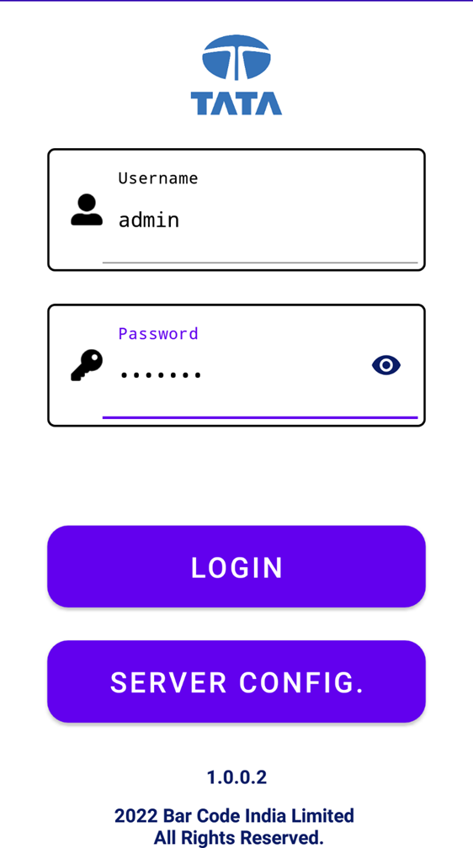

1. Enter User ID and Password.
2. Click on Login button, user will get logged into the application.

*\*In case wrong User ID or Password is entered, an error message will be displayed.*

## Dashboard

On successful login into the device application, following Dashboard screen will be displayed:

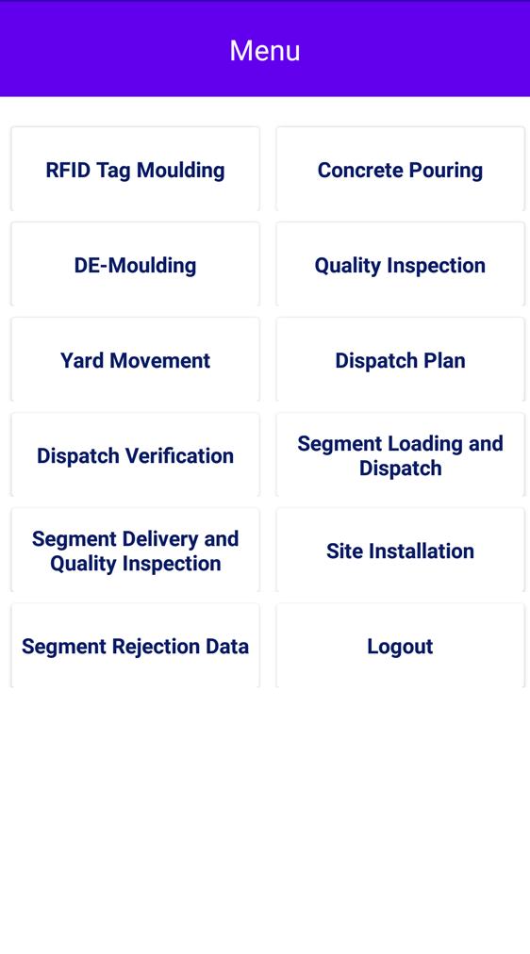Menu Options:

1. RFID Tag Moulding
2. Concrete Pouring
3. De-Moulding
4. Quality Inspection
5. Yard Movement
6. Dispatch Yard
7. Dispatch Verification
8. Segment Loading and Dispatch
9. Segment Delivery and Quality Inspection
10. Site Installation
11. Segment Rejection Data

**Logout**

1. Click on icon displayed on top right corner of the dashboard screen and click on Logout to

logout/ exit from the application.

## Master Modules

### Plant Master

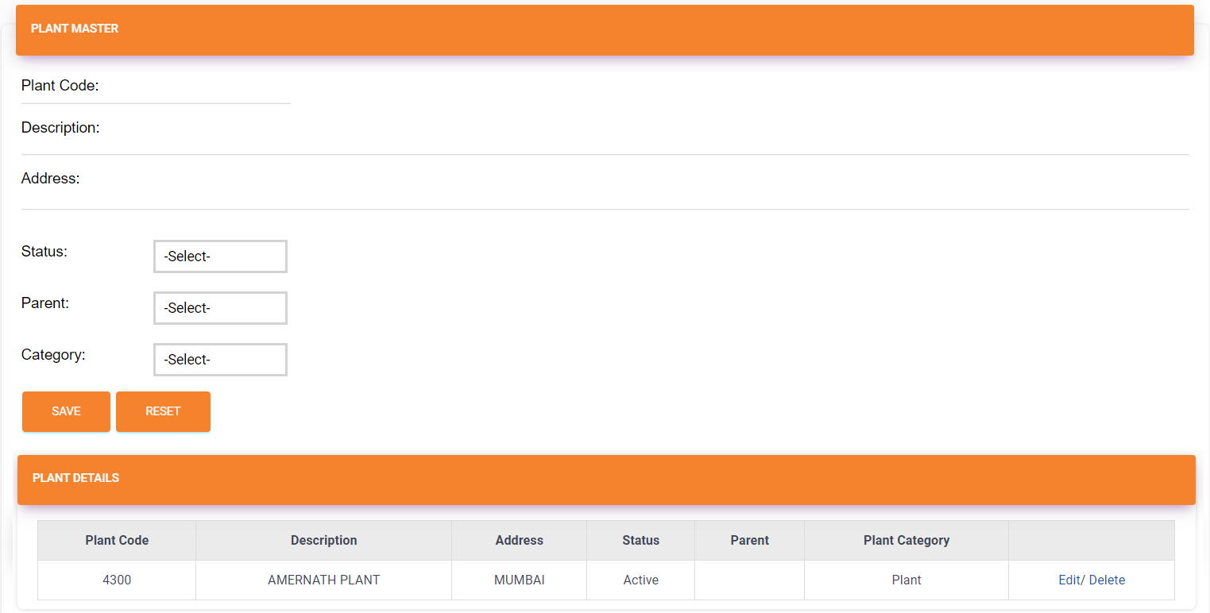This module is used to update the existing Plant details in database. Using this module, user can also delete the Plant details, if required. Each Plant will be license based (i.e. Plant details can only be saved by BCIL members from backend). To view this screen, click on **Masters** from main menu and select **Plant Master**, following screen will get displayed:

**Edit Plant Master**

1. To edit Plant details, click on **Edit** against Plant Code from the data grid, corresponding Plant details will appear in respective text fields.



1. Save button caption will change to **Update.**

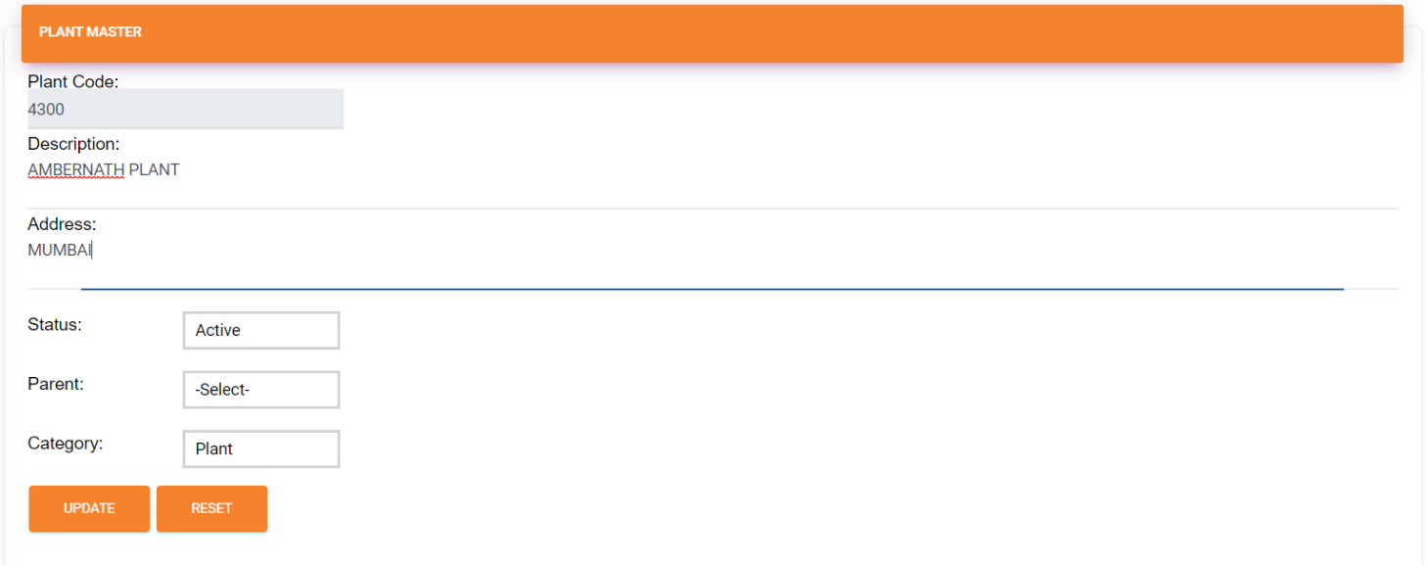

1. Make required changes and click on **Update** button, following success message will appear on screen if selected Plant details are updated successfully:

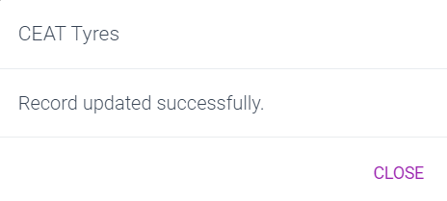

1. Click on **Close**.

## Managing Users & Role/ Rights

## Transactions

### RFID Tag Moulding

This screen allows user to for tag Moulding. To view this screen, click on RFID Tag Moulding from device application’s main menu and following screen will be displayed:

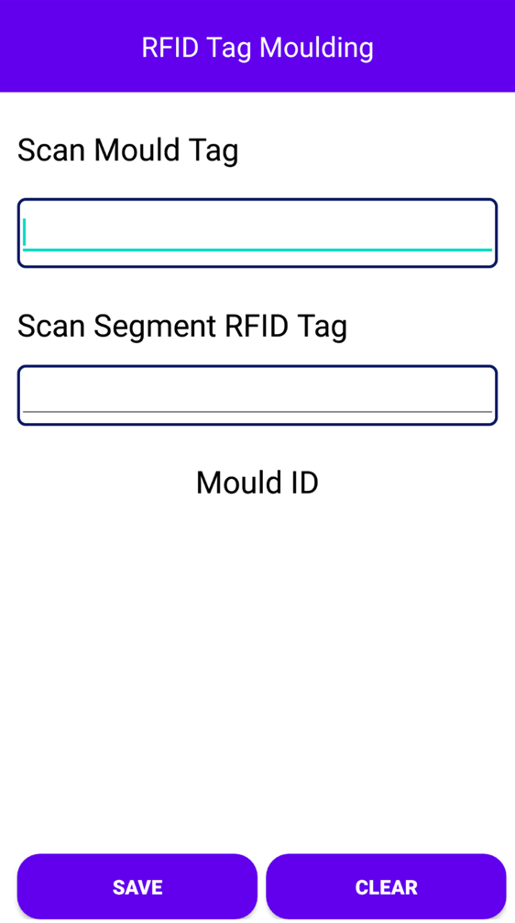

**Save RFID Tag Details**

1. Scan the Mould Tag from the mould.
2. Scan the Segment RFID Tag.
3. Mould Id details get displayed in the table below.
4. Click on Save button, to save the details.

**Clear**

1. Click on Clear to clear the textfields and selections.

### Concrete Pouring

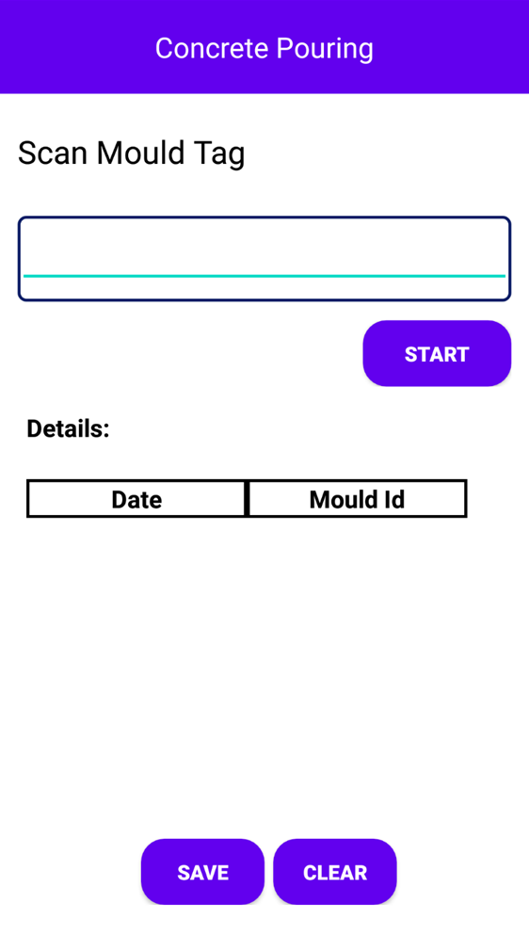This screen allows user to start pouring of concrete on mould. To view this screen, click on Concrete Pouring from device application’s main menu and following screen will be displayed:

**Start Concrete Pouring**

1. Scan the Mould Tag from the mould.
2. Click on start button.
3. Concrete gets poured on the mould.
4. The date and Mould Id details get displayed in the table below.
5. Click on Save button, to save the details.

**Clear**

1. Click on Clear to clear the textfields and selections.

### De-Moulding

This screen allows user to after concrete pouring being to de-mould. To view this screen, click on   
De-Moulding from device application’s main menu and following screen will be displayed:

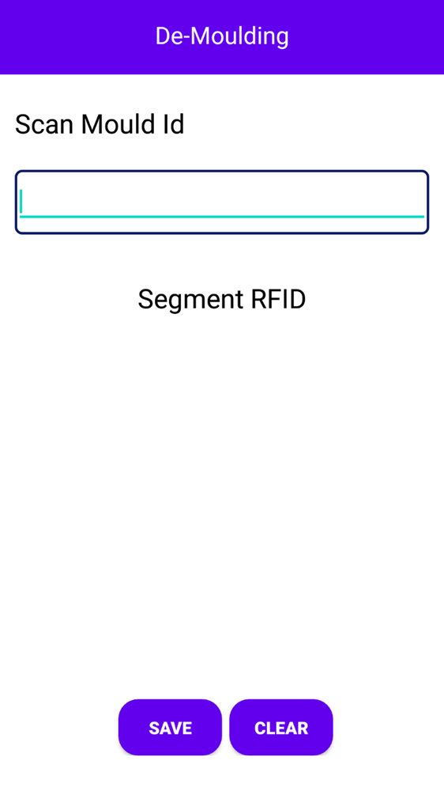

**Save De-Moulding Details**

1. Scan the Mould Tag from the mould.
2. The Segment RFID tag details get displayed in the table below.
3. Click on Save button, to save the details.

**Clear**

1. Click on Clear to clear the textfields and selections.

### Quality Inspection

This screen allows user to check the quality of the segment. To view this screen, click on Quality Inspection from device application’s main menu and following screen will be displayed:

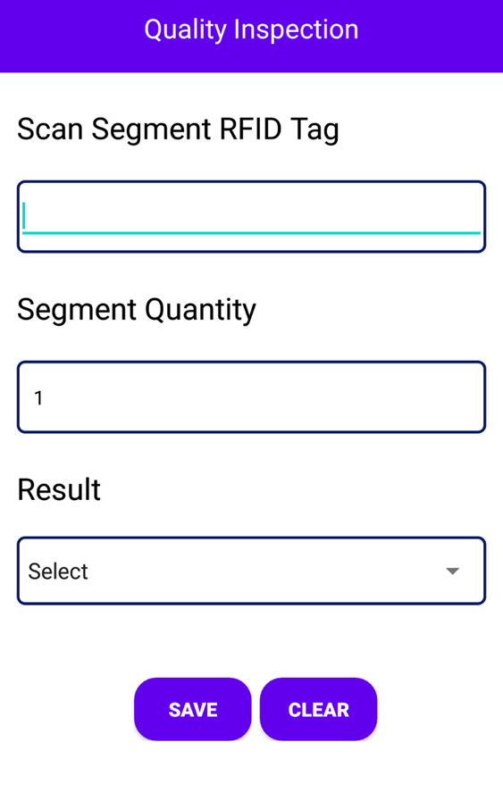

**Save De-Moulding Details**

1. Scan the segment RFID tag of the mould.
2. The Segment quantity gets auto filled in the box.
3. 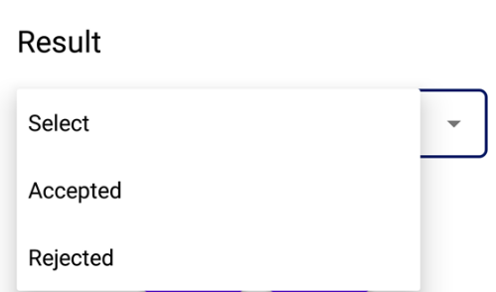Select the Result from the dropdown list.
4. Click on Save button, to save the details.

**Clear**

1. Click on Clear to clear the textfields and selections.

### Yard Movement

This screen allows user to check the movement of the segment in particular location. To view this screen, click on Yard Movement from device application’s main menu and following screen will be displayed:

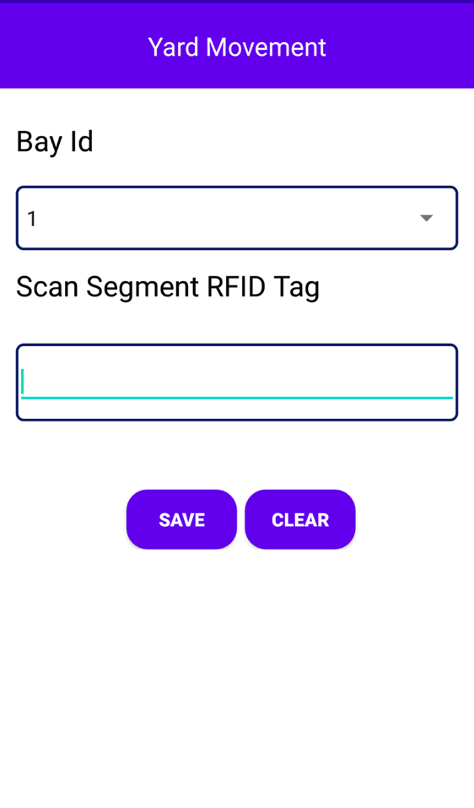

**Save Yard Movement Details**

1. Select the Bay ID from the dropdown list.
2. Scan the segment RFID tag of the mould.
3. The Segment details get displayed on the table below.
4. Click on Save button, the details get saved in the database.

**Clear**

1. Click on Clear to clear the textfields and selections.

### Dispatch Plan

This screen allows user to make the dispatch plan for the segment. To view this screen, click on Dispatch Plan from device application’s main menu and following screen will be displayed:

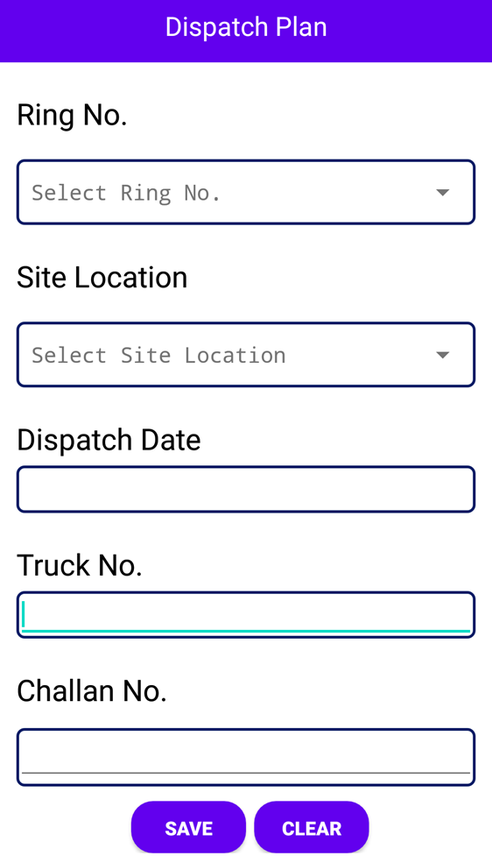

**Save Dispatch Plan Details**

1. Select the Ring Number from the dropdown list.
2. Select the Site location from the dropdown list.
3. Enter the dispatch date or select date from date picker.
4. Enter the truck details in the data field.
5. Enter the Challan No in the data field.
6. Click on Save button, the details get saved in the database.

**Clear**

1. Click on Clear to clear the textfields and selections.

### Dispatch Verification

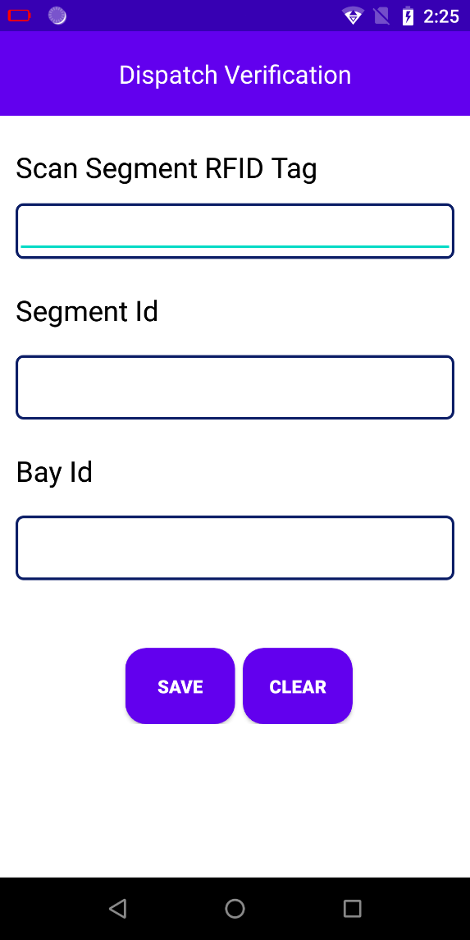This screen allows user to make dispatch verification of the segment that need to be dispatched. To view this screen, click on Dispatch Verification from device application’s main menu and following screen will be displayed:

**Save Dispatch Verification Details**

1. Scan the Segment RFID Tag of the mould.
2. Enter the Segment Details in Segment Id data fields.
3. Enter the Bay Id details in data fields.
4. Click on Save button, the details get saved in the database.

**Clear**

1. Click on Clear to clear the textfields and selections.

### Segment Loading and Dispatch

This screen allows user to load the segment and dispatch to site location. To view this screen, click on Segment Loading and Dispatch from device application’s main menu and following screen will be displayed:

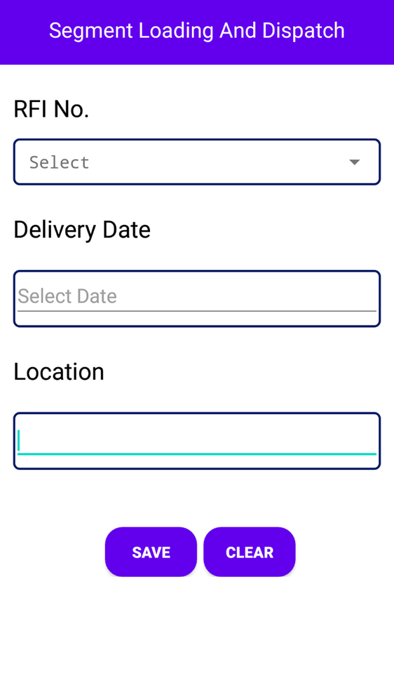

**Save Segment Loading and Dispatch Details**

1. Select the RFI Number from the dropdown list.
2. Enter the Delivery date or select from the date picker.
3. Enter the dispatch Location for segment in data fields.
4. Click on Save button, the details get saved in the database.

**Clear**

1. Click on Clear to clear the textfields and selections.

### Segment Delivery and Quality Inspection

This screen allows user to check the segment delivery and quality inspection for site location. To view this screen, click on Segment Delivery and Quality Inspection from device application’s main menu and following screen will be displayed:

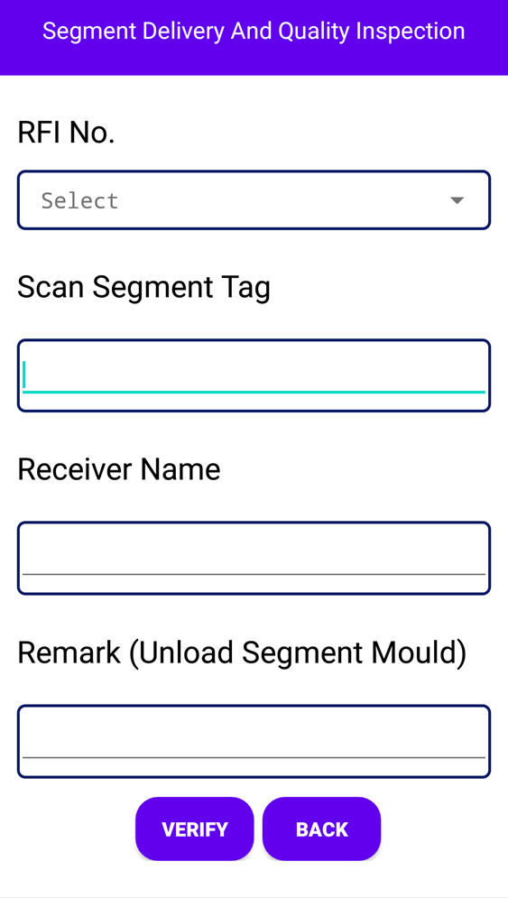

**Verify Segment details and Quality Verification**

1. Select the RFI Number from the dropdown list.
2. Scan the Segment Tag Id of the mould.
3. Enter the Receiver Name in the data field.
4. Enter the Remark if any in the data fields.
5. Click on Save button, the details get saved in the database.

**Clear**

1. Click on Clear to clear the textfields and selections.

### Site Installation

This screen allows check the segment installation at site location. To view this screen, click on Site Installation from device application’s main menu and following screen will be displayed:

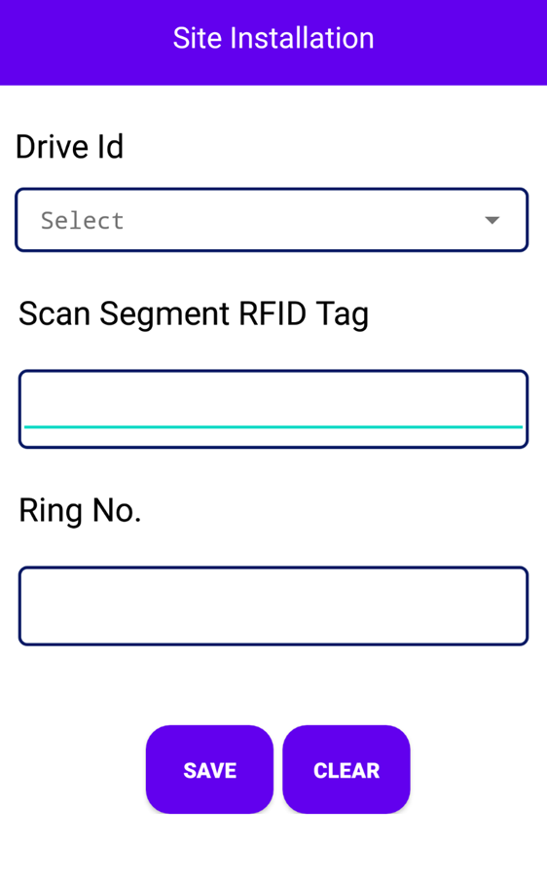

**Save Site Installation details**

1. Select the Drive Id (Location) from the dropdown list.
2. Scan the Segment RFID tag of the mould.
3. Enter the Ring Number in the data field.
4. Click on Save button, the details get saved in the database.

**Clear**

1. Click on Clear to clear the textfields and selections.

### Segment Rejection Data

This screen allows user to check the reject the segment in case of segment gets damaged. To view this screen, click on Segment Rejection Data from device application’s main menu and following screen will be displayed:

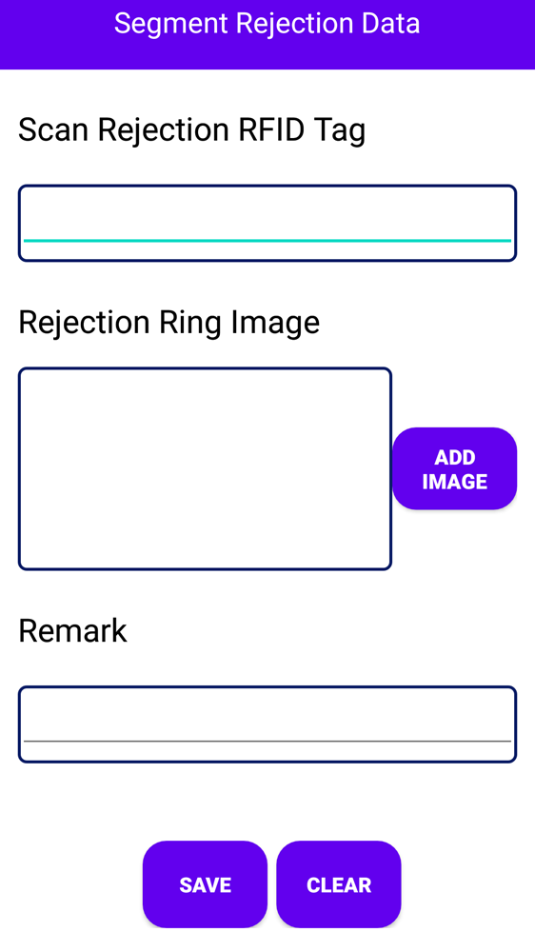

**Save Site Installation details**

1. Scan the Rejected RFID tag separately.
2. Add rejected segment image in the Add image field..
3. Enter the Remarks in the data field.
4. Click on Save button, the details get saved in the database.

**Clear**

1. Click on Clear to clear the textfields and selections.

### Logout

This button is used to logout the application and come back to the main application login page.

# Reports

End User Manual

[Company Name- Project Name]

Confidential & Copyright©2022