Item Level Warehouse Management



Trent Limited

Software Requirement Specification (SRS)

The document details the summary of solution architecture and approach for the development of Segment Management System for Tata Projects Limited. The document is based on the inputs, system study, discussions and meeting held between BCI & Trent Ltd. Teams.

**Prepared By: Omkar Gaonkar**

**Submission Date: 19-12-2022**

**Version: 1.3**

BAR CODE INDIA, 691 Udyog Vihar Phase V, Gurugram, Haryana-122016, PH: 0124 4337555

|  |  |  |  |  |
| --- | --- | --- | --- | --- |
| REVISION NO. | DATE | PREPARED BY | REVIEWED BY | COMMENT |
| 1.0 | 08-08-2022 | Omkar Gaonkar | Ashutosh Kroria | SRS Document for Segment Management System |
| 1.1 | 12-10-2022 | Omkar Gaonkar | Ashutosh Kroria | Changes in Masters and Warehouse functions as per mail from Client. |
| 1.2 | 16-11-2022 | Omkar Gaonkar | Suraj Raut Ashutosh Kroria | Changes in the Receiving material process |
| 1.3 | 19-12-2022 | Omkar Gaonkar | Suraj Raut Ashutosh Kroria | New module- Stock Take module for location.  Change in Receiving material screen and process |

REVISION HISTORY

**Abbreviations:**

|  |  |
| --- | --- |
| **Name** | **Abbreviation** |
| Bar Code India | BCI |
| Warehouse Management Server | WMS |
| Advance Shipping Note | ASN |
| License Plate Label Number | LPN |

Notice:

This document contains information, which is the proprietary property of Bar Code India. This document is received in confidence and its contents cannot be disclosed or copied without the prior written consent of Bar Code India.

Nothing in this document constitutes a guaranty, warranty, or license, express or implied. Bar Code India disclaims all liability for all such guaranties, warranties, and licenses, including but not limited to: Fitness for a particular purpose; merchantability; not infringement of intellectual property or other rights of any third party or of Bar Code India; indemnity; and all others. The reader is advised that third parties can have intellectual property rights that can be relevant to this document and the technologies discussed herein and are advised to seek the advice of competent legal counsel, without obligation of Bar Code India.

Bar Code India retains the right to make changes to this document at any time, without notice. Bar Code India makes no warranty for the use of this document and assumes no responsibility for any errors that can appear in the document nor does it make a commitment to update the information contained herein.

COPYRIGHT

Copyright © ***BCI*** 2022. All rights reserved.

TRADEMARKS

\*Other product and corporate names may be trademarks of other companies and are used only for explanation and to the owners' benefit, without intent to infringe.

Table of Contents

[1 Specification Organization 2](#_Toc122366027)

[2 Introduction 3](#_Toc122366028)

[2.1 Intended Audience and Reading Suggestions 3](#_Toc122366029)

[2.2 Project Scope 4](#_Toc122366030)

[3 Software/Hardware Requirements 5](#_Toc122366031)

[3.1 Computers 5](#_Toc122366032)

[4 Solution Architecture 6](#_Toc122366033)

[5 User Interface Specification Conventions 7](#_Toc122366034)

[6 System Log 8](#_Toc122366035)

[6.1 Error Logs 8](#_Toc122366036)

[6.2 Audit Logs 8](#_Toc122366037)

[7 Architectural Design 9](#_Toc122366038)

[7.1 Web Application 9](#_Toc122366039)

[7.2 Device Application 9](#_Toc122366040)

[7.3 Communication Server 9](#_Toc122366041)

[8 Application Modules 10](#_Toc122366042)

[8.1 Application Login- Web & Device Application 10](#_Toc122366043)

[8.2 User Management 11](#_Toc122366044)

[8.2.1 User Master 11](#_Toc122366045)

[8.2.2 User Rights/ Permission 12](#_Toc122366046)

[8.2.3 User Login 13](#_Toc122366047)

[8.3 Masters 15](#_Toc122366048)

[8.3.1 RFID Reader Master 15](#_Toc122366049)

[8.3.2 Article Master 15](#_Toc122366050)

[8.3.3 Warehouse Master 17](#_Toc122366051)

[8.3.4 Store Master 17](#_Toc122366052)

[8.4 Warehouse 19](#_Toc122366053)

[8.4.1 Receiving Material 19](#_Toc122366054)

[8.4.2 Tag recommissioning 24](#_Toc122366055)

[8.4.3 Dispatch to Store 26](#_Toc122366056)

[8.4.4 Inventory 28](#_Toc122366057)

[8.4.5 Stock Take 30](#_Toc122366058)

[9 SRS Scope Change Process 32](#_Toc122366059)

[9.1 Before Sign Off 32](#_Toc122366060)

[9.2 After Sign Off 32](#_Toc122366061)

[9.3 SRS Acceptance 32](#_Toc122366062)

# Specification Organization

The objective of this document is to supply underlying concepts, procedures, and formats used in the design, development and installation of this software application. This specification consists of three sections organized as follows:

**Section 1: Introduction**

This section provides hardware requirements and documentation conventions.

**Section 2: User Interface**

This section depicts screen design and logic flow, and is categorized into two groups:

* Application Master Module
* Common Routine

**Section 3: System Architecture**

This section provides information of system architecture.

# Introduction

## Intended Audience and Reading Suggestions

The scope of the software would require the development of the front-end application, client device application and communication server to transfer data from application to server. The document lays down the specifications of the middleware application, its architecture and infrastructure requirements.

The entire solution consists of followings:

1. Web Application

2. Communication Server Application

3. Mobile Device Application

## Project Scope

The project scope is to develop and implement and UHF passive RFID based solution with interface to WMS/SAP. The aim of the solution is to automate the process of handling and managing flow of apparel and other products within the Trent supply chain using passive RFID Technology.

The entire solution consists of followings:

* Web Application
* Mobile Device Application
* Communication Server Application

# Software/Hardware Requirements

Below are the hardware and the software requirements of the application:

## Computers

Desktop would require following specifications:-

* I5/i7 Processor with Windows 10 operating System
* 8 GB RAM
* 100GB HDD
* Dot net Framework 4.5

# Solution Architecture

# User Interface Specification Conventions

This section specifies the user interface portion of the application.

**Section Organization**

The User Interface Specification presents screen displays or “**Dialogs**”.

**Documentation Conventions**

This section incorporates illustrations of the application user interface. Each screen display “Dialog” consists of the screen display image, a process name, a paragraph documenting the processing required for the dialog, a paragraph listing the navigation options, and a table listing for each variable field on the dialog, its database source or destination, format, and any instructions required to process the field.

The following section contains a sample dialog with each area identified.

# System Log

System shall maintain internal logs for application.

## Error Logs

These logs will contain any errors encountered during runtime for faster resolution of any problem post deployment.

## Audit Logs

These logs will monitor the activities of user who accessed the application, made changes to File/ Document and the time stamp of these activities.

# Architectural Design

Overall System consists of:

* Web Application
* Device Application
* Communication Server

## Web Application

A Web Application will be developed for performing transactions like Master Creations such as RFID Reader Master, Article Master, Warehouse Master and Store Master Activities.

## Device Application

This application will include transactions including will directly communicate with user input and process the request to communication server.

## Communication Server

This application will handle the device request in real time. Most of business logic on scanning will run on this module.

# Application Modules

## Application Login- Web & Device Application

This login module will provide access to the application modules. Here the admin/user needs to enter the login detail to enter in the application and to perform the desired actions.



**Process:** User needs to enter the User Name/ID and Password in display fields and press the Login button. Application will validate the user credential.

*User will be able to view only those screens/ modules of which he has been given access rights to.*

**Validation**

* User Name/ ID will be unique for all users.
* User Name/ ID and Password length will be set.

After successful login application menu screen will appear; this screen will have the Master and Transaction options etc.

## User Management

The module will let application administrator to manage the Users, and the rights assigned to the same; the rights will define authorized application access of users.

The User Management & Master data will be created using **Web Application.**

### User Master

This module will let user to create application users who will access the application. The master will store the users’ details in system.

|  |  |
| --- | --- |
| **Data Fields** | 1. User ID 2. User Name 3. Description 4. Password 5. Email 6. Address 7. Contact 8. Active/ Inactive |
| **Process Steps** | 1. Enter required details i.e. User ID, User Name, Description, Password in system 2. Email, Address, Contact are optional data fields 3. Check the Active checkbox to make the user active 4. Click on Save button to save details in database 5. Newly added user will appear in data grid |
| **Functions** | 1. Add, Edit/Update, Delete as per requirement. 2. User ID and Password is used to access the application. |
| **Role** | Admin will create/ add user details via window application |
| **Sample Screen** |  |

### User Rights/ Permission

This module will let admin to assign module / screen access rights to the application users. Once assigned, authorized users can access the application. Once permissions are assigned, user will be able to view only those screens/ modules of which he has been given access rights to by Admin.

|  |  |
| --- | --- |
| **Data Fields** | 1. User ID/ Name 2. Module /Screen Names |
| **Process Steps** | 1. Admin will select User Name/ID. 2. Screen/ module names will appear in data grid along with checkbox. 3. Admin will check the checkbox against module/ screen to which selected User should be assigned access permissions. 4. Save and Update the details in database |
| **Functions** | Add, Edit/Update as per requirement |
| **Role** | Admin / Authorized User will assign access rights to the selected User |
| **Sample Screen** |  |

### User Login

This module will let users to login in to the application. Once assigned, authorized users can access the application. Once permissions are assigned, user will be able to view only those screens/ modules of which he has been given access rights to by Admin.

|  |  |
| --- | --- |
| **Data Fields** | 1. User Name 2. Password |
| **Process Steps** | 1. User will enter User Name/ID. 2. Enter the Password as per saved by user. 3. System will check the selected User is valid to login.   *\*User can click on forgot password incase don’t remember the password*   1. Click on Login button to enter the application. 2. The details gets updated in database. |
| **Functions** | Login into the application |
| **Role** | Admin / Authorized User will able to access the login |
| **Sample Screen** | **For Windows Application** |

|  |  |
| --- | --- |
| **Sample Screen** | **For Android Screen** |

## Masters

### RFID Reader Master

The module will be used to read the RFID tags that are slicked on merchandise.

|  |  |
| --- | --- |
| **Data Fields** | 1. Location 2. IP Address 3. Antenna Power |
| **Process Steps** | 1. Enter the Location. 2. Enter the IP address of the RFID tag. 3. The antenna power frequency will be displayed on screen. 4. Save the details in database. |
| **Functions** | 1. View details of the RFID tag details. 2. All master will be downloaded in XLS/XML file from WMS. |
| **Sample Screen** |  |

### Article Master

The module will be used to view the article details downloaded from WMS server.

|  |  |
| --- | --- |
| **Data Fields** | 1. Article Code 2. EAN Number 3. Description |
| **Process Steps** | 1. Enter the article code number. 2. Enter the EAN number in the box. 3. Enter the description of the article. 4. Save the details in the database. |
| **Functions** | 1. View details of the article number for items. 2. All master will be downloaded in XLS/XML file from WMS. |
| **Sample Screen** |  |
| **XML format** |  |

### Warehouse Master

This module will be used to save Location details in database and provide identification to them by unique RFID tag.

|  |  |
| --- | --- |
| **Data Fields** | 1. Warehouse ID 2. Warehouse Description 3. Is Active i.e. Zone is Active or Not |
| **Process Steps** | 1. User will enter Warehouse ID and Warehouse Description. 2. Select the Warehouse is Active or In-active. 3. Save the details in database. |
| **Functions** | 1. Add, edit/update and Delete Storage Location details as per requirement. 2. All master will be downloaded in XLS/XML file from WMS. |
| **Sample Screen** |  |

### Store Master

The module will be used to will be used to save the Store details in database.

|  |  |
| --- | --- |
| **Data Fields** | 1. Store ID 2. Store Description 3. Is Active i.e. Zone is Active or Not 4. POS details |
| **Process Steps** | 1. User will enter Store ID and store Description. 2. Select the Store is Active or In-active. 3. Enter the POS details. 4. Save the details in database. |
| **Functions** | 1. Add, Edit/Update, Delete as per requirement. 2. All master will be downloaded in XLS/XML file from WMS. |

|  |  |
| --- | --- |
| **Sample Screen** |  |

## Warehouse

### Receiving Material

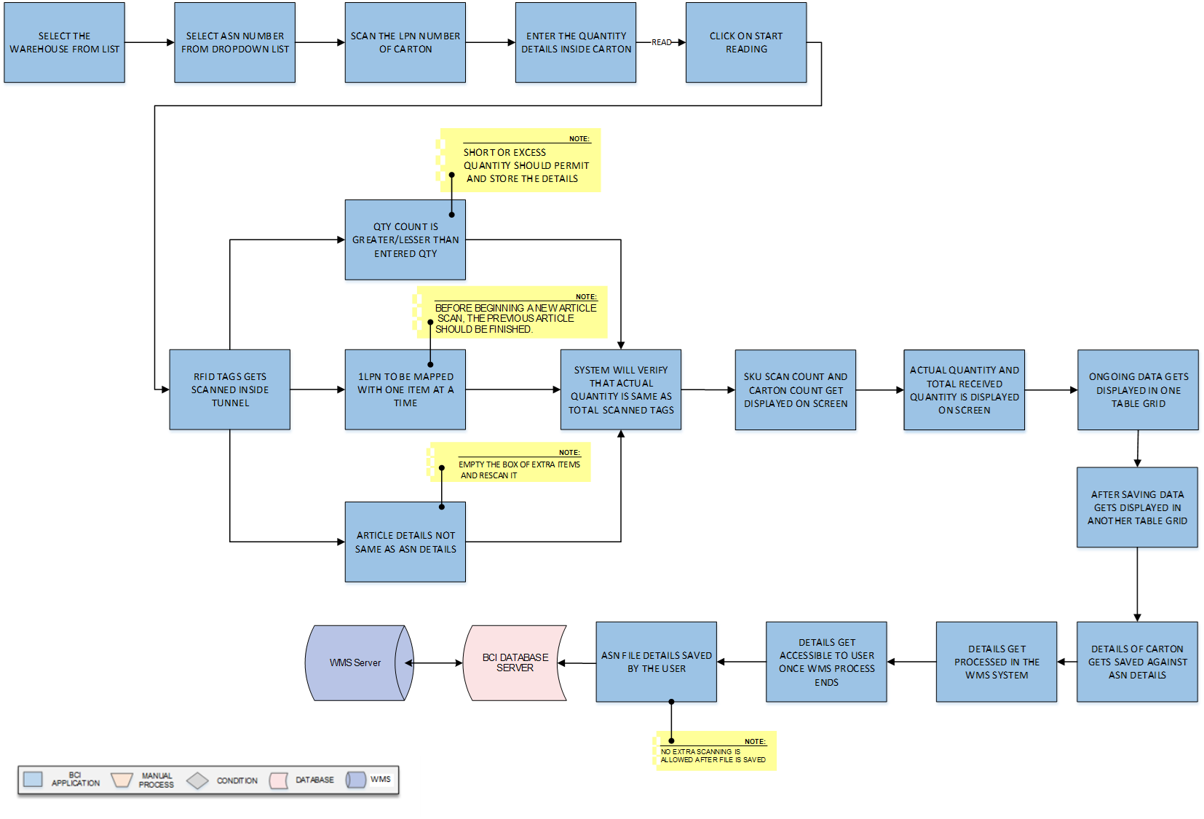

**Activities**

|  |  |
| --- | --- |
| **Module Description** | This module will be used to receive the item is through a tunnel that consist of RFID reader and antenna to check the Tags connected to the merchandiser. The carton consist of item has tag with quantity details on it and passed through the tunnel.  ***\*This activity will be done using Web Application.*** |

|  |  |
| --- | --- |
| **Pre-Conditions** | 1. Authorized access to the application. 2. For unique identification of carton the License Plate Number to be pasted on it. 3. Quantity details and ASN number to be downloaded from WMS system. 4. RFID reader and antenna are working properly. |

|  |  |
| --- | --- |
| **Process Steps** | 1. Select the ASN Number from the list.   *\*ASN number consist of LPN Number, Article, and Quantity.*   1. Scan the LPN number of the Carton. 2. Enter the Quantity details of item in the carton. 3. Click on ‘Start Reading’ to start the reading of material inside tunnel. 4. RFID tags gets scanned inside the carton through tunnel.   *\*RFID reader antenna is connected to the tunnel to read the tags.*   1. The reading count quantity gets displayed on the screen.   *\*Read count quantity gets validated with entered quantity.*   1. If quantity count is less or greater than entered quantity.   *\*Short or Excess Quantity should permit and store the details to the database on the "Box complete" button.*   1. If article is not as per the ASN details downloaded from WMS.   *\*Remove extra items from the box which are not in ASN and rescan it.*   1. One LPN should be mapped against one article, whichever article will be scanned first. 2. A Carton count get incremented after each box completion in data grid box. 3. The actual quantity and received quantity gets displayed on screen. 4. The two table grid displays the one on-going data and another displays the saved table data. 5. Click on the Save button, once quantity is validated with ASN quantity. 6. Details of the Carton gets saved against the ASN details. 7. Data gets saved to XML format and transferred to WMS system. 8. **ASN Close Process** 9. ASN close file gets details from the WMS.   *\*After WMS complete the process at its end.*   1. ASN gets permanently saved/closed.   *\*No extra scanning is allowed after file is saved.*   1. Information is saved in a database and kept in a WMS. |

|  |  |
| --- | --- |
| **Post-Conditions** | 1. Received item details will get saved in the database. 2. Extra item found in the Carton to be informed to vendor. 3. XML format to be checked and validated on WMS Server |

|  |  |
| --- | --- |
| **Validations** | 1. An alert should be displayed in case invalid ASN Number is selected. 2. An alert should be displayed in case RFID tag not scanned properly. 3. An alert should be displayed in case invalid quantity not matched with ASN details. 4. An alert message is displayed in case of any error / invalid activity. |

|  |  |
| --- | --- |
| **Remarks** | Add any remark (If needed). |

|  |  |
| --- | --- |
| **XML Formats** | 1. **Input file downloaded with ASN details.** |

|  |  |
| --- | --- |
| **Remarks** | 1. **Output file after ASN Scanning is Completed**      1. **ASN Close after file pushed and saved with no further Changes.** |

|  |  |
| --- | --- |
| **Sample Screen** | D:\Omkar\14_Trent\Input\Wireframes-stocktake\inbound.png |

### Tag recommissioning



|  |  |
| --- | --- |
| **Module Description** | This module will use to recommission the RFID tag in case of tag is damaged/misplaced in transit. |

|  |  |
| --- | --- |
| **Pre-Conditions** | Article (SKU) and EAP mapping  RFID Printer  Label design and other masters are required to generate the label. |

|  |  |
| --- | --- |
| **Process Steps** | 1. The user will receive the damaged or misplaced RFID tag article. 2. The user will select the SKU/Article code 3. Application will display the EAN detail. 4. Enter the quantity of Article. 5. Click on print button. 6. The system auto generate the RFID tag with barcoded information. 7. Information is saved in a database and kept in a WMS. |

|  |  |
| --- | --- |
| **Post-Conditions** | 1. Printed details will get saved in the database. |

|  |  |
| --- | --- |
| **Validations** | 1. Label serial number should not be duplicate |

|  |  |
| --- | --- |
| **Remarks** | Add any remark (If needed). |

|  |  |
| --- | --- |
| **Sample Screen** |  |

### Dispatch to Store

**Activities**

|  |  |
| --- | --- |
| **Module Description** | This module shows the process to pack and dispatch the article from the Warehouse to the Stores mentioned against the Purchase Order. |

|  |  |
| --- | --- |
| **Pre-Conditions** | Material should have MOLD ID tags.  Mold to be iron cased with tag attached to it. |

|  |  |
| --- | --- |
| **Process Steps** | 1. The user will receive the purchase order. 2. The user will select and pack the requested items into cartons. 3. Place the Cartons on the tunnel. 4. Scan the LP label before applying a fresh one. 5. Enter the quantity of the cartons. 6. Verify the details of Cartons through tunnel. 7. Through a tunnel, the article is checked against the Purchase Order. 8. The WMS Database Server stores details. 9. If the quantity obtained falls short of the purchase order. 10. Information about the pending quantity is sent to WMS. 11. The remaining quantity is used to generate the new PO. 12. The system auto generate the ASN number for it. 13. Information is saved in a database and kept in a WMS. |

|  |  |
| --- | --- |
| **Post-Conditions** | 1. Dispatch item details will get saved in the database.   Purchase Order details to be verified from Server. |

|  |  |
| --- | --- |
| **Validations** | 1. An alert should be displayed, if quantity is more than Purchase Order. 2. An alert should be displayed in case of Pending quantity. 3. Details of Pending quantity will be sent to WMS server for new ASN creation. 4. An alert message is displayed in case of any error / invalid activity. |

|  |  |
| --- | --- |
| **Remarks** | Add any remark (If needed). |

### Inventory

**Activities**

|  |  |
| --- | --- |
| **Module Description** | This module will be used to count the Inventory stored in the warehouse. The inventory can be segregated and counted based on whole count or on article wise count. |

|  |  |
| --- | --- |
| **Pre-Conditions** | Inventory material stock count to be downloaded on system.  RFID hand machine to be properly scanning the tags of stocks. |

|  |  |
| --- | --- |
| **Process Steps** | Select the Inventory task.  Select the task ID on RFID reader machine.  Use the location ID to scan the area where the stock is situated.  Physically scan the warehouse's stock with an RFID device.  Each stock count results in an increase in the scan count.  Check the stock details in the system against the stock count.  If there is a difference between the system count and the real count.  *\*Recheck the Stock tags and make a report for same.*  Conciliated report would be made for it.  The warehouse's whole stock can be checked, and the inventory can be verified.  Users can also check stocks by article if they choose.  Information is saved in a database and kept in a WMS. |

|  |  |
| --- | --- |
| **Post-Conditions** | Inventory stocks to be verified by the person physically.  Auto-data updating on server in real time. |
| **Validations** | 1. An alert should be displayed in incase article tags are not scanned. 2. An alert message is displayed in case of any error / invalid activity. |

|  |  |
| --- | --- |
| **Remarks** | Add any remark (If needed). |

### Stock Take

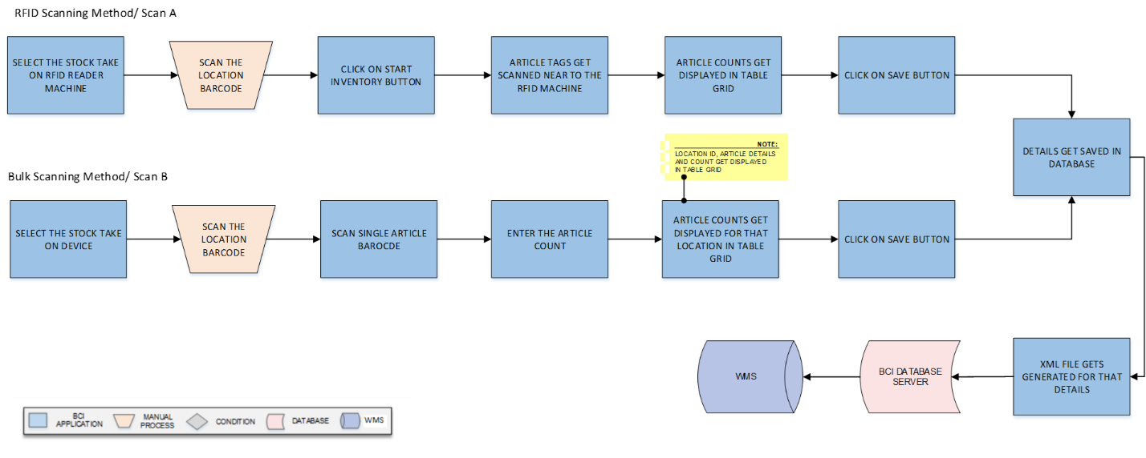

**Activities**

|  |  |
| --- | --- |
| **Module Description** | This module will be used to count the stock by the use of RFID Scanning and Bulk scanning at locations in the warehouse. The inventory can be segregated and counted based on scanner used for count.  ***\*It will be used for Android Application.*** |

|  |  |
| --- | --- |
| **Pre-Conditions** | HHT machine to be properly working with the system.  RFID hand machine to be properly scanning the tags of stocks. |

|  |  |
| --- | --- |
| **Process Steps** | **RFID Scanning Method (Scan A)**  Scan location barcode to scan the area where the stock is situated.  Click on Start Inventory button.  Article tags gets scanned near to the RFID reader machine.  The article counts get displayed in the table grid below.  Click on Save button, once scanning is completed.  The stock count gets incremented for that location.  The XML file will be generated for the following details.  Information is saved in a database and kept in a WMS.  **Bulk Scanning (Scan B)**  Scan location barcode to scan the area where the stock is situated.  Scan single Article barcode by use of machine.  Enter the Article Count in the data grid.  The article counts get displayed for that location in the table grid.  *\*The Location, Article details and Count get displayed in table grid.*  Click on Add button (Optional field).  *\*To add more article details and count for the location.*  Click on Save button, to save details in a database and kept in a WMS.   1. The XML file will be generated for the following details.   Click on Clear button, to clear the data in the data fields. |

|  |  |
| --- | --- |
| **Post-Conditions** | RFID Machine scanned data to be verified by the user.  Stocks to be verified by the person physically.  Auto-data updating on server in real time. |

|  |  |
| --- | --- |
| **Validations** | 1. An alert should be displayed in incase article tags are not scanned. 2. An alert message is displayed in case of any error / invalid activity. |

|  |  |
| --- | --- |
| **Remarks** | Add any remark (If needed). |

|  |  |
| --- | --- |
| **Sample Screen** | **RFID Tag Scanning/ Scan A** **Bulk Scanning/ Scan B** |

# SRS Scope Change Process

## Before Sign Off

Any changes in SRS need to be informed in writing by Trent Limited Ltd. It will be incorporated / confirmed only after doing detailed feasibility study by BCI.

* If any change is out of scope then this would be done as a CR post feasibility and priority will be decided based on mutual agreement.
* Once the change is developed , any further change in the same would be considered as a CR

## After Sign Off

Any changes in proposed solution after approval of this document by Trent Ltd. are subjected to confirmation from BCI, taking feasibility constraints into account. These changes will be incorporated (if any) into the solution only after delivering proposed solution & may be charged as extra.

* Any change in the proposed solution due to customer system design or process will be considered as CR
* Any process which is not mentioned in this document will not be considered as “mutual understanding or default presence or standard practice”.

The changes in proposed solution before & after acceptance will be mutually agreed and duly signed and accepted by Trent Ltd. & BCI.

## SRS Acceptance

|  |  |
| --- | --- |
| **For Trent Limited** | **For Bar Code India (BCI)** |
| **Name:** | **Name:** |
| **Designation:** | **Designation:** |
| **Department:** | **Department:** |

Agreed and Accepted by Trent Ltd. and Bar Code India