Department of Computing
CS-344: Web Engineering

Lab 14: Book Dashboard App
State Management & Context in React

Class: BESE-14AB
Date: 18.12.25
Instructor: Ms. Naema Asif

Student Name: Ammer Saeed
Registration No.: 466445
Section: BESE-14B

December 23, 2025

Introduction
This lab explores advanced React concepts focusing on state management with objects and arrays, and implementing global state using the Context API. The project builds a comprehensive Book Dashboard application that demonstrates real-world state manage- ment patterns.

Section 1: State with Objects

Concept Overview
In React, when managing object state, we must update it immutably. This means creating a new object rather than modifying the existing one. The spread operator (...) helps achieve this.

Profile Editor Component
The Profile Editor demonstrates how to manage an object containing multiple properties (name and age) and update them independently.
import React , { use State } from ’ react ’;
function Profile Editor () {
// Initialize state with an object
const [ profile , setProfile ] = use State ({ name : ’ John Doe ’,
age: 25
});
// Update name while preserving other properties
const handle Name Change =
setProfile ({
... profile ,
name : e. target. value
});
};
( e)
=> {
//
//
Copy existing properties
Update only name
// Update age while preserving other properties
const handle Age Change =
setProfile ({
... profile ,
age: e. target. value
});
};
( e)
=> {
//
//
Copy existing properties
Update only age
return (
<div >
<h2 > Profile Editor </ h2 >
<input
type =" text" value ={ profile . name } on Change ={ handle Name Change }
/ >
<input
type =" number"
1
2
3
4
5
6
7
8
9
10
11
12
13
14
15
16
17
18
19
20
21
22
23
24
25
26
27
28
29
30
31
32
33
34
35

36
value ={ profile . age }
on Change ={ handle Age Change }
/ >
</ div >
);
}
37
38
39
40
41

Listing 1: ProfileEditor Component

Key Takeaways
- The spread operator creates a shallow copy of the object
- Only the specified property is updated
- React detects the new object reference and triggers a re-render
- This pattern prevents accidental property loss

Section 2: Arrays of Objects

Concept Overview
Managing arrays of objects requires careful handling to maintain immutability. Common operations include adding, removing, and updating items using array methods like map(), filter(), and the spread operator.

Todo List Component
The Todo List component demonstrates full CRUD operations on an array of todo objects.
function Todo List () {
const [ todos , setTodos] = use State ([
{ id: 1 , title : ’ Learn React ’, completed : false }
]);
const [ newTodo , setNew Todo ] = use State (’’);
// Add new todo with unique ID const handle Add Todo = ( e) => {
e. preventDefault ();
const new Todo Item =
id: Date . now (), title : newTodo , completed : false
};
{
// Generate unique ID
// Create new array
setTodos ([... todos ,
setNew Todo (’’);
with existing and new
new Todo Item ]);
// Clear input
item
};
// Rest of component ...
1
2
3
4
5
6
7
8
9
10
11
12
13
14
15
16
17
18
19
20
21
22
23

24
}

Listing 2: Todo List - Adding Items

1
// Delete todo by filtering out the item with matching ID const handle Delete Todo = ( id) => {
setTodos( todos. filter( todo => todo . id !== id));
};
2
3
4

Listing 3: Todo List - Deleting Items

1  2  3 | // Toggle completed status  const handle Toggle Complete = ( id) => {  setTodos( todos. map ( todo =>
4 | todo . id === id
5 |  | ? { ... todo , completed : ! todo . completed }
6 |  | : todo
7 | ));
8 | };
 |  | Listing 4: Todo List - Updating Items

Key Array Operations
- Add: Use spread operator to create new array with added item
- Delete: Use filter() to create array without the item
- Update: Use map() to create array with updated item
- Unique IDs: Use Date.now() for simple unique identifiers

Section 3: Global State with Context

Concept Overview
React Context solves the ”prop drilling” problem by providing a way to share state across the entire component tree without passing props through every level.

Role Context Implementation

1
import React , { create Context , useContext , use State } from ’ react ’;
// Create context
const Role Context = create Context ();
// Custom hook for easy access export const use Role = () => {
const context = use Context( Role Context); if (! context) {
throw new Error(’ use Role must be used within RoleProvider ’);
}
return context;
};
2
3
4
5
6
7
8
9
10
11
12
13

14  15  16  17  18  19  20  21  22 | // Provider component  export const Role Provider = ({ children }) => { const [ role , setRole ] = use State (’ user ’);  const toggle Role = () => { setRole ( prevRole =>  prevRole === ’ user ’ ? ’ admin ’ : ’ user ’  );
23 | };
24
25 | co | nst value = {
26 |  | role ,
27 |  | toggleRole ,
28 |  | isAdmin : role === ’ admin ’,
29 |  | isUser: role === ’ user ’
30 | };
31
32 | re | turn (
33 |  | <Role Context. Provider value ={ value } >
34 |  | { children }
35 |  | </ Role Context. Provider >
36 | );
37 | };
 |  | Listing 5: Creating Role Context

Using Context in Components

1
function BookCard ({ book , onEdit , on Delete }) {
// Access context anywhere in the tree const { isAdmin } = use Role ();
return (
<div className =" card " >
<h3 >{ book. title } </ h3 >
<p >{ book. author } </p>
{/* Conditional rendering based on role */}
{ isAdmin &&
<div >
<button
<button
</ div >
)}
</ div >
(
on Click ={() => on Edit( book)} >Edit </ button >
on Click ={() => on Delete ( book. id)} >Delete </ button >
);
}
2
3
4
5
6
7
8
9
10
11
12
13
14
15
16
17
18
19

Listing 6: Role-Based Rendering

Context Benefits
- Eliminates prop drilling through multiple component levels
- Centralized state management

- Easy to add new consumers
- Clean component interfaces

Final Project: Book Dashboard

Project Overview
The Book Dashboard combines all learned concepts into a complete application with full CRUD functionality, role-based access control, and search capabilities.

Main Features

Book Management
      - Display books in a responsive grid
      - Add new books (Admin only)
      - Edit existing books (Admin only)
      - Delete books with confirmation (Admin only)
      - Search books by title or author

Role-Based Access
      - Admin Role: Full CRUD access with visible action buttons
      - User Role: Read-only access, no action buttons shown
      - Global role switcher accessible from any component

Dashboard Implementation

1
function BookDashboard () {
const { isAdmin } = use Role ();
const [ books , setBooks] = use State ([
{ id: 1 , title : ’ The Great Gatsby ’,
author: ’F. Scott Fitzgerald ’, year: 1925 }
]);
const [ search Term , setSearch Term ] = use State (’’);
// Add book
const handle Add Book = ( new Book ) => { const bookWith Id = {
... newBook ,
id: Date . now ()
};
setBooks ([... books , bookWith Id ]);
};
2
3
4
5
6
7
8
9
10
11
12
13
14
15
16
17
18
19

20
// Delete book
const handle Delete Book = ( id) => { setBooks( books. filter( book => book. id !== id));
};
// Update book
const handle Save Edit = ( updated Book ) => { setBooks( books. map ( book =>
book. id === updated Book . id ? updated Book : book
));
};
// Filter books
const filtered Books = books. filter( book => book. title . to LowerCase (). includes( search Term . to LowerCase ()) || book. author. to LowerCase (). includes( search Term . to LowerCase ())
);
return (
<div >
<input
type =" text" value ={ search Term }
on Change ={( e) => setSearch Term ( e. target. value )} placeholder =" Search books ..."
/ >
{ isAdmin && (
<button on Click ={ handle Add Book } >Add Book </ button >
)}
{ filtered Books . map ( book => (
<BookCard key ={ book. id} book ={ book}
on Edit ={ handle EditBook } on Delete ={ handle Delete Book }
/ >
))}
</ div >
);
}
21
22
23
24
25
26
27
28
29
30
31
32
33
34
35
36
37
38
39
40
41
42
43
44
45
46
47
48
49
50
51
52
53
54
55
56
57
58
59
60
61

Listing 7: Book Dashboard Core Logic

Design Implementation

Color Scheme
The application uses a dark theme with pink accents as specified:
- Primary Color: Dark Light Pink (#FF69B4)
- Background: Dark Navy (#1a1a2e)
- Surface: Dark Blue (#16213e)

- Text: White/Light Gray

CSS Variables

1
: root {
-- primary - color: # FF69B 4 ;
-- primary - light: # FFB 6D 9 ;
-- primary - dark: # C 71585 ;
-- background : #1 a1a2e ;
-- surface : #16213 e;
-- text - primary : # ffffff;
-- border: #0 f3460 ;
}
button {
background - color: var(-- primary - color); color: white ;
border: none ; padding : 10 px 20 px; border - radius: 8 px;
transition : all 0.3 s ease ;
}
button : hover {
background - color: var(-- primary - dark); transform : translate Y (-2 px);
}
2
3
4
5
6
7
8
9
10
11
12
13
14
15
16
17
18
19
20
21
22
23

Listing 8: CSS Color Variables

Key Concepts Summary

Why Use the Spread Operator?
The spread operator is essential for maintaining immutability in React:
- Immutability: Creates new references, allowing React to detect changes
- Prevents Bugs: Avoids accidental mutations of existing state
- Performance: Enables React’s optimization through reference comparison
- Predictability: Makes state updates explicit and traceable

Problems Context Solves
- Prop Drilling: Eliminates passing props through multiple levels
- Code Duplication: Centralized state reduces redundant code
- Maintainability: Changes to shared state in one place
- Component Coupling: Reduces dependencies between parent-child components

Benefits of Component Splitting
- Reusability: Components can be used in multiple places
- Testability: Smaller components are easier to test
- Readability: Clear separation of concerns
- Maintainability: Changes isolated to specific components

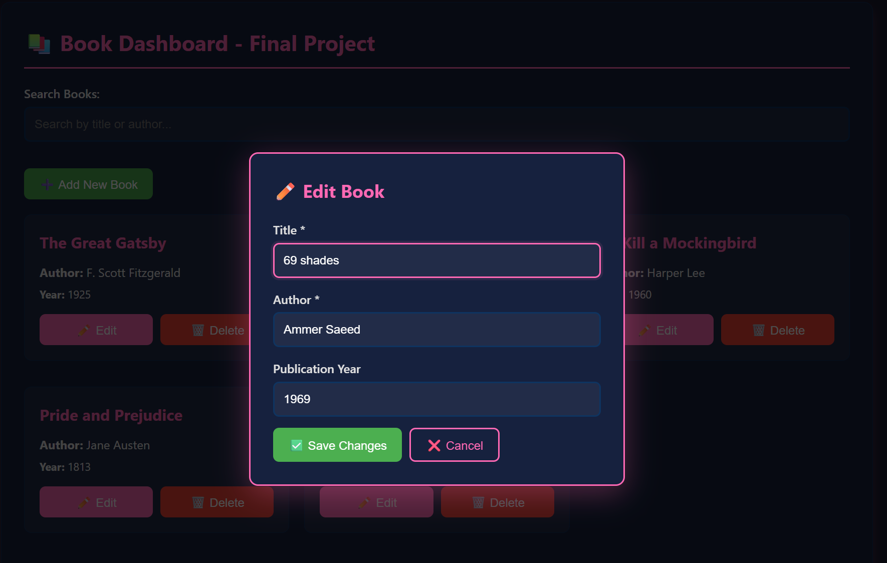

s

