**Class: TYIT Sem: V Roll No.: TYIT10 Date :**

**Course Name : Enterprise Java**

Q.Create a registration servlet in Java using JDBC Index.html

<html>

<head>

<title>TODO supply a title</title>

<meta charset="UTF-8">

<meta name="viewport" content="width=device-width, initial-scale=1.0">

</head>

<center>

<style> body {

background-image: url('https://th.bing.com/th/id/OIP.C- mPq2dSnmE3CuK7AUXEngHaEK?pid=ImgDet&rs=1');

background-repeat: no-repeat; background-attachment: fixed; background-size: cover;

}

</style>

<form action="NewServlet" method="get">

<table>

<h1>REGISTRATION FORM</h1>

<div>

Name:<input type="text" name="t1"><br>

Email Address:<input type="text" name="t2"><br> Phone number:<input type="text" name="t3"><br>

**Class: TYIT Sem: V Roll No.: TYIT10 Date :**

**Course Name : Enterprise Java**

Gender:

Male<input type="radio" name="g" value="male">

Female<input type="radio" name="g" value="female"><br> Date of birth:<input type="date" name="dob"><br>

Hobbies:

Dancing<input type=checkbox value="dancing" name="h"> Drawing<input type=checkbox value="drawing" name="h"> Singing<input type=checkbox value="singing" name="h">

Swimming<input type=checkbox value="swimming" name="h"><br>

<select name="City" id="City">

<option value="City" >City</option>

<option value="virar" >virar</option>

<option value="andheri" >andheri</option>

<option value="bhayandar" >bhayandar</option>

</select>

<br>

<input type="submit">

</center>

</table>

</form>

</div>

</body>

</html>

**Class: TYIT Sem: V Roll No.: TYIT10 Date :**

**Course Name : Enterprise Java**

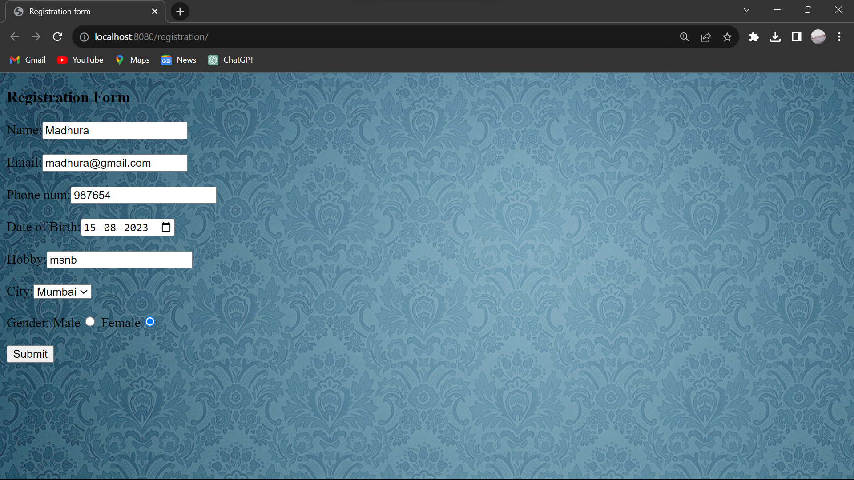

Servlet

import java.io.IOException; import java.io.PrintWriter; import java.sql.Connection;

import java.sql.DriverManager; import java.sql.SQLException;

import java.sql.Statement;

import java.util.logging.Level;

import java.util.logging.Logger;

import javax.servlet.ServletException;

import javax.servlet.annotation.WebServlet; import javax.servlet.http.HttpServlet;

**Class: TYIT Sem: V Roll No.: TYIT10 Date :**

**Course Name : Enterprise Java**

import javax.servlet.http.HttpServletRequest;

import javax.servlet.http.HttpServletResponse;

/**

*

* @author LAB01-PC18

*/

@WebServlet(urlPatterns = {"/NewServlet"}) public class NewServlet extends HttpServlet {

/**

* Processes requests for both HTTP <code>GET</code> and <code>POST</code>
* methods.

*

* @param request servlet request
* @param response servlet response
* @throws ServletException if a servlet-specific error occurs
* @throws IOException if an I/O error occurs

*/

protected void processRequest(HttpServletRequest request, HttpServletResponse response)

throws ServletException, IOException {

response.setContentType("text/html;charset=UTF-8"); try (PrintWriter out = response.getWriter()) {

/* TODO output your page here. You may use following sample code. */ out.println("<!DOCTYPE html>");

**Class: TYIT Sem: V Roll No.: TYIT10 Date :**

**Course Name : Enterprise Java**

out.println("<html>"); out.println("<head>");

out.println("<title>Servlet NewServlet</title>"); out.println("</head>");

out.println("<body>");

String a=request.getParameter("t1"); String b=request.getParameter("t2");

int c=Integer.parseInt(request.getParameter("t3"));

String e=request.getParameter("dob"); String h=request.getParameter("h"); String i=request.getParameter("City"); String f=request.getParameter("g");

out.println("<h1>Your name is ="+ a +"</h1>"); out.println("<h1>Your email id is="+ b +"</h1>");

out.println("<h1>Your phone number id is="+ c +"</h1>"); out.println("<h1>Your date of birth is="+ e +"</h1>");

out.println("<h1>Your hobbies are="+ h +"</h1>"); out.println("<h1>Your city is="+ i +"</h1>");

out.println("<h1>Your gender is="+ f +"</h1>");

Connection con=DriverManager.getConnection("jdbc:derby://localhost:1527/reg", "reg", "reg");

**Class: TYIT Sem: V Roll No.: TYIT10 Date :**

**Course Name : Enterprise Java**

out.println("<h1>Connected</h1>");

String sql="insert into reg values ('"+a+"','"+b+"',"+ c +",'"+e+"','"+h+"','"+i+"','"+f+"')"; out.println("<h1>Query line="+ sql +"</h1>");

Statement stmt=con.createStatement(); stmt.executeUpdate(sql);

out.println("<h1>Sucessfully added</h1>");

out.println("</body>"); out.println("</html>");

} catch (SQLException ex) {

Logger.getLogger(NewServlet.class.getName()).log(Level.SEVERE, null, ex);

}

}

// <editor-fold defaultstate="collapsed" desc="HttpServlet methods. Click on the + sign on the left to edit the code.">

/**

* Handles the HTTP <code>GET</code> method.

*

* @param request servlet request
* @param response servlet response
* @throws ServletException if a servlet-specific error occurs
* @throws IOException if an I/O error occurs

*/

**Class: TYIT Sem: V Roll No.: TYIT10 Date :**

**Course Name : Enterprise Java**

@Override

protected void doGet(HttpServletRequest request, HttpServletResponse response) throws ServletException, IOException {

processRequest(request, response);

}

/**

* Handles the HTTP <code>POST</code> method.

*

* @param request servlet request
* @param response servlet response
* @throws ServletException if a servlet-specific error occurs
* @throws IOException if an I/O error occurs

*/

@Override

protected void doPost(HttpServletRequest request, HttpServletResponse response)

throws ServletException, IOException { processRequest(request, response);

}

/**

* Returns a short description of the servlet.

*

* @return a String containing servlet description

*/

**Class: TYIT Sem: V Roll No.: TYIT10 Date :**

**Course Name : Enterprise Java**

@Override

public String getServletInfo() { return "Short description";

}// </editor-fold>

}

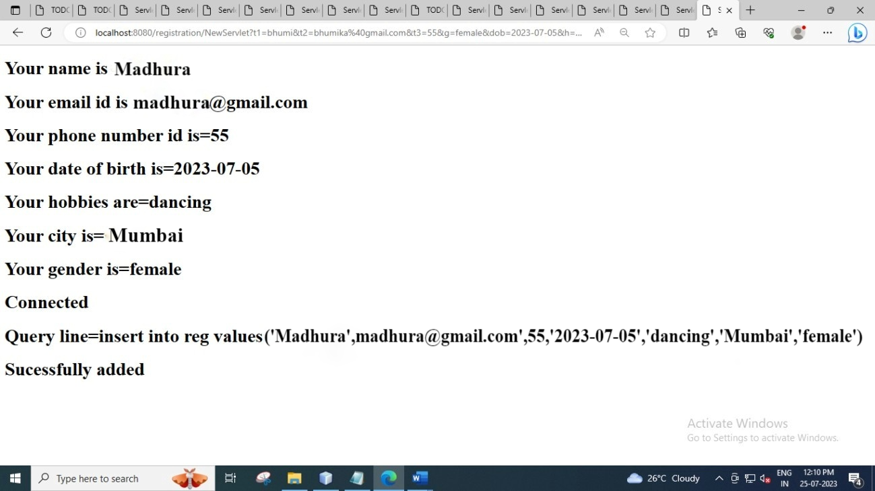

**Class: TYIT Sem: V Roll No.: TYIT10 Date :**

**Course Name : Enterprise Java**

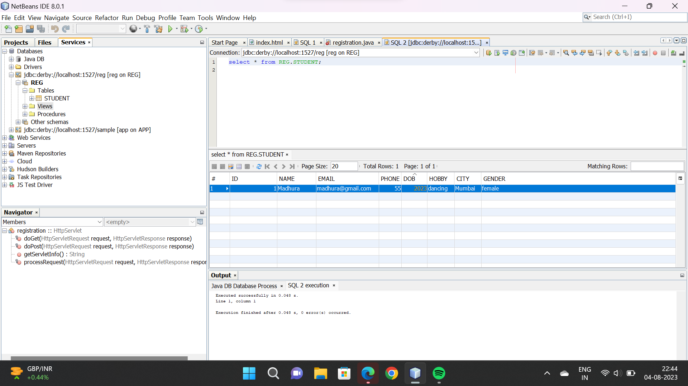

**Class: TYIT Sem: V Roll No.: TYIT10 Date :**

**Course Name : Enterprise Java**

Q.Perform the practical using prepared statement to update the record of the table. Index.html

<html>

<head>

<title>TODO supply a title</title>

<meta charset="UTF-8">

<meta name="viewport" content="width=device-width, initial-scale=1.0">

</head>

<body>

<form method="post" action="yt">

<h1>UPDATE THE TABLE STUDENT USING PREPARED STATEMENT</h1>

Id:<input type="text" name="t1" >

Name:<input type="text" name="t2" >

<input type="submit" value="UPDATE">

</body>

</html>

Servlet:

import java.io.IOException; import java.io.PrintWriter; import java.sql.Connection;

import java.sql.DriverManager;

import java.sql.PreparedStatement; import java.sql.SQLException;

**Class: TYIT Sem: V Roll No.: TYIT10 Date :**

**Course Name : Enterprise Java**

import java.util.logging.Level;

import java.util.logging.Logger;

import javax.servlet.ServletException;

import javax.servlet.annotation.WebServlet; import javax.servlet.http.HttpServlet;

import javax.servlet.http.HttpServletRequest;

import javax.servlet.http.HttpServletResponse;

/**

*

* @author LAB01-PC18

*/

@WebServlet(urlPatterns = {"/yt"}) public class yt extends HttpServlet {

/**

* Processes requests for both HTTP <code>GET</code> and <code>POST</code>
* methods.

*

* @param request servlet request
* @param response servlet response
* @throws ServletException if a servlet-specific error occurs
* @throws IOException if an I/O error occurs

*/

protected void processRequest(HttpServletRequest request, HttpServletResponse response)

**Class: TYIT Sem: V Roll No.: TYIT10 Date :**

**Course Name : Enterprise Java**

throws ServletException, IOException {

response.setContentType("text/html;charset=UTF-8"); in try (PrintWriter out = response.getWriter()) {

/* TODO output your page here. You may use following sample code. */ out.println("<!DOCTYPE html>");

out.println("<html>"); out.println("<head>");

out.println("<title>Servlet yt</title>"); out.println("</head>");

out.println("<body>");

int Id=Integer.parseInt(request.getParameter("t1")); String Name=request.getParameter("t2");

Connection con=DriverManager.getConnection("jdbc:derby://localhost:1527/yt", "yt", "yt");

//out.println("<h1>Connected</h1>");

PreparedStatement pstmt = con.prepareStatement("update yt set name= ? where id=

?");

pstmt.setString(1, Name); pstmt.setInt(2, Id);

int ans=pstmt.executeUpdate(); if(ans==1)

{

out.println("<h1>record updated</h1>");

**Class: TYIT Sem: V Roll No.: TYIT10 Date :**

**Course Name : Enterprise Java**

}

else

{

out.println("<h1>not updated</h1>");

}

out.println("<h1>Connected</h1>"); out.println("</body>");

out.println("</html>");

} catch (SQLException ex) {

Logger.getLogger(yt.class.getName()).log(Level.SEVERE, null, ex);

}

}

// <editor-fold defaultstate="collapsed" desc="HttpServlet methods. Click on the + sign on the left to edit the code.">

/**

* Handles the HTTP <code>GET</code> method.

*

* @param request servlet request
* @param response servlet response
* @throws ServletException if a servlet-specific error occurs
* @throws IOException if an I/O error occurs

*/

@Override

protected void doGet(HttpServletRequest request, HttpServletResponse response) throws ServletException, IOException {

**Class: TYIT Sem: V Roll No.: TYIT10 Date :**

**Course Name : Enterprise Java**

processRequest(request, response);

}

/**

* Handles the HTTP <code>POST</code> method.

*

* @param request servlet request
* @param response servlet response
* @throws ServletException if a servlet-specific error occurs
* @throws IOException if an I/O error occurs

*/

@Override

protected void doPost(HttpServletRequest request, HttpServletResponse response) throws ServletException, IOException {

processRequest(request, response);

}

/**

* Returns a short description of the servlet.

*

* @return a String containing servlet description

*/

@Override

public String getServletInfo() { return "Short description";

**Class: TYIT Sem: V Roll No.: TYIT10 Date :**

**Course Name : Enterprise Java**

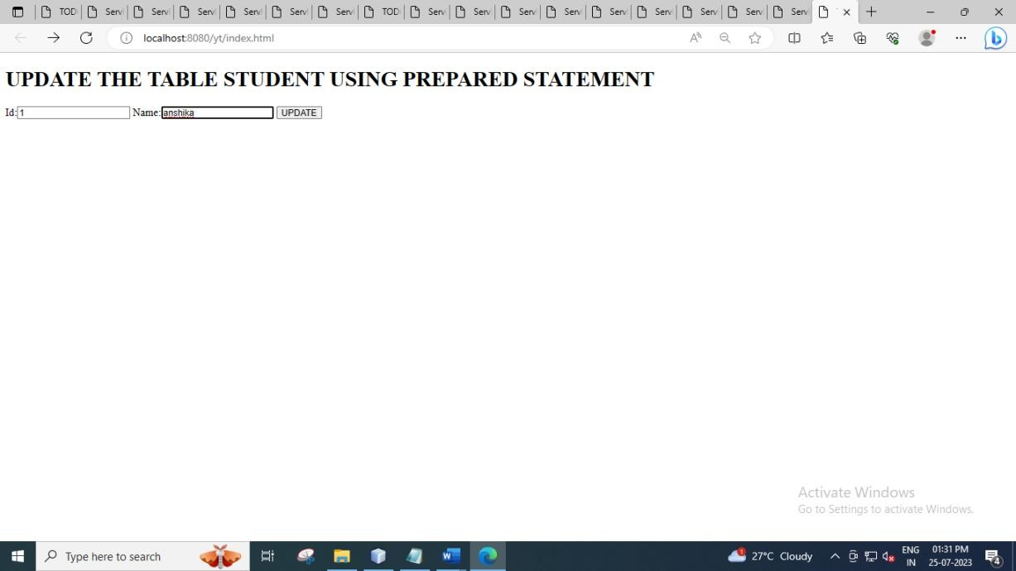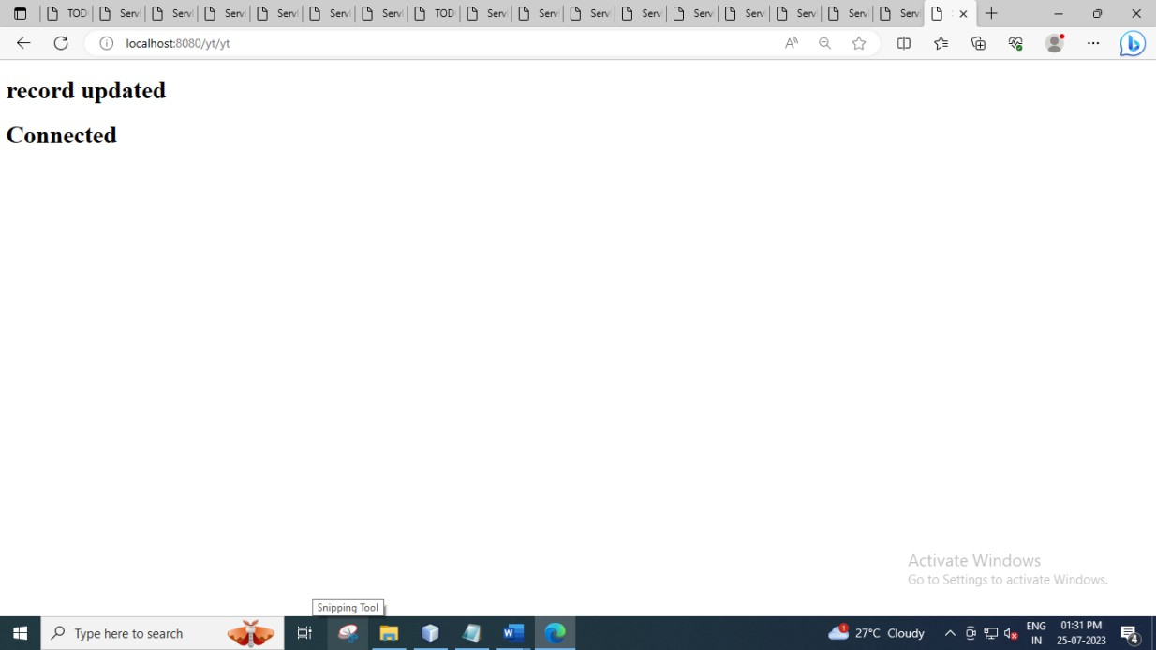

**Class: TYIT Sem: V Roll No.: TYIT10 Date :**

**Course Name : Enterprise Java**

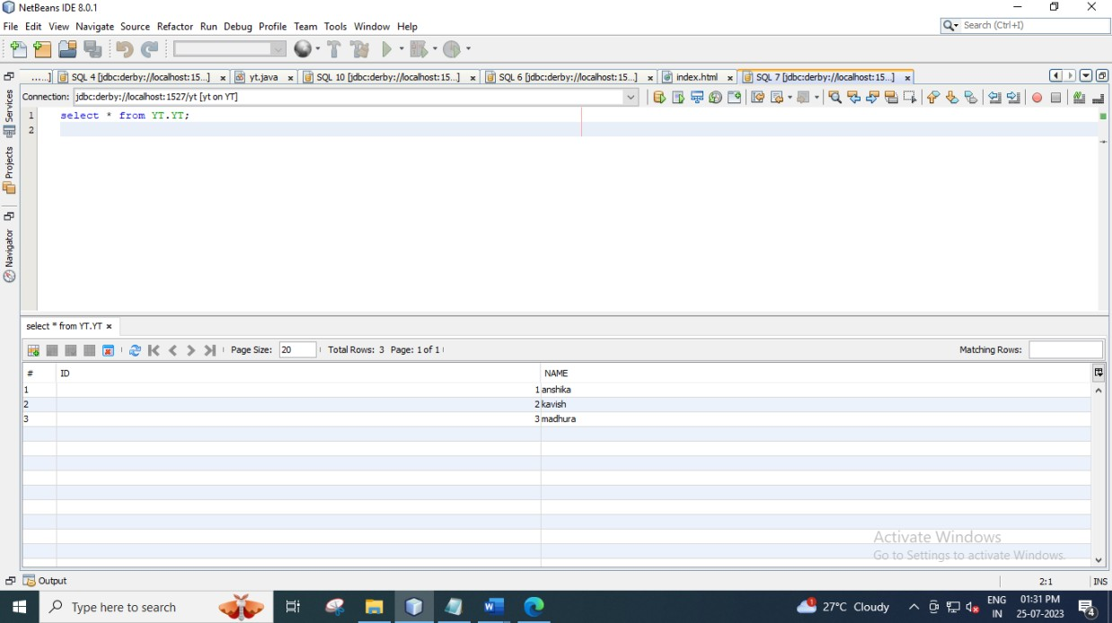

**Class: TYIT Sem: V Roll No.: TYIT10 Date :**

**Course Name : Enterprise Java**

q.) Using Resultset to display the database records into the table :

**SERVLET CODE :**

import java.io.IOException;

import java.io.PrintWriter;

import java.sql.Connection;

import java.sql.DriverManager;

import java.sql.ResultSet;

import java.sql.SQLException;

import java.util.logging.Level;

import java.util.logging.Logger;

import javax.servlet.ServletException;

import javax.servlet.annotation.WebServlet;

import javax.servlet.http.HttpServlet;

import javax.servlet.http.HttpServletRequest;

import javax.servlet.http.HttpServletResponse;

@WebServlet(urlPatterns = {"/result"})

public class result extends HttpServlet {

protected void processRequest(HttpServletRequest request, HttpServletResponse response)

throws ServletException, IOException, SQLException {

response.setContentType("text/html;charset=UTF-8");

try (PrintWriter out = response.getWriter()) {

out.println("<!DOCTYPE html>");

out.println("<html>");

out.println("<head>");

out.println("<title>Servlet result</title>");

out.println("</head>");

out.println("<body>");

Connection cn = DriverManager.getConnection("jdbc:derby://localhost:1527/tyit","tyit","tyit");

out.println("connected");

java.sql.Statement ob = cn.createStatement();

out.println("<TABLE border=5 ALIGN=CENTER >\n");

out.println("<TR BGCOLOR=\"FFAD00\">\n");

out.println("<TH>Firstname<TH>lastname<th>emaild<th>password<th>gender<th>hobbies<th>state<t

**Class: TYIT Sem: V Roll No.: TYIT10 Date :**

**Course Name : Enterprise Java**

h>dateofbirth\n");

ResultSet rs = ob.executeQuery(" select * from tyit");

while(rs.next())

{

String x = rs.getString(1);

String y = rs.getString("lastname");

String z= rs.getString("emailid");

String az = rs.getString("password");

String ax = rs.getString("gender");

String ac= rs.getString("hobbies");

String av= rs.getString("state");

String ab = rs.getString("dateofbirth");

out.println("<TR>\n");

out.println("<TD>"+x+"<TD>"+y+"\n");

out.println("<TD>"+z+"<TD>"+az+"\n");

out.println("<TD>"+ax+"<TD>" + ac+"\n");

out.println("<TD>"+av+"<TD>" + ab +"\n");

}

out.println("</table>");

out.println("</body>");

out.println("</html>");

}

}

@Override

protected void doGet(HttpServletRequest request, HttpServletResponse response)

throws ServletException, IOException {

try {

processRequest(request, response);

} catch (SQLException ex) {

Logger.getLogger(result.class.getName()).log(Level.SEVERE, null, ex);

}

}

@Override

protected void doPost(HttpServletRequest request, HttpServletResponse response)

throws ServletException, IOException {

**Class: TYIT Sem: V Roll No.: TYIT10 Date :**

**Course Name : Enterprise Java**

try {

processRequest(request, response);

} catch (SQLException ex) {

Logger.getLogger(result.class.getName()).log(Level.SEVERE, null, ex);

}

}

/

@Override

public String getServletInfo() {

return "Short description";

}

}

OUTPUT:

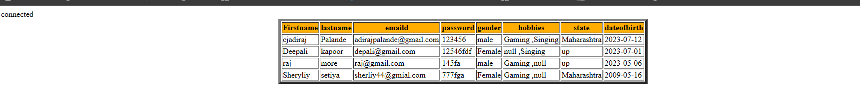

**Class: TYIT Sem: V Roll No.: TYIT10 Date :**

**Course Name : Enterprise Java**

Practical

index.html

<!DOCTYPE html>

<!--

To change this license header, choose License Headers in Project Properties.

To change this template file, choose Tools | Templates

and open the template in the editor.

-->

<html>

<head>

<title>Quiz app</title>

<meta charset="UTF-8">

<meta name="viewport" content="width=device-width, initial-scale=1.0">

<style>

body{

background-color: pink;

font-size: 20px;

padding-left: 20px;

}

</style>

</head>

<body>

<form method="post" action="NewServlet">

<b>Q1. What is the capital of India</b><br>

<input type="radio" name="1" value="chennai">Chennai

<input type="radio" name="1" value="kolkata">kolkata<br>

<input type="radio" name="1" value="Bihar">Bihar

**Class: TYIT Sem: V Roll No.: TYIT10 Date :**

**Course Name : Enterprise Java**

<input type="radio" name="1" value="Delhi">Delhi<br><br>

<b>Q2. Which is the largest state of India?</b><br>

<input type="radio" name="2" value="Mahatma Gandhi">Mahatma Gandhi

<input type="radio" name="2" value="Eleanor Roosevelt">Madhya Pradesh<br>

<input type="radio" name="2" value="Rajasthan">Rajasthan

<input type="radio" name="2" value="Desmond Tutu">Desmond Tutu<br><br>

<b>Q3. Which is the financial capital of India?</b><br>

<input type="radio" name="3" value="Mahatma Gandhi">delhi

<input type="radio" name="3" value="Mumbai">Mumbai<br>

<input type="radio" name="3" value="Dr. Rajendra Prasad">Dr. Rajendra Prasad

<input type="radio" name="3" value="Desmond Tutu">Desmond Tutu<br><br>

<b>Q4. Giddha is the folk dance of?</b><br>

<input type="radio" name="4" value="chennai">Chennai

<input type="radio" name="4" value="kolkata">kolkata<br>

<input type="radio" name="4" value="Punjab">punjab

<input type="radio" name="4" value="Delhi">Delhi<br><br>

<b>Q5. Who invented Computer?</b><br>

<input type="radio" name="5" value="Charles Babbage">Charles Babbage

<input type="radio" name="5" value="Eleanor Roosevelt">Eleanor Roosevelt<br>

<input type="radio" name="5" value="Nelson Mandela">Nelson Mandela

<input type="radio" name="5" value="Desmond Tutu">Desmond Tutu<br><br>

**Class: TYIT Sem: V Roll No.: TYIT10 Date :**

**Course Name : Enterprise Java**

<b>Q6. Brain of computer is?</b><br><br>

<input type="radio" name="6" value="CPU">CPU

<input type="radio" name="6" value="monitor">Monitor<br>

<input type="radio" name="6" value="keyboard">keyboard

<input type="radio" name="6" value="mouse">Mouse<br><br>

<b>Q7. Smallest state of India is?</b><br>

<input type="radio" name="7" value="Goa">goa

<input type="radio" name="7" value="kolkata">kolkata<br>

<input type="radio" name="7" value="punjab">punjab

<input type="radio" name="7" value="Delhi">Delhi<br><br>

<b>Q8. Fastest animal on earth is?</b><br>

<input type="radio" name="8" value="Cheetah">cheetah

<input type="radio" name="8" value="tiger">tiger<br>

<input type="radio" name="8" value="elephant">elephant

<input type="radio" name="8" value="mouse">Mouse<br><br>

<b>Q9. Which plant grows in desert?</b><br>

<input type="radio" name="9" value="Cactus">Cactus

<input type="radio" name="9" value="mango">mango<br>

<input type="radio" name="9" value="rose">rose

<input type="radio" name="9" value="lvy">lvy<br><br>

<b>Q10. Highest dam of India is?</b><br>

<input type="radio" name="10" value="jalaput">Cactus

<input type="radio" name="10" value="Tehri Dam">Tehri<br>

**Class: TYIT Sem: V Roll No.: TYIT10 Date :**

**Course Name : Enterprise Java**

<input type="radio" name="10" value="hirakud">hirakud

<input type="radio" name="10" value="indravati">indravati<br><br>

<input type="submit" value="submit"> </form>

</body>

</html>

newservlet.java

import java.io.IOException;

import java.io.PrintWriter;

import java.sql.Connection;

import java.sql.DriverManager;

import java.sql.ResultSet;

import java.sql.SQLException;

import java.sql.Statement;

import java.util.logging.Level;

import java.util.logging.Logger;

import javax.servlet.ServletException;

import javax.servlet.http.HttpServlet;

import javax.servlet.http.HttpServletRequest;

import javax.servlet.http.HttpServletResponse;

public class NewServlet extends HttpServlet {

protected void processRequest(HttpServletRequest request, HttpServletResponse response)

throws ServletException, IOException {

response.setContentType("text/html;charset=UTF-8");

**Class: TYIT Sem: V Roll No.: TYIT10 Date :**

**Course Name : Enterprise Java**

try (PrintWriter out = response.getWriter()) {

/* TODO output your page here. You may use following sample code. */

out.println("<!DOCTYPE html>");

out.println("<html>");

out.println("<head>");

out.println("<title>Servlet NewServlet</title>");

out.println("</head>");

out.println("<body>");

int count=0,i=1;

Connection con= DriverManager.getConnection("jdbc:derby://localhost:1527/anshika", "anshika", "anshika");

Statement stmt= con.createStatement();

ResultSet rs = stmt.executeQuery("select * from question");

while(rs.next()){

String n= Integer.toString(i);

String s=request.getParameter(n);

if(s.equals(rs.getString(2))){

count++;

}

i++;

}

**Class: TYIT Sem: V Roll No.: TYIT10 Date :**

**Course Name : Enterprise Java**

out.println("<h1>score= " + count + "</h1>");

out.println("</body>");

out.println("</html>");

} catch (SQLException ex) {

Logger.getLogger(NewServlet.class.getName()).log(Level.SEVERE, null, ex);

}

}

@Override

protected void doGet(HttpServletRequest request, HttpServletResponse response)

throws ServletException, IOException {

processRequest(request, response);

}

@Override

protected void doPost(HttpServletRequest request, HttpServletResponse response)

throws ServletException, IOException {

processRequest(request, response);

}

@Override

public String getServletInfo() {

return "Short description";

}// </editor-fold>

}

Output:

**Class: TYIT Sem: V Roll No.: TYIT10 Date :**

**Course Name : Enterprise Java**

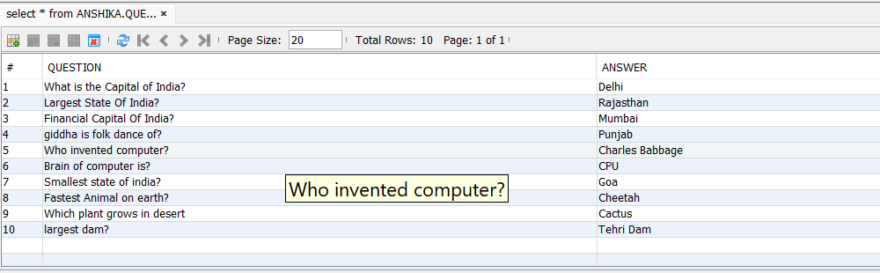

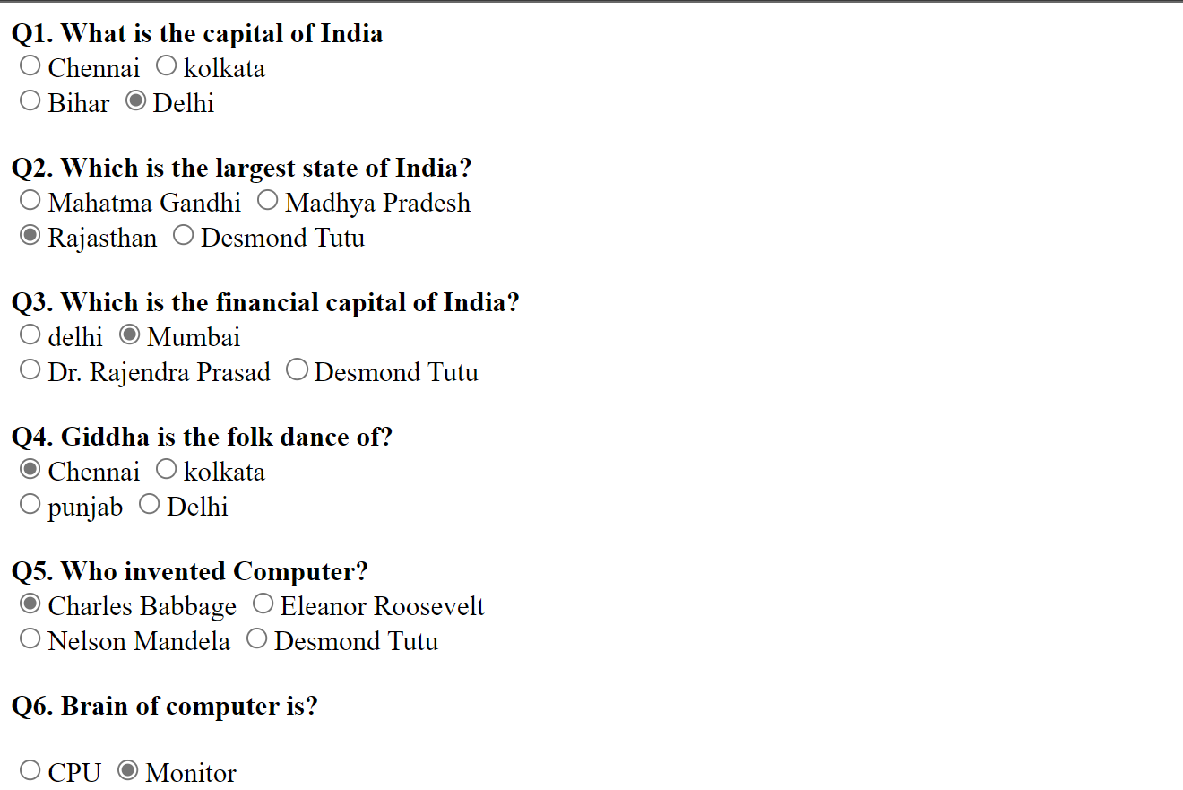

**Class: TYIT Sem: V Roll No.: TYIT10 Date :**

**Course Name : Enterprise Java**

