**Practical 2B**

**Perform the Extraction Transformation and Loading (ETL) process to construct the database in the SQL server.**

**Software requirements: SQLSERVER 2012 FULL VERSION (SQL server20122sp1-FullSlipstream-ENY-x86)**

**Step 1: Open SQL Server Management Studio to restore backup file.**

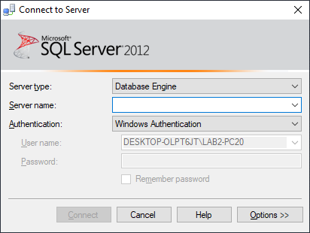

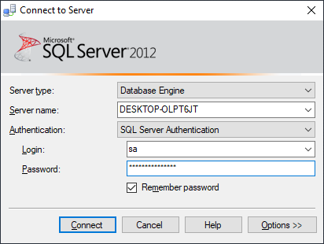

**Step2: Right click on databases and go to restore database.**

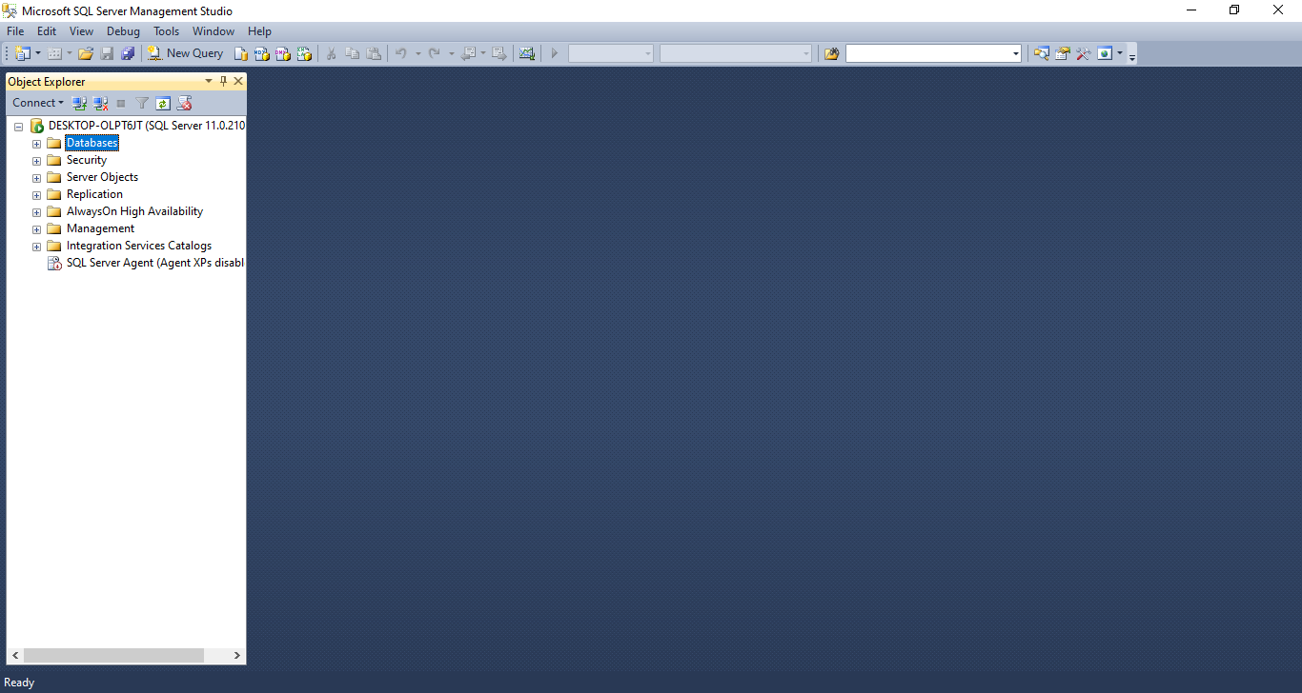

**Step 3: Select Device click on icon towards end of deice box.**

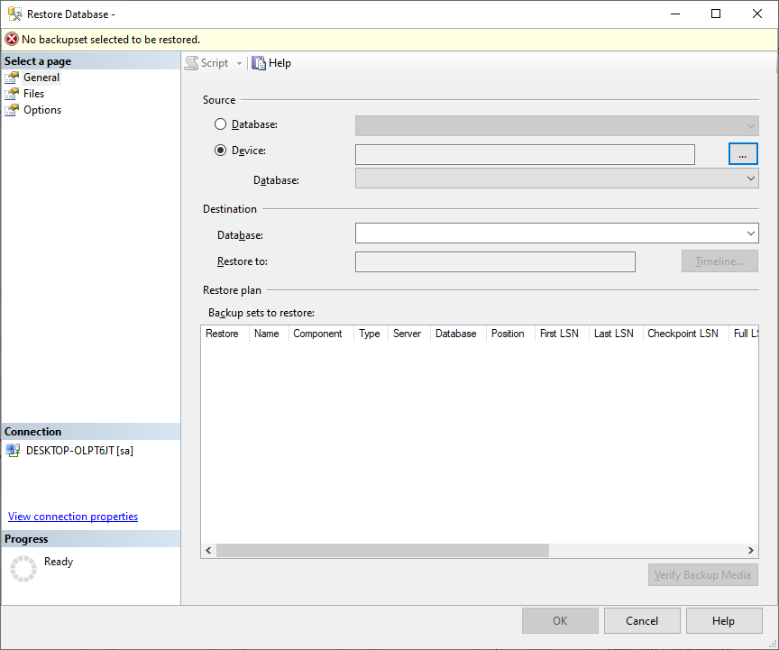

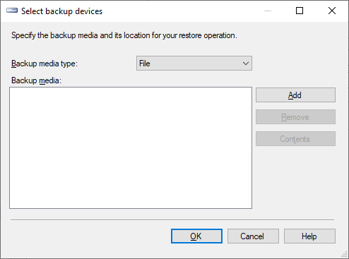

**Step 4: Click on add and select path of backup files.**

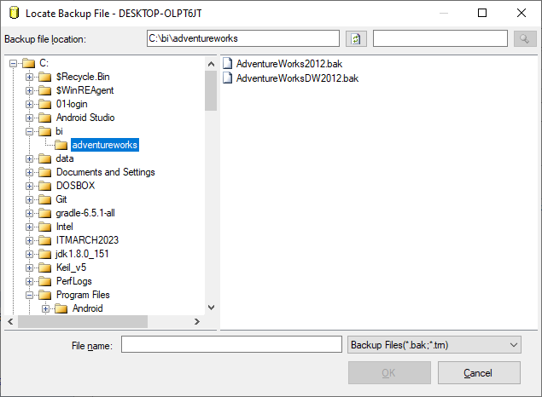

**Step 5: select both files at a time.**

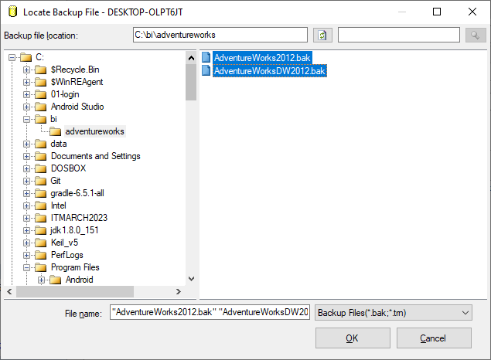

**Step 6: Click ok and in select backup device window add both files of AdventureWorks.**

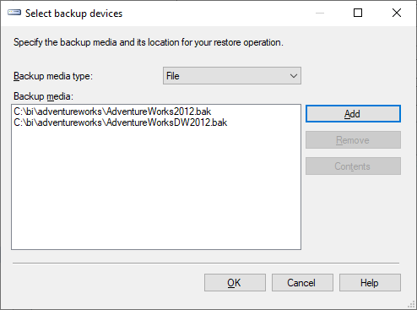

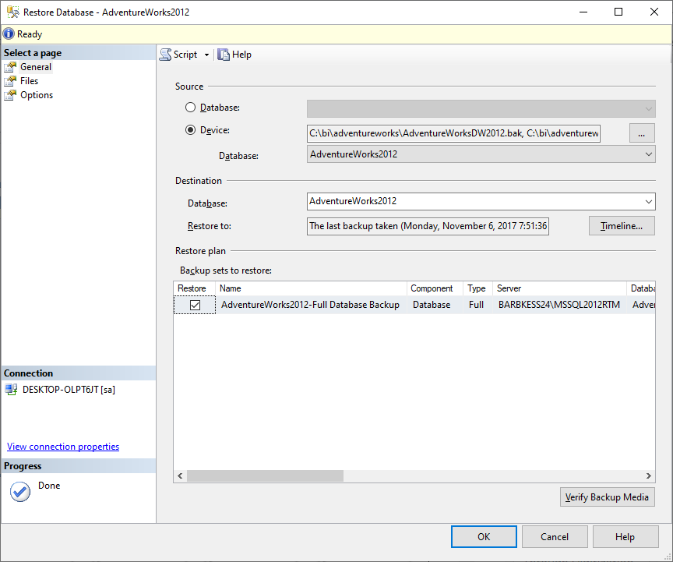

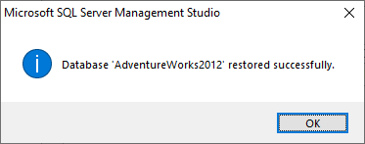

**Step 7: Open SQL Server Data Tools.**

**Select File – New – Project – Business Intelligence – Integration Services Project and give appropriate project name.**

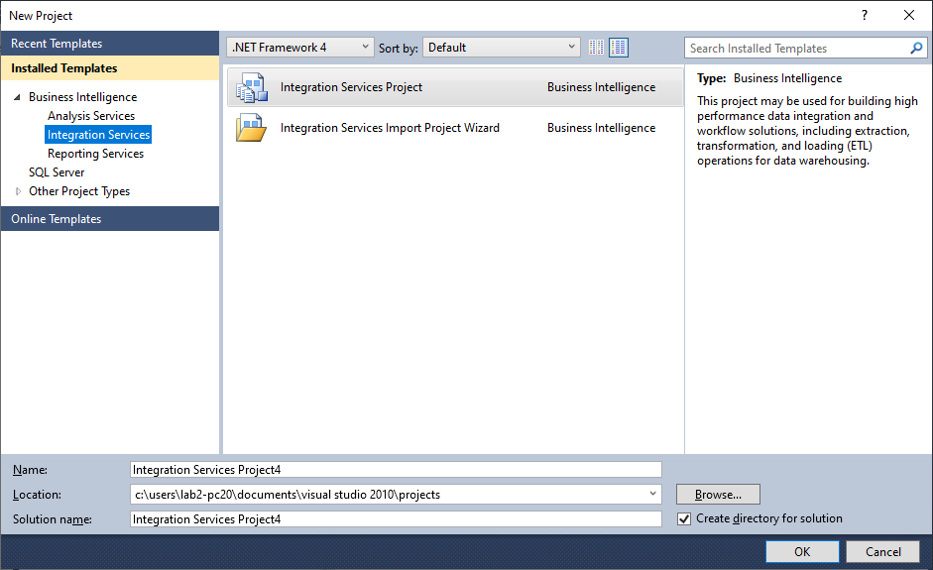

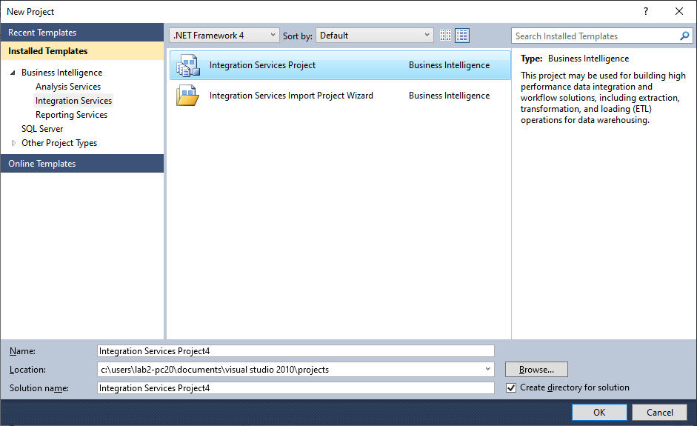

**Environment consists of SQL server integration services (SSIS).**

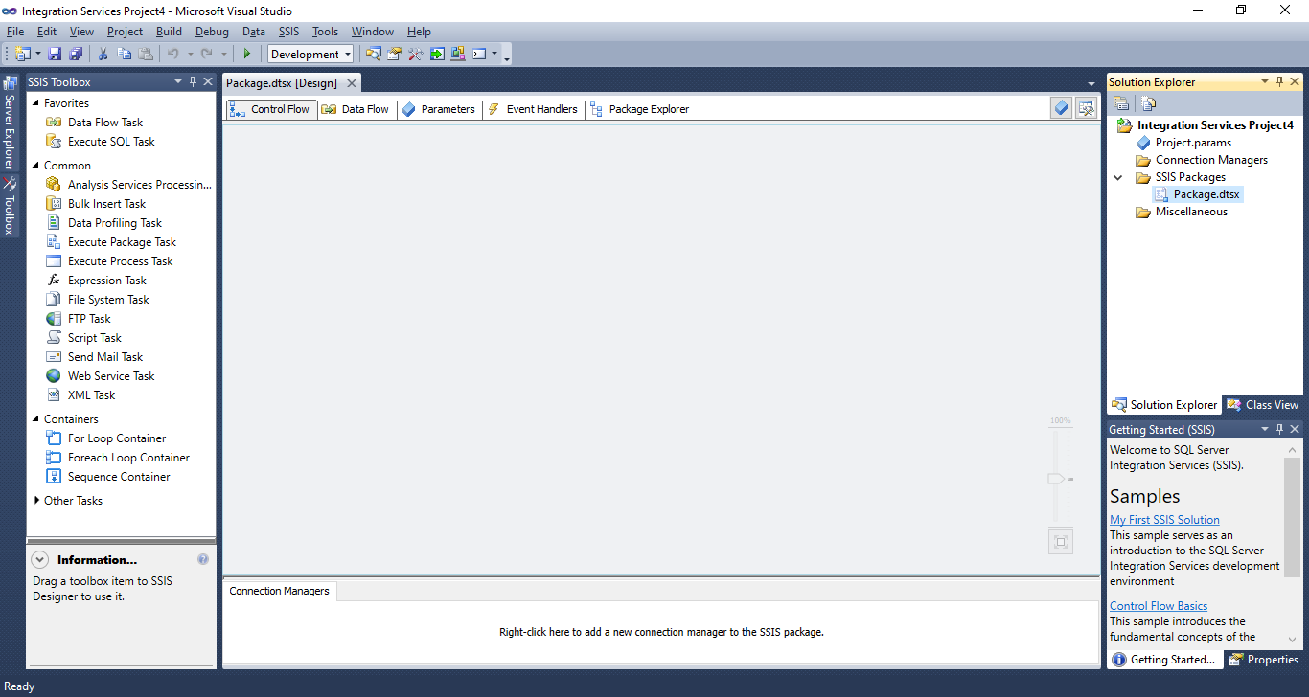

**Step 8: Right click on Connection Managers in Solution Explorer and click new connection manager.** **Add SSIS connection manager window appears.**

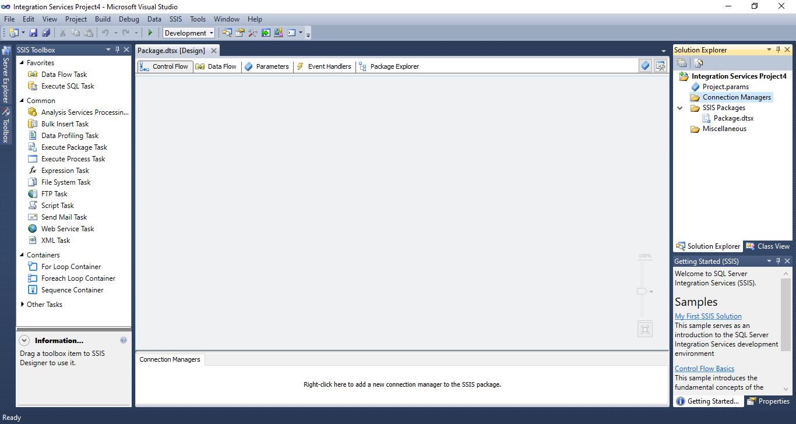

**Step 9: Select OLEDB Connection Manager and click on Add.**

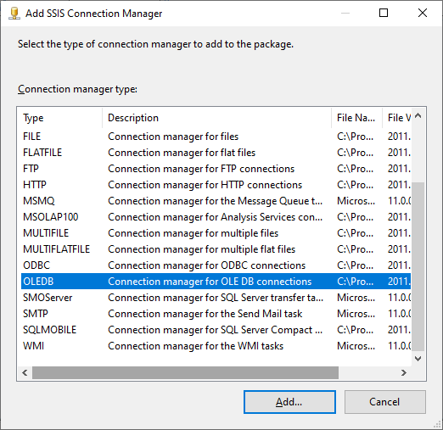

**Step 10: Configure OLEDB Connection Manager window appears and click on New.** 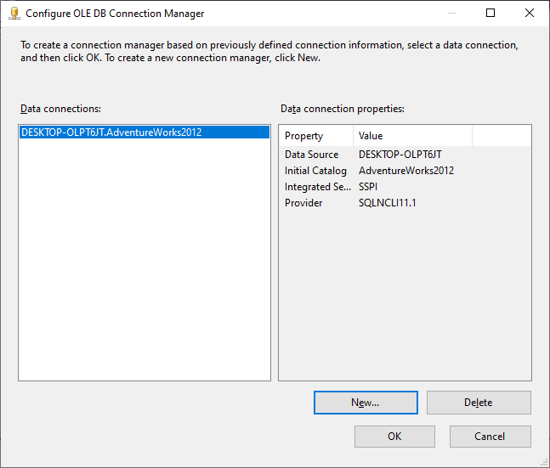

**Step 11: Select Server name (as per your machine) from drop down and database name and click on Test connection.** 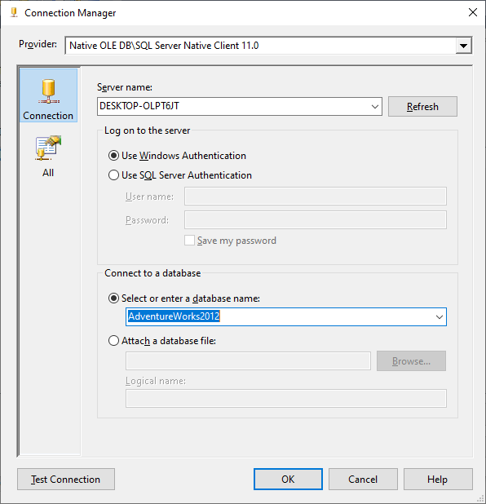

**If test connection succeeded click on OK.**

**Step 12: click on OK.**

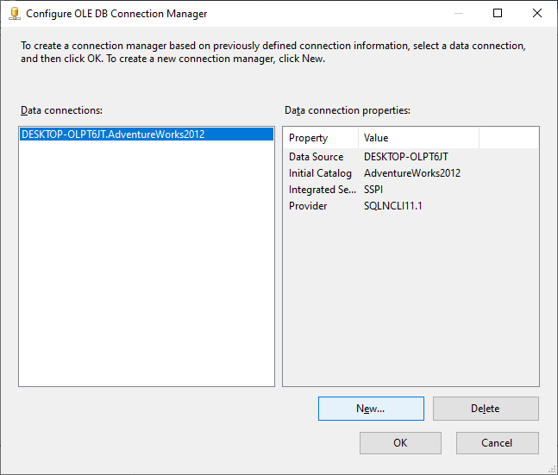

**Connection is added to the connection manager.**

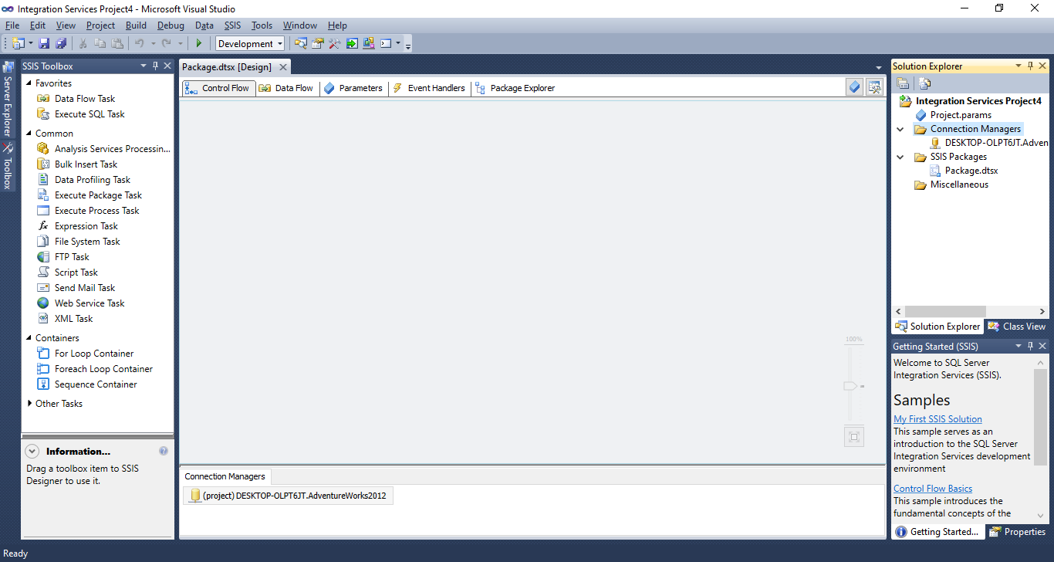

**Step 13: Drag and drop Data Flow Task in Control Flow tab.**

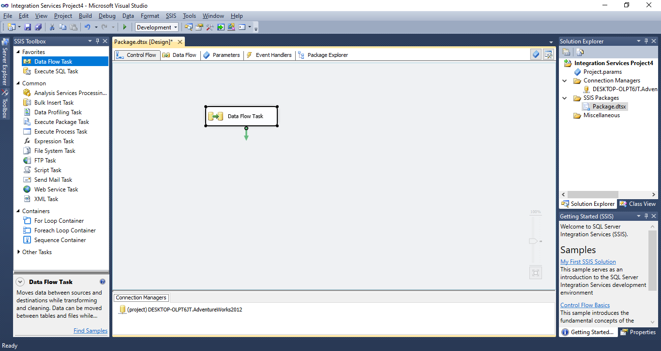

**Step 14: Drag OLEDB source from Other Sources and drop into Data Flow tab.**

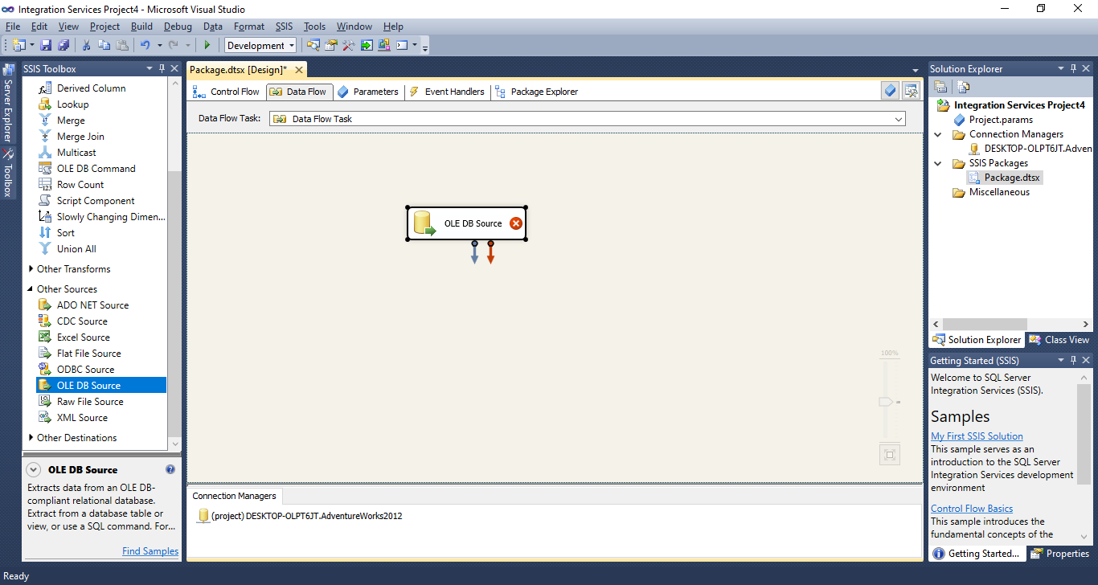

**Step 15: Double click on OLEDB source and OLEDB source Editor appears then click on New to add connection manager.**

**Select [sales].[store] table from drop down and click on ok.**

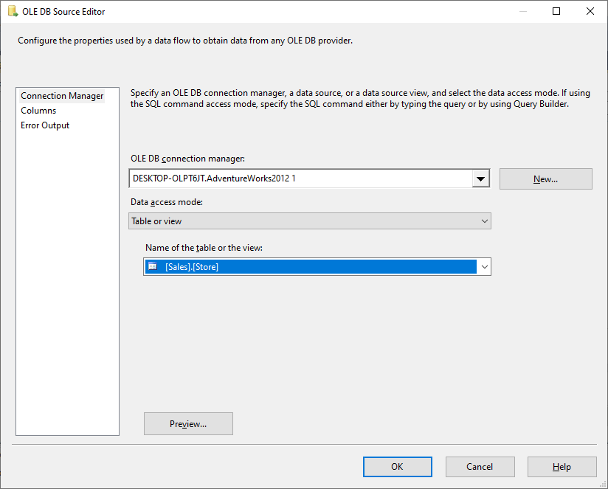

**Step 16: Drag oledb destination in data flow tab and connect both.**

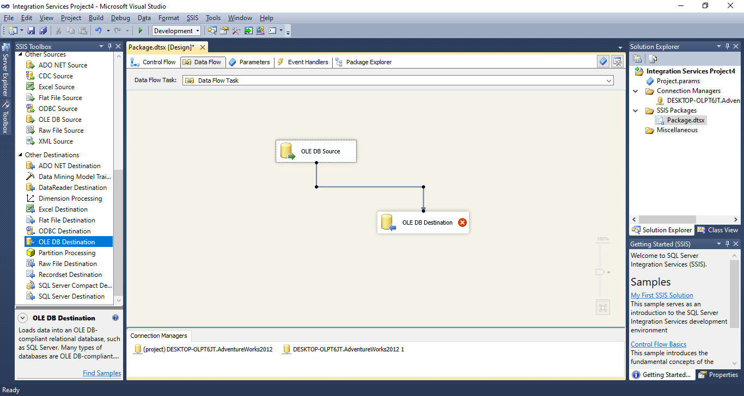

**Step 17: Double click on OLE DB destination**

**Click on New to run the query to get [OLE DB Destination] in Name of the table or the view.** 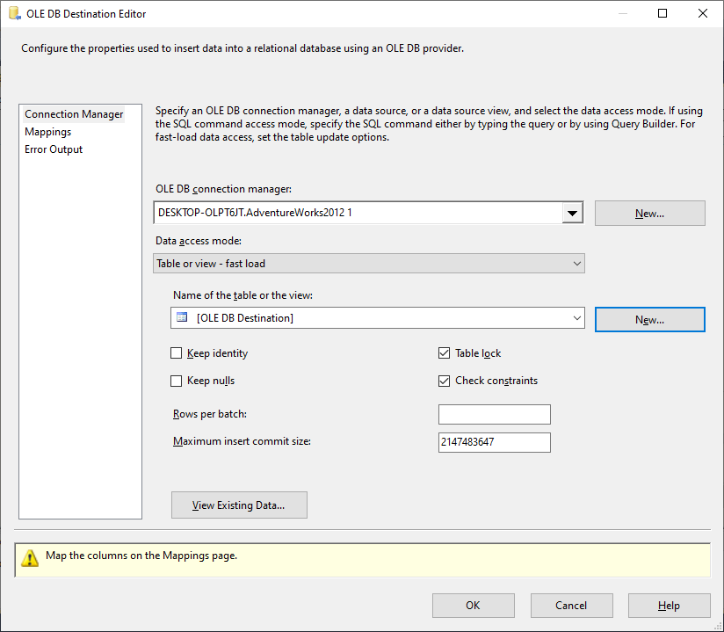

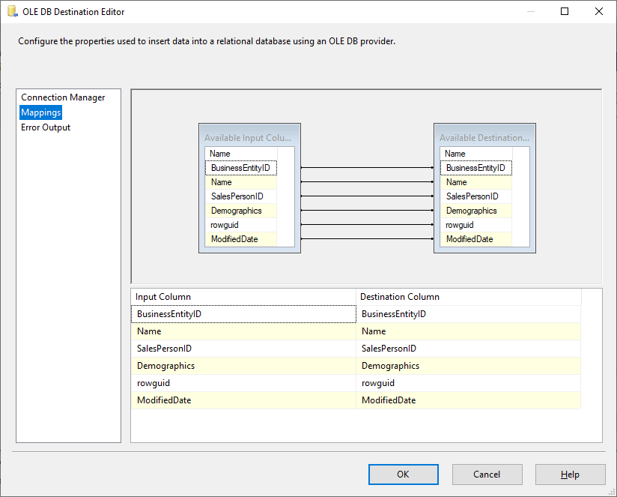

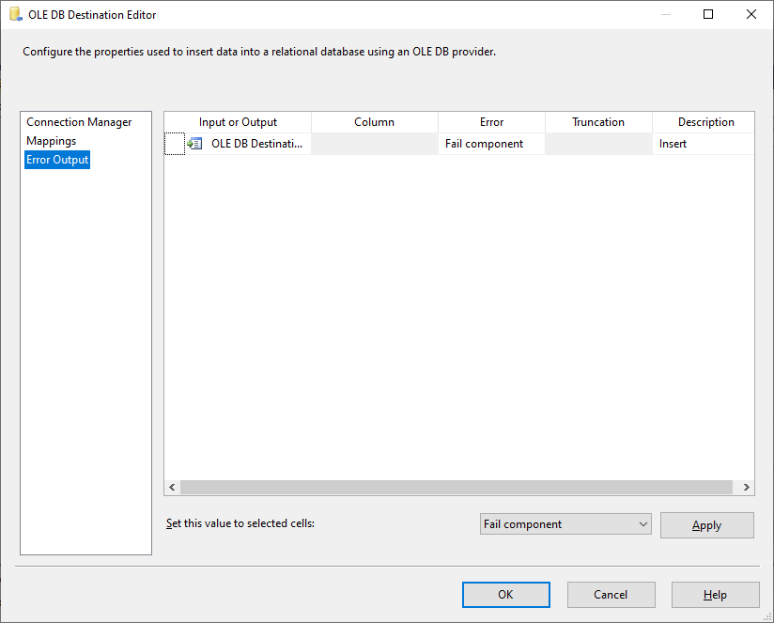

**Click on OK**

**Step 18: Click on Start.**

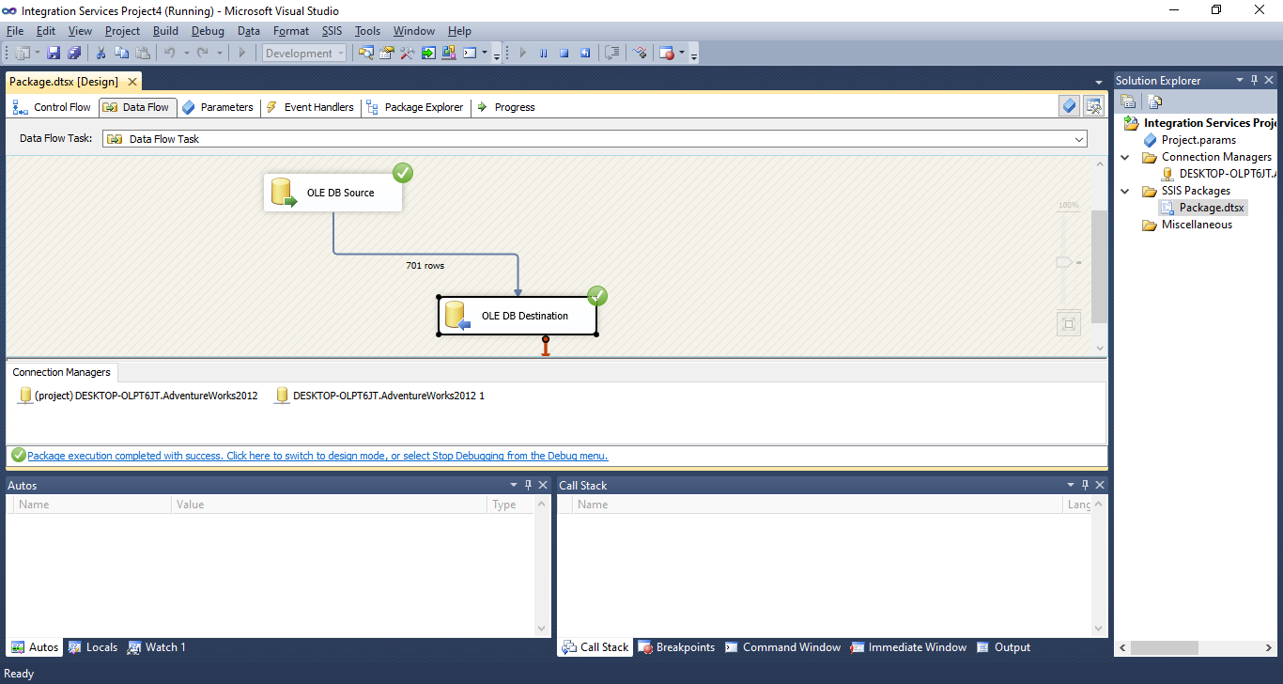

**Step 19: Go to SQK Server Management Studio**

**In database tab – Adventureworks – Right click on [dbo].[OLE DB Destination] - Scrip Table as – SELECT To – New Query Editor Window**

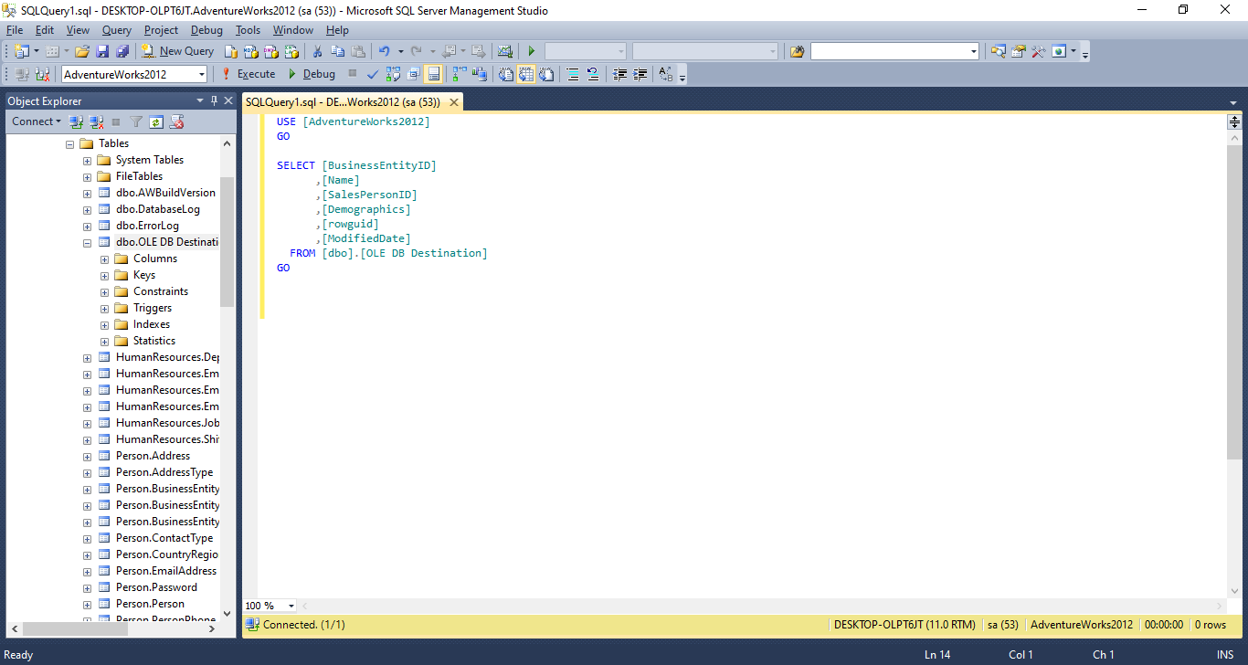

**Step 20: Execute following query to get output.**

