- Priority scheduling non-pre-emptive
#include <stdio.h>

int main()
{
int n, i, current_time = 0, completed_count = 0;
printf("USN:1WA24CS198");
printf("Enter number of processes: ");
scanf("%d", &n);

int pid[n], at[n], bt[n], pr[n];
int ct[n], tat[n], wt[n];
int completed[n];

// Input
for(i = 0; i < n; i++)
{
printf("\nProcess %d\n", i + 1);

printf("Process ID: ");
scanf("%d", &pid[i]);

printf("Arrival Time: ");
scanf("%d", &at[i]);

printf("Burst Time: ");
scanf("%d", &bt[i]);

printf("Priority: ");
scanf("%d", &pr[i]);

completed[i] = 0;
}

while(completed_count < n)
{
int highest_priority = 9999;
int selected_process = -1;

for(i = 0; i < n; i++)
{
if(at[i] <= current_time && completed[i] == 0)
{
if(pr[i] < highest_priority)
{
highest_priority = pr[i];
selected_process = i;
}
}
}

if(selected_process == -1)
{
current_time++;
}
else
{
int start_time = current_time;

ct[selected_process] = start_time + bt[selected_process];

tat[selected_process] =
ct[selected_process] - at[selected_process];

wt[selected_process] =
tat[selected_process] - bt[selected_process];

current_time = ct[selected_process];

completed[selected_process] = 1;
completed_count++;
}
}

printf("\nPID\tAT\tBT\tPR\tCT\tTAT\tWT\n");

for(i = 0; i < n; i++)
{
printf("%d\t%d\t%d\t%d\t%d\t%d\t%d\n",
pid[i], at[i], bt[i], pr[i],
ct[i], tat[i], wt[i]);
}

return 0;
}
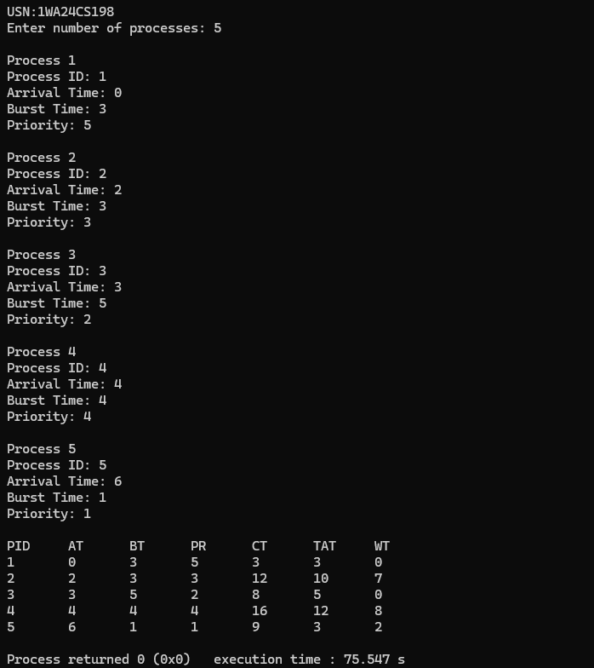

- Priority scheduling Pre-emptive
#include <stdio.h>

int main()
{
int n, i;
printf("USN:1WA24CS198");
printf("Enter number of processes: ");
scanf("%d", &n);

int pid[n], at[n], bt[n], pr[n];
int rt[n], ct[n], tat[n], wt[n];

// Input
for(i = 0; i < n; i++)
{
printf("\nProcess %d\n", i + 1);

printf("Process ID: ");
scanf("%d", &pid[i]);

printf("Arrival Time: ");
scanf("%d", &at[i]);

printf("Burst Time: ");
scanf("%d", &bt[i]);

printf("Priority: ");
scanf("%d", &pr[i]);

rt[i] = bt[i]; // Remaining time
}

int current_time = 0;
int completed = 0;

while(completed < n)
{
int highest_priority = 9999;
int selected_process = -1;

// Find highest priority process
for(i = 0; i < n; i++)
{
if(at[i] <= current_time && rt[i] > 0)
{
if(pr[i] < highest_priority)
{
highest_priority = pr[i];
selected_process = i;
}
}
}

// No process available
if(selected_process == -1)
{
current_time++;
}
else
{
rt[selected_process]--;
current_time++;

if(rt[selected_process] == 0)
{
ct[selected_process] = current_time;

tat[selected_process] =
ct[selected_process] - at[selected_process];

wt[selected_process] =
tat[selected_process] - bt[selected_process];

completed++;
}
}
}

printf("\nPID\tAT\tBT\tPR\tCT\tTAT\tWT\n");

for(i = 0; i < n; i++)
{
printf("%d\t%d\t%d\t%d\t%d\t%d\t%d\n",
pid[i], at[i], bt[i], pr[i],
ct[i], tat[i], wt[i]);
}

return 0;
}

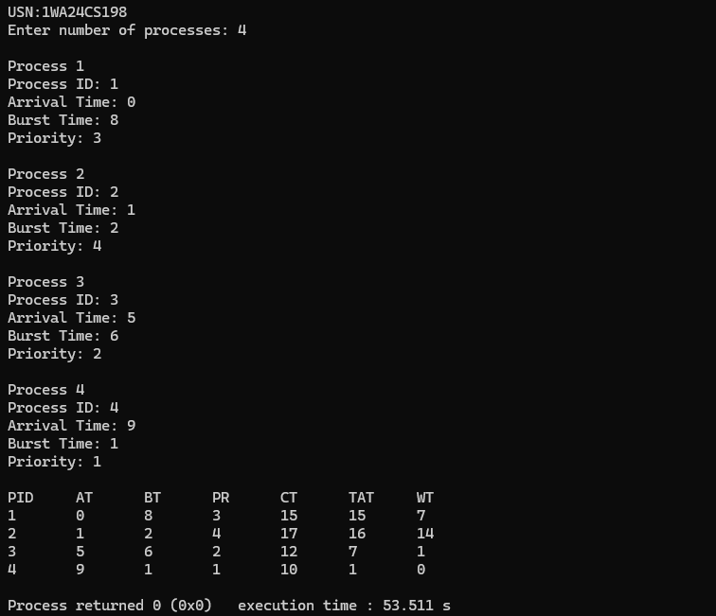

- Round Robin
#include <stdio.h>

int main()
{
int n, tq, i;
printf("USN:1WA24CS198");
printf("Enter number of processes: ");
scanf("%d", &n);

printf("Enter time quantum: ");
scanf("%d", &tq);

int pid[n], at[n], bt[n], rt[n];
int wt[n], tat[n], ct[n];

for(i = 0; i < n; i++)
{
printf("\nProcess %d\n", i + 1);

printf("Process ID: ");
scanf("%d", &pid[i]);

printf("Arrival Time: ");
scanf("%d", &at[i]);

printf("Burst Time: ");
scanf("%d", &bt[i]);

rt[i] = bt[i];
}

int completed = 0;
int current_time = 0;

while(completed < n)
{
int executed = 0;

for(i = 0; i < n; i++)
{
if(at[i] <= current_time && rt[i] > 0)
{
executed = 1;

if(rt[i] > tq)
{
current_time += tq;
rt[i] -= tq;
}
else
{
current_time += rt[i];
ct[i] = current_time;

tat[i] = ct[i] - at[i];
wt[i] = tat[i] - bt[i];

rt[i] = 0;
completed++;
}
}
}

if(executed == 0)
current_time++;
}

float avg_wt = 0, avg_tat = 0;

printf("\nPID\tAT\tBT\tCT\tTAT\tWT\n");

for(i = 0; i < n; i++)
{
printf("%d\t%d\t%d\t%d\t%d\t%d\n",
pid[i], at[i], bt[i], ct[i], tat[i], wt[i]);

avg_wt += wt[i];
avg_tat += tat[i];
}

avg_wt /= n;
avg_tat /= n;

printf("\nAverage Waiting Time = %.2f", avg_wt);
printf("\nAverage Turnaround Time = %.2f\n", avg_tat);

return 0;
}
