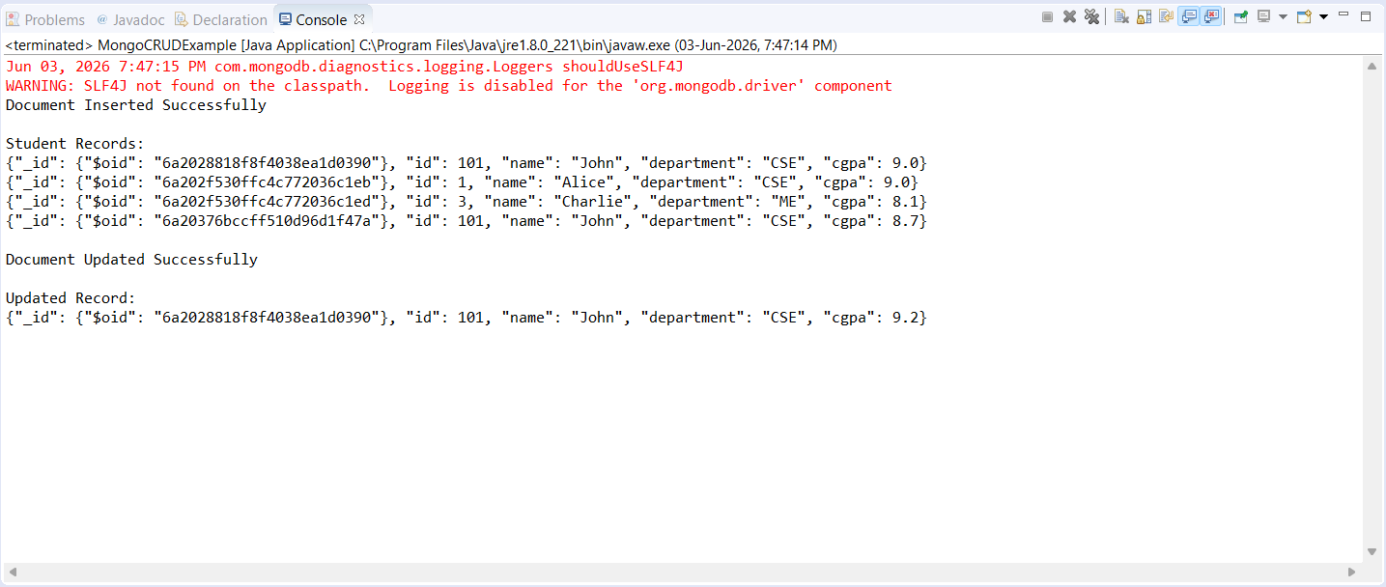
import com.mongodb.client.FindIterable;
import com.mongodb.client.MongoClient;
import com.mongodb.client.MongoClients;
import com.mongodb.client.MongoCollection;
import com.mongodb.client.MongoDatabase;

import com.mongodb.client.model.Filters;
import com.mongodb.client.model.Updates;

import org.bson.Document;

public class MongoCRUDExample {

public static void main(String[] args) {

// Connect to MongoDB
MongoClient mongoClient =
MongoClients.create("mongodb://localhost:27017");

// Access database
MongoDatabase database =
mongoClient.getDatabase("CollegeDB");

// Access collection
MongoCollection<Document> collection =
database.getCollection("Students");

// ==========================
// CREATE
// ==========================
Document student = new Document("id", 101)
.append("name", "John")
.append("department", "CSE")
.append("cgpa", 8.7);

collection.insertOne(student);

System.out.println("Document Inserted Successfully");

// ==========================
// READ
// ==========================
System.out.println("\nStudent Records:");

FindIterable<Document> students = collection.find();

for (Document doc : students) {
System.out.println(doc.toJson());
}

// ==========================
// UPDATE
// ==========================
collection.updateOne(
Filters.eq("id", 101),
Updates.set("cgpa", 9.2)
);

System.out.println("\nDocument Updated Successfully");

// ==========================
// READ UPDATED RECORD
// ==========================
Document updatedStudent =
collection.find(Filters.eq("id", 101)).first();

System.out.println("\nUpdated Record:");
System.out.println(updatedStudent.toJson());

// Close connection
mongoClient.close();
}
}

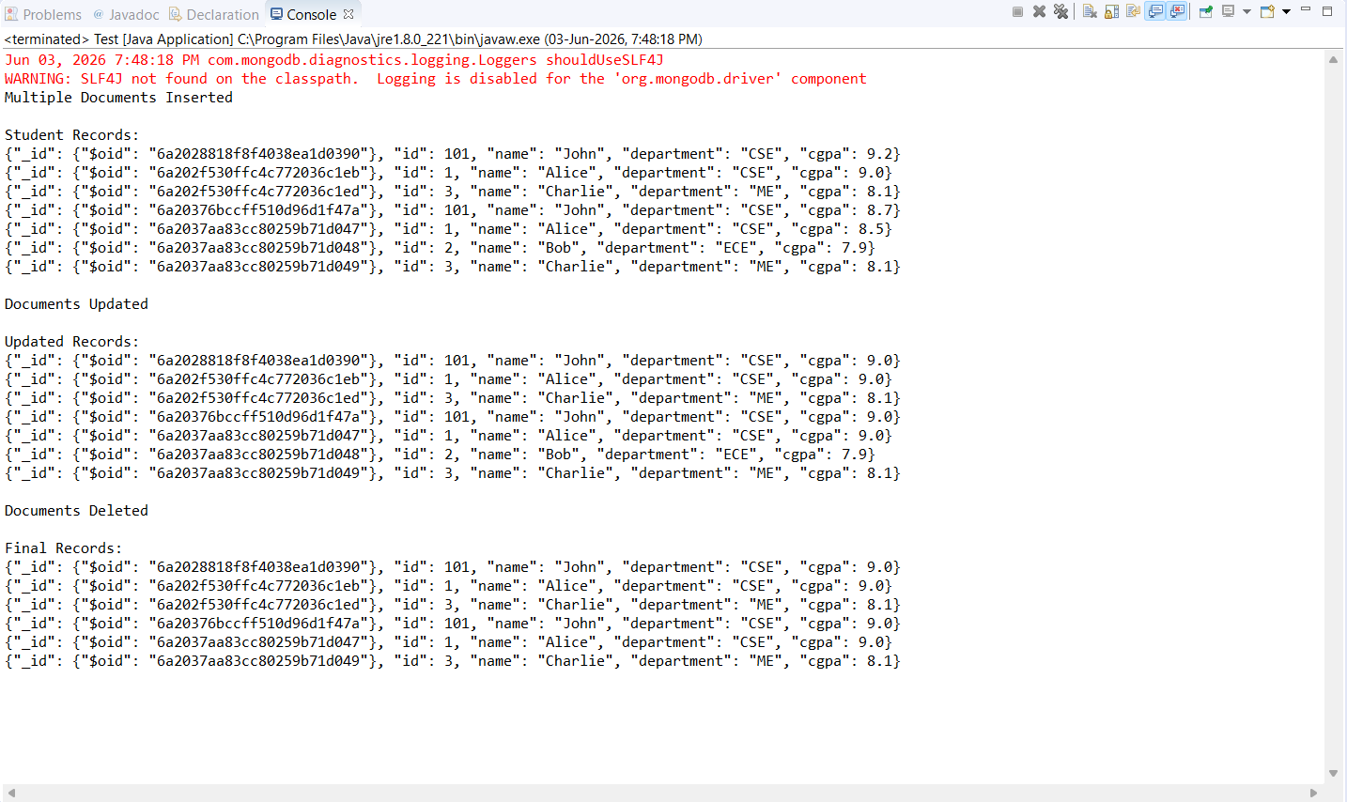

import com.mongodb.client.FindIterable;
import com.mongodb.client.MongoClient;
import com.mongodb.client.MongoClients;
import com.mongodb.client.MongoCollection;
import com.mongodb.client.MongoDatabase;

import com.mongodb.client.model.Filters;
import com.mongodb.client.model.Updates;

import org.bson.Document;

import java.util.Arrays;

public class Test {

public static void main(String[] args) {

// Connect to MongoDB
MongoClient mongoClient =
MongoClients.create("mongodb://localhost:27017");

// Access Database
MongoDatabase database =
mongoClient.getDatabase("CollegeDB");

// Access Collection
MongoCollection<Document> collection =
database.getCollection("Students");

collection.insertMany(Arrays.asList(

new Document("id", 1)
.append("name", "Alice")
.append("department", "CSE")
.append("cgpa", 8.5),

new Document("id", 2)
.append("name", "Bob")
.append("department", "ECE")
.append("cgpa", 7.9),

new Document("id", 3)
.append("name", "Charlie")
.append("department", "ME")
.append("cgpa", 8.1)

));

System.out.println("Multiple Documents Inserted");

System.out.println("\nStudent Records:");

FindIterable<Document> students = collection.find();

for (Document doc : students) {
System.out.println(doc.toJson());
}

collection.updateMany(
Filters.eq("department", "CSE"),
Updates.set("cgpa", 9.0)
);

System.out.println("\nDocuments Updated");

System.out.println("\nUpdated Records:");

FindIterable<Document> updatedStudents =
collection.find();

for (Document doc : updatedStudents) {
System.out.println(doc.toJson());
}

collection.deleteMany(
Filters.lt("cgpa", 8)
);

System.out.println("\nDocuments Deleted");

System.out.println("\nFinal Records:");

FindIterable<Document> finalStudents =
collection.find();

for (Document doc : finalStudents) {
System.out.println(doc.toJson());
}

// Close Connection
mongoClient.close();
}
}

