Omi live: Live Sales Tactical Workbook

- Applicable platforms: TikTok | Instagram | Omi live
- Live stream duration: 45 minutes
- Core objectives: Boost conversion rate + Enhance audience experience + Strengthen environmental protection value

Table of Contents
Part 1: The Full Live Selling Workflow 3
PART 2: Pre-Live Setup 4
1. What You Need to Go Live 4
2. Product selection logic and matching methods 4
3. Creating a product pitch card for each item (FAB method) 7
PART 3: In-Live Execution & Engagement 8
1. Sales Scripts That Convert 8
2.Interaction Tactics & Objection Handling 11
3. Common Objections & Handling Tips 11
4. High-Converting Language Patterns 12
5. Bonus：Suggestions for New User Acquisition Interactive Games (to improve retention + conversion) 13
6. Product Script Template 14
Part 4 FAQ & Answer Toolkit for Live Sales 14
PART 5: Post-Live Review & Optimization 16
1. Post-Live Review Checklist 16
2. Precise Question Review Guide (Live Debrief Questions) 17
3. Action Plan for Optimization 17
4.Example: Live Stream Review Record Template (Can be filled out after each live stream) 18
Part 6 Whatnot Live Sales – Practical Guide 19
1. Whatnot’s Core Gameplay 19
2.Screenshot Examples 19
3. Example: 30-Minute Auction Flow on Whatnot 22
4. Practical Whatnot Operation Guide 23
5. Visual & Layout Tips 23
6. Points for Omi live to Draw On 23
Part 7 Avoid Live Stream Pitfalls 23
1. Live Risk Word & Compliance Sheet 24
2. What NOT to do in Live 24
3. Safe & Clear Phrases to Use 24

Part 1: The Full Live Selling Workflow
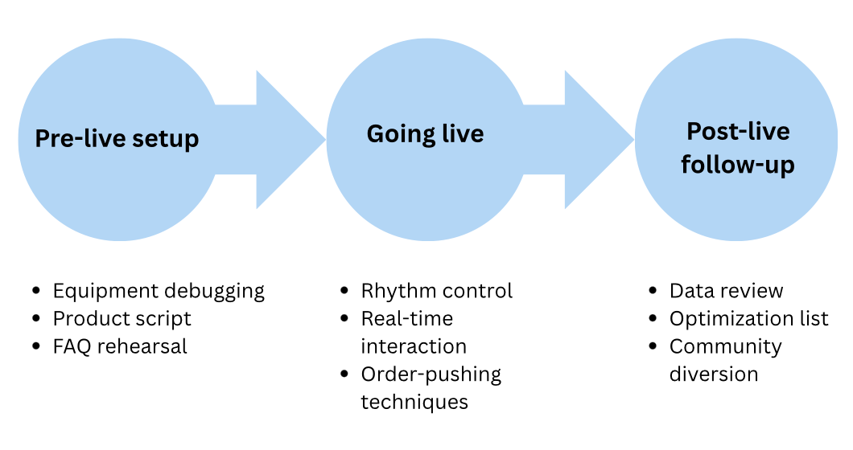

PART 2: Pre-Live Setup

1. What You Need to Go Live
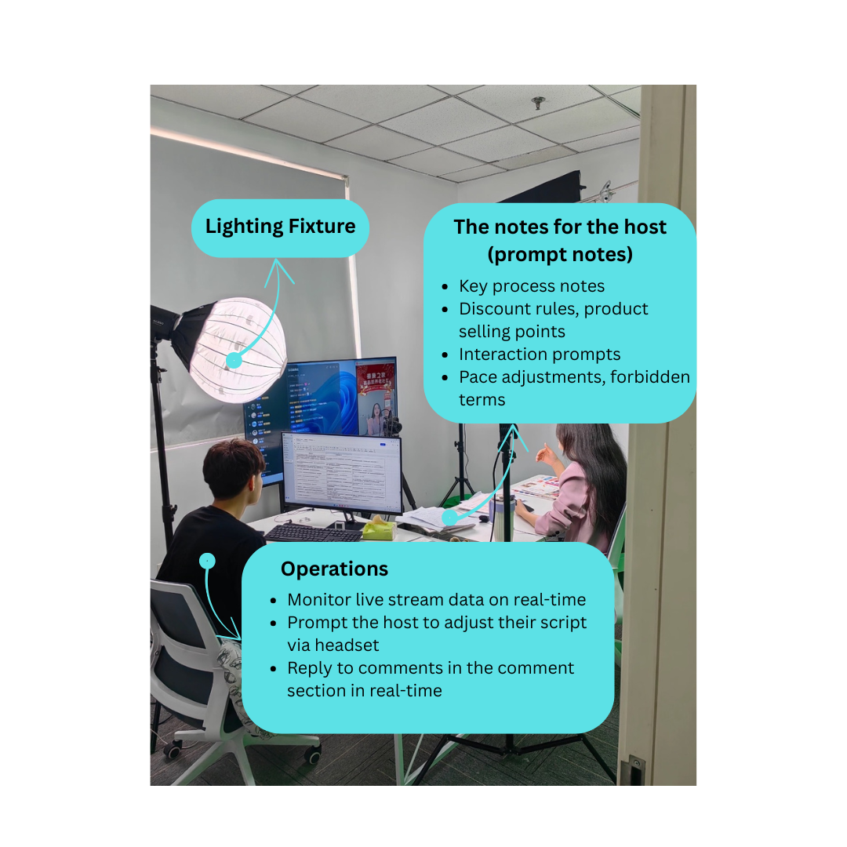
- Equipment checklist (camera/phone, mic, lighting, tripod)
- Ideal lighting & environment setup
- Software & tools: OBS, StreamYard, TikTok Live Studio, etc.

2. Product selection logic and matching methods
The 3-type product mix: Traffic drivers, profit items, hero products
Order of showcasing: High interest > utility > bundle > CTA

Taking the Flower Knows TikTok live stream as an example:
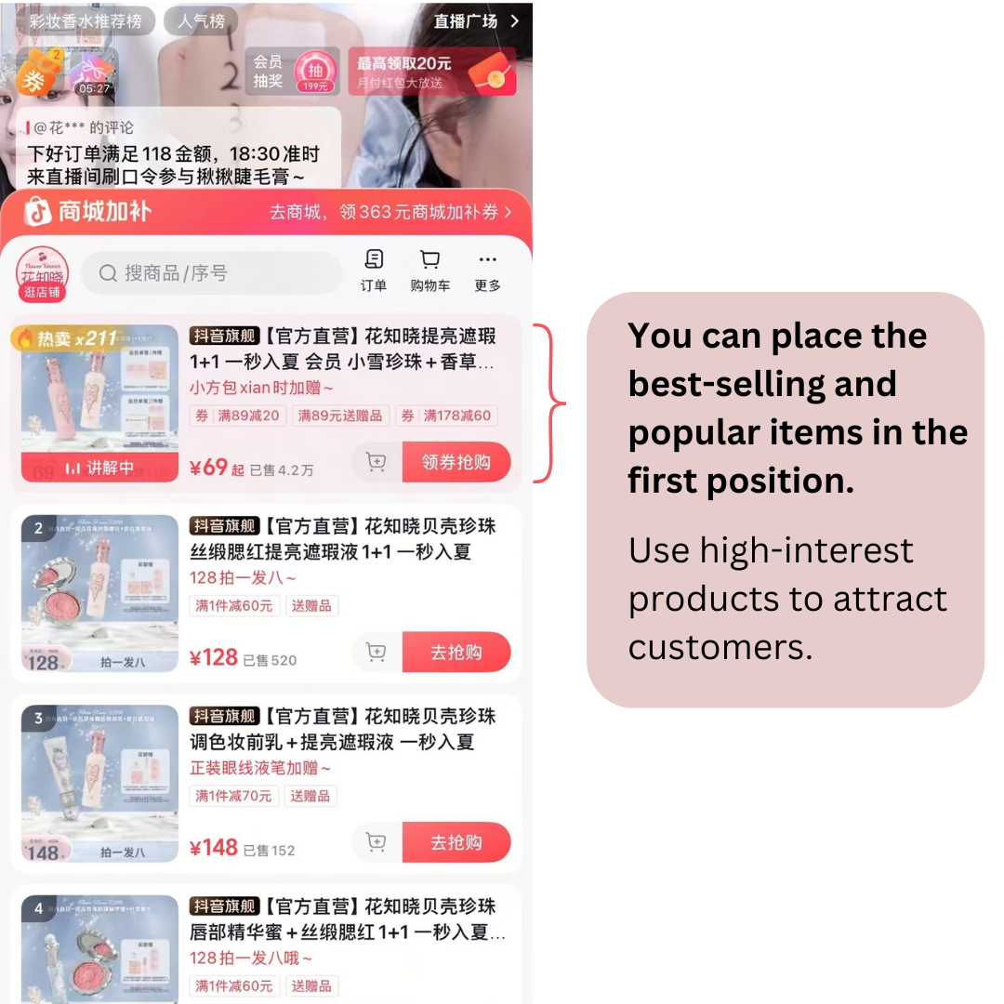
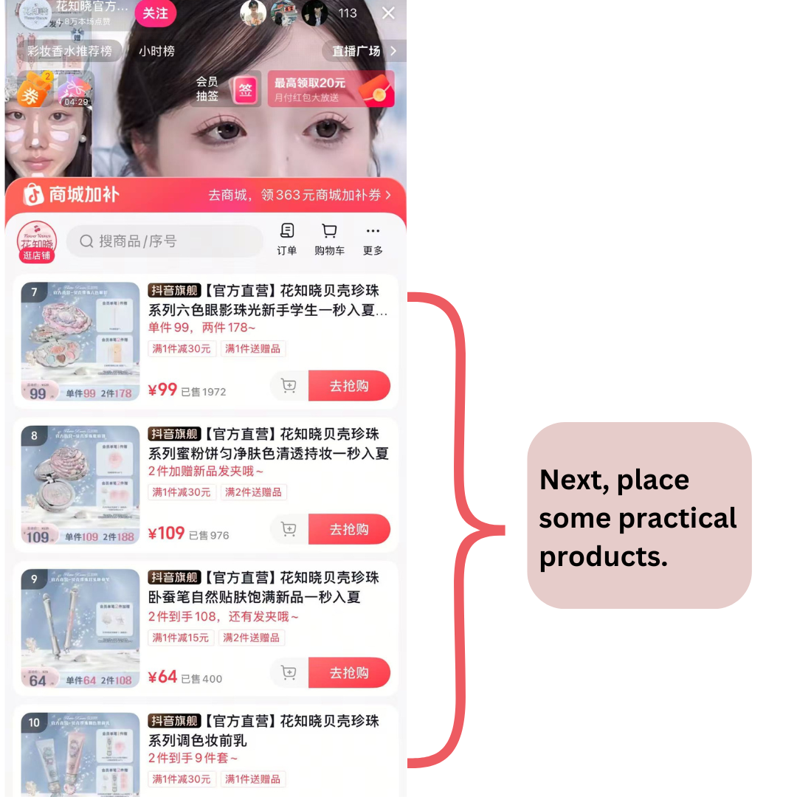
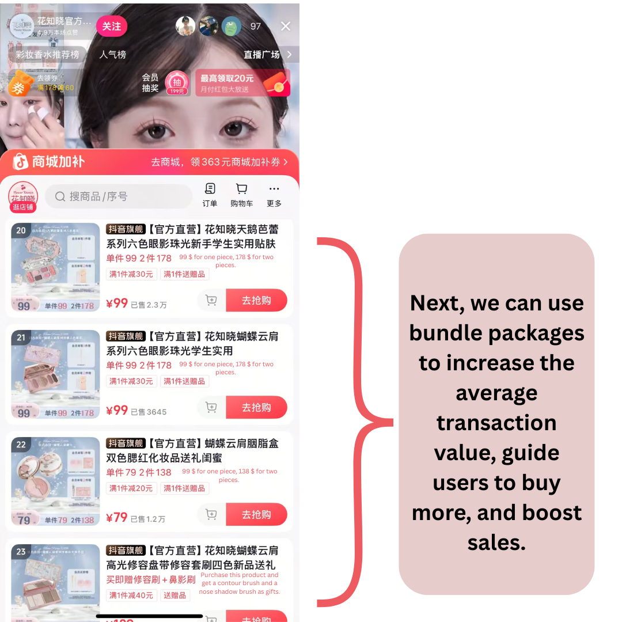

3. Creating a product pitch card for each item (FAB method)

Element | Description | Example (Bamboo Fiber Tissue)
F | Basic function | "Made from 100% degradable bamboo pulp"
A | Comparative advantage | "30% higher water absorbency than wood pulp paper"”
B | User benefit | "Wipes water stains without leaving debris, safer for babies to use"

Taking the PROYA TikTok live stream as an example:
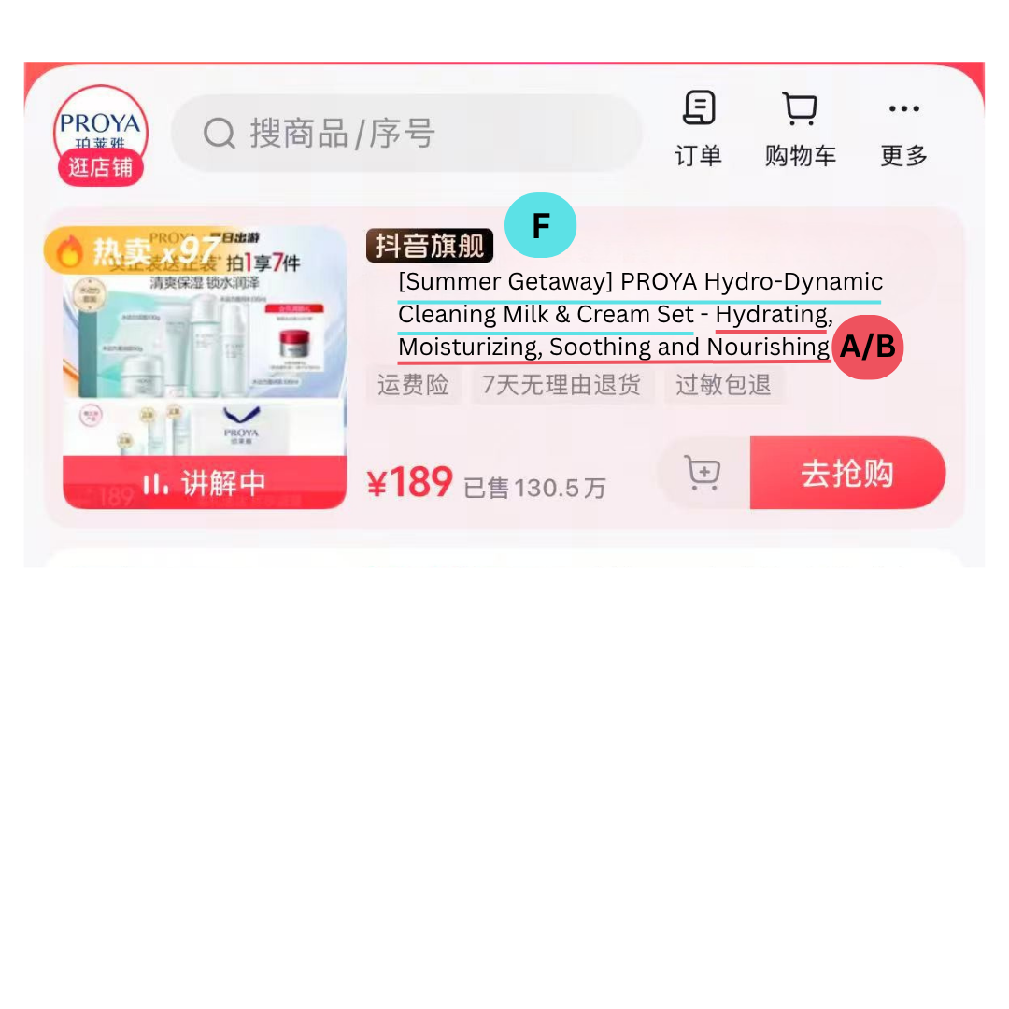

PART 3: In-Live Execution & Engagement

1. Sales Scripts That Convert

OMI LIVE Live Stream Execution Process (Example/Template)
Time Slot | Content Module | Description | Interaction/Sales Actions
00:00–03:00 | Opening & Warming Up | Greet audience + Wait for more viewers to join + Brief intro of highlights (e.g., eco-friendly hot items/limited-time benefits) | "Welcome everyone who just joined—feel free to say hi!"  "We’ll be giving away 1 eco-friendly mystery gift box tonight!"
03:00–08:00 | Brand Introduction & Value Implantation | Briefly share OMI LIVE’s philosophy: environmental protection, sustainable lifestyle, and authentic recommendations | Interactive Q&A: "What’s one eco-friendly choice you’ve made recently?"
08:00–15:00 | Product ① Demo (e.g., plastic-free toiletries/compostable toothbrushes) | Explain functions + Demonstrate scenarios + Address pain points | "We’re releasing the first wave of $5 no-threshold coupons—only for the first 20 orders!"
15:00–18:00 | Comment Interaction & Quick Q&A | Respond to viewers’ questions + Select 1 winner for a giveaway | "Type ‘OMI Eco’ to enter the lucky draw"
18:00–25:00 | Product ②: Lifestyle (tea, eco-friendly cups) | Compare "traditional vs. eco-friendly" + Talk about usage habits + Highlight eco-friendly design | "Type “eco” if you like the green cup!"
25:00–28:00 | Mini Interactive Games | e.g., Spin the wheel/Quiz/Price guessing | Increase watch time + Encourage likes and follows
28:00–35:00 | Product ③: Eco-friendly pet supplies/home cleaning products | Emphasize practicality + Emotional connection + User feedback | "Order tonight and get a set of natural deodorizing bamboo charcoal bags for free!"
35:00–38:00 | Quick Summary + Emphasize Limited-time Benefits | "Tonight’s discounts are only available in the live stream"  "Prices will return to original after the stream ends" | Urge to add to cart and save items
38:00–42:00 | Product ④: Grand finale (e.g., special collaboration items, limited stock) | First "plant interest" then "countdown" to drive impulse purchases | "The link will go live in the last 3 minutes!"
42:00–45:00 | Closing Thanks + Guide to Follow/Join Community | Announce lucky draw results + Thank viewers for comments + Guide to follow/secondary retention | "Join our eco-friendly community—we have surprise recommendations every week!"

Need to notice:

- Switch topics or products every 8–10 minutes to avoid audience fatigue.
- It is recommended to have interactions every 5–7 minutes (such as "Type '1'", "Leave a comment", "Issue coupons").
- The stage manager is responsible for rhythm reminders, comment replies, and coupon distribution simultaneously.
- Background music can be used to enhance the atmosphere, but care should be taken to ensure the volume does not overpower the voice.
- During the live broadcast, it should be repeatedly emphasized: Environmental protection = not a burden, but a smarter choice!

2.Interaction Tactics & Objection Handling

Scenario | Interaction Method | Example Script / Prompt
When the atmosphere is cold | Throw out simple questions + Emoji calls | "How many times have you been to OMI's live stream? Type '1' to let us see "
Build value resonance | Raise questions related to environmental concepts | "Have you tried to get rid of disposable plastics yourself? Leave a comment to tell us your story!"
Promote orders | Interaction countdown / Limited stock info | "Link goes live in the last 10 minutes! Only 12 items left in stock~"
Enhance goodwill | Read comment names + Thank with likes | "Thanks Annie for placing an order! Linda is also in our live stream~"
Guide conversion | Set interaction thresholds to encourage purchases | "Leave a comment 'Eco-friendly life' to get a 10% off coupon + a hidden gift"

3. Common Objections & Handling Tips

User Objections | Response Suggestions | Recommended Script
"Is this really environmentally friendly?" | Emphasize certification / material / packaging | "All the products we recommend have FSC certification or natural degradable labels, and they have a longer service life, making them truly sustainable choices."
"It's a bit expensive. Is it worth buying?" | Compare service life + long-term value | "Although the unit price is a bit higher, for example, this bamboo fiber cleaning cloth can be reused 200 times, which is equivalent to replacing 200 sheets of kitchen paper. It's a win-win choice for both environmental protection and cost-saving."
"Is it really effective?" | Highlight real user feedback / demonstrate | "You can check the comments—many repeat customers are posting 'Super useful'. And we've demonstrated the effect live, so you can see it for yourself~"
"Is it easy to clean / maintain?" | Give examples + scenario-based explanation | "For instance, this litter box is made of stainless steel. It can be cleaned with a simple rinse, leaving no odor—total lifesavers for lazy people."

4. High-Converting Language Patterns

- Scenario-based:
"If you're also looking for a household cleaner that's fragrance-free and gentle on your baby's skin, you can definitely buy this one without hesitation."
- Empathy-based:
"I used disposable tissues for years too, until one day I saw a video of a sea turtle trapped in plastic... That day, I switched to BimBamBoo."
- Scenario + Action-guiding:
"Carry a small spray bottle when you go out, and you'll feel fresh and reassured wherever you are. There's still a discount if you click the shopping cart now."
- "Regret-missing" type:
"This cat urine cleaner is usually out of stock year-round. We just received a new batch from Australia today, and it's only available in the live stream~"

5. Bonus：Suggestions for New User Acquisition Interactive Games (to improve retention + conversion)
Name | Gameplay | Example
Comment Building | Set keyword comments for lucky draw | "Leave a comment with 'Low-carbon life'—we'll draw one winner for an experience pack every 10 participants!"
Limited-time Flash Grab | Open a hidden Bonuses link for 10 minutes | "We're launching a hidden link now, only open for 10 minutes—there's a big gift pack inside!"
Real Story Co-creation | Encourage users to share environmental stories | "What's the most meaningful environmental action you've taken? Leave a comment—we might read it out and send a small gift~"

Reminders for Hosts

- Use viewers' nicknames to get closer to them.
- Downplay the "selling" tone, and emphasize "experience," "resonance," and "lifestyle."
- Make good use of data (sales volume, environmental protection data, material composition) to enhance trust.
- Remember to repeat the core value: "Environmental protection is not about sacrificing quality of life, but making life cleaner and simpler."”

6. Product Script Template
- [Product Name] Compostable Toothbrush
- Demo Duration: 5 minutes
- Core Selling Point: "90-day soil burial degradation = 1 bamboo saves 10㎡ of forest"
- Script Structure:
F→ "Corn starch + bamboo fiber material"
A → "10 times faster degradation than plastic toothbrushes"
B → "Your brushing = helping reduce the Earth's burden"

Part 4 FAQ & Answer Toolkit for Live Sales
1. Regarding the Environmental Friendliness of Products
Q1: Are your products really environmentally friendly? Do you have certificates?
A: All products we recommend come from sustainable brands, such as [Bim Bam Boo], [Peace Coffee], [Dr. Lisa], etc., all of which hold certifications like FSC®, Vegan, and B Corp. We don’t just look at packaging; we also check whether the raw materials and the entire production process are friendly to the planet.

Q2: Are these eco-friendly alternatives not very easy to use?
A: In fact, many customers are surprised on their first try of eco-friendly products, saying, “How come they’re even better than regular products!” For example, bamboo fiber tissues are not only soft but also stronger; natural deodorants eliminate odors without being pungent, and are instead gentler and more reassuring.

Q3: Can eco-friendly cat litter really deodorize? I’m worried my home will smell bad.
A: Products like tofu cat litter have strong water absorption and deodorizing power, and many pet parents can’t go back to other litters after using it. What’s more, when paired with natural bamboo charcoal bags, the odor absorption is even more thorough. The key is that these ingredients are safe for pets—even if they lick them, it won’t cause any harm.
2. Regarding Usage Scenarios and Habit Switching
Q4: How do I use laundry sheets? Are they very different from traditional laundry detergents?
A: It’s completely easy! Just throw the laundry sheet directly into the washing machine—it dissolves easily. It’s more space-saving than liquid detergent, doesn’t stain hands, and won’t spill. The cleaning power is also fully reliable, making it especially suitable for small families and renters.

Q5: Can natural deodorants completely eliminate urine odors?
A: For example, [Cat Wee Cleaner] uses plant enzyme ingredients that neutralize odors instead of masking them, truly eliminating cat urine molecules. We’ve tested it ourselves on carpets, sofas, and litter boxes—it works!

Q6: I have kids/pregnant family members at home. Are these products safe to use?
A: That’s exactly why we recommend them! Products like natural cleaning sprays and tissues are completely free of bleaching agents, fragrances, and chlorine, making them friendly to sensitive groups. They’re also suitable for families with pregnant women and infants.

3. Regarding Price and Cost-Effectiveness
Q7: Eco-friendly products are generally more expensive. Are they really worth buying?
A: We’ve been emphasizing that environmental protection isn’t about being more expensive, but more "economical." For example, one laundry sheet is enough for one wash with no waste; a bamboo cup can last for over 5 years; and tofu cat litter requires less usage. Moreover, you can use them with greater peace of mind—they’re better for pets and your health, and the long-term cost is actually lower.

Q8: Are there any discounts? How to buy more cost-effectively?
A: There are exclusive discounts for orders placed during the live stream. Many products come with limited-time benefits such as buy-one-get-one-free, free shipping, and gifts. If you’re purchasing for the first time, we’ll also recommend trial packs or combo packs, which are very cost-effective!

4. Regarding Logistics and After-Sales Service
Q9: Where is the product shipped from? How long will it take to arrive?
A: Most of the brands we collaborate with have warehouses locally or in Europe and America. Deliveries usually take 3–5 days(for example), and full logistics tracking is supported.

Q10: Can I return it if I’m not satisfied?
A: Of course. The brands we work with support 7-day(for example) no-questions-asked returns and exchanges (products must remain intact). Specific rules for each product will be noted during the live stream～

PART 5: Post-Live Review & Optimization

1. Post-Live Review Checklist

Dimension | Checkpoint | Tool/Method
Audience Performance | Total viewers / Average watch time / Peak concurrent viewers | Platform data backend (e.g., Instagram Insights / Shopee Live Analytics)
Transaction Conversion | Number of cart clickers, order placement rate, conversion funnel | E-commerce platform sales reports
Interaction Participation | Number of comments, likes, coupon usage rate | Live stream tools & stage manager records
Rhythm Performance | Which segment had the most audience drop-off? Which had the highest conversion? | Review live stream recordings (mark by minute)
Product Feedback | Which products triggered the most interest / questions / repurchases? | Comprehensive analysis of comment keywords + sales data

2. Precise Question Review Guide (Live Debrief Questions)
- Which product, after being explained, immediately brought a peak in conversions?
- In which segment of the explanation did the number of viewers leaving surge? What was the problem?
- Which keywords in the sales script received positive responses from the audience (e.g., "degradable," "safe for pregnant women")?
- Which FAQs appeared most frequently? Do they need to be explained in advance in the next live stream?
- Was the value output + interaction guidance completed within the first 3 minutes of the opening?
- Were there any cold moments during the live stream? How were they broken?
- Were there any unanticipated objections? Do answers need to be prepared in advance for the next time?

3. Action Plan for Optimization

Optimization Items | Action Suggestions | Responsible Person
Host Performance | Control speaking speed, improve question guidance, and make product logic clearer | Host themselves / Team for review
Interaction Design | Add keyword lucky draws and like challenge mechanisms | Operations / Stage Manager
Product Sequencing | Place products with high interaction / high conversion rates in the first half | Script Planner
FAQ Setup | Create FAQ answer cards before the live stream starts | Designer + Content Operations
Rhythm Arrangement | Switch rhythm / type every 7 minutes | Director / Live Script Optimizer
Next Live Stream Preview | Embed the time and highlights in advance at the end of this live stream | Host / Live Stream Planner

4.Example: Live Stream Review Record Template (Can be filled out after each live stream)

- Date: July 24, 2025
- Duration: 45 mins
- Viewers Peak: 213
- Total Orders: 72
- Comments: 458
- Conversion Peak: at minute 28 – when introducing bamboo-based cat litter
- Drop Point: minute 12 – long explanation of detergent ingredients
- Top Product: Cat Wee Cleaner (highest order + coupon use)
- FAQ Mentions: “Does it really neutralize smell?” ×7
- Optimization Plan

Part 6 Whatnot Live Sales – Practical Guide

1. Whatnot’s Core Gameplay
- Interaction Methods: Real-time auctions + comment (bullet comments)
- Transaction Mechanism: Countdown + "Sold" confirmation → Enhancing a sense of scarcity
- Scenario Applications: Ideal for limited editions, new product launches, and co-branded products

2.Screenshot Examples
• Opening Screen – Host introduction and preview of the auction or sale theme.
• Product Display & Auction View – Showing the live bidding interface with price updates and countdown timer.
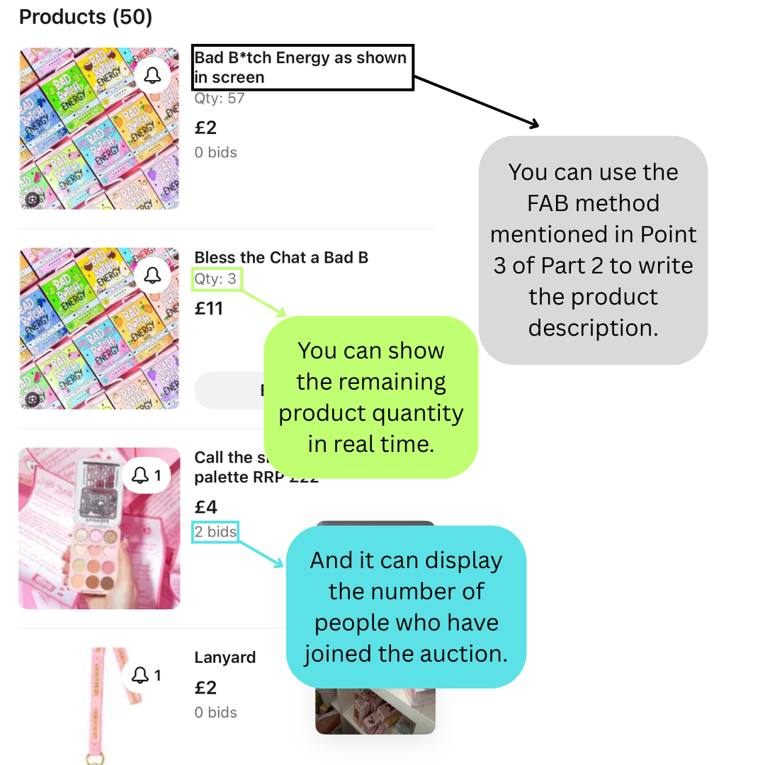
• Audience Interaction – Live chat and bidding activity in real time.
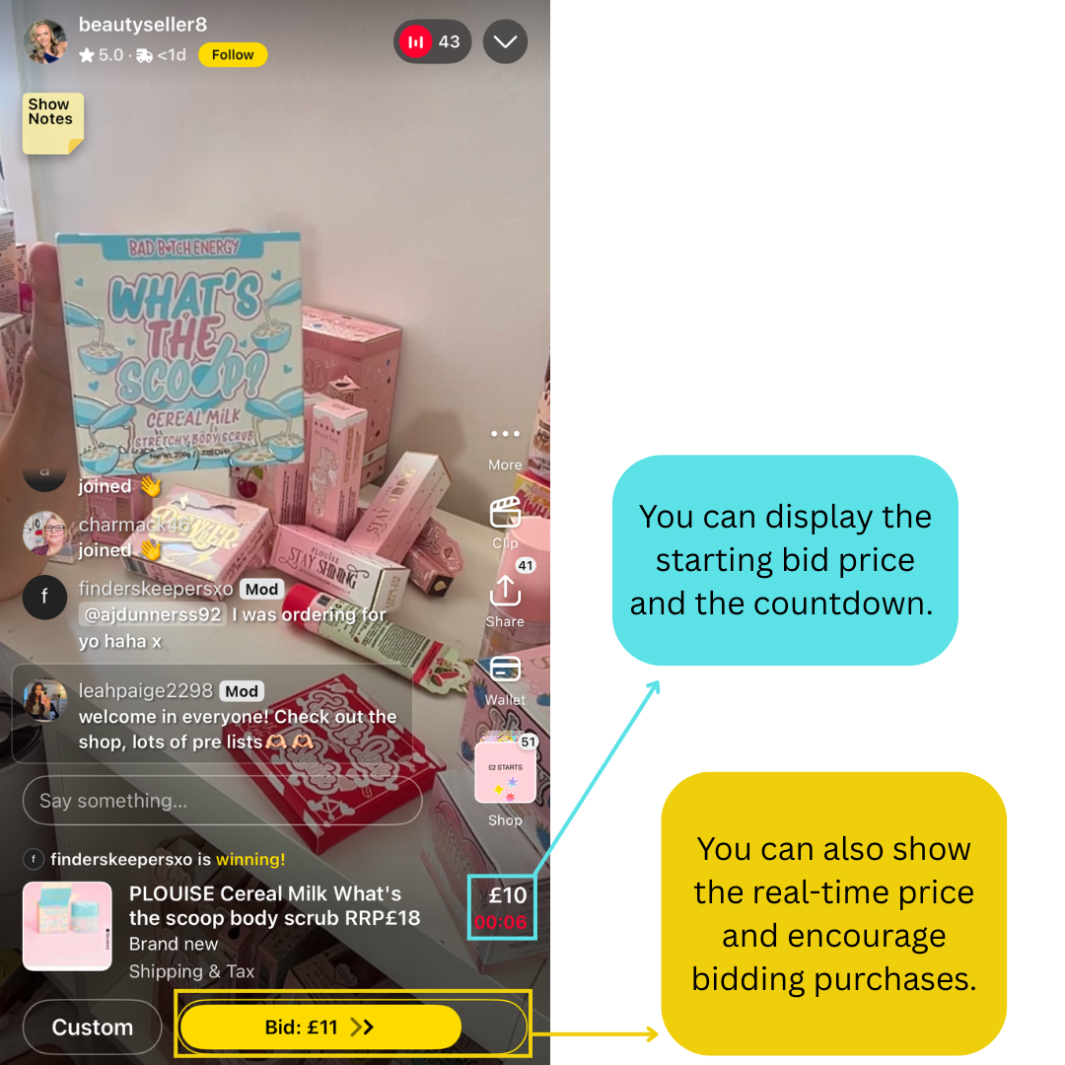

• Sale Confirmation – “Sold to @username” pop-up indicating the winning bid.

3. Example: 30-Minute Auction Flow on Whatnot
Time | Segment | Key Operations | Script Examples
0:00–2:00 | Opening Welcome | Self-introduction + Rule explanation | "Hi everyone, welcome to Omi live Auction! Every item tonight has an exclusive countdown—don’t blink!"
2:00–5:00 | First Product | Showcase + Explain value | "This cup is fully bamboo-made, eco-friendly and biodegradable. Starting bid is €5—who’s going to grab it?"
5:00–7:00 | Confirm Transaction | Announce winner + Interaction | "Congratulations @Anna for winning! Everyone can type ‘Eco’ in the comments to celebrate with her!"
7:00–25:00 | Rotating Auction Items | 2–3 minutes per item, with mini-games in between | "The next product comes with a free gift—type ‘1’ if you want it!"
25:00–28:00 | Summary of Offers | Recap highlights + Encourage repeat orders | "All orders tonight get free shipping + an eco-friendly gift bag—prices go back to normal once the stream ends!"
28:00–30:00 | Closing Guidance | Thank viewers + Guide to follow/join community | "Follow OMI LIVE and join our eco-lifestyle community—there are surprises every week!"

4. Practical Whatnot Operation Guide
- Countdown Settings: Keep each item’s auction time between 60–120 seconds to avoid slowing down the pace.
- Bid Increments: Set based on product value (e.g., €1, €2 increments).
- Interaction Insertion Points: Add a Q&A or mini-game every 2–3 items to maintain engagement.
- Bonus Design: Random lucky draws / order bonuses (e.g., "The 5th order gets a free eco-friendly tote bag").

5. Visual & Layout Tips
- Highlight Whatnot’s unique interface elements (auction button, “Sold” alerts) with contrasting colors.
- Keep layout consistent with TikTok/Douyin examples for visual harmony.
- Add a short “How OMI LIVE Can Apply This” note below each screenshot for direct value connection.

6. Points for Omi live to Draw On
- Combining auctions with direct purchases: Use auctions for scarce products and keep direct purchases for regular products to enhance transaction stability.
- Balancing value and atmosphere: Highlight eco-friendly concepts + community interactions to create a perception of "buying not just a product, but an eco-friendly belief".
- Strengthening rhythm and engagement: Leverage the tension of auctions + the fun of mini-games to boost user retention and conversion.

Part 7 Avoid Live Stream Pitfalls
- Avoid reading the instruction manual → Use daily scenario demonstrations instead
(Example: Show how the coffee cup prevents scalding when holding hot drinks)
- Avoid ignoring bullet comments → The stage manager should synchronize key questions once every 30 seconds
- Avoid vague promotions → Display countdown and remaining stock on the same screen (e.g., 3 minutes | 8 left")

1. Live Risk Word & Compliance Sheet
Avoid Saying… | Say This Instead
“Guaranteed to work” | “Many users noticed great results”
“Cures acne” | “Helps soothe breakouts”
“Eliminates toxins” | “Supports your natural detox process”
“The best / #1” | “One of our most loved picks”
“No side effects” | “Gentle, minimal irritation reported”
“Heals your skin” | “Supports skin barrier recovery”
“100% effective” | “Formulated to deliver visible results”
“Instant results” | “You may notice changes with consistent use”

2. What NOT to do in Live
Don’t Do This | Safer Option
Guarantee outcomes | Share your experience or customer reviews
Bash other brands | Focus on what makes yours unique
Give medical advice | Add disclaimer: “This is not medical advice”
Suggest financial outcomes | Say “We use affiliate links” (if applicable)

3. Safe & Clear Phrases to Use

Use Case | Safe Alternatives
Beauty products | “Lightweight & non-irritating” / “Helps balance skin over time”
Home & lifestyle | “Low-waste and easy to reuse” / “Good for you & the planet”
Health-related products | “Soothing on the skin” / “Formulated with natural ingredients”
Emotional appeal | “Feels calming in your routine” / “Makes your space feel fresh”
Customer endorsement | “Thousands of happy users” / “Chosen for its simplicity and quality”

