### PRACTICAL 5

Aim -: Understanding, Reading and Analyzing Routing Table of a network.

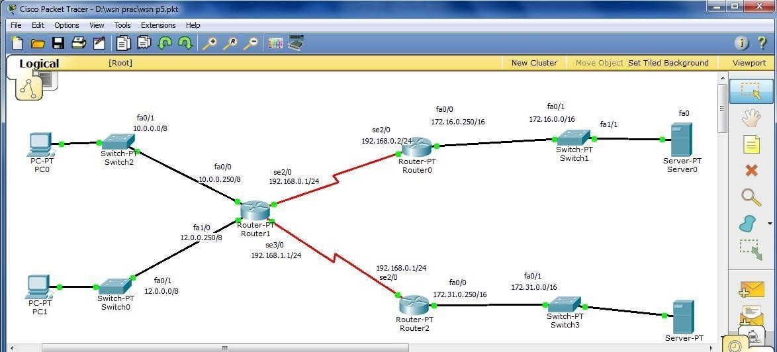

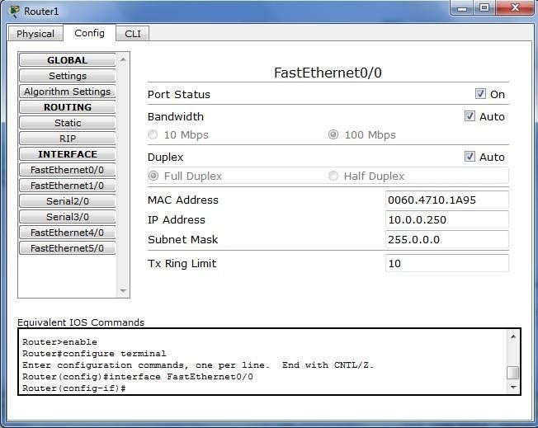

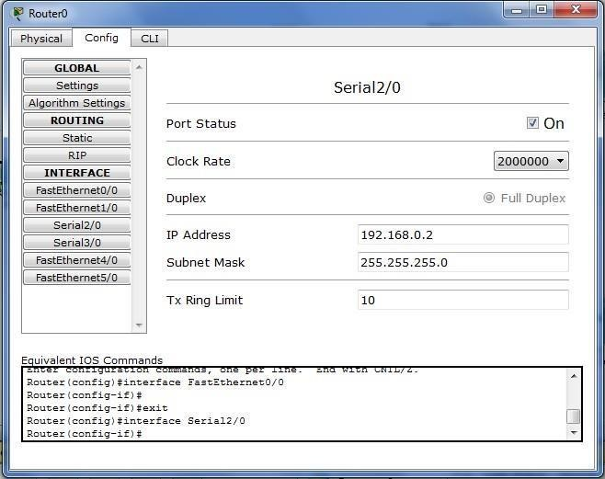

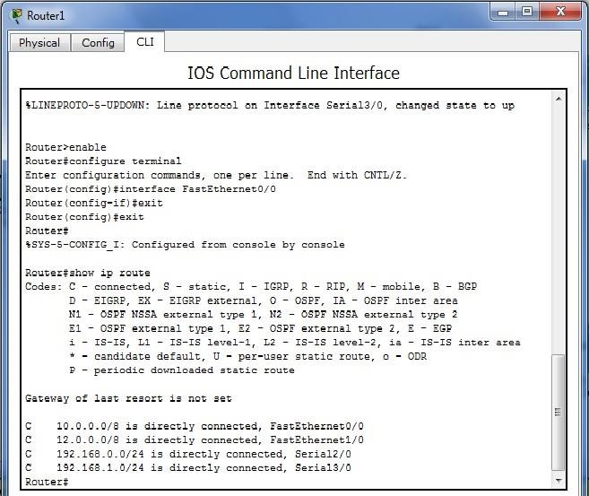

**PRACTICAL 7**

**Aim:** Implementation of wireless sensor network simulation.

1. Create the following topology.

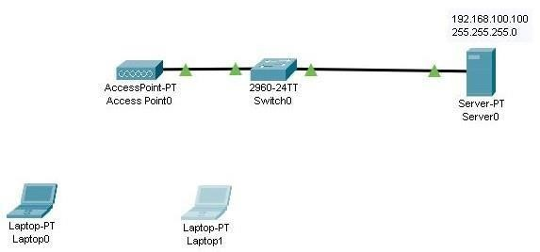

Assign the IP address and mask of server as 192.168.100.100 and 255.255.255.0 respectively.

1. To implement wireless connectivity, change the module of laptop devices as shown in the figure. Repeat for both the laptop.

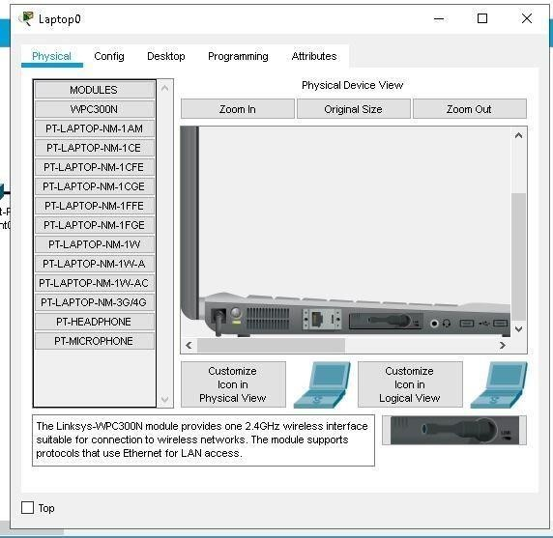

Once the changes are made and laptop is turned on, wireless implementation is displayed.

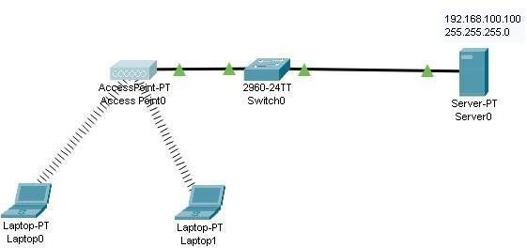

1. Change the SSID of server as follows:

SSID : wireless_name 2.4 GHz channel : 11

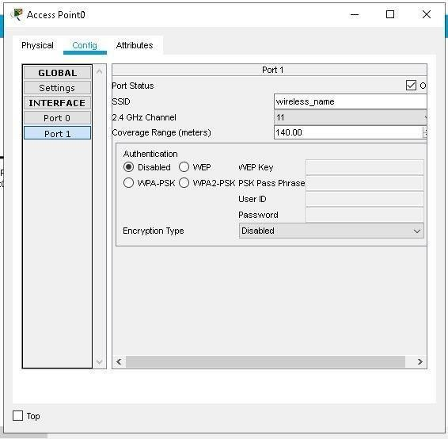

1. Set the IP address of laptop devices as

Laptop0 : 192.168.100.1 Laptop1 : 192.168.100.2

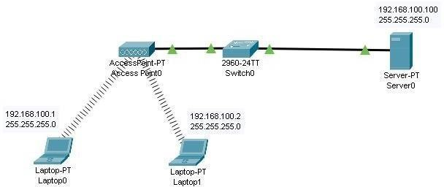

1. In the config, change the SSID of laptop device to wireless_name as shown below. Do the same for another laptop device.

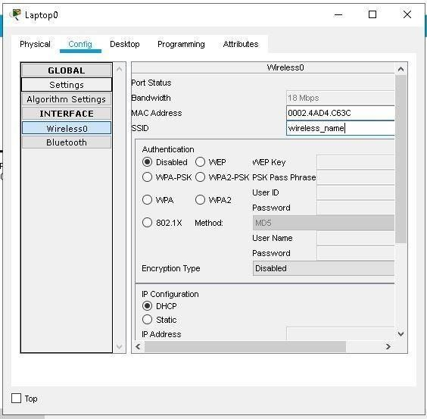

1. From the laptop device command promt, ping the server through the following command:

Ping 192.168.100.100

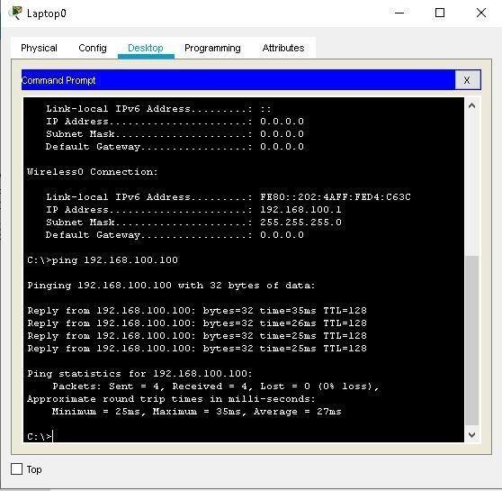

1. From laptop1 ping laptop0.

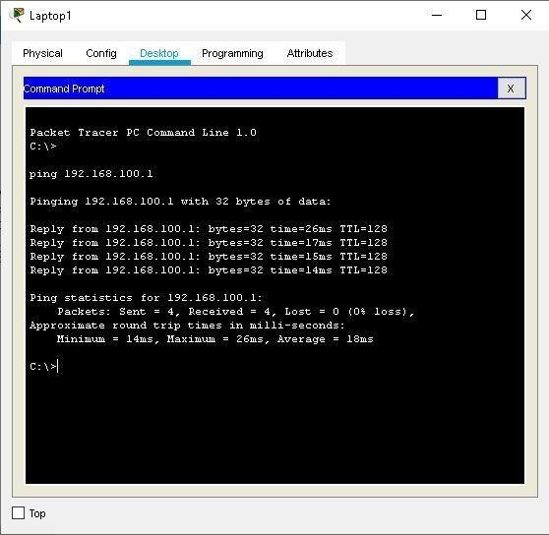

**PRACTICAL 8**

**Aim:** Create MAC protocol simulation implementation for wireless sensor

Network.

Consider the following topology.

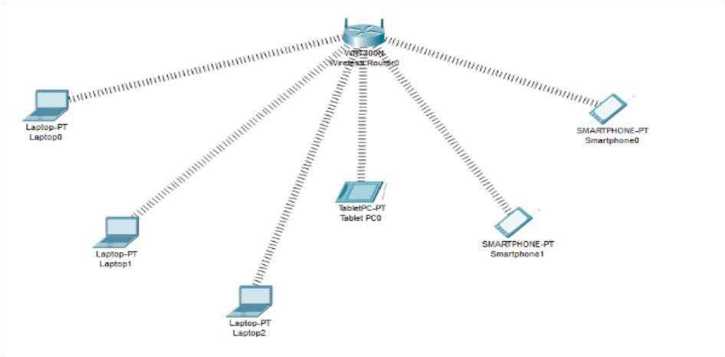

Adding the wireless interface to each Laptops

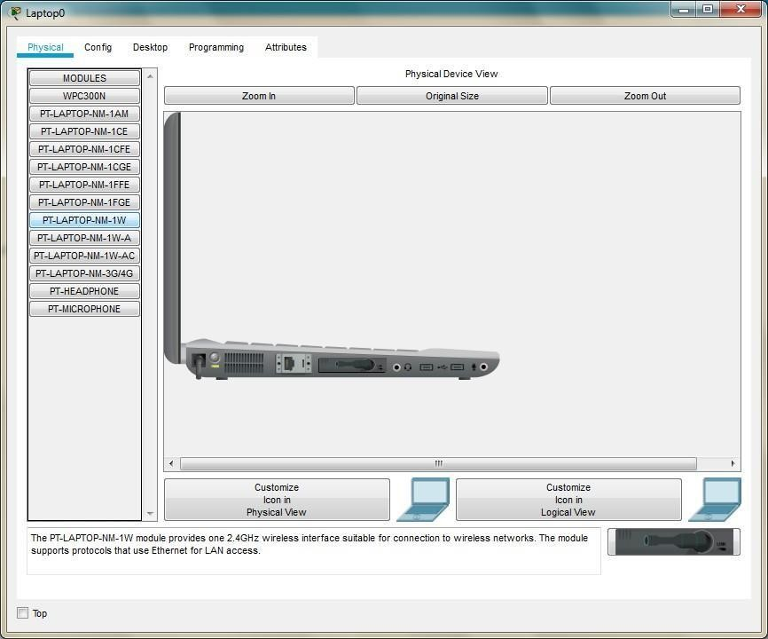

Copy the MAC address of each component as follows.

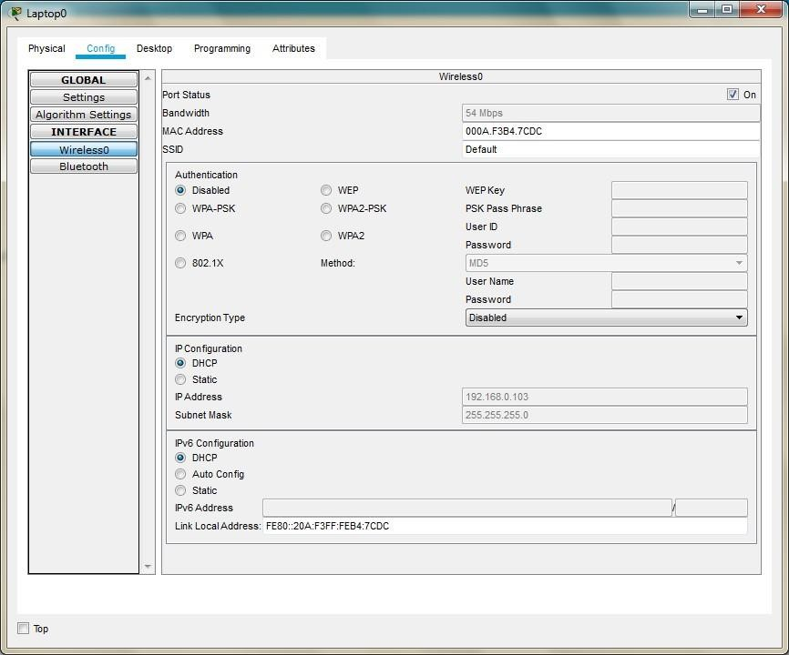

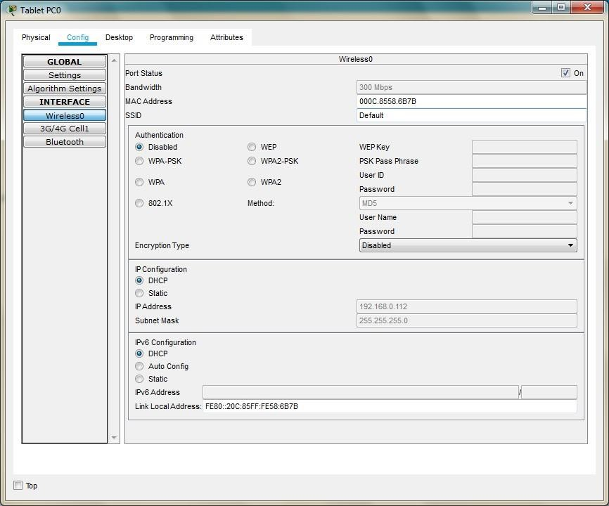

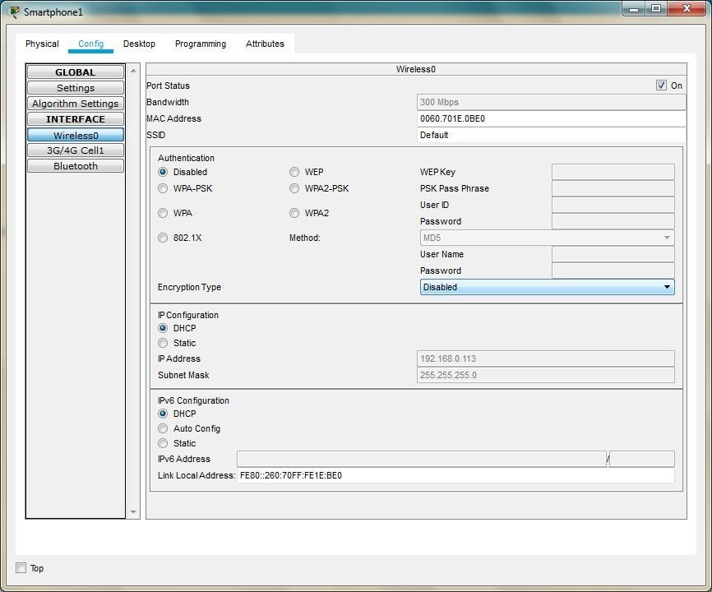

We note the following MAC addresses and convert them to the following form.

|  |  |  |
| --- | --- | --- |
| **Component** | **MAC Address** | **Converted MAC address** |
| **Laptop0** | **000A.F3B4.7CDC** | **00:0A:F3:B4:7C:DC** |
| **Laptop1** | **0001.4269.6539** | **00:01:42:69:65:39** |
| **Laptop2** | **0060.5CB8.B919** | **00:60:5C:B8:B9:19** |
| **TabletPC** | **000C.8558.6B7B** | **00:0C:85:58:6B:7B** |
| **SmartPhone0** | **00D0.9774.32BD** | **00:D0:97:74:32:BD** |
| **SmartPhone1** | **0060.701E.0BE0** | **00:60.70:1E:0B:E0** |

Now we add few addresses in the wireless MAC filter of the Wireless Router and then use the given options for either allow or deny the Wireless access.

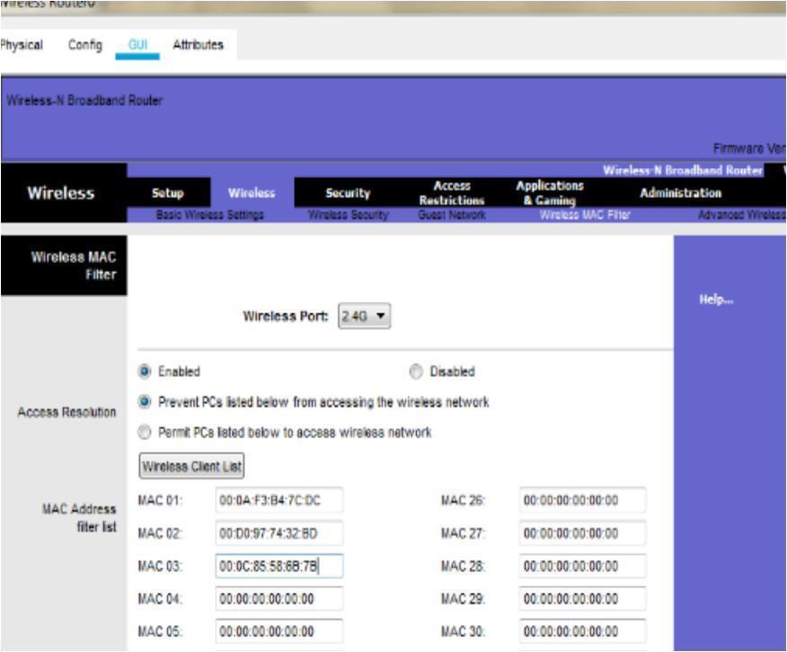

As seen in above screen shot, we add the MAC address of Laptop0, TabletPC SmartPhone0 in the list so as to deny them accessing the Wireless network and then save the settings

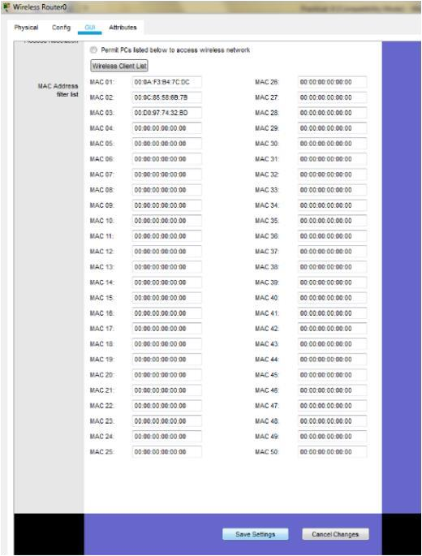

The result so obtained is as shown, the three devices denied any wireless connectivity.

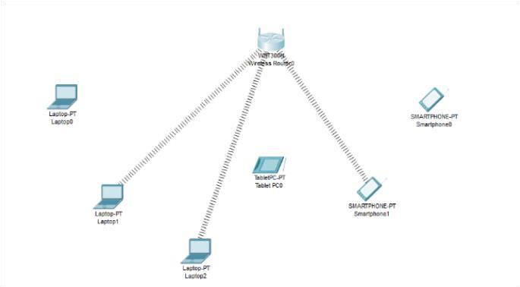

Similarly, we can change the setting so that the above devices get wireless connectivity and the remaining devices do not get the wireless connectivity

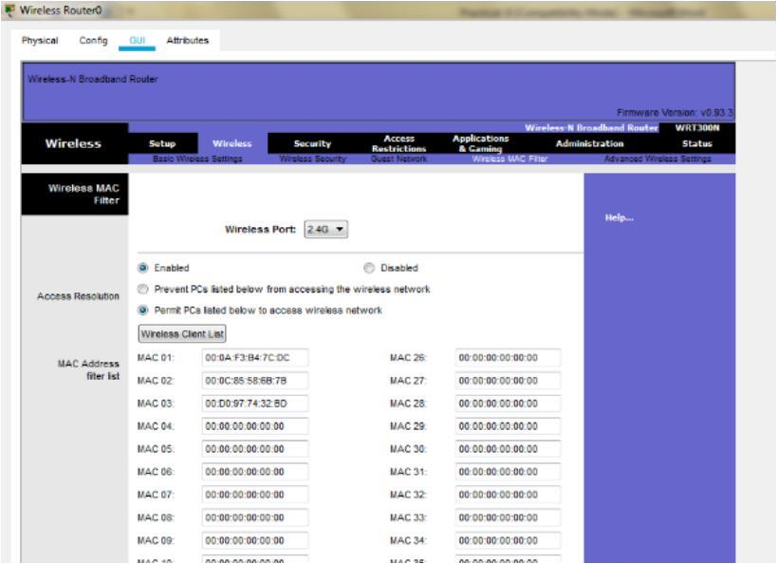

And save the setting and get the following.

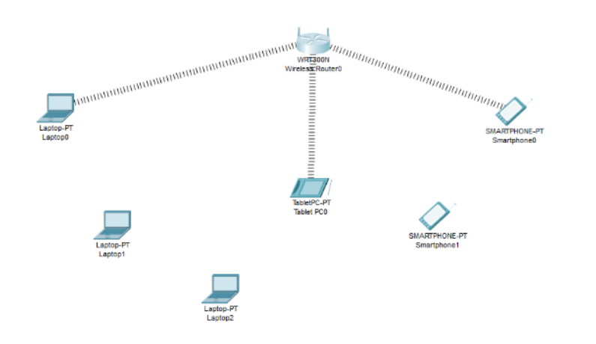

## PRACTICAL 9

**Aim:** Simulate Mobile Adhoc Network with Directional Antenna.

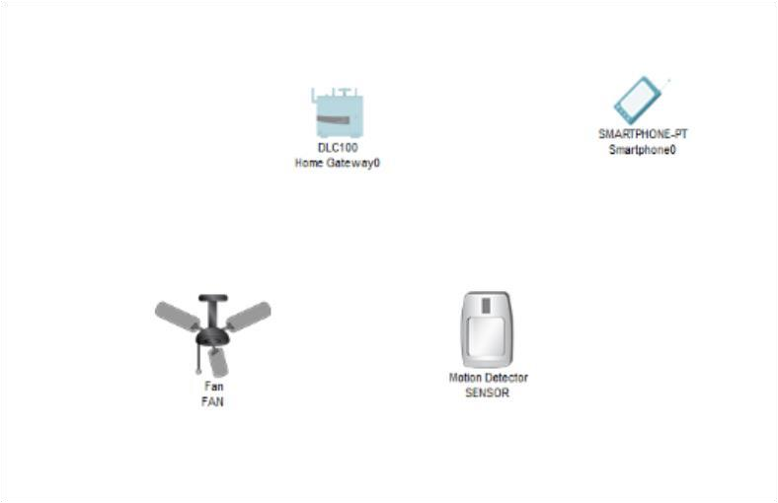

Consider the following



topology.



Click on the Fan and do the following

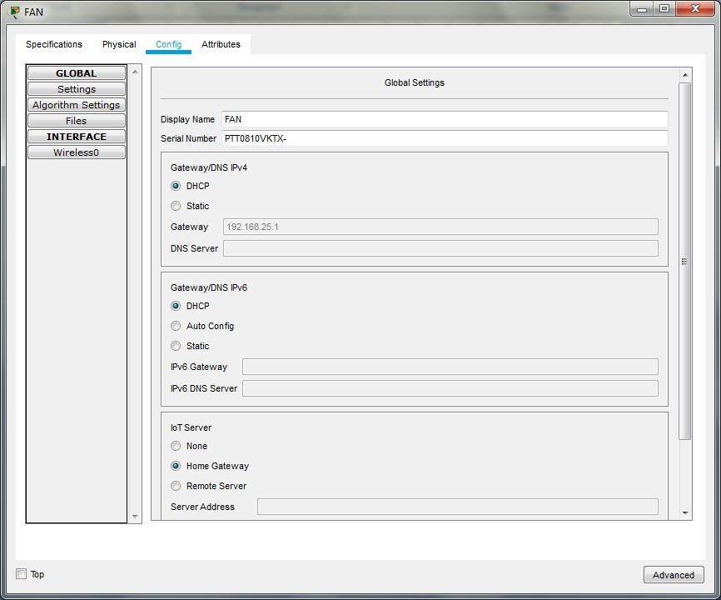

In the Advanced setting do the following for the Network adapter

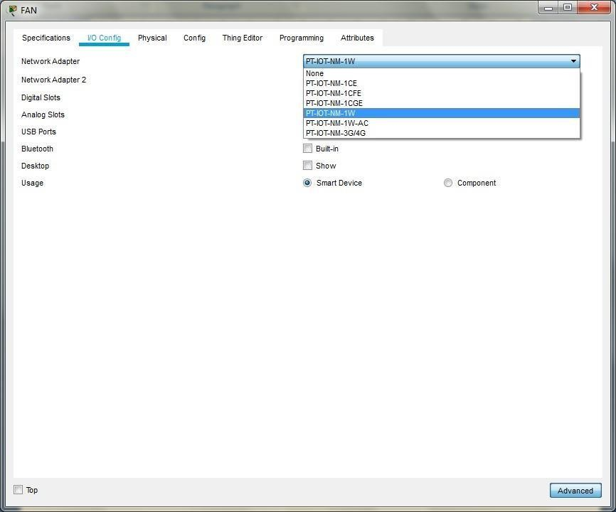

For the motion Detector sensor do the following

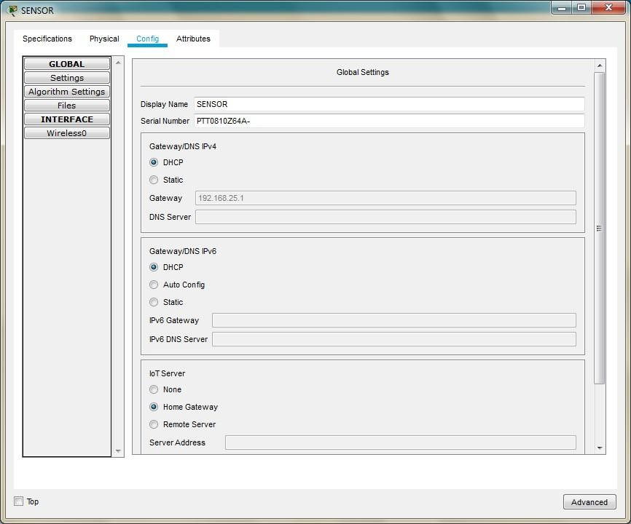

In the Advanced setting do the following for the Network adapter

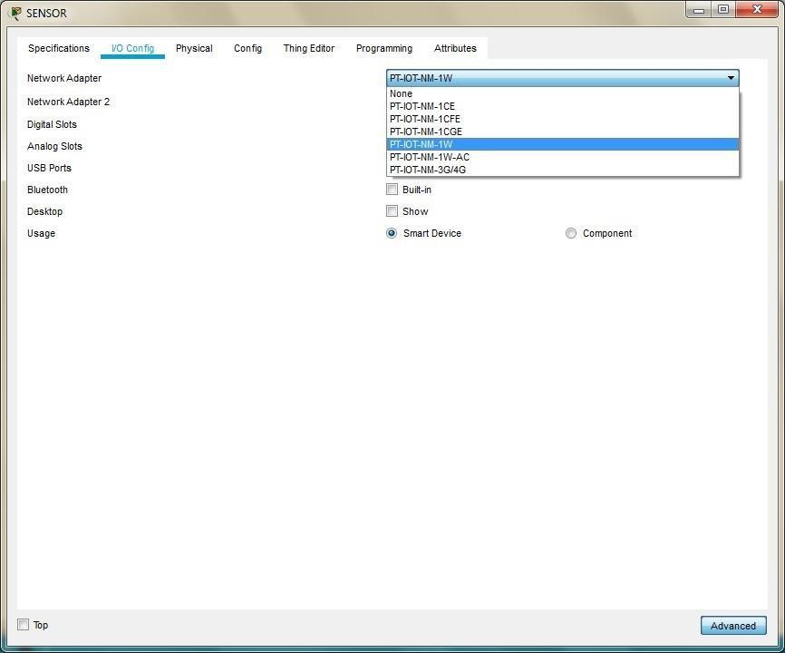

For the smartphone change the SSID to the SSID in the Home Gateway0

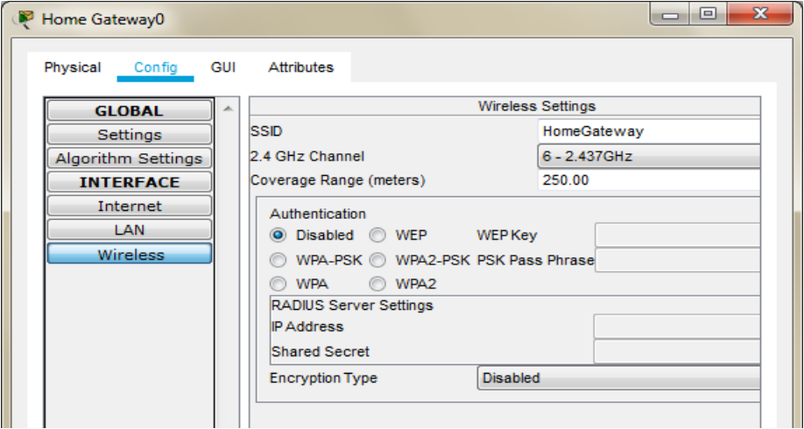

As seen above the SSID is HomeGateway, we use the same and set the SSID in the Smartphone

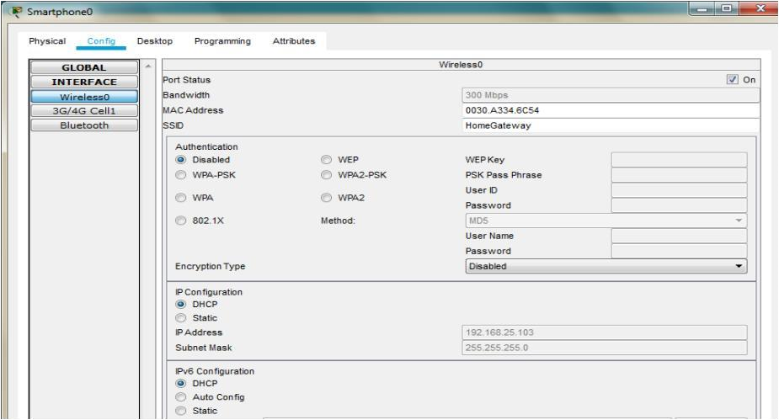

All the devices are now connected to the Home Gateway

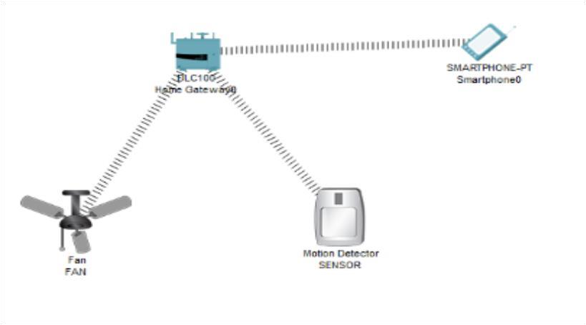

Now open the Web browser of the SmartPhone and type the IP address of the HomeGateway

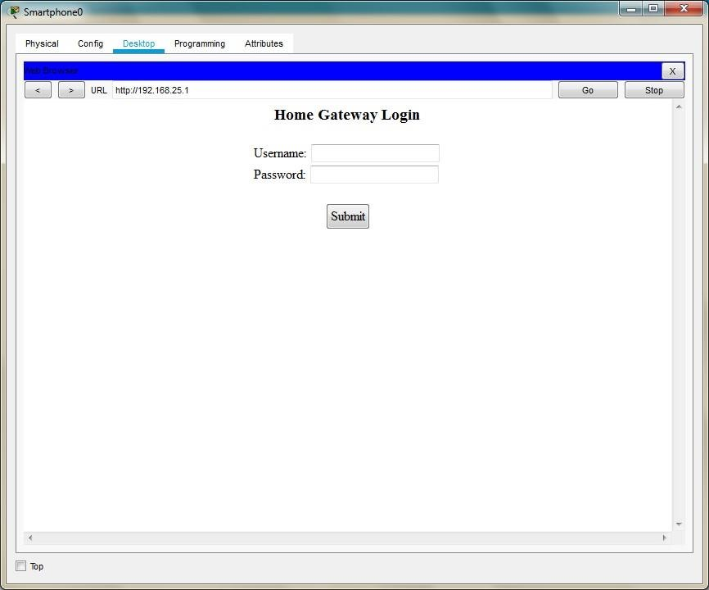

Username : admin

Password : admin

After logging click on conditions and do the following

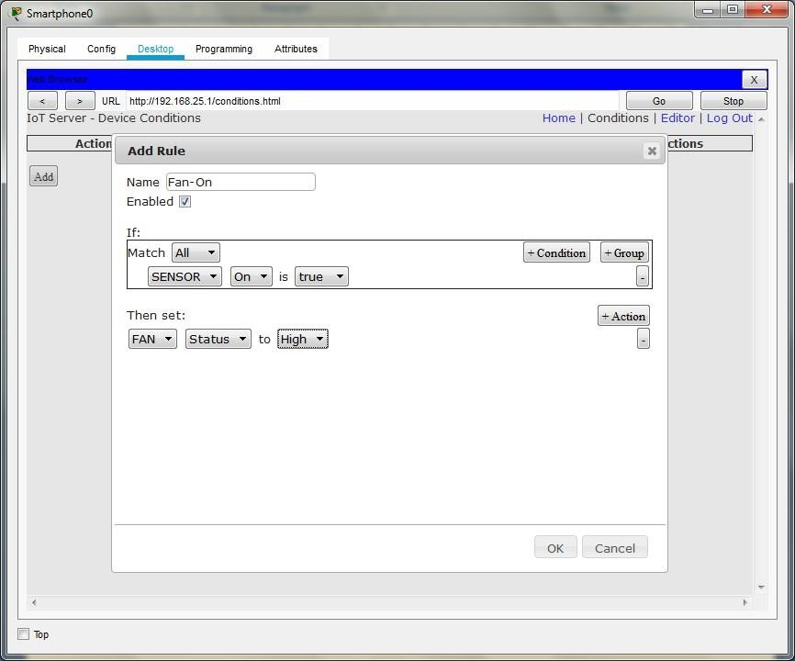

Add another condition as follows

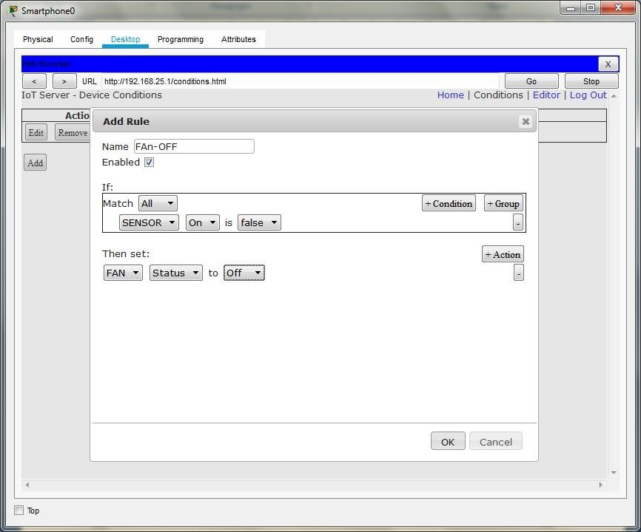

Press the go button after adding the two conditions

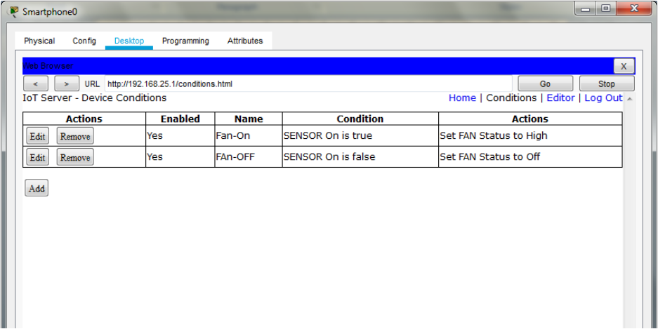

In order to turn ON the fan Press the ALT key and left-click the mouse over the Sensor

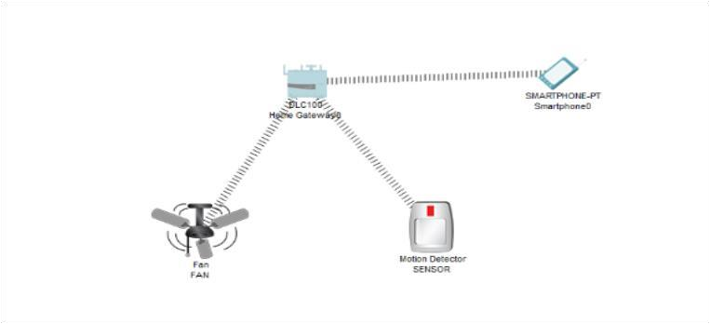

## PRACTICAL 10

**Aim -:** Create a mobile netwrok using Cell Tower, Central Office Server, Web browser and Web Server. Simulate connection between them.

Steps :-

1. Create a network using smartphone, wireless router WRT300N, Hub-pt, 1841 Router, central-office-server, Cell-Tower.
2. Connect cell tower and central office server using coaxial cable.

1. Connect wireless router WRT300N, Hub-pt, 1841 Router, centralofficeserver using copper straight through wire.

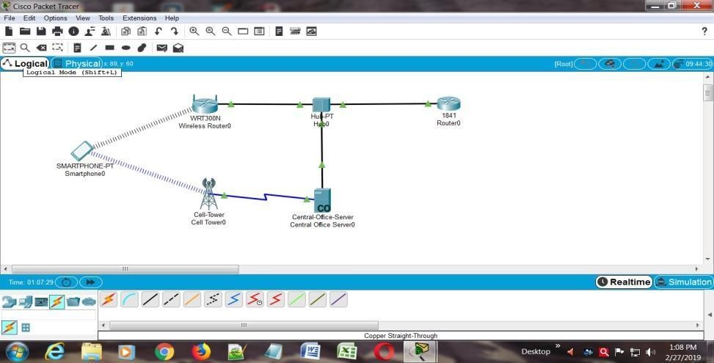

1. Click on wireless router.in config tab select internet.in internet choose ip configuration as static and set ip address and default gateway.

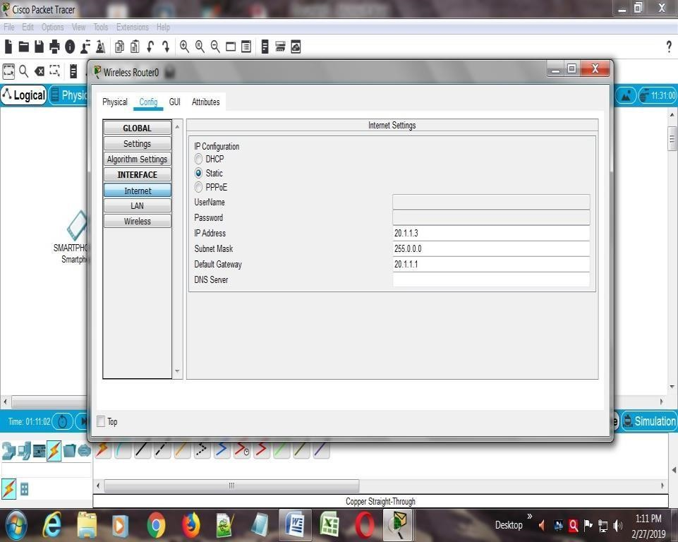

1. Click on router 1841. In config tab select interface and give ip address.

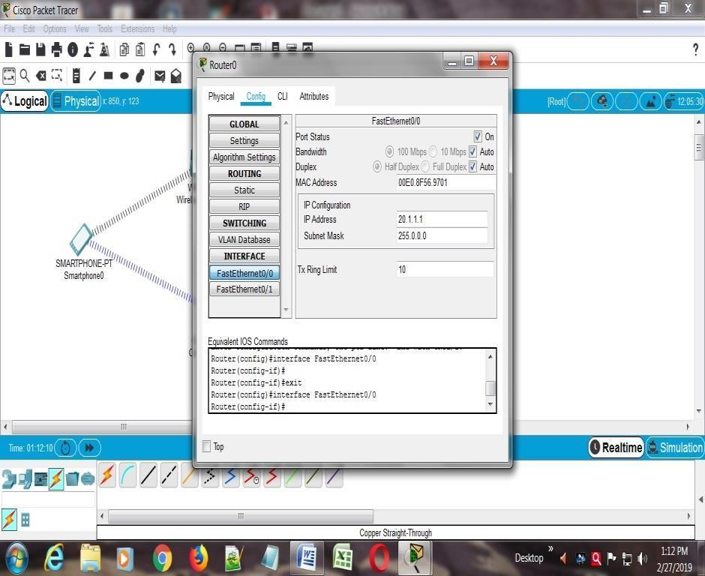

1. Click on smartphone and ping router1841

