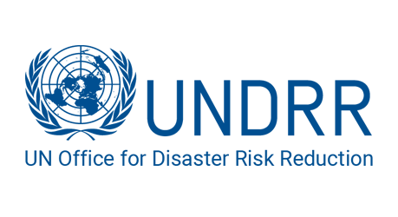 

**Committee:** United Nations Office for Disaster Risk Reduction

**Country:** The Commonwealth of Australia

**Agenda:** Enhancing inclusive early warning early action in disaster prone regions to achieve zero climate disasters.

The aim of #ZeroClimateDisasters is ambitious yet essential in order to eradicate the catastrophic effects of climate change. By 2027, the UNDRR's #ZeroClimateDisasters campaign intends to double down on poverty, inequality, and vulnerability in order to meet the UN SDGs. It also wants to provide early warning and action for everyone by scaling up effective comprehensive risk management. Improving inclusive early warning and action (EWEA) systems is at the heart of this goal. The predicted $210 billion in worldwide economic losses resulting from climate-related disasters in 2020 is a substantial rise from the $140 billion annual average over the preceding ten years. Australia is aware of the urgency and need for disaster risk reduction (DRR) initiatives since it is a country that is regularly hit by climate-related disasters such floods, cyclones, and bushfires. As a founding partner of the "Early Warnings for All" campaign, our goal is to cover every early warning system by the year 2027. Australia emphasizes how important it is to have efficient early warning systems (EWS) and early action (EA) plans. Australia is a proponent of the creation of Early Warning Early Action (EWEA) systems that are inclusive and accessible to all communities, especially underprivileged ones.

Australia strongly believes that enhancing inclusive early warning and early action (EWEA) systems is essential to achieving the goal of zero climate disasters. As a nation frequently affected by these calamities, Australia has firsthand experience of the devastating impacts of climate-related disasters. Australia is actively contributing to the global EWEA agenda through several initiatives:

* Australia provides financial and technical assistance to developing countries for EWEA system development, Through the Australian Department of Foreign Affairs and Trade (DFAT)
* Australia invests in developing and deploying cutting-edge technologies for EWEA. This helps developing countries establish and maintain effective EWEA systems.
* Originated by Geoscience Australia, The Sentinel Hotspots system, uses satellite data to identify and monitor bushfires in real-time.
* Australia advocates for Community-Based Disaster Risk Reduction (CBDRR) programs in order to ensure active participation of communities in EWEA.
* A commercial service named Early Warning Network is introduced in Australia that delivers alerts about severe weather and other hazards via SMS, email, and phone calls.
* With the aim to educate young Australians about disaster resilience through school programs, Australian Disaster Resilience Education for Schools (ADRES) is in motion.

In order to enhance inclusive early warning early action in disaster prone regions, Australia would suggest the followings:

* According to the provision of UNDRR, the long-delayed commitment by states to contribute $100 billion annually to poor nations needs to be fulfilled. This involves improving through the Bridgetown Initiative and allocating funds especially for the Early Warnings for All program and the Santiago Network.
* Provide assistance to the developing countries in establishing strong legal frameworks and governance structures around EWEA.
* Discovering innovative financing models like blended finance, which combines public and private funds for EWEA projects. Additionally, public-private partnerships can leverage private sector expertise and resources for building and maintaining EWEA infrastructure.
* To make the technology more accessible and adaptable to local needs, promote open-source software for EWEA components.
* Expand ongoing initiatives emphasized on training disaster management professionals in developing countries on utilizing advanced EWEA technologies.

**References:**

<https://www.undrr.org/zero-climate-disasters>

<https://www.undrr.org/implementing-sendai-framework/sendai-framework-action/early-warnings-for-all>

<https://www.undrr.org/terminology/early-warning-system>