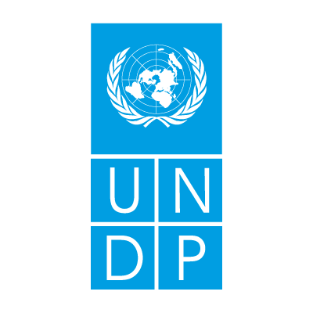 

**Committee:** United Nations Developmental Programme (UNDP)

**Country:** Finland

**Agenda**: Mitigating the Impact of Escalating Food and Energy Costs Leading to Poverty in Sub- Saharan Africa.

A major obstacle to achieving sustainable development goals is the way that rising food and energy prices have exacerbated poverty and food insecurity in Sub-Saharan Africa. Numerous elements have a part in the price increase within this area. Vulnerability to climate change, the conflict between Russia and Ukraine, the COVID-19 pandemic, internal strife, and infrastructure issues indifference of stakeholders, mismanagement of supple chains, geographical faults and many more. Still today, the number of malnourished in SSA stays stubbornly high, despite the latest commitment of the world community through UN Millennium Development Goals (MDG) to half hunger by 2015, only four years from now. In sub-Saharan Africa alone, 600 million people, or approximately 53 per cent of the region’s population, live without access to electricity. Hundreds of millions more have only limited or unreliable electricity The overlapping crises are affecting many parts of Africa’s energy systems, including reversing positive trends in improving access to modern energy, with 4% more people living without electricity in 2021 than in 2019. It is widely recognized that food and energy security will remain a big challenge in SSA throughout the twenty-first century and the by Sustainable Developmental Goals of no poverty and zero hunger by 2030 will not be met, particularly in SSA.

The concept of Sustainable Development Goals is a leading driver of policy planning for the Finnish government. Finland was ranked number one in the SDG Index of the Sustainable Development Report 2021 published by the Sustainable Development Solutions Network SDSN and the Bertelsmann Stiftung. The comparative study rates all UN member states’ performance in advancing Agenda 2030. Finland scored well in eradication of poverty, health, education, water management, energy, equality, peace and justice. Moreover, Finland has set one of the most ambitious climate targets in the world, a legal obligation to reach carbon neutrality by 2035. It has made notable progress towards this target, deploying the first new nuclear reactor in Europe in over 15 years and strongly expanding wind generation. Finland has made its progress on its clean energy transition, the country has the second lowest share of fossil fuels in its energy supply among IEA members. The geographical focus of Finland’s development cooperation is Africa, and cooperation is carried out mainly with the least developed countries. It is estimated that in 2030, as many as two thirds of the world’s poorest people will live in fragile countries or countries affected by conflict and violence. Issues concerning fragile states continues as an important development policy concern and a part of Finland's foreign and security policy. Finland states the urgency and severity of the issue, especially its effect on miserable populations**.** Finland advocates for full economic growth and advancement, focusing on flexible agricultural systems and renewable energy infrastructure.

Under these circumstances, Finland suggests UNDP for adopting these measures:

1.**Investment in Sustainable Agriculture**: Increased investment in sustainable agriculture practices, including climate-friendly agriculture, enhancing food security and flexibility to climate change are the main concerns for Finland. Encouraging to implement modern farming techniques, seeds, and irrigation systems are some examples of it.

2.**Renewable Energy Initiatives**: In order to reduce dependency on fossil fuels and mitigate energy costs, Finland recommends the development and implementation of renewable energy initiatives in Sub-Saharan Africa. Investments in solar, wind, and hydroelectric power projects, as well as capacity-building programs in energy efficiency etc. are some notable factors of it.

3.**Engagement of Local Communities:** A drastic change in the developmental process can be made by empowering local communities, particularly women and youth, for active participation. Finland focuses over involvement of local groups including providing access to education, vocational training to support the establishment of sustainable livelihoods.

4.**Enhanced International Cooperation**: To mention and identify the root causes of poverty and inequality in Sub-Saharan Africa, Finland restates its commitment to international cooperation and partnerships. Working interactively with UN agencies, regional organizations, general society, and the private sector to mobilize resources, share best practices, and coordinate efforts for maximum positive results are some remarkable examples of it.

**References:**

1.<https://www.oecd-ilibrary.org/energy/finland-2023-energy-policy-review_d435fa51-en>

2.<https://www.iea.org/reports/africa-energy-outlook-2022/key-findings>

3.<https://unctad.org/publication/commodities-glance-special-issue-access-energy-sub-saharan-africa>

4.<https://um.fi/documents/35732/48132/food_security_and_natural_resources__including_access_to_water_and/dd7430a1-a30e-1f8c-129f-cd9c8e5e9c91?t=1525690524377#:~:text=To%20improve%20food%20security%2C%20Finland,on%20wom%2D%20en%20and%20youth>.