

Faculty of Engineering, Computing and the Environment

CI7525 Assignment Part B

  - Name : Mohammed Meraj Rahman
  - Group 25
  - K-Number : K2005941
  - Topic 3: Sentiment analysis of Game Reviews

Table of Contents
1. Problem and Task Description 3
2. Dataset Choice and Characteristics 3
2.1 Dataset Overview 3
2.2 Data Cleaning 4
3. Methodology and Fine-Tuning Approach 4
3.1 Custom Six Class Sentiment Classification 4
3.2 Class Imbalance and Data Splitting 5
3.3 Tokenisation 6
3.4 Model Selection 6
3.5 Training Configuration and Custom Weighted Trainer 7
4. Comparative Analysis and Performance Evaluation 8
4.1 Training Dynamics and analysis 8
4.2 Overall Model performance 9
4.3 Per Class F1 Analysis 10
4.4 Confusion Matrix Analysis 11
5. Conclusion of Key Findings and Potential Improvements 12
5.1 Key Findings 12
5.2 Limitations and Potential Improvements 13
References 14
Appendix II 14
AI Usage and Prompts 14

Problem and Task Description
Sentiment analysis of user-generated game reviews presents a fundamental natural language processing challenge due to the informal, domain-specific, and highly varied nature of gaming language. Steam, the world's largest digital games marketplace, hosts millions of reviews where players recommend or do not recommend a title. While Steam's binary label system captures overall sentiment direction, it provides insufficient granularity for actionable developer feedback: knowing that 18.5% of reviewers are dissatisfied tells a developer nothing about whether to fix their servers, reduce their DLC pricing, or redesign their progression system.
This work develops and evaluates a fine-tuned transformer-based multi-class sentiment classifier that extends binary Steam labels into a six-class taxonomy capturing distinct dimensions of player experience. The practical motivation is direct and commercially relevant: game developers who can distinguish 'players love the combat mechanics' from 'players love the soundtrack' can allocate studio resources more precisely. Separating technical failure complaints from design criticism enables engineering and creative teams to respond independently. This level of feedback granularity is not achievable with standard binary or three-class sentiment systems.
In this project, we walk through the full pipeline of transformer-based NLP, covering tokenisation and data preparation including a custom six-class labelling scheme derived from word frequency analysis, fine-tuning three pre-trained transformer architectures with explicit model selection rationale, evaluating performance using multi-class metrics and visualisation techniques including confusion matrices and per-class F1 analysis, and critically reflecting on results, limitations, and trade-offs.
The three architectures chosen were DistilBERT, BERTweet, and RoBERTa, each selected to test a distinct hypothesis: whether computational efficiency, domain alignment to informal social media text, or robust general pretraining proves most effective for classifying the distinctive language of Steam game reviews.

Dataset Choice and Characteristics

Dataset Overview
As per instruction for Topic 3, we utilized the SirSknarani/steam_reviews_clean dataset from HuggingFace. This dataset features over 4.4 million English Steam reviews, all pre-processed, paired with Steam binary recommendation labels.
Whilst the data was quite clean, initial data exploration presented with massive imbalance in the data with: 3,650,100 positive reviews (81.5%) against only 826,133 reviews.
This 4.4:1 positive-to-negative ratio reflects Steam's inherent review culture satisfied players post more frequently, and the platform's wishlisting mechanics naturally filter for buyers already predisposed to enjoy the game. Structurally, the dataset was completely clean, featuring zero null values across the text and label columns, with review lengths ranging from 0 (empty entries) to a maximum of 8,001 characters. But would have liked it the dataset featured number of hours played per review to make a better guess along with if the person has been gifted the game or not.

Data Cleaning
The following preprocessing steps were applied prior to labelling:
- Null removal: verified via isnull() — none found, retained for robustness
- Short review removal: reviews under 10 characters after whitespace stripping were dropped, eliminating uninformative entries such as empty strings and single characters
- Deduplication: exact duplicate review texts were removed to prevent training data contamination
- Length normalisation: reviews were capped at 512 characters, consistent with the dataset's existing 100-word truncation

As the dataset was already clean to begin with the post cleaning size saw a reduction of only 0.4% which is negligible amount of difference. This validated that the dataset’s suitability for the task without extensive preprocessing of the tables.

Methodology and Fine-Tuning Approach

Custom Six Class Sentiment Classification
We derived the initial sentiment labels from the recommendation field. However, rather than settling for basic binary polarity, we engineered a domain-specific six-class taxonomy. This approach breaks down both positive and negative recommendations into three distinct subcategories. We developed this structure through manual inspection of Steam review language patterns and validated it using quantitative frequency analysis.
Table 1 outlines the resulting classifications.
Table 1: Six Class Classification with label IDs, class names, characteristic vocabulary, and polarity
ID | Class | Description | Polarity
0 | Positive_Gameplay | Mechanics, combat, exploration, fun, challenge, progression | Positive
1 | Positive_Narrative | Story, characters, writing, lore, dialogue, immersion | Positive
2 | Positive_Aesthetics | Graphics, music, atmosphere, art style, animation | Positive
3 | Technical_Issues | Bugs, crashes, lag, fps drops, freezes, performance | Negative
4 | Price_Sensitive | Value, DLC costs, microtransactions, overpriced, refunds | Negative
5 | Negative_Design | Boring, repetitive, poor pacing, shallow, disappointing design | Negative

The taxonomy was derived through a three-stage empirical process. First, word frequency analysis was conducted on separate samples of 50,000 positive and 50,000 negative reviews. After filtering standard stopwords and game-specific noise terms (game, play, buy, recommend), distinct vocabulary clusters emerged: positive reviews showed high frequency of mechanics-related terms (combat, controls, exploration), narrative terms (story, character, dialogue), and aesthetic terms (graphics, soundtrack, atmosphere). Negative reviews clustered around technical failures (bug, crash, lag), pricing concerns (price, DLC, microtransaction), and design criticisms (boring, repetitive, disappointing). These clusters directly motivated the six keyword lists.
Labels were assigned using keyword scoring: for each review, match counts were computed across the three classes matching its binary polarity, and the highest-scoring class was selected. Reviews with zero keyword matches across all applicable classes were assigned to the default catch-all: Positive_Gameplay for positive reviews and Negative_Design for negative reviews.

Class Imbalance and Data Splitting
As the foundational dataset was already heavily imbalanced to begin with, applying our new granular labeling scheme compounded the issue. Specifically, the Positive_Gameplay class was acting as a natural catch-all as it dominated the distribution at 68% (3,030,990 samples).
To counter this severe skew, we implemented a two-stage balancing strategy. First, we applied stratified random sampling to under sample any class exceeding 150,000 samples down to that threshold. Second, we calculated class weights using sklearn's compute_class_weight ('balanced' strategy) and integrated them into the training process via a custom WeightedTrainer using class-weighted cross-entropy loss. The table below shows the final distributation, validation keyword coverage rates, and the applied class weights.
Category | Raw Count | After Cap | Coverage | Train Split | Class Wt.
Positive_Gameplay | 3,030,990 | 150,000 | 39.0% | 2,333 | 0.991
Positive_Narrative | 411,812 | 150,000 | 20.6% | 2,333 | 0.991
Positive_Aesthetics | 189,589 | 150,000 | 14.6% | 2,333 | 0.991
Technical_Issues | 202,175 | 150,000 | 26.0% | 2,333 | 0.991
Price_Sensitive | 141,806 | 141,806 | 23.2% | 2,201 | 1.048
Negative_Design | 478,474 | 150,000 | 13.5% | 2,333 | 0.991

Table 2: Class distribution before and after balancing, keyword coverage rates from frequency analysis validation (proportion of target reviews matched by each keyword list), training split counts, and computed class weights. Price_Sensitive has a marginally high
Due to the computational constraints of Google Colab, I extracted a final 20,000-sample subset from the balanced dataset, carefully preserving the newly established class proportions. I then divided this data into training (14,000), validation (3,000), and test (3,000) sets using a 70/15/15 stratified random split, ensuring consistent distribution across all stages.

Tokenisation
We configured each model's respective HuggingFace tokenizer with padding='max_length', truncation=True, and max_length=128. We selected this 128-token ceiling specifically to accommodate the dataset's 100-word cap. Since 100 words translate to roughly 110 to 125 tokens after subword splitting and adding special tokens like [CLS] and [SEP], this limit provides a safe buffer to prevent any review from being truncated. Although the three tokenizers rely on distinct vocabularies (DistilBERT uses WordPiece, BERTweet uses tweet-adapted byte-pair encoding, and RoBERTa utilizes a larger byte-pair encoding vocabulary), applying this unified maximum length ensures a fair and consistent comparison.

Model Selection
Model | Params | Architecture | Pretraining Corpus | Selection Rationale
DistilBERT | 66M | BERT (distilled) | Wikipedia + BookCorpus | Efficient baseline
BERTweet | 135M | RoBERTa-based | 850M English tweets (informal text) | Domain-matched
RoBERTa | 125M | RoBERTa | Web crawl + Wikipedia + Books | Robust general model

Table 3: Model specifications and selection rationale. Three architectures were chosen to test distinct hypotheses about classifier effectiveness on informal game review text.
We selected DistilBERT to evaluate whether a lightweight, distilled model suffices for six-class sentiment classification, establishing a clear accuracy-efficiency frontier. To test the domain-matching hypothesis, we integrated BERTweet. Steam reviews share key linguistic traits with tweets, including lowercase text, informal grammar, frequent short sentences, and censored profanity, which Steam automatically replaces with heart symbols (♥♥). These similarities suggest that pretraining on 850 million tweets may offer unique structural advantages. Finally, RoBERTa tests whether superior general pretraining, driven by dynamic masking, larger batches, and the omission of the next-sentence prediction objective, can overcome domain mismatch. Using this trio allows for a comprehensive comparison across computational efficiency, domain specificity, and general robustness.

Training Configuration and Custom Weighted Trainer
All models were trained with identical hyperparameters to isolate architectural effects. A custom WeightedTrainer class extending HuggingFace's Trainer was implemented to apply class-weighted cross-entropy loss, overriding the compute_loss method to weight the loss function by the pre-computed class weights. This ensures the model receives proportionally stronger gradient signal from minority classes during backpropagation. Table 4 below summarises all training parameters:
Hyperparameter | DistilBERT | BERTweet | RoBERTa
Max Epochs / Best Checkpoint | 4 / Epoch 2 | 3 / Epoch 2 | 4 / Epoch 2
Learning Rate | 2e-5 | 2e-5 | 2e-5
Train / Eval Batch Size | 16 / 32 | 16 / 32 | 8 / 16
Warmup Steps | 100 | 100 | 100
Weight Decay | 0.01 | 0.01 | 0.01
Max Sequence Length | 128 tokens | 128 tokens | 128 tokens
Loss Function | Weighted Cross-Entropy | Weighted Cross-Entropy | Weighted Cross-Entropy
Checkpoint Selection | Best val loss | Best val loss | Best val loss

Table 4 Hyperparameters used
Training hyperparameters. RoBERTa uses batch size 8 due to its larger internal activations requiring more GPU memory. All models use load_best_model_at_end=True, restoring the checkpoint with lowest validation loss for final evaluation. The 2e-5 learning rate follows Devlin et al. (2019)'s fine-tuning recommendations. Warmup over 100 steps prevents the randomly initialised 6-class classification head from producing large gradients that could destabilise pretrained encoder weights at training onset.

Comparative Analysis and Performance Evaluation

Training Dynamics and analysis
Table 5 shows per-epoch training and validation losses for all three models. The ones that are green marks the best validation checkpoint; red indicates validation loss increased (overfitting onset). DB = DistilBERT, BT = BERTweet, RB = RoBERTa.

Epoch | DB Train | DB Val | BT Train | BT Val | RB Train | RB Val | Best
1 | 0.4513 | 0.5584 | 0.4023 | 0.4896 | 0.4773 | 0.5277 | BT
2 | 0.2748 | 0.4682 | 0.2142 | 0.4160 | 0.3606 | 0.5088 | BT
3 | 0.1320 | 0.4905 | 0.1943 | 0.4569 ↑ | 0.1580 | 0.5634 ↑ | —
4 | 0.2373 | 0.5227 ↑ | — | — | 0.1838 | 0.6410 ↑ | —

Table 5 Training and validation loss per epoch for all three models.
All best checkpoints occur at epoch 2, confirming that the 20,000-sample training set limits useful learning beyond two epochs for all architectures tested.
And in the figure below Figure 1 illustrates the loss trajectory across all steps within each epoch. Initializing with a loss near 1.80, all models converge rapidly during epoch 1 as the classification head adapts to the six-class task. From epoch 2 onward, a distinct divergence between training and validation loss emerges, confirming overfitting as training loss steadily declines while validation loss climbs. RoBERTa (red) experiences the most pronounced overfitting, with validation loss rising from 0.5088 at epoch 2 to 0.6410 by epoch 4, despite training loss dropping to 0.1838, yielding a final gap of 0.46. DistilBERT (blue) demonstrates the lowest susceptibility to overfitting, aligning with its compact architecture, while BERTweet (green) exhibits intermediate behavior, triggering an early halt at epoch 3 due to rising validation loss.

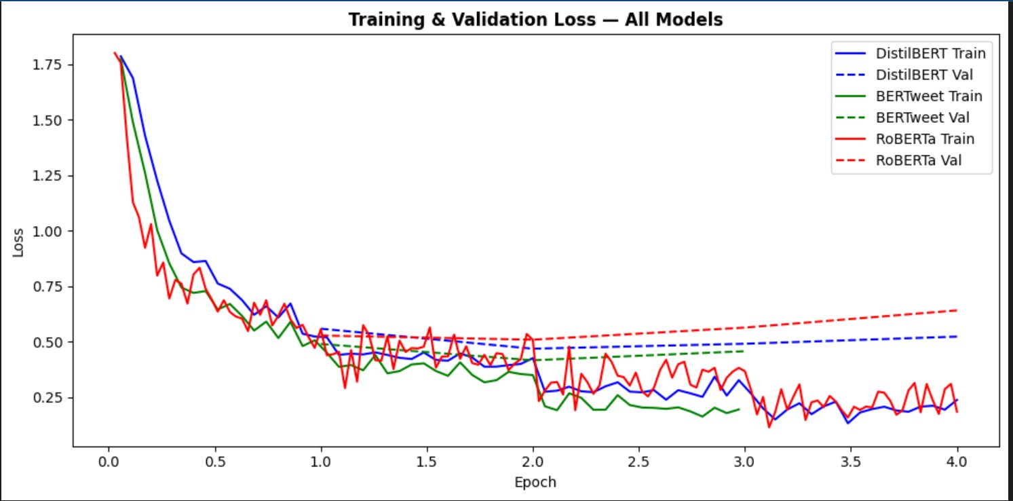
Figure 1: Training (solid) and Validation (dashed) Loss across epochs for DistilBERT (blue), BERTweet (green), and RoBERTa (red). All best checkpoints occur at epoch 2. RoBERTa shows the strongest overfitting signal from epoch 3 onwards.

Overall Model performance
Table 6 presents weighted precision, recall, F1-score, and accuracy on the held-out 3,000-sample test set using the best checkpoints from epoch 2 for all models. Weighted averaging gives proportional weight to each class based on test set size, providing an appropriate aggregate metric for the near-balanced class distribution. Green marks the best-performing model overall.
Model | Precision | Recall | F1-Score | Accuracy
DistilBERT | 0.8459 | 0.8473 | 0.8457 | 85.0%
BERTweet | 0.8773 | 0.8763 | 0.8761 | 87.6%
RoBERTa | 0.8814 | 0.8820 | 0.8814 | 88.2%
Table 6 : Overall classification performance.
Overall RoBERTa achieved the highest results (F1: 0.8814, Accuracy: 88.2%), beating DistilBERT by 3.6 points in F1. BERTweet closely followed (F1: 0.8761, Accuracy: 87.6%) with distinct per-class advantages. Because all models easily surpassed the 0.167 random baseline, the results validate the efficacy of fine-tuning for this domain-specific task.
Because RoBERTa and BERTweet share near-identical overall performance, differing by just 0.55 percentage points in F1, evaluating them at the per-class level is vital to uncover where their true strengths lie.

Per Class F1 Analysis
Table 7 presents F1-scores per class. ▲ = best class for that model, ▼ = worst class for all models, green = best score on this class across all models.
Class | DistilBERT F1 | BERTweet F1 | RoBERTa F1
Positive_Gameplay ▼ all | 0.7463 | 0.8043 | 0.7952
Positive_Narrative | 0.8726 | 0.8966 | 0.8882
Positive_Aesthetics | 0.9051 ▲ | 0.9203 ▲ | 0.9140
Technical_Issues | 0.8799 | 0.8974 | 0.9222
Price_Sensitive | 0.8922 | 0.9050 | 0.9301 ▲
Negative_Design | 0.7806 | 0.8349 | 0.8414
Weighted Average | 0.8457 | 0.8761 | 0.8814
Table 7 : Per Class F1 Score Across All Models
Positive_Gameplay (Weakest: 0.75–0.80 F1)
All models struggled with Positive_Gameplay because it served as a catch-all default for positive reviews lacking specific keywords. This class suffered from high intra-class variance, bundling everything from single-word memes to long combat essays. Because this underperformance persisted across all model sizes (66M to 135M parameters), the issue stems from label noise rather than model capacity. Notably, BERTweet performed best here (0.8043 F1) because short, meme-style Steam reviews structurally mirror tweets.
Positive_Aesthetics & Price_Sensitive (Strongest: 0.90+ F1)
These classes consistently excelled because their vocabularies (e.g., "soundtrack," "overpriced") are highly distinct and rarely overlap with other categories. Price_Sensitive achieved RoBERTa’s highest per-class score (0.9301 F1) despite being the smallest class, proving that lexical distinctiveness drives accuracy far more than raw dataset size.
Technical & Commercial Complaints (RoBERTa's Edge)
RoBERTa led on both Technical_Issues (0.9222 F1) and Price_Sensitive (0.9301 F1). This edge stems from its web-crawl pretraining data, which likely included support forums and error reports rich in complaint vocabulary. These results demonstrate that comprehensive general pretraining outperforms tweet-specific pretraining when classifying formal negative sentiment.

Confusion Matrix Analysis
The figures below present confusion matrices for all three models. The colour scale encodes prediction counts: bright yellow indicates the diagonal (correct classifications), dark purple indicates near-zero off-diagonal misclassifications.

Figure 2: DistilBERT Confusion Matrix (left) | Figure 3: BERTweet Confusion Matrix (right)
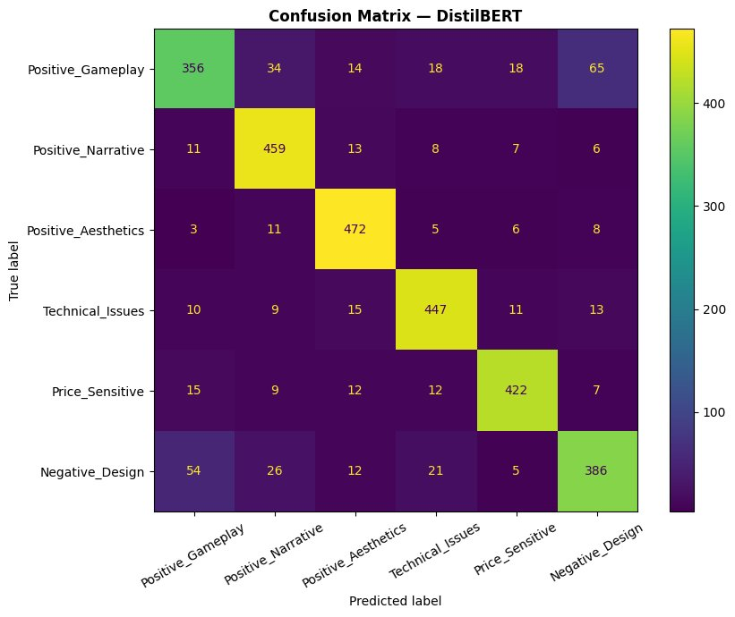 | 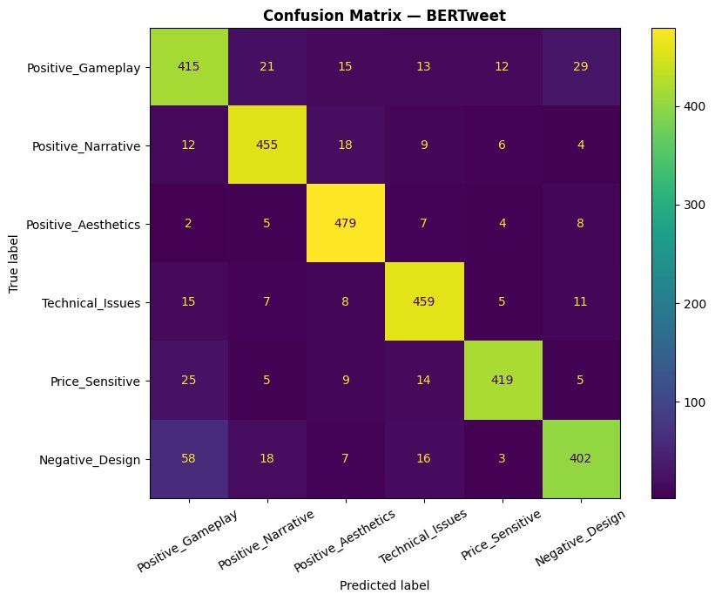

Figure 4: RoBERTa Confusion Matrix
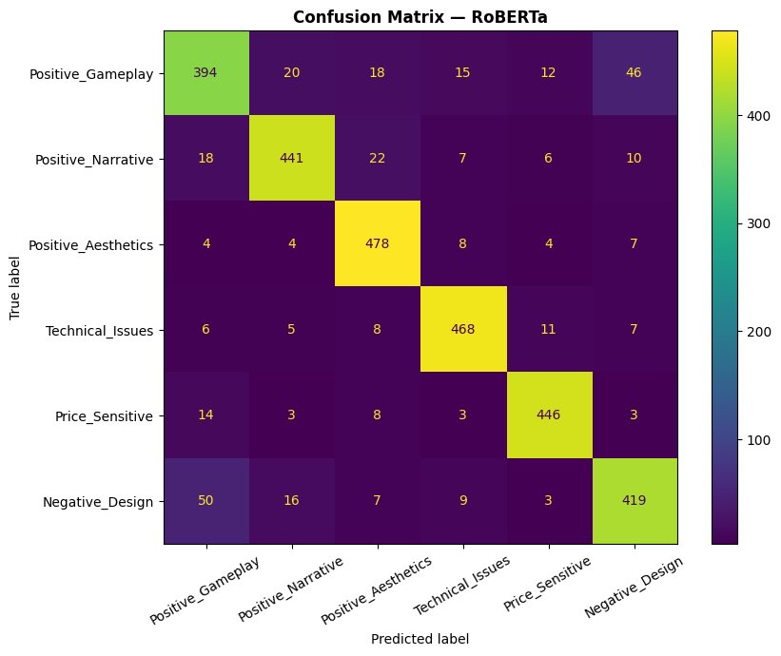

The confusion matrices reveal three distinct error and performance patterns:
Gameplay-to-Design Confusion: The Positive_Gameplay row yields the highest off-diagonal misclassifications across all models. This is especially evident in the Negative_Design column, where DistilBERT misclassified 65 reviews, BERTweet 29, and RoBERTa 46. This overlap highlights the semantic ambiguity of catch-all default categories, where reviews lacking specific keywords confuse both the model and the labeler.
RoBERTa's High Recall: RoBERTa maintains the most uniformly distinct diagonal, particularly excelling in Technical_Issues (92.7% recall) and Price_Sensitive (93.5% recall). This confirms its superior ability to isolate and categorize distinctive negative vocabulary.
Design-to-Gameplay Shift: The Negative_Design row presents the second-highest error rate, with 54 (DistilBERT), 58 (BERTweet), and 50 (RoBERTa) reviews misclassified as Positive_Gameplay. This pattern underscores how easily vague negative feedback bleeds into default sentiment categories.

5. Conclusion of Key Findings and Potential Improvements

5.1 Key Findings
This project demonstrates that pretrained transformer models can be effectively fine-tuned for granular, six-class Steam review classification. All three architectures significantly outperformed the 16.7% random baseline, validating both the custom taxonomy and the keyword-based labeling pipeline.
RoBERTa achieved the highest overall performance (Weighted F1: 0.8814, Accuracy: 88.2%), confirming that robust general pretraining with improved training objectives generalises effectively to domain-specific tasks. Its particular strength on technical and pricing complaint vocabulary, the most lexically distinctive negative categories suggests that breadth of pretraining data outweighs domain alignment for categories with unambiguous lexical signatures.
BERTweet performed comparably overall (F1: 0.8761) while demonstrating a complementary strength profile: its best per-class score was on Positive_Gameplay (0.8043), the noisiest and most challenging class. Short, informal, meme-style positive reviews share structural characteristics with tweets, and BERTweet's social media pretraining provides genuine advantage precisely where other models struggle most. This validates the domain-matching hypothesis for informal text but reveals that domain advantages are class-specific rather than uniformly distributed.
DistilBERT delivered a strong baseline (0.8457 F1). Using 40% fewer parameters than RoBERTa, it retained 95.9% of its performance, offering an excellent trade-off for real-time deployment.

5.2 Limitations and Potential Improvements
Label Noise Positive_Gameplay Catch-All Generalistion: The keyword-based default assignment creates systematic noise in the largest positive class. Reviews expressing genuine gameplay enthusiasm without recognised keywords are incorrectly assigned alongside truly ambiguous entries. Future work should apply active learning to identify the most ambiguous Positive_Gameplay reviews for targeted human annotation, replacing the default-assignment heuristic with a human-verified gold standard for this class.
Training Data Volume: Due to the limited GPU compute available on Google Colab, training was restricted to a 20,000-sample subset, which ultimately constrains overall learning. This limitation is highly apparent in RoBERTa’s 125M parameter architecture, which exhibits clear overfitting starting at epoch 3. Scaling up to the full balanced dataset of approximately 841,806 samples, while implementing gradient accumulation to mitigate GPU memory constraints, would likely recover 2 to 5 percentage points in F1 and permit extended, meaningful training for all models.
The Challenge of Sarcasm and Irony: Steam's reviewing culture thrives on irony, creating persistent label noise for machine learning models. Users frequently pair positive recommendations with negative text like "This game ruined my life," or register negative reviews with positive text like "Must Play :)." To counter this platform-specific humor, future pipelines could implement a preprocessing sarcasm-detection step. Identifying short reviews with mismatched sentiment signatures or hyperbolic language would allow developers to isolate or exclude these misleading entries entirely.
Ensemble Methods: RoBERTa and BERTweet demonstrate complementary strengths: RoBERTa excels on negative technical and pricing categories while BERTweet excels on informal positive text. A soft-voting ensemble combining all three models' class probability distributions would inherit both advantages. Given that the models achieve similar overall accuracy, an ensemble is likely to outperform any individual model particularly on the difficult catch-all classes.
Model-Specific Hyperparameter Tuning: All three models used identical hyperparameters for fair architectural comparison. However, RoBERTa's overfitting pattern suggests it would benefit from a lower learning rate (1e-5) or higher dropout, while BERTweet's rapid convergence suggests it could tolerate a higher learning rate. Per-model hyperparameter search via grid or Bayesian optimisation could yield meaningful additional gains without architectural changes.

References
[1] Devlin, J., Chang, M. W., Lee, K., & Toutanova, K. (2019). BERT: Pre-training of Deep Bidirectional Transformers for Language Understanding. In Proceedings of NAACL-HLT 2019.
[2] Liu, Y., Ott, M., Goyal, N., Du, J., Joshi, M., Chen, D., Levy, O., Lewis, M., Zettlemoyer, L., & Stoyanov, V. (2019). RoBERTa: A Robustly Optimized BERT Pretraining Approach. arXiv preprint arXiv:1907.11692.
[3] Nguyen, D. Q., Vu, T., & Nguyen, A. T. (2020). BERTweet: A Pre-trained Language Model for English Tweets. In Proceedings of EMNLP 2020: System Demonstrations.
[4] Sanh, V., Debut, L., Chaumond, J., & Wolf, T. (2019). DistilBERT, a Distilled Version of BERT: Smaller, Faster, Cheaper and Lighter. In NeurIPS 2019 EMC2 Workshop.
[5] Wolf, T., Debut, L., Sanh, V., Chaumond, J., Delangue, C., Moi, A., ... & Rush, A. M. (2020). Transformers: State-of-the-Art Natural Language Processing. In Proceedings of EMNLP 2020.
[6] SirSkandrani. (2023). Steam Reviews Clean Dataset. HuggingFace Datasets. Retrieved from https://huggingface.co/datasets/SirSkandrani/steam_reviews_clean
[7] Pedregosa, F., Varoquaux, G., Gramfort, A., Michel, V., Thirion, B., Grisel, O., ... & Duchesnay, E. (2011). Scikit-learn: Machine Learning in Python. Journal of Machine Learning Research, 12, 2825–2830.

Appendix II

AI Usage and Prompts
Debugging and Fixes
- "[KeyError traceback] — groupby label issue"
- "Why is my label 2 and 0 not 1 and 0"
- "My DistilBERT only did one epoch"
- "How do I remove these error codes and have just the epoch training loss show up"
- "It is more messy [logging output] — how to fix"
- "Why is my train loss NaN"
- "Give the entire code but make it simpler [epoch table]"
- Epoch Strategy for DistilBERT: You asked for the ideal number of epochs to run when training DistilBERT on a noisy dataset.
- Adapting for Other Models: You asked how that epoch strategy should change when using RoBERTa and TweetBERT instead.
- Identifying Overfitting (Log 1): You uploaded an image of training and validation loss logs (Epochs 1–8) and asked if it indicated overfitting.
- Identifying Overfitting (Log 2): You uploaded a second, shorter log (Epochs 1–4) and asked if that was also overfitting.
- Refactoring Training Code: You provided your Hugging Face Trainer script and asked how to improve it to properly implement early stopping and handle your noisy dataset.
- Enhancing Evaluation Code: You shared a Python function for evaluating the model and plotting a confusion matrix, asking to make it simpler and to give it a better color scheme.
- Transcribing an Image: You uploaded an image of a "Part B rubric" and asked for it to be converted into minimal text to save tokens for another AI (Claude).
- Handling Hugging Face Warnings: You pasted a large block of terminal output and asked how to remove the "unauthenticated requests to the HF Hub" warning.
- Silencing Setup Logs: You clarified that you wanted to see the actual epoch results and asked how to mute all the Hugging Face initialization messages and warnings so only the epoch table prints.
- Summary Request: You asked for this summary of your prompts.

Contribution Table
Include the following template at the end of the individual report. For each marking criterion:
- Assess the work submitted, by providing a mark from 0-10 for each task of selected topic
- Rate the contribution of each group member (including yourself) towards the group submissions. Use the following scale:
  - Did not contribute to this task
  - Willing but not very successful
  - Average
  - Above Average
  - Outstanding

 |  | Contributions (1-5 each member, including yourself)
Criterion | Mark (0-5) | {Mohammed Meraj Rahman}, {K2005941} | NA
Group discussion | 5 | 5
Model 1 | 4 | 5
Model 2 | 4 | 5
Model 3 | 4 | 5
Group report | 4 | 5
Video | 3 | 5
Individual  conclusion | 5 | X | X

