1 Get SRA

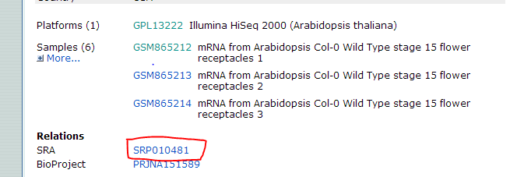

2 go to <http://www.ncbi.nlm.nih.gov/sra> and search that SRA

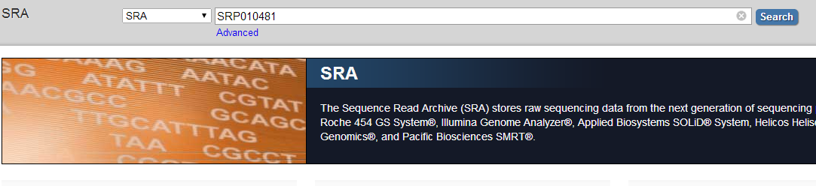

3 select “send to” , check “file” and “RunInfo” in the format dropdown menu.

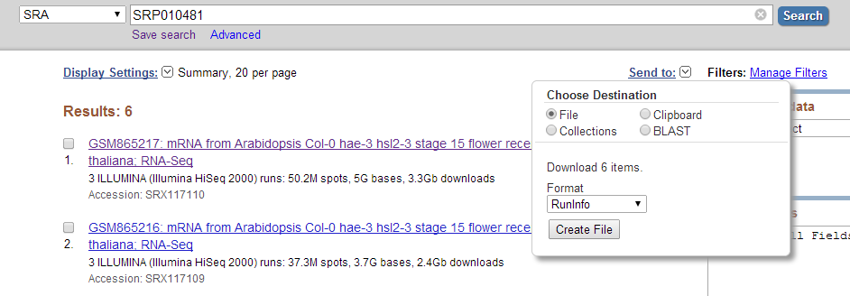

You can get related info needed.