**Main Page**

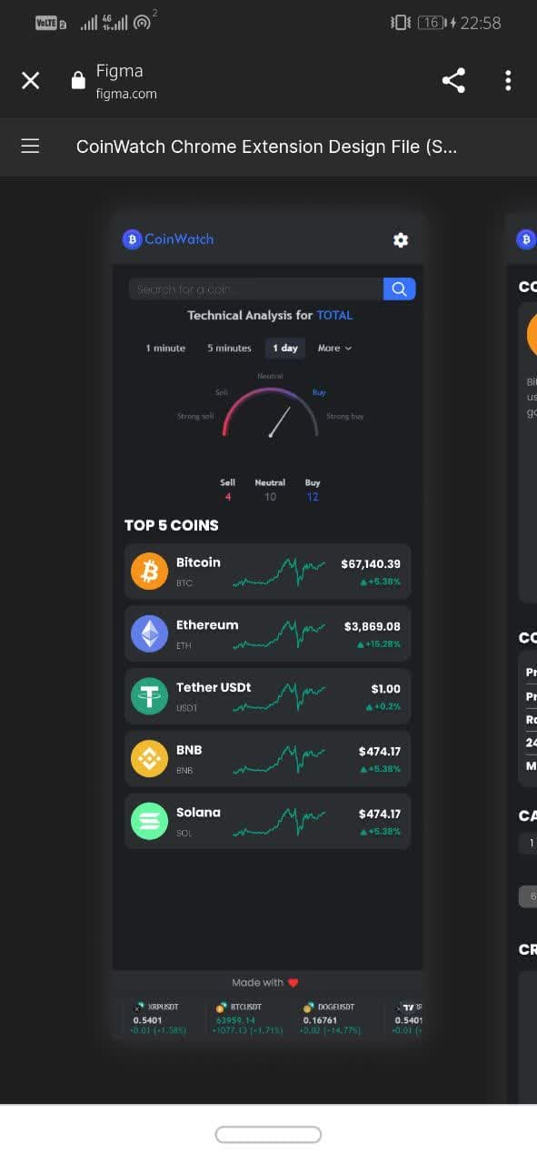When the user opens the plugin, she first sees the plugin icon on the left side.

At the top, there is a wheel that the user can select to change the theme of the extension.

The user also sees a search bar where she can search for the coin she wants.

In the third part, it shows a list of the top 5 coins along with their charts, as well as its current price and its growth and decline rates. By selecting these coins, the user enters the dedicated page of that coin and can get more detailed information. See about Coin.

In the next section, it shows the coins pinned by the user.

At the bottom of the page, the user can see the footer, which also shows the top 5 coins



**Single page**

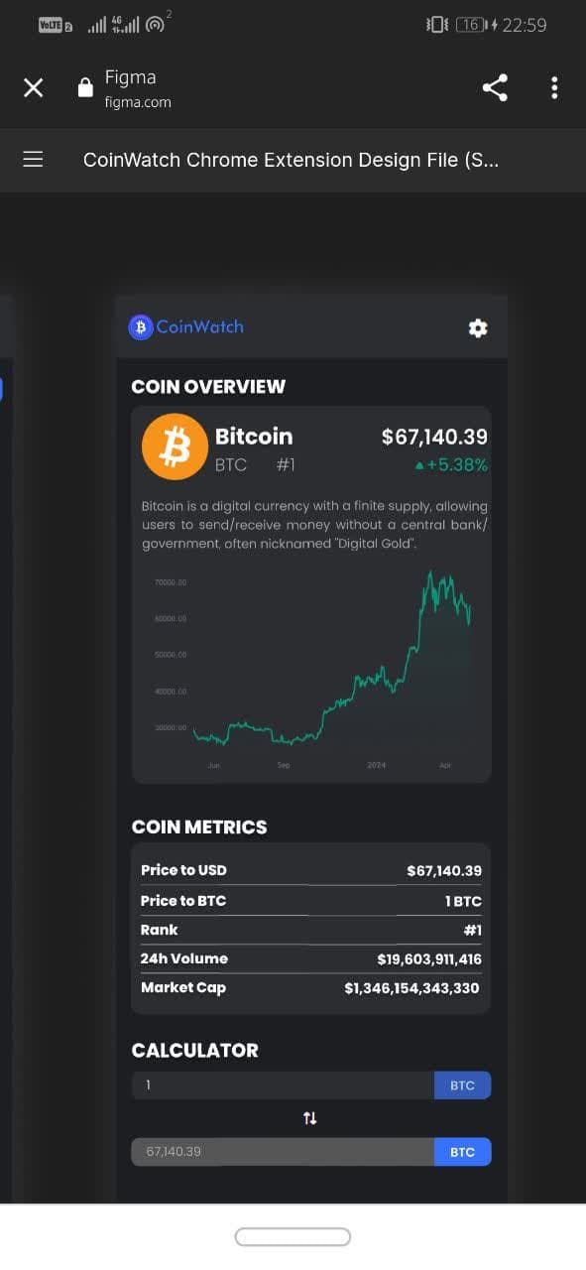By clicking on a coin, the user enters the dedicated page of that coin and can see more detailed information about the coin, including its rating, price, chart, changes in the last 24 hours, etc.

In the next part, the user will see more detailed information, which includes the amount of volume in the last 24 hours and other additional information about that coin. The user will see more detailed information, including the amount of volume in the last 24 hours and other additional information about that coin.



At the bottom of the page, the user can see the news about that coin.

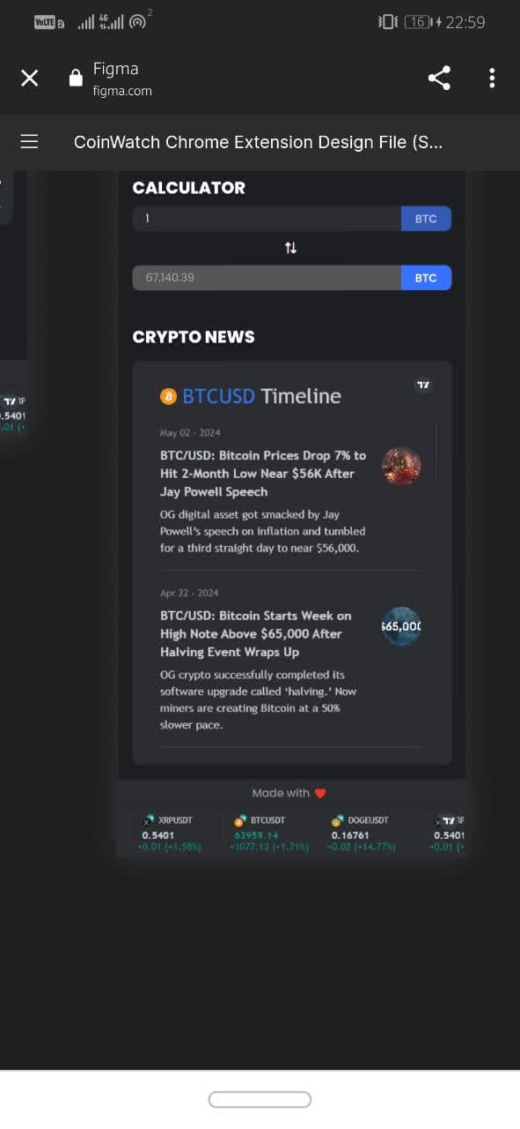

Also, the user can get the relative price of coins in the calculator section by entering the amount of coins and selecting the desired coin in the drop-down list.

At the bottom of the page, the user can see the footer, which also shows the top 5 coins

