**SOME IMPORTANT POINT FOR FINAL REPORT:**

* Color combination for the **cover page of final report**: **Dark Blue with Golden color fonts.**
* Font size on the cover page should be same as provided in the sample.
* Each copy of report should be **hard bound**.
* Font and Font size for report: **Times New Roman 12.**
* Line spacing: **1.5**
* Paper: **Executive Bond Paper with both side printing.**

**B. TECH. PROJECT REPORT**

**On**

**Generation of Point Cloud from a video file**

BY

**Omkar Sawant**

**20CE02027**



**School of Infrastructure**

**INDIAN INSTITUTE OF TECHNOLOGY BHUBANESHWAR**

**2024 Using SLAM and Photogrammetry to generate a Point Cloud from a video**

**A PROJECT REPORT**

*Submitted in partial fulfillment of the*

*requirements for the award of the degrees*

***of***

**BACHELOR OF TECHNOLOGY**

**in**

**CIVIL ENGINEERING**

*Submitted by:*

**Omkar Sawant**

*Guided by:*

**DR. Jothi T.**



**INDIAN INSTITUTE OF TECHNOLOGY BHUBANESHWAR**

**May 2024**

**CANDIDATE’S DECLARATION**

We hereby declare that the project entitled **“<Title of the BTP>”** submittedin partial fulfillment for the award of the degree of Bachelor of Technology in ‘<Name of discipline>’ completed under the supervision of **<Name, designation and discipline of BTP Guide(s)>,** IIT Indore is an authentic work.

Further, I/we declare that I/we have not submitted this work for the award of any other degree elsewhere.

**Signature and name of the student(s) with date**

**_________________________________________________________________**

**CERTIFICATE by BTP Guide(s)**

It is certified that the above statement made by the students is correct to the best of my/our knowledge.

**Signature of BTP Guide(s) with dates and their designation**

|  |  |  |
| --- | --- | --- |
|  |  |  |

**Preface**

This report on “<Title of the BTP>" is prepared under the guidance of Dr. Jothi T.

**Preface write-up may be decided by the students. An example of the same is given below:**

*(Through this report we have tried to give a detailed design of an innovative car control utility for the vehicles and try to cover every aspect of the new design, if the design is technically and economically sound and feasible.*

*We have tried to the best of our abilities and knowledge to explain the content in a lucid manner. We have also added 3-D models and figures to make it more illustrative.)*

**Omkar Sawant**

B.Tech. IV Year

Civil Engineering

IIT Bhubaneshwar

**Acknowledgements**

We wish to thank <Name of BTP Guide(s)> for his/her/their kind support and valuable guidance.

It is their help and support, due to which we became able to complete the design and technical report.

Without their support this report would not have been possible.

***Student may write as per their experience.***

**<Name of the Student(s)>**

B.Tech. IV Year

Discipline of <Name of discipline>

IIT Indore

**Abstract**

**Table of Contents**

|  |  |  |
| --- | --- | --- |
|  | Candidate’s Declaration |  |
|  | Supervisor’s Certificate |  |
|  | Preface |  |
|  | Acknowledgements |  |
|  | Abstract |  |
|  |  |  |
|  | Introduction |  |
|  | Concept Design |  |
|  | Experimentations and Analysis |  |
|  | Finalized Design |  |
|  | Mechanical Design |  |
|  | Electronic Design and Interfacing |  |
|  | Programming Logic |  |
|  | Working, Applicability and Conclusions |  |

Introduction

Photogrammetry is a very recent technique of Computer Vision which uses multiple images of an object taken from different perspectives to form a 3D model or a Point Cloud of that object without the use of expensive laser scanners.

SLAM is an abbreviation for Simultaneous Localization and Mapping which is a

Literature Review

Camera Calibration

Simple Stereo

Triangulation using two cameras.

Left camera pixel $u_{l}=f_{x }\frac{x}{z}+o_{x}$ $v_{l}=f_{y }\frac{y}{z}+o_{y}$

Right camera pixel $u_{r}=f_{x }\frac{x-b}{z}+o_{x}$ $v_{r}=f_{y }\frac{y}{z}+o_{y}$

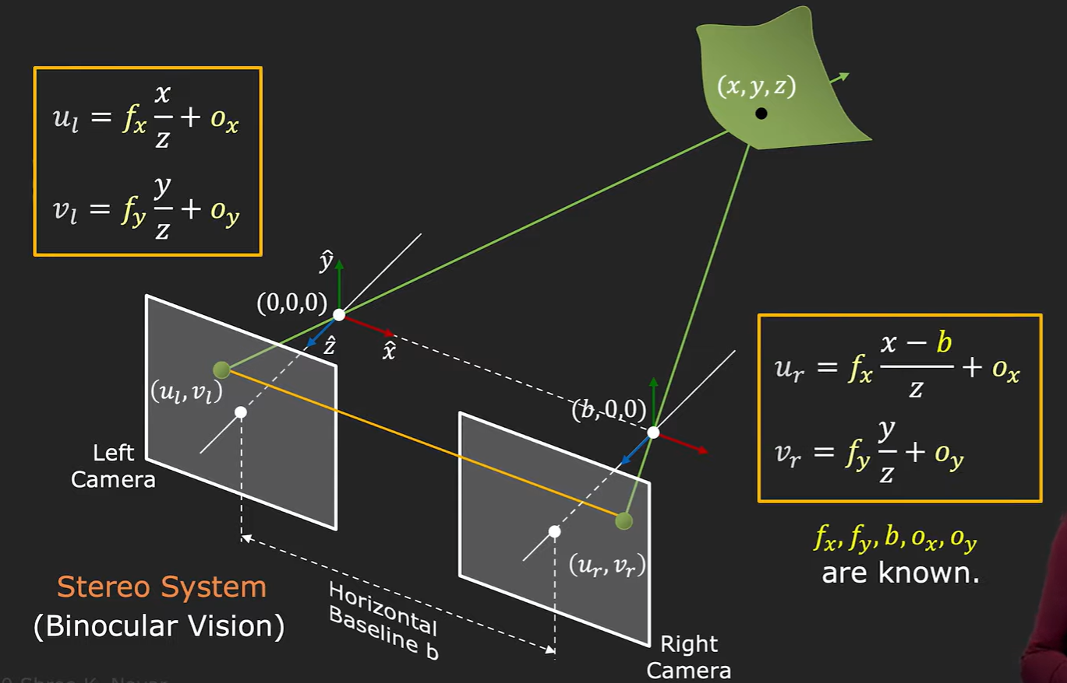

Depth and Disparity



$$\begin{matrix}a & & \\ & & \\ & & \end{matrix}$$

A­‑

**List of Figures**

**List of Tables**

**Chapters**

**Second last chapter** should focus on **Results and Discussion/Analysis**

**Last chapter** should focus on **Conclusions and Scope for Future Work**

**References**

**Appendices (if any)**