DharaAI
An AI-Powered Indian Legal Intelligence Platform
SOFTWARE DESIGN DOCUMENT
Architecture, data design, and component specification for DharaAI

Document | 2 of 5 — Software Design Document
Version | 1.0
Date | 26 July 2026
Status | Draft for team review
Companion documents | SRS · Project Workflow · Role Division · Master Document

Table of Contents

(If this outline looks empty, right-click it and choose “Update Field” — Word/LibreOffice recalculate it from the headings automatically.)

1. Introduction

1.1 Purpose & Scope
This Software Design Document (SDD) specifies how DharaAI is built to satisfy the requirements in the companion SRS. Where the SRS says what the system must do, this document says how: architecture style, component boundaries, data schemas, algorithms, API surface, security design, and the specific engineering decisions made — with rationale — to keep a three-person team able to actually operate everything it builds.

1.2 Design Goals
- Separate ingestion, retrieval, and generation cleanly — each is independently testable and independently scalable.
- One generic document data model for every legal instrument type (Constitution, Act, Rule, Notification, Judgment, Circular, Policy) — never a per-law schema.
- Add a new law as a data-ingestion configuration task, never a code change, from Phase 3 onward.
- Provision infrastructure just-in-time: a service is added when a phase's requirement demands it, not speculatively (this is a recurring theme flagged throughout this document as design decisions, not a one-time note).
- Every design choice traces to an SRS requirement ID; every requirement traces to a design element here.

1.3 How to Read This Document
Section 2 gives the architectural overview and the full pipeline diagram. Section 3 covers data design (schemas). Section 4 goes component-by-component. Section 5 is the API surface. Section 6 gives algorithm-level detail (pseudocode) for the parts that are easy to get subtly wrong. Section 7 is the security threat model. Section 8 is error handling and resilience. Section 9 is a running log of Architecture Decision Records (ADRs) — short, dated, reasoned design decisions, including several that directly correct a less-considered version of this plan from initial project scoping.

2. Architectural Overview

2.1 Architecture Style
DharaAI is built as a small set of independently deployable services around three layers — Ingestion, Retrieval, and Generation — fronted by an API Gateway and a thin Presentation layer. This is deliberately not a single monolith (the three layers have genuinely different scaling and update characteristics) and deliberately not a large microservice mesh either (a three-person team cannot operate a dozen services). The concrete service count is minimized at every phase per the just-in-time provisioning principle in Section 1.2, tracked explicitly in the ADR log (Section 9).

2.2 End-to-End Pipeline
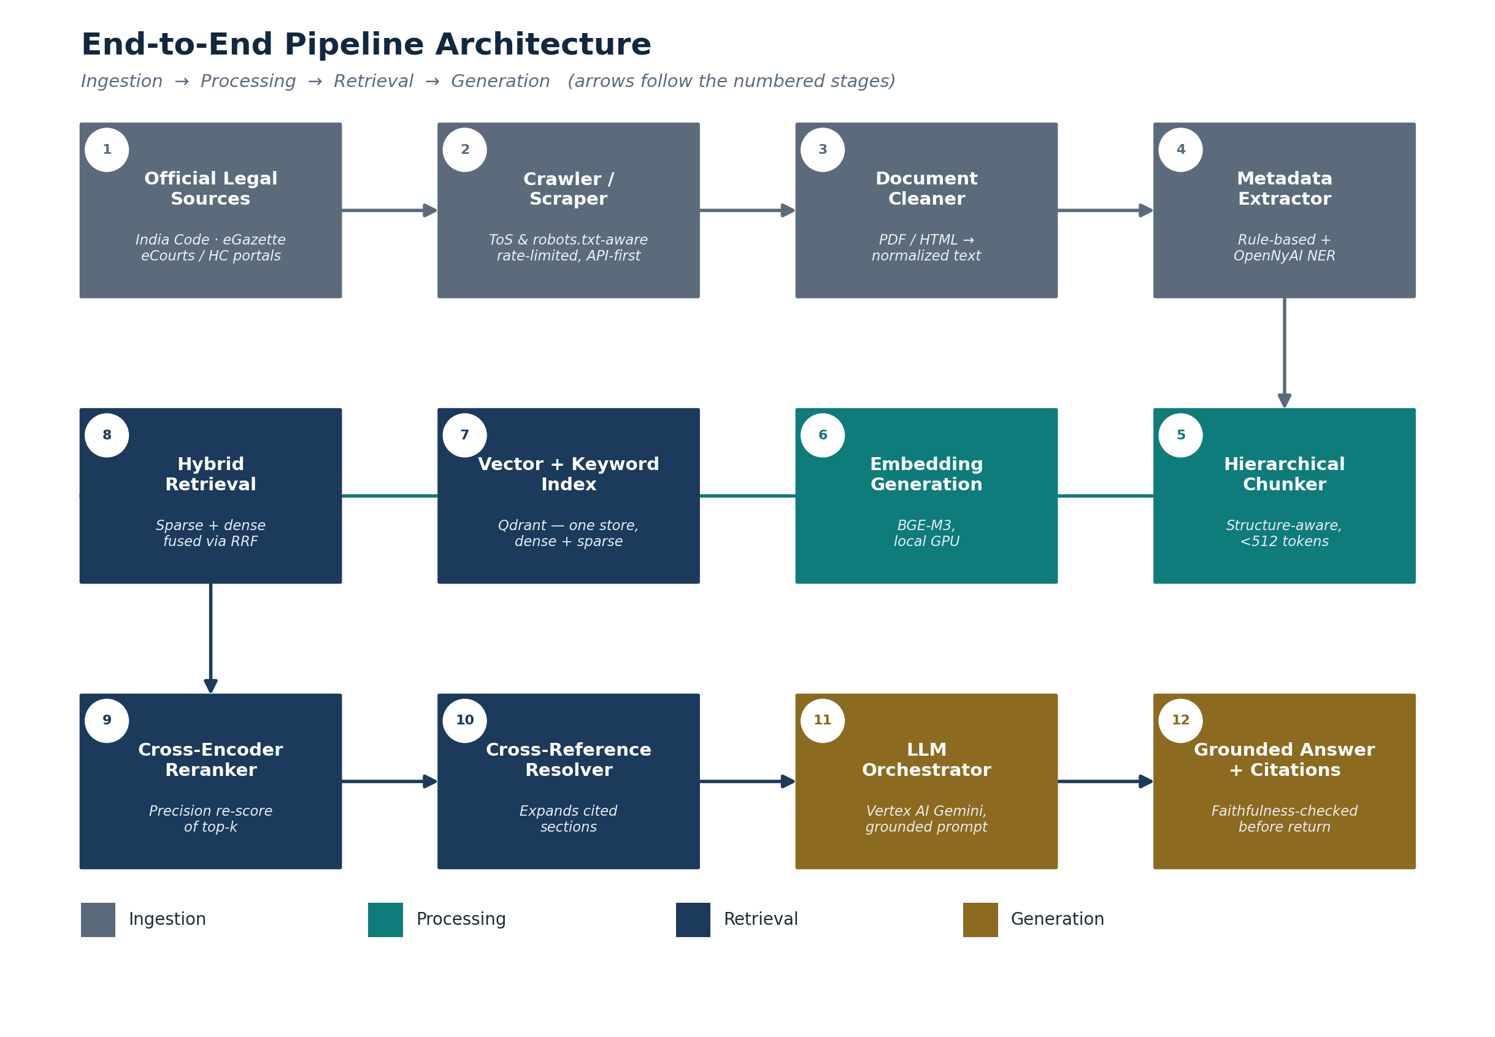
Figure 2.1 — End-to-end pipeline: ingestion through to a grounded, cited answer.
Twelve numbered stages, four conceptual layers. The stage numbering is stable and used throughout this document and the codebase's module naming (e.g. stage08_hybrid_retrieval).

2.3 Component Breakdown
Layer | Components | Primary owner
Ingestion | Source Registry · Crawler/Scraper · Document Cleaner · Metadata Extractor · Ingestion Orchestrator | Member 3
Processing | Hierarchical Chunker · Cross-Reference Extractor · Embedding Service | Member 1 (logic) / Member 3 (pipeline plumbing)
Retrieval | Vector+Keyword Index (Qdrant) · Hybrid Retrieval Service · Cross-Encoder Reranker · Cross-Reference Resolver · Version Resolver | Member 1
Generation | Query Classifier · Context Assembler · LLM Orchestrator (Vertex AI) · Faithfulness Checker | Member 1
Platform | API Gateway · Auth Service · Admin Service · Feedback/Analytics Service · Evaluation Harness | Member 3 (services) / Member 1 (eval harness)
Presentation | Next.js web app · Citation viewer · (Phase 7: mobile app) | Member 2

2.4 Deployment Architecture
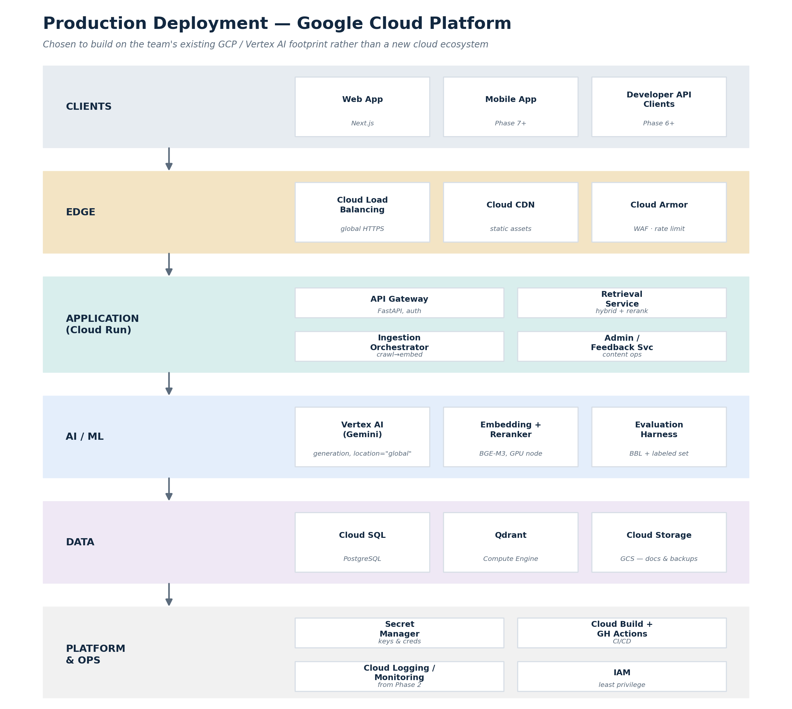
Figure 2.2 — Production deployment on Google Cloud Platform.
Development uses Docker Compose to run Postgres, Qdrant, and the FastAPI services locally, with embedding/reranking inference running on the local GPU and generation calls going out to Vertex AI even in dev — so the dev and prod generation path are identical, and the only thing that changes between environments is where Postgres/Qdrant live.

2.5 Technology Stack Summary
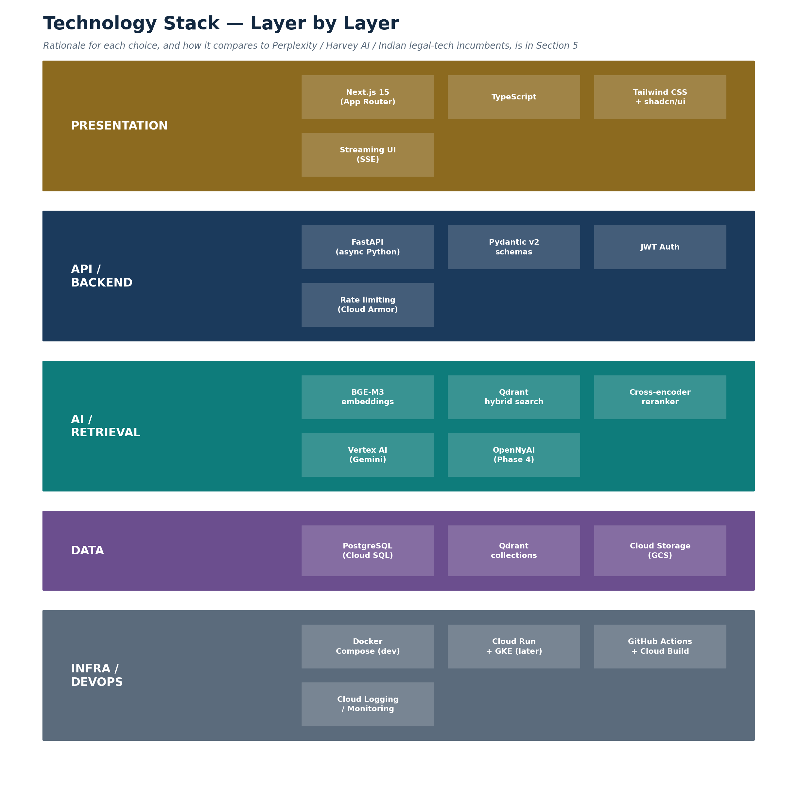
Figure 2.3 — Technology stack by layer. Full rationale and competitive comparison in the Master Document, Section 5.

3. Data Design

3.1 Universal Legal Document Schema
Every instrument type — the Constitution, a central Act, a state Rule, a notification, a judgment — is represented by the same hierarchy. This is the single most load-bearing design decision in the system: it is what makes FR-ING-005 (zero-code onboarding) possible.
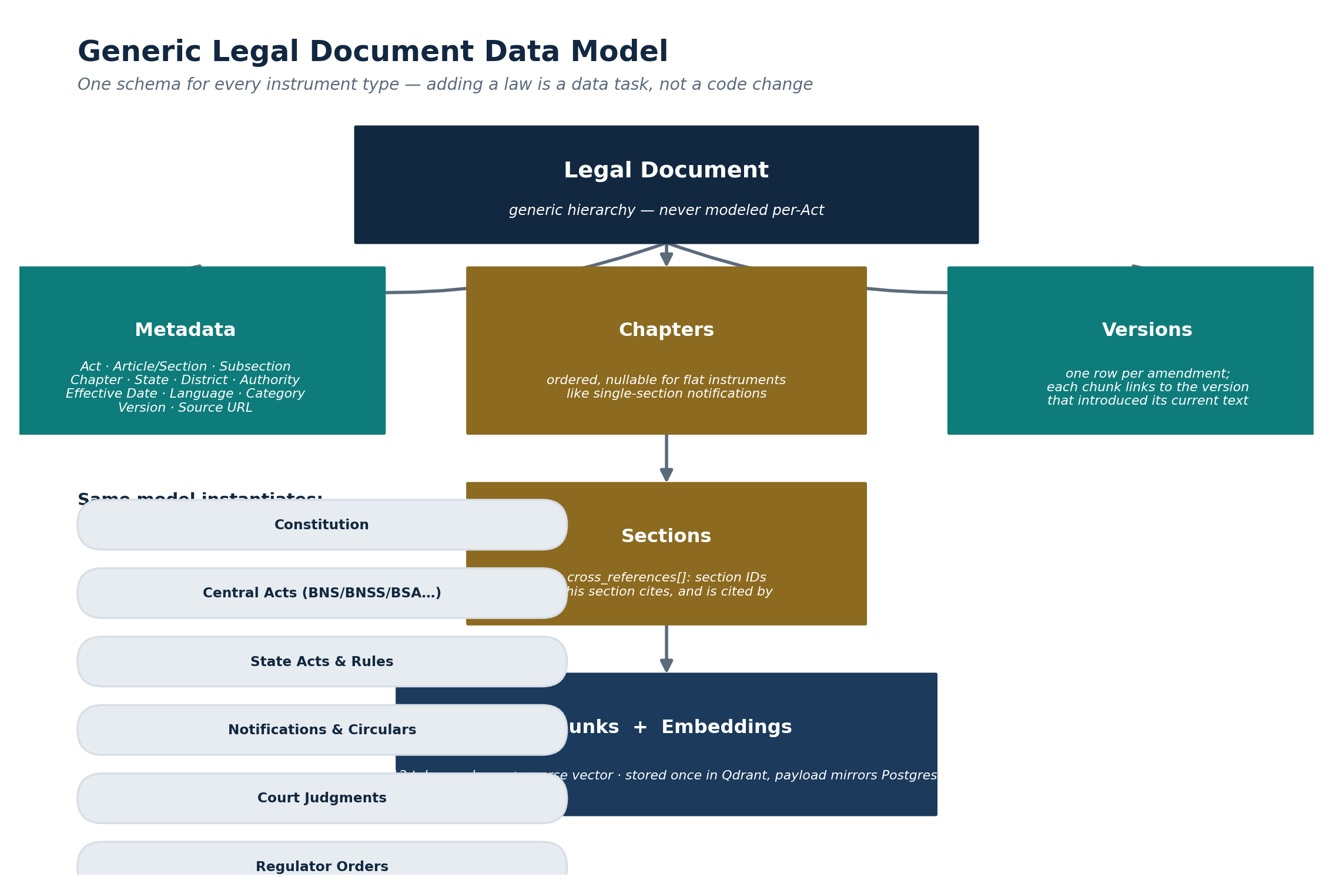
Figure 3.1 — Generic legal document data model.

3.1.1 Canonical JSON representation
{
"document": {
"id": "uuid",
"title": "The Constitution of India",
"doc_type": "constitution | act | rule | notification | judgment | circular | policy",
"jurisdiction": "central | state",
"state": null,
"authority": "Constituent Assembly",
"category": "fundamental-law",
"language": "en",
"source_url": "https://...",
"current_version_id": "uuid"
},
"chapters": [
{ "id": "uuid", "number": "III", "title": "Fundamental Rights", "order": 3 }
],
"sections": [
{
"id": "uuid", "chapter_id": "uuid", "number": "21",
"text": "No person shall be deprived of his life or personal liberty...",
"effective_from": "1950-01-26", "effective_to": null,
"current_version_id": "uuid",
"cross_references": ["art-19-id", "art-14-id"]
}
],
"versions": [
{ "id": "uuid", "section_id": "uuid", "amendment_ref": "44th Amendment, 1978",
"date": "1978-06-20", "text_snapshot": "..." }
]
}

3.2 PostgreSQL Schema
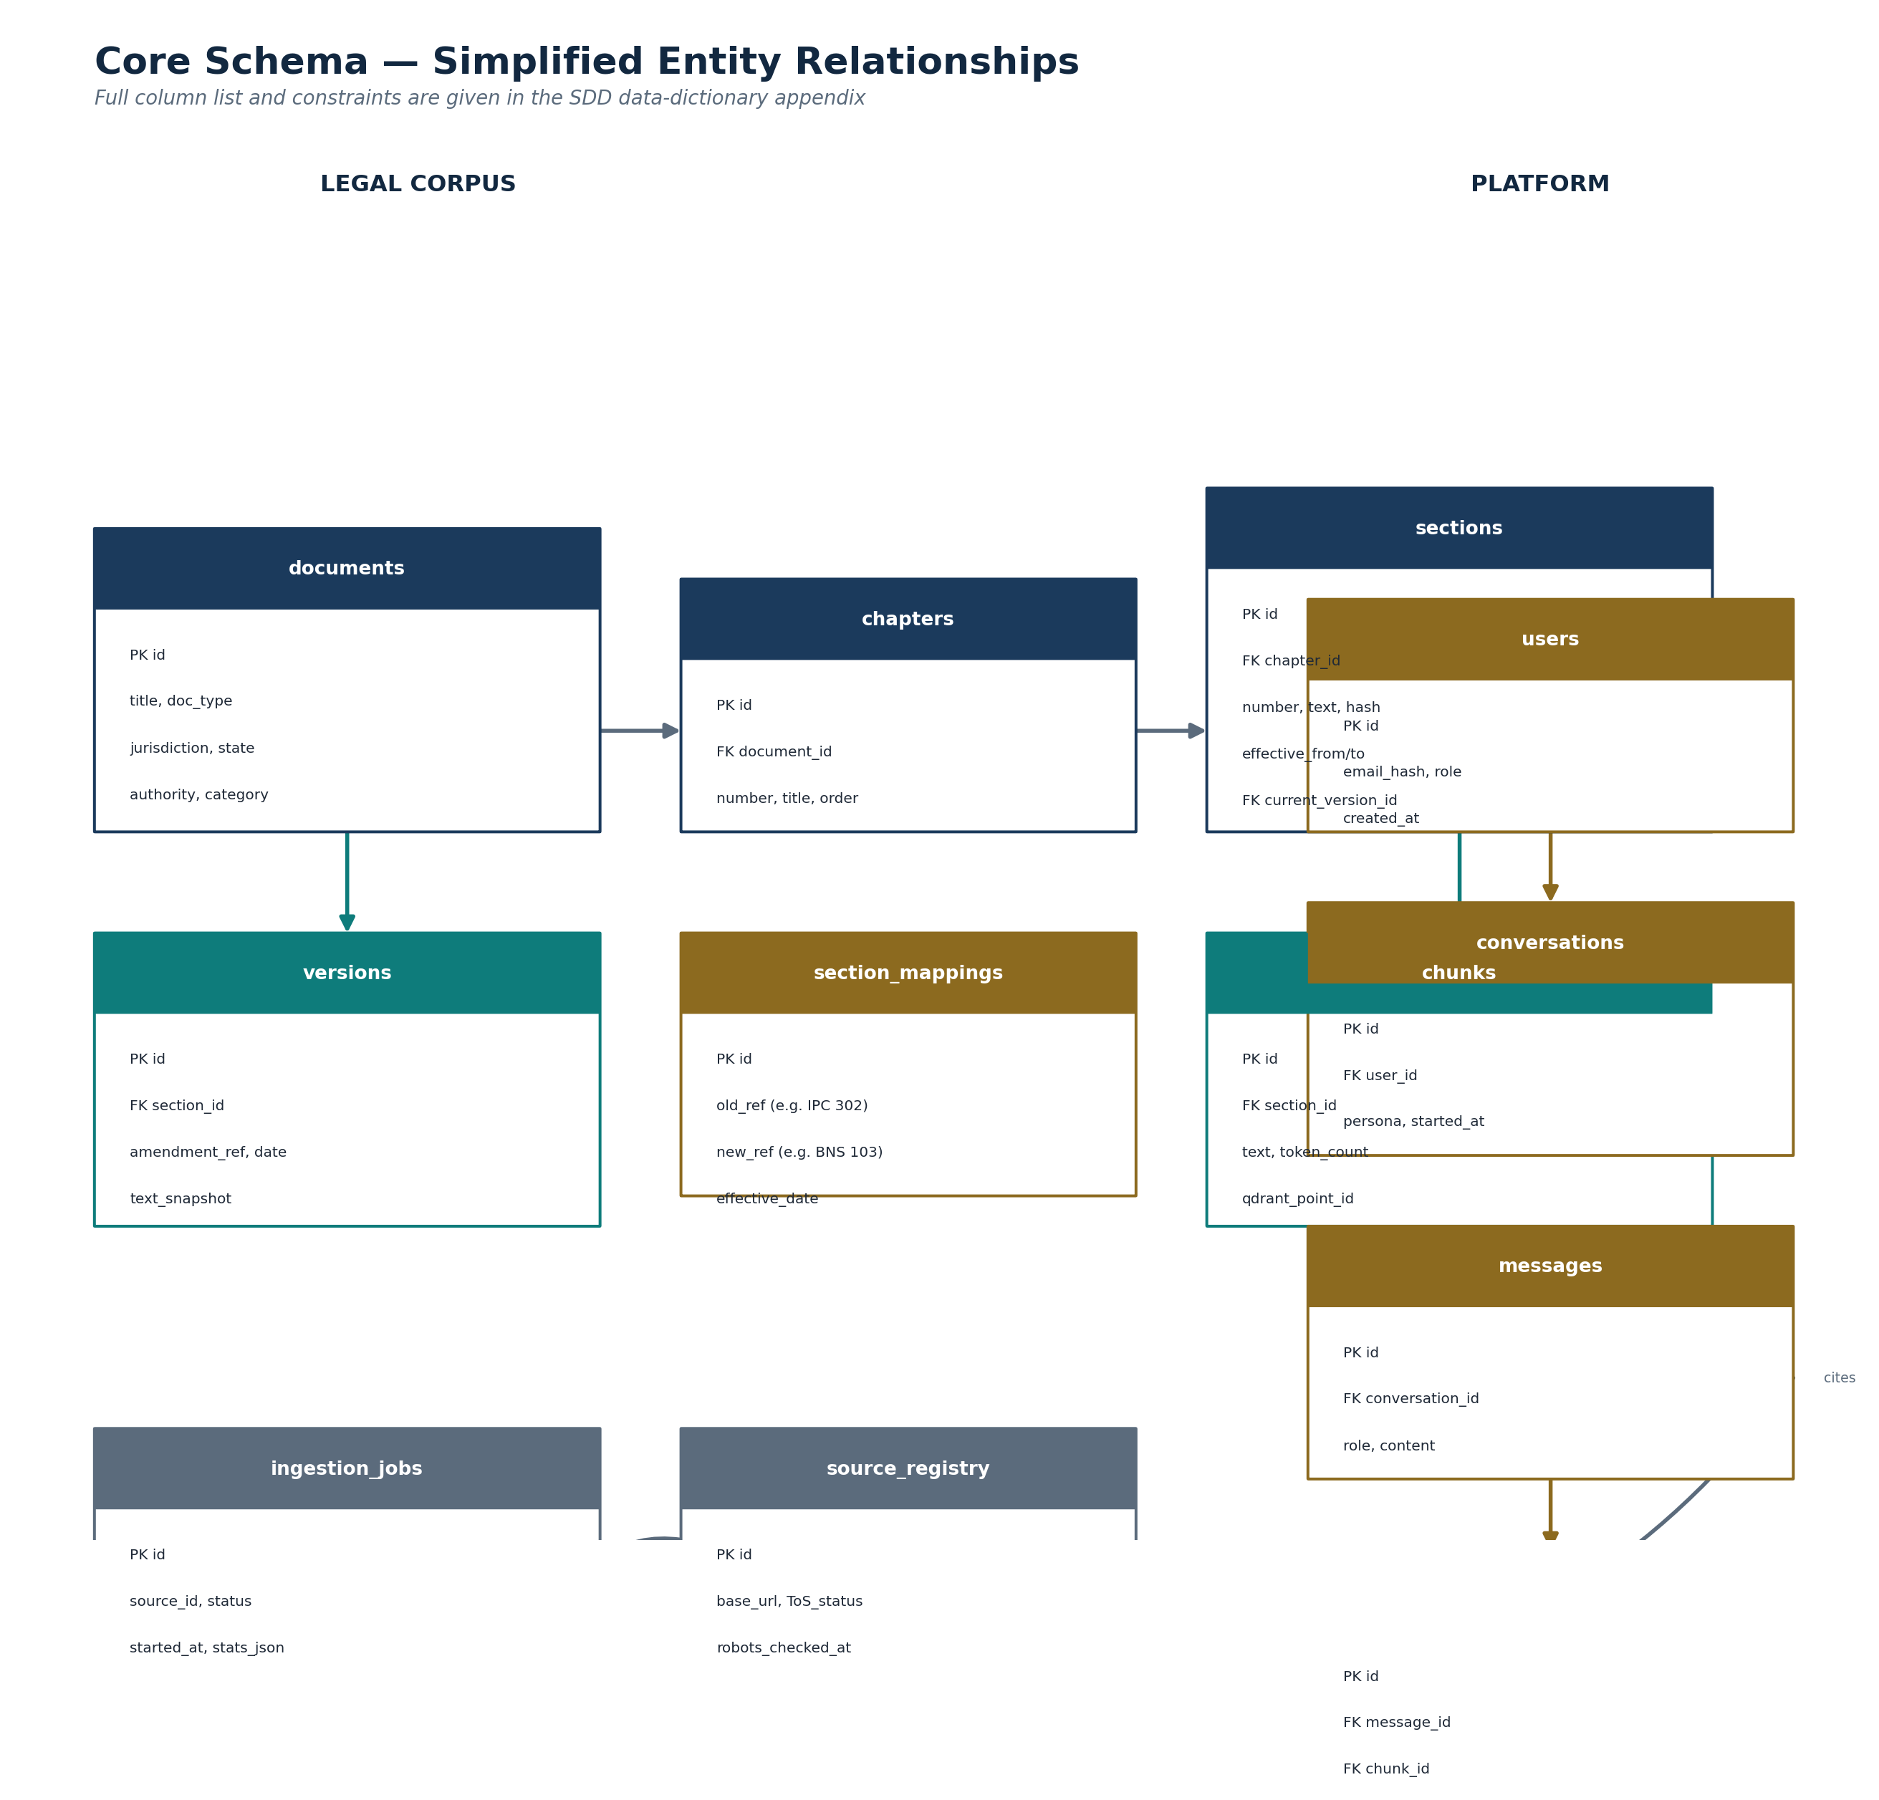
Figure 3.2 — Simplified entity relationships. Full DDL in Appendix A.

3.2.1 Core tables (summary)
Table | Purpose | Key columns
documents | One row per legal instrument | id, title, doc_type, jurisdiction, state, authority, category, current_version_id
chapters | Ordered grouping within a document | id, document_id (FK), number, title, order
sections | The addressable legal unit | id, chapter_id (FK), number, text, effective_from/to, current_version_id (FK), cross_references[]
chunks | Retrieval-sized slices of a section | id, section_id (FK), text, token_count, qdrant_point_id
versions | One row per amendment to a section | id, section_id (FK), amendment_ref, date, text_snapshot
section_mappings | Repealed → replacement provision links | id, old_ref, new_ref, effective_date, notes
source_registry | ToS/robots.txt compliance tracking per source | id, base_url, tos_status, official_api_available, robots_checked_at
ingestion_jobs | Ingestion run tracking | id, source_id (FK), status, started_at, stats_json
users | Account records | id, email_hash, role, created_at
conversations | One row per chat session | id, user_id (FK), persona, started_at
messages | One row per chat turn | id, conversation_id (FK), role, content
citations | Links a message to the chunks it cited | id, message_id (FK), chunk_id (FK)
feedback | Per-answer user feedback | id, message_id (FK), rating, comment

3.3 Qdrant Collection Design
- One collection per corpus layer (e.g. dharaai_statutes, and from Phase 4, dharaai_judgments) rather than one giant collection, so reranking/filtering stays fast as the corpus grows across phases.
- Each point carries both a dense vector (BGE-M3, 1024-dim) and a sparse vector (BM25-style) in the same record, using Qdrant's native named-vector hybrid support — this is what removes the need for a separate Elasticsearch/OpenSearch service (ADR-001).
- Payload mirrors the Postgres foreign keys the chunk belongs to (section_id, document_id, chapter_id) plus the filterable metadata fields (jurisdiction, doc_type, effective_from/to) so metadata filtering happens inside Qdrant, not as a separate join.
- HNSW index parameters start at Qdrant's defaults (m=16, ef_construct=100) and are only tuned if the evaluation harness (FR-EVAL-001) shows a recall shortfall — premature tuning without a measured baseline is avoided.

3.4 Cross-Reference Graph Design
Rather than a dedicated graph database (Neo4j or similar), the cross-reference graph is stored as a simple adjacency structure inside Postgres: each section row carries a cross_references array of section IDs it cites, and the reverse lookup (“what cites this section”) is a single indexed reverse query, not a recursive traversal, because Phase 1–3 only needs one-hop expansion (FR-RET-003), not multi-hop graph reasoning. See ADR-002.

3.5 Caching Strategy (Deferred)
No caching layer (Redis or otherwise) exists at MVP. The retrieval path is fast enough without one at Phase 1–2 traffic levels (NFR-PERF-001), and adding a cache before there is a measured latency problem would be exactly the kind of speculative complexity this design avoids (ADR-006). The design does not preclude adding Redis later — the Hybrid Retrieval Service is structured so a cache can sit in front of it without changing its interface.

4. Component Design
Each component below follows the same shape: purpose, inputs/outputs, internal logic worth calling out, and error handling. Components are listed in pipeline order.

4.1 Ingestion Orchestrator
- Purpose: coordinates a source through crawl → clean → extract → chunk → embed → index, recording progress in ingestion_jobs so a failure partway through is resumable, not a full re-run.
- Error handling: each stage writes its output before the next stage starts; a failed stage marks the job failed with the stage name and error, and is retryable from that stage rather than from scratch.

4.2 Crawler / Scraper Service
- Purpose: fetches source documents from official portals, gated by the source_registry compliance check (FR-ING-001).
- Design: official APIs are used wherever a source provides one; scraping is the fallback, always rate-limited and always identified by a descriptive user agent, never disguised as a browser.

4.3 Document Cleaner
- Purpose: normalizes PDF/HTML into clean text while preserving Part/Chapter/Section/Clause structure markers the chunker depends on.
- Note: OCR for scanned (image-only) PDFs is explicitly deferred to Phase 7 — Phase 1–6 sources are targeted specifically because they are available as text-layer PDFs or HTML.

4.4 Metadata Extractor
- Purpose: populates the metadata envelope (FR-ING-003) using deterministic rules for statute structure, and — from Phase 4 only — OpenNyAI's NER and rhetorical-role models for judgment text.
FIX APPLIED — Scoping OpenNyAI correctly
OpenNyAI's pretrained models are trained specifically on court judgment structure (facts, arguments, issues, precedents, ruling). Applying it to statute ingestion in Phase 1–3 would be using a tool outside its trained domain for no benefit — statute metadata extraction is handled by simpler, more reliable rule-based parsing instead. This is a refinement on the general “use OpenNyAI” suggestion from initial planning.

4.5 Hierarchical Chunker
- Purpose: splits section text into ≤512-token chunks at natural boundaries (sub-section, clause), never mid-sentence, and never crossing a section boundary.
- Why 512 tokens: the cross-encoder reranker (4.9) is most accurate within the input-length range it was fine-tuned on; oversized chunks measurably hurt reranking precision.

4.6 Cross-Reference Extractor
- Purpose: pattern-matches citation phrases (“as defined in Section 2(l)”, “subject to Section 8”, “under Article 32”) during chunking and resolves them to section IDs, populating both the forward and reverse edge of the cross-reference graph (Section 3.4).

4.7 Embedding Service
- Purpose: generates BGE-M3 dense embeddings for each chunk, batched for GPU throughput, running on the team's local development GPU rather than a paid embedding API.
- Constraint: batch size is tuned to the 6 GB-class VRAM budget; the service fails loudly (not silently truncates) if a batch would exceed it, rather than producing degraded embeddings.

4.8 Vector + Keyword Indexer
- Purpose: writes each chunk's dense and sparse vectors plus metadata payload into the appropriate Qdrant collection (Section 3.3).

4.9 Hybrid Retrieval Service
- Purpose: executes FR-RET-001: runs sparse and dense search against Qdrant, merges by Reciprocal Rank Fusion (algorithm detail in Section 6.1).

4.10 Cross-Encoder Reranker
- Purpose: re-scores the fused top-k (typically top-20) with a small, self-hosted cross-encoder model, returning the top-n (typically top-5–8) for context assembly.

4.11 Cross-Reference Resolver
- Purpose: implements FR-RET-003 — expands the reranked chunks with any section they cite, so context assembly never hands the LLM a clause stripped of a definition it depends on.

4.12 Query Classifier
- Purpose: runs before retrieval, implementing FR-SEC-003: flags out-of-scope queries (non-legal, or outside the current corpus) and unsafe/high-stakes queries (FR-SEC-004) before any retrieval or generation budget is spent.

4.13 Version Resolver
- Purpose: implements FR-VER-001–003: applies the latest-version default, honors an as-of-date parameter when present, and checks section_mappings for a repealed→replacement match before falling back to a “section not found” response.

Decision logic (see also Section 6.4 for full pseudocode)
- If the query references a section number with no current match, check section_mappings for an old_ref match first — this is what makes the IPC→BNS flagship feature (FR-VER-003) work.
- If a match exists, surface both the old and new reference and the retrospective-application note (offences before 1 July 2024 tried under the old law) rather than silently substituting one for the other.

4.14 LLM Orchestrator / Prompt Builder
- Purpose: assembles the grounded prompt (retrieved chunks + citation-format instructions + persona-appropriate tone) and calls Vertex AI's Gemini API (FR-GEN-003).
NOTE — Operational gotcha carried into this design
Some Gemini model versions require location="global" rather than a specific Vertex AI region — a real region-availability issue worth checking explicitly during Phase 0 setup rather than discovering it mid-Phase-1.

4.15 Faithfulness Checker
- Purpose: implements FR-FAITH-001: a second-pass check (lightweight entailment model or a second, narrowly-scoped LLM call) verifying each cited claim against its cited chunk before the answer is returned.

4.16 API Gateway
- Purpose: single FastAPI entrypoint handling auth, rate limiting (FR-SEC-001), request routing to the retrieval/generation pipeline, and response streaming.

4.17 Auth Service
- Purpose: implements FR-AUTH-001 — lightweight email-based sign-in, JWT session tokens; OAuth/SSO explicitly deferred (WON'T at MVP).

4.18 Admin Service
- Purpose: implements FR-ADMIN-001/002 — source_registry and ingestion_jobs visibility, plus the flagged-answer review queue, from Phase 3.

4.19 Feedback & Analytics Service
- Purpose: implements FR-FEED-001 — captures per-answer feedback and feeds it toward evaluation-set growth over time.

4.20 Evaluation Harness
- Purpose: implements FR-EVAL-001–003 — runs the hand-labeled tiered set and the BBL subset, computes the Section 6 (SRS) metrics, and gates CI from Phase 2 onward.

4.21 Frontend Application
- Purpose: Next.js App Router application implementing FR-UI-001–003: streaming chat, citation viewer, optional filters.
- State management: kept deliberately simple (React state + server components) — no global state library is introduced until a real cross-page state need appears.

5. API Design
All endpoints are versioned under /api/v1. Authentication is a bearer JWT for the web app and an API key (Phase 6+) for developer/partner access. Streaming responses use Server-Sent Events.
Method & Path | Purpose | Notes
POST /api/v1/query | Submit a legal question, stream a grounded answer | SSE stream; final event includes citation list
GET /api/v1/documents | List/search corpus documents | Filterable by doc_type, jurisdiction
GET /api/v1/sections/{id} | Fetch a section's current text + metadata | Powers the citation viewer
GET /api/v1/sections/{id}/versions | Fetch version history for a section | FR-VER-002 as-of-date support
GET /api/v1/mappings/{old_ref} | Look up a repealed→replacement mapping | FR-VER-003, e.g. IPC-302 → BNS-103
POST /api/v1/auth/signup, /login | Account creation / session | FR-AUTH-001
POST /api/v1/feedback | Submit per-answer feedback | FR-FEED-001
GET /api/v1/admin/ingestion-jobs | List ingestion job status (admin only) | FR-ADMIN-001, Phase 3+
GET /api/v1/admin/flagged-answers | Review queue for low-faithfulness answers | FR-ADMIN-002, Phase 3+
POST /api/v1/dev/query | Developer API equivalent of /query | API-key auth, usage-based rate limit, Phase 6+
GET /api/v1/health | Liveness/readiness probe | Used by Cloud Run health checks

5.1 Sample response shape
{
"answer": "Article 21 guarantees that no person shall be deprived...",
"citations": [
{
"section_ref": "Constitution, Article 21",
"chunk_id": "uuid",
"excerpt": "No person shall be deprived of his life or personal liberty...",
"source_url": "https://...",
"version_note": "latest (no amendments since adoption)"
}
],
"faithfulness_check": { "passed": true, "score": 0.94 },
"scope": { "in_scope": true, "persona_tier": "student" }
}

6. Algorithm Design

6.1 Hybrid Retrieval Scoring & Merge (Reciprocal Rank Fusion)
Sparse and dense search return two ranked lists over the same candidate space. RRF combines them by rank position, not raw score — this avoids the common pitfall of trying to normalize two incomparable score distributions (BM25-style scores and cosine similarities live on different scales).
RRF_score(d) = sum over each ranked list L containing d of:
1 / (k + rank_L(d))
# k is a smoothing constant (typically 60)
# a document ranked highly in either list scores well;
# a document ranked highly in BOTH lists scores best

6.2 Chunking Algorithm (Summary)
for each section in document.sections:
if token_count(section.text) <= 512:
emit single chunk
else:
split at sub-section / clause boundaries
merge small adjacent pieces up to the 512-token budget
never split mid-sentence, never cross a section boundary

6.3 Cross-Reference Resolution
for each chunk in reranked_top_n:
refs = chunk.section.cross_references
for ref in refs:
if ref not already in context_set:
add ref's current-version text to context_set (marked as "referenced, not primary")
# primary chunks are always shown to the user as citations;
# referenced-but-not-primary chunks inform the model but are
# not cited unless the model's claim actually depends on them

6.4 Version Resolution Decision Tree
resolve_version(query_section_ref, as_of_date=None):
if as_of_date given:
return section version whose [effective_from, effective_to) covers as_of_date
if query_section_ref matches a current section:
return current version (default: latest)
if query_section_ref matches section_mappings.old_ref:
return {
current_version_of(mapping.new_ref),
note: "formerly " + old_ref + "; retrospective application:
offences before " + mapping.effective_date + " tried under old law"
}
return "not found" -> low-confidence fallback (FR-GEN-005)

6.5 Faithfulness Scoring
For each citation in a draft answer, the checker verifies the claim text is entailed by the cited chunk's text (not merely topically related). A configurable threshold (default per Section 6 of the SRS: >90% pass rate target, tracked in aggregate) determines whether the answer ships as-is or triggers a revise/fallback path.

6.6 Query Classification
- In-scope check: is this a legal question within the current corpus's jurisdiction and topic coverage?
- Multi-hop detection: does answering require comparing or combining multiple distinct provisions? (Phase 1–2: flagged and scoped out per FR-RET-004; Phase 3+: routed to query decomposition.)
- Safety/high-stakes detection: does this resemble a request for individualized legal advice or a ready-to-file document? (FR-SEC-004)

7. Security Design
A public tool that takes free-text input and hands it to an LLM is a target for prompt injection and cost-abuse; this was treated as a first-class design concern, not an incident-response afterthought.
Threat | Mitigation
Prompt injection (user input attempts to override grounding or elicit fabricated case law) | System prompt structure separates instructions from retrieved content and user input; faithfulness checker (4.15) catches ungrounded claims regardless of how they were elicited; query classifier (4.12) flags adversarial patterns.
Cost-abuse (draining LLM/API budget via high-volume or maximally-expensive queries) | Per-IP and per-session rate limiting (FR-SEC-001) from the Phase 1 production milestone; query classifier short-circuits obviously out-of-scope requests before they reach the expensive retrieval+generation path.
PII leakage from judgment text (Phase 4+) | DPDP-aligned redaction/exclusion pipeline (FR-ING-006) runs before ingestion, not as a post-hoc filter on output.
Unauthorized admin access | Admin endpoints require a separate, more restrictive auth path (NFR-SEC-004); no shared credential with the public chat surface.
Credential/secret leakage | All secrets in Secret Manager; CI checks block commits containing credential-shaped strings; no secrets in Docker images.
Injection via the admin panel itself (Phase 3+) | Admin inputs are parameterized/validated identically to public-facing inputs — an internal tool is not treated as a trusted perimeter.
Scraping abuse complaints from source portals | Source registry (FR-ING-001) gate plus conservative rate limits and a descriptive user agent keep the crawler itself a good citizen of the sources it depends on.

7.1 DPDP-Aligned Data Handling Flow (Phase 4)
- 1. Judgment text acquired → 2. Automated PII scan flags likely personal-data spans (names in specific case categories: family, matrimonial, POCSO-adjacent) → 3. Flagged spans redacted or the document excluded per the documented policy → 4. Only the redacted/cleared text proceeds to chunking and indexing → 5. The redaction decision and rationale is logged against the document for audit.

8. Error Handling & Resilience
Failure mode | Handling
Vertex AI generation call fails or times out | Graceful degradation: return the top retrieved sources directly (retrieval-only mode) with a clear notice, rather than a hard error (NFR-REL, Section 5.3 of the SRS).
Ingestion stage fails partway through a source | Job marked failed at the specific stage in ingestion_jobs; retryable from that stage, not from scratch (Section 4.1).
Qdrant unavailable | API Gateway returns a clear 503 with retry-after; circuit breaker prevents cascading retries from hammering a degraded dependency.
Faithfulness check itself errors (not fails — errors) | Treated conservatively as a failed check — the answer is held back, not shipped on the assumption the check would have passed.
Malformed or unparseable source document during ingestion | Logged and skipped with a clear reason in ingestion_jobs.stats_json; does not halt the rest of the batch.
- All services emit structured (JSON) logs with a correlation ID per request, so a single user-reported bad answer can be traced end-to-end through retrieval, reranking, and generation.

9. Design Decisions & Rationale
Short, dated-by-phase records of decisions that could reasonably have gone another way, kept here so the reasoning survives past the moment it was made — several of these directly correct a less-considered version of the plan from initial project scoping.
ID | Decision | Rationale
ADR-001 | Use Qdrant's native hybrid search instead of adding Elasticsearch/OpenSearch | Qdrant supports dense + sparse vectors natively in one collection with RRF/DBSF fusion built in. A second search service before retrieval quality is even proven on the Phase 1 corpus is exactly the over-provisioning this design avoids. Elasticsearch is revisited only if a specific, measured need for it appears (e.g. complex faceted search at Phase 6+ scale).
ADR-002 | Store the cross-reference graph as a Postgres adjacency array, not a dedicated graph database | Phase 1–3 only needs one-hop reference expansion (FR-RET-003). A dedicated graph database (Neo4j or similar) is a seventh service to operate for a feature that a single indexed array column and a reverse-lookup query already satisfy.
ADR-003 | Self-host BGE-M3 for embeddings rather than call an embedding API | Avoids per-token embedding costs that scale with a growing corpus, keeps the corpus reproducible fully offline, and fits within the team's local GPU budget (Section 2.5 of the SRS).
ADR-004 | Use Vertex AI (Gemini) for generation rather than self-hosting an LLM | The 6 GB-class VRAM development budget cannot host a capable LLM alongside embeddings and reranking. Vertex AI also builds directly on the team's existing operational GCP experience rather than introducing a new serving stack.
ADR-005 | Defer GKE; use Cloud Run until a phase's load genuinely requires it | Cloud Run's request-based autoscaling comfortably covers Phase 1–3 traffic. GKE adds real operational overhead (cluster management, node pools) that isn't justified until Phase 4+ scale or a workload GKE specifically enables (e.g. persistent GPU nodes for reranking at higher volume).
ADR-006 | Defer Celery/Redis until ingestion is genuinely asynchronous at scale | Phase 1–2 ingestion volume (a handful of large but finite legal instruments) runs fine as synchronous, resumable jobs (Section 4.1). A task queue is added when ingestion volume or source count makes that necessary, not on the assumption it eventually will.
ADR-007 | Defer Prometheus/Grafana until something is in production worth monitoring at that level | Cloud Logging and Cloud Monitoring (already part of the GCP deployment) cover Phase 1–2 observability needs. A dedicated metrics stack is added when dashboards genuinely earn their operational cost.
ADR-008 | MVP persona: law students & judiciary/bar-exam aspirants, not general citizens | Competitive research (Master Document, Section 2) found the citizen-facing “know-your-rights chatbot” niche already has several active entrants in India. The exam/student angle is both differentiated and objectively benchmarkable via BhashaBench-Legal, without narrowing the underlying retrieval engine, which stays general-purpose.
ADR-009 | OpenNyAI scoped to Phase 4 (judgments) only, not Phase 1 (statutes) | OpenNyAI's pretrained NER and rhetorical-role models are trained on judgment structure specifically; applying them to statute metadata extraction would be a domain mismatch. Statute extraction uses simpler, more reliable rule-based parsing instead.
ADR-010 | IPC→BNS repealed-mapping feature treated as a MUST at Phase 2, not a stretch goal | It is simultaneously a genuine, high-volume real-world user need and the clearest concrete demonstration of the versioning design actually working under a real stress test.

Appendix A — Illustrative DDL
Representative DDL for the core corpus tables; full migrations live in the codebase, not duplicated here in full.
CREATE TABLE documents (
id UUID PRIMARY KEY DEFAULT gen_random_uuid(),
title TEXT NOT NULL,
doc_type TEXT NOT NULL CHECK (doc_type IN
('constitution','act','rule','notification','judgment','circular','policy')),
jurisdiction TEXT NOT NULL CHECK (jurisdiction IN ('central','state')),
state TEXT,
authority TEXT,
category TEXT,
language TEXT DEFAULT 'en',
source_url TEXT NOT NULL,
current_version_id UUID,
created_at TIMESTAMPTZ DEFAULT now()
);
CREATE TABLE sections (
id UUID PRIMARY KEY DEFAULT gen_random_uuid(),
chapter_id UUID REFERENCES chapters(id),
number TEXT NOT NULL,
text TEXT NOT NULL,
effective_from DATE NOT NULL,
effective_to DATE,
current_version_id UUID,
cross_references UUID[] DEFAULT '{}',
UNIQUE(chapter_id, number)
);
CREATE TABLE section_mappings (
id UUID PRIMARY KEY DEFAULT gen_random_uuid(),
old_ref TEXT NOT NULL, -- e.g. 'IPC-302'
new_ref TEXT NOT NULL, -- e.g. 'BNS-103'
effective_date DATE NOT NULL, -- 2024-07-01
notes TEXT
);

Appendix B — Glossary Cross-Reference
See the SRS, Appendix B, for the shared glossary of legal terms used across this document set.

