DharaAI
An AI-Powered Indian Legal Intelligence Platform
PROJECT WORKFLOW
Phased delivery plan — each phase to production before the next begins

Document | 3 of 5 — Project Workflow (Phased Roadmap)
Version | 1.0
Date | 26 July 2026
Status | Draft for team review
Companion documents | SRS · SDD · Role Division · Master Document

Table of Contents

(If this outline looks empty, right-click it and choose “Update Field” — Word/LibreOffice recalculate it from the headings automatically.)

1. How to Read This Roadmap
This is a “walking skeleton” roadmap: each phase ships a smaller-but-complete slice all the way to a live, publicly reachable production deployment before the next phase starts — not nine phases of parallel half-finished work. A phase is not “done” because the code is written; it is done when it has cleared the Definition of Production-Ready below and is answering real queries at its stated URL.
NOTE — Why this ordering differs from a naive statute-by-statute rollout
The Constitution and the BNS/BNSS/BSA criminal codes are grouped into the same Phase 1, rather than treating the new criminal codes as a later addition. They are, as of 1 July 2024, current law — not a future nice-to-have — and pre-structured reference material for them exists, making them a natural MVP co-launch rather than a Phase-4 afterthought.

1.1 Definition of “Production-Ready” (applies to every phase)
- Deployed to a live, publicly reachable URL on the GCP production environment — not “works on my machine” or staging-only.
- Passes the phase's stated Definition of Done, including any evaluation-metric gate that applies from Phase 2 onward.
- Rate limiting, basic monitoring, and a rollback plan are in place before traffic is real (from Phase 1 onward).
- A short internal demo is recorded or given — forces the team to confirm it actually works end-to-end, not just in a unit test.

1.2 Full Roadmap at a Glance
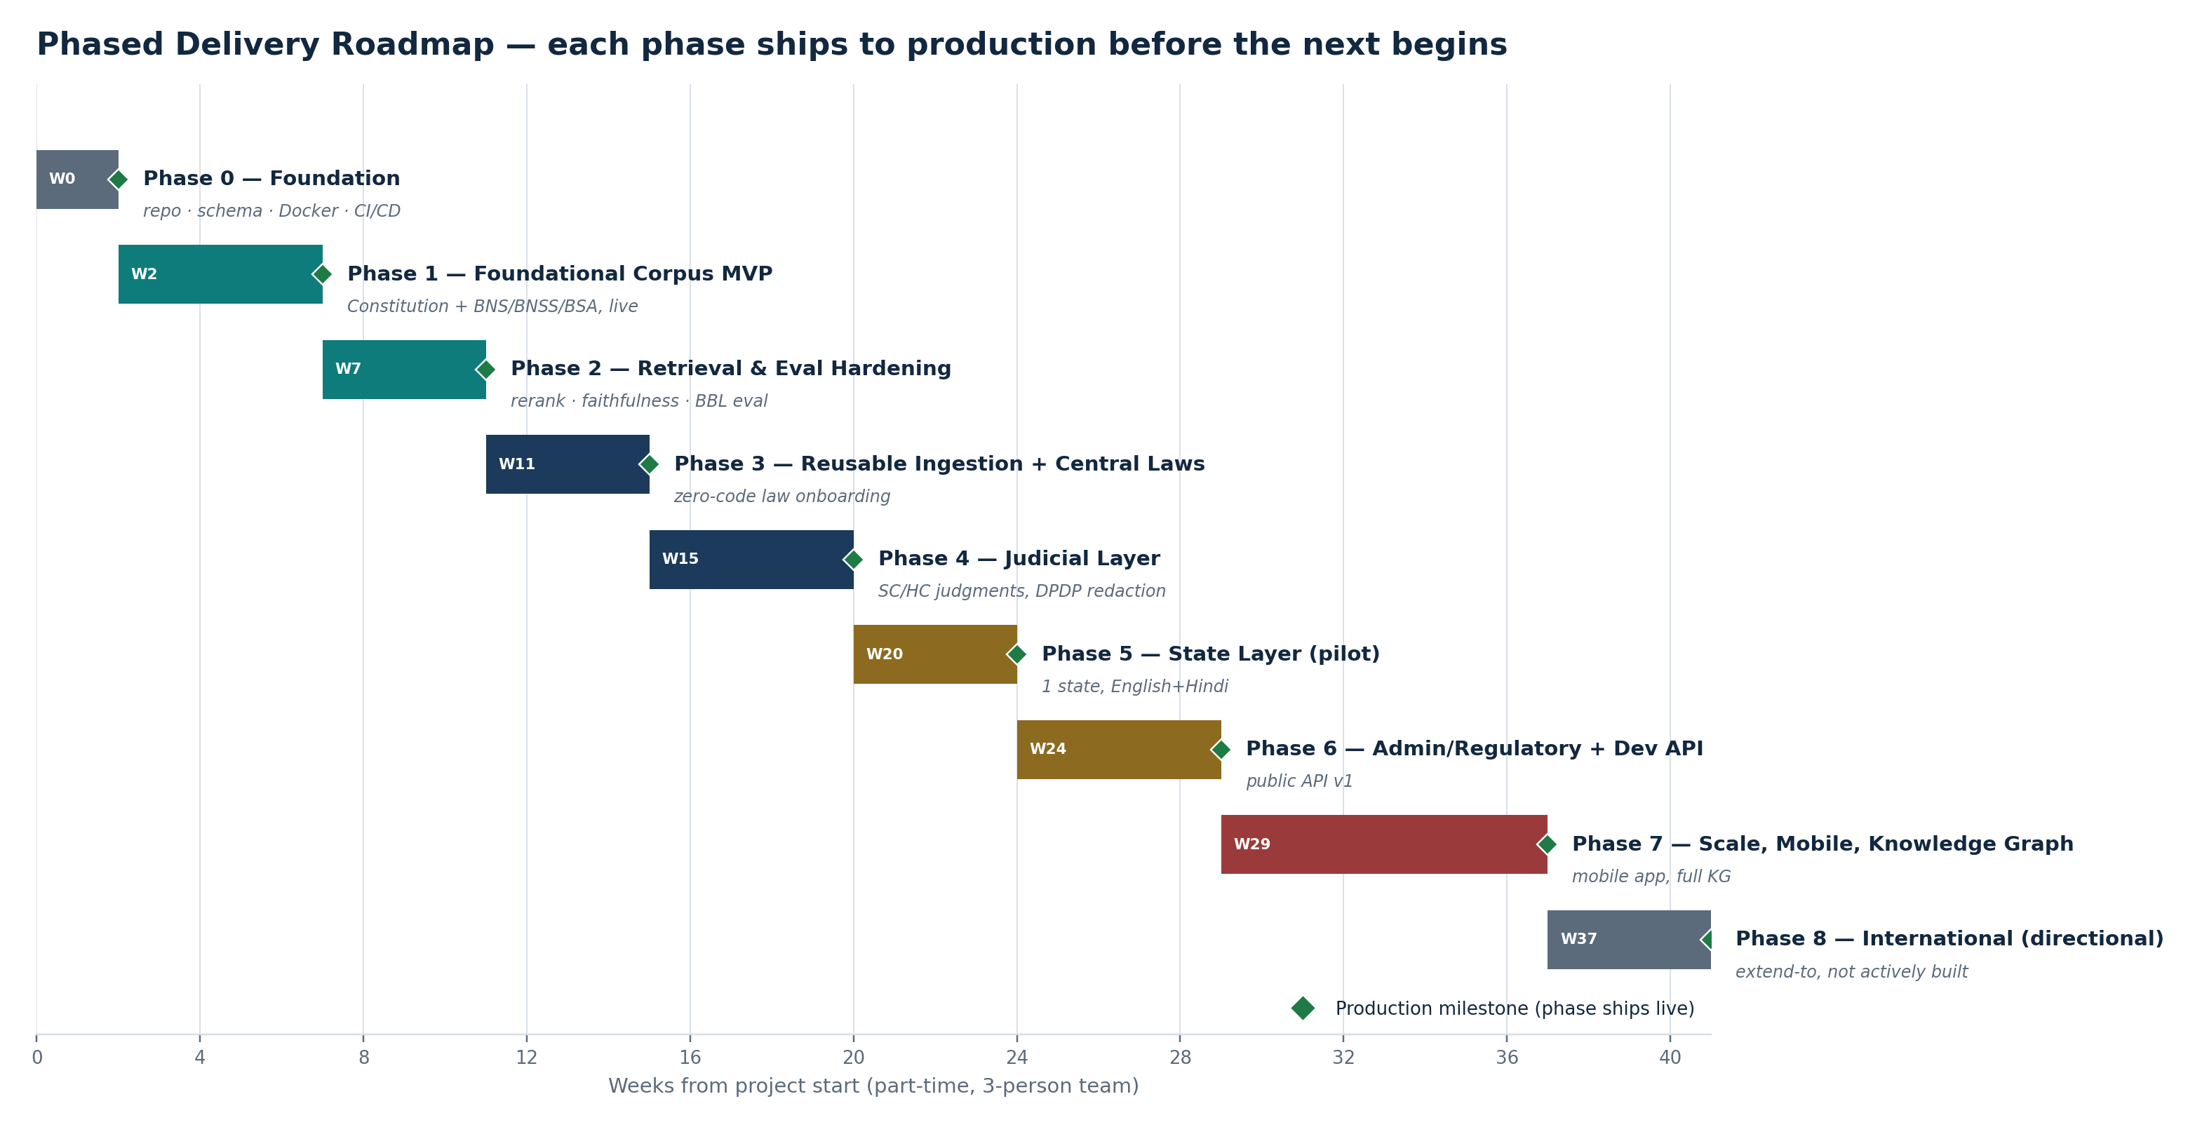
Figure 1.1 — Nine phases, each ending in a production milestone (green diamond).
Phase | Focus | Duration
0 | Foundation & infrastructure | 2 weeks
1 | Foundational corpus MVP (Constitution + BNS/BNSS/BSA) | 5 weeks
2 | Retrieval & evaluation hardening | 4 weeks
3 | Reusable ingestion pipeline + central laws | 4 weeks
4 | Judicial layer (SC/HC judgments) | 5 weeks
5 | State layer (one pilot state) | 4 weeks
6 | Administrative/regulatory layer + developer API | 5 weeks
7 | Scale, mobile, knowledge-graph maturity | 8 weeks
8 | International expansion (directional only) | not actively scheduled
ASSUMPTION — How these durations were estimated
Estimates assume a part-time-realistic pace for a 3-person team (evenings/weekends alongside other commitments, consistent with a student/early-career team), not a funded full-time team. Treat them as planning inputs to revise after Phase 0–1 give the team a real velocity baseline — not a commitment.

Phase 0 — Foundation & Infrastructure
Weeks 0–2 · Nothing user-facing yet — the goal is a repo, a schema, and a deploy pipeline the whole team can build on without stepping on each other.

Objectives
- Finalize the universal legal document schema (SDD Section 3.1) and the initial Postgres migration.
- Stand up Docker Compose for local dev (Postgres, Qdrant, FastAPI skeleton).
- Create the GCP project, IAM service accounts, and Secret Manager setup.
- Stand up CI/CD (GitHub Actions → Cloud Build → Cloud Run) deploying a health-check endpoint.
- Check and log ToS/robots.txt status for the Phase 1 sources (India Code, eGazette) in the source registry — before any crawler code is written.

Task Breakdown
Owner | Tasks
Member 1 (AI/ML) | Confirm BGE-M3 + reranker run within the local GPU/VRAM budget; draft the hybrid-retrieval evaluation-set format ahead of Phase 2.
Member 2 (Frontend) | Next.js project scaffold, design-system starting point (Tailwind/shadcn), deployed skeleton page on Cloud Run/Vercel.
Member 3 (Backend/Data) | Postgres schema + migrations, Docker Compose, GCP project/IAM setup, CI/CD pipeline, source-registry ToS review.

Definition of Done / Production Milestone
- CI/CD pipeline deploys a health-check endpoint to Cloud Run on every merge to main.
- Any team member can stand up the full local dev environment from a clean checkout with one documented command.
- Source registry contains a logged compliance status for every Phase 1 source.

Phase 1 — Foundational Corpus MVP
Weeks 2–7 · The first real production milestone: a publicly reachable MVP answering Constitution and BNS/BNSS/BSA questions with citations.

Objectives
- Ingestion pipeline v1: Constitution + BNS/BNSS/BSA, structure-preserving cleaning, rule-based metadata extraction.
- Hierarchical chunking (≤512 tokens) and local BGE-M3 embedding generation.
- Hybrid retrieval v1 using Qdrant's native dense+sparse search, merged by RRF.
- Grounded generation via Vertex AI with enforced citation formatting; single-hop questions only (multi-hop explicitly out of scope, per FR-RET-004).
- Minimal chat UI: one page, streaming answers, citation cards — no auth dashboard, no admin panel yet.
- Core safety: rate limiting and UPL-avoidance disclaimers live from day one of public access.

Task Breakdown
Owner | Tasks
Member 1 (AI/ML) | Chunking logic, embedding pipeline, hybrid retrieval service, prompt design, citation-format enforcement.
Member 2 (Frontend) | Chat UI, streaming response rendering, citation card component, mobile-responsive layout.
Member 3 (Backend/Data) | Crawler/scraper for India Code + eGazette (Constitution, BNS/BNSS/BSA), document cleaner, metadata extractor, API gateway, basic auth, rate limiting.

Definition of Done / Production Milestone
- Publicly accessible at a real URL; answers Constitution and BNS/BNSS/BSA questions with working citations.
- Rate-limited, basic auth in place; UPL disclaimers live on every answer.
- Internal smoke-test set (informal at this stage — the formal evaluation harness is Phase 2) shows retrieval is returning the right section for direct-lookup questions.

Phase 2 — Retrieval & Evaluation Hardening
Weeks 7–11 · Turns “it seems to work” into a measured, defensible v1.0 with published quality numbers.

Objectives
- Add the cross-encoder reranker and cross-reference resolver (SDD Sections 4.10–4.11).
- Build the faithfulness checker (FR-FAITH-001) and wire it into the response path.
- Build the hand-labeled tiered evaluation set (50–100 questions: direct, paraphrased, multi-hop-flagged, adversarial) and run BhashaBench-Legal's English subset as a secondary check.
- Ship the version resolver with the explicit latest-law default and the IPC→BNS repealed-mapping feature (FR-VER-001–003) — the flagship differentiator.
- Security hardening: prompt-injection resistance testing, query classifier (in-scope/safety) live before retrieval runs.

Task Breakdown
Owner | Tasks
Member 1 (AI/ML) | Reranker integration, cross-reference resolver, faithfulness checker, version resolver + IPC→BNS mapping table, evaluation harness build, run + report metrics against SRS Section 6 targets.
Member 2 (Frontend) | Surface version/mapping notes in the citation viewer (“formerly IPC 302” style notices); polish streaming UX based on Phase 1 usage.
Member 3 (Backend/Data) | Query classifier service, rate-limit tuning from real Phase 1 traffic, feedback-capture endpoint, structured logging with correlation IDs.

Definition of Done / Production Milestone
Metric | Target
Recall@5 (hand-labeled set) | > 85%
Citation faithfulness | > 90%
Out-of-scope refusal accuracy | > 95%
Retrieval latency, p95 | < 500 ms
v1.0 public launch, with these metrics published (even informally, e.g. in the project README) — the IPC→BNS mapping feature is demoed live as part of this milestone.

Phase 3 — Reusable Ingestion Pipeline & Central Laws
Weeks 11–15 · Proves the architecture's core promise: a new law is a data task, not a code change.

Objectives
- Generalize the ingestion pipeline into source-agnostic configuration (crawler target, parser profile, metadata mapping) per FR-ING-005.
- Onboard the Companies Act, GST Act, IT Act, and Consumer Protection Act using only that configuration — zero retrieval/generation code changes.
- Ship the admin panel v1: source registry and ingestion-job visibility (FR-ADMIN-001).
- Add query decomposition for true multi-hop questions (moving past the Phase 1–2 single-hop scope, FR-RET-004).

Task Breakdown
Owner | Tasks
Member 1 (AI/ML) | Multi-hop query decomposition, retrieval-quality regression checks as corpus grows, evaluation-set expansion to cover new Acts.
Member 2 (Frontend) | Document-type/jurisdiction filters in search UI (FR-UI-003); admin panel UI.
Member 3 (Backend/Data) | Ingestion pipeline generalization, admin panel backend, onboarding the four new Acts, CI-gated evaluation (FR-EVAL-003).

Definition of Done / Production Milestone
- A new central Act is onboarded and answerable in production in under one working day of configuration effort — demonstrated live, not just claimed.
- Evaluation harness runs automatically in CI and blocks a release on regression.

Phase 4 — Judicial Layer
Weeks 15–20 · The highest-stakes phase from a compliance standpoint — does not ship without its DPDP redaction gate passing.

Objectives
- Ingest Supreme Court and High Court judgments; integrate OpenNyAI's NER and rhetorical-role models, which are trained specifically for this judgment-structure task (unlike Phase 1–3's statute-focused rule-based extraction).
- Build and pass the DPDP-aligned redaction/exclusion pipeline (FR-ING-006) before any judgment is indexed.
- Upgrade the citation viewer to show case excerpts and rhetorical-role context (facts / issue / holding).
- Extend UPL-safe answer design: case-law interpretation answers carry appropriately stronger disclaimers than statutory lookups.

Task Breakdown
Owner | Tasks
Member 1 (AI/ML) | OpenNyAI integration, rhetorical-role-aware chunking for judgments, retrieval tuning for case-law-style queries.
Member 2 (Frontend) | Citation viewer upgrade for case excerpts, stronger disclaimer UX for case-law answers.
Member 3 (Backend/Data) | Judgment crawler/ingestion, DPDP redaction pipeline build + audit logging, ToS review for eCourts/HC portal sources.

Definition of Done / Production Milestone
- Judgment search and interpretation live in production, with the redaction audit log reviewed and passed — this gate is not skippable under schedule pressure.

Phase 5 — State Layer (Pilot State)
Weeks 20–24 · First test of the architecture outside central law — and the first multilingual content.

Objectives
- Select one pilot state's Acts, Rules, Notifications, and Circulars to ingest.
- Extend query/answer support to Hindi using BGE-M3's multilingual embeddings (FR-I18N-001), starting with the pilot state's content.

Pilot State Selection Criteria (not pre-committed in this document)
Rather than naming a state here, the team should score candidates against: (1) digitized gazette/legal-text quality and completeness, (2) English-language availability alongside the vernacular (reduces Phase 5 translation scope), and (3) an official API or clean bulk-access path (ties back to FR-ING-001). Maharashtra, Karnataka, and Delhi are commonly cited as having comparatively strong digital legal-publication infrastructure and are reasonable starting points to evaluate against these criteria.

Task Breakdown
Owner | Tasks
Member 1 (AI/ML) | Multilingual retrieval evaluation (Hindi query → correct section), embedding-quality checks across languages.
Member 2 (Frontend) | Language toggle / bilingual answer rendering.
Member 3 (Backend/Data) | State-source ingestion, ToS review for the chosen state's portals.

Definition of Done / Production Milestone
- Pilot state's layer live in production; English and Hindi queries both return correctly cited answers for that state's content.

Phase 6 — Administrative & Regulatory Layer + Developer API
Weeks 24–29 · Opens the platform to other developers — the first real B2B/API surface.

Objectives
- Ingest select regulatory sources (RBI, SEBI, MCA, GSTN, IRDAI, TRAI) and local administrative material.
- Ship the public developer API (FR-API-001): API-key auth, usage-based rate limiting, published docs.
- Add a lightweight compliance-assistant flow for the business/startup use case, still within the UPL-safe disclaimer design.

Definition of Done / Production Milestone
- Developer API live in production with API-key auth and usage-based rate limiting; regulatory corpus live and citable.

Phase 7 — Scale, Mobile & Knowledge-Graph Maturity
Weeks 29–37 · Graduates several Phase 1–6 deferrals (Section 9 ADR log in the SDD) once real usage justifies them.

Objectives
- Full knowledge-graph layer beyond the lightweight adjacency structure, if multi-hop/graph-style queries at this point justify it.
- Native mobile app; OCR support for scanned/image-only documents (extends ingestion beyond the Phase 1–6 text-layer-only sources).
- Amendment-timeline visualizations and a compare-law-versions UI, building on the version resolver's existing data model.
- Revisit the Phase 1–6 infrastructure deferrals (Elasticsearch, Celery/Redis, Prometheus/Grafana, GKE) against real, measured need rather than speculative planning.

Definition of Done / Production Milestone
- Mobile app store listing live; knowledge-graph-backed multi-hop reasoning live for the query classes that need it.

Phase 8 — International Expansion (Directional)
Weeks not actively scheduled · Deliberately not a scoped build phase — an architectural compatibility statement, not a commitment.
The generic document model (SDD Section 3.1) is not India-specific at the schema level, which is what makes a future US/UK/EU/UN/treaty layer architecturally plausible without a rebuild. This phase is intentionally written as “designed to extend to” rather than given a task breakdown, duration estimate, or Definition of Done — turning it into a real phase before there is a funded team and a specific market thesis for it would be scope creep, not ambition.

