DharaAI
An AI-Powered Indian Legal Intelligence Platform
ROLE DIVISION
A rebalanced three-person team structure for DharaAI

Document | 4 of 5 — Role Division (Team of 3)
Version | 1.0
Date | 26 July 2026
Status | Draft for team review
Companion documents | SRS · SDD · Project Workflow · Master Document

Table of Contents

(If this outline looks empty, right-click it and choose “Update Field” — Word/LibreOffice recalculate it from the headings automatically.)

1. Why This Split, and Why It Changed
The initial planning conversation split the team as AI/ML+MLOps (everything from data ingestion through deployment), Frontend, and Backend. Under that split, Member 1 alone owned crawling, cleaning, chunking, embeddings, retrieval, reranking, prompt engineering, evaluation, deployment, and monitoring — while Members 2 and 3 split a comparatively lighter frontend/backend workload. That is not a sustainable division for a 3-person team shipping through nine phases.
This document rebalances it: data scraping and document cleaning move to Member 3 (Backend/Data), since crawling, PDF-to-text normalization, and structuring are backend engineering tasks, not ML tasks. That frees Member 1 to focus on the parts that are genuinely ML-specialist work — vector-space quality, hybrid-retrieval tuning, OpenNyAI integration, evaluation — rather than being the default owner of everything the other two roles don't claim.

1.1 Team Structure at a Glance
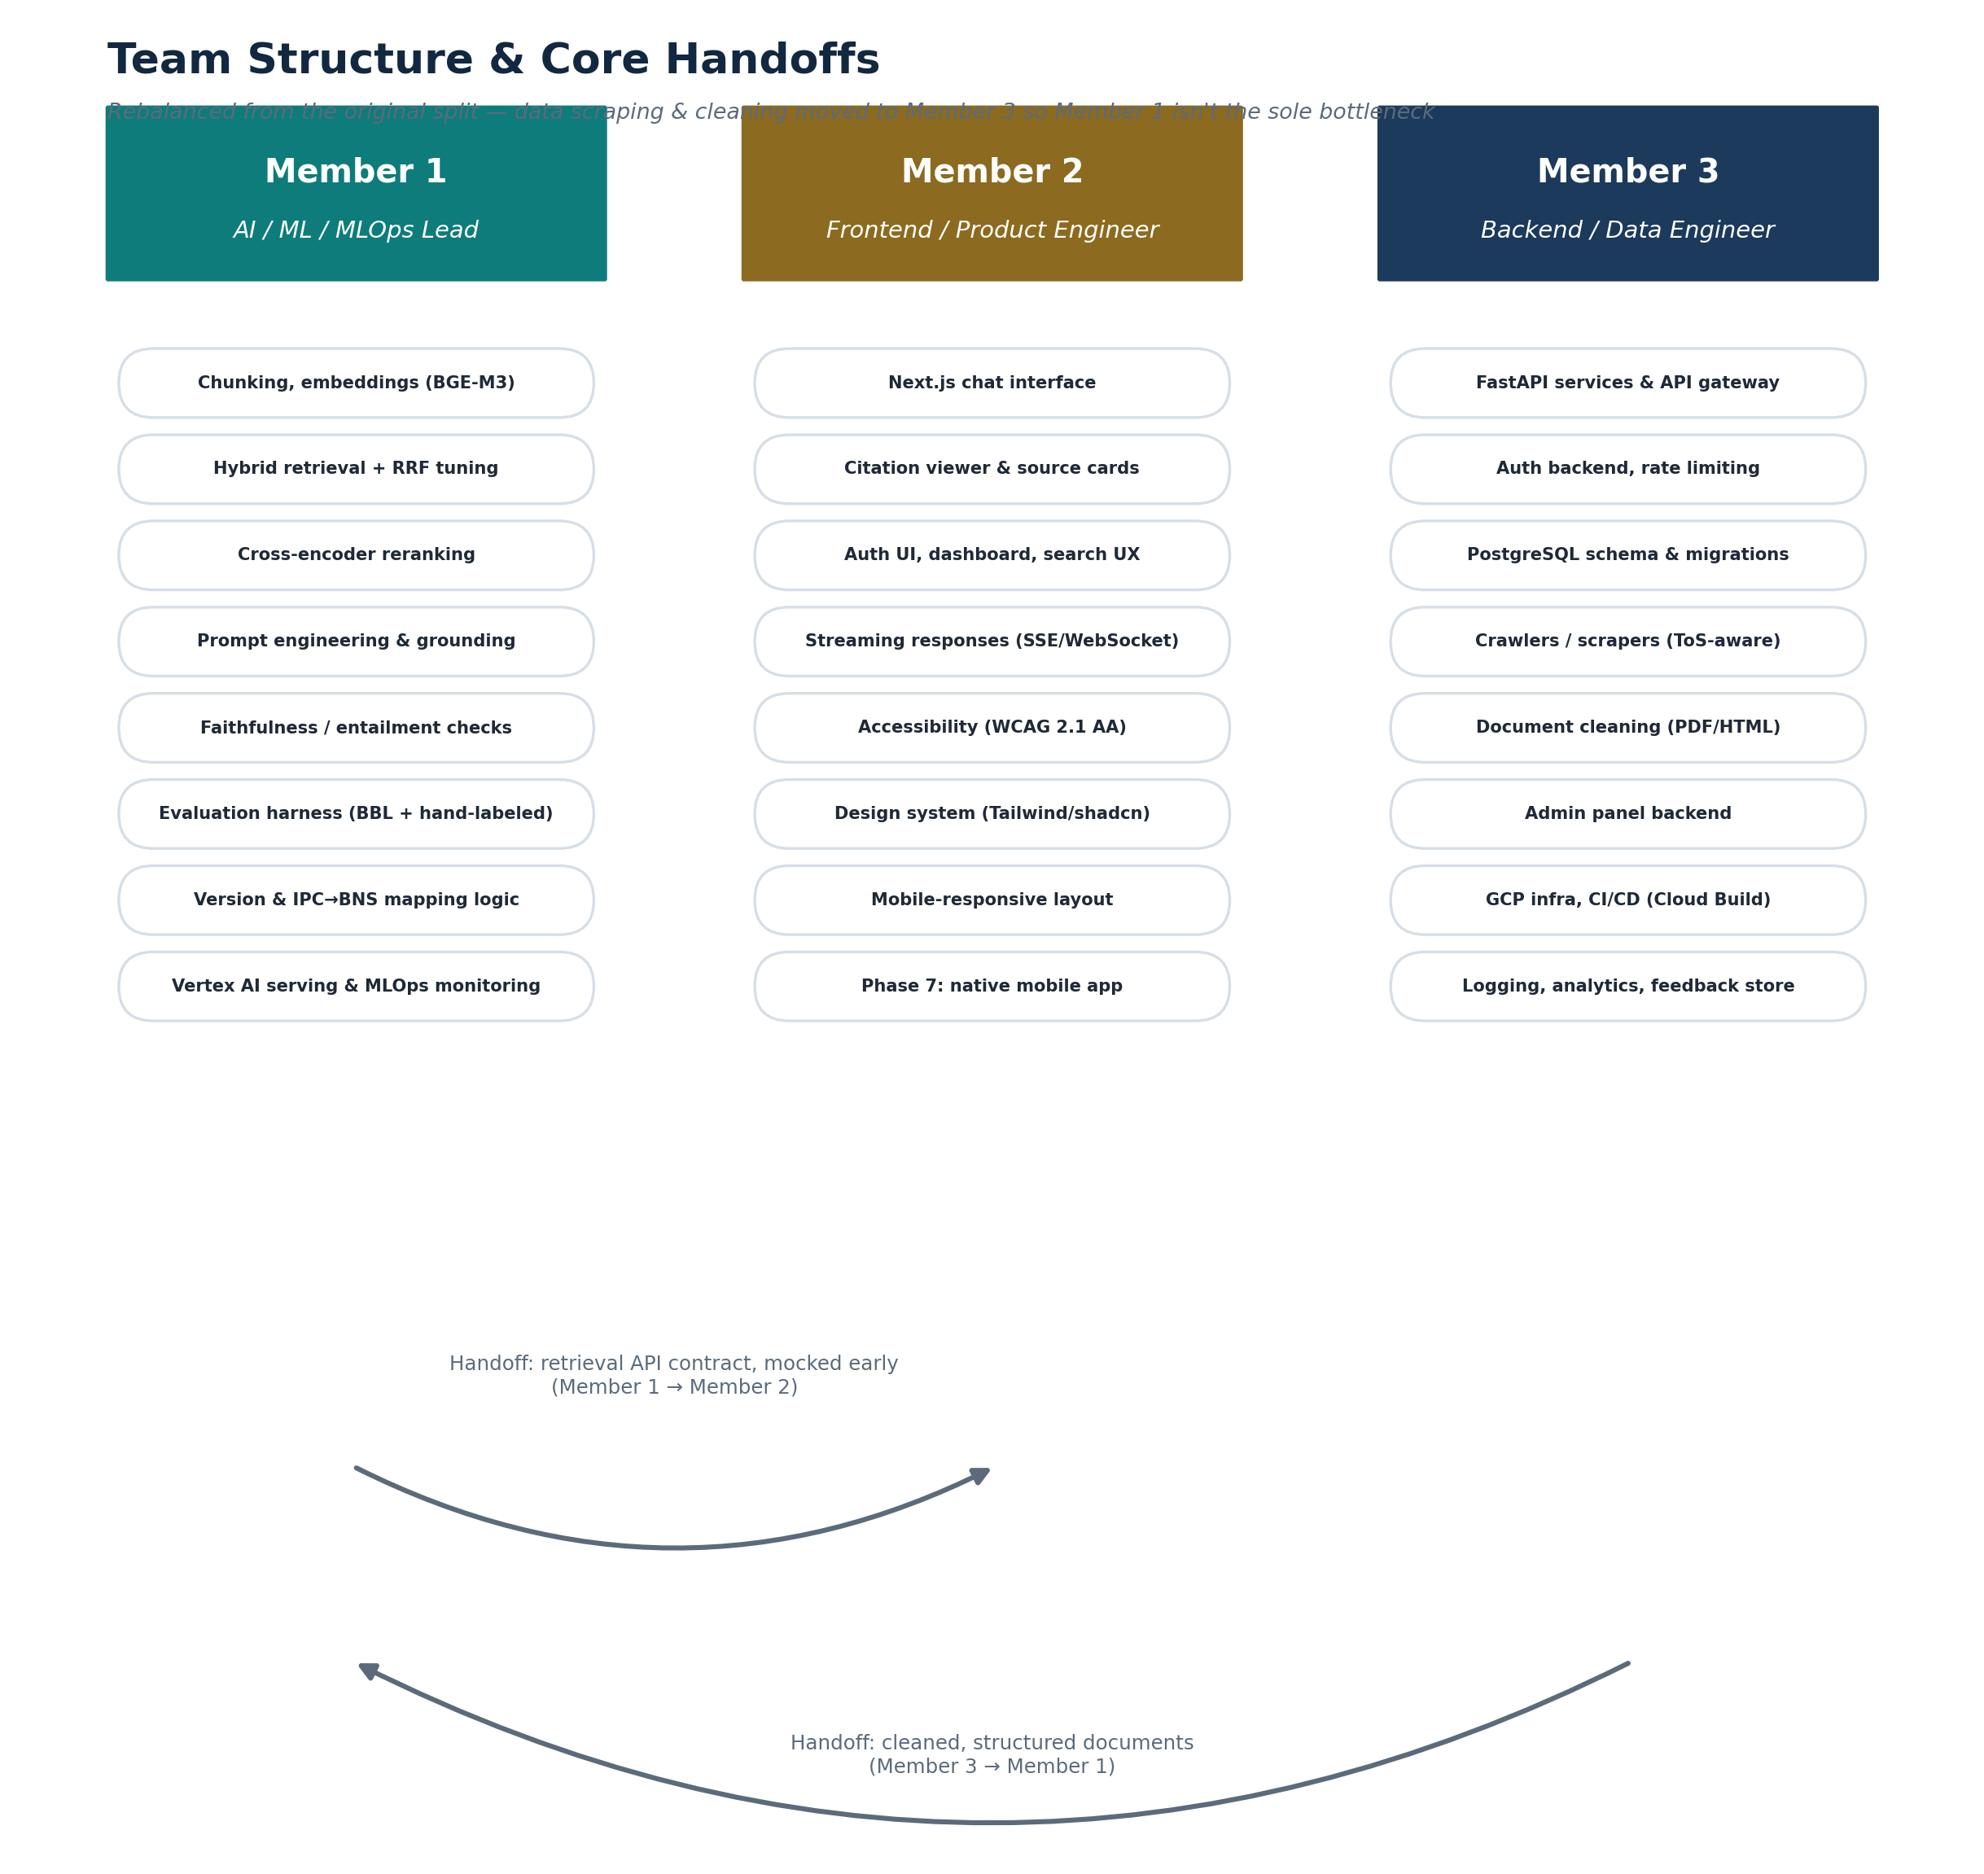
Figure 1.1 — Three roles and the two core handoffs between them.

1.2 Workload Balance Across Phases
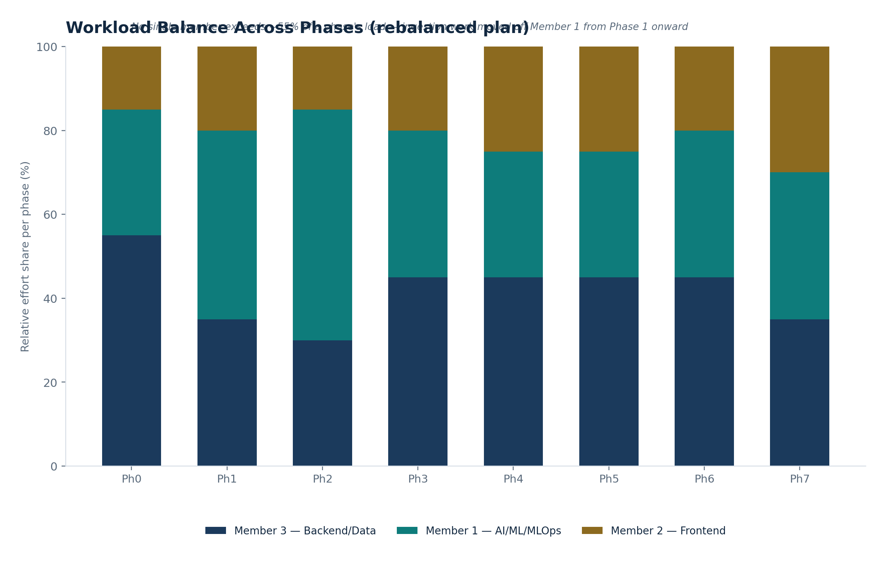
Figure 1.2 — Illustrative relative effort share per phase. No member exceeds roughly 55% of a phase's load; compare to the original split, where Member 1 alone carried the ingestion pipeline through every phase.
NOTE — These percentages are illustrative, not a timesheet
They exist to make an argument — that the rebalanced split doesn't quietly recreate the original bottleneck — not to be tracked literally week to week.

2. Member 1 — AI / ML / MLOps Lead

2.1 Core Responsibilities
Area | Specifics
Processing | Hierarchical chunking logic, cross-reference extraction rules (works from documents Member 3 has already cleaned and structured).
Embeddings | BGE-M3 embedding pipeline, batching within the local GPU/VRAM budget.
Retrieval | Hybrid retrieval (RRF merge), cross-encoder reranking, cross-reference resolution, version resolution + the IPC→BNS mapping logic.
Generation | Prompt engineering, citation-format enforcement, Vertex AI integration, faithfulness checking.
Evaluation | Hand-labeled evaluation set design and maintenance, BhashaBench-Legal integration, CI-gated regression evaluation (Phase 2+).
MLOps | Retrieval-quality monitoring in production, model/version tracking as embedding or reranker models change.
Judicial NLP (Phase 4+) | OpenNyAI integration for judgment NER and rhetorical-role labelling.
Multilingual (Phase 5+) | Cross-lingual retrieval quality (English/Hindi).

2.2 What Changed From the Original Plan
- Data scraping and document cleaning — moved to Member 3.
- Deployment and general infra ops — moved to Member 3 (Member 1 remains responsible for ML-specific serving concerns, e.g. embedding/reranker inference and Vertex AI integration, but not general Cloud Run/CI-CD ops).

2.3 Ramp-Up / Learning List
- Qdrant's hybrid (dense + sparse) search API and payload filtering.
- Cross-encoder reranker models and their input-length sensitivity.
- OpenNyAI's model set and its intended scope (judgment structure, not statute structure — see SDD ADR-009).
- Vertex AI's Gemini API, including the location="global" region-availability nuance for some model versions.

3. Member 2 — Frontend / Product Engineer

3.1 Core Responsibilities
Area | Specifics
Chat interface | Next.js streaming chat UI — the primary user-facing surface from Phase 1.
Citation viewer | Source-excerpt panel, metadata display, link-through to official source; version/mapping notices (e.g. “formerly IPC 302”) from Phase 2.
Auth & account UX | Sign-in flow built against Member 3's auth backend.
Search UX | Optional filters (Phase 3+: jurisdiction, doc type, date range).
Accessibility | WCAG 2.1 AA conformance for the public web app.
Design system | Tailwind/shadcn-based component library, kept consistent as new UI (admin panel, filters, citation viewer upgrades) is added phase over phase.
Phase 7 | Native mobile app; amendment-timeline and compare-versions UI.

3.2 Handoff Points
- Consumes the retrieval/generation API contract from Member 1 — built against a mocked response shape early in Phase 1 so frontend and backend work proceed in parallel rather than serially.
- Consumes the auth API from Member 3.

3.3 Ramp-Up / Learning List
- Server-Sent Events / streaming response patterns for the chat UI.
- Designing citation UI that stays readable with variable-length legal text excerpts.

4. Member 3 — Backend / Data Engineer

4.1 Core Responsibilities
Area | Specifics
Data acquisition | Crawlers/scrapers for official sources, ToS/robots.txt compliance checks and source-registry maintenance — moved here from the original all-Member-1 plan.
Document cleaning | PDF/HTML → normalized, structure-preserving text — also moved here.
API & services | FastAPI gateway, auth service, rate limiting, admin panel backend.
Database | PostgreSQL schema, migrations, performance.
Infrastructure | GCP project setup, IAM, Docker Compose, CI/CD (GitHub Actions + Cloud Build), Cloud Run deployment.
Observability | Structured logging with correlation IDs, Cloud Logging/Monitoring setup.
Feedback & analytics | Feedback-capture endpoint and storage.
Compliance engineering (Phase 4) | Builds the DPDP-aligned redaction pipeline (working from the policy Member 1 and the team define together).

4.2 What Changed From the Original Plan
- Absorbs crawling and document cleaning — the single biggest rebalancing move in this document.
- Owns general infra/deployment ops end to end, rather than that being folded into the AI/ML role.

4.3 Ramp-Up / Learning List
- FastAPI async patterns at the throughput this pipeline needs.
- GCP IAM least-privilege service-account design.
- Respectful, compliant crawling practice (rate limiting, robots.txt, identifying user agents, official-API-first).

5. Shared Practices

5.1 Handoff Contracts
Handoff | What's handed off | Direction
Cleaned, structured documents | Normalized text with preserved Part/Chapter/Section markers, ready for chunking | Member 3 → Member 1
Retrieval/generation API contract | Response shape (mocked early in Phase 1, real by end of Phase 1) | Member 1 → Member 2
Auth API contract | Sign-in/session endpoints | Member 3 → Member 2
Evaluation results | Metrics against the SRS Section 6 targets, reported each phase | Member 1 → whole team

5.2 Cadence
- Short standup at the start of each working session — what shipped, what's blocked, what handoff is needed next.
- A demo at the end of every phase before that phase's production milestone is declared done — not a status update, an actual working walkthrough.
- Decisions that cut across roles (e.g. a new ADR-worthy architecture choice) are logged in the SDD's ADR log, not left as a verbal agreement.

5.3 Definition of Ready / Definition of Done
- Definition of Ready (before starting a task): the relevant SRS requirement ID is known, and any upstream handoff (Section 5.1) it depends on has actually landed — not just been promised.
- Definition of Done (before closing a task): meets the SRS acceptance criterion, and — if it changes a production-facing behavior — is included in that phase's Definition of Production-Ready checklist in the Project Workflow document.

5.4 Decision-Making
Cross-cutting technical disagreements default to whoever owns the affected area (Member 1 for retrieval/generation quality trade-offs, Member 2 for UX trade-offs, Member 3 for infra/data trade-offs); disagreements that cross areas are resolved by brief written discussion captured as an ADR, so the reasoning — not just the outcome — is preserved for the next phase.

